Odour diary
Publication F1019 June 2021

Your details | (full name)
 | (address)
Diary start date |  | / / | Diary end date | / /

What to do if you are affected by offensive odour
- Call EPA on 1300 EPA Vic to report the odour.
- Record your observations in this odour diary.
- Keep the diary record for future issues.
- EPA may use information from your diary as evidence for legal action.

About this odour diary
Residents submitting this form to EPA may have to either provide a formal statement or appear as a witness in court. If they are uncomfortable in doing this, EPA will not be able to progress with them as a witness. This document is to assist residents to record their observations during times when they are being affected by offensive odour. The template is used in preparing witness statements.

Why EPA Needs Community Evidence
All businesses that produce odour are required to minimise odour as far as reasonably practical. One of the harms defined in the Environment Protection Act 2017 (the Act) is a change to the condition of the environment that make it offensive to the senses of human beings.
To fine or prosecute a company for offensive odour, among other things, requires evidence of how people were affected. Through interpreting the Act and subordinate legislation, offensive odour can be defined as odour which affects the general life, health and well-being of an individual, as a result of the intensity, character, frequency, and duration of the odour.
People experience odours differently. To build a successful prosecution, EPA requires individual reports demonstrating how the presence of the offensive odour has infringed on peoples’ lives.
This evidence cannot be provided by an EPA officer if they are not living in the area. They cannot claim that their general life, health and wellbeing are being affected.

What to Include
Each of the odour logs prepared needs to have sufficient information in case you are requested to prepare a formal statement at a later date. Some prompts have been provided overleaf, but please remember:
- Fill in as much detail as you can
- Each observations needs a new statement – making it clearer to differentiate observations over time
- Try to be realistic and objective about your observations – an odour of “15 out of 10” may reflect how you feel about the odour, but will not give a realistic measure of the level of odour in the area.

Reporting Pollution
The community supports EPA by reporting pollution in its area to us on 1300 EPA VIC.
EPA officers use information such as wind data, recent field investigations and information from the community to determine possible sources.
Follow-up action may include on-site attendance, after consideration of the extent, nature and severity of pollution reports from the community.

Describing odour
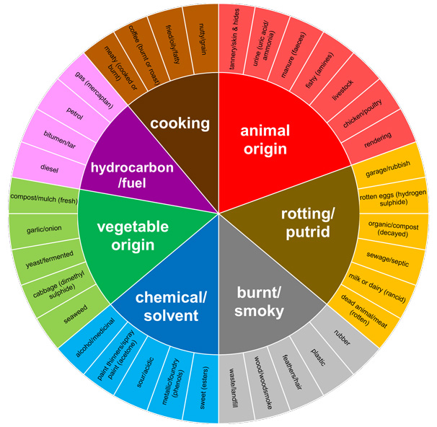
Figure 1: Odour wheel

Common industrial odour descriptors

01 Fragrant/Perfume
02 Nut Roasting
03 Sweet
04 Fruity
05 Bakery
06 Coffee-like
07 Spicy
08 Meaty (cooked)
09 Raw meat, blood-like
10 Herbal, green, cut grass
11 Cooked vegetables
12 Garlic, onion
13 Sea/marine
14 Fishy- fresh or rotten
15 Woody, resinous
16 Burnt, smoky
17 Medicinal, ether-like, anaesthetic
18 Chemicals
19 Fibreglass resin-like styrene
20 Paint-like
21 Petrol, diesel, kerosene, solvents
22 Ammonia/Urine
23 Rotten egg, sulphurous
24 Gas-like (methylmercaptans)
25 Tar-like
26 Metallic 27 Oil, fatty
28 Sour, acrid, vinegar
29 Silage
30 Compost
31 Musty, earthy, mouldy
32 Rubbish
33 Rancid
34 Putrid, foul decaying, vomit
35 Dead animal
36 Manure
37 Sewage, septic
38 Other (describe)

Details of odour event
Odour first noticed | (time) | (date)
Time reported | (time) | (date)
Odour Intensity | Strong | Weak
Odour description
- What did it smell like?
- Was it consistently present?
- How long did it last?
How the odour affected you
- How did the odour present make you feel?
- How long did you feel this?
- Did the odour disrupt your activities?

Details of odour event
Odour first noticed | (time) | (date)
Time reported | (time) | (date)
Odour Intensity | Strong | Weak
Odour description
- What did it smell like?
- Was it consistently present?
- How long did it last?
How the odour affected you
- How did the odour present make you feel?
- How long did you feel this?
- Did the odour disrupt your activities?

Details of odour event
Odour first noticed | (time) | (date)
Time reported | (time) | (date)
Odour Intensity | Strong | Weak
Odour description
- What did it smell like?
- Was it consistently present?
- How long did it last?
How the odour affected you
- How did the odour present make you feel?
- How long did you feel this?
- Did the odour disrupt your activities?

Details of odour event
Odour first noticed | (time) | (date)
Time reported | (time) | (date)
Odour Intensity | Strong | Weak
Odour description
- What did it smell like?
- Was it consistently present?
- How long did it last?
How the odour affected you
- How did the odour present make you feel?
- How long did you feel this?
- Did the odour disrupt your activities?

Details of odour event
Odour first noticed | (time) | (date)
Time reported | (time) | (date)
Odour Intensity | Strong | Weak
Odour description
- What did it smell like?
- Was it consistently present?
- How long did it last?
How the odour affected you
- How did the odour present make you feel?
- How long did you feel this?
- Did the odour disrupt your activities?

Details of odour event
Odour first noticed | (time) | (date)
Time reported | (time) | (date)
Odour Intensity | Strong | Weak
Odour description
- What did it smell like?
- Was it consistently present?
- How long did it last?
How the odour affected you
- How did the odour present make you feel?
- How long did you feel this?
- Did the odour disrupt your activities?

