Regulating Litter and other Waste
  - Local government toolkit
Publication 1927 | November 2022
Regulatory Enablement Branch
epa.vic.gov.au
Environment Protection Authority Victoria
GPO BOX 4395 Melbourne VIC 3001
1300 372 842

This publication is for general guidance only. You should obtain professional advice if you
have any specific concern. EPA Victoria has made every reasonable effort to ensure accuracy
at the time of publication.

Give feedback about this publication online: epa.vic.gov.au/publication-feedback

EPA acknowledges Aboriginal people as the first peoples and Traditional custodians of the land
and water on which we live, work and depend. We pay respect to Aboriginal Elders past and present
and recognise the continuing connection to, and aspirations for Country.

Contents
Using this toolkit 5
Littering and illegal dumping in Victoria 5
Litter prevention 5
What the law says 7
Role and powers of EPA 7
Litter authorities 8
Litter enforcement officers 8
Where a litter enforcement officer can act 9
Powers of litter authorities and litter enforcement officers 9
Definitions of waste and litter 10
Priority waste and dangerous litter 11
Unlawful deposit of waste 11
What is unlawful deposit of waste? 11
When is it lawful to deposit waste? 12
Waste deposited by the landowner 12
Connected deposits of waste 13
Estimating the volume of waste 13
Defining a waste offence 13
Waste deposited from vehicles 15
Liability of owners and drivers 15
Exceptions to liability 16
Written statement 16
Requesting information from VicRoads 16
Litter offences under the Regulations 17
Depositing or affixing unsolicited documents 17
Persons who commission or engage the distribution of unsolicited documents 17
Offence relating to public litter receptacle 17
Loading of vehicles 18
Investigating litter and other waste offences 18
Receiving reports of litter and other waste 20
Signed reports provided to EPA or councils 20
Initial investigation 20
Referral of reports 21
Using your powers to investigate 21
Powers of entry 22
Powers of entry on commercial and industrial land 22
Powers of entry at residential premises 22
Investigating waste deposited on or from private land 22
Litter enforcement officer may ask a person’s name and address 23
Litter enforcement officer to provide proof of identity and official status 23
Waste information gathering notice 23
Interacting with suspects 25
Evidence 26
Contemporaneous notes 27
Photographs and videos 27
Statements 28
Material goods and documents 28
Sampling waste 28
Continuity of evidence 28
Taking compliance and enforcement action 29
Litter enforcement officer may request persons to remove waste 30
Waste abatement notice 30
Infringements 30
Prosecution 30
Court may order person to remove waste 31
Stakeholders and networks 33
Appendix A: Schedule of offences 35
Appendix B: Waste information gathering notice 37
Appendix C: Waste abatement notice 39
Appendix D: Infringement notices 41
Appendix E: Prosecution 43
Appendix F: Estimating volume of waste 44
Why do LEOs need to estimate the volume of waste? 44
How is volume assessed? 44
Recommended methods for estimating volume 44
Reference items for estimating volume 46
Calculating the volume of different shaped waste 47
Accessibility 54
Interpreter assistance 54

Using this toolkit
This toolkit is a resource for litter authorities, including councils, and litter enforcement officers in Victoria. The toolkit sets out the laws under the Environment Protection Act 2017 (the Act) and Environment Protection Regulations 2021 (the Regulations) that prohibit littering and other unlawful deposit of waste and the associated penalties. It explains the powers of litter authorities and litter enforcement officers to investigate and enforce the law.
The toolkit also:
- shows how enforcement action works alongside litter prevention strategies
- provides tips for investigating litter and dumping
- includes case studies.
Use this toolkit with:
- the Act and Regulations at legislation.vic.gov.au
- information about illegal dumping epa.vic.gov.au

Littering and illegal dumping in Victoria
Littering and other unlawful deposit of waste presents a significant challenge to EPA, councils and other litter authorities across Victoria. It causes pollution, impacts our health, threatens wildlife and affects the amenity of our communities. It costs councils and the State Government millions of dollars a year, diverting public money from other services to the community.
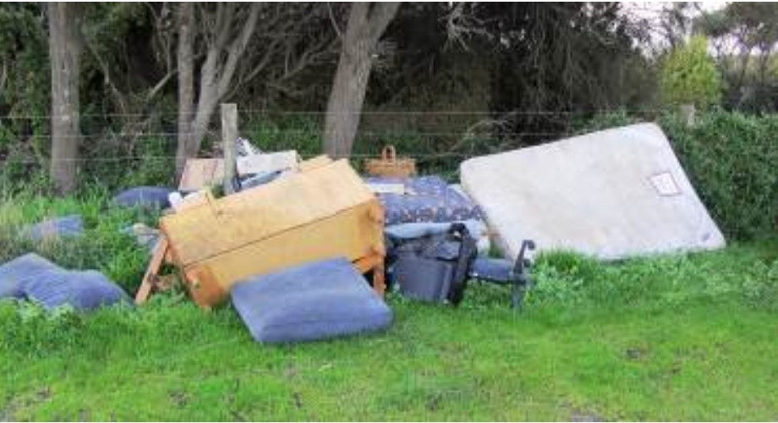
Common examples of waste often disposed of illegally include:
Figure 1. Illegal dumping at Kilcunda Cemetery
- televisions, appliances and electronic
waste (e-waste)
- furniture and mattresses
- cigarette butts
- industrial waste
- construction and demolition materials
- garden waste and soil
- packaging
- old cars
- tyre and chemical waste stockpiles.

Litter prevention
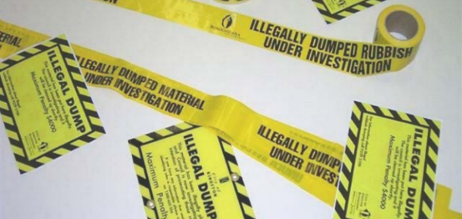
Litter authorities use a range of methods to discourage littering and illegal dumping, change behaviour and educate the community. Preventative approaches can be effective either on their own or combined with the enforcement powers explained in this toolkit.
Effective enforcement can reinforce positive behaviours around responsible litter and waste actions. It can support preventative approaches (such as education and providing adequate facilities) and create a general deterrent.
Figure 2. Illegal dumping tape and litter
alert cards
Effective preventative approaches include:
- education and awareness campaigns,
especially social media
- engaging with residents
- communicating enforcement outcomes
- information about disposal options
- access to transfer stations
- using ‘under investigation’ barrier tape when dumping is found on roadsides, especially in high visibility locations
- strategies such as delayed response collection of waste, combined with signage
and warnings
- infrastructure such as:
- barriers, bollards and fencing to prevent access to land
- permanent and movable signage to warn the area is under surveillance
- surveillance cameras
- lighting in targeted locations, signage and bins at litter hot spots and roadside stops.
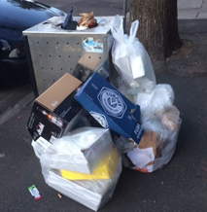
Overflowing public bins
A local council asked an EPA Officer for the Protection of the Local Environment (OPLE) to help solve a recurring litter problem.
During summer the area saw a big increase in visitors. Despite regular waste collection, overflowing rubbish bins was a frequent problem. Commercial waste from local shops seemed to be contributing to the problem.
The OPLE worked with council waste collectors to map problem areas and helped develop a flyer for local traders. The flyer outlined their obligations and potential fines. The OPLE visited 89 local businesses, speaking with staff, handing out flyers, and emailing business owners to support them to comply with their obligations.
Figure 3. Overflowing street bins. Photo: EPA

After this education campaign, the OPLE worked with the council litter enforcement officers to conduct surveillance and collect evidence of further non-compliance. When some businesses continued to use the public bins, the council took enforcement action.
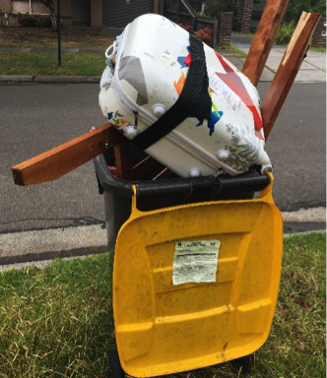
Preventing litter in the City of Monash
Overflowing bins and kerbside dumping are serious problems in the Clayton area. The area is home to many students who attend Monash University.
It has a high proportion of renters who are regularly moving in and out of the area.
The City of Monash ran a public education campaign in two phases to increase understanding and reduce litter and waste in the area.
Phase 1
Distribution of educational material including:
Figure 4. Overflowing bins. Photo: Monash City Council

- a letter explaining which waste goes in which bin
- waste collection calendars if bins were put out on the wrong dates or left out for more than 24 hours.
Phase 2
Door knocking to engage and educate residents, encouraging them to do the right thing instead of punishing mistakes.
The campaign highlighted several problems, including:
- a lack of understanding about what should go in rubbish, recycling or green waste bins
- people putting hard waste out too early for hard waste collection
- residents who were unaware they could get a larger rubbish bin, or landlords who weren’t willing to pay for one.
The campaign showed promising results. After phase 1, the number of overfilled rubbish bins dropped from 163 to 84. After phase 2, it dropped further from 84 to 43.
Before phase 1, 90 households had illegally dumped waste. This dropped to 83 after phase 1 and to 46 after phase 2.
During the campaign the council issued 25 infringements for overflowing bins and illegal dumping.

What the law says
Waste is primarily dealt with in Chapter 6 of the Environment Protection Act 2017 (the Act).
The objectives of Chapter 6 are to:
- minimise litter and waste disposal by encouraging management of waste in accordance with the waste hierarchy
- promote waste reduction, resource recovery and efficiency
- minimise the impact on human health and the environment from waste.
Powers of litter authorities
Litter authorities including EPA, councils and other land managers can enforce the laws in
Part 6.3 Litter and other waste. This includes:
- offences for unlawful deposit of litter and other waste that are based on increasing scales by volume and have associated escalating penalties
- disposal and removal of litter and other waste
- powers, functions and enforcement tools of litter authorities and litter enforcement officers.
These powers and enforcement tools, as well as the litter penalty structures, have been designed to allow litter authorities to better deal with dangerous litter and unlawful deposit of larger volumes of waste.
These laws support a proportionate response to the challenge of littering and dumping in our communities.
The offences in Part 6.3 are infringement offences (a fine can be issued) and, as summary offences, a person accused of unlawful deposit of waste can be prosecuted in the Magistrates’ Court. For penalties see Appendix A: Schedule of offences.

Role and powers of EPA
Along with Part 6.3, EPA has additional powers to deal with waste. EPA can also enforce:
- duties in Parts 6.4 and 6.5 of the Act relating to industrial waste and priority waste
- duties in Chapter 3 relating to pollution incidents and contaminated land that may also apply
- the general environmental duty (GED) - section 25 of the Act. The GED applies to waste where it arises from an activity that may give rise to risks of harm to human health or the environment.
Figure 5 below shows the role of EPA alongside other litter authorities such as councils, in regulating litter and other waste under the Act.

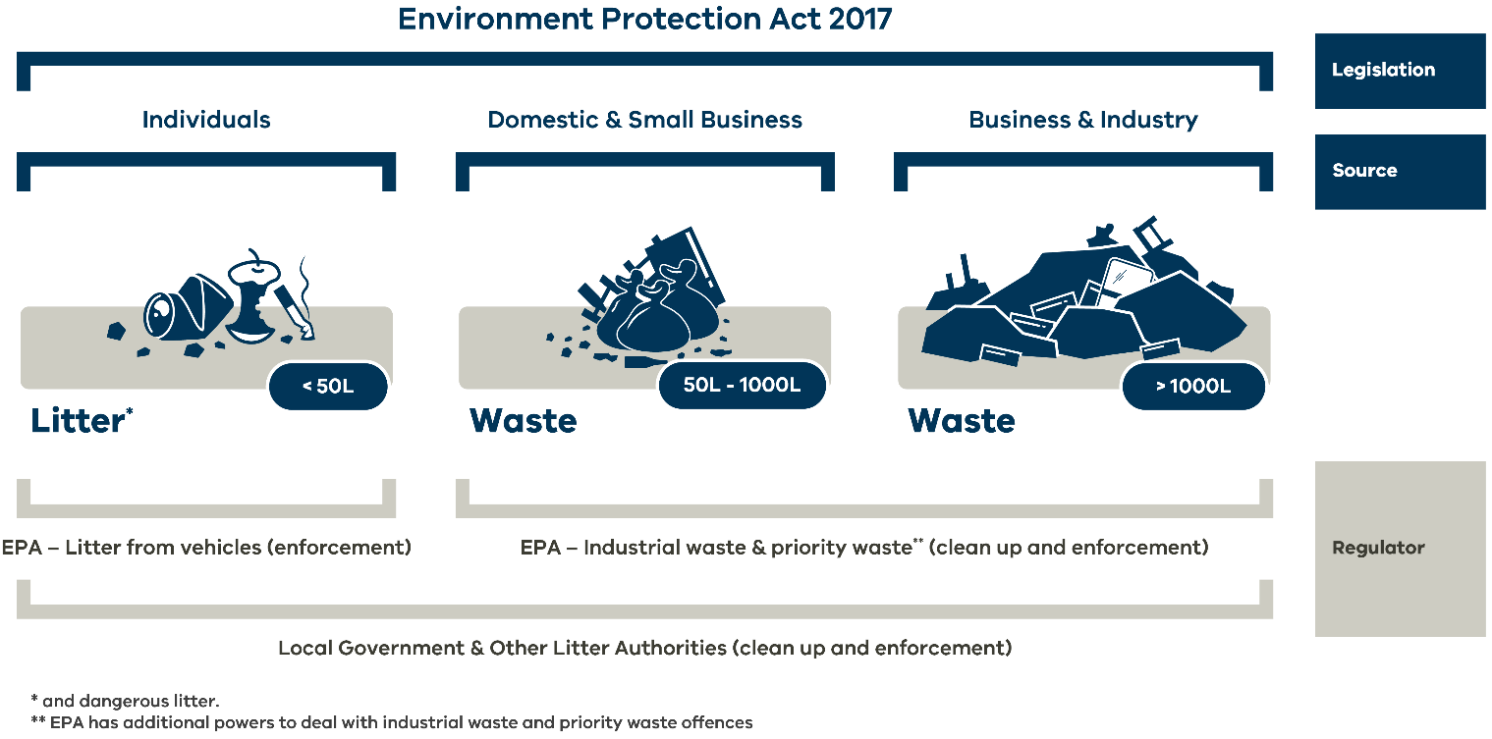
Figure 5. Regulation of litter and other waste in Victoria

Litter authorities
Litter authorities, including councils and other land managers such as Parks Victoria, VicRoads, rail authorities and water authorities, play an important role in litter and waste prevention. They have powers under the Act and Regulations to deal with a broad variety of waste from domestic, commercial and industrial sources.
Litter authority is defined in section 3 of the Act as:
- the Authority (EPA)
- any other body created by or under an Act
- a government department
- a council
- the Secretary, being the body corporate established by Part 2 of the Conservation, Forests and Lands Act 1987
- a body created by Order of the Governor in Council under section 113 to be a litter authority.

Litter enforcement officers
The Act creates the statutory role of litter enforcement officer (LEO). LEOs are appointed by litter authorities and have powers to investigate and act when unlawful deposit of waste occurs.
A litter authority may appoint an employee or every member of a class of employee as an LEO under section 114(2) of the Act.
EPA can also appoint any person as a LEO under section 114(1). EPA’s authorised officers are also LEOs and do not require an additional appointment.
Transition provision for litter enforcement officers
LEOs who were appointed under the Environment Protection Act 1970 don’t need to be re-appointed. However, if the opportunity arises, it would be prudent for LEOs reliant on a transitioned appointment to be appointed under the Act.
Litter enforcement officer is defined in section 3 of the Act as:
- a person appointed by EPA or a litter authority as a litter enforcement officer
- an authorised officer under the Act
- a police or protective services officer
- an authorised officer under the Victorian Fisheries Authority Act 2016 appointed for the purposes of this Act.

Where a litter enforcement officer can act
While EPA authorised officers and police have state-wide powers, LEOs employed by other litter authorities can only act in the situations set out in section 114(2) of the Act.
Because council municipal areas overlap with land managed by other litter authorities, it is generally up to the relevant litter authorities to decide who will act. In some cases, there may be restrictions preventing councils from acting on land managed by other government agencies
or authorities.
Litter enforcement officers – Section 114
- The Authority may appoint a person as a litter enforcement officer.
- A litter authority may appoint an employee of the litter authority, or each member of a class of employee of the litter authority, as a litter enforcement officer in relation to:
- any bus, tram, watercraft, rail vehicle or aircraft owned or managed by the litter authority that is used for a public purpose; or
- in the case of a litter authority that is a council, any land or waters in a council’s municipal district; or
- any land or waters under the control or management of the litter authority; or
- any offences under this Part that may result in waste appearing on land or waters under the control or management of the litter authority (regardless of where the offence occurs).

Powers of litter authorities and litter enforcement officers
Litter authorities and LEOs have powers to enforce the litter and other waste laws under the Act and Regulations. These powers are summarised in Table 1 below. They are explained in more detail throughout this toolkit.
Table 1: Powers of litter authorities and LEOs
Section/  Regulation | Power | LEO | Litter authority
s114(2) | Appoint an employee as a LEO |  | ✓
s119 | Request person to remove waste | ✓
s121 | Issue a waste abatement notice; or vary or revoke a waste abatement notice | ✓ | ✓
s122 | Remove waste and recover costs |  | ✓
s124 | Powers of entry | ✓
s125 | Ask a person’s name and address | ✓
s127-s129 | Issue a waste information gathering notice; extend period for complying with the notice; amend or revoke a requirement in the notice | ✓
s130 | Apply for a court order to compel compliance with a waste information gathering notice | ✓
s307(1), (4)(e) | Serve an infringement notice for an infringement offence under Part 6.3 of the Act | ✓
s347(4) | Take proceedings for an offence under Part 6.3 of the Act | ✓ | ✓
s347(5)  Regulation 59 | Take proceedings for an offence under Part 4.1 of the Regulations | ✓ | ✓
s307(1), (4)(a)  s347(5)  Regulation 59 | Issue an infringement notice for an infringement offence under Part 4.1 of the Regulations. | ✓ | ✓

Definitions of waste and litter
The Act uses a broad, criteria-based definition of ‘waste’ to establish the subject matter of the offences. It then adds in graduated and increasingly higher offences that distinguish between minor acts of littering and larger scale dumping
The definitions that support the range of litter and waste offences are as follows:
Waste is defined in section 3 of the Act and includes any of the following─
- matter, including solid, liquid, gaseous or radioactive matter, that is deposited, discharged, emitted or disposed of into the environment in a manner that alters the environment
- a greenhouse gas substance emitted or discharged into the environment
- matter that is discarded, rejected, abandoned, unwanted or surplus, irrespective of any potential use or value
- matter prescribed to be waste
- matter or a greenhouse gas substance referred to in paragraph (a), (b), (c) or (d) that is intended for, or is undergoing, resource recovery.
Litter is defined in section 112 of the Act as a quantity of waste that does not exceed 50 litres.
Dangerous litter is defined in section 112 of the Act as litter that is wholly or partly comprised of one or more of the following:
- oil, fuel, grease, paint or solvents
- a lit cigarette or lit cigarette butt
- glass
- a syringe
- any substance, material or other thing prescribed by Regulations.

Priority waste and dangerous litter
The Act and Regulations define certain waste types as priority waste. Priority wastes (listed in Schedule 5 of the Regulations) are industrial wastes that require special management. Industrial waste is defined in section 3 of the Act and includes wastes that come from commercial, industrial or trade activities.
Regulation 54 prescribes that priority wastes (in quantities less than 50 litres) are dangerous litter.
What can a LEO do about unlawful deposit of priority waste?
LEOs can act if priority wastes from a commercial, industrial or trade activity are unlawfully deposited in a volume of less than 50 L - making them dangerous litter.
Priority wastes unlawfully deposited in larger volumes should be referred to the EPA who have additional powers to deal with offenders.

Unlawful deposit of waste
The key offences in Part 6.3 of the Act are in section 115 unlawful deposit of waste. These offences are broken up by volume of waste, as well as waste type in the case of dangerous litter.
The offences under section 115 have escalating penalties associated with them. The lowest is for litter (waste less than 50 L), and the highest penalties are for depositing waste exceeding 1,000 L.
Section 115: Unlawful deposit of waste
- A person must not deposit waste that is litter other than in circumstances specified in sub-section (5).
- A person must not deposit waste that is dangerous litter other than in circumstances specified in sub-section (5).
- A person must not deposit waste of more than 50 L but not more than 1000 L other than in circumstances specified in sub-section (5).
- A person must not deposit waste of more than 1000 L other than in circumstances specified in sub-section (5).
This is an extract from section 115 of the Act. Read the full Act section at legislation.vic.gov.au

What is unlawful deposit of waste?
Deposit of waste occurs when a person parts with the possession of litter or other waste. This includes the burning of waste, and where waste blows from or falls or escapes from a premises or place.
The deposit of waste is unlawful unless the circumstances set out in section 115(5) apply – see next section.
Refer to the following definitions from the Act that are important in determining if waste has been unlawfully deposited:
Deposit is defined in section 3 of the Act as, in relation to litter and waste, means the act of parting with the possession of litter or waste and includes the disposal of litter or waste by burial or burning and also includes burial or burning of litter or waste on land owned by or in the control or possession of the person responsible for burying or burning the litter or waste.
Note this definition was amended in the Act in 2022.
Additionally, section 115(7) of the Act states that the unlawful deposit of waste includes waste that is blown from, or falls or escapes from, a premises or place.
- place includes land, waters, a location, an area or a region (section 3 of the Act)
- place also includes a receptacle (section 112 of the Act).

When is it lawful to deposit waste?
In some circumstances it is lawful to deposit waste. These circumstances are set out in section 115(5):
- A person deposits waste in a premises or place provided for the deposit of waste, appropriate for waste of that size, shape, nature or volume. An example is an appropriately sized bin – section 115(5)(a).
- A person deposits waste in or on premises or a place in such a way that it cannot leave the premises or place without human assistance, and the person; owns, controls or is in possession of the premises or place, or has the consent of the owner or person in control of the premises – section 115(5)(b). Note:
  - Industrial waste offences may still apply in this situation. If suspected, the matter must be referred to EPA.
- Industrial waste offences may still apply in this situation. If suspected, the matter must be referred to EPA. A person is authorised to deposit the waste by a law – section 115(5)(c).
- A person deposits the waste as a consequence of a lawful activity that cannot reasonably be avoided – section 115(5)(d)​.
- A person accidentally deposits the waste and it is not reasonably possible to retrieve it – section 115(5)(e).

Waste deposited by the landowner
An offence of unlawful deposit of waste may not have occurred if the waste is deposited on land owned or controlled by the person who deposited it (or by a person who has the consent of the person who owns or controls the land), so long as the waste cannot leave the premises without human assistance (section 115(5)(b)). In this situation (for example a person dumping the waste from a shed they demolished on their property), a LEO may not be able to act, however a breach of section 25 – the general environmental duty, or other waste offence may still apply where EPA can take enforcement action.

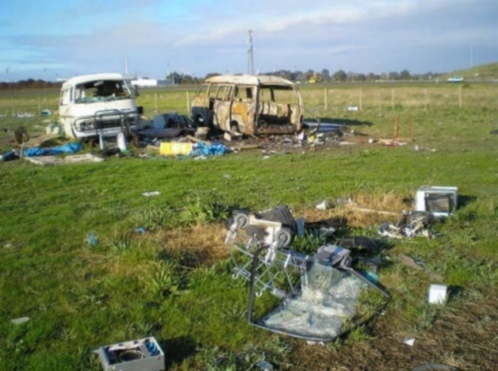
Connected deposits of waste
Figure 6. Illegal dumping at property in Geelong. Photo: City of Greater Geelong
Section 115(6) provides that two or more deposits of waste in or on premises or a place may be taken to be one deposit if the two or more deposits constitute a connected series of deposits.
For example, three loads of waste bricks of 500 L in volume each that can be reliably attributed to the same person, may constitute one deposit of 1,500 L of waste. In this case an offence under section 115(4) applies, which attracts a higher penalty.

Estimating the volume of waste
The offences for deposit of waste under section 115 are based on volume in litres (L). The three volume-based thresholds are:
- Less than 50 L (for litter and dangerous litter)
- More than 50 L but less than 1,000 L
- More than 1,000 L.
To work out which offence may apply, LEOs need to estimate the volume of the waste, or the total volume of a connected series of deposits (section 115(6)).
Read more and find resources in Appendix F: Estimating volume of waste.

Defining a waste offence
Table 2 provides examples of how commonly dumped items fit the definitions of litter and other waste. It also includes the relevant offences under Part 6.3 of the Act that litter authorities can enforce.
Remember – discarding litter or other waste is not always illegal - there are circumstances where it is lawful to deposit waste- see When is it lawful to deposit waste?
Table 2: Defining different types of waste
Waste example | How it is defined in the Act
Cigarette butts | Waste because it’s ‘matter that is discarded, rejected, abandoned, unwanted or surplus’.  Litter because it’s less than 50 L in volume.
Lit cigarettes or cigarette butts | Waste because it’s ‘matter that is discarded, rejected, abandoned, unwanted or surplus’.  Litter because it’s less than 50 L in volume. Also defined by the Act as ‘dangerous litter’.
Household rubbish | Waste because it’s ‘matter that is discarded, rejected, abandoned, unwanted or surplus’.  Litter if it’s less than 50 L in volume.  Dumping two or more bags of household rubbish in the same place with a total volume more than 50 L may be an offence under section 115(3) or 115(4).
Household rubbish including glass | Waste because it’s ‘matter that is discarded, rejected, abandoned, unwanted or surplus’.  ‘Litter’ if it’s less than 50 L in volume. Glass is defined in the Act as ‘dangerous litter’.
Domestic and commercial hard waste, such as mattresses, fridges, furniture | Waste because it’s ‘matter that is discarded, rejected, abandoned, unwanted or surplus, irrespective of any potential use or value’.  ‘Litter’ if it’s less than 50 L in volume. If the volume exceeds 50 L, it may be an offence under section 115(3) or 115(4).  If the waste arises from trade or commercial activities, it is also industrial waste. A LEO or litter authority may deal with the waste under Part 6.3 of the Act, or may refer the incident to EPA who have additional powers for industrial waste. See Referral of reports.
Dumping around charity stores and bins | Waste because it’s ‘matter that is discarded, rejected, abandoned, unwanted or surplus, irrespective of any potential use or value’.  ‘Litter’ if it’s less than 50 L by volume, because it is not in ‘a place that …is appropriate for waste of that … volume’.  Waste if it’s more than 50 L by volume, because it is not in ‘a place that …is appropriate for waste of that … volume’ and attracts an offence under section 115(3) or 115(4).
Overflowing public street litter bins | Waste because it’s ‘matter that is discarded, rejected, abandoned, unwanted or surplus’.  ‘Litter’ if it’s less than 50 L by volume, because it is not in ‘a place that …is appropriate for waste of that … volume’.  Waste if it’s more than 50 L, because it is not in “a place that …is appropriate for waste of that … volume” and an offence under section 115(3) or 115(4).
Construction and demolition waste, waffle pods etc | Waste because it’s ‘matter that is discarded, rejected, abandoned, unwanted or surplus, irrespective of any potential use or value’.  The volume is likely to exceed 50 L, making it waste that attracts an offence under section 115(3) or 115(4).  If the waste arises from trade or commercial activities, it is also industrial waste. A LEO or litter authority may deal with the waste under Part 6.3 of the Act, or may refer the incident to EPA who have additional powers for industrial waste. See Referral of reports.
Asbestos | Waste because it’s ‘matter that is discarded, rejected, abandoned, unwanted or surplus’.  ‘Dangerous litter’ if it’s less than 50 L by volume because asbestos, if it arises from commercial, industrial or trade activities, is an industrial waste classified as priority waste under schedule 5 of the Regulations.  ‘Litter’ if the volume is less than 50 L and arises from a domestic source. For example, if it arises from an individual conducting their own home renovation.  If the volume exceeds 50 L it may be waste that attracts an offence under section 115(3) or 115(4).  If asbestos has been dumped in larger volumes, it may be appropriate for a LEO or litter authority to refer the incident to EPA- See Referral of reports  Warning: Removing, transporting and disposing of asbestos can be dangerous. You must manage asbestos waste the right way. Always take a sample if you suspect you are dealing with asbestos and follow Occupational Health and Safety and WorkSafe guidance. Find out more about dealing with asbestos waste on the EPA website.
Waste paint washed into stormwater drain | Waste because it’s ‘matter that is discarded, rejected, abandoned, unwanted or surplus’.  ‘Dangerous litter’ if it’s less than 50 L by volume because paint and solvents are ‘dangerous litter' under the definition in section 112.  If the volume exceeds 50 L it may be ‘waste’ that attracts an offence under section 115(3) or 115(4).  If the waste arises from trade or commercial activities, it is also industrial waste. A LEO or litter authority may deal with the waste under Part 6.3 of the Act, or may refer the incident to EPA who have additional powers for industrial waste. See Referral of reports.

Waste deposited from vehicles
The Act includes laws that attribute waste deposited from a vehicle to the vehicle owner. These laws target litter thrown from vehicles such as cigarette butts, food packaging and unsecured loads. Failure to adequately cover or secure trailer loads can result in litter entering storm water systems and polluting local creeks and waterways. Items that fall on the road and roadside also present a safety risk for motorists and negatively affect amenity.
Litter from vehicles can be:
- addressed by councils and other litter authorities taking action
- reported to EPA.

Liability of owners and drivers
If waste is deposited in contravention of section 115, the following persons are taken to have committed the offence (section 116):
- the driver of the vehicle
- the registered owner of the vehicle
- a person authorised by the registered owner to use the vehicle when the offence was committed.
A LEO can act against any of the above, and the course of action will depend on the evidence at hand. Do you know the vehicle registration or driver’s identity, or do you have a witness? Sections 116(3), (4) and (5) further define the liability of vehicle owners, and ensure a person accused of an offence is fairly dealt with.

Exceptions to liability
There are exceptions to the liability of drivers, vehicle owners or authorised users (section 117):
- the waste was deposited by a passenger of public transport
- if the vehicle was stolen at the time of the waste offence, the vehicle’s registered owner, or authorised user is not liable
- the liable person provides a written statement stating they did not deposit the waste. Section 118 sets out what information needs to be provided.

Written statement
A person issued with an infringement notice under section 116 can dispute the infringement on the grounds they were not the person who deposited the waste (section 118). They can do this by providing a written statement within 10 business days. In the statement they must identify another person, or if they saw another person near the waste, giving enough details to identify and locate that person.
Penalties apply for proving false or misleading information in connection to a written statement. Refer to Appendix A: schedule of offences.
Templates
EPA provides templates for the section 118 written statement and for a statutory declaration that litter authorities can provide to recipients of infringements issued in relation to litter deposited from a vehicle. These templates are available from the ‘Council Support EP Act’ SharePoint site. Council officers can request access to this site by emailing jointregulator@epa.vic.gov.au.

Requesting information from VicRoads
Litter authorities may request information about the identity of registered vehicle owners from VicRoads. VicRoads provides training in confidentiality to council employees who wish to access vehicle information. Obtaining information from third parties is covered in the Collecting evidence section of this toolkit.
Waste deposited from a vehicle
A witness reported to council a table tennis table dumped on a roadside, supplying the vehicle registration details. The council LEO requested the vehicle owner’s details from VicRoads, then contacted the vehicle owner requesting they remove the waste under section 119. The person complied with the LEO’s request. The LEO decided to take no further action.
Figure 7. Photo: Mornington Peninsula Shire Council

A cigarette dropped by the beach
As a LEO from a coastal council conducted a litter count at a beach carpark, she saw a man drop a cigarette out the window of a parked car. The officer approached the car and identified herself. She then advised the man he had committed an offence of unlawful deposit of a waste that is litter under section 115(1) and would receive an infringement notice.
The LEO requested the man’s name and address under section 125, which he refused to supply. The LEO then informed him that the owner of the vehicle would receive an infringement notice under section 116 - liability of owners and drivers of vehicles. The LEO requested the vehicle information from VicRoads and issued an infringement notice to the owner.

Litter offences under the Regulations
Part 4.1 of the Regulations includes additional offences related to litter and unsolicited documents.
A litter authority or LEO can:
- initiate court proceedings for all offences under Part 4.1
- issue an infringement notice for all offences under Part 4.1 except regulation 56.
Penalties are listed in Appendix A - Schedule of offences.

Depositing or affixing unsolicited documents
Regulation 55 provides an offence that addresses a range of issues mainly relating to unsolicited advertising material such as junk mail, leaflets placed on vehicles and posters affixed to buildings in public places.
There are exceptions to the offence when documents are placed in mailboxes, unless a No Junk Mail sign is present.
Preventing unwanted junk mail
- Residents receiving unwanted junk mail should attach a No Junk Mail sign to their mailbox.
- Report illegal or irresponsible distribution practices to the Distribution Standards Board (DSB).
- DSB can provide free No Advertising Material stickers to residents.

Persons who commission or engage the distribution of unsolicited documents
Regulation 56 provides an offence relating to the distribution of unsolicited documents, including engaging another person to distribute an unsolicited document, in a way that contravenes Part 4.1. This includes paying someone to place advertising leaflets under car windscreen wipers.

Offence relating to public litter receptacle
Regulation 57 provides an offence for defacing, setting fire to, damaging or destroying a receptacle for waste provided by a litter authority.

Loading of vehicles
Regulation 58 provides an offence relating to vehicle loads that are not well secured. A person in control of a moving vehicle must ensure it is loaded so no part of the load can leave without human assistance.
There is an exception to the offence where a person was required to move the vehicle in accordance with a lawful instruction from an authorised officer or police officer.
Remember this offence is committed by the driver. The registered vehicle owner is not automatically liable as with an offence of unlawful deposit of waste.
Read more about waste deposited from vehicles.

Investigating litter and other waste offences
As a LEO, you will investigate incidents of unlawful deposit of litter and other waste and decide how to respond.
LEOs:
- follow up with witnesses
- make observations and collect other evidence
- investigate suspects
- provide guidance on how to comply with the law
- take compliance and enforcement action if required.
This section of the toolkit provides LEOs with general guidance for investigating litter and waste offences and explains your powers.
Figure 8 on the next page shows the process LEOs can follow when investigating litter and other waste offences.

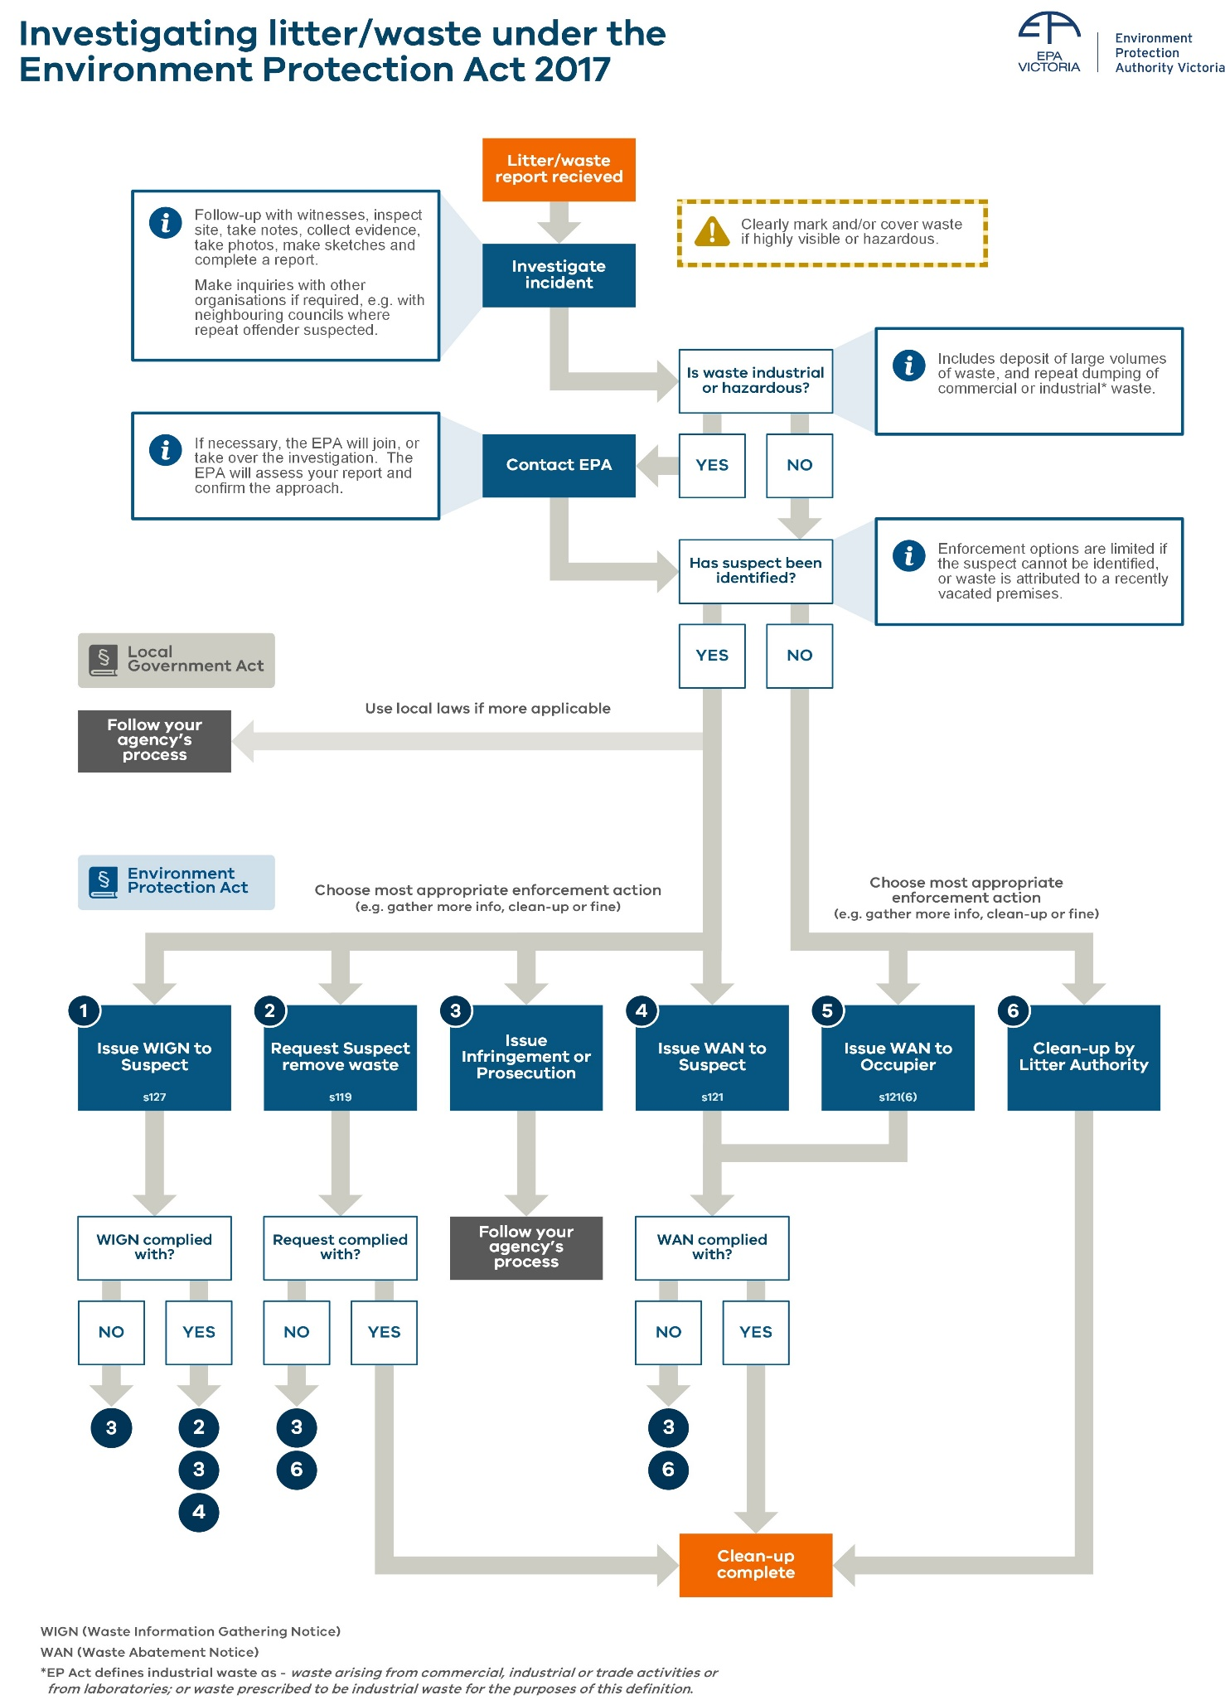
Figure 8. Investigating litter and other waste reports

Receiving reports of litter and other waste
EPA, councils and other litter authorities receive reports of litter and illegal dumping through their call centres, websites and reporting apps. Reports may come from the public or
other agencies.
Reporters should be encouraged to provide as much information as possible, such as photos, location of the dumping, contact information and any other details.

Signed reports provided to EPA or councils
EPA and councils (but not other litter authorities) can take enforcement action against an offence under Part 6.3 based on a signed written report lodged by a person who witnesses
an offence. Section 131 lists the information the reporter must supply. It is an offence to supply false or misleading information in connection with a litter or waste report.
Taking action based on public reports (under section 131) is a cost-effective method of enforcement and empowers the community to help prevent littering.
Public reporters should be encouraged to keep original details of their report, such as any notes made, in case the matter proceeds to court.

Initial investigation
Having received a report or detected litter or illegal dumping through other means, LEOs will conduct an initial investigation. This stage involves:
Understanding the nature of the litter or waste issue | Its location, type of waste, size and nature of the deposit (e.g. kerbside dumping, litter blowing from a premises or waste burning).
Following up with witnesses | Ask the reporter or other witnesses questions such as:  - Do they have information about the possible offender, e.g. description of person, vehicle make and/or registration number, business name on vehicle?  - Have they witnessed similar incidents?  - How long has the waste been there?
Decide what kind of response to start with | Ask yourself:  - Does the waste need to be cleaned up immediately?  - Is the waste hazardous or in a highly visible location?  - Is there evidence indicating who may have deposited the waste?  - What further information do I need?  - Will a site inspection be required?  - Can compliance and enforcement action be taken immediately? (e.g. where council has received a signed written report, or you have other evidence about the identity of the suspected offender)  - Does the report need to be referred to another agency?

Referral of reports
Depending on the nature of the waste, the scale of the waste offence, or the location, it may be appropriate to involve or refer the report or investigation to another litter authority.
Referral to EPA
EPA is Victoria’s environmental regulator. Contact EPA regarding waste incidents involving:
- industrial waste, especially suspected repeat or organised dumping of industrial waste
- waste that is hazardous
- very large volumes of waste
- storages of waste that may require EPA permission, for example stockpiling more than five cubic metres of waste tyres.
EPA will assess the report or evidence collected and may provide advice or take over the investigation.
Littering from vehicles can also be reported to EPA online epa.vic.gov.au or by calling 1300 372 842 (1300 EPA VIC).
Referral to other litter authorities
If the offence occurred in an area under the control or management of another litter authority, contact that organisation to determine who is best placed to take action.
Police assistance
When investigating a suspect known to be aggressive, or if assistance is required to gain entry to a premises where unlawful deposit of waste is believed to have occurred, it may be appropriate to seek police assistance. LEOs should follow their organisation’s protocols regarding involving police in illegal dumping investigations. Under the Act, police officers also have LEO powers.
Collaborative prosecution
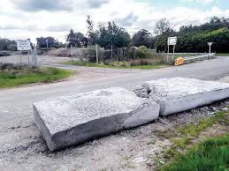
In 2020 EPA, the Victorian Building Authority and Mornington Peninsula Shire worked together to prosecute an alleged serial concrete dumper.
Multiple incidents of roadside dumping at sites from Pearcedale to Cape Schanck had been reported to Mornington Peninsula Shire. The incidents caused serious road safety concerns and cost the council and VicRoads thousands of dollars to remove.
Figure 9. Dumped concrete. Photo: EPA
The local council’s investigation was referred to EPA because of its serious nature.
EPA charged a Tarneit man with multiple incidents of dumping industrial waste. The matter was heard by the Magistrate’s Court, which fined the man $50,000 and ordered him to pay EPA’s legal fees and the clean up costs incurred by the council.

Using your powers to investigate
The Act provides LEOs with powers to investigate litter and waste incidents. This includes powers to enter premises and request information. LEOs also have obligations to identify themselves.

Powers of entry
To investigate a suspected waste offence under Part 6.3 of the Act, LEOs can enter premises used for a range of purposes (such as commercial or trade purposes), at any reasonable time, but cannot generally enter a house or other residential dwelling. LEO powers of entry come from section 124 of the Act.
Section 124 Powers of entry of litter enforcement officers
For the purposes of performing a function or duty or exercising a power under this Part, a LEO may enter a part of premises or a place, at any reasonable time, if—
- that part is not being used as a residential premises; and
- the officer reasonably believes that an offence of unlawful deposit of waste, (sections 115(1),(2),(3) or (4)) or failure to comply with a waste abatement notice (section 121(5) & (7)), is being, or is likely to be committed at, a premises or a place not being used for residential premises.

Powers of entry on commercial and industrial land
If a LEO holds a reasonable belief that a litter or waste offence has occurred at a property that is used for industrial, commercial or trade purposes, they can enter at any reasonable time.
What is a ‘reasonable time’? This generally means, in the case of a business, during the ordinary
operating hours of that business.

Powers of entry at residential premises
Generally, LEOs do not have the power to enter a house or other residential dwelling, such as a caravan or bungalow, or the land associated with that dwelling, such as a backyard. However, there are situations where you may be able to enter land associated with a residential premises. For example:
- Where the premises is, for example, under construction or being renovated, then it may be reasonable to conclude that those areas are not being used as residential premises (for example where the front yard of the house is being used to store construction materials).
- Land adjoining residential premises and used for commercial or industrial purposes, such as farmland, may not be considered residential.
- Where a home business operates from a property, you cannot enter the part used for residential purposes. You can only enter the part used for industrial, commercial or trade purposes.
In these scenarios, use your judgement, exercise your powers within the scope of your training and, if in doubt, seek advice from your manager.

Investigating waste deposited on or from private land
To make sure you are acting lawfully, be clear where you can act, and if this extends to private land.
Ask yourself:
- Do I have jurisdiction? – See ‘Where can a LEO act?’
- Do I have powers of entry?
- Has an offence occurred? See What constitutes unlawful deposit of waste?
- What action can you lawfully take? Check the specific provisions of any enforcement tool you are considering using, for example waste abatement notice.
Consider the following scenario about deposit of waste and private land.
Scenario: Unsecured waste stored on a building site
A large pile of mixed construction waste has been stored on a building site next to a council reserve.
A LEO from the local council investigates. They conduct an onsite inspection of the waste, using their powers to enter the site. However, it may also be possible for the officer to make an assessment without entering the site (the officer must use their judgement here).
The LEO observes that the waste materials are not secured. They are concerned that some the lighter waste is likely to be blown from the site onto the council reserve next door. For example, plastic wrapping from insulation batts.
Because waste could leave the property without human assistance, the LEO believes that an offence is likely to occur. They consider enforcement action including requesting the builder to remove the waste, and/or a waste abatement notice to require the building to improve their waste storage practices. The LEO has the option of a waste abatement notice because council manages the land that the waste is likely to be deposited on (the reserve next to the building site).

Litter enforcement officer may ask a person’s name and address
If a LEO reasonably believes a person is committing, is likely to commit or has committed an offence under Part 6.3, the officer may request the person state their name and ordinary place of residence or business. This power comes from section 125 of the Act.
In asking for a person’s name and address the officer must:
- inform the person of the reason for their beliefs
- give them sufficient information to enable them to understand the nature of the offence.
It is an offence to fail to comply with this request without a reasonable excuse, or to provide a false name or address. If a LEO suspects a false name or address has been given, they can request proof. For penalties see Appendix A: Schedule of offences.

Litter enforcement officer to provide proof of identity and official status
LEOs exercising their powers must produce proof of identity and official status if requested (section 126 of the Act). For example, if you are using your powers of entry to gain access and investigate, or are asking a person you reasonably believe has committed an offence for their name and address. Always carry identification issued by your organisation.

Waste information gathering notice
Waste information gathering notices (section 127 of the Act) can be used by LEOs to obtain information about waste they reasonably believe has been unlawfully deposited.
A WIGN can be issued to a person the LEO reasonably believes:
- previously had possession of waste; or
- was responsible for commissioning the production or distribution of material that
became waste.
The information obtained through a WIGN can be used as evidence when taking enforcement action such as requiring removal of the waste, or issuing an infringement notice. Read more in Appendix B: Waste information gathering notice.
Using waste information gathering notices
Tip 1: WIGNs are a broad tool to gather information about a waste offence. However, a WIGN would only be useful if the person or company it’s issued to can provide information about the waste offence. If the party doesn’t have the relevant information, then section 127(4) of the Act applies and there is no obligation to comply with the notice. For example, if a LEO finds plastic wrap from construction material with the supplier’s name on it among other dumped construction waste, issuing a WIGN to the supplier is only useful if they are likely to know who they sold the material to.
Tip 2: If you don’t get a response from a WIGN and suspect the person may not be at the address you sent the notice to, further investigation may be required, such as door knocking or requesting information from a real estate agent. Use the information you have and your judgment to determine if the person is choosing not to comply with the notice, in which case an infringement may be appropriate, or whether they may not have received the notice.
Scenario: Dumping on vacant land
A community member reported household waste had been dumped on a vacant block. The waste included several garbage bags and boxes of general household waste, and hard waste items including a heater, TV and dryer. A council LEO inspected the site, taking notes, photos and measuring the waste to help estimate volume. An invoice with a name and address was found in one of the boxes. The same details were on an address sticker on the side of another box. The officer then organised removal of the waste by the council.
The LEO sent a waste information gathering notice to the name and address on the invoice. There was no reply to the notice, so the LEO went to the address and, using the powers under section 125, asked the occupant for their name and address, to confirm their identity matched the name on the invoice. The LEO informed the occupant that they suspected they were responsible for depositing the waste. In this instance the LEO decided to issue an infringement notice to the occupant for failure to comply with the waste information gathering notice (2 penalty units).
Scenario: Issuing a waste information gathering notice for skip bins on vacant land
The owner of some vacant land found six dumped skip bins of waste and reported it to the local council. A LEO investigated the report.
Among the waste the LEO found documents, letters and receipts naming different companies, suggesting each waste pile may have come from a different source. One pile held information about a company called Needing an Upgrade. The pile included construction and demolition waste.
The LEO contacted the owner of Needing an Upgrade. Susan, the owner, told the LEO a skip bin company took the waste. However, she was reluctant to give documentation or evidence.
The LEO told Susan that her company would be issued a waste information gathering notice. The officer issued this notice on the grounds that the company previously had possession of the waste.
The waste information gathering notice required Susan to provide information about the skip bin company. The response to the notice named the skip bin company as Skips-4-U Pty Ltd.
The officer issued Skips-4-U with a waste abatement notice, requiring them to remove the skip bins within seven days and dispose of waste to a lawful place. The LEO also issued the company with an infringement notice for the offence of unlawful deposit of waste greater than 1,000 L under section 115(4).

Interacting with suspects
During an investigation LEOs will usually need to communicate directly with suspects - often face-to-face. The following is general advice for interacting with suspected offenders.
Act within your powers | When investigating and collecting evidence, always act within your powers, including powers of entry. Failing to gather evidence in a lawful way can result in damage to your organisation’s reputation. It could also mean the evidence you collected is inadmissible in any subsequent enforcement action.
Be courteous | Avoid being overbearing or getting involved in arguments.
Identify yourself | You must show identification if requested under section 126 of the Act. However, it is good practice to always identify yourself. For example ‘My name is ....... I am a litter enforcement officer for........ Council.’
Explain the offence and ask name and address | Where you have evidence that a person may have committed an offence, explain to them what you know or have seen, and what the law says.  For example:  - ‘I have just seen you leave/drop/throw/place etc. a .......... (specify the litter/waste) on the road / footpath / ground etc.’  - ‘It is an offence to deposit litter/waste in that manner’.  Or  - ‘I have found evidence (such as a bill or letter with their name on it amongst the waste, or information from a witness) that (specify the litter/waste) belongs to you’.  - ‘It is an offence to deposit litter/waste in that manner.’  - ‘I am requesting your name and address’ or ‘please confirm your name and address is…’ ‘in relation to the litter/waste’.  Remember…  - you should tell the person ‘as a litter enforcement officer I have the power to request your name and address’.  - give the person enough information to understand the suspected offence.  - inform them it is an offence not to comply with your request for their name and address (if name and address are not given, note any identifying features of the offender and details such as vehicle type and registration.)  - Consider whether to ‘caution’ the suspect before, or during, further questioning. The caution should be issued whenever an LEO forms a belief that there is sufficient evidence to establish that the person has committed an offence.  - LEOs do not need to caution suspects if only asking a person’s name and address in accordance with section 125.
Listen to a person who denies or disputes an offence | Sometimes a person may not be aware they have committed an offence, such as leaving household waste on the curb side without booking a collection. In this instance educating the person about the law may be the most appropriate response.  If you do not accept the explanation the person gives, you can say so. For example. ‘I have heard your version of what happened, but I saw you throw the (bottle, cigarette butt etc.) and I am therefore serving you an infringement notice.’
Explain what action you intend to take: | Your options for taking action include:  - providing information about the law  - giving a warning  - requesting waste be removed  - issuing a notice and explaining review rights  - explaining penalties for not complying with a verbal request or notice.  The action you take should be proportionate to the offence. For example, if the person is willing to remove the waste when asked, issuing an infringement notice may not be necessary.  See taking compliance and enforcement action.
Keep the discussion short | After explaining the offences and action you intend to take, avoid engaging in further discussion or argument with the offender.
Take notes or fill out a report as soon as  you can. | Always take notes to record your interaction with a suspected offender.  If you intend to issue an infringement notice for the offence, you can make a report in the remarks section of the penalty infringement notice. Longer reports, if necessary, should be made in the manner approved by your organisation.

Evidence
LEOs must have sufficient evidence to support their belief that a person has committed an offence if they intend to take enforcement action such as issuing a notice. One point of evidence may not be enough. You may need to consider a range of ways to prove your point.
Evidence is anything which may be submitted to prove or disprove the facts under inquiry. This includes evidence a person deposited waste, and that there are no lawful circumstances excusing the deposit of waste.
Evidence needs to be gathered by a LEO to:
- prove or disprove a non-compliance
- support your judgement and decision to issue a notice or infringement
- be used in court proceedings.
Evidence can take many forms, including:
- information provided in an email, or information provided orally by a person
- witness statements
- photos and video footage
- your own observations, such as notes and sketches taken of an illegal dumping site, or someone’s answers to your questions
- samples of waste
- other material goods or documentation supporting your claims
- information from third parties such as VicRoads or a banking institution.
Next we will look at key evidence types in more detail.

Contemporaneous notes
Notes taken by an officer as part of an investigation act as important evidence to support enforcement action.
Notes are an official record of what the officer saw and heard during the course of their investigations, including any conversations they had. Include sketches and ‘mud maps’ in
your notes.
Notes should be taken contemporaneously (at the time of the observations or actions taking place). Officers should always keep their original notes.
Notes are used to:
- complete a report, statement or affidavit, all of which can be used as evidence
- provide details that support enforcement action such as issuing infringements and
other notices
- form part of evidence that an officer gives in court when they are unable to rely solely on their memory to answer questions.

Photographs and videos
Photos and videos are taken during an investigation when you need an objective and indisputable record of the scene and evidence. They are key evidence supporting your judgement and decisions about taking enforcement action.
When taken correctly, photos and videos can be worth a thousand words. Remember to take photographs and video (and notes or sketches) before disturbing anything.

Statements
A statement is something said or written which gives information in a formal way. Statements are a way to capture information from witnesses about the circumstances of an alleged offence and are admissible in court.
Types of statements likely to be used as part of a waste investigation include:
- witness statements taken from a witness or reporter to gather their account of
the incident
- a person’s response to a waste information gathering notice you have issued
- statements from a LEO to support court proceedings.

Material goods and documents
LEOs will often identify physical evidence, including material goods and documents, such as items that bare a person or business’s name and address. It is important to preserve potential evidence and ensure there is no interference with exhibits or the area where the item is located
or stored.
Remember to:
- wear gloves when collecting evidence for safety and to avoid fingerprint contamination
- clearly identify the item and record it.

Sampling waste
Samples are a small part or quantity intended to show what the whole is like. It may be beneficial to take samples of waste such as soil or demolition waste to prove the type of waste, any dangerous contaminants such as asbestos, or where it may come from. The resulting data can be used as evidence.

Continuity of evidence
To preserve the evidential value of an exhibit (such as material goods or samples) as it passes from one person to another, the chain of possession must be clearly established. This is called continuity of evidence.
Once it has been determined an item will be seized as an exhibit, logical and systematic procedures must be followed to ensure that continuity of the item can be proven. Proper records of, and adherence to these procedures, should be maintained by LEOs. It is the responsibility of the investigating officer to ensure the exhibit has not been altered, tampered with, or had its identifying label changed while in their possession.
Obtaining information from third parties
LEOs can request information from third parties to help with an investigation. For example, requesting the name and address of a registered vehicle owner from VicRoads or tenant details from a real estate agent or DHHS. If a receipt or invoice or receipt is found, a person’s name and address can be requested from finance or banking institutions.
Most councils do this by sending a letter citing the Information Privacy Principles (2.1(g)(i) of the Privacy and Data Protection Act 2014), which allows for personal information to be lawfully released for law enforcement purposes.
In the letter, you should explain your statutory role, for example, I am a litter enforcement officer appointed by X Shire, to administer and enforce legislation including the Environment Protection Act 2017 and General Purposes Local Law 2012.
Outline the nature of the offence and what information you are seeking.

Taking compliance and enforcement action
Where a LEO reasonably believe a person has committed an offence under Part 6.3 of the Act, they have powers to take compliance and enforcement action.
To determine the most appropriate compliance and enforcement action, LEOs should consider all relevant circumstances of the offence, in conjunction with any compliance and enforcement policies their organisation has.
Figure 10 below shows how litter authorities and LEOs can take an escalating and proportionate approach to compliance and enforcement.
This section then explains these compliance and enforcement options.

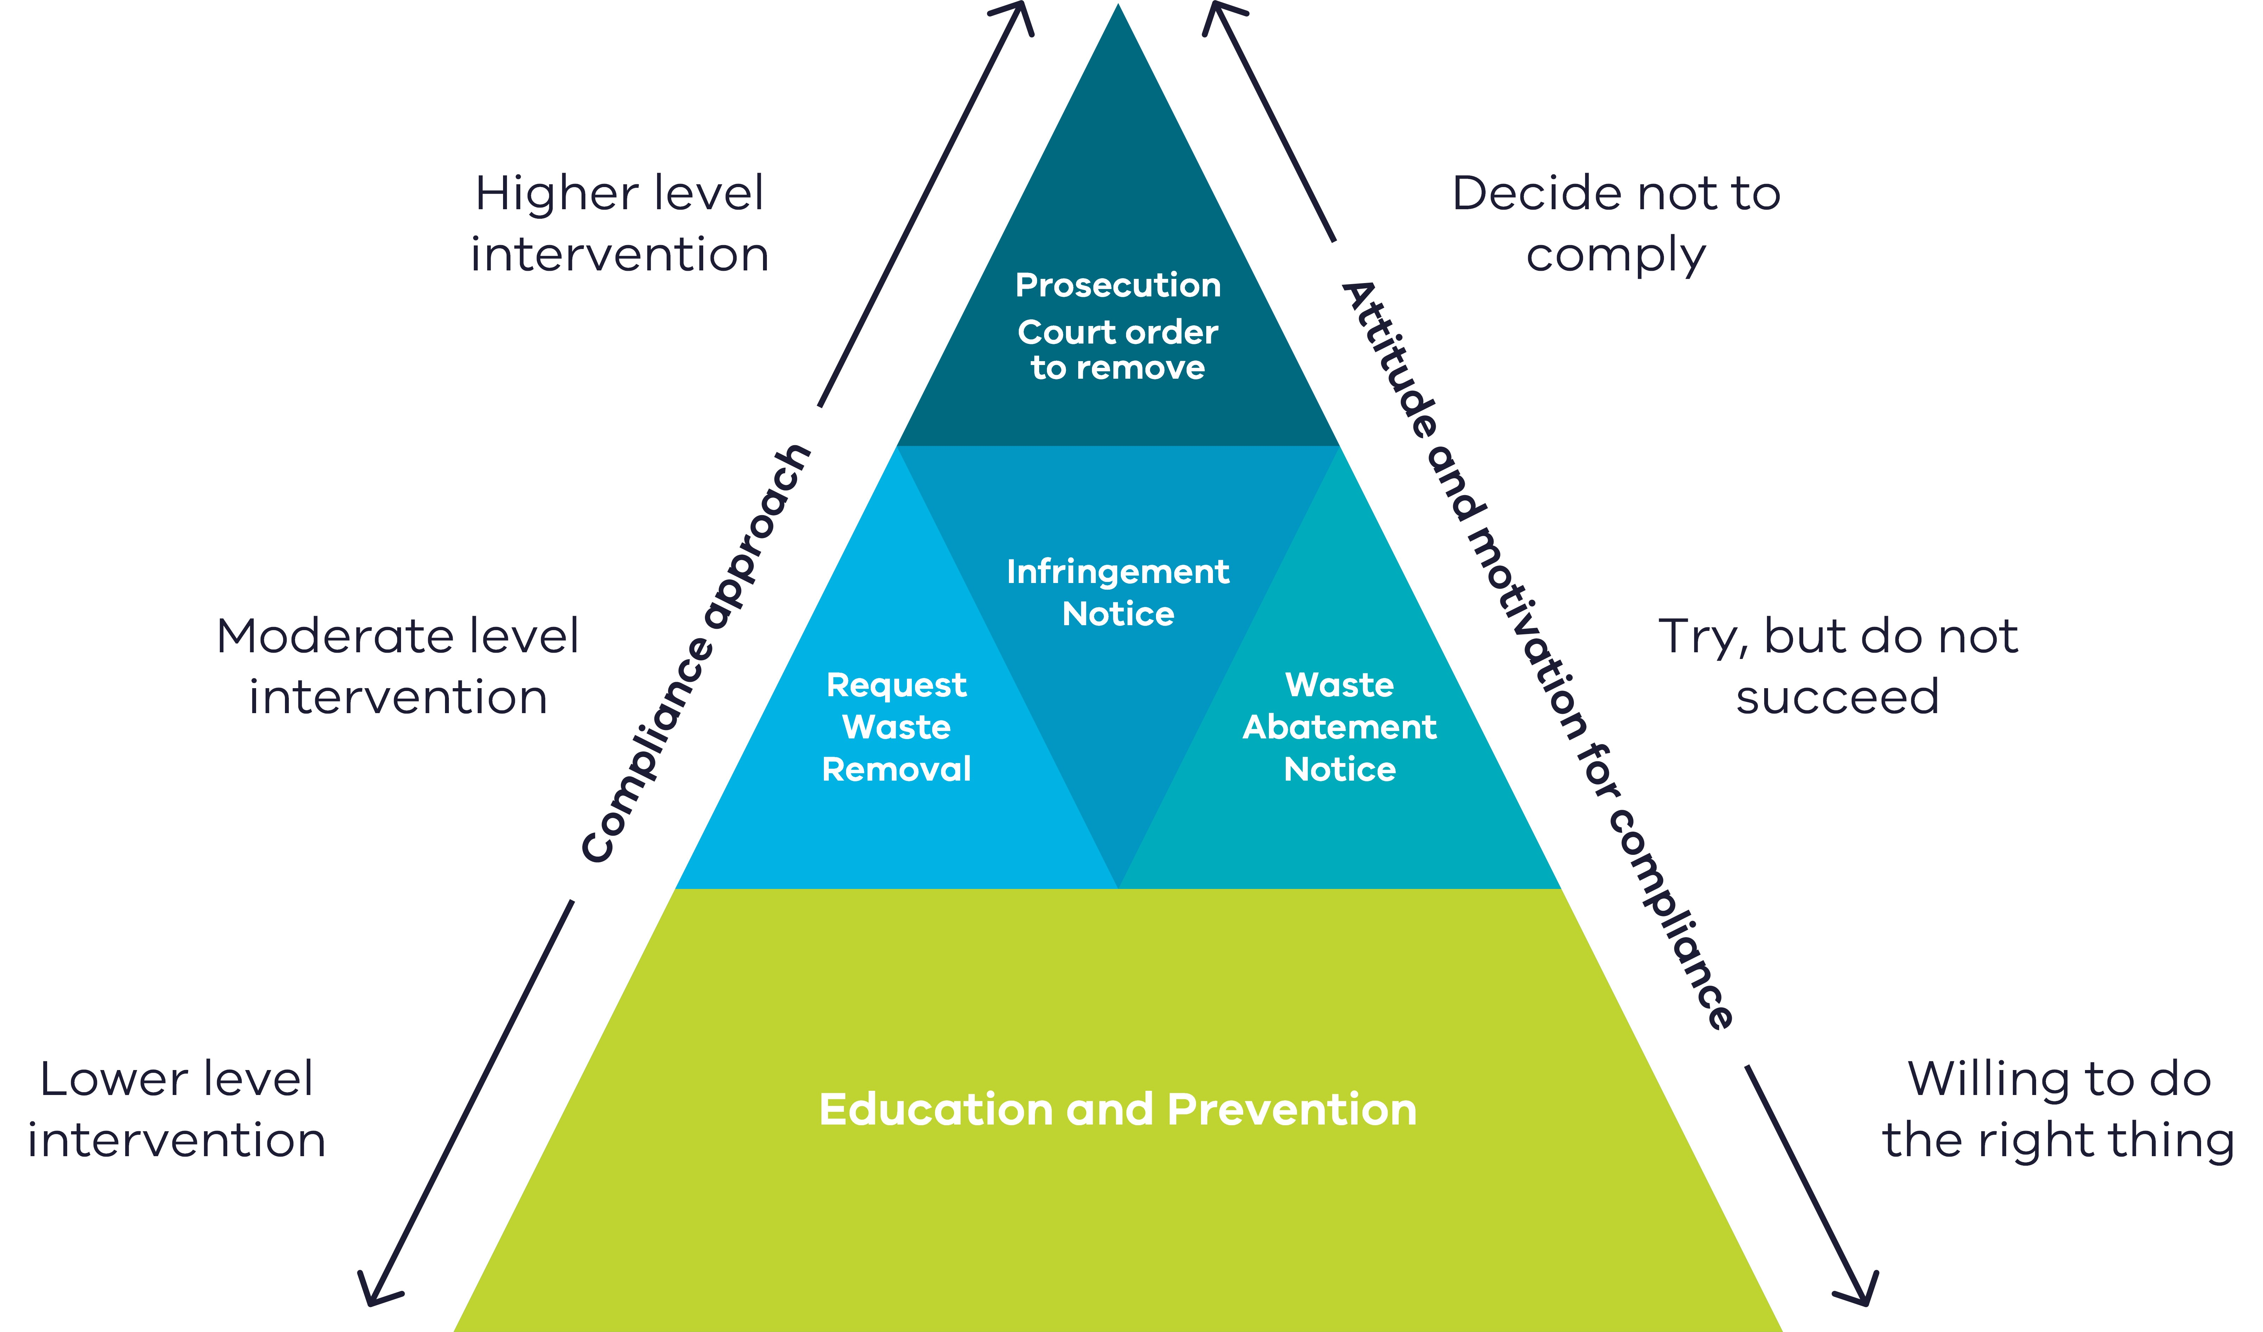
Figure 10: Compliance and enforcement approach to litter and other waste offences

Litter enforcement officer may request persons to remove waste
If a LEO reasonably believes a person has deposited waste in contravention of Part 6.3 of the Act, they can request the person remove the waste (section 119 of the Act). The request should be made in writing where practical. If given verbally, it should be followed up in writing such as though a letter or email. The LEO should make a note of this action in their notebook or logbook.
Are there consequences if a person fails to comply?
It is an offence not to comply with a LEO’s request to remove waste under section 119.
An infringement can be issued. For penalties see Appendix A: Schedule of offences.

Waste abatement notice
Waste abatement notices (section 121 of the Act) can be used by LEOs to manage waste, or material that may become waste, and ensure it is deposited in a lawful manner.
Waste abatement notices are designed to address waste which has a negative impact on the health, safety or welfare of the public, negatively impacts the proper use of a place, or is a hazard to the environment.
Read more in Appendix C: Waste abatement notice.

Infringements
Infringement notices impose a financial penalty for certain breaches of the law. This allows certain contraventions to be dealt with through a fine rather than court proceedings. Infringement notices can be served by LEOs for certain infringement offences under Part 6.3 of the Act and Part 4.1 of the Regulations.
Read more:
- Appendix A: Schedule of offences – lists infringement offences and penalties
- Appendix D: Infringement notices – explains how LEOs can use infringement notices

Prosecution
Litter and waste offences under the Act are summary criminal offences that are heard in the Magistrates’ Court. Summary offences are considered less serious and have lower maximum penalties than indictable criminal offences.
Read more:
- Appendix A: Schedule of offences– lists maximum penalties that a court can order
- Appendix E: Prosecution

Court may order person to remove waste
If a court finds a person guilty of an offence against Part 6.3, under section 120 of the Act the court may require the person to do one of the following:
- clear away the waste
- pay compensation for the removal of waste to another person or body that has management or control of the land or waters where the waste was deposited
Such an order may be instead of or in addition to any other penalty imposed by the court.
Supervision of the clean up
If the court orders a person to remove waste, the court will nominate a supervisor to oversee the clean up, such as the owner of the land, or officer of a council or other land manager.
If the person complies with the order to remove waste, the supervisor must send a statement to the person confirming the clean up is complete.
Are there consequences if a person fails to comply?
It is an offence not to comply with a court order to remove waste. If a person contravenes the order, the supervisor can apply to the court, which can issue a summons and may impose an additional fine.
Scenario: Overflowing bins at a shopping centre
There are often overflowing bins behind a small suburban shopping centre. The bins are unsightly and litter regularly blows out onto the surrounding footpath, gutters and street.
A litter enforcement officer investigates and finds it difficult to identify the particular businesses responsible. The officer issues a waste abatement notice to the shopping centre’s facility management company because they have not provided enough bins, or emptied the bins within a reasonable timeframe. The notice requires the company to clean up excess waste and create a waste management plan to address ongoing issues.
Note: If food and odour are involved, these complaints could be dealt with through a joint investigation between council LEOs and Environmental Health Officers.
Scenario: Roadside dumping
A member of the public called a council’s Litterwatch hotline to report seeing waste dumped on a road reserve. They also supplied photos of the waste.
A LEO investigated and found two cubic metres of sheeting and asbestos. A licenced asbestos removalist was engaged to remove the waste. The LEO took the witness’s statement, which included the licence plate of the car seen dumping the waste. By requesting vehicle details from VicRoads, the LEO was able to contact and interview a suspect.
Due to the serious nature of the offence, which involved a hazardous material, the LEO chose to prosecute the accused through the Magistrates’ Court, rather than issuing an infringement notice. The result was a successful prosecution. The offender was found guilty and ordered to pay a fine and the council’s clean up and legal costs.
Scenario: Mud from a building site
A resident reports mud and debris from a building site are covering pedestrian and vehicle access routes. A LEO inspects the site, taking photos as evidence, and contacts the building site supervisor to request clean up, using their powers under section 119. The supervisor complies, so the LEO decides not to issue a WAN.
A week later, the issue is reported again. This time the LEO issues a notice to the builder requiring clean up and a change in practices to prevent the issue recurring. The LEO can issue a waste abatement notice because the waste has ended up on the footpath, road and stormwater drains that are managed by council.
Supporting business to comply with their obligations
In 2019, Officers for the Protection of the Local Environment (OPLEs) investigated poor environment practices at several construction sites in Casey.
They found several issues, including premix concrete slurry running into the stormwater system.
An uncovered pile of sand on a downward sloping driveway also risked sediment run-off into the
stormwater system.
The OPLE provided the sites with advice on how to comply with the law. This included digging a small sediment pond, installing a sediment sock barrier, and covering the pile of sand. Because of the short-term nature of the building projects, the OPLE focused on supporting the construction businesses to comply with their obligations with simple but effective solutions, rather than taking enforcement action.
The OPLE saw more serious issues at other sites and referred them to the local Casey Litter Enforcement Officer for immediate regulatory action. The OPLE worked with the council officer to serve a notice on the spot, sending a clear message about the standards expected from residential building companies.
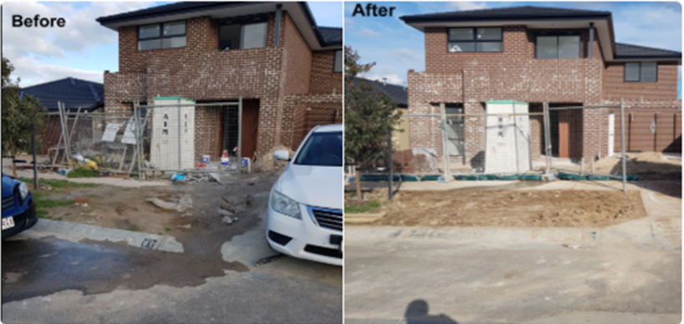
Figure 11: Stormwater issues from a construction site Photo: OPLE program, EPA

Stakeholders and networks
Environment Protection Authority Victoria
EPA is Victoria’s environmental regulator. EPA is an independent statutory authority, established in 1971. EPA works to prevent and reduce the harmful effects of pollution and waste on Victorians and their environment, by working with the community, industry, businesses and joint regulators of the Act, including litter authorities.
epa.vic.gov.au
Ph 1300 372 842 (1300 EPA VIC)
Council LEOs can find more resources on EPA’s Council Support SharePoint- email jointregulator@epa.vic.gov.au to become a member.

Head office  200 Victoria Street  Carlton 3053 | West Metro  Level 2, 12 Clarke Street  Sunshine 3020 | South West  West 1, 33 Mackey Street  North Geelong 3215
Southern Metro  Level 3, 14 Mason Street  Dandenong 3175 | North East  27–29 Faithfull Street  Wangaratta 3677 | Gippsland  8-12 Seymour St  Traralgon 3844
North Metro  Building One,  13a Albert Street  Preston 3072 | North West  Level 1, 47–51 Queen Street  Bendigo 3550
Litter Enforcement Officer Network
The Litter Enforcement Officer Network (LEON) is a professional network consisting of LEOs, land managers and individuals brought together by their concern for litter or illegal dumping. LEON focuses on reducing litter and illegal dumping by upskilling officers, promoting best practice and encouraging strong working relationships with land managers. LEON provides resources, engagement and training opportunities for LEOs and tracks illegal dumping in Victoria.
litterenforcement.org
Department of Environment, Land, Water and Planning
The Department of Environment, Land, Water and Planning (DELWP) works in partnership with a range of agencies and stakeholders to protect and preserve Victoria’s native landscape. DELWP directs environmental policy development for Victoria and coordinates the environment portfolio with support from EPA and Sustainability Victoria.
environment.vic.gov.au

Sustainability Victoria
Sustainability Victoria (SV) is a Victorian State Government statutory authority established under the Sustainability Victoria Act 2005. SV facilitates and promotes environmental sustainability in the use of resources by delivering programs addressing integrated waste management and resource efficiency. SV is responsible for state-wide waste management strategy and planning, including alternatives to waste disposal.
sustainability.vic.gov.au

Recycling Victoria
Recycling Victoria is a new business unit of DEWLP. It oversees and provides strategic leadership to the waste and recycling sector in Victoria.
vic.gov.au/strengthening-our-waste-and-recycling-system

Appendix A: Schedule of offences
This table lists the litter and waste offences under the Act and Regulations that litter authorities can enforce. Infringement offences are listed in Schedule 10 of the Regulations.
Section in the Act or Regulation | Summary of offence | Maximum court penalty  in penalty units | Infringement penalty in penalty units | Infringement offence code
Section 115(1) | Unlawful deposit of litter | 20 (natural person) | 2 (natural person) | 0200
 |  | 100 (body corporate) | 10 (body corporate) | 0201
Section 115(2) | Unlawful deposit of dangerous litter | 60 (natural person) | 4 (natural person) | 0202
 |  | 300 (body corporate) | 20 (body corporate) | 0203
Section 115(3) | Unlawful deposit of waste of more than 50 L but less than 1,000 L | 100 (natural person) | 6 (natural person) | 0204
 |  | 500 (body corporate) | 30 (body corporate) | 0205
Section 115(4) | Unlawful deposit of waste of more than 1,000 L | 240 (natural person) | 10 (natural person) | 0206
 |  | 1200 (body corporate) | 50 (body corporate) | 0207
Section 119 | Fail to remove waste when requested by a litter enforcement officer | 10 (natural person) | 2 (natural person) | 0208
 |  | 50 (body corporate) | 10 (body corporate) | 0209
Section 121(5) | Refuse or fail to comply with waste abatement notice | 40 (natural person) | 6 (natural person) | 0210
 |  | 200 (body corporate) | 30 (body corporate) | 0211
Section 121(7) | Fail to comply with notice to remove or dispose of waste | 40 (natural person) | 6 (natural person) | 0212
 |  | 200 (body corporate) | 30 (body corporate) | 0213
Section 125(3) | Fail to comply with request by litter enforcement officer to provide name and address | 20 (natural person) | 2 (natural person) | 0214
Section 125(4) | State false name or address to litter enforcement officer | 20 (natural person) | 2 (natural person) | 0215
Section 125(6) | Fail to comply with request by litter enforcement officer to provide proof of name or address | 20 (natural person) | 2 (natural person) | 0216
Section 127(3) | Refuse or fail to comply with waste information gathering notice | 10 (natural person) | 2 (natural person) | 0217
 |  | 50 (body corporate) | 10 (body corporate) | 0343
Section 132 | Supply false or misleading information | 40 (natural person) | Not an infringement offence | N/A
 |  | 200 (body corporate)
Regulation 55(1) | Unlawful deposit of unsolicited document | 10 (natural person) | 2 (natural person) | 0247
 |  | 50 (body corporate) | 10 (body corporate) | 0248
Regulation 55(3) | Unlawful deposit of junk mail | 10 (natural person) | 2 (natural person) | 0249
 |  | 50 (body corporate) | 10 (body corporate) | 0250
Regulation 56(1) | Commission the distribution of unsolicited documents | 20 (natural person) | Not an infringement offence | N/A
 |  | 100 (body corporate)
Regulation 56(2) | Engage another person to distribute unsolicited documents | 20 (natural person) | Not an infringement offence | N/A
 |  | 100 (body corporate)
Regulation 57 | Damage public waste receptacle | 20 (natural person) | 4 (natural person) | 0251
 |  | 100 (body corporate) | 20 (body corporate) | 0252
Regulation 58(1) | Fail to secure load | 20 (natural person) | 4 (natural person) | 0253
 |  | 100 (body corporate) | 20 (body corporate) | 0254

Appendix B: Waste information gathering notice
What it is | Waste information gathering notice (WIGN) – section 127 of the Act  A WIGN can be used by LEOs to obtain information about waste they reasonably believe has been unlawfully deposited.  The information obtained through a WIGN can be used as evidence to take enforcement action such as requiring removal of the waste, or issuing a waste abatement notice or infringement, or prosecution for unlawful deposit of waste.
Grounds for issuing the notice | A LEO may issue a WIGN to a person where they reasonably believe the person:  - previously had possession of the waste, or  - was responsible for commissioning the production or distribution of, material that became waste.
Who can issue the notice | LEOs have the power to issue this notice.
Who the notice may be issued to | A WIGN can be issued to a person (meaning natural person or body corporate) believed to have previously had possession of the waste, or be responsible for commissioning the production or distribution of material that became waste.
What the notice can require | A WIGN can require any relevant information about the waste specified in the notice. The following information can be requested by the notice under section 128(2):  - how, when and where the waste came into or left the person’s possession  - if the waste has left the person’s possession – the name and address of another person who currently has possession of the waste  - the name and address of another person who was involved in commissioning the production or distribution of material that became waste.
Information the notice must contain | The information that must be included in the notice is set out in section 128(1), including:  - name and address of recipient  - grounds on which the notice is issued  - actions that the person must take  - period within which the person must comply  - penalties for non-compliance.  Notices can be issued by email, mail, leaving it at the usual or last known address, or in person. Refer to section 344 of the Act - service of documents.  Use the notice template provided by EPA.  Email jointregulator@epa.vic.gov.au
Time period to comply with the notice | The timeframe within which the person must comply with the notice must be stated in the notice. The LEO will decide what is a reasonable timeframe to comply.
Amending or revoking a notice | By serving a written notice of amendment, the LEO can:  - extend the time period that the person has to comply with the notice, or  - revoke or amend any requirements in the notice.
Consequences if a person fails to comply | It is an offence not to comply with a WIGN without a reasonable excuse. An infringement notice can be issued.  It is also an offence to supply false or misleading information in connection with a WIGN. This is a serious offence that must be pursued through court proceedings.  For penalties see Appendix A: schedule of offences.  Note: litter enforcement officers can seek a court order under section 130, compelling compliance​ with a waste information gathering notice.

Appendix C: Waste abatement notice
What it is | Waste abatement notices (WAN) – section 121 of the Act  A WAN can be used by EPA, litter authorities and LEOs to manage waste, or material that may become waste, and ensure it is deposited in a lawful manner.
Grounds for issuing the notice | A WAN can be issued if EPA, a litter authority, or a LEO reasonably believes a  person has:  - deposited waste in contravention of Part 6.3  - deposited waste at a premises or place that causes risks of harm to human health or the environment  - deposited waste at a premises or place in a way that makes the premises or place disorderly, or detrimentally affects its proper use  - engaged in, or proposes to engage in, an activity that causes or is likely to cause a contravention of Part 6.3.  Restrictions on issuing a WAN  WAN have stricter criteria compared to most other litter and waste enforcement tools. Section 121(2) limits litter authorities (other than EPA) from issuing WANs except in relation to land or waters under their management or control. This mainly effects councils, who otherwise generally have powers in relation to any land or waters in their municipal district. This doesn’t necessarily mean that council LEOs cannot issue waste abatement notices to deal with issues arising from private land.
Who may issue the notice | A WAN can be issued by EPA, a litter authority or LEO, in the circumstances set out above.
Who the notice may be issued to | A WAN may be issued to a person (meaning natural person or body corporate), who has caused or is likely to cause the deposit of waste.  If the person who caused the waste issue cannot be located, a notice may be issued to the occupier of the place or premises where waste has been deposited. In this case, under section 123, the occupier may recover costs of removing waste from the person who deposited the waste.
What the notice can require | A WAN may require the person who deposited the waste to:  - conduct a cleanup to remove waste  - restore the premises or places impacted by waste  - modify activities that cause waste to be deposited  - lawfully dispose of waste.  In the case of a notice issued to the occupier, the notice may require the removal or disposal of the waste.
Information the notice must contain | The information to be included in the notice is set out in section 121(4). It includes name and address of recipient, grounds on which the notice is issued, the actions a person must take, and penalties for non-compliance.  Notices can be issued by email, mail, leaving it at the usual or last known address, or in person. Refer to section 344 of the Act - service of documents.  Use the notice template provided by EPA.  Email jointregulator@epa.vic.gov.au
Time period to comply | The time period within which the person must comply must be stated in the notice. The LEO issuing the notice will decide on a reasonable time period.
Varying or revoking the notice | A WAN may be varied or revoked by serving a written notice to the person.
VCAT review | The person on whom the waste abatement notice is issued can apply for review at the Victorian Civil and Administrative Tribunal.
Consequences for not complying | Unless the notice recipient has a reasonable excuse for not complying with the notice, enforcement action can be taken, including:  - a LEO may serve an infringement notice  - the litter authority may remove or dispose of the waste, recovering any reasonable costs incurred in doing so under section 122  - a LEO or litter authority may initiate court proceedings.  For penalties see Appendix A: Schedule of offences.

Appendix D: Infringement notices
About infringement notices | Infringement notices impose a financial penalty for certain breaches of the law. This allows certain contraventions to be dealt with through a fine rather than court proceedings.
Who can serve them | Infringement offences under the Act:  - Infringement notices can be served by LEOs for offences under Part 6.3 of the Act. This LEO power comes from section 307(4)(e) of the Act.  Infringement offences under the Regulations:  - Infringement notices can be served by litter authorities or LEOs for infringement offences under Part 4.1 of the Regulations. This power is derived from s307(4)(a) and s347(5) of the Act, and regulation 59.  Revenue from litter and waste infringements is retained by the litter authority that issued them.
What they can be served for | Schedule 10 of the Regulations lists infringement offences.  Other than section 132 (supply false or misleading information) all offences under Part 6.3 of the Act are infringement offences.  In Part 4.1 of the Regulations, all offences are infringement offences, except for Regulation 56(1) and (2) dealing with the distribution of unsolicited documents.  Refer to Appendix A: Schedule of offences.
Who they can be served to | An infringement notice can be served to a person (meaning natural person or body corporate), believed to have committed an infringement offence. Under Part 6.3 of the Act, this mainly relates to the person responsible for unlawfully depositing waste, but can also be issued to the occupier of a premises who has failed to comply with a waste abatement notice.
How to serve an infringement notice | - Notices under the Act can be issued by email, mail, leaving it at the usual or last known address, or in person. Refer to section 344, Service of documents.  - Litter enforcement officers should follow their organisation’s own processes for serving infringement notices, and refer to the Infringements Act 2006 and relevant Regulations.
Disputing an infringement | Under the Infringements Act 2006, recipients of an infringement notice can apply to have their infringement reviewed by the authority that issued it. Applications for review must be made within 14 days of the applicant becoming aware of the infringement notice.  A vehicle owner or driver issued with an infringement under section 116 of the Act can submit a written statement under section 118 within 10 days. See Waste deposited from vehicles.
What happens if the person doesn’t pay the infringement? | Litter authorities have three options:  - Unpaid infringements can be referred to Fines Victoria who, for a fee, will pursue the recipient of the infringement to recoup the debt online.fines.vic.gov.au.  - The infringement can be withdrawn, with the offence then prosecuted through the Magistrates’ Court.
Penalty units | A penalty unit is monetary amount that is fixed for a financial year by the Treasurer and adjusted annually in line with CPI - see Department of Treasury and Finance website.  Offences under the Act and Regulations list the maximum number of penalty units (for both natural persons and body corporates) that can be imposed by a court in the event of a prosecution. For infringement offences, Schedule 10 of the Regulations lists the applicable penalty units.  See Appendix A: Schedule of offences.

Appendix E: Prosecution
When proceedings may be initiated | Scenarios when court proceedings may be appropriate include:  - an offence is too serious to be dealt with by way of an infringement notice  - a person has failed to pay a penalty within the time specified  - the person is a repeat offender and previous enforcement action has not been a deterrent  - the accused has elected to have the matter of an infringement notice referred directly to the Magistrates’ Court for determination.
Who may initiate proceedings | For an offence under Part 6.3 of the Act, a litter authority or LEO can initiate court proceedings. This power comes from section 347(4) of the Act.  Litter authorities and LEOs can also initiate court proceedings for an offence under Part 4.1 of the Regulations. This power is derived from s347(5) of the Act, and Regulation 59.  Follow the prosecution procedures of the council or agency concerned.
Timeframe for court proceedings | Legal proceedings for the litter and waste section of the Act (for summary offences) or the Regulations must begin within twelve months after the commission of the alleged offence. For further details see the Criminal Procedure Act 2009.
Brief of evidence | If initiating court proceedings, a LEO may be required to compile a brief of evidence containing all relevant evidence into a concise and structured format.  The format and process for assembling a brief may vary according to the requirements of the prosecuting authority and the nature of the matter. The LEO should consult their own agency and prosecutors, or local council. The compilation of any brief of evidence reflects on your professionalism. Ensure where possible that all relevant documentation and evidence has been supplied.  The brief of evidence is likely to include:  - brief cover and table of contents  - summary  - copy of charges  - the identity of the alleged offender  - list of witnesses and exhibits  - all admissible evidence, including exhibits, statements (witnesses and LEO), photographs and video, transcript of interview, certificate concerning litter offences  - prior convictions of the accused (if any)  - the method used to commit the offence.
Certificate concerning litter offences - section 339 | Section 339 provides a ‘certificate concerning litter offences’. This certificate, submitted as part of a court proceeding, is evidence confirming a person is a LEO or that land or waters are under the control or management of a litter authority, at the time of an offence under Part 6.3.

Appendix F: Estimating volume of waste

Why do LEOs need to estimate the volume of waste?
The offences for deposit of waste under section 115 are based on volume in litres (L). The three volume-based thresholds are:
- less than 50 L (for litter and dangerous litter)
- more than 50 L but less than 1,000 L
- more than 1,000 L.
The Act aims to deter people from dumping waste and therefore avoid the costs of collecting and transporting the waste items. When people dump, these costs are worn by local government or the State. The larger the volume of the waste, the greater the nuisance of cleaning up that waste, hence the greater penalties.
LEOs need reliable evidence of waste volume estimate to identify the appropriate offence. In criminal law terms the purpose of your evidence is to establish, beyond reasonable doubt, that the volume of waste clearly falls into one of the three volume thresholds.
Where the volume is close to either the 50 L or the 1,000 L threshold, your evidence must reliably establish which threshold applies. For example, a household garbage bag may be close to the 50 L mark, so extra care may be needed to substantiate whether the deposit is in the litter offence or belongs to the next threshold up. Your goal is to ensure no reasonable doubts remain about the volume of the waste.
Often it will be clear which volume threshold applies. A single plastic drinking bottle is clearly
less than 50 L. Several dumped chemical pods of 1,000 L each will be more than 1,000 L. In these circumstances a visual estimate, supported by photos and other notes, should be enough to confirm the correct threshold.

How is volume assessed?
The volume of waste is the volume of space the item(s) takes up – not just the volume of the materials from which it is composed. For example, a dumped fridge is assessed by its outer dimensions only.

Recommended methods for estimating volume
Use one or more of the recommended methods to estimate volume listed below. The methods
are listed from least to most precise.
It is important to take clear, contemporaneous notes and photographs or video, to record the method you are using.
Method of volume estimation | When and how to use it
Method 1:  Visual estimation based on the types of waste | When to use  For commonly dumped items, estimates can be made using typical volumes for those items. For example, standard dimensions for a single, double, queen or king size mattress can be used to calculate estimated volume. Similarly, paint cans generally have standard volumes. This method may be particularly useful where waste is spread out.  How to use  Having estimated the volume of the main components of the waste deposit, add up each of the volumes to calculate the total volume and select the correct offence. Remember that a visual assessment using reference volumes will only produce an approximation of an amount  of waste.  See Reference items for estimating volume.
Method 2:  Visual estimation using a scale object | When to use  Taking photographs of the waste pile can be used to estimate the dimensions of the waste, and then to calculate volume. This method is useful where:  - you suspect the waste contains hazards such as asbestos  - the waste deposit is too high to physically measure  - you are limited by time or environmental conditions.  How to use  Take photos from each side of the waste (at least four angles), placing an object (such as a surveyor’s staff) next to the waste to show scale. It may be useful to include two scale objects to show both vertical and horizontal scales. You could also include a person in the photo to show scale.  Convert estimated measurements to volume using the methods explained in the last row of this table.
Method 3:  Direct measurement | When to use  Physically measuring the dimensions of a waste deposit offers the greatest precision in estimating volume. It is also the most time consuming. Weigh up the cost and benefits of using this approach.  How to use  Use a tape measure to obtain dimensions of the waste deposit in order to more precisely estimate its volume, or at least its minimum volume. If the waste forms a recognisable shape, that basic shape should be noted and calculations may be made using a tape measure that are needed to be able to calculate an estimated volume. Common examples where you could use this shape-based approach include:  - piles of mostly uniform materials that form a cone shape, such as dumped piles of soil – where you can use the base area and pile height measurements to estimate volume  - individual items that form box shapes, such as mattresses, whitegoods, and boxes of waste – where the length, width and height of the items can be used to calculate the volume(s)  - materials in bags or individual items that form a cylindrical shape, such as plastic bags containing rubbish, individual tyres or paint cans – where the diameter and height/length can be used to estimate the volume
Ensure the volume is expressed in litres  (for methods 2  and 3) | To ensure volume measurements are recorded in litres the following methods can be used:  - Take measurements in centimeters in order to make the calculations, or  - Convert cubic metres (m3) to L by multiplying the value by 1000:  e.g.  - 0.05m³ = 50 L  - 0.5m³ = 500 L  - 1m³ = 1,000 L  - 10m³ = 10,000 L  See also Calculating volume of different shaped waste which assumes measurements are taken in meters and includes a section on converting measurements and units.

Reference items for estimating volume
Using the typical volume of commonly dumped items can be an efficient way of estimating waste volume. Litter authorities can add to this list to meet local needs.
Item | Typical volume (L)*
Retail water casks | 10 L
Round plastic buckets for domestic use | 9–10 L
Large wine-casks | 4 L
Passenger tyre | 50–80 L
Council (wheelie) bins – general waste | 140 L
Council (wheelie) bins - recycling/green waste | 240 L
Petrol ‘jerry cans’ | 20 L
Bar fridges | 120–550 L
Single door fridge | 400–1000 L
Double door fridge | 1000–1500 L
Single mattress | 350 L (0.92 m x 1.90 m x 0.2 m)
Double mattress | 525 L (1.38 m x 1.90 m x 0.2 m)
Queen size mattress | 621 L (1.53 m x 2.03 m x 0.2 m)
* Volumes are approximations only

Calculating the volume of different shaped waste
Basic shape | Example | Measurements needed  (in metres) | Diagram | Volume calculation  (in litres) | Issues
Boxes | Whitegoods  Mattresses  Actual boxes | Height of box  Width of box  Length of box | 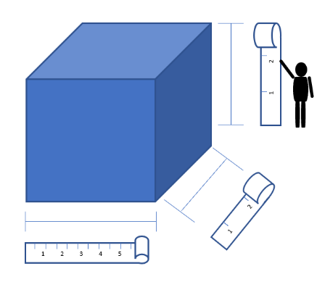 | The volume of a box is calculated by multiplying the length, width and height.  - Multiply the length by the width, then by the height  - Multiply by 1,000  Formula: ($V=lwh)$  Volume = length x width x height
Cylinders | Drums  Cans  Tyres | Height of cylinder  Radius (half the width of the cylinder) | 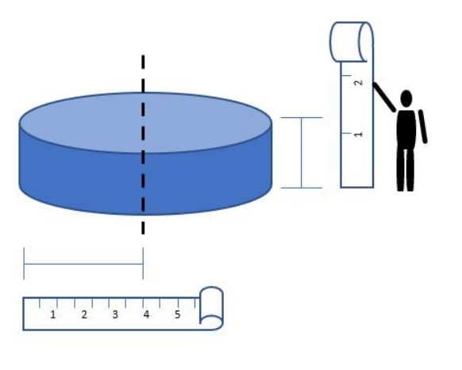 | The volume of a cylinder is calculated by multiplying the height of the area by the base.  - multiply the radius by itself (e.g. if the radius is 4, multiply 4 by 4)  - multiply by the height  - multiply by 3.14 (known as “pi” or π)  - multiply by 1,000  Formula: ($V=πr^{2}h)$  Volume = 3.14 x (radius x radius) x height
Conical piles with a circular base | Dumped soil or clippings | Height of pile  Radius of pile (half the width) | 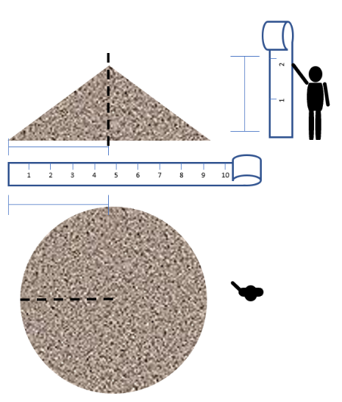 | The volume of a cone with a circular base is calculated by multiplying the area of the base by the height of the pile and then dividing by three.  - multiply the radius by itself  (e.g. if the radius is 4.5, multiply 4.5 by 4.5)  - multiply by the height  - multiply by 3.14  - divide by 3  - multiply by 1,000  Formula: ($V=(πr^{2}h)/3)$  Volume = 1/3 x 3.14 x (radius x radius) x height | What if only part of the pile is conical shaped?  See examples below on how you can estimate the minimum volume by imagining a symmetrical cone shape within the pile.

Conical piles with an oval base | Dumped soil or clippings | Height of pile  Long axis of pile  Short axis of pile | 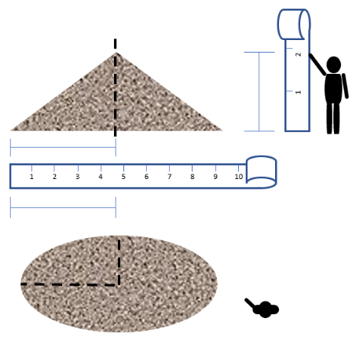 | The volume of a cone with an oval base is calculated by multiplying half the long axis (R1) by half the short axis (R2), then multiplying by 3.14. This gives you the area of the base. Then multiply the area of the base by the height and divide by three.  - multiply the two axis measurements  - multiply by the height  - multiply by 3.14  - divide by 3  - multiply by 1,000  Formula: $(V=(πR1R2h)/3$)  Volume = 1/3 x 3.14 x short axis x long axis x height | What if only part of the pile is conical shaped?  See examples below on how you can estimate the minimum volume by imagining a symmetrical cone shape within the pile.

Differing conical piles: Ways to estimate the minimum volume of complex conical piles
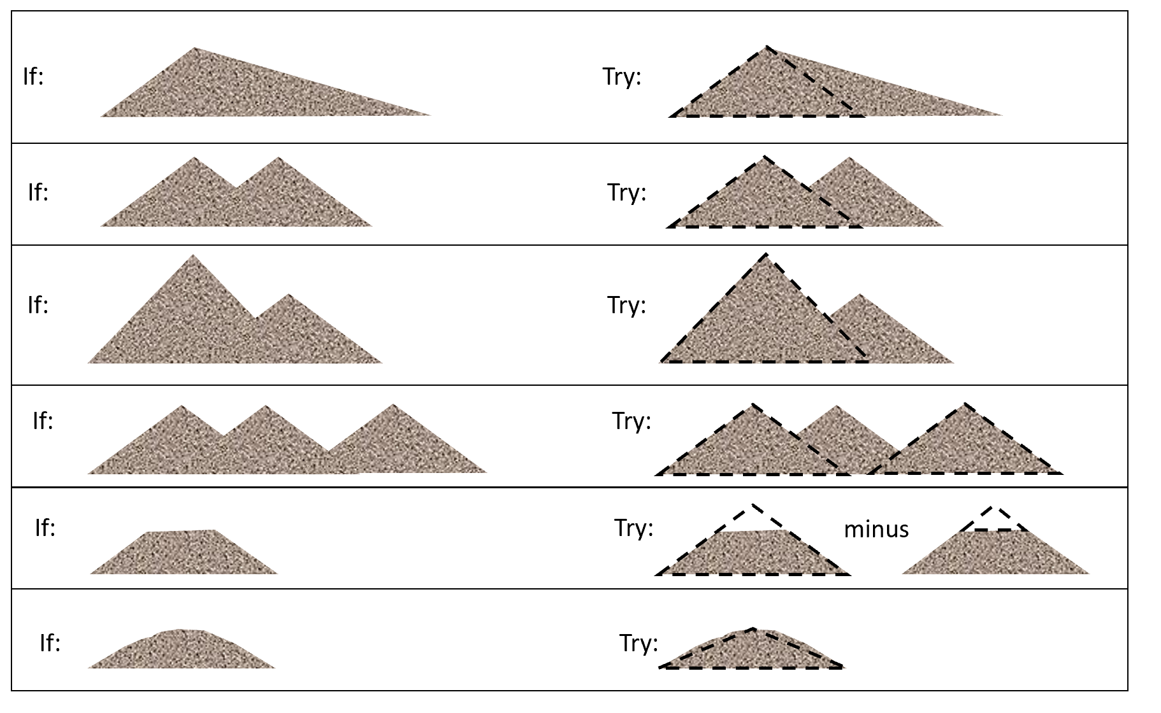

Different approaches to calculating volume of waste
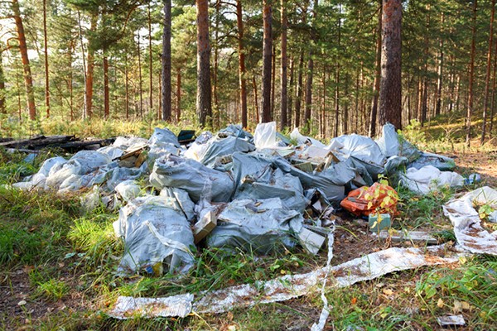  Strategy:  - measure volume of one bag (consider retaining as evidence)  - count number of bags. | 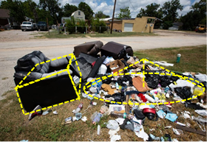  Strategy:  - use cone calculation for loose rubbish  - use box calculations for furniture  - add the volumes.
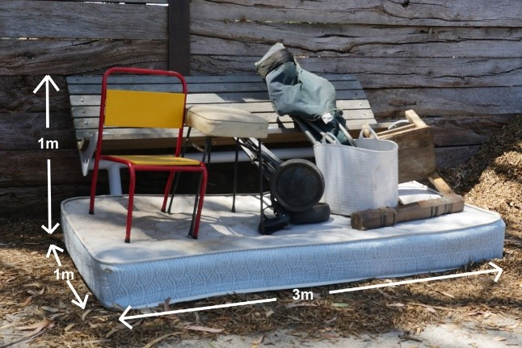  Strategy:  - measure volume of mattress, chairs  and bucket  - calculate total volume.  Image from Yarra Ranges Council | 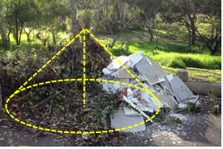  Strategy:  - use cone calculation for larger cone  - photograph from each angle.
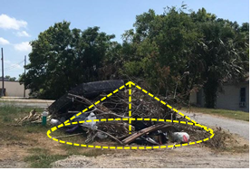  Strategy:  - use cone calculation  - photograph from each angle. | 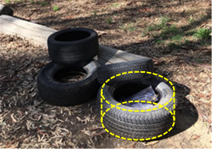  Strategy:  - use cylinder calculation  - count number of tyres  - photograph from each angle.
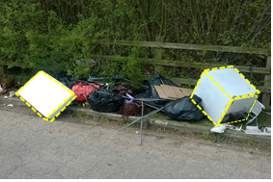  Strategy:  - use box calculation for mattress and whitegoods  - count number of bags and measure volumes  - add the volumes. | 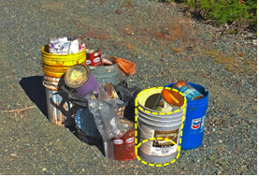  Strategy:  - use cylinder calculation for the cans, unless volume is on the label  - photograph from each angle.
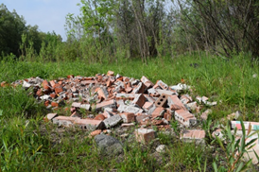
Strategy:
- use box calculation
- undertake a rough count number of visible bricks
- photograph from each angle
OR
- estimate using a total volume approach for the whole pile.
Photographing waste using reference objects
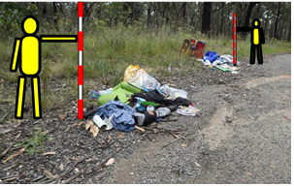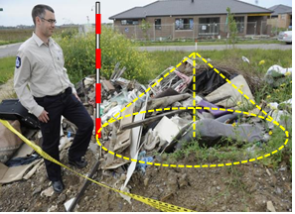

Accessibility
Contact us if you need this information in an accessible format such as large print or audio.
Please telephone 1300 372 842 or email contact@epa.vic.gov.au

Interpreter assistance
If you need interpreter assistance or want this document translated, please call 131 450 and advise your preferred language. If you are deaf, or have a hearing or speech impairment, contact us through the National Relay Service.
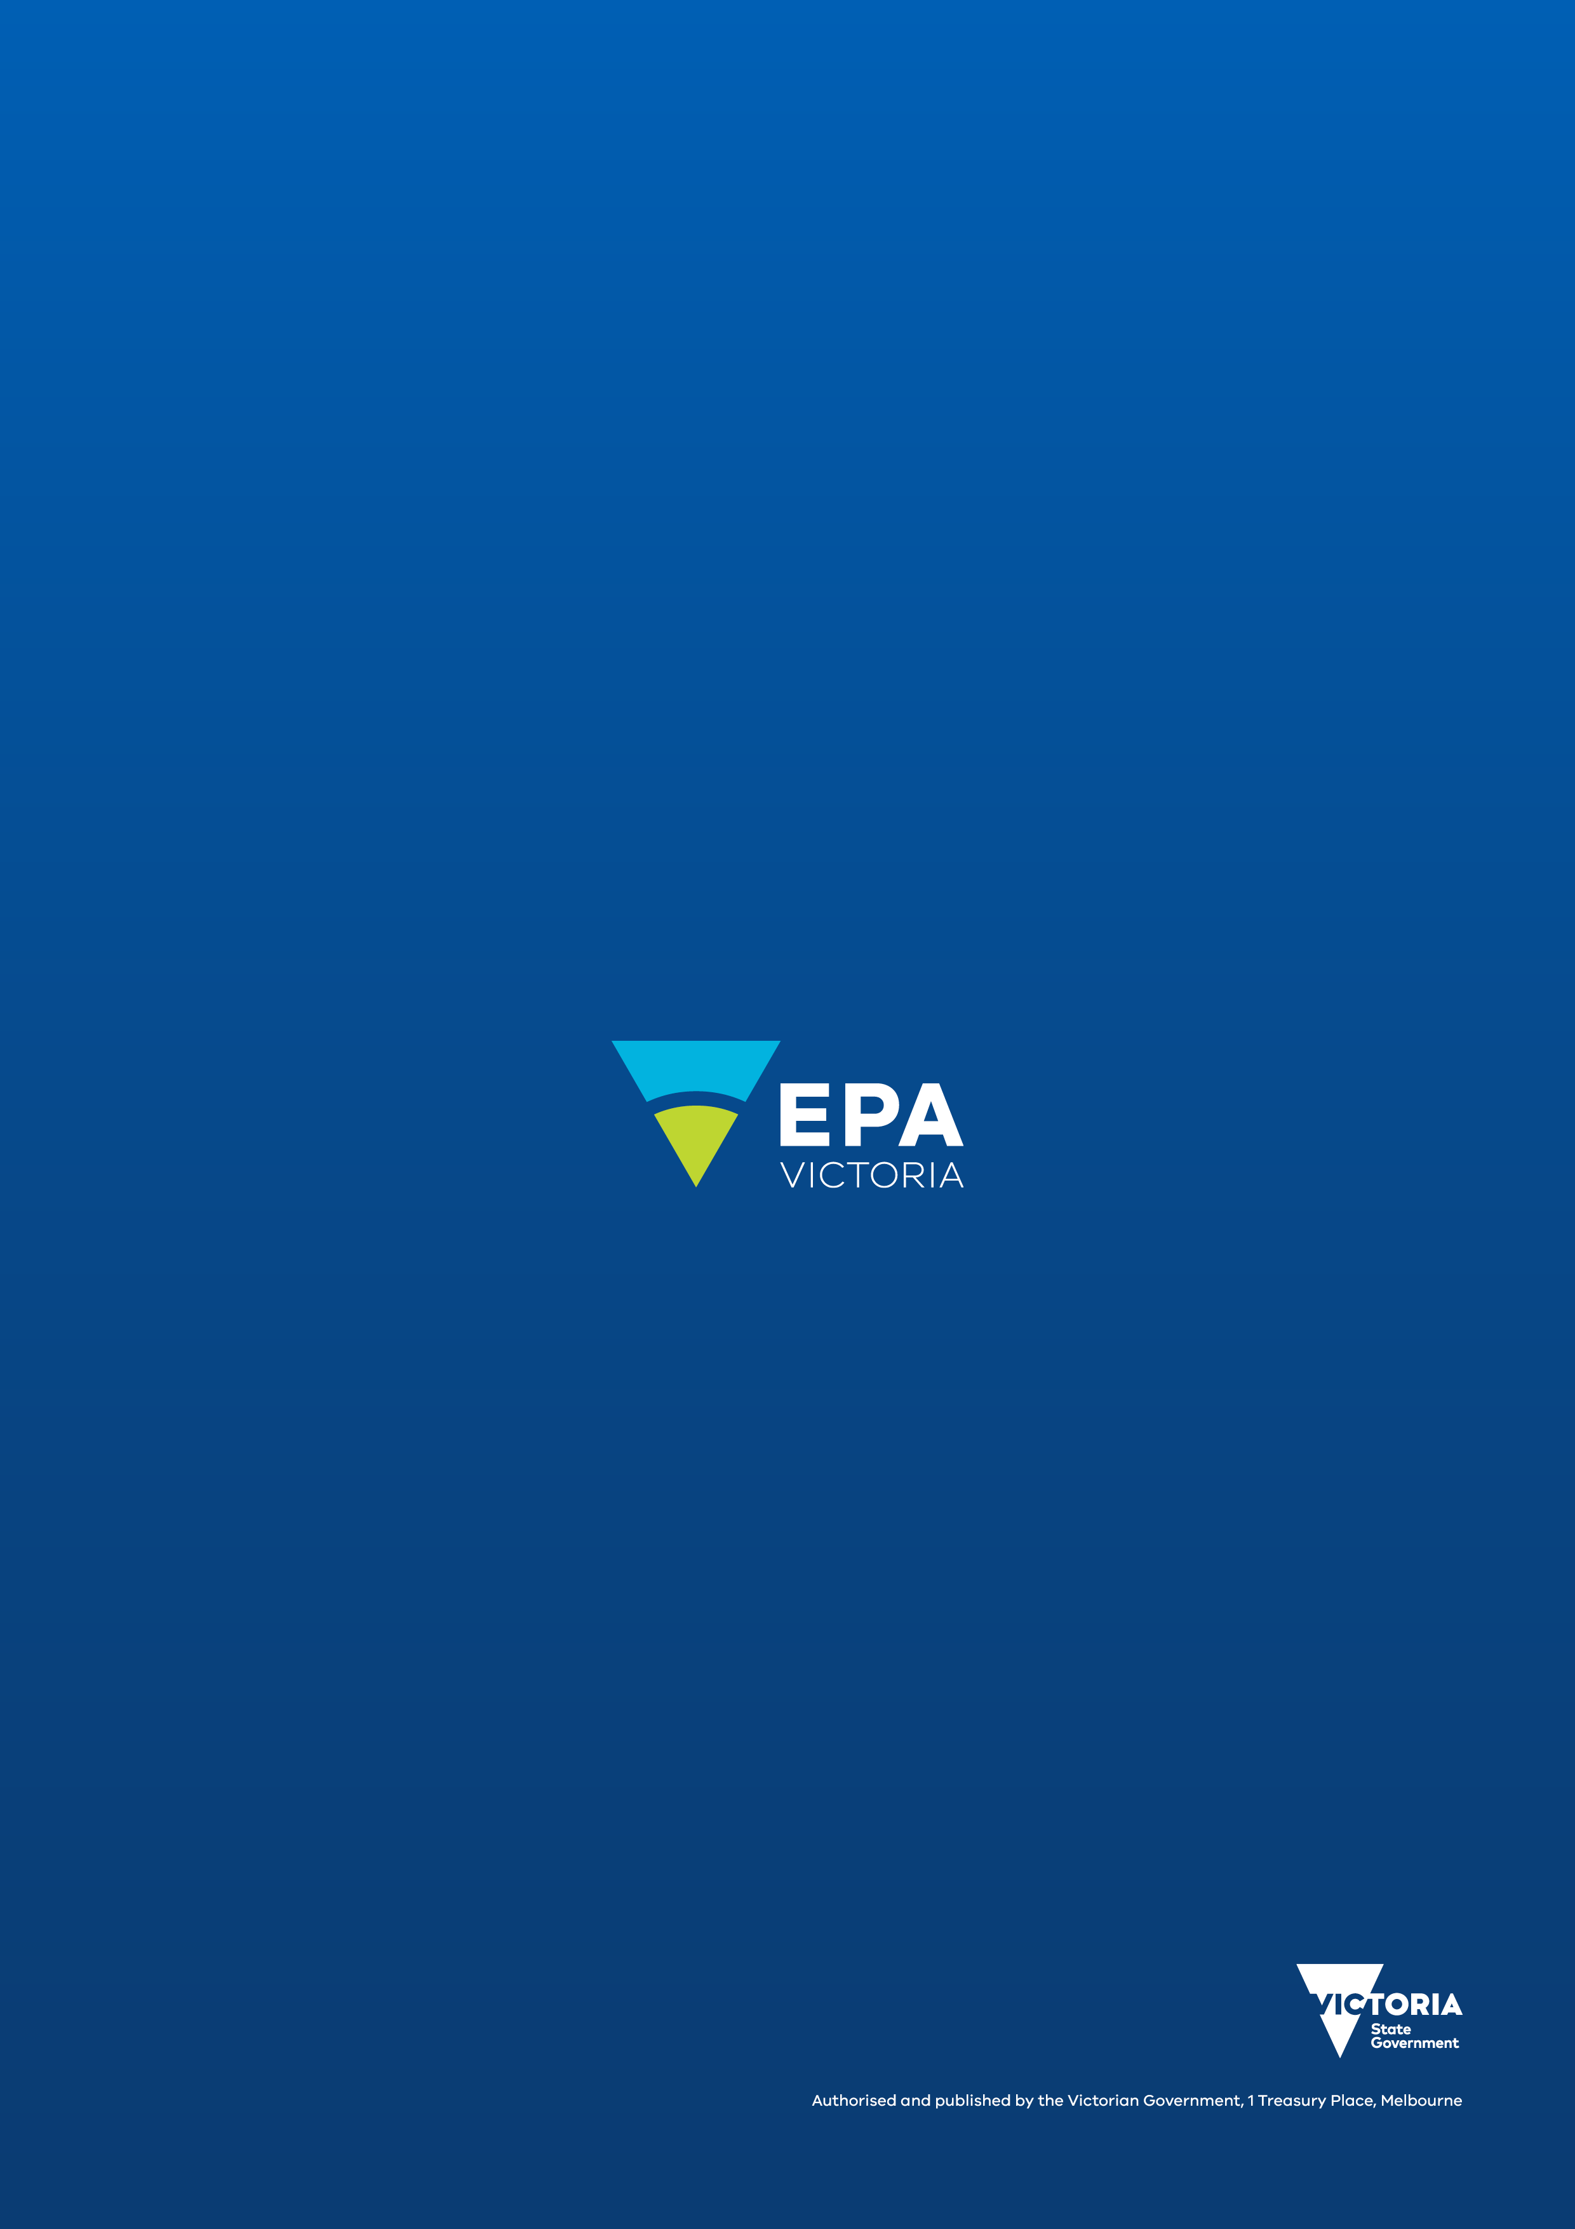
epa.vic.gov.au
Environment Protection Authority Victoria
GPO BOX 4395 Melbourne VIC 3001
1300 372 842

Cover your load- City of Whittlesea; Metro Waste Resource Recovery Group; July 2017; Recycling Victoria website
Evidence Act 2008, s 139.
Evidence Act 2008, s 139(4)

