Regulating Residential Noise
  - Local government toolkit

Publication 1969 | November 2022
Regulatory Enablement Branch

epa.vic.gov.au
Environment Protection Authority Victoria
GPO BOX 4395 Melbourne VIC 3001
1300 372 842

This publication is for general guidance only. You should obtain professional advice if you
have any specific concern. EPA Victoria has made every reasonable effort to ensure accuracy
at the time of publication.

Give feedback about this publication online: epa.vic.gov.au/publication-feedback

EPA acknowledges Aboriginal people as the first peoples and Traditional custodians of the land
and water on which we live, work and depend. We pay respect to Aboriginal Elders past and present
and recognise the continuing connection to, and aspirations for Country.

Contents
About this council toolkit 5
About the environment protection laws 5
Council investigation under different Acts 5
Noise regulation in Victoria 6
Part A: Residential noise 7
Unreasonable noise from residential premises 7
Definition of unreasonable noise 7
Unreasonable noise from residential premises under the Act 8
Definition of residential premises 8
What residential premises includes 9
What residential premises doesn’t include 9
Residential noise laws and penalties 9
Who can enforce the residential noise laws 12
Councils 12
Residential noise enforcement officers 12
Police 12
Regulatory approach for residential noise complaints 12
Process for investigating residential noise complaints 13
Stage 1: Initial investigation 13
Contemporaneous notes 15
Stage 2: Site assessment 15
How to assess if noise is unreasonable 17
Assess the noise using the definition in the Act 19
Approaches to assessing noise 23
Stage 3: Tools to address non-compliance 25
Choosing a compliance and enforcement approach 26
Aggravated noise 29
Who can act against aggravated noise? 29
Part B: Noise from construction, demolition and removal of residential premises 29
About construction noise 30
Activities that are considered residential construction 30
Delegation to councils and authorised officers 30
General environmental duty 31
Section 166 – Environment Protection Act 2017 31
Investigating residential construction noise 32
Assessing residential construction noise 32
Authorised officer entry and inquiry powers 34
Compliance and enforcement tools: Noise from construction, demolition and removal of residential premises 34
Information and education 35
Improvement and prohibition notices 35
Enforcement of improvement and prohibition notices 36
Review of improvement notices and prohibition notices 36
Providing issued notices to EPA 36
Contact EPA 36
Appendix 1: Other residential premises 38
Who is responsible for unreasonable noise in these settings? 38
Organised care accommodation 38
Short-stay accommodation 38
Home-based business 39
Apartments 39
Appendix 2: Investigation flowchart 40
Appendix 3: Residential noise improvement notice – section 172 41
Appendix 4: Unreasonable noise direction – section 175 43
Appendix 5: Entry orders for residential noise – section 176 44
Appendix 6: Infringement notices 45
Appendix 7: Prosecution 47
Appendix 8: Injunction relating to residential noise – section 174 48
Appendix 9: Council authorised officer powers 49
Appendix 10: Improvement notice – section 271 54
Appendix 11: Prohibition notice – section 272 56
Accessibility 58
Interpreter assistance 58

About this council toolkit
EPA has developed this toolkit to support local government (council) officers working in residential noise compliance and enforcement in Victoria. The toolkit has two parts:
Part A – explains how councils can regulate residential noise under the Environment Protection Act 2017 (the Act) and Environment Protection Regulations 2021 (the Regulations).
Part B – explains how councils can regulate noise from the construction, demolition and removal of residential premises under the Act through a delegation of powers from EPA.
It includes practical tips and advice on how council officers can investigate noise complaints using the Act’s risk-based compliance framework. It also includes case studies that show the impacts unreasonable noise can have on people.

About the environment protection laws
The Act came into effect on 1 July 2021 replacing the previous environment protection laws.
Local government continues to have a key role in regulating several environmental and human health issues under the Act, including resolving noise issues between neighbours. The Act provides councils with powers and tools to manage residential noise.
Local government can also regulate noise from residential construction, demolition and removal of residential premises under the Act’s general environmental duty (GED). This is through a delegation of powers from EPA.
The GED is the centrepiece of the 2017 Act (https://www.epa.vic.gov.au/for-business/new-laws-and-your-business/general-environmental-duty). The GED requires everyone to eliminate or minimise impacts to human health and the environment, so far as reasonably practicable.
Under the GED, people involved in construction or demolition activities are required to minimise the risk of harm to human health or the environment, including harm from noise.

Council investigation under different Acts
Council officers are often appointed under multiple Acts, so it’s important to understand when you can investigate and enforce the Act and Regulations.
Use this toolkit to understand when and how council and council officers can enforce the environment protection laws in relation to noise.
Further guidance
- The Act and Regulations
- Information about noise
- Construction guide to preventing harm to people and the environment
(EPA Publication 1820)
- Civil construction, building and demolition guide (EPA Publication 1834)
- Administering your powers under the Environment Protection Act 2017: Guide for local government and litter authorities (EPA publication 1993)

Noise regulation in Victoria
Councils, EPA and the police all play a role in regulating noise in Victoria.
Councils can:
- regulate residential noise under the Environment Protection Act and Regulations.
- regulate noise from residential or commercial premises and noise from dining/licensed venues using other legislation such as the Planning and Environment Act 1987 (including planning permits and schemes), Public Health and Wellbeing Act 2008 or Local Laws.
EPA regulates commercial and industrial noise and noise from entertainment venues.
Victoria Police can act on residential noise, such as late night parties, and noise from entertainment venues.
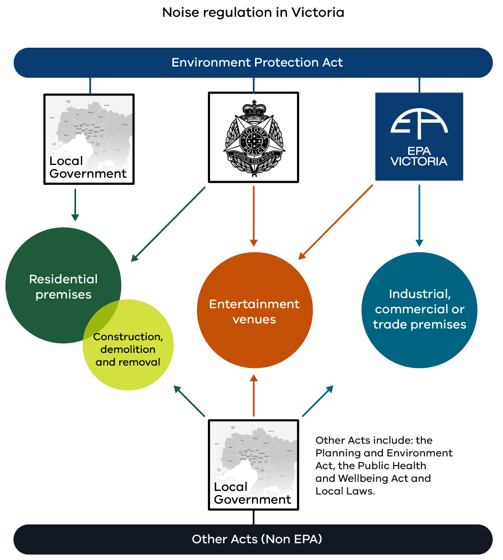
Figure 1: Noise regulation in Victoria

Part A: Residential noise
Common sources of residential noise
Common sources of problem noise include:
- stereos and radios
- televisions and home theatre systems
- air conditioners
- lawn mowers
- power tools.
Noise is unwanted sound that can be annoying or disturbing. Over time, if the noise continues or is too loud, it can impact people’s health and wellbeing.
The impact of noise can be greater when it disrupts a person’s sleep. For example, when noise makes it difficult to fall asleep or wakes them during the night. The short-term effects of sleep disturbance from noise include impaired mood, daytime sleepiness and poorer mental alertness or cognitive performance. Long-term disturbed sleep or shortened sleep is associated with negative health outcomes.
Noise can also annoy people. Annoyance is a stress reaction, that in the long term contributes to other negative health impacts. People’s reactions to noise can include frustration, anger, exhaustion, agitation and helplessness.
Residential noise can also interfere with how a person uses and enjoys their home. They may be impacted when they try to read, rest, listen to TV or music, spend time outdoors or engage in other quiet activities. While some noise can be expected as a normal by-product of activities around the home, it can become unreasonable depending on how loud it is, how often it happens and when it occurs.

Unreasonable noise from residential premises
The Act defines unreasonable noise and provides for a specific obligation not to emit unreasonable noise from residential premises. It also describes who can investigate and enforce the law, their powers and the action they can take.

Definition of unreasonable noise
In section 3 of the Act, unreasonable noise means:
- noise that is unreasonable having regard to the following:
  - its volume, intensity or duration
  - its character
  - the time, place and other circumstances in which it is emitted
  - how often it is emitted
  - any prescribed factors or
- noise that is prescribed to be unreasonable noise
- does not include noise prescribed not to be unreasonable noise.

Unreasonable noise from residential premises under the Act
Unreasonable noise
Noise can be considered unreasonable based on any factors, or multiple factors, but doesn’t have to be every factor.
Noise can also be considered unreasonable if it’s emitted from an item prescribed in the Regulations during prohibited times and can be heard in a habitable room of any other residence.
Importantly, any noise from a residence can be unreasonable at any time of the day.
Section 167(1) of the Act describes the obligation on any individual not to emit unreasonable noise from residential premises, including penalties for non-compliance.
A person must not:
  - emit unreasonable noise from residential premises or
  - permit an unreasonable noise to be emitted from residential premises.
Section 167(2) provides for what would be considered as unreasonable noise, without limiting subsection (1). Under this section a person is taken to emit an unreasonable noise from residential premises if the person uses a prescribed item, except in the case of an emergency:
- at any time prescribed as a prohibited time and
- if noise emitted by that item can be heard in a habitable room in residential premises other than premises in which the item is being used, whether or not a window or door is open.
For section 167(2):
- Regulation 114 sets out the prescribed items and prohibited times
- A ‘habitable room’ means a room other than a kitchen, storage area, bathroom, laundry, toilet or pantry (section 167(3)).

Definition of residential premises
Residential premises is a place where a person or people live. It has a specific meaning in Part 7.6 of the Act.
Section 165 of the Act says that in this Part –
residential premises –
- means any premises used primarily for residential purposes, including but not limited to the following:
  - any land, building or appurtenances used for or in connection with residential premises
  - an outbuilding situated on land used for or in conjunction with residential premises.
- does not include land at any time when construction, demolition or removal of residential premises (other than maintenance or repair of an existing building) is being carried out on the land.

What residential premises includes
Residential premises include private dwellings such as apartments and houses. It also includes land used for residential purposes such as garden areas, driveways, outdoor entertaining areas and utility areas.
Other locations can also be residential premises depending on the circumstances. They’re described in Appendix 1: Other residential premises and include:
- home-based businesses
- organised care accommodation in a residential setting
- short-stay accommodation.
Repair or maintenance of an existing building on residential land falls within the Act’s definition of residential premises.

What residential premises doesn’t include
Residential premises doesn’t include land at any time when construction, demolition or removal of residential premises is undertaken. Examples that distinguish between repair and maintenance and construction or demolition are provided in Part B: Noise from construction, demolition and removal of residential premises.
Construction, demolition and removal of residential premises applies to all scales of activities including:
- residential subdivision developments
- building of new houses and apartments
- single house knockdown and rebuild projects.
Additionally, some parts of apartment buildings are not treated as residential premises. See Appendix 1: Other residential premises for examples.

Residential noise laws and penalties
Table 1 sets out the residential noise laws under the Act and the associated penalties. It also lists the enforcement powers of councils, residential noise enforcement officers and police to act when non-compliance occurs. These powers are explained further in the next section.
Note: Infringement offences are listed in Schedule 10 of the Regulations.

Table 1: Residential noise laws and penalties
Act Section | Residential noise laws | Enforcement powers | Maximum court penalty in penalty units | Infringement penalty in penalty units | Infringement offence code
167(1) | A person must not emit, or permit to be emitted, unreasonable noise from residential premises. | S170(2)  A RNEO, police officer, or person claiming to be directly affected by the alleged offence may take proceedings for an offence against s167(1) – unreasonable noise from residential premises | 120 (natural person)
 |  |  | 600 (body corporate)
 |  | s307 (1) & (4)(b)  A RNEO or police officer can issue an infringement notice in relation to an infringement offence* under section 167(1), in the circumstances set out in section 167(2) (use of a prescribed item during a prohibited time)’. |  | 2 (natural person) | 0222
 |  |  |  | 10 (body corporate) | 0223
171(1) | A council may appoint a person as a residential noise enforcement officer
172 | A council may issue a residential noise improvement notice
172(6) | A person issued with a residential noise improvement notice must comply with the notice. | s170(6)  A RNEO may take proceedings for an offence against section 172(6) | 120 (natural person)
 |  |  | 600 (body corporate)
 |  | s307 (1) & (4)I  A RNEO may issue an infringement notice for an infringement offence* under section 172(6) |  | 5 (natural person) | 0226
 |  |  |  | 25 (body corporate) | 0227
174 | A Council or police officer may apply to a Court for an injunction relating to residential noise.
175 | A RNEO or police officer can give an unreasonable noise direction (in effect for 72 hours).
175(4) | A person must comply with an unreasonable noise direction given by a police officer or residential noise enforcement officer. | s170(4)  A RNEO or police officer can take proceedings for an offence against 175(4) | 120 (natural person)
 |  |  | 600 (body corporate)
 |  | s307(1) & (4)(b)  A RNEO or police officer can issue an infringement notice in relation to an infringement offence* under section 175(4) |  | 5 (natural person) | 0228
 |  |  |  | 25 (body corporate) | 0229
176 | A police officer* may apply to a court officer^ for an order to enter residential premises to investigate unreasonable noise.
177 | A person must not obstruct a police officer in taking any action authorised by an order under section 176. | 170(5)  A police officer may take proceedings for an offence against section 177 | 60 (natural person)
 |  |  | 300 (body corporate)

* Police officer must be of or above rank of senior constable
^ magistrate or registrar of the Magistrates' Court.

Who can enforce the residential noise laws
The Act gives powers to councils, residential noise enforcement officers and police officers to act when unreasonable noise occurs.
People directly affected by unreasonable noise can also take court action themselves. Refer to Table 1 above.

Councils
The Act provides powers to councils to regulate residential noise issues.
Councils can:
- appoint a person or class of persons as a residential noise enforcement officer (RNEO). This person does not need to be an employee of the council.
- issue residential noise improvement notices. These notices are often used to deal with ongoing noise issues.

Residential noise enforcement officers
RNEOs have specific powers to investigate and act when unreasonable noise occurs.
RNEOs can:
- initiate Court proceedings on behalf of council for certain residential noise offences
- issue infringement notices for certain residential noise offences
- give an unreasonable noise direction
Council officers who were previously appointed under section 48A(1) of the Environment Protection Act 1970 to act on residential noise don’t need to be re-appointed (refer to section 496 of the Act).

Police
The regulation of residential noise is shared between councils and police. Police officers can:
- initiate Court proceedings for certain residential noise offences
- issue infringement notices for certain residential noise offences
- give an unreasonable noise direction
- apply to a Court officer for an order to enter residential premises to investigate unreasonable noise.
Police officers can assist council RNEOs in their investigation of noise complaints by gaining access to residential premises, or providing protection if noise makers are displaying anti-social or threatening behaviour.
Police can also respond to residential noise complaints outside of business hours, such as party noise.

Regulatory approach for residential noise complaints
The next sections cover:
- recommend approaches for investigating residential noise complaints
- guidance for RNEOs on how to assess whether noise is unreasonable under the Act.
Use the following guidance and Appendix 2: Investigation flowchart, along with your council’s investigation procedures.

Process for investigating residential noise complaints
As an RNEO it’s recommended you follow these stages:
- Stage 1: Initial investigation to understand the problem
- Stage 2: Site assessment to assess the noise
- Stage 3: Using compliance and enforcement tools to address non-compliance.
There is no single approach for every situation. The nature of the noise problem and the attitude of the noise maker will inform your actions. For example, the length of the investigation, the effort you make to educate and support neighbours to resolve issues themselves before you consider taking enforcement action.

Stage 1: Initial investigation
Most residential noise investigations start with a report or complaint to council. The report is assigned to an officer or team who will being an investigation.
Purpose | - Get an initial understanding of the nature of the noise issue, such as its severity, impact and how often it occurs.  - Understand the people involved, such as the actions or intent of the noise maker, any attempts to resolve the issue and the sensitivities of the person who’s impacted.
Approaches | - Use desk top approaches to find out as much as you can about the situation, for example:  - Speak to the noise-affected person to understand their situation. You may have a person who has only recently started to hear a noise and be disturbed by it – right through to cases where a person’s health has been severely impacted by ongoing noise.  - Provide the affected person with a noise diary to establish a noise pattern, if required  - Speak to the alleged noise maker to discuss the issue and share information about noise, its impacts and the law.  - Use ‘How to assess if noise is unreasonable’ to help you make an assessment against the definition of unreasonable noise.  - Respond within a reasonable time and move to action  where possible.  - Refer to the guidance for communicating with noise-affected people.  - Take contemporaneous notes to record the details of your investigation (find more information in the next section)
Questions to ask yourself | Review the notes given to you about the incident:  - Is there enough information about the noise issue?  - Is the noise source known?  - Has the person reported noise issues to council before?  - Will I need to meet the person affected by  the noise at their house?  - What further information do I need?  - Do I need to take a longer-term approach to establish a pattern of noise before taking further action?
Decision | - If you decide that you go to the affected person’s house to assess whether the noise is unreasonable - go to Stage 2.  - If you decide that you already have enough information to take action, such as providing information to the noise maker or issuing an unreasonable noise direction (s175)– go to Stage 3- Using compliance and enforcement tools to address non-compliance.

Communicating with noise-affected people
How you communicate with the person affected by the noise can be as important as getting the noise stopped or reduced. Build trust with the person who’s reported the noise by acknowledging their frustration. They may have suffered with the noise problem for some time and their health and wellbeing may be being affected.
Be open in your communication. Explain the role of council in regulating noise and the likely outcomes they can expect. It’s important to manage the person’s expectations around what can be achieved. For example, sometimes even when the noise is reduced to comply with the law, there may still be a level of noise. If people don’t understand what outcomes can realistically be achieved out of the investigation, they may continue to be aggrieved even when the noise is reduced.
When you’ve finished your investigation speak to the person who reported the noise. Explain the outcome of the investigation to them, including the reasons for action taken by council.

Understand the health impacts
Noise is subjective and the impact can range from a minor disturbance or irritation through to a substantial loss of quality of life and even to profound debilitation. People have a wide range of sensitivity to noise, which means noise doesn’t have to be particularly loud to affect some people. Some residents may be impacted even if a noise doesn’t sound very loud.
In determining what action to take, listen to the person’s account of how the noise is affecting them. Take the negative impacts to their health into consideration along with the factors covered in How to assess if noise is unreasonable.

Communicating with people making noise
Understand the attitude of the person making the noise. You might encounter someone who isn’t aware they’re causing a problem – to someone who’s using noise to aggravate or harm their neighbour.
Start by identifying yourself and if you are meeting them in person, show your ID if asked. Explain that unreasonable noise is an offence and that they may be emitting unreasonable noise which is impacting other people.
Always be courteous, remembering that they may not be aware they’re causing a problem for their neighbours, or their children or teenagers may be the cause. If the resident doesn’t answer to your knock, leave a card for a call back.
Avoid being overbearing or getting involved in an argument and be sure to act within your powers. RNEOs have no powers of entry to residential premises. If a person is known to be aggressive, request assistance from the police. If you do need to take further enforcement action, explain what action you intend to take.
If appropriate, use the below information and publications to educate and inform noise emitters and noise-affected people.
- Annoyed by noise (EPA Publication 406.8)
- Cool air: Quietly and efficiently. A guide to buying and operating an air conditioner
(EPA Publication 1176.1)
- Reduce noise from your home

Contemporaneous notes
It’s important to take contemporaneous notes. These are the notes you take during your investigation about what you saw and heard, including any conversations. They become an official record and can act as important evidence to support enforcement action. Take notes at the time you observe the actions taking place and always keep your original notes.
Your notes may be needed to:
- complete a report, statement or affidavit – all of which can be used as evidence
- provide details that support enforcement action, such as issuing infringement notices and other notices
- form part of evidence that an officer gives in court (with the court’s permission) when they are unable to rely solely on their memory to answer questions.

Stage 2: Site assessment
From your initial investigation you may have enough information to resolve the matter, or to take enforcement action.
However, if you think a site assessment is required to assess if the noise is unreasonable, or if there’s an ongoing noise issue, do this before taking further action.
Purpose | - Assess the noise onsite.  - Decide if unreasonable noise is being emitted.  - Resolve the issue through discussion with the parties, or by taking enforcement action
Approaches | - Plan your visit to the affected person’s residence to maximise your chances of making a valid assessment – consider the timing, recurrence and nature of the noise.  - Ensure you have consent of the affected person to enter their residence Listen to the noise at the location where the effected person is experiencing the noise (e.g. inside a habitable room in the house)  - Listen to the noise and consider the definition of unreasonable noise and the grounds for notices and directions.  - Speak with the noise maker. Remember RNEOs do not have powers to enter a premises without the consent of the occupier.  - Measure the noise only when required to back up your assessment.  - Use supporting evidence such as diaries and corroboration when required.  - Avoid lengthy investigations. Use lower-level compliance and enforcement tools where appropriate.  - Consider the reasonable needs of noise makers and those impacted.  - Use approaches that reflect the noise maker’s attitude and the noise’s impact on the sufferer.  - Where appropriate, equip people to resolve issues.
Questions to ask yourself | - Is there a clear pattern of the noise to guide my attendance approach?  - Is there a time of day that’s best to assess the noise?  - What do I need to consider about the attitude or behavior of the noise maker?  - Do I know enough to take regulatory action?
Decision | - Use the information in the ‘How to assess if noise is unreasonable’ section below to help you make an assessment against the definition of unreasonable noise.  - If you decide enforcement action is required, go to Stage 3- Using compliance and enforcement tools to address non-compliance.  - Follow your council’s own investigation and interview procedures.

How to assess if noise is unreasonable
Air conditioner use during a heat health alert day
Prohibited times for the use of air conditioners are set out in Regulation 114. They don’t apply on a day that a heat health alert is declared by the Chief Health Officer.
This means that air conditioner use is not prescribed as unreasonable noise from residential premises, up until midnight on the day of a health heat alert.
However, if the noise from the air conditioner used during a heat health alert period is excessively loud and/or rattly for example, it might still be unreasonable based on those factors.
Remember that any noise at any time can be assessed as unreasonable if the factors of unreasonable noise are evident.
Noise from residential neighbours can impact people in their homes. These effects can include sleep disturbance and interference with domestic activities. It can also cause a range of negative emotions or reactions. Even though these effects can occur, they’re not the test of whether the noise is unreasonable.
To decide whether unreasonable noise is being emitted, assess the noise using:
- the prescribed items and times in Regulation 114, or
- the factors to consider for unreasonable noise set under section 3 of the Act.
The test for whether the noise is unreasonable using the Regulations is straightforward and based on:
- whether the noise is emitted from a prescribed item listed in Regulation 114 at a corresponding time, and
- is audible within a habitable room of any other residence.
In special cases, such as an emergency, or a heat health alert, some noise sources listed in the Regulations are not prescribed to be unreasonable noise.
Figure 2 shows how to assess noise using the Act and Regulations together.
It’s important to note that noise from prescribed items can be unreasonable outside of the prohibited times, under the definition of unreasonable noise. Unreasonable noise also applies to noise types not listed in the Regulations, such as ongoing and frequent clanging gates or shutters in the early morning.
What the affected person says about how the noise interferes with their activities at home can help you decide whether the noise is unreasonable. For example, the affected resident might describe the need to increase the sound of their TV to hear it over the noise. This disturbance to an ordinary activity can indicate that the noise is unreasonable as it’s too loud.
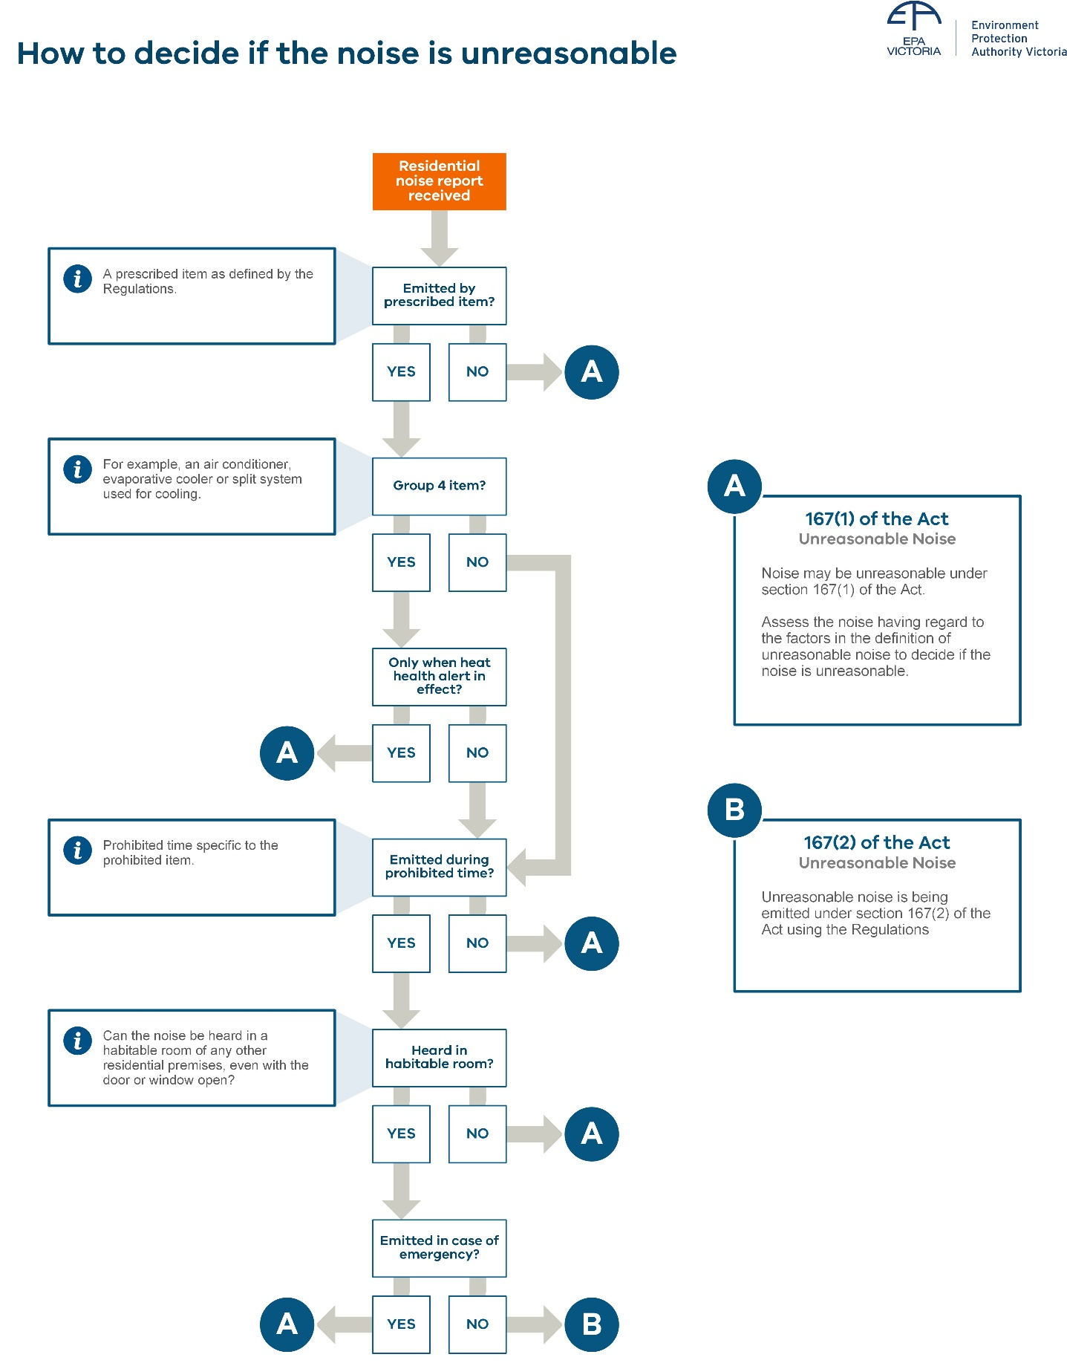
Figure 2: Assessing if noise is unreasonable

Assess the noise using the definition in the Act
Under section 3 of the Act, unreasonable noise is noise that is unreasonable having regard to:
- how intense or loud it is – its intensity
- how far it spreads – its volume
- what the noise sounds li–e - its character
- how long it continues – its duration
- how often it is emitted and
- the time, place and other circumstances in which it’s emitted.
Each of the factors and how they’re assessed is described below. Noise can be assessed as unreasonable based on any factor – not every factor. Sometimes the noise might be a combination of factors, for example a tonal droning sound that can be heard in the outdoor area and within the living and bedrooms may be unreasonable because of what the noise sounds like (its character) and that it spreads widely throughout the affected residence
(its volume).

Intensity
Intensity means how loud the noise is. Intense noise can be very intrusive. It can disturb sleep and everyday activities such as reading, watching television or having a conversation. You can gauge intensity by:
- the disturbance to the affected person’s daily activities
- by listening and comparing the loudness of the noise to other sounds in the neighbourhood or within the residence or
- measuring it in decibels.
Noise is too intense if it’s the dominant sound and is heard over background sounds. For example, if it’s loud enough to cause people in the area to move away or raise their voices to hold a normal conversation.
Some normal domestic activities are unavoidably loud, such as using lawn mowers or powered garden tools. If outside of the prohibited times, consider how long the noise continues and how often it occurs. These factors will help you to decide if the noise is unreasonable.
When noise is very loud, it can also cause structures to vibrate or ratt–e - worsening the impact.
A resident describes the impact of an extreme case of unreasonable noise:
“We had loud music from morning until night. Sometimes almost 24 hours a day. You couldn’t sleep, you couldn’t think, you couldn’t watch your tele, you couldn’t read. I used to go to bed with cushions and things wrapped around my ears, and you could feel the floor going boom, boom, like this.”
“Because I could feel it pumping through my body. I could feel it vibrating my organs. I could feel it in my head, just shaking everything or shaking our windows.”

Volume
Residents describe the impact of high-volume noise in exceptionally severe cases
“… I have nowhere else to go to escape this noise … It makes me feel incredibly tense.”
“It's not only us, we're their next-door neighbours, but the neighbours above, even like two or three floors above. It seems like the noise just travels up as well… it goes, literally, for [the whole length of the] apartment.”
“It goes through his whole place, through my whole place and out the other side.”
Volume means how far the noise spreads throughout the affected home, both indoors and out. It can be a problem where noise travels throughout the building (especially in apartments) or if it’s low-frequency sound. Having nowhere to escape from the noise increases its impact
on people.
Assess volume by:
- asking the affected resident where the noise is heard at the home, both inside and outside
- listening to the noise in different areas of the affected residence, noting which areas are impacted by the noise.
The noise doesn’t need to be loud in all areas to be unreasonable. Volume considers the presence of noise throughout the home and the need for areas to be free from intruding noise.
Noise that has particularly high volume would be heard in more than one adjoining residence. Ask the neighbours whether they can also hear the noise and where in their property it can be heard.

Character
Character means what the noise sounds like. Noise with unpleasant character is more disturbing than noise of the same loudness without the character. The character of the noise is:
- tonal if it can be described as squealing, whining, humming, droning or throbbing
- intermittent if it suddenly becomes noticeably louder and maintains the louder level for at least one minute
- impulsive if it has a sudden burst of sound that can be described as banging, hammering or thudding
- a rattle if it has a rapid succession of short, sharp sounds, usually from something shaking
or vibrating.
Residents describe the impacts of noise with character:
The impact of recurring and ongoing noise can be severe
“We were always on edge as we didn’t know when the music would start, how long it would go for and when it would stop.”
“We live in the country and you’d get a nice weekend and want to spend it outside, then you’d end up with the neighbour’s twelve dirt bikes running around their property… the windows would be shaking.”
In this case, the noise is unreasonable due to the unpleasant sound of the dirt bikes – the tonal sound and the increase and decrease in level (intermittency), combined with the intensity of the noise causing the windows to shake and rattle.

Duration
Duration means how long the noise continues. Assess duration by determining how long the noise continues and whether there are sufficient breaks in it to provide rest or relief.
Your assessment of duration can be supported by:
- a diary or notes from the affected person documenting when the noise starts and stops
- a recording of the noise taken over a longer period – a few days to a week.
Duration of the sound is a relevant consideration when there’s an element of choice by the noise maker, rather than necessity. For example, a lawn mower is noisy, but it usually stops when all the grass is mowed – the duration is often short, so it’s reasonable.
Noise for a longer duration that occurs for a substantial proportion of the non-prohibited hours would be unreasonable, unless there are breaks to provide rest and relief from the noise. Also consider how often the noise recurs and whether it’s from a short-term project or an ongoing activity.
Residents describe the impact of unreasonable noise with a long duration without respite:
“… My blood pressure went up to the degree where I was in some trouble and had to go to hospital because I had no relief unless I actually left my house and went somewhere else.”
“On Saturday, ’he'd start around about 9 am and plays until around about 9:30 pm. There might be a half an hour break here and there, or an hour break here and there.”
In this case, daily music practice unreasonably continued for almost all hours other than the prohibited times (10 pm – 7 am) leaving minimal time for the affected resident to enjoy their own home. Daily music practice of shorter duration, such as a few hours, could be reasonable providing it wasn’t too loud or spread too far through the affected home.
For noise from equipment that typically operates for long periods such as for heating and cooling, consider the intensity and character of the sound, rather than its duration, when deciding if the noise is unreasonable.

How often the noise is emitted
This factor means how often the noise recurs. Frequently occurring noise can be a problem particularly when it happens day after day, or every weekend.
Infrequently recurring noise can also impact on people for months or years, as it can be difficult to assess. Uncertainty about when noise will occur and when it will stop can also lead to heightened anxiety. What may not be recognised is that these impacts often remain even when the noise is not occurring. This can be the case with unresolved issues, especially long-term, unpredictable noise.
How often the noise is emitted can be assessed by:
- a diary or notes from the affected person documenting when the noise occurs
- a recording of the noise taken over a longer period – a few days to a week.
In extreme cases where noise is unreasonable, the impacts on residents can be substantial.
“There was one time where it was like eight days in a row, eight nights, it just went on and on and on, and poor ‘Joan’, we ended up having to take her to the hospital. She ended up with high blood pressure, she just got stressed right out, that was it, off to the casualty. It was terrible.”
“It goes on and it goes on and it goes on. Usually for about eight to ten days, night after night…”
Residents also describe the impact of recurring noise:
“You’re saying, ‘God, are the motorbikes going to start up?’ So even though they’re not there, you’re on edge because you don’t know… you think, ‘next ten minutes will tell. Is he going to get out on the bike or isn’t he?’ And like I say, it’s not [just] when the noise is going, you’re on edge all the time.”
Recurring noise (even if not continuous) can severely impact upon people and needs to be considered.

The time, place and other circumstances in which it is emitted
Noise from animals
and the law
When animals disturb neighbours with noise, local council officers can use the Domestic Animals Act 1994 to investigate or prosecute. This includes noise from barking dogs.
It’s an offence for the person living in the house to let their animals make persistent noise that disturbs people.
Noisy domestic animals can also be unreasonable noise under the Act.
Time means when the noise occurs. Noise at night and in the early morning hours can disturb sleep. The Regulations prohibit the use of certain items of equipment during the late-evening and night if they can be heard in another residence. Noise from sources not listed in the Regulations can also be unreasonable if occurs at times when people normally sleep.
The time that noise occurs can be understood from:
- a diary or notes from the affected person documenting when the noise occurs
- a recording of the noise taken over a longer period – a few days to a week.
Residents describe the impact of night-time and early morning noise:
“So, they started doing up their house last November and after three weeks, when they started it, I think’it's there at 6:30 am. They might pull up at six o’clock and listen to the radio or have a cuppa or rattle some chains or move some equipment or do something. Then things get sort of started by 6:30, seven o’clock.”
Time can also be considered if the affected resident needs rest or sleep at times when others are usually awake. For example, those with young children, people with chronic illness and shift workers may need to sleep during the day. If applicable, take this into account in your assessment.
Place refers to whether the activity is fitting or expected within the residential setting. For example, riding trail bikes might reasonably be expected to occur at times on a rural property. However, it would be unexpected within a built-up urban area and doesn’t fit with the context in which the noise is heard. Even in rural settings, noise from trail bikes can be unreasonable if it’s too loud, happens too often or continues too long.
As noise is emitted from normal residential activities, other circumstances can be considered when deciding if the noise is unreasonable. Other circumstances can be a determining factor making the noise unreasonable if it’s being emitted to harm, irritate, or get at residents as part of an unrelated neighbour dispute. For example, an unrelated dispute about trees, fences or parking. That is, the noise is being emitted to make life unpleasant in response to an actual or perceived wrong. This can be described as “tit-for-tat” behaviour. While enforcement of unreasonable noise is an option in this case, more benefit might be gained by referring the neighbours to mediation.
Another aspect of other circumstances includes whether the noise emitter has tried to reduce the noise impacts or install controls.
This could be relevant where the noise from fixed equipment is marginally (about 1-2 dB) above the guideline level in Noise Guidance: Assessing noise from residential equipment (EPA Publication 1973) and noise control has been installed. Further noise reduction to meet the guideline level will cost proportionally more and the reduction would not be audibly noticeable. This isn’t a valid consideration if noise control hasn’t been implemented and the equipment could be relocated or replaced to eliminate the unreasonable noise.

Approaches to assessing noise
Approaches to assessing noise are listed at the start of this topic. In summary, the noise needs to be assessed at an appropriate time and place. You’ll need to consider the circumstances of the noise emission and listen to the noise. While an assessment may include noise measurements, in most situations noise measurements won’t be needed.

Assessment time
Assess the noise at a time and under the circumstances that represent the likely worst case of impact. Consider:
- when the noise is likely to be occurring
- when the noise most impacts upon the affected resident
- other sounds that may be present at the time such as background sounds.
Background sounds are normally lower in the evening than in the day and are usually highest during periods of peak traffic. Residential noise will be more intrusive when background sound levels are lower. So, if the noise affects a neighbour in the late evening, make your assessment at this time.
Likewise, if noise interferes with use of an outdoor entertainment area, make the assessment at a time when the area would be used, either during the day or in the early evening.

Assessment place
The assessment location must represent the relevant indoor and/or outdoor area where the person is being affected by the noise of interest. Ensure you have consent of the affected person to enter their residence.

Relevant outdoor areas
These areas are parts of the residential property used by the affected resident for recreational and domestic activities such as rest and enjoyment. This includes gardens, outdoor entertaining areas and courtyards. It excludes areas not normally used for rest, recreation or enjoyment, such as an access walkway, or a utility area.

Relevant indoor areas
These areas include habitable rooms, such as bedrooms, living areas and study areas. Relevant indoor areas are not limited to habitable rooms but may exclude infrequently and briefly used rooms, such as a laundry or storage area.

Listen to the noise
Listening to the noise will help you decide if it’s unreasonable using the definition in the Act. Either listen to the noise, or a noise logger recording and consider:
- Can the noise be heard within relevant areas (indoor or outdoor) of the affected residence? How far does the noise spread throughout the affected residential premises? In which rooms or areas of the residence can you hear the noise?
- Is the noise at a level that would prevent the affected resident(s) from enjoying their own home? Does it impact their ability to watch television, have a conversation, or focus on tasks such reading or studying?
- What other sounds can be heard and at what level relative to the noise being assessed? Note whether traffic noise is much louder than the noise being assessed, or if the noise being assessed can be heard clearly over other sounds.
- How long does the noise continue during your site visit, or during the noise
logger recording?
- Does the noise continue at the same level? If the noise you hear is not continuous at the same level, note the pattern of noise recurrence.
- What does the noise sound like and does it have character that people find disturbing?
What you hear and observe, plus your contemporaneous notes will provide evidence for any interventions (stage 3) you might make.

Noise diaries
Seeking a noise diary from the affected person can be useful if your initial investigation (stage 1) shows that a longer-term approach is needed to establish a pattern of noise before you take further action.
Noise diaries can indicate a pattern of noise that warrants attendance or the use of noise loggers. They’re useful if the noise is sporadic, occurring occasionally across the week with no immediately obvious predictable pattern.
Encourage the noise reporter and other affected persons at their address to keep a log of the instances of noise over the next 14 days or so. Ask them to provide enough detail and record as many occurrences of the noise as possible. Explain that this will help you to gather evidence to see if any pattern is established so you can develop a response strategy based on the likely times the noise occurs.
Check back after approximately 14 days to see if any pattern has been established. This helps determine the best time to conduct any site visits.
Noise diaries should be kept just long enough to demonstrate the occurrence of the noise and be proportionate to the severity of impact. Avoid open-ended or inconclusive use of them.
A noise diary can provide supporting evidence when deciding if the noise is unreasonable based on its time, duration or how often it’s emitted.
If the noise is predictable or continuous, a diary might not be needed as evidence. If the noise is severe, waiting for a diary would only delay the investigative action.

Role of noise measurement
In most cases, residential noise can be assessed without using measurements. Noise measurements are most useful when assessing noise from fixed residential equipment.
Noise loggers can measure noise levels and record sound continuously for around a week. They’re battery powered, robust boxes with a pole-mounted microphone. They can be set up, locked and left at the affected residence, even outdoors, to be picked up at a later date.
Noise logging with sound recording can be useful to:
- establish if there may be a pattern sufficient to establish an appropriate time for a site visit
- back-up your observations, such as to show that the noise you heard continued for longer periods after you left
- confirm that the noise persists after you’ve given advice to the noise maker
- help you when deciding if the noise is unreasonable based on its time, duration or how often it’s emitted.
When assessing noise emitted from prescribed items during prohibited hours under the Regulations, the noise needs to be assessed within a habitable room. For all other assessment, place the logger outside at the affected residence.
When setting up a noise logger tell the resident that the logger records sound and anything they say could be recorded. Ask them to keep a noise diary for the period of logging as it will help you interpret the sounds that are heard on the recording.

Stage 3: Tools to address non-compliance
With an understanding of the issue, take proportionate action to resolve it. It’s important to understand the range of compliance and enforcement tools and approaches available and provide appropriate and proportionate responses to each noise complaint.

Purpose | - Remedy the issue, to the extent possible.  - Decide whether to punish or sanction the noise maker.  - Equip those responsible for the noise to manage it in future.
Approaches | - Take proportionate action including:  - providing information and education reinforced by warnings of enforcement action where relevant.  - giving a direction for short term abatement if it suits the type of noise – section 175.  - issuing an improvement notice for a longer-term remedy of the problem – section 172.  - issuing an infringement notice for emitting unreasonable noise or breach of an unreasonable noise direction or notice.  - prosecute through the Magistrates’ Court.  - seek a court injunction – section 174.  - Choose your approach based on the seriousness of the issue.  - Be fair and consider the power imbalances between individuals.  - Use approaches that reflect the noise-maker’s attitude and the impact of the noise on the sufferer.  - Remember RNEOs cannot enter the noise maker’s residence without their consent.
 | Read more in Choosing a compliance and enforcement approach and Appendix 3: Compliance and enforcement tools for residential noise.
Questions to ask yourself | - Do I have sufficient evidence to justify an enforcement response?  - Do I have the power to take the enforcement action I am considering?  - What’s the most appropriate response given the attitude or behavior of the noise maker?  - What tool or approach, or mixture of approaches will provide an enduring remedy?
Decision | Based on the information you have, choose a proportionate response.  Figure 3 outlines the tools available following the model of responsive regulation. Responsive regulation guides officers to use an approach that reflects the behaviour of those causing the non-compliance.  Table 2 will help you to choose the right compliance and enforcement tool for the situation.

Choosing a compliance and enforcement approach
When you’re considering the compliance and enforcement options for residential noise, your approach should be dynamic and respond to the behaviour of the noise maker.
For example, although you might routinely start with guidance, it might be appropriate to issue an infringement notice to someone with an established pattern of deliberate breaches of the residential noise laws. Table 2 will help you to choose appropriate approach and tools for
the situation.

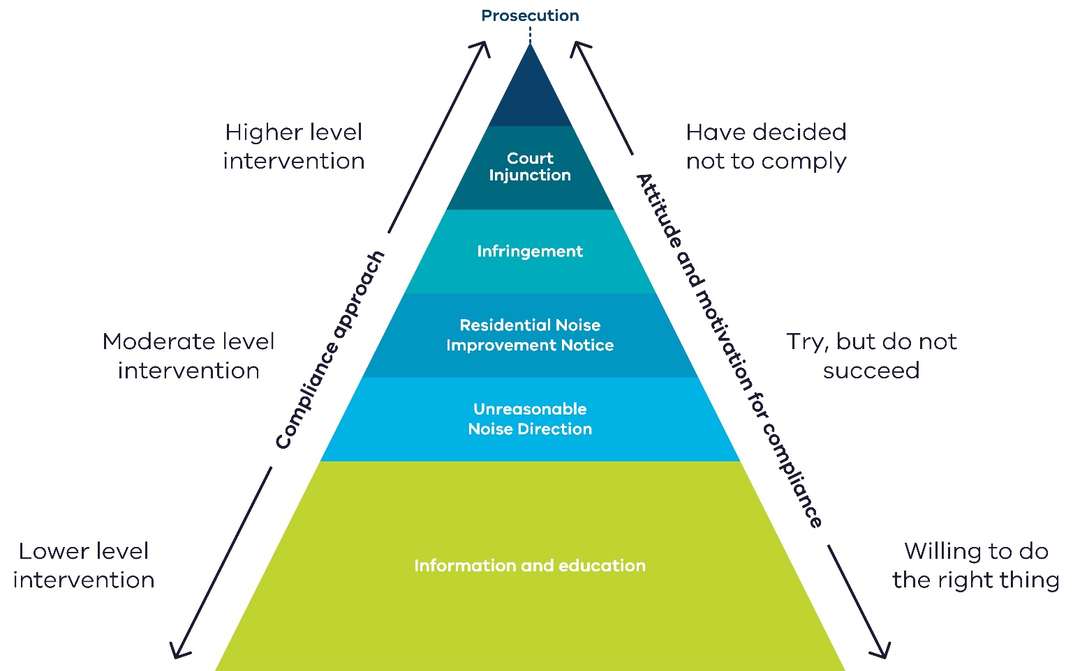

Figure 3: Compliance and enforcement approach to residential noise

Table 2: Compliance and enforcement tools for residential noise
Level | Type of intervention | Suitable situations | Unsuitable situations | Other considerations
Lower level | Information and education | Where the individual was unaware of the impact of the noise on a neighbour and where the impact is intermittent or low. | Repeat offenders and deliberate actions to emit noise | Level of harm to an individual or neighbourhood.
Moderate level | Unreasonable noise direction  (section 175) | Where the noise has had a significant short-term impact and needs to stop, but there is evidence of contrition and a desire to rectify the situation. | Circumstances where there is evidence of sustained or repeated non-compliance. Where issues are identified that reasonably require some time to comply, such as repairing or replacing residential equipment. | Consider the timeliness of this approach and the likelihood of compliance based on details of the incident.
 | Residential noise improvement notices  (section 172) | Where a particular noise source has been identified and needs to be rectified, such as a pool pump or air conditioner. | Short term, intermittent noise that is disturbing but largely rectified by a change in behaviour, such as playing music loudly or at late hours. | Consider this option for repeated offences by different people at the same premises when a longer-term solution is needed. Such as in short-stay accommodation.
 | Infringement notices | Where guidance or previous directions to cease emitting noise or notices have been ignored, or where the noise is high impact (such as early morning or late at night) | One off/accidental or low impact. | This generally shouldn’t be the first enforcement tool. But it might be, depending on actions or behaviour of the noise maker or the level of harm. Consider issuing an official warning rather than an infringement notice. Under section 8 of the Infringements Act 2006, any issuing officer may serve an official warning rather than an infringement notice, if they consider it appropriate to do so.
 | Injunctions relating to residential noise  (section 174) | Ongoing or repeat residential noise where the impact is high, and directions or notices have not been complied with. Or where behaviour has not been deterred by an infringement penalty. | One off/accidental or low impact. Where a direction, remedial notice or infringement notice has worked to stop the noise. | Due to the serious consequences for not complying with an injunction- they should be used for only the most serious occurrences. An injunction can be used in parallel with prosecution.
 | Prosecution (Magistrates’ Court proceedings) | Ongoing or repeat residential noise where the impact is high and directions or notices have not been complied with. Or where an infringement notice has been ineffective in stopping the noise. | One off/accidental or low impact. Where a direction, remedial notice or infringement notice has worked to stop the noise. | Prosecution can be initiated in parallel with other interventions such as notice or direction.

Aggravated noise
Aggravated noise (section 168 of the Act) is a more serious offence and significant penalties apply. If a council officer is investigating an incident that they believe may contravene this law, they should refer the matter to EPA who can take enforcement action.
Section 168 Aggravated noise
A person must not emit or permit to be emitted noise that is prescribed as aggravated noise.
Under regulation 115, for the purposes of section 168 of the Act, noise emitted from residential premises is prescribed to be aggravated noise if the noise:
- arises from the use of an item listed in the table in regulation 114 (unreasonable noise from residential premises) at a prohibited time, and
- results, or is likely to result, in harm to human health or the environment.
To prove this offence, evidence is required to prove harm or the likelihood of harm to human health or the environment, not just that unreasonable noise has been emitted. For example, the noise has resulted in ongoing sleep disturbance.
The aggravated noise law provides additional penalties for the most serious occurrences of residential noise, such as ongoing and very loud or intrusive night-time noise.
In some instances, council may have previously taken enforcement action for unreasonable noise from residential premises, or under the nuisance provisions of the Public Health and Wellbeing Act 2008. Where the offending continues despite council enforcement action, with continued impacts on neighbours, including harm or likely harm to their health, the penalties for aggravated noise may be a more effective deterrent.

Who can act against aggravated noise?
Neither councils, RNEOs nor police have powers to take enforcement action for aggravated noise. Only EPA can take this action. If you believe that aggravated noise is being emitted, contact EPA.

Part B: Noise from construction, demolition and removal of residential premises
Part B of this toolkit explains how council can regulate noise from the construction, demolition and removal of residential premises (residential construction noise). This includes land development for residential and mixed-use subdivisions, houses and apartments.
Residential construction noise is not regulated under the residential noise laws explained in Part A. The Act specifically excludes residential premises when under construction, demolition or removal as being ‘residential’ for the purpose of regulating noise (see definition of residential premises in Part 7.6, section 165 of the Act).
Instead, residential construction noise is covered under the general environmental duty (GED) and section 166 of the Act, which prohibits unreasonable noise from non-residential premises.
EPA delegates additional functions and powers to councils. This enables councils to regulate residential construction noise under this framework.

About construction noise
Noise from construction is often characterised by the presence of multiple intrusive noise sources that are also generally intermittent in nature. The nature of this noise can be disturbing. It also generally occurs over long periods of time, such as during the construction of large residential projects.
Find out more about construction noise and its impacts on human health.

Activities that are considered residential construction
To decide whether the works fall under repair or maintenance of an existing residential building – Part A, or residential construction – Part B, consider:
- the activity’s purpose
- its scale and
- who is responsible for managing the noise? Is it the homeowner or a registered builder?
Generally, Part B applies to:
- alterations to a building that increase or decrease the floor area or height of the building or require demolition of all or part of the home
- works that require a registered builder or certificate of consent for an owner-builder.
Apart from underpinning or replacing footings, most works to repair or maintain an existing residential building are exempt from building permit requirements. The need for a building permit may also be a useful indicator of whether the works are residential construction.

Delegation to councils and authorised officers
Council can appoint a person or a class of persons as an authorised officer (AO) under section 242(2) or (2A) of the Act. This includes non-employees of the council, such as specialist contractors.
This is made possible by a delegation of functions and powers from EPA to councils. Councils can appoint AOs for certain purposes listed in the delegation, including regulating residential construction noise.
The powers of council AOs are limited by a direction issued by EPA with respect to the delegation.
An AO of the council can:
- exercise certain powers of entry and inquiry under Part 9.3 of the Act
- issue improvement notices and prohibition notices under sections 271 and 272 of the Act.
These powers and notices are explained in detail later in this toolkit.
Guidance for councils about the delegation, direction and appointing AOs is provided in Administering your powers under the Environment Protection Act 2017: Guide for local government and litter authorities (EPA Publication 1993).

General environmental duty
The general environmental duty (GED) (section 25 of the Act) is central to Victoria’s environment protection laws. Anyone engaging in an activity that may give rise to risks of harm to human health or the environment from pollution (including noise) or waste must minimise those risks, so far as reasonably practicable. The GED applies to all Victorians.
Section 25 General environmental duty
- A person who is engaged in an activity that may give rise to risk of harm to human health or the environment from pollution or waste must minimise those risks, so far as reasonably practicable.
Read section 25 in its entirety within the Act at legislation.vic.gov.au
This means those in management and control of construction and demolition activities must understand and proactively manage the risks of harm from noise to people near their
building site.
Regulating residential construction noise under the GED allows councils to focus regulatory effort on preventing the impacts of noise, rather than prohibiting certain activities. Councils can then respond to community concerns about excessive construction noise based on the risks posed by residential construction activity and how effectively that risk is being managed.
Guidance and good industry practices provide the expected performance standards for managing and minimising risks.
Council AOs can assess whether those undertaking construction activities have appropriate controls in place instead of just focusing on the noise level, characteristics or impacts that have occurred. Refer to assessing residential construction noise.

Section 166 – Environment Protection Act 2017
As you’ve read above, regulating residential construction noise under the GED focuses on good practice controls and measures. In some circumstances though, there may not be a reasonably practicable control or measure. Or controls may be in place, but the noise is still affecting nearby residents.
In these cases, council AOs can use breach of section 166 of the Act - unreasonable noise at non-residential premises, as the basis for an improvement notice (section 271 of the Act) to require changes on-site to minimise the noise, or prohibition notice (section 272 of the Act) to stop the activity causing the noise.
Examples of noise issues from residential construction sites that may be hard for builders to control include vehicle delivery noise and where construction is occurring in high-density living or sensitive-use areas.
Section 166 Unreasonable noise
- A person must not, from a place or premises that are not residential premises –
- emit an unreasonable noise
- permit an unreasonable noise to be emitted.

Investigating residential construction noise
When investigating a residential construction noise report, council AOs should follow the same general regulatory approach for residential noise complaints set out in Part A, with a few notable differences including.
- how noise is assessed under the GED
- entry and inquiry powers that council AOs can use
- the compliance and enforcement options available to council AOs.
Refer to Appendix 2: Investigation flowchart.

Assessing residential construction noise
Council AOs can use the following EPA guidance to assess whether builders or demolition companies are taking reasonable steps to minimise noise from their activities:
- Guidance about the general environmental duty.
- Reasonably practicable (EPA Publication 1856)
- Construction: Guide to preventing harm to people and the environment (EPA Publication 1820)
- Civil construction, building and demolition guide (EPA Publication 1834)
- Construction industry guidance
Table 3 sets out specific considerations for assessing against the GED or unreasonable noise from non-residential premises.
Table 3: Assessing residential construction noise under the GED and s166 - unreasonable noise from
non-residential premises
Legal requirement | Assessing compliance
General environmental duty – section 25 | Assess residential construction noise under the GED by determining how well an individual or business:  - understands how their activities may create risks of harm to people or the environment from noise.  - has put in place reasonably practicable measures to eliminate or reduce risks of harm from noise.  Assess if the person in management or control is using and maintaining:  - plant, equipment, processes and systems in a way that minimises risks. For example, by maintaining machinery and equipment to the manufacturer’s specifications.  - systems for identifying, assessing and controlling risks  - adequate systems to ensure that if harm eventuates the effects are minimised.  Have they provided information, instruction, supervision and training to people engaged in activities to ensure they comply with the above?  It doesn’t matter whether there’s been an impact on people or the environment or not, the GED is breached whenever there is a risk of harm not being proportionally managed.  In summary, look at whether good industry standards have been adopted, rather than focusing on the level and impact of the noise itself.  With regards to the builder, contractor or owner-builder, your assessment should consider:  - the business – How well do they understand the inherent risks in their business that cause noise? How do you know?  - the industry – What noise controls would you expect to be in place for this industry? How does that compare to other duty holders in a similar business? How do they fit into the hierarchy of controls?  - risks and controls – What’s in place? How effective are those controls? How well are workers informed and competent in implementing these controls?  - evidence – What kinds of evidence would you look for that could indicate how risks are being managed?  - unmanaged risks – What additional reasonably practicable controls would you recommend?  - communication – How do you work with the builder, contractor or owner-builder to understand their risks and controls?
Unreasonable noise- section 166 | If you’re using the unreasonable noise offence, use the same considerations that are described in Part A – How to assess if noise is unreasonable.  The unreasonable noise offence relies on character or properties of noise. You need to consider the factors of the noise itself and whether this is reasonable in the context. For example, could more be done to reduce the level (intensity) of the noise or its duration?  Guidance around construction, such as setting noise levels for evening work, could be used for assessing whether unreasonable noise  has occurred.

Authorised officer entry and inquiry powers
Entry to residential premises under construction,
demolition or removal
When regulating noise under Part 7.6 of the Act, residential premises does not include land at any time when construction, demolition or removal of residential premises (other than maintenance or repair of an existing building) is being carried out on the land.
This means that council AOs investigating residential construction noise are not subject to the restrictions on entry to residential premises in section 248 of the Act.
Council AOs appointed under s242(2) or (2A) of the Act have certain powers of entry and inquiry. These powers come from Part 9.3 of the Act and can be used to investigate matters specified in the EPA delegation to councils, including residential construction noise issues.
Council AO powers are listed in Appendix 4.
Council AOs may need to inspect a residential premises under construction, demolition or removal to assess compliance with the Act, including for the purpose of:
- determining compliance with the general environmental duty (s25) or unreasonable noise (s166) provisions of the Act
- determining if a person has complied with an improvement or prohibition notice issued by a council AO.
Actions on entry
Under section 249 of the Act, immediately upon entry, the AO needs to take all reasonable steps to notify the occupier of the place or premises (or the apparent occupier) of their entry. The AO must also produce their identity card for inspection.
This requirement to notify the occupier does not apply where the occupier has been notified in advance of the entry, or where announcing entry would unreasonably interfere with or delay the exercise of the inspection powers.
Entry reports
As soon as practicable after an AO exercises a power to enter and inspect a premises, they must also provide a written report to the occupier with details about the entry and inspection. This includes the time of entry and departure, the purpose of entry and inspection, what actions took place and what the officer observed, and how the occupier can contact council and the AO for more details. This requirement is under section 254 of the Act.

Compliance and enforcement tools: Noise from construction, demolition and removal of residential premises
As we have learnt, where an alleged breach of the GED or unreasonable noise (non-residential premises) laws occurs, a council AO can issue an improvement notice or prohibition notice to address the residential construction noise issue.
Note that councils cannot commence proceedings for breach of the GED or section 166. Instead, they use these notices to bring a person into compliance with these laws.
Figure 4 below shows how councils AOs can apply an escalating and proportionate approach to taking compliance and enforcement action for residential construction noise issues.
In the next section we will look at the compliance and enforcement options for councils.

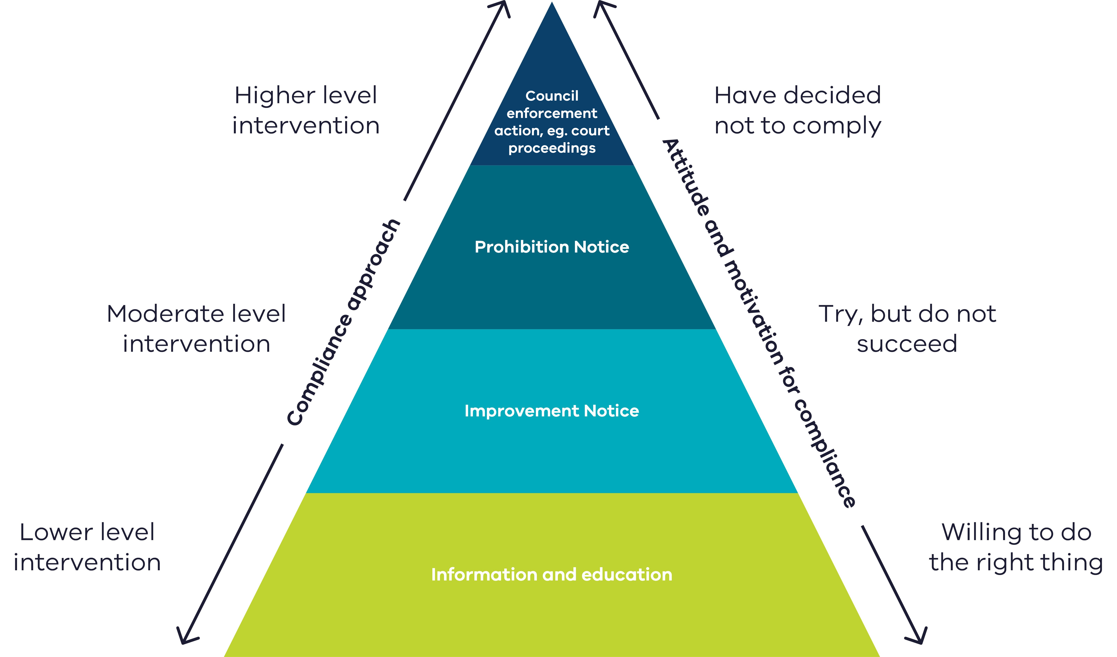
Figure 4: Compliance and enforcement approach to residential construction noise

Information and education
EPA guidance can be provided to builders or demolition companies to help them take reasonable steps to minimise noise from their activities. Refer to the guidance listed in Assessing residential construction noise.

Improvement and prohibition notices
To act on residential construction noise issues, AOs of the council can issue:
- an improvement notice (section 271 of the Act) to require actions to fix a problem, or
- a prohibition notice (section 272 of the Act) to stop an activity causing a problem.
An authorised officer of the council can issue these notices if they reasonable belief that the grounds for issuing those notices are satisfied. One ground for issuing these notices includes an alleged contravention of the Act or Regulations, including an alleged breach of either the GED or unreasonable noise (section 166).

Enforcement of improvement and prohibition notices
Where an improvement or prohibition is not complied with, council can act. Action can be taken by an employee of the council that has been appointed under section 347(7) of the Act to take proceedings in relation to delegated functions and powers.
A council employee with this appointment can:
- take proceedings for an alleged offence of non-compliance with an improvement notice (section 286) or prohibition notice (section 287). This includes an alleged failure to report as required by such a notice (section 288). This power comes from section 347 of the Act.
- issue an infringement notice for non-compliance with a reporting requirement of a notice (section 288). This power comes from sections 307(1) and (4) and 347(7) of the Act.
Note: Council cannot appoint a contractor or other non-employee to take proceedings. This limitation also extends to the power to issue an infringement notice for failure to comply with a reporting requirement in a notice. A council’s ability to engage the services of a legal practitioner to conduct proceedings on its behalf is not affected.
Read more:
- Appendix 10 Improvement notice
- Appendix 11 Prohibition notice
- Administering your powers under the Environment Protection Act 2017: Guide for local government and litter authorities’ (EPA publication 1993)

Review of improvement notices and prohibition notices
A person who has received an improvement notice or prohibition notice has the right to apply to EPA for a review of the notice under section 429 of the Act.
Review of an improvement notice or prohibition notice issued by council can only be performed by EPA under the Act. Notice recipients can apply to EPA for a review by calling 1300 372 842 (1300 EPA VIC). If council receives review applications by mistake, email them to EPA immediately at internalreviews@epa.vic.gov.au.

Providing issued notices to EPA
EPA requires councils to provide copies of all improvement and prohibition notices issued by the council. This is so that EPA has a copy of the notice in the case of an internal review request. Send to issued notices to council_issued_notices@epa.vic.gov.au.

Contact EPA
epa.vic.gov.au
Ph 1300 372 842 (1300 EPA VIC)
EPA Council Support SharePoint site – council officers can email jointregulator@epa.vic.gov.au to become a member and access resources.

Head office:  200 Victoria Street  Carlton 3053 | West Metro  Level 2, 12 Clarke Street  Sunshine 3020 | South West  West 1, 33 Mackey Street  North Geelong 3215
Southern Metro  Level 3, 14 Mason Street  Dandenong 3175 | North East  27–29 Faithfull Street  Wangaratta 3677 | Gippsland  8-12 Seymour St  Traralgon 3844
North Metro  Building One,  13a Albert Street  Preston 3072 | North West  Level 1, 47–51 Queen Street  Bendigo 3550

Appendix 1: Other residential premises
Residential premises don’t just include houses. There are other situations that may be considered residential premises. Councils, RNEOs and police have powers to act with regards to unreasonable noise from these other types of residential premises, including:
- organised care accommodation in a residential setting
- short-stay accommodation
- home-based businesses
- apartments

Who is responsible for unreasonable noise in these settings?
Section 167(1) of the Act applies to a person who emits unreasonable noise and a person who permits unreasonable noise to be emitted. This means it’s not only the person making the noise who has a responsibility under this law. For example, a rental provider may have caused or permitted unreasonable noise to be emitted if their property has a noisy air conditioner that they haven’t replaced or made quieter. This is relevant when considering noise from the types of residential premises discussed in this Appendix.

Organised care accommodation
Organised accommodation in a residential setting like residential care for children and young people in community-based houses and disability supported accommodation can be residential premises. The residential noise laws apply in these settings.
Institutions that are not primarily used for residential purposes such as hospitals, health and aged care facilities, respite care and boarding schools are not residential premises. Laws that apply to noise emitted from these premises are the:
- GED – unreasonable noise (non-residential premises) under section 166.
- Regulations – Part 5.3 Division 3 - Unreasonable and aggravated noise from commercial, industrial and trade premises.

Short-stay accommodation
Short stay accommodation can be residential premises if it’s in a residential setting, such as a private house or apartment. This doesn’t apply to premises that aren’t used primarily for residential purposes. For example, accommodation within public premises such as a hotel, motel or tourist establishment.
For short stay accommodation, the Act and the Regulations for residential noise apply to:
- the people staying at the accommodation
- the property owner, and
- any agent or property manager that lets the property.

Home-based business
Residential premises can include a home-based business. This means the residential noise laws apply to home-based businesses.
The Victoria Planning Provisions (VPPs) define a home-based business as an occupation carried on in a dwelling, or on land around a dwelling, by a resident of the dwelling (VPP 73.03 Land use terms). Clause 52.11 of the VPPs has requirements to ensure that the amenity of the neighbourhood is not adversely affected by a business conducted in or from a dwelling and considers amenity impacts including from vehicle parking, transporting material and goods and hours of operation.
Enforcing residential noise law under the Act is separate to any consideration of home-based business under the planning system. For home-based businesses, it’s recommended that the planning scheme be used in the first instance. This is because a decision to grant a planning permit for the business will consider whether the site is suitable for the particular home-based business or not. It will also consider whether it’s compatible with the surrounding use
and development.
If the scale of the operation doesn’t require a planning permit, any noise emission from the operation of the business at the residential property should be investigated as
residential noise.

Apartments
Buildings with multiple dwellings such as apartments are residential premises. But plant and equipment used by all apartments collectively and controlled by the building owners or owners’ corporation are not considered residential. Noise from these areas is assessed as commercial, industrial or trade noise under the Regulations. Such equipment includes car stackers, carpark roller doors, lift equipment and air conditioning or heating that services more than a single dwelling.
In addition, if buildings include commercial premises such as shops as well as apartments, only the parts of the land or building that are used for residential purposes are residential premises.

Appendix 2: Investigation flowchart
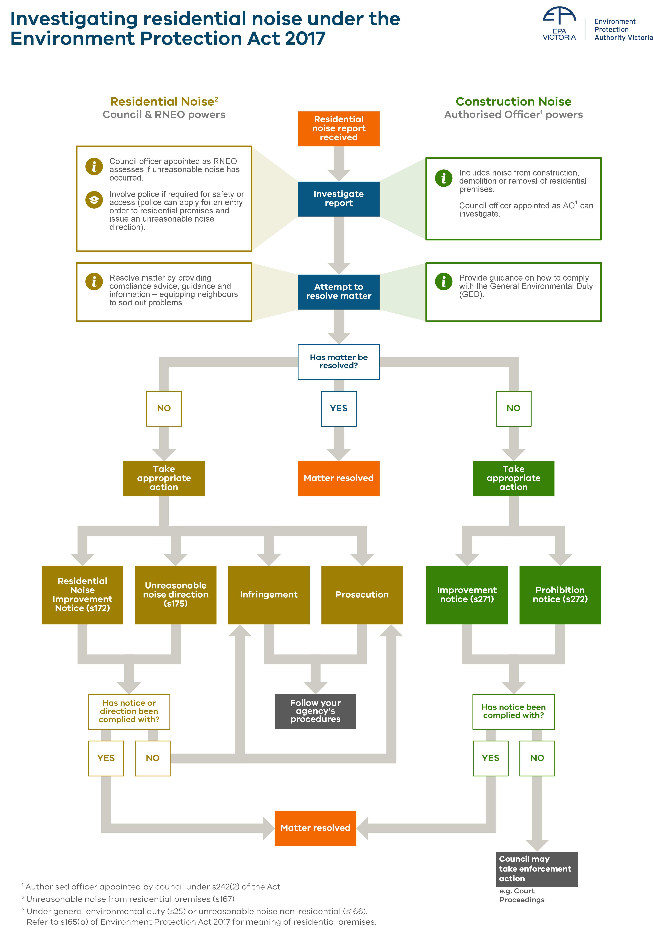
Figure 5: Investigating residential noise under the Act

Appendix 3: Residential noise improvement notice – section 172
About this notice | Residential noise improvement notices (section 172 of the Act) can be issued to address residential noise issues.  A residential noise improvement notice can require a person to take specified action and can remain in place for a specified period.  These factors make it a good tool to address recurring noise issues, by requiring changes to equipment or behaviour.  Examples:  - Noisy pool pumps or use of powers tools during prohibited hours.  - Playing persistent loud music, where the person has previously ignored warnings about their behaviour. This shows a clear risk that the person will or is contravening the Act.
Grounds for issuing the notice | A residential noise improvement notice can be issued to a person if the council reasonably believes that the person has or is likely to contravene:  - Part 7.6 of the Act (Control of unreasonable and aggravated noise), or  - the regulations relating to the emission of noise from residential premises.
Power to issue this notice | The Act gives the power to issue a residential noise improvement notice to councils. Councils will need to delegate this power to appropriate employees.
Who can receive this notice | A residential noise improvement notice can be issued to a person (meaning a natural person or body corporate) who the council reasonably believes has or is likely to contravene Part 7.6 or the regulations relating to the emission of noise from residential premises.
What the notice can requires a person to do | A residential noise improvement notice may require the person to:  - abate (decrease or stop) the noise; or  - do any other thing that the council reasonably considers necessary to prevent or minimise the noise.  Examples of requirements are not running the air conditioning at night, replacing an old air conditioner or relocating it.  A requirement may be expressed to be general or limited in operation as to particular times, places or circumstances (section 172(3)).  For example, a notice may require the person to stop the activity that emits the noise. It may also specifically require the person to reduce the noise level from an item of equipment by a certain amount in decibels.
Information that must be included in the notice | A residential improvement notice must:  - specify the name and address of the person to whom it is issued  - state the grounds on which the notice is issued  - specify the actions that the person must take to comply with the notice  - specify the period within which the person must comply with the notice  - set out the penalty for failing to comply with the notice, and  - specify how the person may apply to VACT for review of the decision to issue the notice.  Use the template provided by EPA. Email jointregulator@epa.vic.gov.au for templates.
Issuing the notice | Use the template provided by EPA.  Notices under the Act can be issued by:  - email  - in person  - mail  - or by leaving it at the usual or last known address.  For more information refer to section 344 of the Act – Service of documents.
Setting the time period to comply | The time period within which the person must comply with the notice must be stated in the notice. The delegated council officer will decide what is a reasonable time period to comply. The time period can also be extended by the council.
Revoking or amending a notice | By serving a written notice of amendment, the council can:  - extend the time period that the person has to comply with the notice, or  - revoke or amend any requirements in the notice.
VCAT review | A person served with a residential noise improvement notice can apply to the Victorian Civil and Administrative Tribunal (VCAT) for a review of the decision to issue the notice.
Consequences for not complying with the notice | If a person doesn’t comply with a residential noise improvement notice, an RNEO can:  - serve an infringement notice  - initiate court proceedings  The penalties that apply are listed in the Residential noise offences and powers section.

Appendix 4: Unreasonable noise direction – section 175
About this direction | An RNEO or a police officer can give an unreasonable noise direction (section 175 of the Act) if they reasonably suspect an offence against s167(1) has occurred (emit or permit unreasonable noise to be emitted).  An unreasonable noise direction can stay in place for up to 72 hours. This enforcement tool can be used by RNEOs or police officers on-the-spot, to compel a person to stop the noise immediately. It’s often the next step when compliance advice alone hasn’t been successful.
Power to give a direction | An unreasonable noise direction (section 175 of the Act) can be given by a RNEO or police officer.
Who can receive a direction? | An unreasonable noise direction can be given to either:  - a person who has committed an offence against section 167(1), or  - someone apparently in charge of residential premises on which an offence against section 167(1) is suspected of being committed. For example, this might apply to an adult in a household where unreasonable noise is being made by minors.
What a direction can require a person to do | A person can be directed to take action that a RNEO or police officer considers necessary to stop or prevent unreasonable noise from recurring.
Giving a direction | Section 175 doesn’t specify how the direction must be given, however if given verbally, it’s good practice to follow up with a written direction.  Take notes or make a report to record the action you have taken.
Consequences for not complying with a direction | If a person doesn’t comply with an unreasonable noise direction, a RNEO or a police officer can:  - serve an infringement notice  - initiate court proceedings.  The penalties that apply are listed in Table 1: Residential noise laws and penalties.

Appendix 5: Entry orders for residential noise – section 176
About entry orders | If no other measures to stop unreasonable noise from residential premises have been effective, under section 176 of the Act, a court officer can make an order enabling a police officer to enter residential premises.
Police officer can apply for an entry order | A police officer of or above the rank of senior constable can apply for an entry order. The police officer must reasonably believe no other measure would be effective to stop the noise.  While councils can’t apply for an entry order themselves, RNEOs may choose to request assistance from police to gain entry to residential premises. They may do this if they’re dealing with a noise issue where the impact on other people is significant and the offender is being unresponsive or uncooperative.
What an entry order allows a police officer to do | If an entry order has been made, a police officer can:  - use such force as is reasonably necessary to gain entry to any residential premises from which unreasonable noise is being emitted to investigate the noise  - give any direction under section 175(2) that they believe is necessary to abate the noise.
Obstructing a police officer | Obstruction of a police officer while they’re taking action under an entry order made under section 176, is an offence (section 177 of the Act). A person must not:  - hinder, delay or obstruct a police officer, or  - if the person is the occupier of any place or premises, refuse to permit a police officer to take any action they are authorised to take under the entry order.  A police officer can initiate court proceedings for an offence under section 177.  The penalties that apply are listed in Table 1: Residential noise laws and penalties

Appendix 6: Infringement notices
About infringement notices | An Infringement notice is a notice served for an alleged offence against the law (an 'infringement offence”), in accordance with the requirements under the Infringements Act 2006. An infringement notice may impose a financial amount (the “infringement penalty”), the payment of which may otherwise expiate an alleged offence.  This allows certain offences (known as ‘infringement offences’) to be dealt with through payment of the infringement penalty, rather than through court proceedings. (The recipient of an infringement notice however may elect to have the alleged offence referred to be heard and determined in Court). The value of the infringement penalty is expressed in ‘penalty units’.  Official warnings  Under section 8 of the Infringements Act, any issuing officer may serve an official warning rather than an infringement notice, if they consider it appropriate.
Infringement notices for residential noise offences | The offences under the Act and Regulations that have an infringement penalty associated with them are listed in Schedule 10 to the Regulations.  Infringement offences related to residential noise  RNEOs and police officers have powers to issue infringement notices for residential noise offences. These powers come from section 307 of the Act.  Residential noise infringement offences include:  - section 167(1) – person must not emit or permit unreasonable noise from residential premises (RNEO or police officer may issue)  - section 172(6) – Person issued with a residential noise improvement notice must comply with the notice (only an RNEO can issue)  - section 175(4) – Person must comply with an unreasonable noise direction (RNEO or police officer may issue)  Infringement offence related to improvement & prohibition notices (residential construction noise issues)  A council employee appointed under section 347(7) of the Act to take proceedings in relation to delegated functions and powers, may issue an infringement notice for an offence against section 288 of the Act– Failure to comply with a reporting requirement of an improvement or prohibition notice.  This power comes from sections 307(1) and (4) and 347(7) and of the Act.
Who may receive an infringement notice | - An infringement notice can be served to a person believed to have committed an infringement offence. For residential noise infringement offences, this may be the person responsible for unreasonable noise, and/or who fails to comply with a notice or direction. It’s important that RNEOs are familiar with the elements of each infringement offence.  - The recipient of an improvement or prohibition notice may be issued an infringement notice for breach of s288.
Issuing infringement notices | - Councils follow their own processes for serving infringement notices. EPA does not need to approve the infringement notice format used, however it must comply with the requirements in the Infringements Act 2006 and associated Regulations.  - Notices under the Act may be served by email, postal mail, leaving it at the usual or last known address, or in person. Refer to section 344, Service of documents.
How can an infringement be disputed? | Under the Infringements Act 2006, recipients of an infringement notice may apply to have their infringement reviewed by the enforcement agency that issued it. Applications for a review must be made within 14 days of the applicant becoming aware of the infringement notice (section 64(c) of the Infringements Act 2006).
What happens if the person doesn’t pay the infringement? | Councils have three options:  - Unpaid infringements may be referred to Fines Victoria who, for a fee, will pursue the recipient of the infringement to recoup the debt.  - The infringement may be withdrawn, with the offence then pursued through the Magistrates Court.
Penalty units | A penalty unit is a monetary amount that is fixed for a financial year by the Treasurer in line with CPI and is adjusted annually by the Department of Treasury and Finance.  Offences under the Act and Regulations list the maximum number of penalty units that can be imposed by a court. The infringement offences listed in Schedule 10 of the Regulations, list the applicable penalty units for the infringement offence.  Penalty units for both natural persons and body corporates are listed. Penalty units for body corporates are five times higher.

Appendix 7: Prosecution
About prosecution | A prosecution is a criminal proceeding, initiated in a Court of relevant jurisdiction, against a person alleged to have committed an offence against the law.  Residential noise related offences under the Act and Regulations are summary offences that are considered less serious and have lower penalties than indictable criminal offences. Summary offences are heard in the Magistrates’ Court.  The maximum penalties that a court can apply to residential noise offences are listed in Table 1: Residential noise laws and penalties.
Power to initiate court proceedings for residential noise offences | Proceedings for residential noise offences  RNEOs and police officers can take proceedings for certain residential noise offences. This power comes from section 170 of the Act.  Note that for an offence under 167(1) – unreasonable noise from residential premises – proceedings can also be initiated by a person claiming to be directly affected the by alleged offence. For example, the neighbour of a person emitting unreasonable noise.  Proceedings for offences relating to improvement and prohibition notices  A council employee appointed under section 347(7) of the Act to take proceedings in relation to delegated functions and powers may take proceedings for offences relating to improvement notices and prohibition notices issued by an AO of the council for residential construction noise issues.
Court timeframes | Criminal proceedings for an alleged summary offence must be commenced (via filing and service of charges against the accused), within 12 months after the commission of the alleged offence. For further details see the Criminal Procedure Act 2009.

Appendix 8: Injunction relating to residential noise – section 174
About injunctions | Injunctions relating to residential noise (s174 of the Act) can be granted by a Court (defined in the Act as either a Magistrates’ Court, County Court or Supreme Court), where a person has engaged or is proposing to engage in conduct that is a breach of any provision relating to residential noise under the Act or Regulations.  An injunction is a Court order directing a person to do a specific thing or, more commonly, to not do a specific thing.
Who can apply for an injunction? | Council or a police officer can apply to the Court for an injunction.  An application can be made for an injunction even if court proceedings have already been initiated for a residential noise offence under the Act or Regulations, for example by the council.
What an injunction can require a person to do | An injunction can:  - restrain a person from engaging in specified conduct that the Court reasonably considers to be the source of, or contributing to, the emission of noise, or  - require a person to do a specified act or thing that the Court considers reasonably necessary to prevent, minimise or remedy the contravention.
Consequences for not complying | A person who doesn’t comply with an injunction from a Court, may be held in contempt of court. This can result in the person being imprisoned.  The council or police would need to bring proceedings for contempt of court if the injunction is not complied with.

Appendix 9: Council authorised officer powers
Where EPA has delegated some of its functions and powers to council, the Act allows councils to appoint a person as an authorised officers (AO) under section 242(2) or (2A) of the Act.
Council AOs have a limited set of AO powers that can be used to investigate residential construction noise issues.
Note: In this table ‘AO’ means a person appointed by a council as an AO under s242(2) or (2A) of the Act.
Part 9.2 Appointment of AOs |  |  | Description
242(2)  242(2A) |  | Council may appoint a person as an AO | Where EPA has delegated powers or functions to council, council may appoint an employee, or a specified person, as an AO. This appointment relates to the purpose of the functions or powers delegated to the council. This includes regulating onsite wastewater management systems.
243 |  | AO identity cards | Council must issue an identity card to each person it appoints as an AO.  AO must show their card when asked to do so when performing a function or exercising a power under the Act.
Part 9.3 Inspection and inquiry powers |  |  | Description
246  247 | AO may enter and inspect any place or premises  Entry and inspection of a place or premises when open to the public |  | When can an AO enter and inspect?  For the purpose of performing a function or duty, or exercising a power under the Act, an AO may enter and inspect a place or premises for the following purposes:  - determining if a person has contravened the Act or Regulations  - monitoring compliance with the Act or Regulations  - determining if there is a risk of harm to human health or the environment from pollution, waste or contaminated land  - inspecting or testing equipment or a vehicle.  AOs may enter and inspect a place or premises at any reasonable time, including when open to the public.  In circumstances where they believe there’s an immediate risk of material harm to human health or the environment, they may enter at any​ other time.  What is material harm?  Section 5 of the Act defines material harm​, in relation to human health or the environment, as harm ​that is caused by pollution or waste that:  - involves an actual adverse effect on human health or the environment that’s not negligible; or  - involves an actual adverse effect on an area of high conservation value or of special significance; or  - results in, or is likely to result in, costs in excess of $10,000​ (or a higher amount prescribed by the Regulations) being incurred in order to take appropriate action to prevent or minimise the harm or to rehabilitate or restore the environment to the state it was in before the harm.  Any one of the​ above ​may satisfy the definition of ‘material harm’.
248 | Residential premises |  | Restrictions on entry to residential premises  AOs must not enter and inspect premises that are used ​only for residential purposes ​except:  - with the consent of the occupier ​for the time being of the premises; or  - ​if the AO reasonably believe​s that a person has contravened, is contravening or is about to contravene, the Act or Regulations; or  - ​if the AO reasonably believe​s there’s an immediate risk of material harm to human health or the environment.  In the circumstances in the last two dot points above, an AO may only enter ​and inspect in a part of the premises that the council AO believes is necessary for the purposes of determining if:  - a person has contravened, is contravening or is about to contravene the Act or Regulations; or  - ​if there is an immediate risk of material harm to human health or the environment.  Limitation on council AO powers (search warrant)  Council AOs are limited from applying for a search warrant from a magistrate (section 261 of the Act). This limitation means that section 248(1)(b) does not apply to council AOs. This limitation is set out in a direction in respect to the delegation to councils.
249 | Announcement on entry |  | Immediately on entering a place or premises, AOs must take all reasonable steps to notify the occupier or apparent occupier and show their identity card.  The AO is not required to do this if it would unreasonably interfere with performing a function or duty or exercising a power under the Act or cause unreasonable delay, or if the person has been notified in advance.
250 | Person(s) assisting AO |  | An AO may request the assistance of any person for the purpose of entry and inspection. For example, another council officer, police officer or interpreter.  The occupier of person in management or control must allow the person assisting the AO access.
251 except 251(2)(h) | Powers on entry |  | What can a council AO do during an inspection?  An AO may do anything they reasonably believe is necessary to perform a function or duty or exercise a power under the Act. This may include (but is not limited to):  - inspecting, examining and making enquiries  - take and remove samples of a substance or thing  - carrying out testing and examination  - taking photographic, audio, video or any other type of recording  - examine, copy or take extracts from a document  - inspect, examine or test any plant, equipment, vehicle or other thing  - bring equipment or materials to the place or premises  - request the assistance of any person at the place or premises  - take any other action.  An AO may carry out or cause to be carried out, any testing or examination or a thing, including testing of a thing that results in the destruction of that thing.  Council AOs must take all reasonable steps to minimise any disruption caused by their entry and not remain at the premises longer than reasonably necessary.  Limitation on council AO powers (seizure)  Council AOs are limited from using the power under section 251(2)(h) of the Act- that means they cannot seize and remove a thing connected with a suspected contravention. This limitation is set out in a direction in respect to the delegation to councils.
252 except s252(1)(c) | AO may require production of documents |  | During an inspection, a council AO may require documents necessary for the purpose of their investigation. They may also examine or make copies of documents.  Limitation on council AO powers (retaining documents)  Council AOs are limited from using the power under section 252(1)(c) of the Act- that means they cannot retain a document or part of a document. This limitation is set out in a direction in respect to the delegation to councils.
253 | AO may require information or answers |  | An AO who enters a place of premises may require information or answers from a person at the place or premises for the purpose of performing a function or duty or exercising a power under the Act.  An AO must only require information or answers if they reasonably believe that the person has knowledge of a matter or thing relevant to another person’s compliance with the Act or Regulations.  Note that section 268 of the Act provides protection against self-incrimination with regards to powers under Part 9.3. This means that if providing information would incriminate the person, they may have a reasonable excuse not to provide the information. This excuse doesn’t apply to producing documents and only applies to individuals, not companies.
254 | Report to be given about entry and inspection of place or premises |  | Entry report  If a council AO has used their powers of entry and inspection, they must give the occupier or apparent occupier a written report about the entry to the premises, when they leave the premises, or as soon as possible after the AO leaves the place or premises.  The report must be in writing and include:  - the time of the entry and departure  - the purpose of the entry and inspection  - a description of any actions taken at the place or premises  - a summary of any observations of the AO at the place or premises  - the procedure for contacting the AO for further details of the entry and inspection.  Note: the report may be emailed, given in person, mailed or left at the usual or last known residential address (with a person apparently at least 16 years old) - section 344 of the Act - Service of documents.
259 | AO may ask for a person’s name and address |  | An AO may ask a person to state their name and address if they reasonably believe the person has:  - committed, are committing or are about to commit an indictable offence against the Act; or  - they think the person can help them with their investigation of an indictable offence.  The AO must inform the person of their reasonable beliefs. If the person is suspected of committing an offence, the AO must give the person sufficient information to understand the nature of the offence.  For offences relating to OWMS, this power could only be used by council AOs investigating indictable offences including:  - failure to obtain a permit  - breach of a permit condition  - breach of the general environmental duty  - breach of compliance with an improvement or prohibition notice issued by the council AO.
Part 10.2 Improvement and prohibition notices |  |  | Description
271 | Improvement notice (issue) |  | An AO may issue an improvement notice.  Refer to Appendix 8.
272 | Prohibition notice (issue) |  | An AO may issue a prohibition notice.  Refer to Appendix 8.
279 | Amendment of notices |  | An AO may amend an improvement notice or prohibition notice. This includes extending the period which the person has to comply with the notice or revoking or amending any requirement in the notice.  Refer to Appendix 8.

Appendix 10: Improvement notice – section 271
About this notice | An improvement notice (section 271 of the Act) can require a person to take action to remedy a non-compliance with the Act or Regulations.  This can include non-compliance with the GED or section 166 (unreasonable noise – non-residential premises) in relation to residential construction noise.
Grounds for issuing this notice | An AO of the council can issue an improvement notice for residential construction noise if they have reasonable belief a person is:  - contravening the Act or Regulations  - engaging in/proposing to engage in an activity that has caused or is likely to cause harm to human health or the environment from pollution or waste.  Improvement notices do not require harm to have occurred and can be issued during an inspection to address inadequately controlled risks observed onsite.
Power to issue this notice | This notice can be issued by an AO of the council appointed under s242(2) or (2A) of the Act, in relation to residential construction noise issues.
Who may receive this notice | An improvement notice can be issued to the person (meaning natural person, body corporate or company) who the council AO believes has:  - contravened the Act or Regulations, or  - has caused harm to human health or the environment.  In many cases, improvement notices will be issued to the person, meaning the natural person or body corporate/company, conducting the relevant activity.
What this notice can require a person to do? | An improvement notice can require a person (meaning natural person, body corporate or company), to take any action that an AO reasonably considers necessary to remedy a non-compliance.  Alternatively, it can be used to require that the recipient remedy the activity that has caused or is likely to cause harm to human health or the environment from pollution or waste.
Information this notice must include | Section 271(4) requires that an improvement notice must:  - specify the name and address of the person to whom it is issued  - state the grounds on which the notice is issued  - specify the actions that the person must take to comply with the notice  - specify the period within which the person must comply with the notice  - set out the penalty for failing to comply with the notice, and  - specify how the person may seek review of the decision to issue the notice.  Use the template provided by EPA. Email jointregulator@epa.vic.gov.au for templates.
Serving the notice | Notices under the Act can be issued by email, in person, postal mail, or by leaving it at the usual or last known residential address (with a person apparently at least 16 years old).  For more information refer to section 344 of the Act - Service of documents.
Setting the timeframe to comply | The date by which the person must comply with the notice must be stated in the notice. The council AO preparing the notice will specify a reasonable length of time for which to comply. A notice recipient may seek review of, or amendment to the notice, including specified time frames, under the Act (see section 429 of the Act).
Revoked and amending this notice | By serving a written notice of amendment under section 279 of the Act, the council AO may:  - extend the period of time the person has to comply with the notice  - revoke or amend any requirements in the notice.
EPA review | A person who is issued an improvement notice from a council AO may apply to EPA to have the decision to issue the notice reviewed - Section 429 of the Act.  Applications to EPA must be made within 10 business days (after the day the notice is served).  Notice recipients can request a review by calling EPA on 1300 372 842 (1300 EPA VIC).  If council receives review applications by mistake, email them to EPA immediately at internalreviews@epa.vic.gov.au
VCAT review | If the review process by EPA is completed but the notice recipient still seeks further review, they may apply to the Victorian Civil and Administrative Tribunal (VCAT) for a review of the decision to issue the notice (section 430 and 431 of the Act).  Applications for VCAT review must be made by the notice recipient within 15 days of EPA making its review decision under section 429. An applicant must seek review by EPA under section 429 the Act before seeking VCAT review of the decision (see section 431(2) of the Act).
Consequences for not complying with this notice | Section 286 of the Act provides that a person to whom an improvement notice is issued must not, without reasonable excuse, fail to comply with that notice. Criminal or civil proceedings may be initiated for failure to comply with section 286.  Section 288 of the Act provides that a person must not fail to comply with a reporting requirement in an improvement notice.
Enforcing improvement notices | An employee of the council appointed under section 347(7) of the Act may:  - take proceedings for an offence against sections 286 or 288 of the Act  - issue an infringement notice for an offence against section 288 of the Act

Appendix 11: Prohibition notice – section 272
About this notice | A prohibition notice (section 272 of the Act) requires a person to stop an activity that contravenes the Act or Regulations and involves an immediate risk of harm.  This can include non-compliance with the GED or section 166 (unreasonable noise – non-residential premises) in relation to residential construction noise.  Prohibition notices may come into immediate effect and may be followed by an improvement notice to address ongoing residential construction noise issues.
Grounds for issuing this notice | An AO of the council may issue a person with a prohibition notice for residential construction noise issues if the AO reasonably believes that the person:  - is contravening or has contravened the Act or Regulations, or  - has engaged in or proposes to engage in an activity that has caused or is likely to cause harm to human health or the environment from pollution or waste.  AND  there is regard to the immediacy of risk and degree of harm that could occur, so that stopping an activity quickly is necessary.  The notice must state the grounds on which it is issued.
Power to issue this notice | A prohibition notice may be issued by an AO of the council appointed under section 242(2) or (2A) of the Act, in relation to residential construction noise issues.
Who may receive this notice | A prohibition notice can be issued to the person (meaning natural person, body corporate or company) who the council AO believes has:  - contravened the Act or Regulations, or  - has caused harm to human health or the environment.  In many cases, improvement notices will be issued to the person, meaning the natural person or body corporate/company, conducting the relevant activity.
What this notice can require a person to do | The notice may prohibit the activity and may also require any other thing the AO reasonably considers necessary to prevent or minimise harm or risk of harm.
Information the notice must include | s272(3) requires that an improvement notice must:  - specify the name and address of the person to whom it is issued  - state the grounds on which the notice is issued  - specify the actions that the person must take to comply with the notice  - specify the date from which the prohibition takes effect and the period within which the person must do any other thing required by the notice  - set out the penalty for failing to comply with the notice, and  - specify how the person may seek review of the decision to issue the notice.  Use the template provided by EPA. Email jointregulator@epa.vic.gov.au for templates.
Issuing the notice | Notices under the Act can be issued by:  - email  - in person  - postal mail  - by leaving it at the usual or last known residential address (with a person apparently at least 16 years old).  For more information refer to Section 344 of the Act - Service of documents.
Setting the timeframe to comply | The notice must specify the date from which the prohibition takes effect and the time period for compliance with the notice. A notice recipient may seek review of, or amendment to the notice, including specified time frames, under the Act (see section 429 of the Act).
Revoked and amending this notice | By serving a written notice of amendment under section 279 of the Act, the AO can:  - extend the time period that the notice is in effect, or  - revoke or amend any requirements in the notice.
EPA review | A person who is issued a prohibition notice from an AO (including a council AO) may apply to EPA to have the decision to issue the notice reviewed (section 429 of the Act).  Applications to EPA must be made within 10 business days (after the day the notice is served).  A recipient is entitled to apply to the Authority for a stay of the decision to issue the notice, pending the outcome of any application for internal review under the Act (see section 429 of the Act).  Notice recipients can request a review by calling EPA on 1300 372 842 (1300 EPA VIC).  If council receives review applications by mistake, email them to EPA immediately at internalreviews@epa.vic.gov.au.
VCAT review | If the review process by EPA is completed but the notice recipient still seeks further review, they may apply to the Victorian Civil and Administrative Tribunal (VCAT) for a review of the decision to issue the notice (section 430 and 431 of the Act).  Applications for VCAT review must be made by the notice recipient within 15 days of EPA making its review decision under section 429. An applicant must seek review by EPA under section 429 the Act before seeking VCAT review of the decision (see section 431(2) of the Act).
Consequences for not complying with this notice | Section 287 of the Act provides that a person to whom an improvement notice is issued must not, without reasonable excuse, fail to comply with that notice Criminal or civil proceedings may be initiated for failure to comply.  Section 288 of the Act provides that a person must not fail to comply with a reporting requirement in prohibition notice.
Enforcing a prohibition notice | An employee of the council appointed under section 347(7) of the Act may:  - take proceedings for an offence against sections 287 or 288 of the Act  - issue an infringement notice for an offence against section 288 of the Act

Accessibility
Contact us if you need this information in an accessible format such as large print or audio.
Please telephone 1300 372 842 or email contact@epa.vic.gov.au

Interpreter assistance
If you need interpreter assistance or want this document translated, please call 131 450 and advise your preferred language. If you are deaf, or have a hearing or speech impairment, contact us through the National Relay Service.
epa.vic.gov.au
Environment Protection Authority Victoria
GPO BOX 4395 Melbourne VIC 3001
1300 372 842

Limitations of council AO powers are set out in the 'Direction in respect of functions delegated to councils by Delegation Reference 2021.Council.001’.

