Illegal Waste Dumping

What materials are commonly dumped?
We have all seen dumped waste. Some types of illegal dumping are easier to recognise than others.

Hiding in plain sight
The two most common types of waste reported to us are household waste (19% of all waste reports) and liquid waste (17%). Whitegoods and furniture stand out when they’re tossed. Likewise, businesses pumping waste where they shouldn’t is not easy to conceal.
Waste reports lodged with EPA during the 2021-2022 financial year
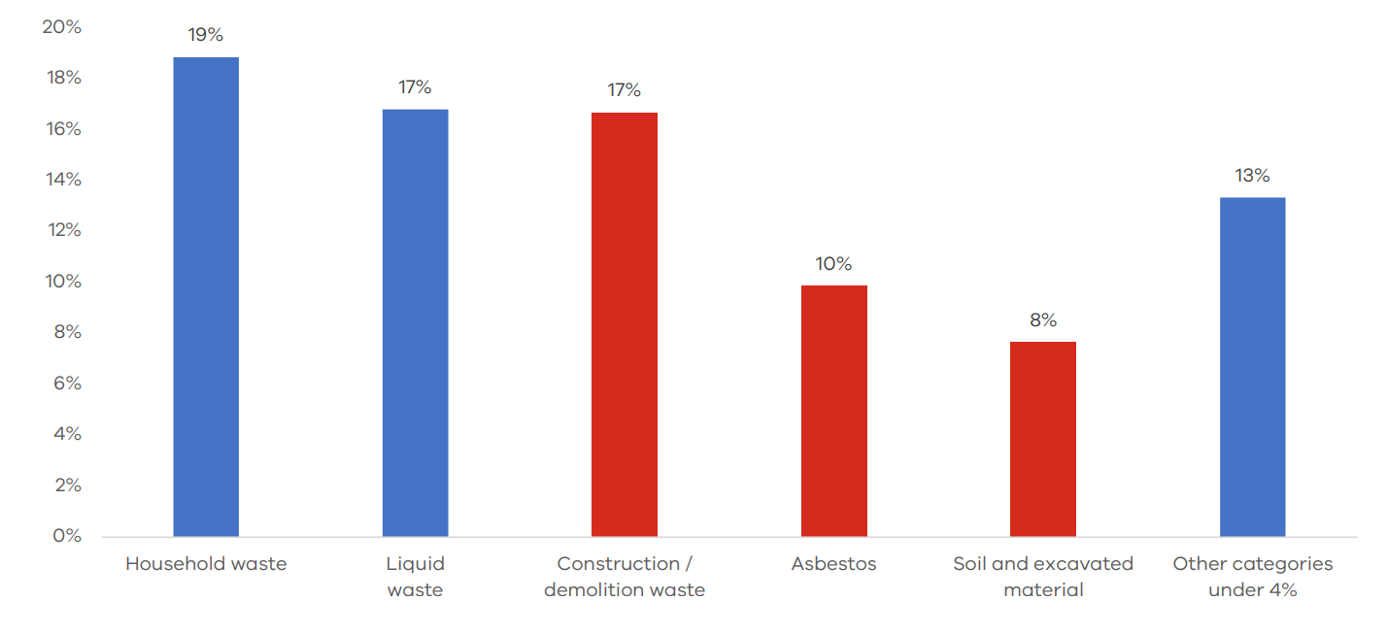
It is the next 3 categories that can be more difficult to recognise. Construction waste is often dumped on blank lots or other construction sites. Asbestos can be in sheets, blocks or present in a wide range of products. A pile of soil in a park may not seem out of place until testing shows that it is contaminated.
While often harder to spot, these materials are dangerous for our community and difficult to remove from our environment.
Dumped tyres and batteries are less-often reported. Both are major fire risks that can contaminate our environment with toxic chemicals.
If something looks out of place, report it to us online or by calling 1300 372 842.

Are things getting worse?
It is difficult to determine if there are more cases of illegal waste dumping now than in years’ past. What we do know is that:
- Victorians are increasingly reporting environmental crime, and
- Our ability to track hazardous waste is better than it has ever been before.
Waste reports to us increased 14% in 2020-21 and another 8% in 2021-22. These increases are likely to be linked to Victorians working from home and witnessing more cases of waste crime each year. For comparison, noise reports more than doubled in 2020-21 and increased by another 21% in 2021-22.
With more reports coming in:
- Our officers have more data to link crimes and identify perpetrators
- Our understanding of trends in waste crime improves.
Each illegal dumping report we receive contributes to our response to waste crime. Our goal is always to prevent harm from pollution and waste.
Report illegal waste dumping online or by calling 1300 372 842.

