Publication 1756.1* December 2020
* This replaces 1756 issued September 2019
Contents
About this summary 2
Definitions 2
Overview of the new laws 3
Waste in Victoria 3
The Environment Protection Amendment Act 2018 3
General environmental duty 3
The new environment protection framework 3
Proposed waste Regulations 4
Waste types and duties 5
Waste classification 6
What is waste classification? 6
Priority waste category 7
Designation 7
Mixing, blending or diluting priority waste 8
Accredited consigners 8
Transport 8
Waste tracking 8
Transport permissions 8
Lawful place 9
Permissions 9
Permission exemption 10
Emergency authorisation 10
Determinations 10
Declaration of Use 11
Other Regulations for meeting lawful place requirements 12
Sections of the EP Act and the Regulations relating to waste 13
Next steps 14

About this summary
This summary explains the waste framework in the proposed Environment Protection Regulations. For more information about what is in these proposed Regulations, please see the Guide to the proposed Environment Protection Regulations (publication 1753).

Definitions
Accredited consignor: a person, authorised by EPA, to undertake waste duties on the waste producer’s behalf.
Designation: a legal instrument that enables EPA to classify or categorise a new or existing waste, or to authorise the mixing, blending or diluting of waste.
Determination: a legal instrument that allows EPA to set standards for waste to be lawfully received.
Duty holder: any person or group of people that has duties and obligations under the EP Act.
EPA-set Declaration of Use (DoU): an EPA-set standard, which authorises the receipt of waste for certain safe uses. EPA sets conditions or limitations and the waste receiver declares that the place or premises is suitable to receive that waste.
Industry-set Declaration of Use (DoU): an industry-set agreement between the waste generator and receiver, to describe any potential harms or handling requirements for the safe use of the waste and declare that the place or premises is suitable to receive that waste.
Lawful place: a place that is lawfully authorised to receive industrial waste. A lawful place will require an EPA permission or a Declaration of Use or receipt of the waste as authorised under a Determination or Regulation 63 of the Regulations.
Priority waste category: priority waste destined for landfill and contaminated soils can fall into one of six categories: Category A-D, soil containing asbestos only and packaged waste asbestos. They are based on their hazard characteristics and type of contamination. These categories inform appropriate management and disposal. Sometimes the process of determining a category is called categorisation, but it is part of waste classification.
Waste classification: the process of identifying and describing industrial waste by waste code and waste type (industrial, priority or reportable priority waste), based on its hazard level and potential for mismanagement. Also includes determining the priority waste category.
Waste code: a code that is applied to waste for the purpose of identification and management.

Overview of the new laws

Waste in Victoria
Managing waste is a complex and challenging task. Waste can cause great harm to human health and the environment. A high level of technical knowledge is often required to understand it. Poor waste management also comes at a great financial cost. It is estimated that Victoria spends $193 million every year on:
- stockpile fires
- clean up of abandoned waste
- illegal waste sites
- lost revenue.
Waste is a complex area with many risks – so it is important to have effective Regulations to prevent harm and support safe waste management.

The Environment Protection Amendment Act 2018
The Environment Protection Amendment Act 2018 (EP Act) is intended to come into effect on 1 July 2021. The new EP Act introduces a new approach to environmental issues for Victoria, focusing on preventing waste and pollution impacts rather than managing those impacts after they have occurred. For an overview of the new EP Act, see Factsheet: Environment Protection Amendment Act 2018
The new legislation will enhance the protection of Victoria’s environment and human health through a proportionate, risk-based environment protection framework.

General environmental duty
The cornerstone of the new EP Act is the general environmental duty (GED). The GED requires Victorians to understand and minimise their risks of harm to human health and the environment from pollution and waste. For more information, see Industry guidance: supporting you to comply with the general environmental duty (publication 1741).

The new environment protection framework
A suite of subordinate instruments and guidance will be made under the new EP Act as part of the new environment protection framework (Figure 1). These include: ​
- Regulations - set out how to fulfil duties and obligations, and particular processes that support the proposed EP Act.
- Environment reference standard (ERS) - articulate community expectations about the state of the environment, providing a basis for assessing and reporting on environmental conditions.
- Orders - provide further prescription as to the duties and obligations.
- Compliance Codes - provide practical guidance to duty holders on how to comply with their duties or obligations.
- Non-statutory guidance - support industry to understand their environmental obligations with a preventative focus and assist industry to manage their risks.
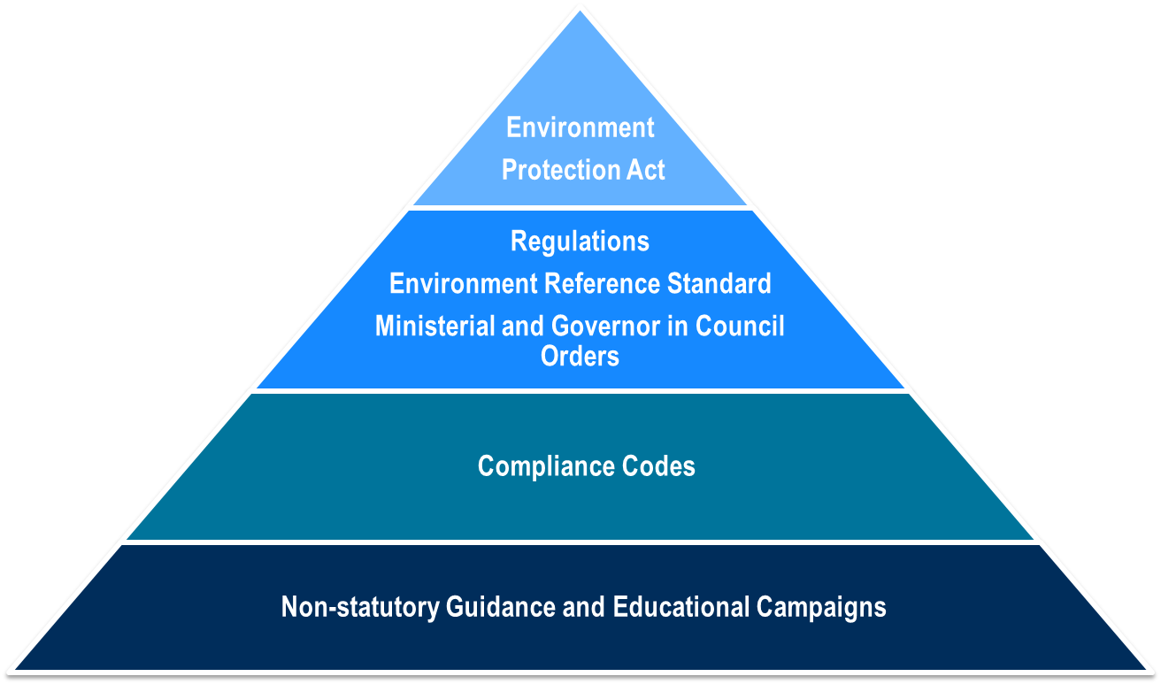
Figure 1: The new environment protection framework
​

Proposed waste Regulations
The proposed waste Regulations set out how the duties in the new EP Act are to be met by duty holders. They add to the new EP Act and convert these duties into actions to follow.
The aims of the proposed waste Regulations are to:
- manage risks to human health and the environment
- support and encourage waste resource recovery and reuse.
The three steps for a duty holder to manage industrial waste under the EP Act and the proposed Regulations are:
- Classification: properly identify and classify it so that it is clear what duties apply to the waste and how to manage it.
- Transportation: provide sufficient information about the waste to the transporter. Priority waste has further containment and isolation requirements. Reportable priority waste has a transaction control, where each time the waste changes hands, EPA must be informed through the electronic waste tracker
- Lawful place: ensure that industrial waste only goes somewhere with lawful authority to receive it, through a permission, Declaration of Use, Determination or is authorised under Regulation 63 of the Regulations.
These three steps assist with compliance with the GED (Figure 2).
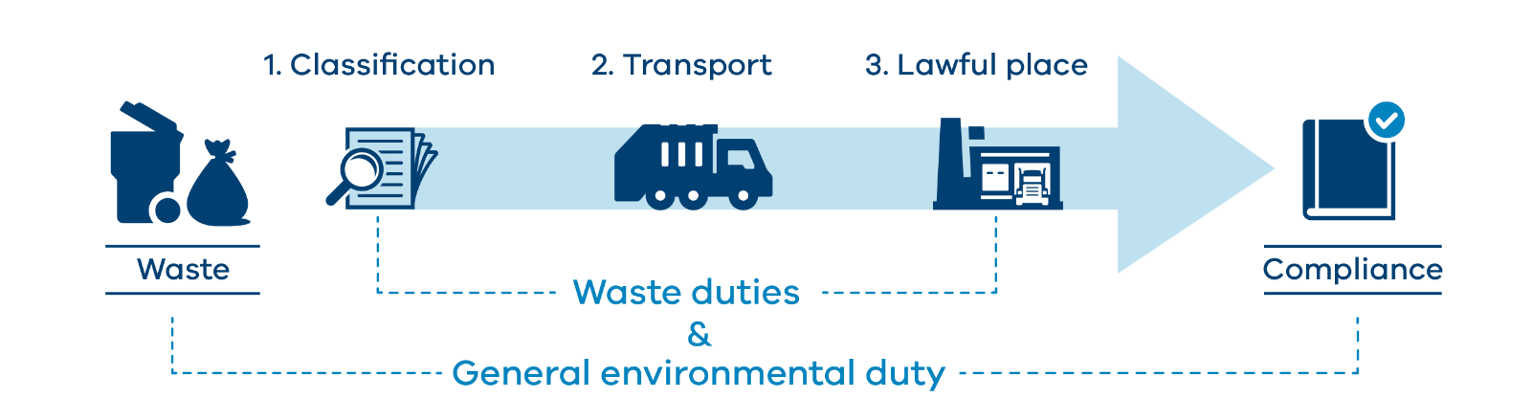
Figure 2: Overview of the waste framework

Waste types and duties
There are three different waste types (Figure 3):
- Industrial waste - waste arising from commercial, industrial, trade activities or from laboratories; or that has been prescribed as industrial waste.
- Priority waste - any municipal and industrial waste, that is prescribed to be priority waste for the purposes of:
  - eliminating or reducing risks of harm to human health or the environment
  - ensuring the waste is managed in accordance with the duties
  - facilitating waste reduction, resource recovery and resource efficiency.
- Reportable priority waste - a subset of priority waste that carries the highest levels of controls. It poses the greatest level of risk to human health and the environment.

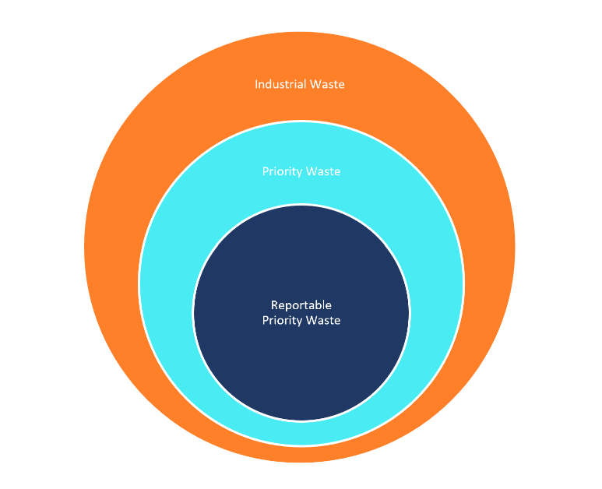
Figure 3: The three types of waste

Each waste type has duties and controls that apply to that type of waste (Figure 4). The duties and controls associated with these waste types accumulate. For example, reportable priority waste must be managed in accordance with the industrial, priority and applicable reportable priority waste duties. See Table 1 for further details on each duty and where they can be found in the EP Act.
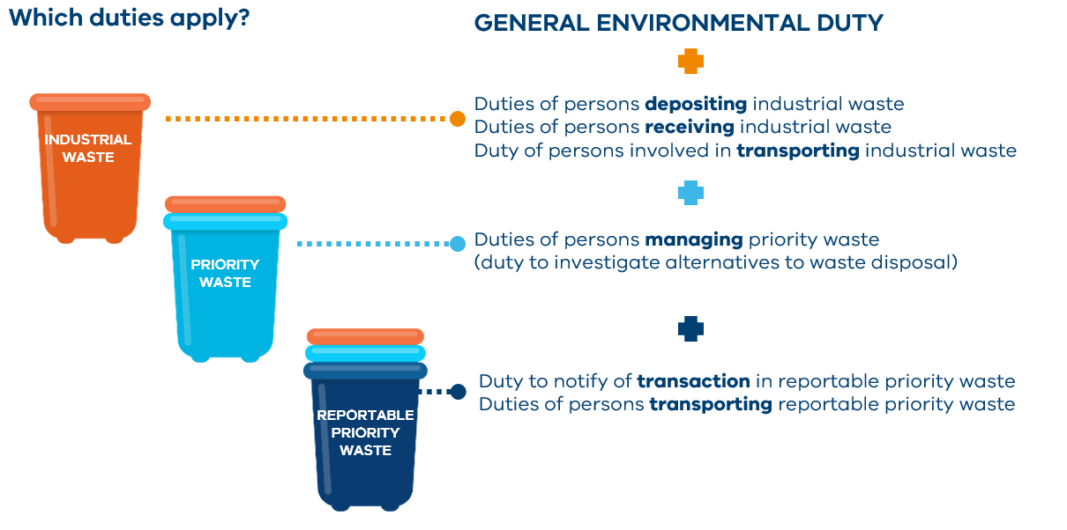
Figure 4: Which duties apply to different waste types

Waste classification

What is waste classification?
All industrial waste needs to be classified to determine what waste type it is and how to manage it. This enables duty holders to meet their obligations under the GED and minimise the risk of harm to the environment and human health. Classifying industrial waste involves:
- Determining the relevant waste code or codes.
- Determining if it is industrial waste, priority waste or reportable priority waste, and which waste duties apply.
- For priority waste consigned for disposal to landfill or for soil that is priority waste, determining which priority waste category or disposal category applies.
The new waste classification framework pre-classifies most industrial wastes in Schedule 5 of the Regulations, specifying both the applicable waste code and the type of waste. This means that for most industrial waste, the waste code and type of waste can readily be determined using Schedule 5 of the Regulations.
Some wastes can be hazardous in certain circumstances, but not in others. For example, drilling muds may be hazardous when contaminated with hydraulic fluids. They are non-hazardous if the mud is not contaminated. For these wastes, a mirror code is proposed.
A mirror code has two variations: hazardous or non-hazardous. A hazardous variant of a mirror code has additional controls and requirements to the non-hazardous variant.

Priority waste category
The relevant priority waste category must be identified for priority waste consigned for disposal to landfill or for soil that is priority waste. These are set out in Schedule 6 of the Regulations.
The priority waste categories are:
- Category A waste - prohibited from disposal to landfill.
- Category B waste.
- Category C waste.
- Category D waste - for soil only.
- Soil containing asbestos only.
- Packaged waste asbestos.
Priority waste categories are generally determined based on the hazard level and potential for mismanagement, with higher waste levies applying to higher hazard priority waste. The exception is asbestos waste for which a lower waste levy rate applies because, although it is high hazard, there is no safe alternative to landfill disposal.
The priority waste categories are often referred to as the disposal category but, where the waste is soil, these categories apply to all offsite management options, not just disposal to landfill. This extends to onsite management options for soil sourced onsite from contaminated land.
Category D waste is a new category for soil only. It is intended to support limited containment options for Category C soils with lower levels of contamination, but that are still more contaminated than fill material (see Waste Disposal Categories—Characteristics and Thresholds (publication 1828)). A duty holder can apply for a permit to safely contain Category D soil on the project site at which it was generated.

Designation
A designation allows EPA to determine how to classify or categorise a new waste, or an existing waste in a way that expands on, or refines, the application of the prescribed classification set under the Regulations. This allows EPA to account for new circumstances and emerging issues.
EPA may issue a designation on its own motion, or a person who has the management or control of priority waste may apply for a designation. The designation is valid for a maximum of five years and is subject to EPA-set conditions. It may apply for specified circumstances or to a specified person.
For example, a designation may:
  - reclassify a waste from reportable priority waste to priority waste, in specific circumstances
  - reclassify for disposal a waste from Category A to Category B
  - create a new waste code for a newly identified waste
  - enable waste to be mixed, blended or diluted to a lower-risk category.

Mixing, blending or diluting priority waste
Mixing, blending or diluting priority waste to change the waste classification may result in unsafe practices. For example, highly contaminated soil could be blended with less contaminated soil to lower the priority waste category, allowing the soil to be disposed of at a lower-threshold landfill or being sold as fill material.
It is prohibited, unless it occurs in accordance with a designation issued by EPA. There are strict criteria that must be met for EPA to issue a designation for the mixing, blending or diluting of priority waste.

Accredited consigners
An option for waste producers to meet their obligations under the EP Act and the Regulations is to engage an accredited consigner. An accredited consigner is an appointed professional who has the approval of EPA to lawfully manage specific types of waste. Accredited consigners can assist a duty holder to:
- classify their waste
- ensure the waste reaches a lawful place
- ensure they meet their waste duties.

Transport
The transport of waste can be risky owing to the inherent hazard of the waste if it is not properly managed and handled. A transporter of waste must comply with the GED and with specific transport duties (Table 1). In addition, EPA has a requirement that reportable priority waste must be transported under a permission.

Waste tracking
As per the duty to notify of transaction in reportable priority waste, EPA must be informed every time a reportable priority waste is exchanged. EPA is developing a new electronic waste tracker tool, to monitor the movement of waste more quickly and accurately. This will help to prevent potential harm to Victorians and the environment.
Duty holders may use the waste tracker or, with approval from EPA, provide data from their own electronic tracking tool.

Transport permissions
Schedule 1 of the EP Act states that transportation of reportable priority waste must be done in accordance with the appropriate EPA permission. The specific permissions are:
- Permit: A10a - Transporting high-risk reportable priority waste.
- Registration: A10b - Transporting reportable priority waste, excluding waste codes B100, E100, G100 or R100.
- Permit: A11 - Transporting controlled waste into Victoria.
- Permit: A12 - Transporting any solid reportable priority waste out of Victoria.
The Regulations set out a range of conditions for these permissions, which align with the Dangerous Goods Act 1985. Some examples include:
- the permission holder to ensure that the driver has undertaken dangerous goods training
- adhering to load restraint requirements
- maintaining documentation onboard that provides information to emergency services in the event of an accident
- appropriately placarding the vehicle.

Lawful place
A key requirement of the EP Act is that all industrial waste is deposited at a place that is lawfully able to receive it. This is referred to as a lawful place. A lawful place might also be authorised to engage in activities such as resource recovery or landfill disposal. The EP Act requires that waste producers take all reasonable steps to ensure that the waste arrives at such a location.
The lawful place framework is designed to be a comprehensive framework that covers all industrial activities and wastes. This ensures that there are no loopholes or gaps that could result in harm.
It creates risk management controls that are:
- proportionate to the level of risk
- tailored to different circumstances
- flexible, to allow for industry to do what is best for their circumstance.
The proposed Regulations outline how a receiver of industrial waste can be considered a lawful place. There are several ways to meet the lawful place requirement. These are:
- permission
- permission exemption
- emergency authorisation
- declaration of use
- determination
- deemed authorisation under Regulation 63.
These permissions and tools have varying levels of requirements based on risk (Figure 5).
Licence
Permit
Registration
Determination or Declaration of Use
Regulation 63

Figure 5: Different lawful place tools by risk and requirements to comply.

Permissions

Licence
Licences are proposed for the most complex activities that pose the greatest risk of harm to human health and the environment, or a high potential for mismanagement. They involve a detailed assessment process, customised conditions and ongoing EPA oversight.

Permit
Permits apply to activities that are of moderate risk or high risk with low complexity and are not adequately addressed through the GED alone. The conditions of a permit can also provide additional direction and clarity for duty holders on risk management using a lower-burden instrument than licensing.

Registration
Registrations are a simple mechanism that are automatically granted upon application and may include standard conditions for the relevant activity. They are suited to activities that pose moderate to low risks, and in instances where applying standard controls across a sector may raise the standard of compliance and minimise risks to human health and the environment (including as a precautionary approach to the management of emerging risks).
For further details on the permissions scheme, see Permissions scheme Draft policy (publication 1799). For information about which activities would require licences, permits and registrations, see Schedule 1 of the proposed Regulations.

Permission exemption
A place or premises is a lawful place to receive industrial waste if it is exempt from the need to hold a permission to receive that type of waste.
A site may be exempt from having to hold a permission to receive industrial waste:
- under the Regulations
- if granted an exemption by EPA

Emergency authorisation
EPA may grant a temporary emergency authorisation for the storage, treatment, handling, deposit or disposal of waste under section 157 of the EP Act.
To grant an emergency authorisation, EPA must be satisfied that the authorised activity:
- will not have significant adverse effects on human health or the environment; and
- is for the purposes of meeting a temporary emergency or providing for the temporary relief of a public nuisance or community hardship

Determinations
A determination is a legal instrument that allows EPA to set standards for the receipt of waste to be authorised. A site or premises can be deemed to be authorised to receive (i.e. lawful place) and use certain industrial waste if the standards or conditions in a determination are met.
Determinations are suitable when there is an opportunity:
- to lower regulatory burden and provide certainty
- for businesses in accessing a standalone standard to apply to their industry
- to apply standards or conditions to level the playing field
- to create an EPA-set DoU.

Requirements
- The waste receiver is responsible for ensuring that the determination is complied with, however, waste producers will need to ensure that waste substances meet standards.
- The Regulations do not set requirements for compliance, however the GED and the waste duties will continue to apply.

Examples of potential wastes
- Processed pasteurised solid organic waste.
- Manures, animal wastewater and effluent.
- Construction and demolition aggregates.
- Fill material, excluding soil that has undergone thermal desorption treatment.

Declaration of Use
A Declaration of Use (DoU) is an agreement for how a specific industrial waste can be directly reused. It describes the waste, assesses its risks and identifies legitimate use.
Under the new EP Act, the duty to deposit waste at a lawful place will apply to all industrial wastes, including those that are intended for reuse or recovery. A DoU will enable industry to:
- meet the lawful place duty without the need to apply for a permission
- manage their risks of harm easily
- encourage information sharing in the reuse and recovery market.
Two types of DoUs have been proposed – one that EPA authorises and another that industry self-assesses.

EPA-set DoU
An EPA-set DoU is a set of standards that EPA specifies, through a determination, for how to manage certain low-risk marginal wastes.

Requirements
- Meet the requirements of the GED and waste duties.
- No requirement for a producer to describe and declare the material.
- The receiver must ensure that the waste will only be used in accordance with the standards.
- The premises must be suitable for the receipt of the waste.
- Record keeping requirements retain for two years, which applies to the EPA-issued documentation.

Potential uses
The tool will be useful in specific scenarios, for example:
- immature organic wastes, where primary producers have capacity to rest large volumes
- marginal fill material, such as for backfilling voids in commercial, industrial or mining scenarios.

Industry-set DoU
An industry-set DoU is a self-assessed agreement between a producer and receiver, for low-risk wastes. It supports innovation by not requiring EPA to set a standard. It leverages the GED by setting a state of knowledge relating to any latent harms and describing handling requirements.

Requirements
- Meet the requirements of the GED and waste duties.
- Be in a manner and form approved by EPA.
- Manage the risks of harm so far as reasonably practicable.
- Keep the declaration for a period of two years.
- Remain in effect for up to 12 months before requiring revisiting.
- EPA may cancel a declaration.
- Describe the type of waste.
- Ensure the premises receiving the waste is suitable for the purposes.

Uses
- Waste for resource recovery.
- Waste, other than soil, for a substitute to raw material; a commercial, industrial, trade or laboratory activity.
- Application to land for:
  - commercial garden and landscaping organics that do not contain any physical or chemical contamination
  - untreated timber, including sawdust
  - natural organic fibrous waste.

Other Regulations for meeting lawful place requirements
As per Regulation 63, there are several scenarios where a person, place or premises is authorised to receive industrial waste without the need for a permission, determination or DoU. They include:
- in accordance with a trade waste agreement under the Water Act 1989
- manure, including any mixture of manure and biodegradable animal bedding from agricultural sources, for discharge or deposit to land of less than 20 m³ per month
- no more than five m³ of industrial waste that is not priority waste
- no more than five m³ for the following types of priority wastes and scenarios:
  - timber treated with hazardous substances
  - tyres
  - e-waste, excluding batteries
  - storage of waste tyres
  - for receipt at a laboratory for the purposes of analysis
  - greenhouse gas substances, for injection as part of greenhouse gas sequestration operations carried out in accordance with the Greenhouse Gas Geological Sequestration Act 2008
  - if the waste may be lawfully exported from Australia directly from that place or premises.

Sections of the EP Act and the Regulations relating to waste
Table 1: Duties in the new EP legislation.
Duties | Requirements | Section in EP Act
General environmental duty | Anyone undertaking an activity that gives rise to a risk of harm to human health or the environment (from pollution and waste) must minimise that risk as far as reasonably practicable. | 25
Duties of persons depositing industrial waste | Must send industrial waste to a lawful place and not illegally dump it. | 133
Duties of persons receiving industrial waste (‘lawful place’) | Must only receive industrial waste if the place or premises is authorised to receive it. | 134 and 3(1)**
Duty of persons involved in transporting industrial waste | Must take all reasonable steps to ensure that industrial waste is transported and received at a place or premises that is authorised to receive it. This includes:  - identifying and classifying the waste  - providing sufficient information about the waste to the next person in the supply chain  - verifying that the place or premises is authorised to receive the waste. | 135
Duties of persons managing priority waste | Must:  - classify the waste  - contain the waste, to prevent escape or contamination  - isolate the waste, to ensure resource recovery remains practicable  - provide information regarding the waste to the next person in the supply chain so that they can meet their duties. | 139
Duty to investigate alternatives to waste disposal | Must take all reasonable steps to identify and assess alternatives to waste disposal. | 140
Duty to notify of transaction in reportable priority waste | Must inform EPA every time a reportable priority waste is exchanged, through EPA’s electronic waste tracker. | 142
Duty of persons transporting reportable priority waste | Must not transport or cause or allow the transportation of reportable priority waste other than in accordance with a permission. | 143
** In s.3(1), see the definition of ‘authorised to receive industrial waste’.
Table 2: Where key waste areas are found in the proposed Regulations.
Key area | Proposed Regulation
Classification | 20, 61, 62, 66-70, 85, 86, 216, Schedule 5
Transport | 20, 28-30, 63, 65-85, 186-193, 201-203, Schedule 5, Schedule 7, Schedule 11
Lawful place | 13, 49, 50, 63, 64, Schedule 7
Categories | 62, 67, 68, Schedule 6
Declaration of Use | 5, 63, 64
Permissions | 16-21, 37-42, 53, 167, 219-224, Schedule 1
Designations | 61, 62, 65-70, 86, 87, 216, Schedule 6
Determinations | 5, 29, 32, 63, 64, Schedule 1
Accredited Consigners | 88-92, 212, 216, Schedule 7

Next steps
The new EP Act and Regulations are intended to commence on 1 July 2021. EPA and the Department of Environment, Land, Water and Planning (DELWP) reviewed the public comment submissions and finalised and published the proposed Regulations and standards. EPA will be providing a response to public comment in mid to late 2020. The proposed Regulations are for viewing only, rather than any additional public comment. The following documents are available for the public to view:
- proposed Regulations, proposed Transitional Regulations and a related Regulatory Impact Statement (RIS)
- proposed Environment Reference Standard (ERS) and a related Impact Assessment (IA).
These documents can be accessed through Engage Victoria: engage.vic.gov.au. Please contact EPA on 1300 372 842 (1300 EPA VIC) or email sublegreform@epa.vic.gov.au if you require more information.

Disclaimer
The information in this publication is for general guidance only. It does not constitute legal or other professional advice and should not be relied on as a statement of the law. As it is intended only as a general guide, it may contain generalisations. You should obtain professional advice for your specific circumstances.

Regulatory Impact Assessment: Proposed Environment Protection Regulations, Department of Environment, Land, Water and Planning (DELWP) and EPA 2019.

