Publication 2008.2 | October 2022

Guide to the duty to notify of contaminated land
epa.vic.gov.au
Environment Protection Authority Victoria
GPO BOX 4395 Melbourne VIC 3001
1300 372 842

The information in this publication is for general guidance only. It does not constitute legal or other professional advice and should not be relied on as a statement of the law. Because it is intended only as a general guide, it may contain generalisations.
You should obtain professional advice if you have any specific concern. EPA has made every reasonable effort to provide current and accurate information, but does not make any guarantees regarding the accuracy, currency or completeness of the information.

Give feedback about this publication online: epa.vic.gov.au/publication-feedback

EPA acknowledges Aboriginal people as the first peoples and Traditional custodians of the land
and water on which we live, work and depend. We pay respect to Aboriginal Elders past and present
and recognise the continuing connection to, and aspirations for Country.

Contents
1 Purpose 4
1.1 How to use this guideline 4
1.2 Scope 6
1.3 Status 6
2 Overview of the duty to notify 7
3 Determining who is required to notify 8
3.1 Determining who is in management or control of land 8
3.2 Determining who is required to notify EPA for land under shared management or control 8
4 Determining if land is contaminated by notifiable contamination 9
5 Interpretation of the of notification criteria 12
5.1 Sampling data for soil, water or vapour 12
5.2 Substances listed in the NEPM (ASC) 13
5.3 Sample results for contamination on land you manage or control exceed a localised elevated value threshold or an average threshold 13
5.3.1 Applicable investigation or screening levels based on the relevant ‘land use’ settings 13
5.3.2 Changes in land use on the land or adjacent land 14
5.3.3 Assessment of soil vapour results 14
5.3.4 Estimating vapour intrusion risk from soil and groundwater sampling results 15
5.3.5 Assessment of soil contamination results 16
5.4 The likelihood of a person being exposed to contamination in soil or vapour 16
5.4.1 When a person is, or is likely to be, exposed to the contaminant in or on soil 16
5.4.2 When a person is, or is likely to be, exposed through vapour inhalation to contamination or any by-product of contamination on land you manage or control 17
5.5 Contamination in or on soil on adjacent land which has entered, or is likely to have entered, from your land 19
5.6 Soil contamination present on your land that is likely to enter and remain on adjacent land 21
5.7 A contaminant listed in Schedule B1 of the NEPM (ASC) is likely to enter or is present in groundwater that discharges to surface water or is useable and would exceed an ADWG or ANZG guideline value 22
5.7.1 Contamination of groundwater which discharges, or is likely to discharge, to surface water 23
5.7.2 Contamination of groundwater that is used or may be used 23
5.8 A contaminant listed in Schedule B1 of the NEPM (ASC) is entering or likely to enter surface water that would exceed an applicable ADWG or ANZG guideline value 24
5.9 Non-aqueous phase liquid (NAPL) 26
5.9.1 When you reasonably should be aware that NAPL is present 26
5.10 Potential exposure to friable asbestos 27
5.11 Onsite retention of contaminated soil 29
6 Other notification requirements 30
6.1 Other reporting requirements to EPA 30
6.2 Notifying EPA of imminent or immediate risks of harm 30
7 Exemptions 30
7.1 Industrial waste stockpiles 31
7.2 Environmental audits and remedial notices 32
7.2.1 Environmental audits and remedial notices issued under the Act 32
7.2.2 Active environmental audits 32
7.2.3 Material changes on land subject to a 1970 Act remedial notice or environmental audit 32
7.3 Activities undertaken on land since a 1970 Act audit was completed 32
7.4 Section 53V audits 33
8 The notification process 33
8.1 Timing of the notification process 34
8.2 Information that must be provided to EPA 34
8.3 Information relating to the management response 35
8.4 Responding to new information 35
8.5 The status of the ‘management response’ in assessing what is notifiable circumstances 36
8.6 Potential follow up actions by EPA 36
9 Additional considerations for notifiable contamination 37
9.1 When EPA considers that circumstances are ‘likely’ for the purposes of notification 37
9.2 Guidance on assessing and managing NAPL impacts on groundwater and surface water 38
9.3 Land use that does not fit into the NEPM (ASC) land use settings 38
9.4 Notification of connected parcels of land 39
9.5 Naturally enriched concentrations 40
9.6 Notifying of other substances 41
9.7 Further guidance on assessing the likelihood of surface water and groundwater discharges 41
9.8 Notification of changes to your management response? 41
9.9 Additional considerations for onsite retention of contaminated soil 42
9.10 The footnotes to the tables in Section 6 of Schedule B1 of the NEPM (ASC) 42
10 How EPA will assess compliance 43
10.1 EPA’s regulatory approach 43
10.2 Skills, knowledge and experience required to be aware of notifiable contamination 44
11 Glossary 45
12 Acronyms and abbreviations 49
13 Appendix A: Summary of notification triggers by segment of the environment 50
14 Appendix B Referenced documents and standards 53

Purpose
The Environment Protection Act 2017 (the Act) requires a person in management or control of land (a 'duty holder') to notify EPA of certain types of contamination of land (which includes groundwater) in certain circumstances. This guideline aims to help you to determine when you must complete a contaminated land notification to meet your ‘duty to notify’ under section 40 of the Act.
When a person in management or control of land believes their land may be contaminated, they must first meet their ‘duty to manage contaminated land’ (duty to manage) under section 39 of the Act. The duty to manage requires them to minimise risks of harm to human health or the environment from that contamination so far as reasonably practicable. Information about the duty to manage is contained in EPA publication 1977 Guide to the duty to manage contaminated land. While meeting the duty to manage a person may also become aware that the nature and extent of the contamination also makes it notifiable to EPA.
While there is a requirement under the Act for those in management or control of contaminated land to notify of certain circumstances, anyone can report suspected or confirmed contamination or pollution incidents at any time by calling EPA on 1300 372 842.
This guideline is targeted at environmental professionals and duty holders with a reasonable level of knowledge of environmental performance and contaminated land.
EPA has published information on its website for those who have less technical knowledge or a different role in managing contaminated land. See Our approach to managing contamination in Victoria.
EPA has also published guidance on how to work with consultants as part of helping you to meet your obligations in relation to contaminated land.

How to use this guideline
This guideline is one of several publications EPA has issued to support the contaminated land scheme. Figure 1 identifies the role of this guideline (highlighted in light blue) in the broader process of contaminated land duties.

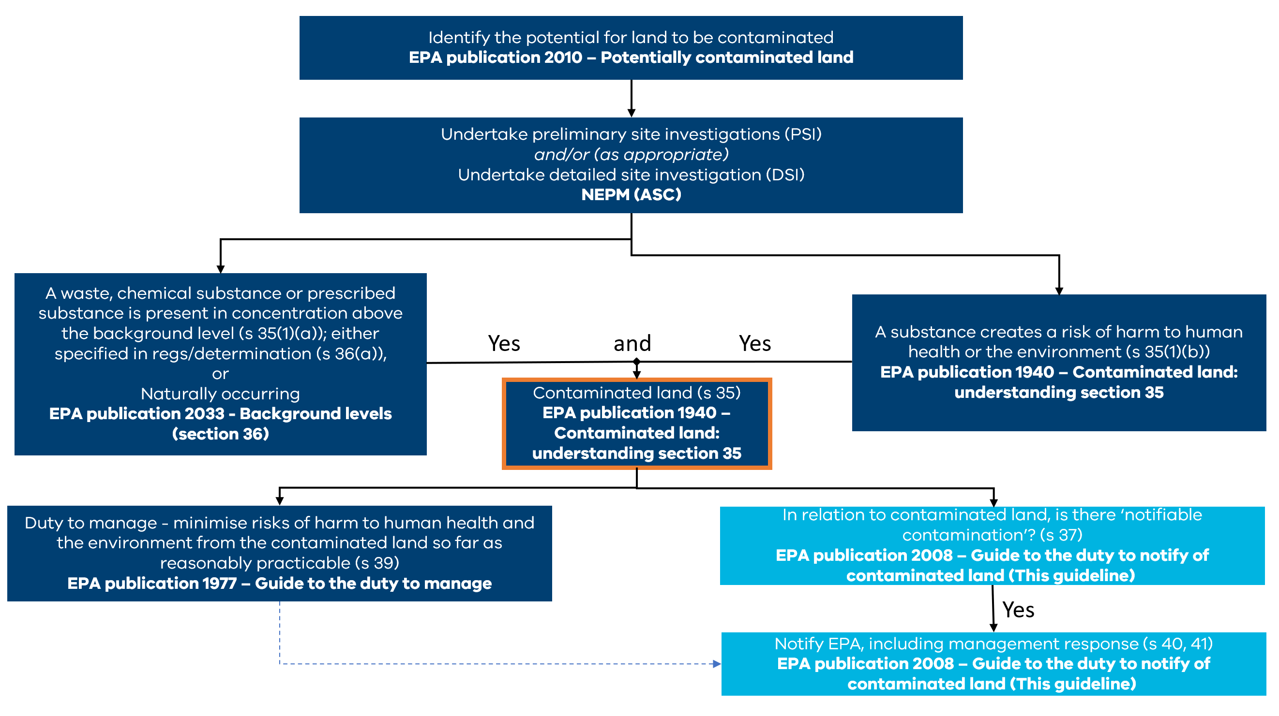
Figure 1: The context of this publication (highlighted in light blue) in relation to the general steps that may apply under the contaminated land duties.
This guideline should be read in conjunction with:
- Contaminated Land Policy (publication 1915)
- Contaminated land: Understanding section 35 of the Environment Protection Act 2017 (publication 1940)
- Guide to the duty to manage contaminated land (publication 1977)
- Potentially contaminated land - A guide for business (publication 2010)
- Background Levels Methodology Guidance (publication 2033).
This guideline helps you to determine if the duty to notify applies to you by working through the following steps:
Step 1: Determining if you are the person in management or control of land who is required to notify (Section 3).
Step 2: Determining if your land is contaminated by notifiable contamination (Section 4).
The guideline then sets out:
- Interpretation of the notification criteria – Section 5 sets out information that supports interpretation of the notification criteria.
- Other notification requirements – Section 6 sets out the other circumstances in which notification to EPA may be required.
- Exemptions – Section 7 sets out circumstances when notification may not be required.
- The notification process – Section 8 provides guidance on preparing and completing a notification to EPA, and what follow up actions EPA may take.
- Additional considerations – Section 9 sets out other matters that may need consideration in relation to the duty to notify of contaminated land.
- Assessing compliance – Section 10 sets out how EPA will assess compliance with the duty to notify of contamination land.
- Supporting information – Sections 11-14 include a glossary, acronyms and abbreviations used through the guideline, a summary of notification triggers by segment of the environment and referenced documents and standards.
There may be times during your assessment that you identify an imminent or immediate risk of harm to human health or the environment. If this happens you should inform EPA immediately, as discussed in Section 6.2.

Scope
This document provides guidance on:
- how to determine if you are a person required to notify EPA of notifiable contamination under section 40 of the Act
- circumstances where contaminated land needs to be notified to EPA
- reporting requirements, including the information required for notification as per section 41 of the Act
- circumstances that are exempt from the notification requirements.
It does not provide detailed instructions on how to complete the notification process in accordance with section 41 of the Act. For further information on how to complete a notification, please refer to EPA’s webpage: Contaminated Land Notification Process.

Status
This publication provides guidance to assist those in management or control of contaminated land to interpret the requirements of the duty to notify as set out in section 40 of the Act.
Adopting the approach set out in this guideline may help you to demonstrate to EPA and other interested parties (including other duty holders and other government agencies) that you have taken reasonable steps to comply with the duty to notify when it applies to you.
EPA may use the guideline to provide you with advice and support to comply. However, compliance with this guidance does not necessarily constitute compliance with the EP Act.
This publication supersedes proposed draft publication: Notifiable contamination guideline: Duty to notify of contaminated land (EPA Publication 2008.1).

Overview of the duty to notify
The duty to notify EPA under section 40 of the Act will apply where all the following criteria are met:
- You are the person in management or control of land.
- The land (which includes groundwater) is contaminated, and the contamination meets the definition of ‘notifiable contamination’ in section 37 of the Act and in part 2.1 of the Regulations.
- You have become aware, or reasonably should have become aware, of the notifiable contamination.

However, there are the two exceptions to the requirement to notify EPA of contamination under section 40(4) of the Act:
- when the person required to notify is aware that a notification has already been made
- when the notifiable contamination is prescribed exempt notifiable contamination.
More information about these exceptions is outlined in Section 7.
Section 40 of the Act requires a person in management or control of land to notify EPA, as soon as practicable, where they become aware (or reasonably should have become aware) that the land is contaminated by ‘notifiable contamination’.
Part 2.1 of the Environment Protection Regulations 2021 (Regulations) prescribes notifiable contamination. The following is a summary of the types of contamination that are notifiable:
- contamination of soil (including friable asbestos) that exposes a person to that contamination
- contamination of soil that is moving, has moved or is likely to move onto adjacent land
- contamination of groundwater that is being used, or may be used
- the entry of contamination into surface water
- contamination of soil or groundwater that indicates a risk of exposure to vapour
- any presence of non-aqueous phase liquid (NAPL) in groundwater, surface water or an aquifer
- contaminated soil sourced from that land that can be lawfully retained onsite.
Information on how to interpret these notification criteria is summarised is presented in Sections 4 and 5 of this Guideline.
Circumstances that are exempt from the notification requirements are set out in section 40(4)(b) of the Act and in regulation 13, as described in section 7 of this guideline.
Section 41 of the Act requires EPA to be notified in the manner and form approved by EPA. The information that must be notified is set out in section 41(2) of the Act and regulation 14 of the Regulations, as described in section 8 of this guideline.
A person who is required to notify EPA of contaminated land but fails to do so may be subject to prosecution or civil penalty proceedings. The Act currently provides for a maximum penalty of:
- 120 penalty units – in the case of a natural person
- 600 penalty units – in the case of a body corporate.
Anyone engaging or proposing to engage in an activity associated with contaminated land must also meet their general environmental duty (GED). Find out more about the GED on EPA’s GED webpage.
Notification of contaminated land (including groundwater) is important to support EPA in fulfilling its role in reducing the harmful effects of pollution and waste on human health and the environment. It assists EPA to understand the nature and distribution of land and groundwater contamination in Victoria and respond strategically to contaminated land issues.

Determining who is required to notify

Determining who is in management or control of land
A notification must be provided to EPA by any person in management or control of contaminated land who becomes aware of (or reasonably should have become aware of) notifiable contamination.
Guidance on determining whether you are in management or control of land is contained in EPA publication 1977 Guide to the duty to manage contaminated land. This includes information on circumstances when management or control may be shared.
If you are legally required to notify EPA, a contractor or agent may complete the notification on your behalf. The contractor or agent should be able to satisfy EPA that they are authorised to make a notification on your behalf.

Determining who is required to notify EPA for land under shared management or control
More than one person may have management or control of the land. Notification by one of those people will generally satisfy the notification obligation for all other people in management or control of the contaminated land.
You should not assume that another person has notified. To ensure that section 40(4)(a) of the Act applies (notification is not required if a person is aware that a notification has already been made in accordance with section 40(1)) you need to be aware that EPA has in fact already been notified (for example, you may be aware through information sharing arrangements in place between the people in management or control of the land).
, or reasonably should have become aware, that the land you manage or control is contaminated by notifiable contamination as prescribed in Part 2.1 of the Regulations.

Determining if land is contaminated by notifiable contamination
Contaminated land or groundwater is only notifiable when specific substances are present above specific concentrations, and in specific circumstances.
The specific substances covered by the definition mean at least one of the following:
- substances named in Section 6 of Schedule B1 of the NEPM (ASC) (see regulation 13(d)
- friable asbestos in or on soil on land (see regulation 9)
- NAPL in groundwater, surface water or an aquifer on or in land (see regulation 10(3))
The specific concentrations above which notification is required are the values set out for the corresponding substances:
- the Health Investigation Levels (HILs) and Health Screening Levels (HSLs) for the specific substances listed in Section 6 of Schedule B1 of the NEPM (ASC), in relation to substances in soil and vapour
- the concentration thresholds in the Australian Drinking Water Guidelines (ADWG) or the Australian and New Zealand Guidelines for Fresh and Marine Water Quality (ANZG) for the specific substances listed in Section 6 of Schedule B1 of the NEPM (ASC), in groundwater and surface water
- airborne asbestos fibre levels in excess of 0.01 fibres per mL by means of inhalation.
The applicable concentrations for HSLs and HILs are further specified for different circumstances.
The specific circumstances that make contamination notifiable are:
- where a person is, or is likely to be, exposed to the contaminant (in relation to contaminants in or on soil (including friable asbestos)
- the contaminant has entered from, or is likely to have entered from, the land onto adjacent land (in relation to contaminants in or on soil)
- the contaminant is likely to enter and remain on adjacent land (in relation to contaminants in or on soil)
- the groundwater contamination discharges, or is likely to discharge, to surface water or is used, or may be used, for human consumption or contact, stock watering or irrigation
- the contamination discharges to surface water
- in relation to excavated soil (other than fill material) from contaminated land sourced onsite that is not an activity for which permission is required, where it is proposed to be retained on site .
It is noted that typically, an investigation will not be required solely to determine whether notifiable contamination is present. The obligation in section 40 of the Act arises where a person is aware (or should reasonably be aware) of the presence of contamination that satisfies the notifiable circumstances set out in Part 2.1 of the Regulations. The most common way that a person would become aware of such contamination is while meeting their duty to manage. EPA publication 1977 Guide to the duty to manage contaminated land sets out the type of information you may encounter that may lead you to suspect that your land may be impacted by contamination.
Alternatively, you may have existing information on contamination that leads you to believe it is notifiable. The existing information may provide sufficient evidence to determine if the contamination is notifiable contamination, and to notify EPA.
Figure 2 is a decision-making diagram for determining if the contamination on the land you manage or control requires you to complete a notification to EPA. Section 5 of this guideline includes technical information for assessing each of these elements.

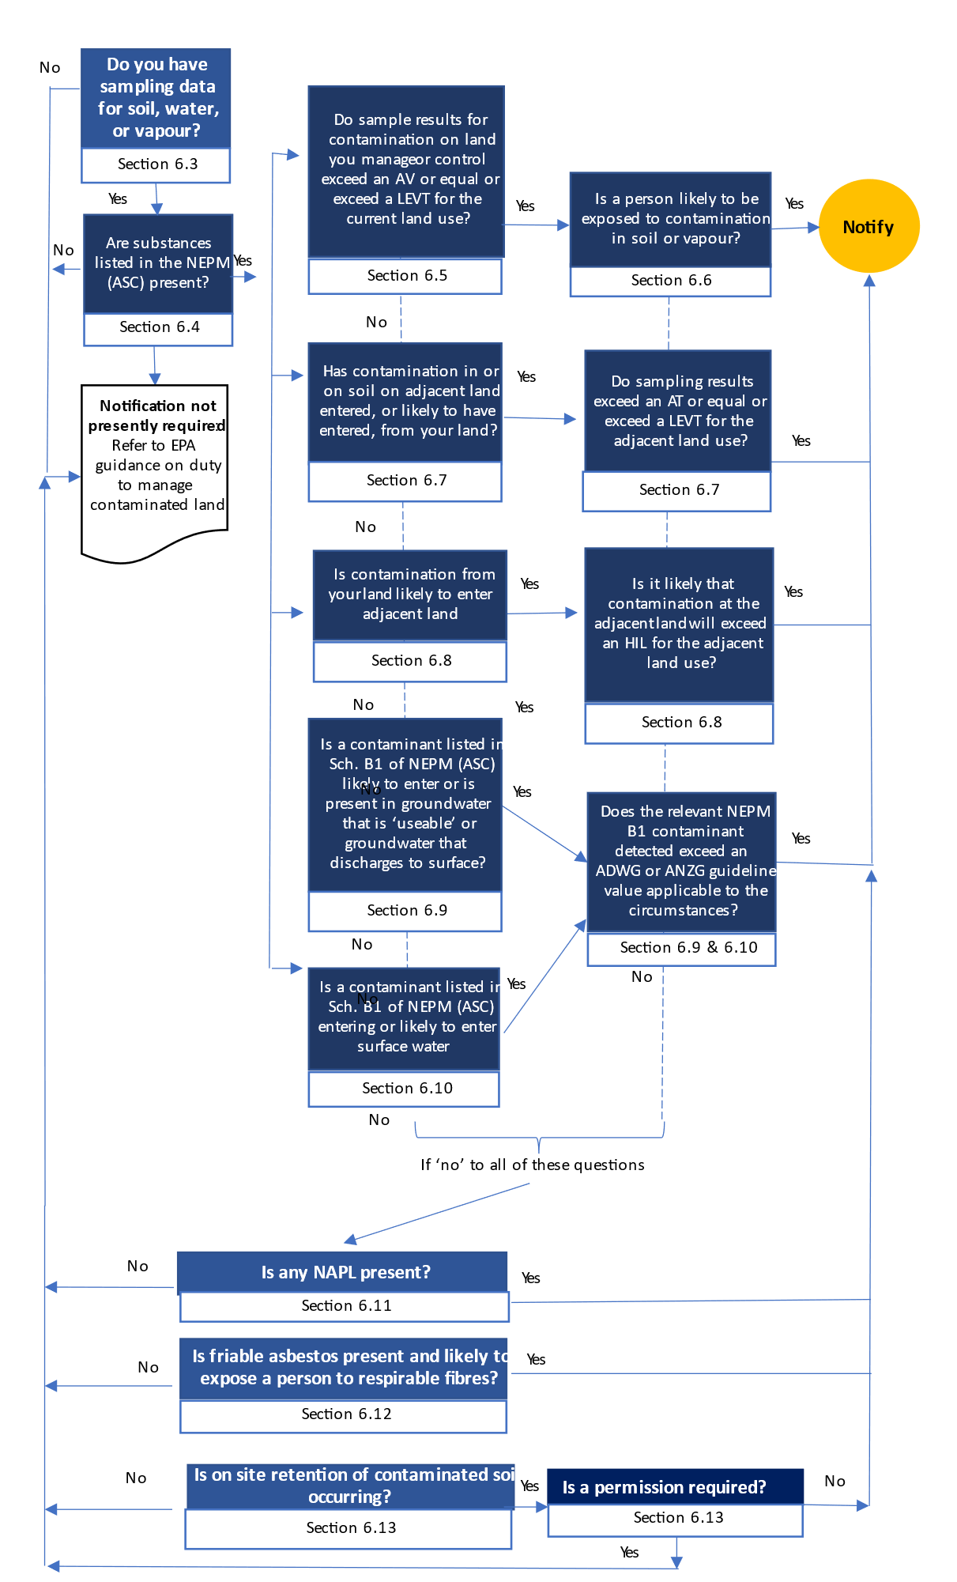
Figure 2 Key considerations for identifying notifiable contamination as per part 2.1 of the Regulations.

Interpretation of the of notification criteria
The section sets out the technical information you will need to answer the 11 questions in the decision-making diagram (Figure 2) to assist you to identify what, if any, contamination on land you manage or control is notifiable.
The notification criteria are based on statistical data about land contamination. When you have reason to suspect land you manage or control may be contaminated by notifiable contamination, you will also be considering, or will already have considered, the contamination from the perspective of your duty to manage. As part of meeting your duty to manage, statistical approaches to sampling should be considered in the design of any sampling conducted. For more information on this refer to EPA publication 1977 Guide to the duty to manage contaminated land.
The key criteria for all the notifiable circumstances are summarised in Appendix A.
The sections below address the 11 key questions in the decision-making diagram. At the end of each section there is a box indicating if notification is required or if further criteria or information must be considered.

Sampling data for soil, water or vapour
One of the considerations of notifiable contamination is the type and concentration of the substances that are present. To determine this you may require sampling data from soil, water (groundwater or surface water) or vapour. Without this data, it may not be possible to determine whether any of the other notifiable circumstances apply.
Generally, site assessments conducted to identify and manage risks of harm to human health and the environment will provide sufficient data for notification purposes. Where significant data gaps are identified, further assessment may be required as part of meeting the duty to manage. EPA acknowledges that notification may sometimes be made at a point where there are still some unresolved data quality issues in a sampling dataset. In this situation, you are encouraged to provide information on these concerns as part of your submission.
If you suspect the land you manage or control is contaminated but you have not yet taken samples, EPA recommends that your first action should be considering the management of the risks of harm to human health or the environment associated with that contamination (section 25 and 39 of the Act) as described in EPA publication 1977 Guide to the duty to manage contaminated land.
While meeting your duty to manage, you may obtain sample results and other information that indicates substances present at your land may constitute notifiable contamination. You must then consider these results in line with the remaining notifiable circumstances.
If you have soil, water or vapour sampling results continue with the next questions.

Substances listed in the NEPM (ASC)
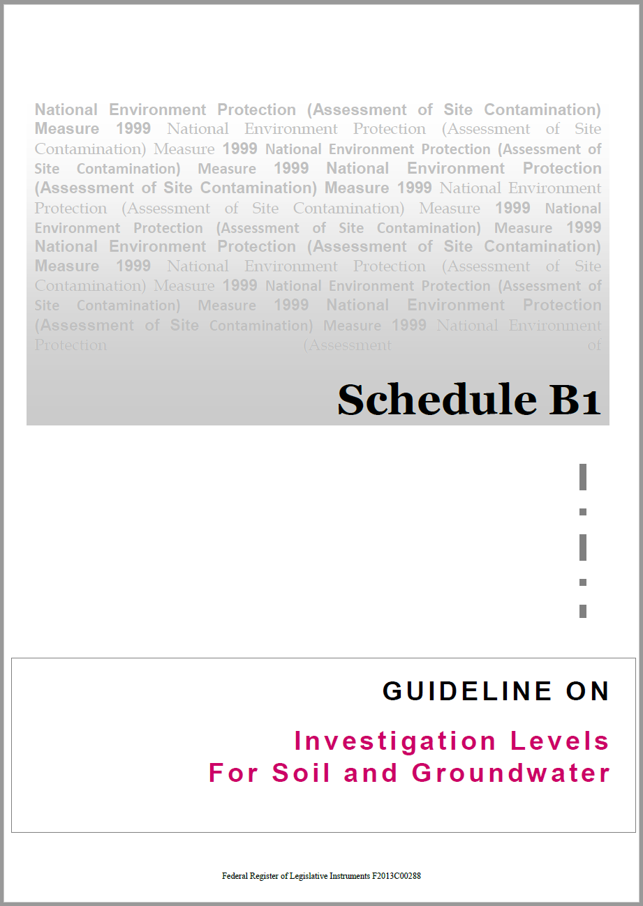
If you have sampling results for contaminated land, the next step in assessing whether you must notify EPA depends on the type of substances you have detected. Not all contaminants are notifiable.
Substances listed in section 6 of Schedule B1 of the NEPM (ASC) may be notifiable when their presence and concentration fulfils the criteria explained in Section 5 of this guideline, and taking into account the additional considerations explained in Section 9 of this guideline.
The substances listed in section 6 of Schedule B1 of the NEPM (ASC) generally represent some of the most frequently encountered substances that can cause land to be contaminated. The list does not represent all substances that cause contamination, only those which require notification to EPA.
The duty to manage contaminated land (section 39) is not limited to substances listed in section 6 of Schedule B1 of the NEPM (ASC). If the land you manage or control is contaminated with other substances you still need to manage the associated risks of harm to human health or the environment in accordance with that duty.
If substances listed in Section 6 of Schedule B1 of the NEPM (ASC) are present on land you manage or control, continue with the next questions.

Sample results for contamination on land you manage or control exceed a localised elevated value threshold or an average threshold
If you manage or control land where contamination is present above an average threshold (AT) or equal to or above a localised elevated value threshold (LEVT) you may need to notify EPA, depending on the circumstances of that contamination.
Note that the AT and LEVT are calculated using the NEPM (ASC) criteria for the land you manage or control, combined with statistical analysis of your sampling dataset as explained in EPA publication 1977 Guide to the duty to manage contaminated land.

Applicable investigation or screening levels based on the relevant ‘land use’ settings
Regulation 8 refers to AT and LEVT, which are both defined in relation to the HIL for the contaminant for the 'current use' of the land, as specified in the NEPM (ASC).
The NEPM (ASC) land use settings are:
- Residential A: residential with garden/accessible soil (home grown produce <10 per cent fruit and vegetable intake, (no poultry), also includes children’s day care centres, preschools and primary schools.
- Residential B: residential with minimal opportunities for soil access, includes dwellings with fully and permanently paved yard space such as high-rise buildings and flats.
- Recreational C: public open space such as parks, playgrounds, playing fields (for example ovals), secondary schools and footpaths. It does not include undeveloped public open space (such as urban bushland and reserves) which should be subject to a site-specific assessment where appropriate.
- Commercial Industrial D: commercial/industrial such as shops, offices, factories, and industrial sites.
Further detail on these settings is set out in section 3.2 of Schedule B7 of the NEPM (ASC).
Assessing which of the NEPM (ASC) land use settings may apply should be based on the actual use. The zoning categories under the Victoria Planning Provisions may provide some assistance where it is not feasible to determine the NEPM (ASC) land use setting from other means.

Changes in land use on the land or adjacent land
The notifiable circumstances covered by section 40 of the Act are not time bound. If your land use type changes or the land use of adjacent land changes to a more sensitive use and you are aware that these changes would result in newly notifiable contamination you will be required to notify EPA of the contamination.
In practice, many land use changes – particularly changes to more sensitive uses requiring potential contamination to be identified and addressed – are addressed more directly by the Planning and Environment Act 1987 and the Victoria Planning Provisions. Nevertheless, it will remain your duty to notify EPA if these changes result in newly notifiable contamination existing on your land.
If additional notifications need to be made (for example, for changes in concentrations, discovery of additional contamination, additional elements of the environment are contaminated, etc.), you will need to contact EPA to update your notification.

Assessment of soil vapour results
Some volatile contaminants in soil and groundwater may pose a risk to human health through the vapour intrusion pathway. For contaminants that may cause vapour intrusion, EPA recommends direct soil vapour monitoring to determine potential risks. Where monitoring data is available for multiple media (for example, groundwater, soil vapour), regulation 11(2)(b) specifies the following circumstance as notifiable: “a person is, or is likely to be, exposed to the contaminant or any by-product of the contaminant.” In some circumstances where concentrations of contaminants in groundwater exceed notifiable criteria, sufficient soil vapour monitoring data may demonstrate the lack of a source-pathway-receptor linkage for humans (for example, it is unlikely for a person to be exposed to the contaminant or any by-product).
For contamination in soil vapour samples, the HILs that apply are the interim soil vapour HIL for volatile organic chlorinated compounds for the current use of the land as specified in section 6 of Schedule B1 of the NEPM (ASC).

Estimating vapour intrusion risk from soil and groundwater sampling results
For land with insufficient soil vapour data, the vapour intrusion risk can also be estimated from the soil and/or groundwater monitoring data by comparing the AT and LEVT to the relevant HSL shown in Table 1.
- Table 1 Summary of vapour intrusion in the Regulations and corresponding NEPM (ASC) references
Regulation number | Sample type | HIL/HSL | Tables s. 6, Sch. B1, NEPM (ASC)
11(1)(a) and 11(1)(b) | Soil vapour samples for volatile organic chlorinated compounds | Interim soil vapour HIL for volatile organic chlorinated compounds applicable to the current land use | 1A(2)
11(1)(c) and 11(1)(d) | Soil vapour samples for petroleum hydrocarbon compounds | Soil vapour HSL for vapour intrusion applicable to the current land use | 1A(5)
11(1)(e) and 11(1)(f) | Soil samples for vapour intrusion | Soil HSL for vapour intrusion applicable to the current land use | 1A(3)
11(1)(g) and 11(1)(h) | Groundwater sample for vapour intrusion | Groundwater HSL for vapour intrusion applicable to the current land use | 1A(4)
Although the notification criteria are based on statistical interpretation of a vapour sampling dataset, duty holders should also be aware of the potential human health risk associated with a single elevated vapour result which exceeds the relevant HIL or HSL. This is discussed further in Section 5.4.2 of this guideline.
If your soil or vapour samples:
- exceed an AT or exceed or equal an LEVT for soil, or
- the concentration of a vapour intrusion sample remains, or is likely to remain, above an AT or equal to or above an LEVT
continue with the next questions.

Assessment of soil contamination results
For contaminants in soil, the AT and LEVT are based on the HILs found in Tables 1A(1) in section 6 of Schedule B1 of the NEPM (ASC). For a description of the applicable land use categories, refer to Section 5.3.1 of this guideline.

The likelihood of a person being exposed to contamination in soil or vapour
A contaminant on land you manage or control that is above an AT or equal to or above an LEVT is notifiable where the contaminant:
- is in or on soil and a person is, or is likely to be, exposed to the contaminant listed in Table 1A(1) in Schedule B1 of the NEPM (ASC), or
- is associated with a vapour inhalation pathway that exposes, or is likely to expose, a person to the contaminant or by-products of the contaminant that are listed in Tables 1A(2) to 1A(5) in Schedule B1 of the NEPM (ASC).
In any of these circumstances you will need to evaluate the significance of the sample results in the context of specific criteria for each of these situations before you can decide if notification is required.

When a person is, or is likely to be, exposed to the contaminant in or on soil
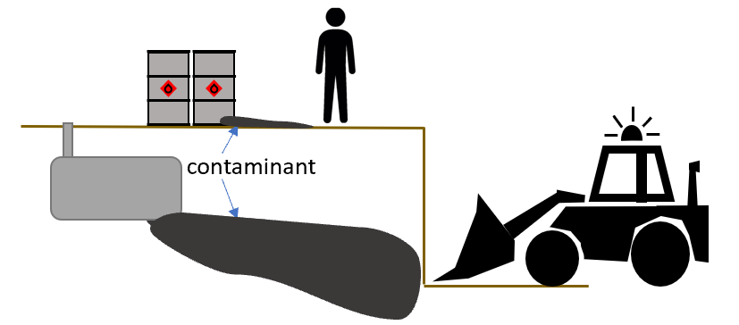
Soil contamination that is (and is likely to remain at) the concentration specified in regulation 8(a) is notifiable when a person is, or is likely to be, exposed to the contamination. This includes circumstances where the exposure occurs beyond land you manage or control.
Consider the following factors when assessing whether a person is, or is likely to be, exposed to a contaminant in or on soil:
- Are one or more source-pathway-receptor linkages to potentially affected humans present on the land.
- For the purposes of this evaluation, source-pathway-receptor linkages are either present or absent. The magnitude or duration of exposure is not considered, only the likelihood of a complete linkage.
- The likelihood of a complete source-pathway-receptor linkage is a function of the activities occurring (or likely to occur) on the land, the people who have access to the land, the depth of contamination or the location of the contamination on the land itself (among others).
The likelihood of exposure is to be considered before any management intervention that is or would be applied to reduce the likelihood of exposure.
If a person is, or is likely to be, exposed to such contaminant levels, the contamination is notifiable under regulation 8(a).

When a person is, or is likely to be, exposed through vapour inhalation to contamination or any by-product of contamination on land you manage or control
Vapour intrusion from contaminated land may be notifiable in the following circumstances:
- where soil vapour samples you have obtained show potential to exceed HILs or HSLs for vapour intrusion
- where soil samples you have obtained indicate potential for vapour intrusion
- where groundwater samples you have obtained show potential for vapour intrusion.
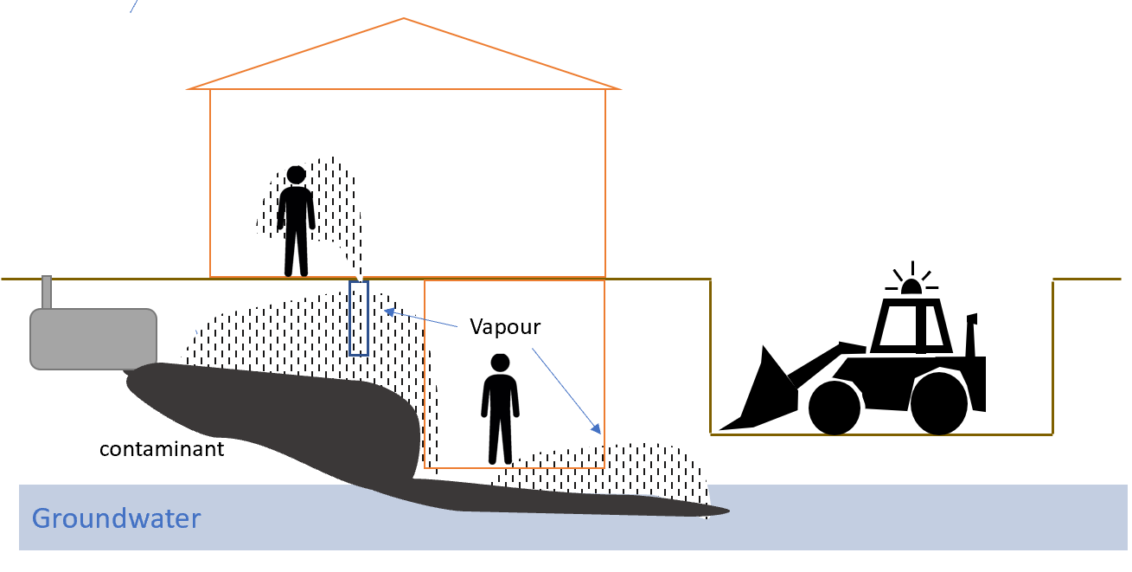
The results obtained in these circumstances are only notifiable under regulation 11 where:
- the results either exceeds an applicable AT or equals or exceed an LEVT; AND
- the concentration of a contaminant remains, or is likely to remain, above those values; AND
- a person is, or is likely to be, exposed to the contaminant or any by-product of the contaminant.
The investigation and screening levels for vapour-related contamination adopt the same land use settings as those for soil (see Section 5.3.1 of this guideline).
In addition to the principles set out in Section 5.4.1 of this guideline, EPA expects you to consider the following factors when assessing whether a person is, or is likely to be, exposed to vapour associated with a contaminant:
- The conceptual site model – including consideration of the lateral and vertical distribution of the contamination, the lithology of the land’s subsurface, building characteristics, mechanisms by which vapour could migrate into buildings, and any preferential pathway that might play a key role in this migration (for example service lines and sewer pipes).
- Is one or more source-pathway-receptor linkage to potentially affected humans present on the land. For the purposes of this evaluation, source-pathway-receptor linkages are either present or absent. The magnitude or duration of exposure is not considered in this assessment, only the likelihood of a complete linkage. The likelihood of a complete source-pathway-receptor linkage is a function of the likely activities that might occur on the land, the people who have access to the land, the depth of contamination or the location of the contamination on the land itself (among others).
Immediate exposure risks
In some circumstances, land and groundwater contamination can have an acute impact on air quality. Where a person may have been, or likely could be, exposed to elevated levels of contaminants in vapour creating an acute risk of harm, you should alert EPA on 1300 372 842 as soon as possible as part of your duty to manage those risks of harm. The priority when an imminent risk is identified is to take swift action to prevent harm. Completing a contaminated land notification should not be the primary way you alert EPA about an imminent risk.
Where land is also a workplace within the meaning of the Occupational Health and Safety Act 2004, it may also be necessary to notify WorkSafe Victoria.
The NEPM (ASC) recommends that immediate action should be taken where potentially explosive or acutely toxic gas concentrations are present in buildings or in-ground services (for example utility trenches, sumps or drains) that connect a vapour source to a building. Emergency management actions, such as relocation of building occupants, should be implemented as necessary. This includes notification to emergency services and potentially affected parties including service providers.
See also section 6.2 of this guideline on responding to immediate risks of harm from contamination.
The approach described above involves the use of average and individual results for notifying EPA under regulation 11 and creates a clear pathway for when notification is or is not required.
When evaluating vapour intrusion risks outside of the context of notification (for example when identifying reasonably practicable control measures under your duty to manage), these statistical approaches are usually not valid.
Vapour intrusion risks vary greatly based on factors that occur on relatively small spatial scales, such as the distribution of individual rooms in a building, or the presence of preferential pathways for vapour movement. Based on this, the use of average estimates across the land, or of individual results compared to 2.5 times the relevant HIL or HSL does not usually provide an accurate indication of health risk. In these circumstances, the industry standard typically involves the direct comparison of measured groundwater, soil, or soil vapour concentrations to HILs or HSLs, without the use of average or of 2.5 times conversion factors.
If a person is, or is likely to be, exposed to the contaminant through vapour inhalation, the contamination is notifiable under regulation 11.

Contamination in or on soil on adjacent land which has entered, or is likely to have entered, from your land
A contaminant that is above an AT or equal to or above an LEVT is notifiable if the contaminant is present in or on soil on land adjacent to your land and the contamination has, or is likely to have, entered from your land (Reg 8(b)).  The applicable AT and LEVT is based on the land use of the adjacent land (see Section 5.3.1 of this guideline for land use categories and corresponding investigation levels). | 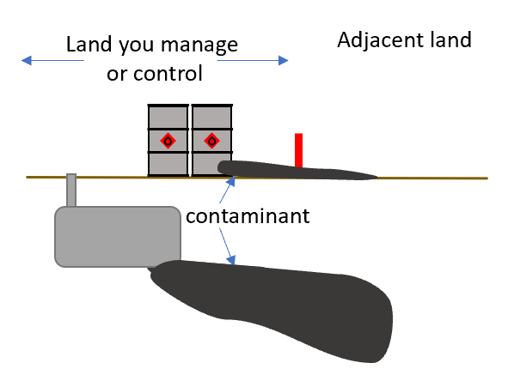
You may become aware of these circumstances from sampling you have undertaken or where information is provided by a third party (for example the person in management or control of the adjacent land). Depending on the circumstances, the person in management or control of the adacent land may themselves be required to notify EPA under section 40 of the Act. For example, if the presence of the contamination in their land satisfies the notifiable circumstances (for example a person on their land being exposed to the contamination under regulation 8(a)).
Assessing whether a contaminant has, or is likely to have, entered from your land may involve making reasonable assumptions about what activities took place or are taking place on your land and what contaminants are known to be present, and weighing up the likelihood based on that evidence.
This can be challenging. EPA recommends that you presume your land is the source of contamination on adjacent land if there is a real and not remote chance, considering all the circumstances, that it has entered from your land. Obtaining conclusive evidence of the origin of the contamination should not be used to delay notification.
Factors that may assist you to determine if contamination on adjacent land is likely to have entered from your land may include:
- contaminants of a type associated with your activities or history – when the contaminant(s) detected on the adjacent land are of a type that are associated with the current or past activities on your land, EPA considers that this may indicate that it entered from your land
- the conceptual site model for your land shows (among other things) the plausible mechanisms by which contamination could migrate from the source land onto nearby adjacent land.
The word ‘adjacent’ is not defined in the Act or Regulations so EPA understands the term by reference to its ordinary meaning of ‘next to or adjoining something else’. In the context of Part 2.1 of the Regulations ‘adjacent’ refers to land affected or likely to be affected by contamination originating from land under your management or control.
Land where you share a boundary is invariably ‘adjacent’ land. Land that is not directly connected may still be considered adjacent even where a boundary is not shared. In some circumstances, contamination will have travelled a distance that is beyond the land with which you share a boundary. The purpose of section 40 of the Act is to ensure EPA has information relevant to its duties and functions as an environment protection regulator. For example, if a plume of contamination has migrated across several sites and reached a more sensitive land use, then it is important that EPA is notified.
If contamination on adjacent land has (or is likely to have) entered from your land, and that contamination is above an AT or equal to or above an LEVT for the relevant land use, the contamination is notifiable under regulation 8(b).

Soil contamination present on your land that is likely to enter and remain on adjacent land
Contamination of land you manage or control is notifiable when:  - a contaminant from your land is likely to enter and remain on adjacent land, and  - the concentration of that contaminant is likely to be above the HIL for that contaminant for the current use of the adjacent land, as specified in section 6 of Schedule B1 of the NEPM (ASC) (Reg8(c)). | 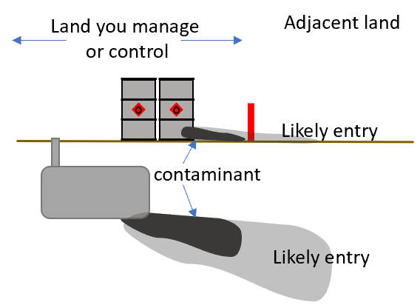
When assessing potential contamination at the adjacent land you should consider the current use of that land based on the land use categories set out in Section 5.3.1 of this guideline. For example, if your land use is industrial and the adjacent land also has industrial land use, then the relevant threshold would be the HIL-D for Commercial Industrial land use. If, however, the adjacent land is used for residential purposes then the relevant threshold would be the HIL-A or B (depending on the land use density) for residential land use.
The relevant contaminants and NEPM (ASC) HILs are listed in Table 1A section 6 of Schedule B1 of the NEPM (ASC).
When determining if contamination is likely to enter and remain on adjacent land at a concentration exceeding a specified contaminant HIL, EPA recommends that you consider:
- Fate and transport mechanisms that might affect the movement of the contaminant in the environment.
- Features on the land that might affect the potential movement of contamination, such as drainage lines, existing utility pits, stormwater and sewer lines, exposure to wind or precipitation, slope, etc.
- Proximity of the contamination on your land to a land boundary.
Further, section 41(2)(c) of the Act requires notifications to EPA to include information on the ‘nature and extent of the contamination’. This means all land impacted by the contamination, whether you share a boundary or not, needs to be identified in your notified information (to the extent that information is known to you at the time you give the notice).
The duty to manage also requires you to provide adequate information to any person that the you reasonably believe may be affected by the contamination. For further information see EPA publication 1977 Guide to the duty to manage contaminated land.
If soil contamination on or in your land is likely to enter adjacent land and contaminant concentrations exceed the applicable NEPM (ASC) HIL for the adjacent land use, then the contamination is notifiable under regulation 8(c).

A contaminant listed in Schedule B1 of the NEPM (ASC) is likely to enter or is present in groundwater that discharges to surface water or is useable and would exceed an ADWG or ANZG guideline value
The entry or likely entry of a type of contaminant listed in Table 1C in Schedule B1 of the NEPM (ASC) into groundwater may be notifiable if the groundwater:
- discharges, or is likely to discharge, to surface water, or
- is used, or may be used, for:
  - human consumption or contact (for example recreational contact) or
  - stock watering or
  - irrigation

Contamination of groundwater which discharges, or is likely to discharge, to surface water
For contamination of groundwater that discharges, or is likely to discharge to surface water, EPA only expects to be notified under regulation 10(1) where the predicted concentration of the contaminant in the groundwater at the point of discharge to surface water would be, or would likely be, above (and remain above):
- the default guideline value for that contaminant specified in the ANZG; or
- the guideline value for that contaminant specified in the ADWG.
Regulation 10(1) applies to known or likely circumstances. Consideration of potential discharges of contaminated groundwater to surface water should be informed by the CSM, including factors such as the background quality of the waterbody, the distance to any surface water receptors and the predicted concentration of the contaminant in the groundwater at the point of discharge to the surface water..
EPA recommends the selection of the appropriate guideline value from the ANZG should be guided by the applicable environmental value for the surface water at the at the predicted point of discharge determined with reference to the Environmental Reference Standard. Guidance on interpreting the environmental reference standard is set out in: EPA Publication 1992 Guide to the Environment Reference Standard.
If a NEPM contaminant is likely to enter groundwater that discharges to surface water, and the concentration of the contaminant in the groundwater at the predicted point of discharge to the surface and would exceed an ADWG or ANZG guideline value (relevant to the values of the surface water as set out in the ERS), the contamination is notifiable under regulation 10(1).

Contamination of groundwater that is used or may be used
Contamination of groundwater which is used or may be used for human consumption or contact, stock watering or irrigation will only be notifiable under regulation 10(1) where the concentration of the contaminant in the groundwater is, or is likely to be, above (and is likely to remain above):
- the default guideline value for that contaminant specified in the ANZG (for recreational contact, stock watering or irrigation) or
- the guideline value for that contaminant specified in the ADWG.
You should consider if there is an actual or possible use of the groundwater in the vicinity of your site. Note EPA Publication 840.2: The cleanup and management of polluted groundwater interprets ‘vicinity’ in the context of groundwater uses in a 2 km radius. To assess for actual current use, consider both registered and unregistered bores. This is best completed by conducting a groundwater bore search on state government websites (for example Department of Environment, Land, Water and Planning, Visualising Victoria’s Groundwater, Victoria Unearthed) to understand whether groundwater is used close to your land and if so for what purpose. Further guidance is provided in EPA publication 668 Hydrogeological assessment (groundwater quality) guidelines. Note: licencing of a groundwater bore under the Water Act 1989 is not required for any bore constructed to a depth of 3 metres or less. So, information about these bores may not be discovered through a groundwater bore search. This is worth considering in areas with a shallow water table where it is possible that unlicenced shallow bores may exist and be in use.
To assess for possible groundwater use, the best guide is Table 5.3 of the Environment Reference Standard which presents environmental values that apply to the groundwater segments relevant to the site, noting that water-based recreation (human contact) is applicable to all groundwater segments. When the relevant groundwater segment includes the environmental value of potable water supply or stock watering, EPA recommends that you assume that unregistered stock and domestic bores may be present.
Section 15(2) of the Environment Reference Standard outlines where an environmental value may not apply. Section 7.2.2 of EPA publication 1992 Guide to the Environment Reference Standard provides additional guidance to determine when an environmental value does not apply. If an environmental value does not apply, it may be considered that groundwater is not useable with respect to that environmental value.
The notifiable circumstances covered by section 40 of the Act are not time bound. If there is a change in conditions and you are aware that the change would result in newly notifiable contamination then you will be required to notify EPA.
Where a groundwater water quality restricted use zone (GQRUZ) has been determined EPA will take this into account when assessing your notification submission.
If a NEPM contaminant is likely to enter or is present in groundwater that is used or may be used for human consumption or contact, stock watering or irrigation and would exceed an ADWG or ANZG guideline value (relevant to the use or adopted in lieu of a missing value for that use), the contamination is notifiable under regulation 10(1).

A contaminant listed in Schedule B1 of the NEPM (ASC) is entering or likely to enter surface water that would exceed an applicable ADWG or ANZG guideline value
The entry or likely entry of contaminants listed in Table 1C of Schedule B1 of the NEPM (ASC) into surface water must be notified if the concentration of the contaminant in the surface water:
- is, or is likely to be, above the default guideline value for that contaminant specified in the ANZG, or the guideline value for that contaminant specified in the ADWG, and
- is likely to remain above that specified concentration (regulation 10(2)).
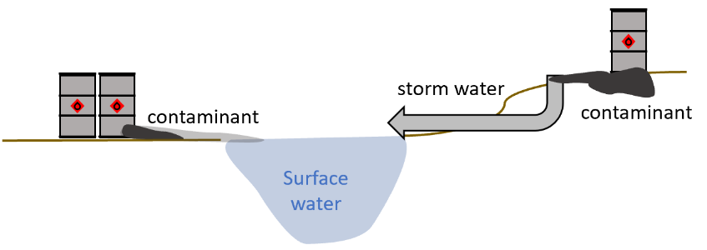
Water sampling results may indicate notifiable contamination where contaminants have already entered surface water. When assessing whether the contaminants present in the water samples are likely to have originated from your site, you should give consideration to the background water quality to determine if the contamination is originating from up gradient or from your site.
In assessing if there is an actual or likely discharge to surface water by which contamination originating from your site is likely to enter surface water and is likely to remain above the specified concentration you must consider potential pathways for contaminant migration. This requires consideration of the location of surface water bodies and drainage/stormwater discharges in the proximity of your land. A discharge may occur where a stormwater drain or other overland flow pathway connects to a creek that runs through your land or an adjacent waterway. You should also consider the potential for contaminated water to be transported overland across adjacent land, for instance through a stormwater drain.
EPA recommends that you consider surface water bodies at, adjacent to, or within approximately 2 kms down hydraulic gradient of your land. This is an approximate distance to consider, and may vary depending on the contaminant of concern, drainage/stormwater connections at your site and the aquifer properties.
The point of discharge to surface water is the relevant point at which to determine whether the contamination is notifiable.
If concentrations of contamination discharging to a surface water body are at such a concentration that they may pose an imminent risk to surface water users or aquatic life this is a notifiable incident, in accordance with section 30 of the Act. You must take immediate action to address the risk posed by the discharge. You must also notify EPA immediately in accordance with section 32 of the Act. Section 6.2 of this guidance provides more information about responding to immediate or imminent risk. See Reporting a notifiable incident on EPA’s website for more information.

When assessing the potential for adverse impacts on surface water EPA recommends you should consider the likely uses of the surface water as well as the environmental value of the surface water at the point of discharge. This consideration should guide your selection of the relevant default guideline values presented in ANZG and ADWG.
Ecosystem protection criteria are provided in the ANZG guidance. The application of the ANZG criteria take into account actual and desired ecosystem quality. To determine the appropriate level of ecosystem protection for the surface water discharge location EPA recommends that you identify the relevant environmental segment and the corresponding environmental values for that segment as set out in the Environment Reference Standard.
For additional guidance on assessing groundwater and surface water behaviour, see Section 9.7 of this guideline.
If a NEPM contaminant is entering or likely to enter surface water that would exceed the applicable ADWG or ANZG guideline value, the contamination is notifiable under regulation 10(2).

Non-aqueous phase liquid (NAPL)
The presence of NAPL in groundwater, surface water or an aquifer on or in land is notifiable in accordance with regulation 10(3). Guidance on the appropriate management response to NAPL is provided in EPA publication 1977 Guide to the duty to manage contaminated land.

When you reasonably should be aware that NAPL is present
NAPL commonly occurs when petroleum hydrocarbons, chlorinated hydrocarbons or inorganic compounds (such as mercury) are released to the environment (for example as a spill, by leaking from aboveground or underground storage systems, when poured down drains, etc.). In assessing your duty to notify about NAPL, consider whether these types of systems, infrastructure, or chemicals may have been used at your land.
The nature of these chemicals means that they are not miscible (that is, not capable of mixing without separation of the two phases) with water and are either light (float to the top of the water) or dense (sink to the bottom). When released to land and groundwater they can be present in the unsaturated and saturated zones of the aquifer, and may be observed or visible in several ways, such as:
- staining of soils (for example, visible chemicals within the soil column or geological voids including cracks, fractures, pore spaces)
- sheens or measurable thicknesses of separate phase liquid in a groundwater bore or trenches where water gathers
- analytical results from soil, groundwater or soil vapour samples indicate that the saturation limit or solubility of the chemical has been reached
- analytical results from soil, groundwater or soil vapour samples indicate that the concentrations are approaching a percentage of the pure phase solubility that indicates the presence of NAPL (for example, petroleum hydrocarbons at 10 per cent or volatile chlorinated hydrocarbons at 1 per cent pure phase solubility are typically considered indicative of the presence of NAPL) but you should consider the state of knowledge for the particular chemical of concern at the time of assessment.
The presence of NAPL in an onsite or offsite drain or utility may be one indicator that NAPL is present in soil or groundwater below the land, and may be an avenue through which contamination is, or is likely to discharge to groundwater or surface water. So, while NAPL presence in a drain or utility is not a criterion for notification, EPA recommends further investigation to determine whether NAPL is present in soil, groundwater or surface water, or is likely to enter groundwater or surface water.
It is noted that the presence of NAPL in soil is not in itself a notifiable circumstance unless the soil forms part of an aquifer.
If there is evidence that NAPL is present in groundwater, surface water or an aquifer, the contamination is notifiable under regulation 10(3).

Potential exposure to friable asbestos
The presence of friable asbestos in or on soil on land is notifiable if a person is, or is likely to be, exposed to airborne asbestos by means of inhalation at fibre levels of above 0.01 fibres per millilitre (regulation 9). | 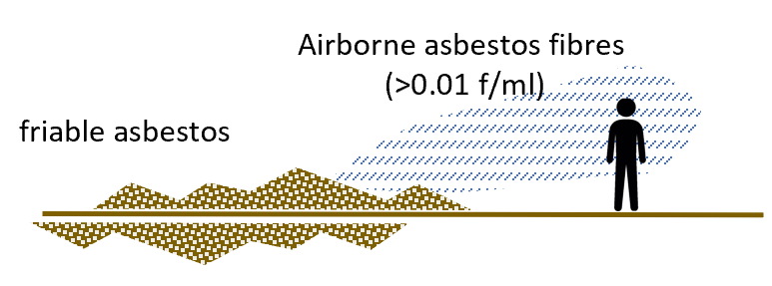
Friable asbestos that is not in or on soil on land is not notifiable, for example in a flange, gasket or lining remaining attached to piping. People in management or control of land containing asbestos not in or on soil may be subject to obligations under the Occupational Health and Safety Act 2004, as well as waste obligations under the (Environment Protection) Act if it becomes waste.
The presence of friable asbestos on or in soil may be identified through:
- asbestos registers prepared for the land under the Occupational Health and Safety Regulations 2017
- detection of fibres in air from monitoring results
- visually, where friable asbestos material is present in visible quantities in the soil.
The concentration of fibres per millilitre of air can be assessed using the membrane filter method in the National Occupational Health and Safety Commission’s Guidance Note on the Membrane Filter Method for Estimating Airborne Asbestos Fibres 2nd Edition.
While air monitoring results may provide definitive evidence of exposure to airborne asbestos fibres, regulation 9 also requires notification when exposure from soil derived airborne fibres is likely but not confirmed.
In considering whether a person is likely to be exposed to more than 0.01 fibres per millilitre of air by inhalation, EPA recommends that you take into account:
- What is known about the presence of asbestos on the land – if there is no reasonable expectation that friable asbestos was used as part of the buildings or structures on the land then it is unlikely that the land will be notifiable under section 40.
- Data confirming the presence of asbestos on or in the soil – this may include, but is not limited to, soil samples confirming presence of the friable asbestos.
- Past land use history – including whether any demolition on the land was completed in a controlled manner in according with occupational health and safety legislation.
- Potential for asbestos on or in the soil to be disturbed and released into the air.
- Whether the release of asbestos fibres is likely to occur at a rate that would result in airborne concentrations exceeding 0.01 fibres per millilitre.
Judgement may need to be exercised to form a view about the likelihood that friable asbestos is present on or in the soil, and whether a person is likely to be exposed to respirable fibres. Such judgement may include reliance on advice provided by specialist consultants. See Section 9.1 of this guideline for more information about when EPA considers that circumstances are ‘likely’.
WorkSafe Victoria has published compliance codes addressing the removal and management of asbestos in the workplace, including guidance on assessing the likelihood that airborne asbestos fibres will be generated.
EPA also recognises that Victoria’s workplace health and safety duties on employers and those in management or control of a workplace impose duties in relation to minimising the risks to the health and safety of employees and other people from the presence of friable asbestos. These duties also regulate removal of asbestos and its disposal at a place that can lawfully receive it.
If your land contains friable asbestos in or on soil which could expose a person to airborne fibres at >0.01 f/mL (before any management intervention) the contamination is notifiable under regulation 9.

Onsite retention of contaminated soil
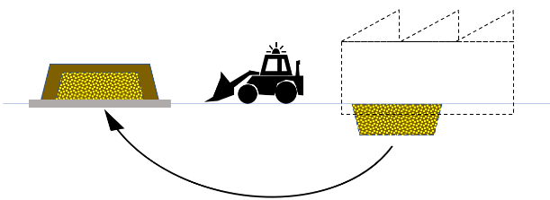
Regulation 12 requires EPA to be notified of onsite retention of excavated surplus soil if all of the following apply:
- the soil arises from contaminated land sourced onsite
- the soil is not fill material
- retention of the soil is not an activity for which permission is required.
Regulation 13(d) adds the following requirement which must be met for retained soil to be notifiable:
- there are contaminant(s) listed in section 6 of Schedule B1 of the NEPM (ASC).
As part of site redevelopment, it may be necessary to reconfigure the site layout. There may be circumstances where soil could be retained at a site as part of redevelopment or reconfiguration, in a way that minimises the risks of harm so far as reasonably practicable. Information you should consider when deciding whether to retain contaminated soil on your site is set out in Section 9.9 of this guideline.
EPA considers the term ‘retention’, within the context of regulation 12, refers to circumstances where:
- contaminated soil, sourced from your site, has been excavated, and
- the soil is surplus to requirements, and
- a decision has been made to keep that soil onsite.
Soil that is ‘fill material’ within the meaning of the Regulations is not notifiable. For guidance on determining if the soil at your site meets the definition of 'fill material', refer to EPA Publication 1828.2 Waste disposal categories – characteristics and thresholds.
In some circumstances the decision to retain contaminated soil onsite will require a permission. See Section 9.9 for further information on potential permissions for waste retention. If you are required to obtain a permission for your soil retention activity you are not required to complete the notification process.
Notification of retained soil will assist in maintaining a record of that retained soil and associated management requirements are made available to future people in management or control of the land.
If contaminated soil is to be retained onsite the contamination may be notifiable under regulation 12.

Other notification requirements
This guideline only relates to notifiable contamination under section 40 of the Act. This section provides a summary of other relevant reporting requirements.

Other reporting requirements to EPA
There are other notifiable obligations that require reporting to EPA not covered in this guidance, including (for example):
- pollution incidents that cause or threaten to cause material harm to human health or the environment (section 32 of the Act)
- where an imminent state of danger to human health or the environment from pollution or waste is identified by an environmental auditor in carrying out any of their functions (section 216 of the Act)
- reporting requirements under a permission issued under Chapter 4 of the Act or a remedial notice issued under Chapter 10 of the Act.
Notifications may also be required under other legislation, such as occupational health and safety laws. If you are unsure what notification requirements may apply, EPA recommends that you seek professional advice.

Notifying EPA of imminent or immediate risks of harm
Some contaminants can pose imminent or immediate risks of harm to human health or the environment due to their toxicity, pathogenicity, flammability, or explosivity, particularly when present at higher concentrations.
Managing the imminent or immediate risk of harm may include contacting EPA as soon as practicable. However, notifying EPA of an imminent risk does not discharge your duty to notify as it does not cover all the information required by the duty to notify. More detail about responding to imminent risk is presented in section 4.1 of EPA publication 1977 Guide to the duty to manage contaminated land.
Suspected or confirmed imminent or immediate risks of harm to human health and/or the environment should be reported as soon as practicable to EPA on 1300 372 842, as well as any relevant emergency services.

Exemptions
There are some circumstances that are exempt from notification under section 40(4) of the Act. One circumstance is where the duty holder is aware that a notification has already been made in accordance with section 40 of the Act (discussed in section 3.2 of this guideline). The other exempt circumstances are those set out in regulation 13:
- Industrial waste stockpiles (regulation 13(a)): A stockpile of industrial waste at a place or premises authorised to receive industrial waste, other than retention of soil described in regulation 12 (detailed in Section 7.1 of this guideline).
- Land under an Environment Protection Act 1970 (1970 Act) remedial notice (regulation 13(b)): Contamination of land for which a notice was served by EPA under section 31A, 31B, or 62A of the 1970 Act for land or groundwater contamination, that was in force immediately before the repeal of that Act or had been revoked if there has been no material change in the condition of the land after the notice was served or revoked (material change is explained below in Section 7.2.3).
- Land which had an environmental audit completed under the 1970 Act prior to 1 July 2021 (regulation 13(c)): Land for which a certificate of environmental audit or a statement of environmental audit has been issued by an environmental auditor under the 1970 Act, if—
- no potentially contaminating activities have been carried out on the land after the certificate or statement was issued (see Section 7.2.1 below); and
- there has been no material change in the condition of the land after the certificate or statement was issued (explained in Section 7.2.3 below); and
- there are no adverse effects on land adjacent to the land.
- Contamination from a waste or chemical substance not specified in section 6 of Schedule B1 of the NEPM (ASC) (regulation 13(d)): other than contamination arising from:
- friable asbestos described in regulation 9
- NAPL described in regulation 10(3).
These substances can be notified to EPA voluntarily – this is discussed in Section 9.6 of this guideline.

Industrial waste stockpiles
Activities involving industrial waste, including waste soil, are regulated under Part 6.4 of the Act.
Waste that is comprised of contaminated soil that has been lawfully received is not notifiable to EPA under section 40 of the Act in accordance with regulation 13(a). For example, where contaminated soil is transferred to a place or premises authorised to receive that soil under Chapter 6 of the Act (for example a permissioned landfill, or where an EPA determination applied), then the person with management or control of the receiving place or premises is not required to notify EPA of contaminated land. Further guidance on understanding lawful place is provide on EPA’s website. See Understanding lawful place.

Environmental audits and remedial notices

Environmental audits and remedial notices issued under the Act
Under the Environment Protection Act 2017 (the Act), if EPA issues a remedial notice for land you manage or control, or an environmental audit commences, you will not be exempt from the duty to notify under section 40 of the Act. EPA will, however, consider the relevance of this duty when considering the requirements to be included in remedial notices or if EPA chooses to review the audit scope.

Active environmental audits
As of 1 July 2021, if an environmental auditor has been engaged to conduct an environmental audit and notified EPA of this engagement but the audit is not complete (such that neither a certificate nor statement of environmental audit has been issued) the exemption in regulation 13(c) does not apply. In this situation you must notify EPA when you become aware or reasonably should have become aware that notifiable contamination is present. You cannot wait until the audit is finished before notifying EPA as you are required to notify EPA as soon as practicable.

Material changes on land subject to a 1970 Act remedial notice or environmental audit
The exemptions in regulation 13(b) and (c) in relation to remedial notices and environmental audits (where certificates or statements of environmental audit have been issued) under the 1970 Act do not apply where there has been a material change in the condition of the land after the notice was served or revoked, or after the audit certificate or statement was issued.
A material change aims to distinguish changes of minor or insignificant nature from those that tend to impact the assumptions made about the original circumstances that have important implications for the ongoing circumstances. Material changes may include instances where a spill or dumped waste occurred after the audit was completed or the notice revoked.

Activities undertaken on land since a 1970 Act audit was completed
Where land had been the subject of a certificate of environmental audit or a statement of environmental audit under the 1970 Act but potentially contaminating activities have occurred on that land since the certificate or statement was issued, then any notifiable contamination identified at the land must be notified to EPA.
For example, if land was cleaned up to an industrial use standard, new industrial activities were commenced, and new notifiable contamination was caused, the contamination will be notifiable despite the existence of a statement of environmental audit.
EPA regards ‘potentially contaminating activities’ to include any failure to have fulfilled a statement of environmental audit’s conditions regarding management of the contamination. If notifiable contamination is identified for such land, it will be notifiable.
If it becomes apparent that adjacent land has been adversely affected, you must notify EPA, even if an audit has been completed for your land, if one or more of the notifiable circumstances that relate to offsite impacts is satisfied.
For example, if a statement of environmental audit was completed, but later it was identified that a person was exposed to vapour intrusion (within the meaning of regulation 11) on adjacent land because of contamination on your land, that contamination would be notifiable. Similarly, if an ongoing condition under the audit (for example, installing and monitoring groundwater wells) uncovers that land adjacent is, or is likely to be, adversely affected by contamination from your land, then the duty to notify may apply.

Section 53V audits
The exemption from notification in regulation 13(c) applies only in relation to circumstances where a certificate or a statement of environment audit has been issued under section 53X of the 1970 Act. Therefore land which has been subject to a 53V audit is not included in this exemption. The exemption for 53X audits was included due to the breadth of their scope. Section 53V reports do not cover the same comprehensive scope, meaning they are unlikely to have resulted in the same degree of disclosure of contamination to EPA as would be made through a section 53X audit.

The notification process
Before notifying EPA under the duty to notify it is important that you:
- are satisfied you meet all criteria for the type(s) of notifiable contamination in the Regulations and as set out in Sections 4 and 5 of this guideline
- have taken all practicable steps to gather the relevant information to complete your notification in the manner and form required by EPA, including your management response or proposed management response – more detail is provided in Section 8.3 of this guideline.
If you are not able to confirm the basis upon which you believe you must notify, and you cannot provide an adequate level of detail required by EPA under section 41 of the Act, EPA may not be able to accept your notification. However, it is noted that there may be circumstances where you become aware of high levels of contamination which may create a risk of harm, before you have had time to gather an adequate detail to complete the notification process. This is discussed below in Section 8.1.

Timing of the notification process
Section 40(1) of the Act requires a person in management or control of land to notify EPA as soon as practicable after the person becomes aware of, or reasonably should have been aware of the notifiable contamination.
EPA understands that it generally will not be reasonably practicable to notify EPA of contamination until sufficient information such as soil and groundwater data has been collected to enable the duty holder to determine if notifiable contamination exists. The contaminated land duties under the Act create obligations on persons in management or control of contaminated land to proactively manage risks posed by the contamination. In many instances, it will only be practicable to notify EPA of notifiable contamination when you have started meeting your duty to manage which may include completing contamination assessment activities and have acquired the necessary information and knowledge to make a notification.
However, when the person is aware of, or should reasonably be aware of notifiable contamination, having an incomplete understanding of that contamination should not prevent them from notifying EPA.
There may be some limited circumstances when, early in the assessment process you become aware of contamination of a scale and extent likely to pose a likely or imminent risk to human health or the environment. One example of this might be when you observe visual or olfactory evidence of contamination, such as signs of a significant fuel or chemical spill. In this case you should contact EPA immediately, and EPA can guide you in determining the most appropriate course of action which may include completing a notification prior to obtaining all the required information. You should also consider whether the circumstance of the contaminant might pose an imminent risk, as discussed in Section 6.2 of the guideline.
Section 41(2) of the Act requires a duty holder to provide EPA the information that they know at the time of notification. If you do not know some of the required information, section 41(4) of the Act requires you to provide further information as soon as practicable after you become aware of it, in order to complete the scope of matters set out in section 41 and regulation 14. Additionally, failure to assess and characterise risks from contaminated land to a level that would allow notification for the purposes of sections 40 and 41 may prevent you from meeting your duty to manage contaminated land or the GED.

Information that must be provided to EPA
Section 41 of the Act specifies that the notification should be in a form approved by EPA and include the information set out in section 41(2). Regulation 14 also requires you to provide information on the management response, or proposed management response, to the notifiable contamination as part of the notification. One purpose of providing information on the management response is to allow EPA to assess how you are meeting your duty to manage.
Detailed guidance on the form and manner of notification is provided on EPA’s webpage: Contaminated Land Notification Process.

Information relating to the management response
EPA publication 1977 Guide to the duty to manage contaminated land sets out the standard of conduct EPA expects for duty holders under section 39 of the Act.
Under the duty to notify, EPA requires information on what management response a person notifying has in place or is proposing to put in place – that is, how they are meeting their duty to manage under section 39 of the Act. The benefit of providing EPA with this information is that it will help EPA to assess whether a duty holder is complying with their duty to manage. This allows EPA to determine which persons in management or control of contaminated land may be required to provide further information or be inspected by EPA to confirm if their approach appropriately meets the duty to manage, and which contaminated lands EPA is satisfied are being managed to an acceptable standard.
EPA’s webpage: Contaminated Land Notification Process provides a pro forma setting out the information requirements for your notification, including what is required in a management response. The amount of information you need to provide will depend on the nature and extent of the risk being managed. You will need to include reference to all evidence you have (or are in the process of gathering) to support your statements and conclusions relating to the assessment and control of risk of harm to human health and the environment. You are not required to provide these documents as part of the notification process, but all relevant assessments, documents and reports need to be made available to EPA on request.

Responding to new information
In accordance with section 41(4) of the Act, if you did not know information you are required to provide under section 41(2) at the time of notification, but you subsequently become aware of it, you are required to provide a new notification or an update to the existing notification to EPA as soon as practicable upon becoming aware of that new information.
In some cases re-notification or updates to your notification may be required because:
- contamination that is notifiable was discovered after a notification was made
- a new and more sensitive use commences on the land resulting in different lower thresholds applying to that use
- new information becomes available that materially changes anything already notified to EPA
- information was being gathered at the time of notification where a staged assessment was being completed but it was not available or presentable to EPA at the time (for example groundwater monitoring data).

The status of the ‘management response’ in assessing what is notifiable circumstances
You must notify as soon as practicable after you become aware of notifiable contamination, even if you plan to take mitigation or management steps that will mean the contamination will no longer be notifiable. Information on the presence of contamination before mitigation or management provides EPA with an understanding of the nature and extent of contamination across Victoria and supports EPA to fulfil its duties and functions as a regulator.
Further, the notification process includes a requirement to provide a management response that is in place or a proposed management response. A duty holder’s management response or proposed response (how they will meet their duty to manage) will help EPA determine what, if any, response is required from EPA.
Where management responses rely on administrative controls (such as site induction requirements, site registers and procedures) it is important that EPA is aware of the underlying presence of the contamination despite these controls, because the effectiveness of administrative controls is highly dependent on the compliance attitude of site occupants. The selection of risk controls is explained in EPA publication 1977 Guide to the duty to manage contaminated land.
So, when assessing for the presence of an exposure or migration pathway, or the likelihood of that pathway exposing a person to contamination, the notifiable circumstances are those that apply before consideration of management responses that may aim to disrupt or limit the exposure/migration pathway.

Potential follow up actions by EPA
After submitting the notification to EPA, you can expect the following:
- An acknowledgement of your submission–see EPA’s webpage: Contaminated Land Notification Process for more details.
- EPA to make an initial assessment of the risk of harm associated with your notifiable contamination in accordance with our internal triaging process.
- Where EPA considers that the notifiable contamination warrants a closer assessment, your management response will be considered. At this point you might be requested to provide copies of your supporting documentation or further clarity on your notification. EPA will contact you by phone or email, to specify what you are required to provide, and will provide a link to an EPA location where the relevant assessments/reports/documents can be provided.
- If your management response does not provide sufficient detail or does not adequately demonstrate how you are meeting your duty to manage, EPA may seek further assurance on the effectiveness of your response by gathering more information (using broader information gathering powers) or requiring involvement of a suitable professional, such as an environmental auditor.
- Where EPA’s further assessment determines that regulatory action is required to address the management of your notifiable contamination, EPA will contact you to communicate our regulatory approach in accordance with the Compliance and Enforcement Policy.
Throughout this process, EPA’s goal is to be satisfied that the duty holder can demonstrate they understand the contamination, their obligations under the duty to manage, and that they are taking all reasonably practicable steps to minimise the risks of harm to human health and the environment (or if they are the polluter – restoring the land).

Additional considerations for notifiable contamination
This section sets out guidance on how to evaluate elements of the duty to notify to support notification decisions. Evaluation of contamination can be complex and requires judgement to be exercised when identifying when contamination is notifiable.

When EPA considers that circumstances are ‘likely’ for the purposes of notification
The term 'likely' is used in Regulations 8–11, which prescribe notifiable contamination. For example, the relevant contamination is notifiable when:
- a person is likely to be exposed to a contaminant (in relation to a contaminant – including friable asbestos – in or on soil)
- a contaminant is likely to enter and remain on adjacent land
- a contaminant on adjacent land is likely to have entered from the duty holder's land
- a contaminant is likely to discharge to surface water
- the concentration of a contaminant is likely to remain above a specified level.
Generally, the word ‘likely’ has been interpreted to mean a ‘real and not remote chance or possibility’.
To determine whether a particular circumstance is 'likely', EPA recommends that you consider:
- the uses of the land or activities that occur in that location
- the nature and extent (both vertical and lateral) of the contamination.
The findings of a sampling program, combined with the modelling from the Conceptual Site Model (CSM), will help in assessing whether one of the notifiable circumstances is or is not likely.
If the sampling program does not meet National Environment Protection (Assessment of Site Contamination) Measure 1999 (NEPM (ASC)) or AS4482.1 standards for sampling, for instance because the sampling program may not yet be complete, EPA recommends that you make reasonable assumptions on the data to reach a finding of circumstances being ‘likely’ or ‘not likely’. EPA recommends that you should not rely on gaps in the data to conclude that circumstances are not likely.
A narrower set of factors is relevant when considering the circumstance of a contaminant being ‘likely to remain’. In this context the use of ‘likely’ is limited to the predicted duration of the elevated concentration of the contaminant. EPA considers that you can exclude circumstances where there is an elevated concentration of a contaminant of short duration.

Guidance on assessing and managing NAPL impacts on groundwater and surface water
Guidance on the assessment of surface water and groundwater, including how to deal with NAPL impacts, is included in the following standards and guidance:
- NEPM (ASC) (including Schedule B1 and Schedule B2)
- Guidelines for conducting audits for land suitability purposes (EPA publication 759)
- Guidance for the cleanup and management of contaminated groundwater (EPA publication 2001)
- Hydrogeological assessment (groundwater quality) guidelines (EPA publication 668)
- Groundwater sampling guidelines (EPA publication 669)
- Sampling and analysis of waters, wastewaters, soils and wastes (EPA publication IWRG701)
- The design, installation and management requirements for underground petroleum storage systems (UPSS) (EPA publication 888.4)
Other sources of information and guidance may be of assistance, such as CRC CARE (2015) Technical Report 34: A practitioner’s guide for the analysis, management and remediation of LNAPL.

Land use that does not fit into the NEPM (ASC) land use settings
The Regulations define notifiable circumstances by reference to the tables in the NEPM (ASC). If the actual or zoned land use of your land (or relevant adjacent land) does not reasonably fit within the NEPM (ASC) settings, then you may not be required to notify EPA under section 40 of the Act. For example, the NEPM (ASC) land use settings do not describe land that is used for agricultural purposes (in respect of soil), but regulation10(1) does address groundwater that is or may be used for irrigation or as stock water. Therefore, soil contamination at agricultural land would not meet the definition of notifiable contamination but in some cases groundwater or surface water impacts on agricultural land may be notifiable contamination.
It is important to consider the elements of the environment that are or may be contaminated to confirm if a notification is required. EPA may also have issued guidance in your sector that provides more information about complying with the GED and the duty to manage contaminated land.
Generally, EPA considers that land in urban and regional city areas will be covered by one of the four land use settings. Land used for infrastructure, roads and reserves should use the industrial or commercial NEPM (ASC) land use category. When land is used for more than one purpose, EPA considers that the most sensitive land use should be used to inform the appropriate NEPM (ASC) land use setting. If you are unsure of which land use applies in your specific situation, EPA recommends that you be conservative and use the NEPM (ASC) land use that applies to the most sensitive receptor and user on your land.
Even when contamination is not notifiable due to the land use setting, as a person in management or control of such land you must still manage any risks of harm associated with the contamination under your duty to manage. This may include notifying other people that may be affected by the presence of that contamination. You will also be required to minimise any risks of harm from that contamination when engaging in an activity that disturbs or involves the relevant contaminated land (to meet your GED).

Notification of connected parcels of land
Where contamination has moved across a number of sites (that is more than one connected parcel of land) that are under the management or control of the same person, EPA will only require a single notification to address these circumstances. When completing the online notification form (refer to: EPA’s webpage: Contaminated Land Notification Process) you will be asked to include all the relevant land title and parcel details for the area of land that you are notifying.
Similarly, if a single, contaminated site is subdivided before notification is made, when relinquishing management or control of a part of the site that does not include the source area, the contamination on that site will be regarded as ‘offsite’ for the purposes of notifying EPA. If the original site was notified to EPA, then further notification would not be required. If, however, notification had not been required (for example, due to its use for industrial purpose and contamination being below HIL-D levels) and the use of the land changes to a more sensitive use of, then notification may be required.
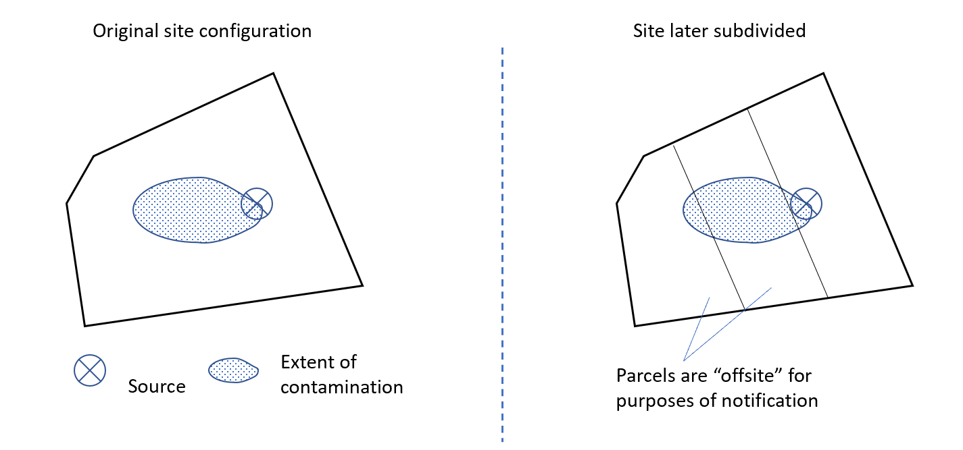
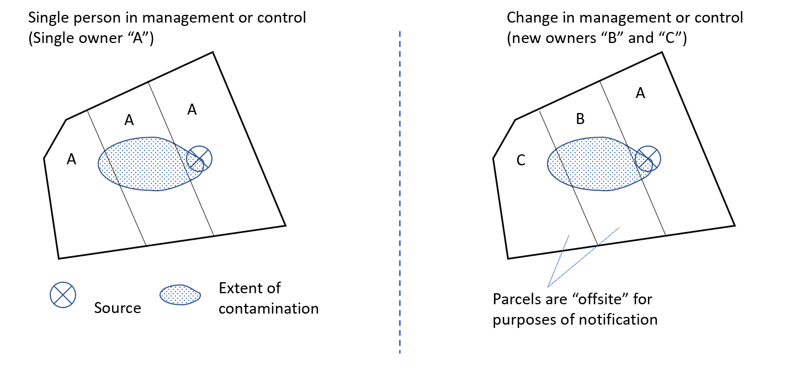

Naturally enriched concentrations
In some parts of Victoria there are naturally higher levels of certain substances that, when deposited or discharged through human activity, are regarded as contaminants. Where the concentration of a contaminant on your land is not higher than the 'background level', as defined in section 36 of the Act, section 40 of the Act does not apply because such land does not fulfil the definition of 'contaminated land' under section 35 of the Act. See EPA publication 1940 Contaminated land: understanding section 35 of the Environment Protection Act 2017 and Background Levels Methodology Guidance (publication 2033).
for more information on the definition of contaminated land.
If, however, the presence of the substance arises from being translocated from another region or from its original strata, then it may fall within the definition of 'contaminated land' in section 35 of the Act. For example, arsenic-containing material extracted at depth and deposited on the surface or near the surface of the land is not regarded as ‘naturally occurring’ simply because the underlying geology has naturally enriched levels of arsenic. Therefore, the contamination may be notifiable if the presence of that material also meets the other criteria for notifiable contamination.
Even when such land is not considered contaminated, the GED will still apply to activities involving that land, that generate waste or pollution that creates a risk of harm to human health or the environment. Further, naturally occurring substances must also be managed in accordance with other provisions in the Act, such as the waste obligations where the substances become ‘waste’ within the meaning of the Act.

Notifying of other substances
Non-notifiable contamination may be reported to EPA voluntarily. If you have only non-notifiable contamination, EPA does not expect notification.
EPA recognises that there are limitations in the NEPM (ASC) where not all contaminants of concern have investigation thresholds for all elements of the environment that may pose a risk to human health and the environment. Through assessment of the land, including consideration of the past and current activities, you may have identified additional contaminants that are not notifiable. If this is the case you can provide this information using the online notification form for your notifiable contamination (refer to: EPA’s webpage: Contaminated Land Notification Process) which has been designed to accept it. If you have information about your management response (how you are meeting your duty to manage) to non-notifiable contamination you can also provide this in the online notification form.

Further guidance on assessing the likelihood of surface water and groundwater discharges
Further guidance on groundwater and surface water assessment and modelling is provided in the following guidelines:
- Water Quality Guidelines (ANZG 2018)
- NEPM (ASC) (including Schedule B1 and Schedule B2)
- Guidance for the cleanup and management of contaminated groundwater (EPA publication 2001)
- Groundwater sampling guidelines (EPA publication 669)

Notification of changes to your management response?
Generally, you do not need to notify EPA of changes to your management response. You may need to update EPA if you significantly change how you are meeting your duty to manage through your management response, or if your actual management response changes from what you proposed.
If you discover any material omission from your original notification when implementing your management response (for example a new, previously unidentified notifiable circumstance becomes evident), or information you were required to provide was not known to you at the time you notified EPA, then you may need to notify EPA of any significant adjustments to the management response (how you are meeting your duty to manage for the notifiable contamination), particularly where a higher risk potential is identified as a result of the additional information.
If EPA visits your site to inspect your management response/your actions to meet your duty to manage, you should be able to demonstrate how the response has been updated in reaction to any new information or material change in circumstances from those on which the original management response was based.

Additional considerations for onsite retention of contaminated soil
Any decision to retain contaminated soil onsite must be consistent with your duty to manage risks of harm from contaminated land. There will be circumstances where retention of soil sourced onsite from contaminated land will not be suitable. Guidance on how you can meet your duty to manage is provided in EPA publication 1977 Guide to the duty to manage contaminated land.
Retention of soil sourced onsite from contaminated land may also require approval under the Planning & Environment Act 1987 and must comply with other Victorian legislation (for example the Occupational Health and Safety Act 2004 where the site is to remain a workplace).
Whether onsite retention is appropriate or not will depend on consideration of what is reasonably practicable to manage the risks of harm to human health and the environment (under the duty to manage) in the circumstances, including the availability and suitability of treatment options. Onsite retention of contaminated soil is only lawful where retention can be achieved in a manner that minimises risks of harm to human health and the environment so far as reasonably practicable. In some cases, onsite retention of larger volumes of contaminated soil may require a permission from EPA. One example of this is an L02 development licence which may be required for retention of contaminated soil in a structure designed for the purpose of preventing further contamination.
You must not import contaminated materials from other sites unless authorised under the Act (for example through a permission, including movement of Category D waste on another part of a ‘project site’ as defined by the Regulations).

The footnotes to the tables in Section 6 of Schedule B1 of the NEPM (ASC)
There are some circumstances when the footnotes to the tables in Section 6 of Schedule B1 of the NEPM (ASC) should be considered. These tables represent investigation and screening levels based on generalised conditions. In some instances, the values cited in the tables are qualified by one or more assumptions – identified using footnotes to the tables. The applicability of some of these footnotes – such as the land use categories – are outlined in more detail elsewhere in this guideline.
While this guideline does not address the assumptions and qualification set out in the footnotes, a person may take those footnotes into account where relevant when determining the trigger level applicable to their circumstances. For example, the HIL for arsenic in soil in Table 1A sets a level that assumes 70 per cent bioavailability of the arsenic. In some parts of Victoria, a lower bioavailability may be assumed in relation to arsenic where the assumption is supported by objective evidence. In such circumstances, it is appropriate to adjust the investigation levels in line with the applicable circumstances of your site rather than rigidly apply the HIL specified in the table.

How EPA will assess compliance
One purpose of this guideline is to provide duty holders with an understanding of what EPA expects for compliance with section 40 of the Act. EPA will use the guideline as part of the way it assesses compliance with section 40.

EPA’s regulatory approach
Any enforcement activity EPA undertakes will be guided by our Compliance and enforcement policy.

Our regulatory approach uses a mix of encouragement and deterrence to motivate action and deliver improved outcomes for Victorian communities and the environment.
As a science-based regulator, we apply a risk-based approach that uses science, intelligence and evidence to prioritise our effort to where we can make the biggest difference. When we make decisions under the Act, we are guided by the principles of environment protection. Our decisions also give regard to human rights under the Charter of Human Rights and Responsibilities.
We work with other organisations, agencies and partners to protect human health and the environment. Local government (councils) play an important role as joint-regulators, bringing timely responses to localised issues of pollution and waste.
We respect and acknowledge Traditional Owner cultural values and knowledge and their responsibility and duty to protect and heal Country. We engage and collaborate with Traditional Owners to consider cultural values as part of our regulatory approach.
When we use our regulatory tools, we focus on the problem and desired outcome and apply them in a consistent, transparent, and proportionate way.

Skills, knowledge and experience required to be aware of notifiable contamination
Section 40(3) of the Act sets out the factors that inform the determination of when a person in management or control of land becomes aware of, or reasonably should have become aware of, notifiable contamination. The factors are:
- the person's skills, knowledge and experience; and
- whether the person could practicably seek advice regarding the contamination; and
- any other circumstances of the contamination.
Table 2 outlines considerations EPA may use when determining if you have the skills, knowledge or experience to be aware of notifiable contamination.
Table 2: Possible considerations for determining if a person has the skills, knowledge and experience to be aware of contamination in accordance with section 40(3)a of the Act
Skills | - Is the duty holder (including staff employed by the duty holder) capable of identifying contamination issues considering the skills possessed or needed as part of their business or undertaking? It is noted that some forms of contamination, such as an oil spill, may be so obvious through visual and olfactory evidence, that the amount of skill needed to be aware of the contamination will be very low.  - Do other participants in the duty holder’s sector (with a comparable size of operations) typically engage or employ environmental specialists about contamination?
Knowledge | - Does the duty holder possess reports that advise of the level of contamination? For example, acquired during purchase of the land.  - Does the duty holder know about past practices on their land that are known to cause contamination? For example, materials provided to the duty holder as part of the purchase of the business or land.  - Should the duty holder reasonably know that an activity currently or historically undertaken on the land is of a nature that would likely result in contamination of that land? For example, storage of bulk chemicals, or fuel storage in underground petroleum storage systems.  - Does the duty holder host (or have they hosted) activities that are generally known to be associated with contamination on the land? For example, land where chemical storage or manufacturing is taking place, or has historically taken place?  - Has the duty holder been advised by EPA, or any other person, of the likelihood of contamination being present at land they manage or control?  - Has the duty holder taken steps to learn about the land's history or received information (for example, through a due diligence exercise) that increased their knowledge of the land's conditions?  - Has the duty holder observed features at the site that might indicate the presence of contamination. For example, visual evidence such as staining of surfaces, olfactory evidence such as strong chemical odours, or the presence of stockpiles of unknown origin that may indicate illegal dumping at an unsecured site.  - One consideration in determining whether a duty holder became aware of (or should have become aware of) notifiable contamination is whether the person could practicably seek advice regarding the contamination.
Experience | - Has the duty holder owned or occupied known contaminated land in the past?  - Does the duty holder participate in part of the property sector where contamination risks have historically arisen? For example, has the duty holder owned or developed inner city or industrial land in the past?  - Is the duty holder participating in, or has the duty holder participated in, activities that are known to cause contamination? For example, operating underground storage tanks, undertaking electroplating activities?

Glossary
Term or Phrase | Definition and guidance
ADWG guideline values | The Australian Drinking Water Guidelines Paper 6 ─ National Water Quality Management Strategy, published by the National Health and Medical Research Council, National Resource Management Ministerial Council, Commonwealth of Australia in 2011, as in force from time to time.
ANZG default guideline values | The Australian and New Zealand Guidelines for Fresh and Marine Water Quality), published by the Australian and New Zealand Governments and Australian State and Territory Governments in 2018, as in force from time to time
Aquifer | (Defined in section 3 of the Act)  A geological structure or formation or an artificial land fill permeated or capable of being permeated permanently or intermittently with water.
Average threshold | (Defined in regulation 4 of the Environment Protection Regulations 2021)  The 95% upper confidence limit on the arithmetic average concentration of a contaminant in or on soil that is equal to the Health Investigation Level (HIL) for that contaminant for the current use of the land, as specified in section 6 of Schedule B1 of the NEPM (ASC). See section 13.2 of Schedule B2 of the NEPM (ASC).
Background level | Refer to section 6.1 of EPA Publication 1940 Contaminated land: understanding section 35 of the Environment Protection Act 2017,
Contaminant | A chemical substance the presence of which may result in the land being ‘contaminated land’ within the meaning of section 35 of the Environment Protection Act 2017.
Friable asbestos | (Defined in regulation 4 of the Regulations)  Asbestos that, when dry—  (a) may be crumbled, pulverised or reduced to powder by hand pressure; or  (b) as a result of a work process becomes such that it may be crumbled, pulverised or reduced to powder by hand pressure.
GED | General environmental duty (see section 25 of the Act)
Groundwater | (Defined in section 3 of the Environment Protection Act 2017)  Any water contained in or occurring in a geological structure or formation or an artificial landfill below the surface of land.  For the purpose of this guideline, and consistent with the Environment Reference Standard clause 13(2), environmental values do not apply to waters in a constructed landfill cell.
Health Investigation Levels (HILs) | Assessment criteria presented in the NEPM (ASC).
Health Screening Levels (HSLs) | Assessment criteria presented in the NEPM (ASC).
Land | (Defined in the Environment Protection Act 2017)  Any land, whether publicly or privately owned, and includes—  (a) any buildings or other structures permanently affixed to the land; and  (b) groundwater.
Localised elevated value threshold | (Defined in regulation 4 of the Environment Protection Regulations 2021)  The concentration of a contaminant in an individual soil sample that is equal to 250% of the HIL for that contaminant for the current use of the land, as specified in section 6 of Schedule B1 of the NEPM (ASC).  This applies to what is sometimes referred to as a ‘hotspot’. Such hotspots may be associated with the source of a contaminant on a site, or they can be a location at which a contaminant has preferentially accumulated.
L02 licence | For the purposes of the Environment Protection Regulations 2021, item 74 (L02—Containment Sites, onsite soil retention) in the Table in Schedule 1, the following is a development licence activity: Onsite retention of contaminated soil (other than fill material) in a structure designed to contain at least 1000 m³ of the soil and to prevent further contamination.
Non-aqueous phase liquid (NAPL) | (Defined in the Environment Protection Regulations 2021)  An organic or inorganic liquid that—  (a) is not miscible with water; and  (b) can exist in soil or groundwater in various forms; and  (c) is commonly present as a measurable thickness (phase-separated) or sheen; and  (d) may be identifiable analytically (in soil or groundwater) when solubility has been reached or observed to be present within the unsaturated soil, rock profile or aquifer matrix.
NEPM (ASC) | National Environment Protection (Assessment of Site Contamination) Measure 1999
Project site | For the purposes of the Environment Protection Regulations 2021, item 25 (A17—Containment of Category D waste soil) in the Table in Schedule 1 of, means any land specified by the Authority in the permit provided that land is—  (a) a single area of land which is identified in a document as part of an amendment to a planning scheme under the Planning and Environment Act 1987 made on or after 1 July 2021; or  (b) land that relates to public works within the meaning of the Environment Effects Act 1978.
Risk | The probability in a certain timeframe that an adverse outcome will occur in a person, a group of people, plants, animals and/or the ecology of a specified area that is exposed to a particular dose or concentration of a chemical substance, i.e., it depends on both the level of toxicity of the chemical substance and the level of exposure.
Site | (Defined in the Environment Protection Act 2017)  Specified land or a specified parcel of land.  For the purposes of section 40, land under a person’s management or control that comprises a series of contiguous parcels will be regarded as a single site for notification purposes.
State of knowledge | The body of accepted knowledge that is known or ought to be reasonably known about the harm or risks of harm to human health and the environment and the controls for eliminating or reducing those risks.  The state of knowledge will develop over time as new technology, systems and processes develop or where there is an emerging risk.  See EPA Publication 1741.1 Industry guidance: supporting you to comply with the general environmental duty for more information about the state of knowledge.
Surface water | (Defined in the Environment Reference Standard 2020)  Waters other than groundwater;  Examples: River, stream, billabong, lake, tidal water, estuary, marine and coastal water.
Useable groundwater | Groundwater that is used, or may be used for human consumption or contact, stock watering or irrigation. This is based on the groundwater segment and applicable environmental values and applies before considering whether the use is existing, likely or unlikely.

Acronyms and abbreviations
Acronym | Definition
ADWG | Australian Drinking Water Guidelines
ANZG | Australian and New Zealand Guidelines for Fresh and Marine Water Quality
AT | Average threshold
CSM | Conceptual site model
DSI | Detailed site investigation
GED | General environmental duty
HIL | Health investigation level
HSL | Health Screening levels
LEVT | localised elevated value threshold
NAPL | Non-aqueous phase liquid
NEPM (ASC) | National Environment Protection (Assessment of Site Contamination) Measure 1999

Appendix A: Summary of notification triggers by segment of the environment
Segment | Contaminant | Exceedance levels | Concentration thresholds | Circumstances | Reg ref
Soil | NEPM ASC, Sch. B1, s 6 | HILs for soil: Table 1A(1) | > average threshold (AT); or  ≥ localised elevated value threshold (LEVT) | A person is, or is likely to be, exposed | 8(a)
 |  |  |  | Contaminant has entered adjacent land from, or likely from, land under your management or control | 8(b)
 |  |  | Likely above the HIL for a contaminant applicable to the current use of the adjacent land | Contaminant is present in or on soil on your land and is likely to enter and remain on adjacent land | 8(c)
 | Friable asbestos |  | > 0.01 fibres/mL inhalation exposure | A person is, or is likely to be, exposed to airborne asbestos fibre by inhalation. | 9
 | Soil sourced from contaminated land | <1,000 m³ (contained in a structure) or any volume otherwise | > fill material thresholds | - It is not fill material  - Is not an activity for which permission is required  - It arises from contaminated land sourced onsite, and  - They are contaminant(s) listed in NEPM (ASC) section 6 Schedule B1.  The soil can safely be retained on site with the risks of harm suitably managed (as the duty to manage should have been considered before deciding to retain). | 12
Soil/ groundwater | NAPL | Any presence in groundwater, surface water or an aquifer on or in land | Commonly present as a measurable thickness (phase-separated) or sheen, or as visible staining or foil or rock  May be identifiable analytically when the saturation limit has been reached or observed to be present within the unsaturated soil, rock profile or aquifer matrix.  May be identified analytically when concentrations in water are above, or approach a known percentage of the solubility limit |  | 10(3)
Water | NEPM ASC, Sch. B1, s 6 | ANZG | Is, or is likely to be, above, and remain above, the guideline or default guideline value for that contaminant | Entry or likely entry of a contaminant into groundwater if the groundwater discharges, or is likely to discharge, to surface water, or the groundwater is used, or may be used, for  (i) human consumption or contact;  (ii) stock watering; or | 10(1)
 |  | ADWG: Guidelines Paper 6 | OR  Is, or is likely to be, above, and remain above, the guideline or default guideline value for that contaminant specified in the ADWG | (iii) irrigation;  OR  Entry or likely entry of a contaminant into surface water, likely to remain above specified concentration | 10(2)
Vapour | NEPM ASC, Sch. B1, s 6 | Soil vapour samples: Interim soil vapour HILs for VOCs: Table 1A(2); | > 95% UCL on the arithmetic average concentration for the current land use and likely to remain above that average concentration  OR | A person is, or is likely to be, exposed to the contaminant or any by-product of the contaminant. | 11(1)(a) & (b)
 |  | Soil vapour samples: Soil HSLs for vapour intrusion: Table 1A(3); | The concentration in an individual sample is equal to or above 250% of the concentration for the current land use and likely to remain above that concentration |  | 11(1)(c) & (d)
 |  | Groundwater samples: GW HSLs for vapour intrusion Table 1A(4); |  |  | 11(1)(e) & (f)
 |  | Soil samples:  Soil Vapour HSLs for vapour intrusion: Table 1A(5) |  |  | 11(1)(g) & (h)

Appendix B Referenced documents and standards
The following references represent standards that help inform the state of knowledge on contamination risks of harm:
Australian and New Zealand Governments and Australian State and Territory Governments, (2018) Australian and New Zealand Guidelines for Fresh and Marine Water Quality, Accessed 7 September 2022.
CRC CARE (2015), Technical Report 34: A practitioner’s guide for the analysis, management and remediation of LNAPL.
Australian Government (As amended 2013),
- National Environment Protection (Assessment of Site Contamination) Measure 1999 (NEPM (ASC)). Accessed 7 September 2022.
  - Schedule B1 Guideline on Investigation Levels for Soil and Groundwater
  - Schedule B2 Guideline of Site Characterisation
  - Schedule B4 Guideline on Site-Specific Health Risk Assessment Methodology
  - Schedule B6 Guideline on The Framework for Risk-Based Assessment of Groundwater Contamination
  - Schedule B7 Guideline on Derivation of Health-Based Investigation Levels
Australian Government National Health and Medical Research Council (2011) Australian Drinking Water Guidelines Paper 6—National Water Quality Management Strategy.
EPA Victoria (2022)
- Hydrogeological assessment (groundwater quality) guidelines (publication 668)
- Groundwater sampling guidelines (publication 669)
- The cleanup and management of polluted groundwater (publication 840.2)
- Guide to the duty to manage contaminated land (publication 1977).
- Background Levels Methodology Guidance (publication 2033).

EPA Victoria (2021)
- Contaminated Land Policy (publication 1915). Accessed 7 September 2022.
- Contaminated land: Understanding section 35 of the Environment Protection Act 2017 (publication 1940). Accessed 7 September 2022.
- Potentially contaminated land - A guide for business (publication 2010). Accessed 7 September 2022.
- Proposed methodology for deriving background level concentration when assessing potentially contaminated land (publication 1936). Accessed 7 September 2022.
- Guide to the Environment Reference Standard (publication 1992). Accessed 7 September 2022.
- Guidance for the cleanup and management of contaminated groundwater (publication 2001). Accessed 7 September 2022.
EPA Victoria (2015)
- Guidelines for conducting audits for land suitability purposes (publication 759). Accessed 7 September 2022.
- The design, installation and management requirements for underground petroleum storage systems (UPSS) (publication 888). Accessed 7 September 2022.
EPA Victoria (2009) Sampling and analysis of waters, wastewaters, soils and wastes (publication IWRG 701). Accessed 7 September 2022.
EPA Victoria (2006) Hydrogeological assessment (groundwater quality) (publication 668). Accessed 7 September 2022.
Safe work Australia’s website provides a range of information on hazardous chemicals, including information on the United Nations Globally harmonized system (GHS) of Classification and Labelling of Chemicals the Hazardous Chemical Information System and the National Occupational Health and Safety Commission’s Guidance Note on the Membrane Filter Method for Estimating Airborne Asbestos Fibres 2nd Edition [NOHSC:3003(2005)] ()
Standards Australia (2005) AS 4482.1—2005, Guide to the sampling and investigation of potentially contaminated soil, Part 1: Non-volatile and semi-volatile compounds.
State Government of Victoria (2021) Environment Protection Regulations. Accessed 7 September 2022.
State Government of Victoria (2017) Occupational Health and Safety Regulations 2017. Accessed 7 September 2022.

Accessibility
Contact us if you need this information in an accessible format such as large print or audio.
Please telephone 1300 372 842 or email contact@epa.vic.gov.au

Interpreter assistance
If you need interpreter assistance or want this document translated, please call 131 450 and advise your preferred language. If you are deaf, or have a hearing or speech impairment, contact us through the National Relay Service

ADWG and the ANZG include a number of substances that are not listed in section 6 of Schedule B1 of the NEPM. Notifiable contamination is limited to the substances listed in the NEPM tables in section 6 (see regulation 13(d)).
For regulations 8(a), 8(b) and 11 the threshold concentration is either the localised elevated value threshold (LEVT) or the average threshold (AT); for regulation 8(c) the threshold is the HIL for the current use of the adjacent land.
For guidance on defining 'fill material', refer to EPA Publication 1828.2 Waste disposal categories – characteristics and thresholds.
NEPM (ASC), Schedule B1, section 2.4.13.
EPA notes that the environmental values for human consumption in the ERS are described differently for surface water (human consumption after treatment) and groundwater (raw water or potable supply) and both refer to the same ADWG values. EPA regards that reference to ‘consumption’ in the ERS equates to reference in the regulations to ‘human consumption or contact’.
The ANZG sets out guidelines applicable to recreational contact and water quality (section 5.2 of ANZECC and ARMCANZ 2000) and incorporated reference to the National Health and Medical Research Council (2008) Guidelines for Managing Risks in Recreational Water noting in particular the footnote ‘a’ on page 155 (Note: The footnote refers to ‘Table 9.1’, but this should be a reference to ‘Table 9.3), which suggests use of a conversion factor to relate drinking water guidelines to recreational contact. For some contaminants a more sensitive threshold may be more appropriate than the general conversion factor suggested by footnote ‘a’.
The ANZG sets out guidelines applicable to livestock drinking water at: https://www.waterquality.gov.au/anz-guidelines/guideline-values/default/primary-industries/stock-water-guidance.
Guidelines applicable to irrigation are set out in section 4.2 of the ANZECC & ARMCANZ (2000)
Note: Only the type of contaminants listed in Table 1C of Schedule B1 of the NEPM (ASC) are relevant to notification. The groundwater investigation levels are not relevant. Instead, refer to the guideline and default guideline values in the ADWG and the ANZG for the corresponding substances listed in Table 1C.
Refer to the glossary for the definition of NAPL used in the Regulations
If friable asbestos is visible on or in the soil (for example, as imported material on site such as waste or soil) then its origin is irrelevant.
EPA notes that at present there is no National Association of Testing Authorities (NATA)-accredited method for quantifying the concentration of friable asbestos in soil.
For example, EPA Determination - Specifications acceptable to the Authority for receiving fill material (http://www.gazette.vic.gov.au/gazette/Gazettes2021/GG2021S301.pdf)
Note: the word ‘likely’ has been consistently interpreted in the context of environmental protection to mean a ‘a real and not remote chance or possibility’. See Pace Farm Egg Products Pty Ltd v Newcastle City Council [2006] NSWCCA 403; 151 LGERA 260 at [54]-[56]); and NSW Environment Protection Authority v Sydney Drum Machinery Pty Ltd (No 4) [2016] NSWLEC 59. EPA considers that the meaning of ‘likely’ should not be interpreted as meaning ‘more likely than not’ or more than a 50 per cent chance.
Note: in administering the Act and the Regulations, EPA will have regard to the principles of environmental protection in Chapter 2 of the Act. Section 20, which is within Chapter 2, states that: If there exist threats of serious or irreversible harm to human health or the environment, lack of full scientific certainty should not be used as a reason for postponing measures to prevent or minimise those threats.
‘Site’ is defined in the Act and means ‘specified land or a specified parcel of land’.

