Trace Elements in Wild Waterfowl & Human Health Risk Assessment

Publication 2057 | April 2023
Minna Saaristo, Land and Waste Sciences

epa.vic.gov.au
Environment Protection Authority Victoria
GPO BOX 4395 Melbourne VIC 3001
1300 372 842

This publication is for general guidance only. You should obtain professional advice if you
have any specific concern. EPA Victoria has made every reasonable effort to ensure accuracy
at the time of publication.

Give feedback about this publication online: epa.vic.gov.au/publication-feedback

EPA acknowledges Aboriginal people as the first peoples and Traditional custodians of the land
and water on which we live, work and depend. We pay respect to Aboriginal Elders past and present
and recognise the continuing connection to, and aspirations for Country.

Contents
Introduction & overview 4
1.1 Background 4
1.2 Overview 4
1.3 Aim 4
1.4. What is the temporal and spatial scope of this study? 4
1.5 What species were targeted and why? 6
1.6 What elements were targeted and why? 6
1.7 Why is lead of concern? 6
Summary Results 7
1.8 Comparison to domestic poultry meat (all species combined) 7
1.8.1 Meat 7
1.8.2 Liver 7
1.9 Comparison to guidelines (all species combined) 8
1.10 Daily intake assessments (all species combined) 9
Advice to public based on EPA’s study 11
1.11. Advice regarding consumption of wild duck meat and livers 11
1.11.1 Copper and Selenium in breast meat 11
1.11.2 Mercury in breast meat 11
1.11.3 Lead in breast meat 11
1.11.4 All trace elements in wild duck livers 12
1.12 Further investigation of lead at sites 12
Accessibility 2
Interpreter assistance 2

Introduction & overview

1.1 Background

In Victoria Australia, wild waterfowl are harvested during the annual duck-hunting season and are consumed by game hunters and the general population. The exact dates of the season can vary year-to-year, but the season typically runs from mid-March to mid-June. Given that ducks feed from both sediment and water, and eat animals (e.g. crustacea, insects, water snails, other molluscs) that are known to bioaccumulate natural and anthropogenically sourced trace elements, there is a possibility that wild duck meat or edible offal might be contaminated.

1.2 Overview
EPA Victoria undertook sampling of wildfowl in May and June 2018 comprising 166 ducks from 19 waterbody sites (Figure 1). Edible parts (breast meat and liver) of ducks were separated for chemical analysis. Across the four waterfowl species targeted, the aim was to collect up to 6 individuals per species, per site. Actual sample numbers collected were: chestnut teal (n = 42), grey teal (n = 57), pacific black duck (n = 51) and pink-eared duck (n = 15). Numbers varied across 0-6 individuals per site. Where more than one individual of a species was obtained at a site, samples were combined to achieve a single homogenised sample per species and site. These samples were then analysed for per- and polyfluoroalkyl substances (PFAS) and trace elements. The PFAS results were reported previously in March 2019 (EPA Report 1734). This report focuses only on the trace element analyses of the same samples.

1.3 Aim
The object of this report is to summarise EPA’s assessment of trace element concentrations in edible portions of wild duck and to evaluate if there is a human health risk from consumption.

1.4. What is the temporal and spatial scope of this study?

The study data is a ‘snapshot study’ conducted over a relatively brief sampling window in 2018. Although constrained in time, the study was geographically expansive (Figure 1). Sites were chosen to capture a range of popular recreational hunting locations in wetlands, rivers and lakes from across Victoria.

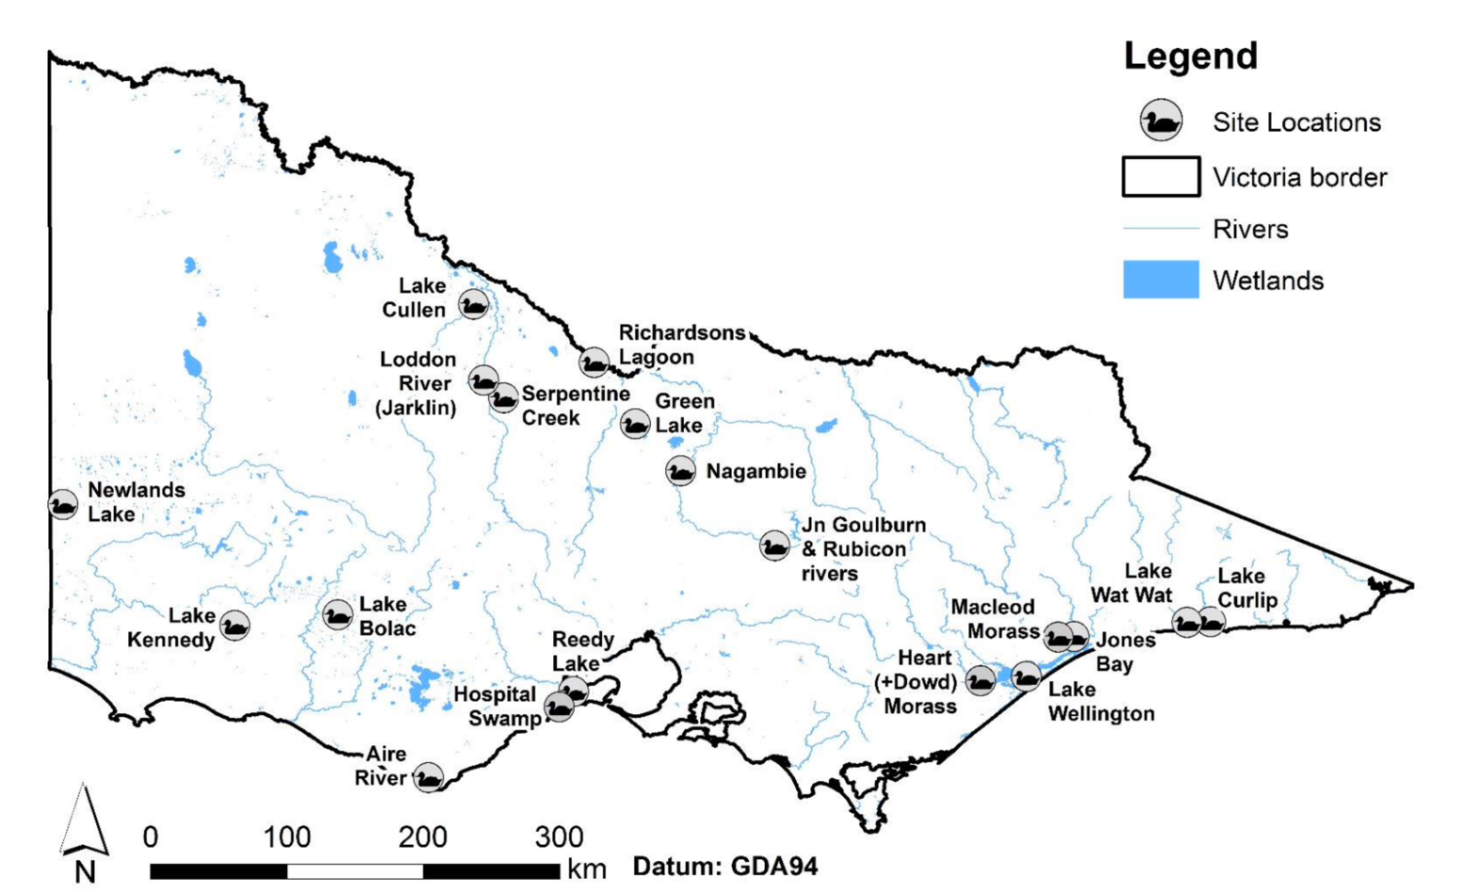

Figure 1. Wetland sampling sites where waterfowl and environmental samples were collected across Victoria during May to June 2018.

- Aire River
- Green Lake
- Heart and Dowd Morasses
- Hospital Swamp
- Jones Bay
- Junction of Goulburn and Rubicon Rivers
- Lake Bolac
- Lake Cullen
- Lake Curlip
- Lake Kennedy
- Lake Wat Wat
- Lake Wellington
- Loddon River (Jarklin)
- Macleod Morass
- Nagambie
- Newlands Lake
- Reedy Lake
- Richardson’s Lagoon
- Serpentine Creek

1.5 What species were targeted and why?

The four duck species (chestnut teals, grey teals, pacific black ducks, pink-eared ducks) studied are available for hunting in the open season, and so can form a component of general public diets. The four species were chosen because they represented >75% of waterfowl harvested in 2017. Importantly, these ducks differ in their feeding modes. Chestnut and grey teals are highly capable divers, but also frequently ‘dabble’ food from the water surface. Pacific black ducks engage in various feeding modes, but tend not to be highly effective divers, and feed more heavily from shallow sediment and waterweeds. Pink-eared ducks are considered almost exclusively filter-feeders and typically only ‘dabble’ the surface (eating small crustaceans and insects). Pink-eared ducks dive infrequently, if at all. These behaviours influence the ducks’ exposure to different sources of contaminants held in aquatic animals, water and sediment.

1.6 What elements were targeted and why?

Eight trace elements (arsenic, cadmium, chromium, copper, lead, mercury, selenium and zinc) were selected for assessment as they are common anthropogenic contaminants, and at elevated concentrations can have toxic effects in humans. Although these trace elements vary in their toxicities, they all have the potential to cause harm if ingested at sufficient quantities.

1.7 Why is lead of concern?

Lead is of particular interest, as there is concern among the public that lead shot used in hunting might leach into the environment and/or be ingested accidentally by ducks. Lead shot was banned in Victoria in 2002, but there is public concern that remnant lead shot may still be present in some waterbody sediments. Lead has well-known toxic effects in humans. Ducks that frequently feed from the bottom (pacific black ducks) or dive for food (the two teal species) are more likely to be exposed to lead shot in sediment. Hence, ducks that seldom dive and almost exclusively ‘dabble’ from the surface (Pink-eared ducks) and less likely to be exposed to lead in sediments.

Summary Results
EPA’s study data indicate that:
- Chromium and zinc concentrations in wild duck meat and livers were not at levels likely to pose a human health risk.
- Arsenic, cadmium, copper, lead, mercury and selenium exceeded residual concentrations reported in domestic poultry and were at or above levels where some personal consideration of health risks associated with consumption of the animal product may be warranted (Table 1).
- Lead concentrations in wildfowl represent a relatively low risk. Lead levels in some ducks did exceed dietary guidelines for domestic meat, but median lead levels across all samples never exceeded 1.2% of recommended dietary limits for adults or children.
- Cadmium, copper, mercury and selenium represent moderate risks. Of these, copper and selenium showed the most pronounced risk. For children, median copper and selenium levels exceeded 20% of daily limits in a single meat serving.
Food Standards Australia and New Zealand (FSANZ) and the World Health Organization (WHO) do not provide guidelines for trace elements in wild waterfowl. Therefore, where available, guidelines for domestic meat and edible offal are applied in this assessment. Further to this, comparisons are made using values obtained from the Australian Residual Metals in Meat and Eggs Survey (Metals in Meat and Eggs Survey, 2009-2010). Where guidelines are referenced, these are from FSANZ Schedule 19 (2016) unless otherwise stated.

1.8 Comparison to domestic poultry meat (all species combined)

1.8.1 Meat
Arsenic, lead and mercury were detected in wild duck meat: arsenic in 22.5% of samples, lead in 32.5% of samples, mercury in 97.5% of samples). In contrast, the Residual Metals in Meat and Eggs Survey reported that arsenic, lead and mercury were never detected in domestic poultry meat. Cadmium was never detected in wild duck meat, corresponding to domestic poultry meat as identified in the Residual Metals Survey. With the exception of chromium, the remaining metals, copper, selenium and zinc, were higher in wild duck meat samples compared to domestic poultry meat (Table 1).

1.8.2 Liver
Lead and mercury were detected in wild duck livers (lead in 100% of samples, mercury in 97.5% of samples), but were never detected in domestic poultry livers In the Residual Metals in Meat and Eggs Survey. All other metals were present in both wild and domestic livers. Except for chromium, all trace elements were higher in the wild duck liver samples (Table 1).

1.9 Comparison to guidelines (all species combined)
Only lead and cadmium have FSANZ guidelines that are specific to meat and edible offal (e.g. liver). The guidelines provide the following maximum concentrations: lead in meat – 0.05 mg/kg; edible offal – 0.5 mg/kg; cadmium in meat – 0.05 mg/kg, edible offal – 0.5 mg/kg. Cadmium was never detected in wild duck breast meat. Cadmium exceeded guidelines for edible offal in 10% of liver samples. Lead exceeded guidelines for both meat and edible offal (liver samples) in 2% samples.
Trace element concentrations in wild duck livers were always greater than domestic meats: median concentrations were higher for arsenic x3; cadmium x41, copper x3.4; lead x18; mercury x3.5). In addition, with the exception of chromium, trace elements in duck meat and livers always exceeded trace element quantities measured in domestic poultry as part of the Australian Residual Metals in Meat and Eggs survey of 2009-2010.
These findings are neither surprising or concerning. Wild ducks have much longer lifespans than domestic poultry (before slaughter) and have more opportunity to bioaccumulate trace elements over a longer life-span. Wild animals are also more likely to be exposed to more natural and anthropogenic trace elements in their environments. Table 2 compares the values found for wild ducks to recommended daily limits.

Table 1. Comparison of the current data (trace elements in ducks) to Residual Metals in Meat and Eggs Study. Medians and 90th percentiles are shown. Where trace elements were not detected in poultry meat (arsenic, cadmium, chromium and lead), poultry liver (cadmium and chromium), or wild duck meat (cadmium), a ‘nd’ (non-detect) notation is used with half the lower limit of reporting (LOR) shown. The LOR is the lower limit at which the element can be detected. The use of half-LOR is a standard reporting method where elements are not detected in analysis, because it cannot be assumed that analyses below the LOR mean there is zero concentration present. Of the elements investigated here, FSANZ guidelines for meat and edible offal are only in place for cadmium and lead. The 90% percentile represents the point at which only 10% of the remaining data is higher. It is used to describe the data similar to the way we use median (50th percentile or middle value) but excluding outlier values that skew the data.
 | FSANZ Guideline |  | Trace elements in ducks study  (all waterfowl species combined) |  |  |  | Residual metals survey  (domestic poultry)
 | Meat | Offal | Breast Meat |  | Liver |  | Poultry Meat  (age 35-52 days) |  | Poultry Liver  (age 35-52 days)
 |  |  | Median | 90th Percentile | Median | 90th Percentile | Median | 90th Percentile | Median | 90th Percentile
 | mg/kg | mg/kg | mg/kg | mg/kg | mg/kg | mg/kg | mg/kg | mg/kg | mg/kg | mg/kg
Arsenic |  |  | 0.025 | 0.07 | 0.075 | 0.27 | nd (0.0025) | 0.01 | 0.01 | 0.13
Cadmium | 0.05 | 0.5 | nd (0.005) | nd (0.005) | 0.205 | 0.473 | nd (0.0015) | nd (0.0015) | 0.01 | 0.01
Chromium |  |  | nd (0.025) | nd (0.025) | 0.025 | 0.025 | 0.05 | 0.07 | 0.05 | 0.09
Copper |  |  | 6.1 | 7.5 | 21 | 35.18 | 0.25 | 0.33 | 2.79 | 3.6
Lead | 0.1 | 0.5 | 0.005 | 0.033 | 0.09 | 0.322 | nd (0.0040) | nd (0.0040) | nd (0.0040) | nd (0.0040)
Mercury |  |  | 0.03 | 0.093 | 0.105 | 0.472 | nd (0.0005) | nd (0.0005) | nd (0.0005) | nd (0.0005)
Selenium |  |  | 0.425 | 0.56 | 1.33 | 2 | 0.21 | 0.36 | 0.6 | 0.76
Zinc |  |  | 11 | 11 | 50 | 59.6 | 5.35 | 6.08 | 24.74 | 35.08

1.10 Daily intake assessments (all species combined)
Daily intake assessments were undertaken for adults and children to better undertake the extent of any health risks identified in the data. This assessment assumed a 70 kg adult eating a 200 g portion of wild duck breast meat or a 100 g portion of liver. The child assessment is for a 15 kg individual eating a 100 g portion of wild duck breast meat or a 50 g portion of liver. Given that the duck meat is likely not the only source of trace elements in a person’s diet, and the known risk that some trace elements can bioaccumulate in the human body, EPA Victoria opted to draw attention to trace elements that equalled or exceeded 5% of daily limit threshold in at least one category of a standard portion. The 5% cut-off is a conservative and risk-averse threshold (Tables 2 and 3).

Table 2. Food intake assessment for wild duck breast meat.
Food Standards Australia and New Zealand (FSANZ) tolerable limits are used to establish the percentage of daily limit for each trace element in an example adult (70 kg adult, 200 g duck meat portion) and child (15 kg, 100 g duck meat portion). Daily limits were obtained from the 20th Australian Total Diet Survey (Part B). Where the amount of a trace element ingested from a single portion exceeds 5% of the daily limit, the value is indicated in bold. Note that the 5% threshold does not constitute advice for or against eating a given species or portion. Rather, it is to allow individuals to make informed decisions about inclusion of wild duck meat or liver in their diet. Chromium and zinc do not have daily dietary limits because the toxicity of these elements is sufficiently low relative to their abundance in a normal human diet that they are considered unlikely to pose a generalised health risk.

BREAST | FSANZ Tolerable Levels |  |  | Median meat 200 g portion | Percent Daily intake  (70 kg adult)  (200 g portion) | Percent Daily intake  (15 kg child)  (100 g portion)
 | mg/kg bw/day | 70 kg adult (mg/day) | 15 kg child (mg/day)
Arsenic | 0.003 | 0.21 | 0.045 | 0.005 | 2.4% | 5.6%
Cadmium | 0.007 | 0.49 | 0.105 | 0.001 | 0.2% | 0.5%
Chromium | na | na | na | 0.005 | na | na
Copper | 0.200 | 14 | 3.0 | 1.22 | 8.7% | 20.3%
Lead | 0.025 | 1.75 | 0.375 | 0.001 | 0.1% | 0.1%
Mercury | 0.001 | 0.49 | 0.011 | 0.006 | 1.2% | 2.9%
Selenium | 0.0125 | 0.875 | 0.188 | 0.085 | 9.7% | 22.7%
Zinc | na | na | na | 2.2 | na | na

Table 3. Food intake assessment for wild duck livers.
Food Standards Australia and New Zealand (FSANZ) tolerable limits were used to establish the daily limit percentage for each trace element in an example adult (70 kg adult, 100 g duck liver portion) and child (15 kg, 50 g duck liver portion). Daily limits were obtained from the 20th Australian Total Diet Survey (Part B). Where the amount of a trace element ingested from a single portion exceeds 5% of daily limit, or where a single portion serve would exceed 5% of the daily recommended limit, the number is indicated in bold. No guidelines are available for chromium and zinc. Note that the 5% threshold does not constitute advice for or against eating a given species or portion. Rather, it is to allow individuals to make informed decisions about inclusion of wild duck meat or liver in their diet. Chromium and zinc do not have daily dietary limits because the toxicity of these elements is sufficiently low relative to their abundance in a normal human diet that they are considered unlikely to pose a generalised health risk.

LIVER | FSANZ Tolerable Levels |  |  | Median liver  100 g portion | Percent Daily intake (70 kg adult)  (100 g portion) | Percent Daily intake  (15 kg child)  (50 g portion)
 | mg/kg bw/day | 70 kg adult (mg/day) | 15 kg child (mg/day)
Arsenic | 0.003 | 0.21 | 0.045 | 0.015 | 3.6% | 8.3%
Cadmium | 0.007 | 0.49 | 0.105 | 0.041 | 4.2% | 9.8%
Chromium | na | na | na | 0.005 | na | na
Copper | 0.200 | 14 | 3 | 4.2 | 15.0% | 35.0%
Lead | 0.025 | 1.75 | 0.375 | 0.018 | 0.5% | 1.2%
Mercury | 0.007 | 0.49 | 0.105 | 0.021 | 2.1% | 5.00%
Selenium | 0.0125 | 0.875 | 0.188 | 0.265 | 15.1% | 35.3%
Zinc | na | na | na | 10 | na | na

Advice to public based on EPA’s study

1.11. Advice regarding consumption of wild duck meat and livers

1.11.1 Copper and Selenium in breast meat
EPA Victoria’s advice is that the data indicates that duck breast meat is unlikely to pose a risk to most healthy adults when eaten in standard portion sizes. However, any person who is already exposed to copper or selenium (such as from a workplace) may wish to take this into account when deciding on portion sizes and frequency for eating duck meat.

1.11.2 Mercury in breast meat
For persons in a category where the standard advice is to limit mercury exposure (e.g. young children and pregnant women), it would be prudent to limit consumption of wild duck meat, in particular Pink-eared Ducks.

1.11.3 Lead in breast meat
Although lead exposure remains a ongoing public concern, lead in wild duck meat was not at a level that presents a clear risk to adults or children, given the current FSANZ guidelines. Nonetheless, lead is present in the ambient environment from a variety of sources even at low concentrations (e.g. dust, soil, water) and the WHO currently advises that no amount of dietary lead can be considered health protective, and especially for children under six years of age. Consequently, some caution around portion sizes and/or frequency of eating wild duck meat is a reasonable consideration.

An important outcome of the data analysis is that measured lead levels in wildfowl were low overall, corresponding with other recent independent research of lead in ducks from across Victoria (Nzabanita et al., 2023). Long-term data on lead in Victoria’s waterfowl is not available, but the 2002 ban of lead shot for hunting in Victoria will have contributed to reducing the amount of lead entering environmental waterways. For example, a recent review on game meats (Veli Nkosi, 2021), shows that in territories where lead shot is not yet banned, lead levels were, on average, higher in game meats than the concentrations measured in this study.

1.11.4 All trace elements in wild duck livers
Consumption of wild duck livers (e.g. homemade pâté) presents a higher risk in general due to the higher levels of all trace elements present in these animal products. EPA Victoria’s advice is that a healthy adult eating a standard portion size of wild duck liver is unlikely to be a significant risk, but care should be taken to consider the context of the individual. As is the case for specific elements in duck breast meat, persons who are already in an advice category to avoid a given toxicant (e.g. mercury, lead), or are otherwise exposed to elements in their diet or workplace (e.g. via agrichemical application of copper), should consider limiting or eliminating wild duck liver. Additionally, care should be taken to adhere to standard portion sizes.

1.12 Further investigation of lead at sites
At the time of laboratory testing, it was noted that at four sites the duck breasts lab concentrations exceeded food safety guidelines (2% of the total samples). However, two sites (Heart Morass and Macleods Morass) already had EPA advice in place regarding high PFAS levels. Environmental sampling was subsequently undertaken only at Serpentine Creek and Richardson’s lagoon. Forty-five samples were collected at each waterbody (15 water, 15 sediment and 15 soil samples). Only two water samples (at Richardson’s Lagoon) returned lead concentrations exceeding Australian and New Zealand Guidelines for Fresh and Marine Water (ANZG 2018). These were 1.7x and 2.7x higher than default guidelines. No nearby point-source of contamination (industrial site, landfill, illegal dumping) was identified.

In considering site-specific advice, some aspects of duck biology need to be considered. Although these duck species do tend to habitually revisit locations, they can range over substantially larger areas (sometimes up to hundreds of kilometres) when migrating to and from breeding sites and/or when following rainfall. This presents obvious complications when unravelling site-specific effects. It is probably sensible to consider any site-level differences observed as ‘effects seen in a flock that is frequenting a site’, rather than being specific to a particular site per se. A flock that tends to frequent a given lake could well show higher levels of a trace element, but the birds might be exposed at a nearby untested location.

- Where opportunities present, future assessments of the eight trace elements in wild waterfowl meat and edible offal is warranted.
- EPA Victoria will finalise its full report in 2023 and make it available to the public and publish the finding in a peer reviewed journal.

Accessibility
Contact us if you need this information in an accessible format such as large print or audio.
Please telephone 1300 372 842 or email contact@epa.vic.gov.au

Interpreter assistance
If you need interpreter assistance or want this document translated, please call 131 450 and advise your preferred language. If you are deaf, or have a hearing or speech impairment, contact us through the National Relay Service.
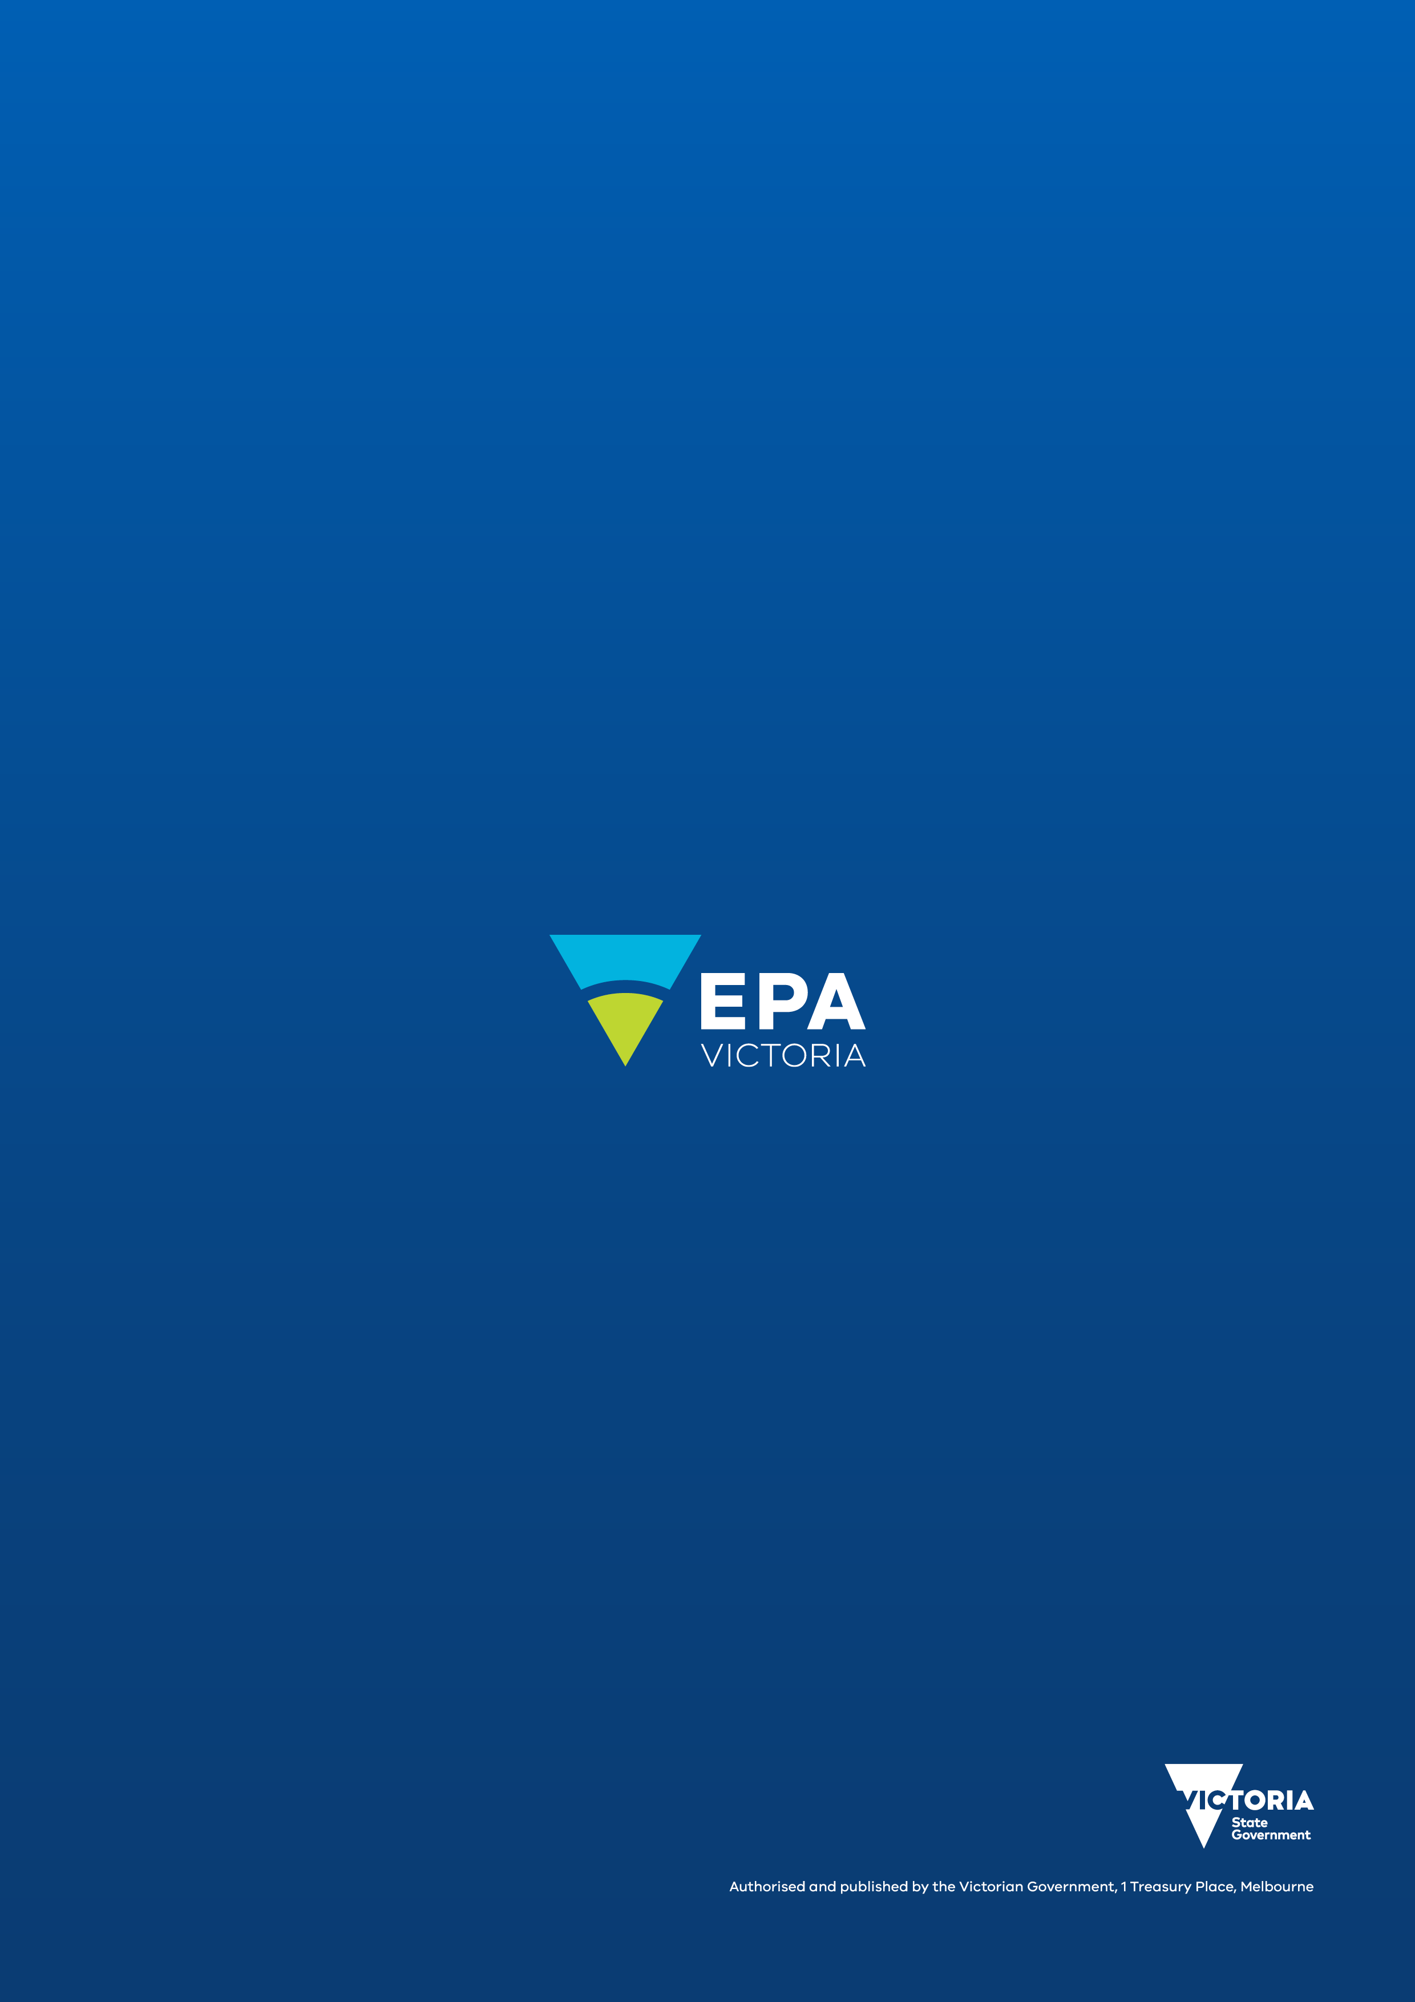
epa.vic.gov.au
Environment Protection Authority Victoria
GPO BOX 4395 Melbourne VIC 3001
1300 372 842

