Authorised and published by the Victorian Government, 1 Treasury Place, Melbourne
Report Card 2021-22

Port Phillip, Western Port and Gippsland Lakes
  - Publication 2059 | May 2023
  - Science Division
Authorised and published by the Victorian Government, 1 Treasury Place, Melbourne

Summary
The annual Report Card summarises the latest environmental water quality in Port Phillip Bay, Western Port and the Gippsland Lakes and their catchments (Figure 1). Environment Protection Authority Victoria (EPA), Melbourne Water and the Department of Energy, Environment, and Climate Change (DEECA) monitor the water quality in these regions. The results are described in this report.
The Report Card uses key indicators of environmental water quality to calculate an overall annual score. The score generates a rating of ‘Very Poor’, ‘Poor’, ‘Fair’, ‘Good’ or ‘Very Good’. This Report Card includes results from July 2021 to June 2022.
In 2021–22, water quality in the bays, lakes and waterways was similar to previous years, except in the East Gippsland Lakes where water quality declined from Good
to Poor.
Data from the Bureau of Meteorology shows that rainfall in central Victoria was average, and well above average in the Gippsland region (Figure 2), repeating a similar pattern seen in 2020-21. Significant rainfalls in the Gippsland catchments in June and November 2021 delivered nutrients to the Gippsland Lakes. Combined with warmer than average summer temperatures, this contributed to a blue-green algal bloom in the Gippsland Lakes that persisted from February to May 2022.
Water quality was mostly Very Good or Good for rivers in the elevated areas where most rivers originate. Water quality generally declined to Poor or Very Poor as the rivers moved through rural, agricultural and urbanised areas in the foothills and coastal plains of the lowlands. In the bays and lakes, water quality was mostly Very Good or Good for areas that are able to mix with the open ocean. Water quality was generally worse in or near rivers that transport pollution from urban and industrial areas.
The annual Report Card has been available on EPA’s website since 2019. Prior to that, results were published on the Yarra and Bay website.

Contents
Figure 1: Location of Port Phillip Bay, Western Port, Gippsland Lakes (dark shading) and their
catchments (light shading).
Summary 2
Contents 2
What is the Report Card? 3
How are the scores calculated? 3
New objectives for analysing water quality Error! Bookmark not defined.
Weather in 2021–22 3
Port Phillip Bay and catchment 4
Western Port and catchment 6
Gippsland Lakes and catchment 9
Further information 11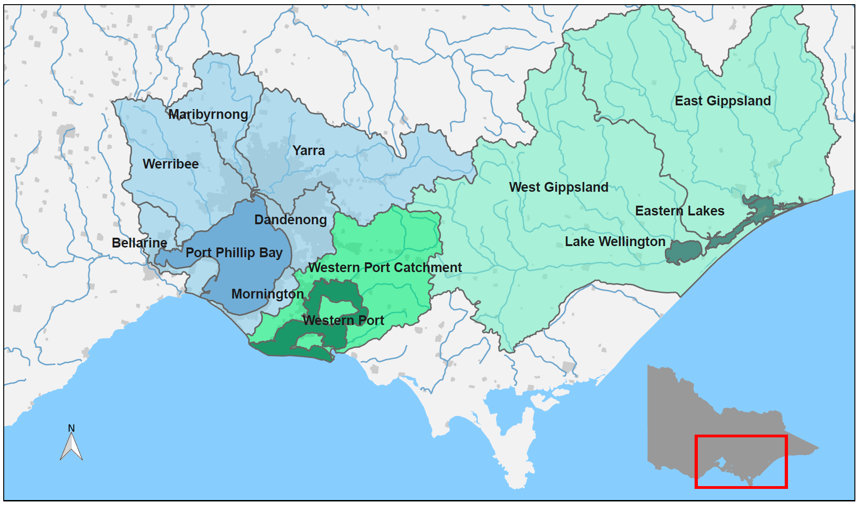

What is the Report Card?
This Report Card provides a snapshot of environmental water quality in Port Phillip Bay, Western Port, Gippsland Lakes, and the waterways in their catchments for 2021–22. These bays and lakes are the largest coastal waterbodies in Victoria. The waterways are a complex network of rivers, wetlands, and estuaries. They are of immense cultural, economic, and environmental value. During summer, EPA forecasts recreational water quality based on microbiological indicators which are not reported here. For more information, see the Yarra Watch and Beach Report programs.

How are the scores calculated?
Key indicators of water quality are assessed against Victorian environmental quality objectives for relevant indicators in the Environmental Reference Standards (2021). These are combined to calculate an overall water quality index score (WQI) out of 10, corresponding to a rating of Very Poor to Very Good (Table 1). For this Report Card,
WQI scores are for the period from July 2021 to June 2022.
Table 1: Water quality index (WQI) scoring categories for Report Card.
Water quality index score | Rating | Description
8–10 | Very Good | High quality waterways generally not impacted by pollution
6–8 | Good | Meets Victorian water quality objectives
4–6 | Fair | Some evidence of stress
2–4 | Poor | Under considerable stress
0–2 | Very Poor | Under severe stress

The water quality indicators used for catchment waterway sites are:
- dissolved oxygen
- metals
- nutrients (total nitrogen and total phosphorous)
- pH
- salinity (not at estuarine sites)
- water clarity.
The indicators used for bay and lake sites are:
- algae (chlorophyll-a)
- dissolved oxygen
- metals (where data is available)
- nutrients (total nitrogen – Port Phillip Bay and Western Port; total phosphorous – Gippsland Lakes)
- salinity (not at the estuarine Eastern Lakes)
- water clarity.
Key indicators gauge risks to aquatic ecosystems from key stressors, such as nutrient inputs, increased sediment, and algal blooms. The scores are summarised at the catchment and bay scale. The scores are calculated by considering the area of the sub catchments and marine zones that each site represents and calculating area-weighted average scores. Only sites that have a minimum of six samples that span the 12-month period are included so that the Report Card more accurately reflects the conditions throughout the year.

Weather in 2021–22
Climatic variation in rainfall and air temperature are known to influence water quality in inland, estuarine, and coastal waterways. Long periods of dry weather can reduce river flows, decrease pollution run-off into waterways, increase salinity, and cause more frequent or prolonged algal blooms. Conversely, wet conditions can increase the transport of pollutants (such as nutrients and sediment) via stormwater from the catchment into waterways and bays.
In 2021–22, rainfall was average across central Victoria, but much higher in eastern Victoria compared with the long-term average (Figure 2). Mean air and coastal sea temperatures were up by a degree throughout the period.
The summer months from December 2021 to March 2022, were notably drier in the Western Port and Port Phillip Region and notably wetter in the Gippsland region.
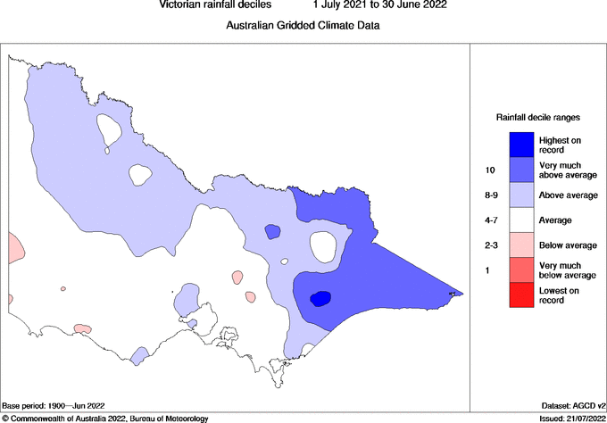
Figure 2: Victorian rainfall decile ranges from 1 July 2021 to 30 June 2022.
(Source: © Commonwealth of Australia 2022, Bureau of Meteorology.)

Port Phillip Bay and its catchment
Port Phillip Bay is a large, shallow embayment. It is surrounded by catchments that are mostly rural, but has large urban areas around its shoreline, including Victoria’s two largest cities: Melbourne and Geelong. The Yarra, Maribyrnong and Werribee Rivers are major river systems that originate in the forested hills and mountains, then flow through rural properties, townships and urban areas to the bay. The bay is connected to Bass Strait by a narrow entrance. Waters in the south of the bay mix well with ocean waters, while riverine inputs highly influence the waters in the north and west. The bay is a
popular location for boating, fishing and swimming, and supports Victoria’s largest recreational fisheries.
The Report Card for Port Phillip Bay and catchment is calculated using data from Melbourne Water and EPA.
Not all monitored sites produce a WQI score every year due to insufficient or unsuitable data. In this Report Card, 89 freshwater and 6 marine sites in the Port Phillip region were used to calculate the WQI scores (Figures 3 and 7).
In 2021–22, water quality in Port Phillip Bay and its catchment varied from Very Good in areas of the bay and upper reaches of the catchment, to Very Poor in highly urbanised waterways. This was similar to previous years (Figures 4 and 6).
Figure 3: Location and WQI scores of Melbourne Water’s monitoring sites in the Port Phillip catchment. Colour indicates WQI score for each site in 2021–22.
Catchment Report Card
Port Phillip Bay comprises six catchments: Yarra, Werribee, Maribyrnong, Dandenong, Mornington, and Bellarine (Figure 3).

Werribee catchment
The Werribee catchment includes rivers and creeks such as Little River, Werribee River, Lerderderg River and Kororoit Creek. These all drain into the northwest area of Port Phillip Bay (Figure 3). About 20 per cent of the catchment retains its natural vegetation, but agriculture is the predominant land use.
Overall, water quality in the Werribee catchment was Poor in 2021–22, a drop from Fair in 2020-21, though long-term condition has improved markedly since 2000 (Figure 4). Water quality was Very Good in the upper reaches of the Werribee catchment in forested areas, but declined to Fair, Poor and Very Poor as waterways flowed through the catchment’s agricultural and urban areas.
Figure 4: Historical WQI scores for the overall Werribee - and Yarra catchments. Colour indicates WQI score for each year.

Yarra, Maribyrnong, Dandenong and Mornington catchments
Water quality was Good in the forested upper Yarra and Maribyrnong catchments but declined to Very Poor in urban areas. The highly urbanised areas of the relatively small Dandenong and Mornington catchments scored the lowest WQI for the Port Phillip region with Very Poor water quality (Figure 3).

Bellarine catchment
The Bellarine catchment is outside Melbourne Water’s service area. Waterwatch data is available for the Bellarine. However, it is collected in a different way that is not consistent with how data is collected in the other catchments. Therefore, a WQI score cannot be calculated for Bellarine catchment.

Bay Report Card
Overall, water quality in Port Phillip Bay was Good in 2021–22. Reduced water clarity resulted in a Poor rating for this parameter (Figure 5). Rainfall data from the Bureau of Meteorology showed the 2021–22 period had average rainfall in areas of the Port Phillip catchment (Figure 2). This rainfall affects the volume of surface and stormwater run-off, which can carry pollutants such as nutrients and sediment into waterways.
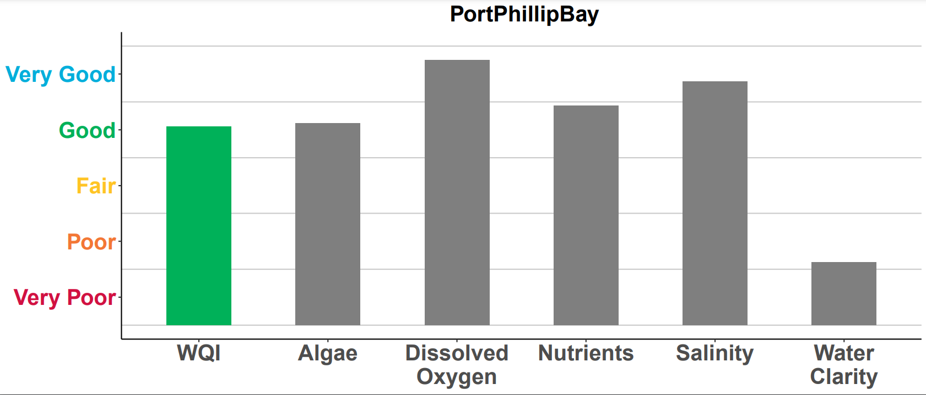
Figure 5: WQI scores for Port Phillip Bay in 2021–22. Coloured bar indicates the overall WQI score. Grey bars are the individual indicators used to calculate the overall WQI score.
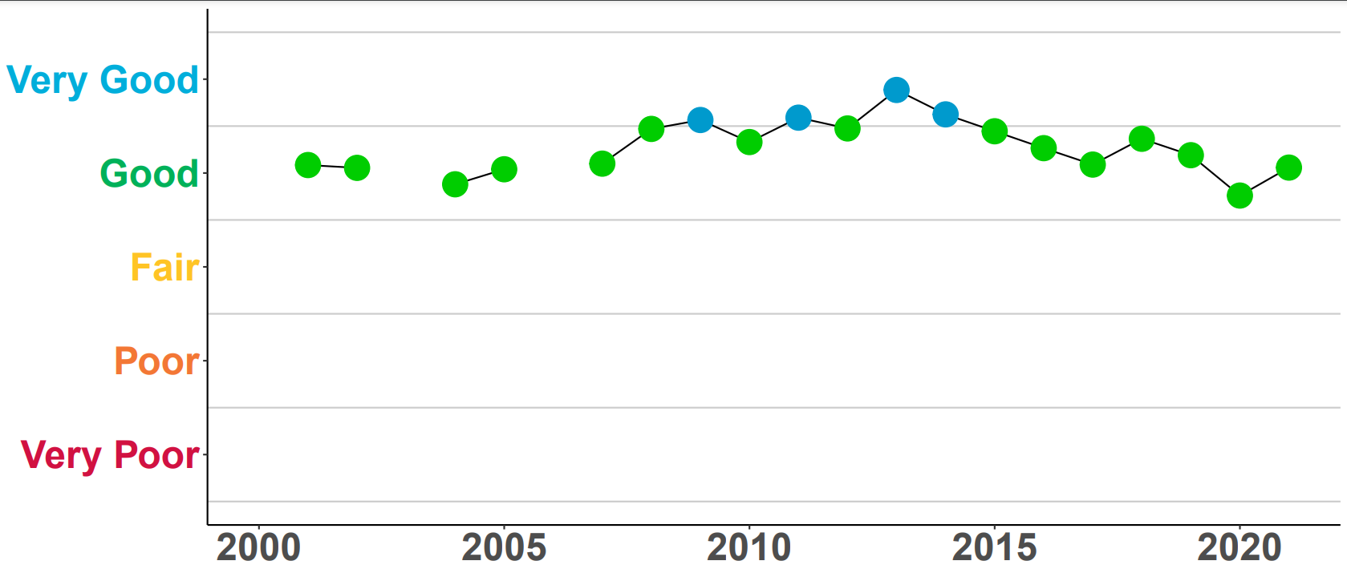
Figure 6: Historical WQI scores for Port Phillip Bay.
EPA has six monitoring locations in Port Phillip Bay (Figure 7). Conditions in Port Phillip Bay have remained relatively consistent since 2002, with overall water quality fluctuating between Good to Very Good (Figure 6). Riverine inputs, particularly nutrients such as nitrogen and phosphorus, highly influences water quality in the northern part of the bay. However, mixing with oceanic waters from Bass Strait and the natural recycling of nutrients in the sediments maintain good water quality.
Figure 7: Locations and WQI scores of EPA long-term marine monitoring sites in Port Phillip Bay.

Dromana
Dromana had Good water quality. This is because the southern area of Port Phillip Bay is well flushed with water from Bass Strait due to regular tidal exchange, and minimal impacts from rivers and urban run-off.

Central Bay and Patterson River
The Central Bay area, including Patterson River, had Good water quality. Water quality can decline during periods of very high rainfall. Following rain, increased flows from the Werribee and Yarra Rivers transports high levels of nutrients and sediments to the northern and eastern parts of the bay. This stimulates algal growth and reduces
light clarity.

Corio Bay, Long Reef and Hobsons Bay
Corio Bay, Long Reef and Hobsons Bay had Good water quality, but the influence of river flows, run-off and stormwater that carry pollutants, such as nutrients, sediments
and heavy metals, means they are not Very Good.

Western Port and its catchment
Western Port is a well-flushed, semi-enclosed bay, with two large islands (Phillip Island and French Island) that constrain water flow. The catchment is largely rural (70 per cent), with state reserves (20 per cent) in the upper catchment, and a fast-growing urban
growth corridor.
Waterways in the catchment flow through areas that have been highly modified to support rural and urban land use. They also support significant environmental values, including vegetated areas near the Bunyip State Park and Strzelecki Ranges. The northern and eastern areas of the bay are mostly intertidal mudflats dominated by catchment inflows from the Bunyip, Lang Lang and Bass Rivers. Tidal exchange with Bass Strait highly influences the western and southern areas.
The Report Card for Western Port and its catchment is calculated using data from Melbourne Water and EPA. In 2021–22, water quality varied from Good in areas of
the upper catchment and the bay, to Very Poor in highly urbanised or intensive
agricultural areas.
Figure 8: WQI scores for the overall Western Port catchment in 2021-22. Coloured bar indicates the overall WQI score. Grey bars are the individual indicators used to calculate the overall WQI score.

Figure 9: Historical WQI scores for the overall Western Port catchment.

Catchment Report Card
Overall, the water quality in Western Port catchment’s waterways was Poor for 2021–22. Scores for the Western Port catchment have remained relatively consistent over time and have mostly shown Poor water quality (Figure 9).
Melbourne Water routinely collects water samples across waterways of the Western Port catchment to assess how water quality is changing over time. Not all monitored sites produce a WQI score every year due to insufficient or unsuitable data. In this Report Card, 23 sites in the Western Port catchment were used to calculate the WQI score (Figure 10).
Water quality was consistently Good in the upper catchment of the Bunyip River, and Fair in the upper catchment Lang Lang which is an improvement on the 2020-21 score. Water quality declined to Poor or Very Poor in waterways in the mid and lower catchment where the land use changes into rural, agricultural and urbanised areas.
Vegetation clearing, draining of the Koo Wee Rup swamp and the progressive growth of agriculture and urban areas has altered the Western Port catchment significantly. The altered drainage regimes and intensive land uses present significant challenges for maintaining water quality in these rivers and streams.
Figure 10: Location and WQI scores of Melbourne Water’s monitoring sites in the Western Port catchment.

Western Port Bay Report Card
Overall, water quality was Good in Western Port for 2021–22. High nutrient levels resulted in a Fair rating for this parameter (Figure 11).
Rainfall data from the Bureau of Meteorology showed the Western Port catchment had average rainfall in the 2021–22 period (Figure 2). This rainfall affects the volume of surface and stormwater run-off. River inputs are a source of nutrients and sediment from the northern and eastern catchments.
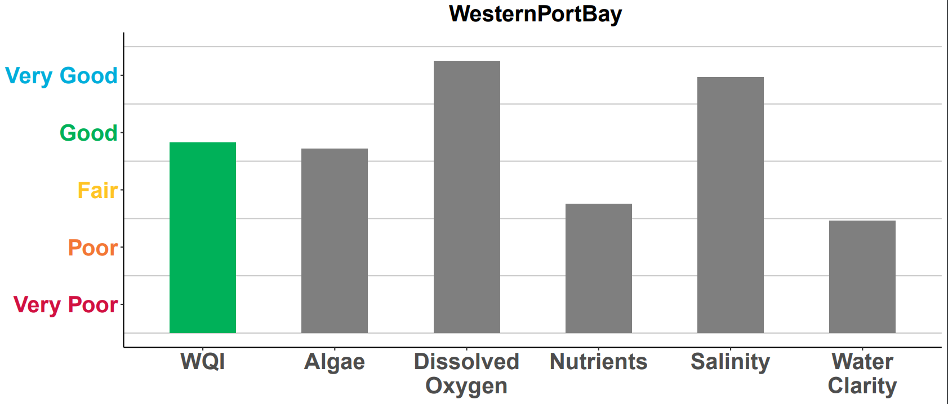

Figure 11: WQI scores for Western Port overall in 2021–22. Grey bars are the individual indicators used to calculate the overall WQI score.

Figure 12: Historical WQI scores for Western Port. Due to limited monitoring, no scores were calculated from 2005–08.

While rainfall can temporarily decrease water quality, conditions in Western Port have generally remained consistent since 2000 (Figure 12). The small catchment inflow volumes and mixing with Bass Strait helps to maintain good water quality in Western Port.
EPA has two monitoring locations in Western Port (Figure 13).

Hastings
The Hastings monitoring site had Good water quality, which has reduced from the previous year when it was Very Good. This area is regularly flushed and mixed with oceanic waters from Bass Strait.

Corinella
The Corinella monitoring site was Fair due to high levels of sediment pollution. This is the same rating as the previous year. The high levels of suspended sediment are caused by a combination of high coastal erosion in the north-east of the bay, deposition of fine sediments from the catchment, and the re-suspension of sediment within Western Port.

Figure 13: Locations and WQI scores of long-term EPA marine monitoring sites in Western Port.

Gippsland Lakes and its catchment
The Gippsland Lakes are a 70 km-long series of large, shallow coastal lagoons. A narrow, artificially maintained channel at Lakes Entrance connects the lakes to Bass Strait. The catchment consists of mostly state reserves, forests and national parks (60 per cent) and rural land (39 per cent). Five major river systems drain directly into the lakes: the Mitchell, Nicholson and Tambo flow into Lake King, while the Latrobe and Avon Rivers flow into Lake Wellington.
The Report Card for Gippsland Lakes and its catchment is calculated using monitoring data from DEECA (26 sites) and EPA (five sites). Scores are only calculated for rivers and streams in the catchment that drain into the Gippsland Lakes. The Gippsland region experienced a second consecutive year of above average rainfall associated with the La Nina climatic pattern that has affected the eastern Australia region. In 2021–22 there was high rainfall during spring/summer (Figure 2), which was reflected in water quality varying from Very Good and Good in most of the catchments. The Gippsland Lakes received high nutrient loads from the catchments, resulting in significant blue-green algal blooms during 2022, especially in the Eastern Lakes, where the WQI reduced from Good to Poor (Figure 14 and 18).
Figure 14: Location and WQI scores of DELWP’s monitoring sites in the Gippsland Lakes catchment.

Catchment Report Card
In West Gippsland, water quality was Good, similar to previous years (Figure 16). The forested areas on the slopes of the Great Dividing Range maintained Very Good water quality. Water quality declined to Fair or Poor along the mid and lower reaches of the Latrobe River, where cleared land and urbanisation have impacted water quality.
In the East Gippsland catchment, Very Good water quality was sustained from 2020-21, in a year characterised by high spring/summer rains. Impacts on water quality associated with river flooding in 2021-2022 appear to have been short-lived and did not affect the annual WQI score for 2021-22. (Figure 15).
Figure 15: Historical WQI scores for the Gippsland catchments.

Figure 16: WQI scores for East Gippsland catchment in 2021–22. Grey bars are the individual indicators used to calculate the overall WQI score.

Gippsland Lakes Report Card
EPA has five monitoring locations in the Gippsland Lakes (Figure 17). Monitoring locations closer to the entrance to Bass Strait (Shaving Point, Lake King) typically have better water quality due to greater tidal exchange. Polluted water discharging from rivers impacted inland monitoring locations (Lake Wellington and Lake Victoria).
Lake Wellington
Lake Wellington is a sink for sediments, nutrients, and contaminants. Wind and waves within the shallow waters of the lake can re-suspend sediments and nutrients. Algal blooms often develop because of the high availability of nutrients. During drier periods with less river inflow, the Lake can also be affected by rising salinity from ingress of marine water, and increased evaporation. Historically, water quality in Lake Wellington has been rated as Poor or Very Poor (Figure 18). The Fair rating, sustained from 2020-21, related to higher river flows reducing salinity within Lake Wellington.
Eastern Lakes
The region experienced high rainfall and run-off during spring/summer 2021-22 that delivered significant nutrient loads to the Lakes. The high nutrient loads, in combination with warmer water temperatures, led to an extensive blue-green algal bloom from February to May 2022. There was a significant drop in the WQI for the Easter Lakes from a rating of Good in previous years, to a rating of Poor in 2021-22 driven by a Very Poor rating for the algal indicator chlorophyll-a (Figure 19). During 2021-22, there were fish deaths, public health warnings and the closure of fisheries both within the Lakes and along the open coast. A similar widespread algal bloom event occurred after significant flooding in 2007, which resulted in a Very Poor WQI rating in the Eastern Lakes.

Figure 17: Locations and WQI scores of EPA’s long-term marine monitoring sites in
Gippsland Lakes.

Figure 18: Historical WQI scores for Lake Wellington. Due to limited monitoring, no scores were calculated for some years between 2001 and 2006.
Figure 19: Overall WQI scores for the Eastern lakes in 2021–22. Grey bars are the individual indicators used to calculate the overall WQI score.

Further information
Water Quality Data
Find data from the catchments at the Victorian government’s Water Measurement Information System (https://data.water.vic.gov.au/).
Find data for the bays and lakes at the Victorian governments open data website Data Vic (https://www.data.vic.gov.au/)
Find information on how DEECA, EPA Victoria and Melbourne Water work to improve water quality across Victoria at EPA’s Report Card web page (https://www.epa.vic.gov.au/for-community/monitoring-your-environment/monitoring-victorias-water-quality/report-card).
Key References
Find out more about the Environment Reference Standard (2021) for Victoria at EPA’s website (https://www.epa.vic.gov.au/about-epa/laws/epa-tools-and-powers/environment-reference-standard).

This publication is for general guidance only. You should obtain professional advice if you have any specific concern. EPA Victoria has made every reasonable effort to ensure accuracy at the time of publication.

This work is licensed under a Creative Commons Attribution 4.0 licence.

EPA acknowledges Victoria’s First Nations peoples as the Traditional Owners of the land and water on which we live and work. We pay our respect to their Elders past and present.

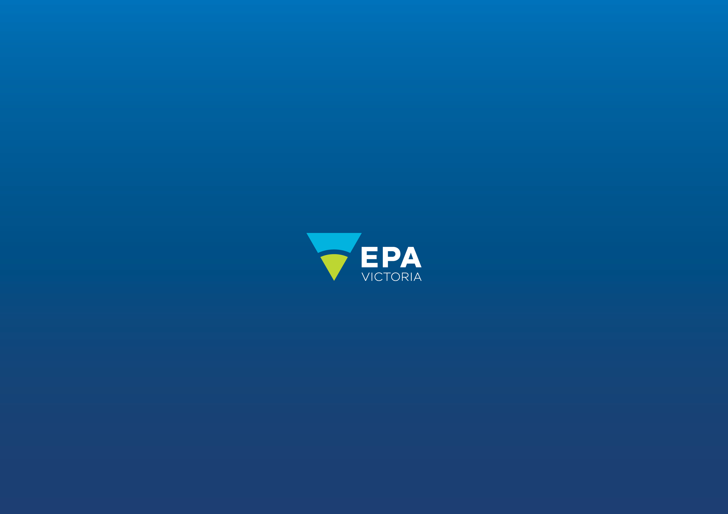
Authorised and published by the Victorian Government, 1 Treasury Place, Melbourne
epa.vic.gov.u
Environment Protection Authority Victoria
GPO BOX 4395 Melbourne VIC 3001
1300 372 842

