

Science report

September 2024

|  |
| --- |
| Derrimut chemical fire: environmental sampling and findings |



Authorised and published by the Victorian Government, 1 Treasury Place, Melbourne

epa.vic.gov.au

Environment Protection Authority Victoria

GPO BOX 4395 Melbourne VIC 3001

1300 372 84

EPA acknowledges Victoria’s First Nations peoples as the Traditional Owners of the land and water on which we live and work. We pay our respect to their Elders past and present. EPA prides itself on promoting and celebrating diversity and inclusion in our workplace. We want our organisation to be a reflection of the community we serve. We encourage all of our people to bring their whole selves to work and are committed to ensuring our workplaces are safe for them to do so.



This content is for general information only. Obtain professional advice if you have any specific concern. EPA Victoria has made reasonable effort to ensure accuracy at the time of publication. Except where noted at [epa.vic.gov.au/copyright](https://www.epa.vic.gov.au/copyright), all content in this work is licensed under the Creative Commons Attribution 4.0 Licence. To view a copy of this licence, visit [creativecommons.org](https://creativecommons.org/).

Contents

Summary 3

Findings 3

Air quality 3

Water quality 3

Sediment 3

Air quality 4

Response 4

Assessment approach 5

Results 5

Water quality 8

Response 8

Assessment approach 9

Results 10

Creek flow conditions 15

Sediment 15

References 16

Glossary terms 17

Appendices 18

# Summary

On 10 July 2024, a large fire occurred at a chemical factory at 118 Swann Drive, Derrimut. The fire burned for approximately 6 hours before being controlled by firefighters. The factory stored solvents, which resulted in volatile organic compound (VOC) emissions being produced during the fire and contaminating firewater that flowed from the site.

This report provides an overview of the air and water quality monitoring during and after the fire. It assesses any human health risks associated with air and water quality, as well as risks to the aquatic environment.

## Findings

Both air and water quality testing results found little or no risk of harm to nearby residents.

Any localised impacts to the environment were short-lived.

### Air quality

Air quality during the fire posed a low risk to nearby residents. This is due to the high temperature of the fire pushing the smoke plume to a high altitude, and wind conditions to disperse and dilute the smoke.

EPA understands Fire Rescue Victoria (FRV) also conducted atmospheric modeling and monitoring at the fire site to identify hazards and quantify the risks so that FRV could respond appropriately. This showed levels dropped significantly in the days after the fire and informed security and safety zones used during the response.

### Water quality

While we initially advised the community to avoid contact with affected waterways, testing showed there was a low risk to human health through accidental ingestion, inhalation or skin contact.

Aquatic ecosystems in Laverton Creek were exposed to high levels of chemicals for less than 8 days. Dissolved oxygen levels were low for the first few days after the fire. While both of these can cause harm to aquatic life, they quickly resolved and there were no reports or evidence of fish or wildlife deaths.

The absence of persistent chemical contaminants in firewater — such as heavy metals or PFAS — resulted in minimal ongoing contamination in Laverton Creek.

### Sediment

Only historical contamination of sediment was found, indicating a previous pollution event.

# Air quality

## Response

Before the fire was under control, the smoke plume quickly reached a high altitude due to the high temperature of the fire. Winds were generally low and from the west, pushing the smoke plume towards the east.

From 10 to 19 July 2024, EPA assessed the impacts on air quality using multiple methods:

* EPA’s fixed Ambient Air Quality Stations (AAQS)
* mobile SmokeTrak devices
* handheld MiniRae gas and VOC detectors
* air canisters (deployed on 11 July) to collect samples over a 24-hour period
* radiello tubes (deployed for 7 days after the fire) to collect VOC samples over a longer period.

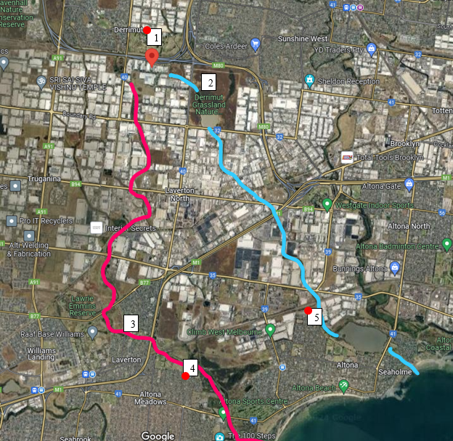

**Figure 1**. Map showing EPA air sampling locations (1-5).

## Assessment approach

For air pollutants such as PM2.5, EPA uses the Victorian Environmental Reference Standard (ERS) to assess impact. The ERS has standards for 24-hour concentrations of PM2.5. EPA also has 1-hour average criteria, which were used in this response due to the duration of the fire.

Particulate matter (PM10 and PM2.5), carbon monoxide, nitrogen dioxide, ozone and sulfur dioxide are considered ‘criteria pollutants’. Air pollutants other than criteria air pollutants are considered ‘air toxics’.

For air toxics, we use Air Pollution Assessment Criteria (APAC) guideline values to check if air pollution levels are harmful to human health. These values help establish if the amount of a specific pollutant in the air is safe or poses a risk. By comparing actual pollution levels to APAC values, we can determine if the air is safe to breathe, or if steps need to be taken to reduce pollution and protect community health.

## Results

EPA’s fixed Ambient Air Quality Stations (AAQS) did not detect elevated levels of PM2.5 or other pollutants associated with the fire.

Results for PM2.5 mobile SmokeTrak measurements are shown in Figure 2. Some locations did show lower air quality, though these are likely to have been associated with traffic at major intersections in these locations.

Additional VOC sampling was also carried out at a range of locations near the fire and at further away locations, near waterways (Figure 1). However they were below levels of concern (see Table 1 and 2 comparisons to APAC).

Observations by EPA Incident Response Officers, coupled with discussions with the Bureau of Meteorology, indicated that the plume was elevated and reached mixing height. These factors increased smoke dispersion and reduced impacts at ground level. Smoke above the mixing height is unlikely to reach ground level at significant concentrations.

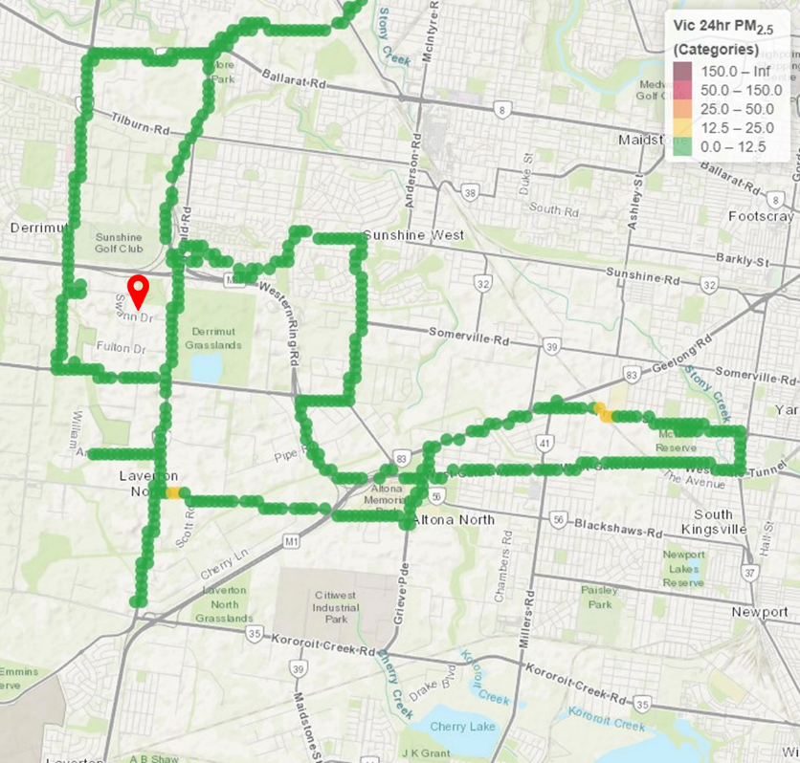

**Figure 2**. Route driven by EPA Incident Response Officers from 2 pm to 7 pm on 10 July 2024 to assess local air quality near the fire. Green denotes ‘good’ air quality. Red pin shows location of fire.

The results from the deployed air canisters detected the aromatic hydrocarbon, toluene, at a concentration of 3.6 µg/m3 at the Mt Derrimut Golf Club (Figure 1 site 1), north of the fire. Toluene has a range of industrial uses and was stored at the site of the fire. Other airborne contaminants were below the limit of detection (Tables 1 and 2).

The air pollution levels measured were averaged over a week. The guidelines for some of the pollutants are for shorter time periods, such as 1 hour or 24 hours. Since the pollution levels were much lower than what would be a concern in those shorter time frames, it is acceptable to compare weekly average to these shorter guidelines.

|  |  |  |  |  |
| --- | --- | --- | --- | --- |
| Location in Figure 1. | Location | Sampling technique | Chemical Results (24 hours) | APAC |
| 1 | Mt. Derrimut Golf Club | Canister sample x 2 | Toluene 3.6 µg/m3 | 15,000 µg/m3 (1 hour) 260 µg/m3 (7 days) |
| 2 | Derrimut Grassland Nature Conservation Reserve at Cherry Creek outfall | Canister sample | Below instrument limits of detection |  |
| 3 | Residential location in Laverton near Kayes Drain, Laverton Creek confluence | Canister sample | Below instrument limits of detection |  |
| 4 | Residential location in Altona Meadows adjacent to Laverton Creek | Canister sample | Below instrument limits of detection |  |
| 5 | Residential location in Altona adjacent to Cherry Creek | Canister sample | Below instrument limits of detection |  |

**Table 1.** Ambient air VOC sampling results 11 to 12 July 2024.*

* Freon gas was detected in each sample above the limit of detection. This is a commonly detected refrigerant in ambient samples and not related to the fire.

Results from all monitoring conducted during and after the event indicated the measured concentrations of air pollutants were below the APAC and ERS parameters established for the protection of human health.

Even for residents who could have been exposed to low levels of fine PM2.5 and VOCs associated with the fire, the risk of potential adverse health effects was low. This includes those living near the Derrimut site, Laverton Creek and Cherry Creek, as well as those susceptible to potential health impacts like children, the elderly, pregnant women and individuals with existing respiratory conditions.

Fire Rescue Victoria routinely undertakes atmospheric monitoring at large fires and hazardous materials incidents. Data from monitoring are used to identify hazards and measure/manage exposure to firefighters and the community. EPA understands FRV Hazmat Technicians and Scientific Advisors performed atmospheric modelling and detection early in the incident. Monitoring was conducted in the staging and operational areas immediately surrounding the fire using gas chromatography/mass spectrometry, electrochemical and photoionisation detectors. Area monitors, used to continuously measure the concentration of toxic gases, were placed around the fireground, particularly in areas where firefighters were working. Results from atmospheric monitoring were broadly consistent with those of EPA.

|  |  |  |  |  |
| --- | --- | --- | --- | --- |
| Location in Figure 1. | Location | Sampling Technique | Chemical Results (7 days) | APAC |
| 1 | Mt. Derrimut Golf Club | Radiello tube | Benzene 0.2 µg/m3 | 29 µg/m3 (24 hours) |
|  |  |  | Ethylbenzene 0.06 µg/m3 | 21,712 µg/m3 (24 hours) |
|  |  |  | Tetrachloroethene 0.020 µg/m3 | 6,800 µg/m3 (1 hour) |
|  |  |  | Toluene 1.1 µg/m3 | 260 µg/m3 (7 days) |
|  |  |  | Trichloroethene 0.21 µg/m3 | 2 µg/m3 (365 days) |
|  |  |  | o-Xylene 0.050 µg/m3 | 8,685 µg/m3 (24 hours) |
|  |  |  | m&p-Xylenes 0.12 µg/m3 | 8,685 µg/m3 (24 hours) |
| 4 | Residential location in Altona Meadows adjacent to Laverton Creek | Radiello tube | Benzene 0.12 µg/m3 | 29 µg/m3 (24 hours) |
|  |  |  | Ethylbenzene 0.05 µg/m3 | 21,712 µg/m3 (24 hours) |
|  |  |  | Toluene 0.3 µg/m3 | 260 µg/m3 (7 days) |
|  |  |  | 1,2,4-Trimethylbenzene 0.03 µg/m3 | 60 µg/m3 (365 days) |
|  |  |  | o-Xylene 0.050 µg/m3 | 8,685 µg/m3 (24 hours) |
|  |  |  | m&p-Xylenes 0.15 µg/m3 | 8,685 µg/m3 (24 hours) |
| 5 | Residential location in Altona | Radiello tube | Benzene 0.41 µg/m3 | 29 µg/m3 (24 hours) |
|  |  |  | Ethylbenzene 0.2 µg/m3 | 21,712 µg/m3 (24 hours) |
|  |  |  | Styrene 0.070 µg/m3 | 260 µg/m3 (7 days) |
|  |  |  | Toluene 1.2 µg/m3 | 260 µg/m3 (7 days) |
|  |  |  | Trichloroethene 0.02 µg/m3 | 2 µg/m3 (365 days) |
|  |  |  | 1,2,4-Trimethylbenzene 0.11 µg/m3 | 60 µg/m3 (365 days) |
|  |  |  | o-Xylene 0.21 µg/m3 | 8,685 µg/m3 (24 hours) |
|  |  |  | m&p-Xylenes 0.58 µg/m3 | 8,685 µg/m3 (24 hours) |

**Table 2.** Ambient air VOC sampling results 11 to 18 July 2024.

# Water quality

## Response

A large volume of water was required to extinguish the fire, resulting in firewater runoff breaking containment and entering the stormwater system. Firewater runoff flowed mainly via the stormwater system into Kayes Drain to the west, and to a lesser extent to Cherry Creek to the east. Kayes Drain flows directly into Laverton Creek to the south. It was unclear how much firewater entered each creek system as it is difficult to trace in underground stormwater drains.

In the days following the fire, EPA and Melbourne Water monitored firewater-affected waterways to assess risks to the aquatic environment and human health (Figures 3 and 4).

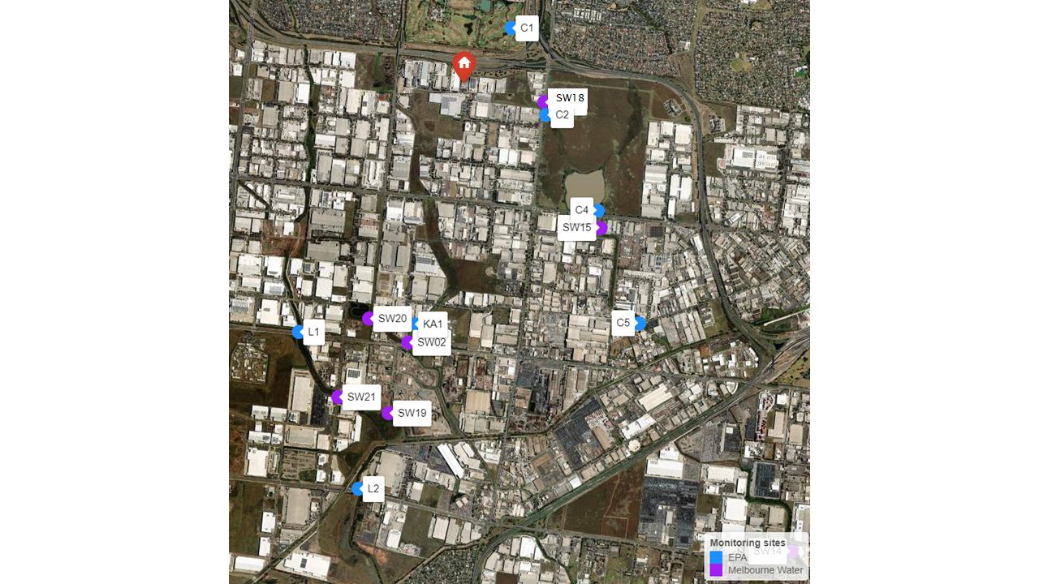

**Figure 3**. Location of EPA and Melbourne Water monitoring sites along the Kayes Drain, Laverton Creek and Cherry Creek waterways. Refer to Appendix A1 for list of sites and map codes. Red pin shows location of fire.

Testing for chemical contaminants and *E. coli* was conducted in Kayes Drain and Laverton Creek on 11 and 13 July, and in Cherry Creek and Cherry Lake on 12 and 13 July. In addition to chemical testing, EPA deployed 2 multiparameter water quality loggers in Laverton Creek at Dohertys Road (Figure 3 site L1), upstream of the Kayes Drain intersection, and further downstream at Merton Street (Figure 4 site L3). These provided continuous information on dissolved oxygen, salinity, turbidity and pH conditions at each site.

Affected waterways were re-sampled a week after the fire to assess the level of recovery, as well as the level of ongoing risks to the environment and community. In this later sampling round, EPA collected both water and sediment samples. Sediment samples can provide a measure of the persistent impacts of sediment contamination associated with the Derrimut fire.

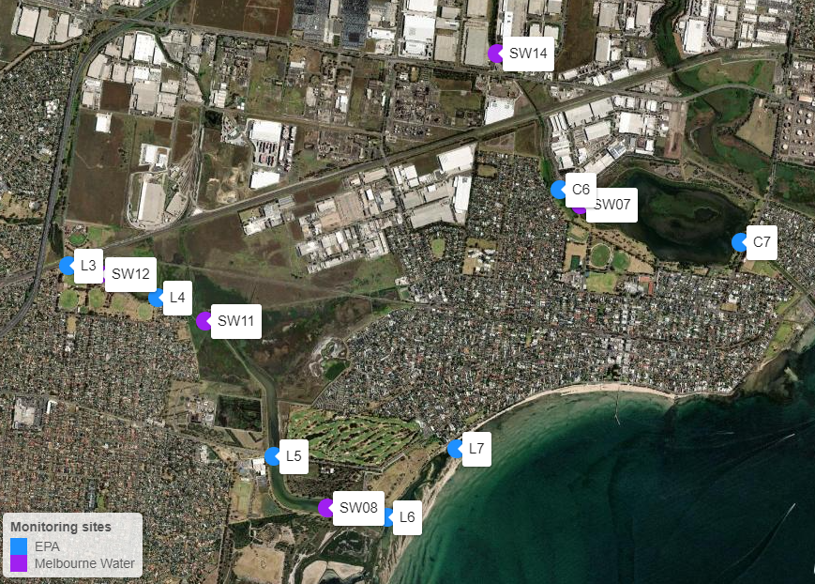

**Figure 4**. Location of downstream EPA and Melbourne Water monitoring sites on Laverton Creek (left) and Cherry Creek (right).

## Assessment approach

We used both the ERS and the Australian and New Zealand Guidelines for Fresh and Marine Waters (ANZG 2018) to assess risks to aquatic ecosystems in affected waterways. The ANZG provide sediment and water quality guidelines to help ensure that chemical and physical stressors do not exceed harmful concentrations. The ‘level of protection’ for these guideline values is the degree of protection given to the waterway based on the condition of the aquatic ecosystem. Urban waterways in Melbourne are highly modified and accordingly receive the lowest level of species protection (90%) under the Victorian ERS.

Risk to human health from waterways was evaluated using recreational water quality guidelines provided by the World Health Organization (WHO) and the National Health and Medical Research Council (NHMRC) in Australia. These guidelines set safe limits for primary contact with water pollutants to ensure that those undertaking water-based activities such as swimming, will not experience health-related harm. The ‘level of protection’ in these guidelines refers to the concentration of pollutants that can be in the water without posing any danger to people undertaking these activities.

## Results

While water quality testing covered a wide range of chemicals (seen at Appendix A2), testing showed the key risks to aquatic ecosystem health was from:

* acetone
* methyl ethyl ketone (MEK)
* methyl isobutyl ketone (MIBK)
* isophorone
* teric N9 industrial detergent (nonylphenol ethoxylate, or NPE)
* ethanol
* isopropyl alcohol
* hydrocarbons.

The greatest firewater impacts were largely restricted to Laverton Creek.

Acetone was a major contaminant in firewater entering local waterways from the Derrimut chemical factory fire (Tables 3 and 4). Acetone was recorded at 7 sites from Kayes Drain to the Laverton Creek outlet, with concentrations ranging from 780-11,000 µg/L (Figure 5). By comparison, acetone was only found at a single site in Cherry Creek (Figure 4, site C6), at the inlet to Cherry Lake (31 µg/L). A similar spatial pattern of contamination predominantly in Kayes Drain and Laverton Creek was evident for other chemicals measured (Tables 3 and 4).

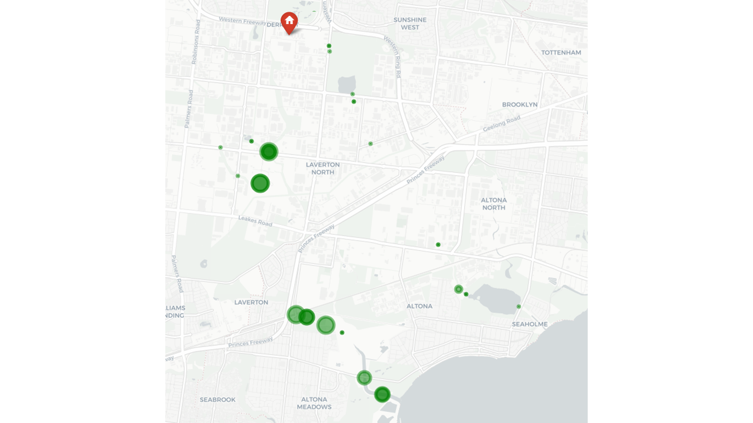

**Figure 5.** Bubble plot showing acetone concentration (µg/L) at sites monitored from 11 to 13 July 2024. The smallest bubble shown indicates where acetone was measured, but not detected. The highest concentration was 11,000 µg/L. Red pin shows location of fire.

Between 11 July and 13 July 2024, maximum concentrations of toluene, xylenes (m, p & o-xylene), ethanol, isopropyl alcohol and isophorone in Kayes Drain and Laverton Creek exceeded the ANZG (2018) aquatic 90% protection level guidelines for aquatic life (Tables 3 and 4).

There were also elevated levels of acetone, methyl ethyl ketone (MEK), 4-methyl-2-pentanone (MBIK) and nonylphenol ethoxylate (NPE). The absence of these chemicals in surface water sampled upstream of the firewater flow confirmed the presence of these chemicals was associated with the contaminated firewater that entered affected waterways. A detailed summary of chemical results at each monitoring site can be viewed in Appendix A3.

Follow-up sampling on 17 and 18 July 2024 found that all these chemicals had declined to levels below the laboratory detection limit, indicating significantly lower risk to aquatic ecosystems in Kayes Drain. These declines are attributed to the high volatility of these chemicals (due to loss via evaporation), as well as dilution and flushing by higher stream flows on 17 July 2024 (see Figure 7).

Testing of *E. coli* was not conducted on the 17 and 18 July 2024, as results from the previous sampling round did not indicate a sewer overflow had occurred.

|  |  |  |  |  |  |  |  |
| --- | --- | --- | --- | --- | --- | --- | --- |
| Chemical | Unit | ANZG 90% ecosystem guideline | Recreational water quality  guideline | Kayes Drain upstream  (SW20) | Kayes Drain Downstream  (SW02, SW19, KA1) | | |
|  |  |  |  | 13 July | 11 July | 13 July | 18 July |
| Acetone | µg/L |  |  | <50 | 6,050 | 7,430 | <10 |
| MEK | µg/L |  |  | <50 | 730 | 830 | <10 |
| MIBK | µg/L |  |  | <50 | 560 | 750 | <10 |
| Benzene | µg/L | 1,300 | 200 | <1 | 3 | 6 | <1 |
| Toluene | µg/L | 230* | 14,000 | <2 | **351** | **638** | <1 |
| Ethylbenzene | µg/L | 110* | 6,000 | <2 | 36 | 59 | <1 |
| Xylenes | µg/L | 100  (m-xylene) | 10,000 | <2 | **279** | **448** | <2 |
| Ethanol | µg/L | 2,400 |  | <50 | **35,800** | **59,600** | - |
| Isopropyl alcohol | µg/L | 4,200* |  | <50 | **5,590** | **9,170** | - |
| Isophorone | µg/L | 130* |  | <2 | **182** | **419** | <20 |
| NPE | µg/L |  |  | <10 | 640 | 180 | <5 |

**Table 3**. Maximum chemical concentrations measured in surface water from Kayes Drain on 11, 13 and 18 July 2024.

Exceedances of the ANZG 90% ecosystem guideline are **bolded**. No exceedances of recreational water quality guideline levels were recorded.

*Guideline values with low reliability.

|  |  |  |  |  |  |  |  |  |  |  |
| --- | --- | --- | --- | --- | --- | --- | --- | --- | --- | --- |
| Analyte | Unit | ANZG 90%  sp. Prot | Rec Water Qual | Laverton Creek Upstream  (L1, SW21) | | Laverton Creek Downstream (L2-6 & SW08, SW11, SW12) | | |  | Altona Beach  (L7) |
|  |  |  |  | 11 July | 18 July | 11 July | 12 July | 13 July | 18 July | 18 July |
| Acetone | µg/L |  |  | <10 | <10 | 11,000 | 2,380 | 1,730 | 15 | <10 |
| MEK | µg/L |  |  | <10 | <10 | 1,300 | 240 | 50 | <10 | <10 |
| MIBK | µg/L |  |  | <10 | <10 | 340 | <50 | <50 | <10 | <10 |
| Benzene | µg/L | 1,300 | 200 | <1 | <1 | 1.4 | <1 | <1 | <1 | <1 |
| Toluene | µg/L | 230* | 14,000 | <1 | <1 | 90 | <2 | <2 | <1 | <1 |
| Ethylbenzene | µg/L | 110* | 6,000 | <1 | <1 | 9.6 | <2 | <2 | <1 | <1 |
| Xylenes | µg/L | 100 (m-) | 10,000 | <2 | <2 | 87 | <2 | <2 | <2 | <2 |
| Ethanol | µg/L | 2,400* |  | - | - | - | **32,800** | **10,800** | - | - |
| Isopropyl alcohol | µg/L | 4,200* |  | - | - | - | **6,230** | 1,930 | - | - |
| Isophorone | µg/L | 130* |  | <20 | <20 | **410** | 43 | 22 | <20 | <20 |
| NPE | µg/L |  |  | <5 | 6 | 380 | 40 | <10 | 8 | <5 |

**Table 4.** Maximum chemical concentrations measured in surface water from Laverton Creek on 11 to 13 and 18 July 2024.

Exceedances of the ANZG 90% guideline values are **bolded** and recreational water quality guideline levels are underlined.

*Guideline values with low reliability.

No chemicals were recorded above the ANZG guidelines for the protection of aquatic life in Cherry Creek (Table 5). Furthermore, few chemicals were recorded above the lab detection limit. Acetone and nonylphenol ethoxylate were recorded at the inlet to Cherry Lake (Figure 4, site C6). There was only one detection of ethanol (346 µg/L) at Boundary Road in Brooklyn (Figure 3, site SW15), where the stormwater drain flows into Cherry Creek. This pattern supports the conclusion that much less contaminated firewater entered Cherry Creek.

EPA investigations identified the industrial detergent Teric N9 (NPE) as a contaminant of potential concern in the firewater. At high concentrations, NPE is toxic to aquatic life, and there are no current water or sediment quality standards for NPE in Australia. The concentration of NPE in surface water was compared to the acute toxicity value to aquatic life of 6,400 µg/L for Teric N9 (Teric N9 Safety Data Sheets); no surface water concentrations exceeded this value (Tables 3, 4 and 5).

Concentrations of the chemical contaminants in water were found to be below the recreational water quality criteria for primary contact. Primary contact refers to activities that include direct contact with water, such as swimming. Therefore, the risks to humans through accidental ingestion, inhalation or skin contact were assessed as low (see Appendix A3).

|  |  |  |  |  |  |  |  |  |  |
| --- | --- | --- | --- | --- | --- | --- | --- | --- | --- |
| Analyte | Unit | ANZG 90%   sp. Prot | Rec Water Qual | Cherry Creek Upstream   (C1) | |  | Cherry Creek Downstream  (C2-7 & SW07, 14, 15, 18) | |  |
|  |  |  |  | 11/07 | 12/07 | 17/07 | 12/07 | 13/07 | 17/07 |
| Acetone | µg/L |  |  | <10 | <10 | <10 | 31 | <50 | <10 |
| MEK | µg/L |  |  | <10 | <10 | <10 | <50 | <50 | <10 |
| MIBK | µg/L |  |  | <10 | <10 | <10 | <50 | <50 | <10 |
| Benzene | µg/L | 1300 | 200 | <1 | <1 | <1 | <1 | <1 | <1 |
| Toluene | µg/L | 230* | 14000 | <1 | <1 | <1 | <2 | <2 | <1 |
| Ethylbenzene | µg/L | 110* | 6000 | <1 | <1 | <1 | <2 | <2 | <1 |
| Xylenes | µg/L | 100 (m-xylene) | 10000 | <2 | <2 | <2 | <2 | <2 | <2 |
| Ethanol | µg/L | 2400* |  | - | - | - | 346 | <50 | - |
| Isopropyl alcohol | µg/L | 4200* |  | - | - | - | <50 | <50 | - |
| Isophorone | µg/L | 130* |  | <20 | <20 | <20 | <2 | <2 | <20 |
| NPE | µg/L |  |  | <5 | <5 | <5 | 8 | <10 | <5 |

**Table 5**. Maximum chemical concentrations measured in surface water from Cherry Creek and Cherry Lake on 11, 12 and 13 July

No exceedances of the ANZG 90% guideline values or recreational water quality guideline levels were measured.

*Guideline values with low reliability.

Dissolved oxygen is a key indicator of water quality. Fish and other aquatic life need oxygen dissolved in the water to breathe, and high concentrations of chemicals in the water use up dissolved oxygen as they degrade. Measuring dissolved oxygen is therefore a key indicator of the impact of firewater pollution. The ERS for dissolved oxygen in urban streams is at least 60%.

Figure 7 displays dissolved oxygen levels in Laverton Creek upstream of the Kayes Drain intersection at Dohertys Road (L1), and downstream at Merton Street (L3). Dissolved oxygen levels on 12 July 2024 were below 50% saturation at Merton Street (L3), below the ERS level of 60% for this waterway.

Lower dissolved oxygen levels at Merton Street (L3) were associated with a high chemical oxygen demand in water samples (530 mg/L compared to background 45 mg/L) and the presence of a range of firewater chemicals. Over the next 5 to 7 days, these returned to levels similar to the reference site at Dohertys Road (L1), between 70 to 90% dissolved oxygen saturation.

Dissolved oxygen at Merton Street (L3) had returned to levels above 60% saturation by 16 July 2024, and remained at this level until 27 July 2024 when monitoring ceased.

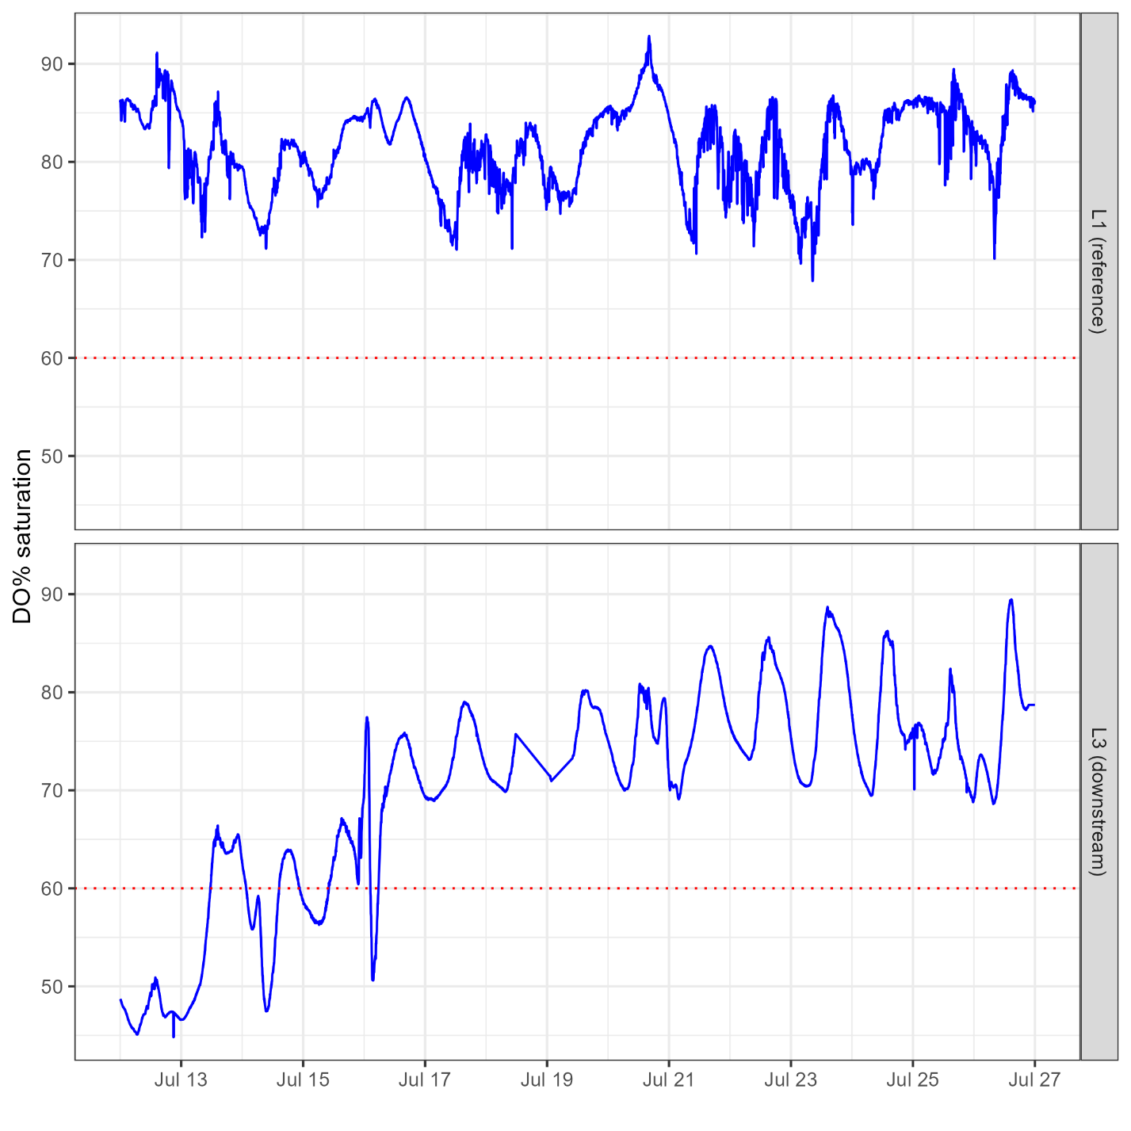

**Figure 6**. Dissolved oxygen (DO%) levels in Laverton Creek shown recorded by Multiparameter Water Quality loggers deployed upstream at site L1 (reference site) and downstream at L3 between 11-26 July 2024

Dashed line at 60% represents Environmental Reference Standard (ERS) for dissolved oxygen.

## Creek flow conditions

Local creeks were flushed by rainfall-driven higher flow events on 16 and 20 July 2024 (Figure 7). The Bureau of Meteorology weather station at Laverton recorded 13.4 mm of rain on 16 July. The rainfall runoff diluted firewater contaminants, reducing their overall concentrations on 18 July, and aiding in flushing contaminants from affected areas.

No daily flow measurements are available for Laverton or Cherry Creeks due to the absence of flow gauges on these creeks. Therefore, flow data from adjacent Kororoit Creek was used to represent local flow conditions in the area. Kororoit Creek, Laverton Creek and Cherry Creek share physical similarities.

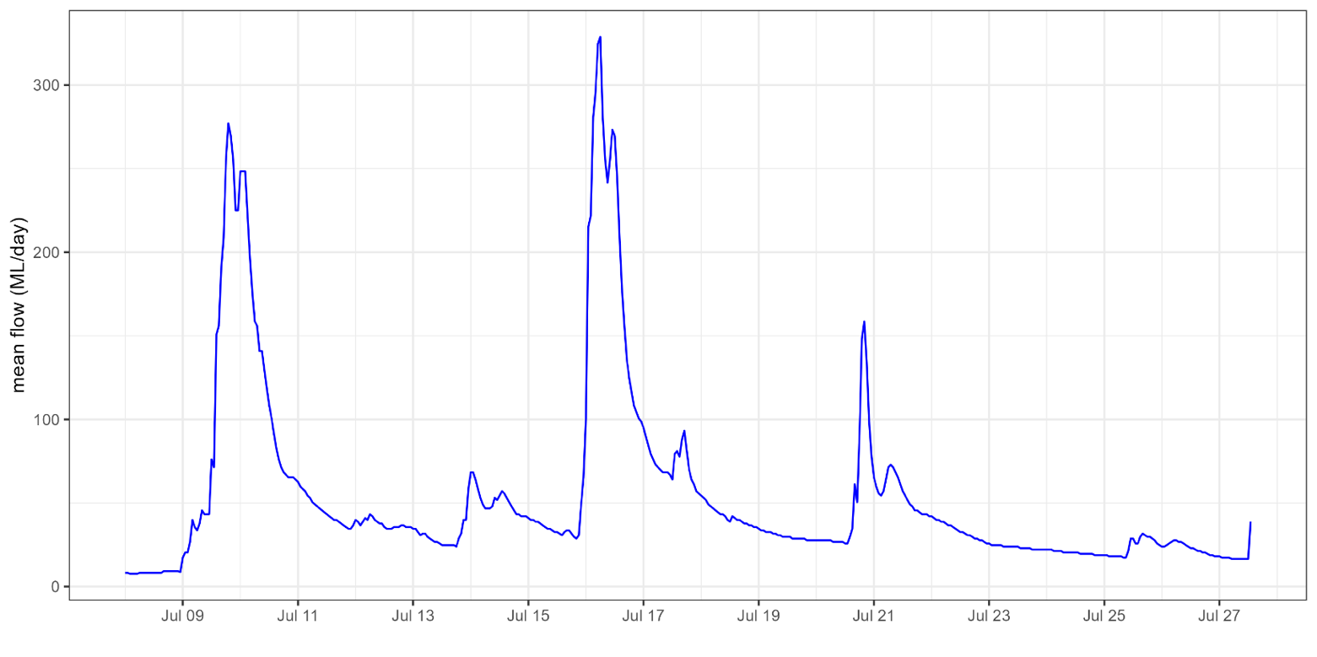

**Figure 7**. Kororoit Creek mean daily flows (ML/day) at Federation Trail, Brooklyn.

# Sediment

Sediments in waterways can become contaminated by the discharge of industrial chemicals.

Sediment monitoring did not show contamination of creek sediments from the fire. The highest sediment hydrocarbons results were in Kayes Drain, upstream of the firewater impacts, suggesting pre-existing contamination of the creek (see Appendix A4).

# References

ANZG (2018). Australian and New Zealand Government Guidelines for fresh and marine waters. <https://www.waterquality.gov.au/anz-guidelines>

EPA (2022). EPA Publication 1961 – Guideline For Assessing and Minimising Air Pollution. <https://www.epa.vic.gov.au/about-epa/publications/1961>

NHMRC (2008). Guideline for Managing Risks in Recreational Water. <https://www.nhmrc.gov.au/about-us/publications/guidelines-managing-risks-recreational-water#block-views-block-file-attachments-content-block-1>

WHO (2021). Guidelines on recreational water quality. <https://www.who.int/publications/i/item/9789240031302>

# Glossary terms

|  |  |
| --- | --- |
| ANZG | Australian and New Zealand Government Guidelines |
| APAC | Air Pollution Assessment Criteria |
| BOD | Biochemical Oxygen Demand |
| COD | Chemical Oxygen Demand |
| DO | Dissolved Oxygen |
| EC50 | Half Maximal Effective Concentration. The concentration of a toxicant required to obtain 50% of the effect over a given time. |
| ERS | Environment Reference Standard |
| LC50 | Lethal Concentration 50. Concentration of a toxicant required to cause death of 50% of an experimental test population. |
| m-, o-, p-xylene | Three xylene isomers. Chemicals that share the same formula but vary slightly in structure (the arrangement of atoms) |
| MAH | Monocyclic aromatic hydrocarbons |
| MIBK | Methyl isobutyl ketone, 4-methylpentan-2-one |
| MEK | Methyl ethyl ketone, 2-butanone |
| NP | Nonylphenol - main degradation product of NPE |
| NPE | Nonylphenol ethoxylate - main active ingredient in Teric N9 |
| OCP | Organochlorine pesticides |
| OPP | Organophosphorus pesticides |
| PAH | Polynuclear aromatic hydrocarbons |
| PFAS | Per- and polyfluoroalkyl substances |
| PFOS | Perfluorooctane sulfonic acid |
| PFOA | Perfluorooctanoic acid |
| PFHxS | Perfluorohexane sulfonic acid |
| PM2.5 | Particulate Matter (2.5 micrometres or smaller in diameter) |
| PM10 | Particulate Matter (10 micrometres or smaller in diameter) |
| Primary contact | Activities where the whole body or the face is immersed in water. Examples of primary contact activities include swimming and surfing. |
| TRH | Total Recoverable Hydrocarbons |
| VOC | Volatile Organic Compound |

# Appendices

Table A1 – Water Quality monitoring locations shown on map Figures 3 and 4. MW denotes sites sampled by Melbourne Water

|  |  |  |  |  |  |
| --- | --- | --- | --- | --- | --- |
| Location | Code | Waterway | Agency | Latitude | Longitude |
| Kayes Drain, Dohertys Rd | SW02 | Laverton Creek | MW | -37.8265 | 144.772 |
| Laverton Ck, Doug Grant Reserve | SW08 | Laverton Creek | MW | -37.8796 | 144.80335 |
| Laverton Ck, Valente St | SW11 | Laverton Creek | MW | -37.8661 | 144.7922 |
| Laverton Ck, AB Shaw Reserve | SW12 | Laverton Creek | MW | -37.8627 | 144.7825 |
| Kayes Drain | SW19 | Laverton Creek | MW | -37.8334 | 144.769602 |
| Kayes Drain (upstream reference) | SW20 | Laverton Creek | MW | -37.8242 | 144.7672 |
| Laverton Ck, Foundation Rd (upstream reference) | SW21 | Laverton Creek | MW | -37.8318 | 144.763452 |
| Laverton Ck, Doherty Rd (reference) | L1 | Laverton Creek | EPA | -37.8255 | 144.7586 |
| Laverton Ck, Leakes Rd | L2 | Laverton Creek | EPA | -37.8407 | 144.7659 |
| Laverton Ck, Merton St | L3 | Laverton Creek | EPA | -37.8621 | 144.7796 |
| Laverton Ck, Victoria St | L4 | Laverton Creek | EPA | -37.8644 | 144.7878 |
| Laverton Ck, Queen St | L5 | Laverton Creek | EPA | -37.8759 | 144.7984 |
| Laverton Creek outlet | L6 | Laverton Creek | EPA | -37.8803 | 144.8088 |
| Altona Beach, Maidstone St | L7 | Laverton Creek | EPA | -37.8753 | 144.8152 |
| Kayes Drain, Doherty Rd | KA1 | Laverton Creek | EPA | -37.8248 | 144.77269 |
| Cherry Lake inlet (boom) | SW07 | Cherry Creek | MW | -37.8577 | 144.8265 |
| Cherry Ck, Kororoit Ck Rd | SW14 | Cherry Creek | MW | -37.8468 | 144.818886 |
| Cherry Ck, Andersons Swamp outlet | SW15 | Cherry Creek | MW | -37.8155 | 144.79553 |
| Cherry Ck, Fitzgerald Rd | SW18 | Cherry Creek | MW | -37.8033 | 144.788688 |
| Cherry Ck, Mt Derrimut Golf Club | C1 | Cherry Creek | EPA | -37.7961 | 144.7846 |
| Cherry Ck, Fitzgerald Rd | C2 | Cherry Creek | EPA | -37.8045 | 144.7889 |
| Andersons Swamp outlet | C4 | Cherry Creek | EPA | -37.8138 | 144.7952 |
| Cherry Ck, Pipe Rd | C5 | Cherry Creek | EPA | -37.8247 | 144.8002 |
| Cherry Lake inlet (boom) | C6 | Cherry Creek | EPA | -37.8566 | 144.8246 |
| Cherry Lake outlet | C7 | Cherry Creek | EPA | -37.8604 | 144.8412 |

Table A2 – Summary of contaminant sampling conducted by EPA and Melbourne Water

|  |  |  |  |  |  |  |  |
| --- | --- | --- | --- | --- | --- | --- | --- |
| Date: | 11/07 | 11/07 | 12/07 | 12/07 | 13/07 | 17/07 | 18/07 |
| Site Code: | SW02 | L1, 3, 4, 5, & C1 | SW07, 08, 11, 12, 14, 15 | C1, 2, 4, 5, 6, 7 | SW02, 07, 08, 11, 12, 14, 15, 18, 19, 20, 21 | C1, 2, 4, 5, 6, 7 | KA1 & L1, 2, 3, 5, 6, 7 |
| Analyte: |  |  |  |  |  |  |  |
| Trae Metals | • | • | • | • | • | • | • |
| Chemical oxygen demand | • | • | • | • | • | • | • |
| Biochemical oxygen demand | • |  | • |  | • |  |  |
| Monocyclic Aromatic Hydrocarbons (MAH) | • | • | • | • | • | • | • |
| Oxygenated compounds | • | • | • | • | • | • | • |
| Sulfonated compounds | • | - | • | - | • | - | - |
| Fumigants | • | - | • | - | • | - | - |
| Halogenated Aliphatic Compounds | • | • | • | • | • | • | • |
| Halogenated Aromatic Compounds | • | • | • | • | • | • | • |
| Trihalomethanes | • | • | • | • | • | • | • |
| Phenolic compounds | • | • | • | • | • | • | • |
| Polynuclear aromatic hydrocarbons (PAH) | • | • | • | • | • | • | • |
| Phthalate esters | • | • | • | • | • | • | • |
| Nitrosamines | • | • | • | • | • | • | • |
| Nitroaromatics and Ketones | • | • | • | • | • | • | • |
| Haloethers | • | • | • | • | • | • | • |
| Chlorinated hydrocarbons | • | • | • | • | • | • | • |
| Anilines and benzidines | • | • | • | • | • | • | • |
| Organochlorine pesticides | • | • | • | • | • | • | • |
| Organophosphorus pesticides | • | • | • | • | • | • | • |
| Total Recoverable Hydrocarbons (TRH) | • | • | • | • | • | • | • |
| BTEXN | • | • | • | • | • | • | • |
| Alcohols | • | • | • | • | • |  |  |
| Nonylphenol ethoxylates | • | • | • | • | • | • | • |
| Poly- and perfluoroalkyl substances (PFAS) | • | • | • | • | • | • | • |
| Alcohols and solvents | • | - | • | - | • | - | - |
| Alkanes | • | - | • | - | • | - | - |
| E. coli | - | • | - | • | - | - | - |

Table A3 – Chemical monitoring results for Kayes Drain and Laverton Creek

|  |  |  |  |  |  |  |  |  |  |  |
| --- | --- | --- | --- | --- | --- | --- | --- | --- | --- | --- |
|  |  |  | Industrial solvents | |  | Alcohols |  |  |  |  |
| Location | Sample date | COD | Acetone | MEK | MIBK | Ethanol | Isopropyl alcohol | n-Propanol | Isobutanol | n-Butanol |
| CAS |  |  | 67-64-1 | 78-93-3 | 108-10-1 | 64-17-5 | 67-63-0 | 71-23-8 | 78-83-1 | 71-36-3 |
| Units |  |  | µg/L | µg/L | µg/L | µg/L | µg/L | µg/L | µg/L | µg/L |
| ANZG 90% sp. FW |  |  |  |  |  | 2,400 | 4,200 |  |  |  |
| EC50/LC50 |  |  | >5,500,000 | >100,000 | >179,000 | 1,350,000 | 4,200,000 |  |  |  |
| Human Health (recreational water quality) | | |  |  |  |  |  |  |  |  |
| Kayes Drain |  |  |  |  |  |  |  |  |  |  |
| SW20 | 13/07/2024 | 71 | <50 | <50 | <50 | <50 | <50 | <50 | <50 | <50 |
| SW02 | 11/07/2024 | 334 | 6,050 | 730 | 560 | **35,800** | **5,590** | 1,140 | 1,240 | 3,510 |
|  | 13/07/2024 | 86 | 1,360 | 190 | <50 | **18,000** | 3,080 | 496 | <125 | 553 |
| SW19 | 13/07/2024 | 478 | 7,430 | 830 | 750 | **59,600** | **9,170** | 2,000 | 2,130 | 6,330 |
| KA1 | 18/07/2024 | 35 | <10 | <10 | <10 | - | - | - | - | - |
| Laverton Creek |  |  |  |  |  |  |  |  |  |  |
| L1 | 11/07/2024 | 45 | <10 | <10 | <10 | - | - | - | - | - |
|  | 18/07/2024 | 36 | <10 | <10 | <10 | - | - | - | - | - |
| SW21 | 13/07/2024 | 13 | <50 | <50 | <50 | <50 | <50 | <50 | <50 | <50 |
| L2 | 18/07/2024 | 48 | <10 | <10 | <10 | - | - | - | - | - |
| L3 | 11/07/2024 | 530 | 8,600 | 760 | 340 | - | - | - | - | - |
|  | 18/07/2024 | 53 | <10 | <10 | <10 | - | - | - | - | - |
| SW12 | 12/07/2024 | 70 | 1,980 | 60 | <50 | **6,780** | 1,860 | 263 | 366 | 742 |
|  | 13/07/2024 | 31 | 1,730 | <50 | <50 | 169 | 205 | <50 | <50 | <50 |
| L4 | 11/07/2024 | 620 | 11,000 | 1,300 | 300 | - | - | - | - | - |
| SW11 | 12/07/2024 | 21 | <50 | <50 | <50 | <50 | <50 | <50 | <50 | <50 |
|  | 13/07/2024 | 37 | <50 | <50 | <50 | <50 | <50 | <50 | <50 | <50 |
| L5 | 11/07/2024 | 250 | 780 | 90 | <10 | - | - | - | - | - |
|  | 18/07/2024 | 160 | 15 | <10 | <10 | - | - | - | - | - |
| SW08 | 12/07/2024 | 195 | 2,380 | 240 | <50 | **32,800** | **6,230** | 874 | 896 | 2,490 |
|  | 13/07/2024 | 820 | 800 | 50 | <50 | **10,800** | 1,930 | 312 | 326 | 774 |
| L6 | 18/07/2024 | 620 | 12 | <10 | <10 | - | - | - | - | - |
| L7 | 18/07/2024 | 950 | <10 | <10 | <10 | - | - | - | - | - |

**Bolded** values exceed guidelines

Table A3 cont. – Chemical monitoring results for Kayes Drain and Laverton Creek

|  |  |  |  |  |  |  |  |  |
| --- | --- | --- | --- | --- | --- | --- | --- | --- |
|  |  | Benzene, Toluene, Ethylbenzene, Xylene (BTEX) | | | | | Total Recoverable Hydrocarbons (TRH) | |
| Location | Sample date | Benzene | Toluene | Ethylbenzene | Xylenes | Sum BTEX | TRH C6-C10 -BTEX | TRH C10-C40 |
| CAS |  | 71-43-2 | 108-88-3 | 100-41-4 |  |  |  |  |
| Units |  | µg/L | µg/L | µg/L | µg/L | µg/L | µg/L | µg/L |
| ANZG 90% sp. FW |  | 1,300 | 230 | 110 | 100 (m-) |  |  |  |
| EC50/LC50 |  |  |  |  |  |  |  |  |
| Human Health (recreational water quality) | | 200 | 14,000 | 6,000 | 10,000 |  |  |  |
| Kayes Drain |  |  |  |  |  |  |  |  |
| SW20 | 13/07/2024 | <1 | <2 | <2 | <2 | <1 | <20 | 130 |
| SW02 | 11/07/2024 | 3 | **351** | 36 | **279** | 669 | 1,030 | 5,010 |
|  | 13/07/2024 | <1 | 14 | <2 | 12 | 26 | 50 | <100 |
| SW19 | 13/07/2024 | 6 | **638** | 59 | **448** | 1,150 | 1,230 | 9,050 |
| KA1 | 18/07/2024 | <1 | <1 | <1 | <2 | <2 | <25 | <100 |
| Laverton Creek | |  |  |  |  |  |  |  |
| L1 | 11/07/2024 | <1 | <1 | <1 | <2 | <2 | <25 | <100 |
|  | 18/07/2024 | <1 | <1 | <1 | <2 | <2 | <25 | <100 |
| SW21 | 13/07/2024 | <1 | <2 | <2 | <2 | <1 | <20 | 190 |
| L2 | 18/07/2024 | <1 | <1 | <1 | <2 | <2 | <25 | <100 |
| L3 | 11/07/2024 | 1.4 | 87 | 9.6 | 87 | 183.6 | 590 | 6171 |
|  | 18/07/2024 | <1 | <1 | <1 | <2 | <2 | <25 | <100 |
| SW12 | 12/07/2024 | <1 | 5 | <1 | 7 | 12 | 50 | 1,030 |
|  | 13/07/2024 | <1 | <2 | <2 | <2 | <1 | <20 | <100 |
| L4 | 11/07/2024 | 1.4 | 90 | 7 | 72 | 169 | 430 | 6,310 |
| SW11 | 12/07/2024 | <1 | <2 | <2 | <2 | <1 | <20 | <100 |
|  | 13/07/2024 | <1 | <2 | <2 | <2 | <1 | <20 | <100 |
| L5 | 11/07/2024 | <1 | 1.6 | <1 | <2 | 1.6 | <25 | 1,760 |
|  | 18/07/2024 | <1 | <1 | <1 | <2 | <2 | <25 | <100 |
| SW08 | 12/07/2024 | <1 | 5 | <2 | <2 | 5 | 80 | 850 |
|  | 13/07/2024 | <1 | <2 | <2 | <2 | <1 | 20 | 280 |
| L6 | 18/07/2024 | <1 | <1 | <1 | <2 | <2 | <25 | <100 |
| L7 | 18/07/2024 | <1 | <1 | <1 | <2 | <2 | <25 | <100 |

**Bolded** values exceed guidelines

Table A3 cont. – Chemical monitoring results for Kayes Drain and Laverton Creek

|  |  |  |  |  |  |
| --- | --- | --- | --- | --- | --- |
|  |  | Monocyclic Aromatic Hydrocarbons (MAH) | | Ketones | Nonylphenol ethoxylates |
| Location | Sample date | Cumene (isopropylbenzene) | 1,2,4-Trimethylbenzene | Isophorone | NPE |
| CAS |  | 98-82-8 | 95-63-6 | 78-59-1 | 9016-45-9 |
| Units |  | µg/L | µg/L | µg/L | µg/L |
| ANZG 90% sp. FW |  | 40 |  | 130* marine |  |
| EC50/LC50 |  |  |  |  | 6,400 |
| Human Health (recreational water quality) | | |  |  |  |
| Kayes Drain |  |  |  |  |  |
| SW20 | 13/07/2024 | <5 | <5 | <2 | <10 |
| SW02 | 11/07/2024 | <5 | 187 | **182** | 640 |
|  | 13/07/2024 | <5 | 16 | 14 | <10 |
| SW19 | 13/07/2024 | 7 | 252 | **419** | 180 |
| KA1 | 18/07/2024 | <1 | <1 | <20 | <10 |
| Laverton Creek | |  |  |  |  |
| L1 | 11/07/2024 | <1 | <1 |  | <5 |
|  | 18/07/2024 | <1 | <1 | <20 | 6 |
| SW21 | 13/07/2024 | <5 | <5 | <2 | <10 |
| L2 | 18/07/2024 | <1 | <1 | <20 | 6 |
| L3 | 11/07/2024 | 2.3 | 70 | **410** | 375 |
|  | 18/07/2024 | <1 | <1 | <20 | 8 |
| SW12 | 12/07/2024 | <5 | 11 | 43 | 40 |
|  | 13/07/2024 | <5 | <5 | 13 | <10 |
| L4 | 11/07/2024 | 1.9 | 100 | **410** | 251 |
| SW11 | 12/07/2024 | <5 | <5 | <2 | <10 |
|  | 13/07/2024 | <5 | <5 | <2 | <10 |
| L5 | 11/07/2024 | <1 | <1 | <20 | 380 |
|  | 18/07/2024 | <1 | <1 | <20 | 6 |
| SW08 | 12/07/2024 | <5 | <5 | 41 | <10 |
|  | 13/07/2024 | <5 | <5 | 22 | <10 |
| L6 | 18/07/2024 | <1 | <1 | <20 | <5 |
| L7 | 18/07/2024 | <1 | <1 | <20 | <5 |

**Bolded** values exceed guidelines

Table A4 – Chemical monitoring results for sediments in Kayes Drain and Laverton Creek.

|  |  |  |  |  |  |  |  |  |
| --- | --- | --- | --- | --- | --- | --- | --- | --- |
| Analyte | Units | DGV* | GV-high** | ISQC  *** | L1 | KA1 | L3 | C5 |
| Nonylphenol ethoxylate | mg/kg |  |  | 1.4 | 0.06 | 0.12 | 0.19 | 0.08 |
| Total Petroleum Hydrocarbons | mg/kg | 280 | 550 |  | **480** | **2410** | <100 | **370** |

**Bolded** values exceed guidelines.

*ANZ default guideline value for sediments

**ANZ GV indicator of high-level toxicity

*\*\*\** Canadian Sediment Quality Guidelines for the Protection of Aquatic Life. Nonylphenol and its ethoxylates 2002

Accessibility

Contact us if you need this information in an accessible format such as large print or audio.   
Please telephone 1300 372 842 or email [contact@epa.vic.gov.au](mailto:contact@epa.vic.gov.au)

Interpreter assistance



If you need interpreter assistance or want this document translated, please call 131 450 and advise your preferred language. If you are deaf, or have a hearing or speech impairment, contact us through the National Relay Service.



[epa.vic.gov.au](https://www.epa.vic.gov.au/)

Environment Protection Authority Victoria

GPO BOX 4395 Melbourne VIC 3001

1300 372 842

](http://www.youtube.com/channel/UCTH9sYvphkFxGlAsIyTecJQ)



Authorised and published by the Victorian Government, 1 Treasury Place, Melbourne