Summary of PFAS concentrations detected in the environment in Victoria

Publication 2049 | October 2022

Contents
1. Introduction 3
1.1. Purpose of this science report document 3
1.2. Scope of this document 4
2. Sources of PFAS 4
2.1. Point source 4
2.2. Non-point source (other sources) 5
3. PFAS in the environment 5
3.1. Properties of PFAS 5
3.2. How PFAS moves through the environment 6
4. PFAS impacts to the environment and human health 7
4.1. Health 7
4.2. Ecological impacts of PFAS 8
5. Ambient levels of PFAS in Victoria 9
5.1. Key concepts and definitions 9
5.2. Methodology: land-use classification 9
6. Current knowledge: ambient concentrations of PFAS in Victoria 12
7. References 13
Accessibility 16
Interpreter assistance 16

- Introduction
Per-and polyfluorinated alkyl substances (PFAS) are a group of more than 4000 manufactured chemicals that have been used throughout the world since the 1950s. Due to their resistance to grease, water, and heat, PFAS have been used for a wide range of common household products (e.g. non-stick cookware and cleaning products) and applications (e.g. fabric stain protection and food packaging). They have also been widely used in firefighting foams.
There is worldwide concern about PFAS due to their wide use, environmental persistence, and chemical properties that allow them to move through the environment and build-up (bioaccumulate) through food chains. Certain PFAS are being phased out around the world because they do not naturally break down in the environment and may pose a risk to the environment and human health.
Due to their widespread environmental presence and persistence, the most studied PFAS are classed as long-chain perfluoroalkyl acids (PFAAs), including PFOS (perfluorooctane sulfonate), PFOA (perfluorooctanoic acid) and PFHxS (perfuorohexane sulfonate). For these reasons, these chemicals have been the major focus of regulatory actions globally (PFAS NEMP 2.0; ITRC 2022). However, as regulations have developed, there are many groups of PFAS still produced in high volumes to replace long-chain PFAS (Wang et al. 2017). These shorter-chain homologues replace PFOS, PFOA and their precursors, yet they are structurally similar and most remain overlooked.
The current understanding of biological impacts is primarily based on the three PFAAs above, as well as on perfluorononanoic acid (PFNA). To address the toxicity concerns, manufacturers replaced PFOS and PFOA with shorter-chain PFAS like perfluorobutanesulfonic acid (PFBS) and GenX. Yet, recent research has shown replacement PFAS are increasingly detected in the environment (Gaballah, et al. 2020), already prompting additional regulatory measures internationally. For example, the US EPA have now developed health advisories for GenX chemicals and PFBS (US EPA, 2022).
The risks posed to human and ecological receptors is determined via the most recent information available on the following factors: the toxicity of the specific PFAS (i.e. hazard), how sensitive receptors may be exposed (e.g. via dermal contact or ingestion), and the frequency and/or duration of the exposure (i.e. exposure conditions) (PFAS NEMP 2.0; ITRC 2022). For example, the 27th Australian Total Diet Study (ATDS) found the overall dietary exposure to PFOS for the Australian population is lower than the Tolerable Daily Intake (TDI), indicating no public health or safety concerns (FSANZ, 2021). Currently, further grouping of other PFAS based on their biological or environmental risk is not possible due to insufficient data on exposure and effects (Cousins et al. 2020). Therefore, the most precautionary approach is necessary to protect the likelihood of adverse effects to human or ecological receptors.
In assessing PFAS concentrations in the environment, EPA will always exercise its judgement independently in line with the Environment Protection Authority’s (EPA’s) objectives and policies. We will weigh up all relevant issues to make a decision based on risk.
  - Purpose of this science report document
The purpose of this document is to provide industry, environmental consultants, and government in Victoria with information to assist in identifying diffuse, anthropogenic non-point source levels of PFAS in the environment.
The report disseminates data gathered by EPA and provides context-dependent concentrations of PFAS in freshwater, sediment and riparian soil in different land use settings (e.g. agricultural, urban, mixed land use). The data has been generated from EPA studies focussed on the migration of PFAS from diffuse non-point sources to receiving waterways (including associated riparian zones). The data presented is of relevance to ecological and human receptors that may be exposed to PFAS in these waterway settings.
This document could be used to:
- improve Victorians understanding of PFAS concentrations in the ambient environment.
  - Scope of this document
This document provides information on PFAS concentrations detected in different land use scenarios in Victoria. It clarifies key concepts and definitions, as well as provides a summary table of the current concentration ranges for PFOS, PFHxS and PFOA in the environment (Table 3).
The data presented relates to PFAS concentrations in receiving waterway environments (including the riparian zone) related to migration from non-point sources. The document does not present data for point-sources or other receiving environments (e.g. terrestrial environments, marine environments, groundwater).
This document is not a guidance document. It is a science report that summarises the state of knowledge on PFAS. It does not:
- set compliance limits
- set background concentrations for PFAS to create specific obligations you must follow
- set out enforceable compliance limits
- assess risks to human health or the environment
- include methods for classification of PFAS impacted waste
- describe concentrations that you may pollute up to
- replace any duty to manage risks to human health or the environment.
- Sources of PFAS
PFAS have never been manufactured in Australia. In Victoria, the major sources of PFAS include the oil and gas industry, firefighting activities, bulk storage facilities for flammable products, chemical manufacturing and metal plating where imported PFAS-containing substances have been used. The source, type and magnitude of a release are important factors driving the significance of potential impacts in the environment. Pollutants enter water environments from two main types of sources:
- a point source, which is a single, identifiable source of pollution, such as a pipe or a drain
- non-point sources of pollution, which are often termed ‘diffuse’ pollution.
Non-point sources refer to inputs and impacts, which occur over a wide area and are not easily attributed to a single source. They are often associated with particular land-uses, as opposed to individual point source discharges (for further details see: https://www.epa.vic.gov.au/for-community/environmental-information/water/protecting-victorias-waters/point-and-non-point-sources-of-water-pollution)
  - Point source
    - Fresh point source
Releases of PFAS from point sources can occur via leaching from soil into groundwater or surface water, from pumping from other sources and other collection systems, if not treated properly. The PFAS NEMP outlines activities associated with point sources of PFAS (PFAS NEMP 2.0). The following are examples of sources which are categorised as ‘fresh point sources’ of PFAS:
- secondary and tertiary sewage effluent
- septic systems
- major industries
- oil and fuel storage
- refineries.
Some sources, such as landfills, have the potential to be new point sources if they are not well managed.
    - Legacy point source
A significant contributor to environmental contamination is from the historical use of aqueous film-forming foams (AFFF) for fire suppression (that is mostly for fire training and to control fires involving flammable liquids). Its use has resulted in PFAS migrating into the environment including, soil, waterways, dust and biota in the receiving environments. Sites that have been historically impacted by PFAS are considered a ‘legacy point source’. These are typically sites where PFAS in no longer being used.
The following are examples of sources that are categorised as ‘legacy point sources’:
- firefighting bases
- airports
- defence sites
- closed landfills
- major industries including oil and fuel storage and refineries.
  - Non-point source (other sources)
For decades, the widespread use of PFAS in many industrial and consumer products, such as waterproof clothing, new carpets and non-stick cookware, has resulted in detectable concentrations of PFAS in the environment. This can result in animal and human exposure through exposure to dust, air and consumption of food and water. The release of PFAS-contaminated water, soil and sediment because of run-off and erosion and the release of PFAS to the atmosphere are considered as small and non-point sources due to the diverse and widespread inputs from anthropogenic pollution. The application of composted materials, including biosolids, to agricultural areas provide a pathway for widespread diffuse and low-level presence of PFAS through leaching to groundwater and surface water run-off and erosion.
- PFAS in the environment
  - Properties of PFAS
There is worldwide concern about PFAS due to their wide use, environmental persistence (that is, long half-lives), and bioaccumulative properties. Bioaccumulation is the uptake of a contaminant from food and/or water by an organism resulting in an increase in concentration of the contaminant in that organism over time. Degradability and toxicity of PFAS are mostly influenced by chain length and functional group: the longer the chain, the more likely the substance is to be toxic and bioaccumulative. Previous studies have shown that long perfluorocarbon chains have higher bioaccumulation potential in humans and animals compared with short perfluorocarbon chains (Kudo et al., 2001; Martin et al., 2003) due to their higher relative hydrophobicity.
PFAS compounds PFOA and PFOS have been phased out in many locations around the world
(see Stockholm Convention on Persistent Organic Pollutants: http://chm.pops.int/TheConvention/
Overview/tabid/3351/Default.aspx), but due to their persistence are still present in the environment.
The total number of PFAS compounds in use, however, has not declined because new PFAS compounds
(e.g. GenX) have been introduced as substitutes regardless of their potential risks (e.g. high mobility, persistence, and toxicity).
  - How PFAS moves through the environment
PFAS are soluble chemicals in water and can move easily through the environment through surface water run-off, erosion and leaching to groundwater. Low concentrations of PFAS can be detected in Australian soil, sediment, surface water, groundwater, biota, air, dust and waste. The ways in which PFAS can move in the environment are illustrated in Figure 1 and Figure 2.
For example, PFAS that has been used or discharged to soil on industrial sites (e.g. fire training grounds) can migrate to run-off via surface water pathways to surface water bodies, such as rivers, creeks and dams. PFAS in soil can also leach to groundwater. In municipal wastewater treatment plants (WWTPs), PFAS can be present in both liquid effluents, that discharge to the environment, and biosolids. Finally, in residential situations, PFAS in consumer goods may be discharged to sewer and ultimately WWTPs. PFAS may also enter stormwater systems and be discharged to local waterbodies.
    - Bioaccumulation pathways
- . PFAS movement from industrial sites and pathways for human and environmental exposure
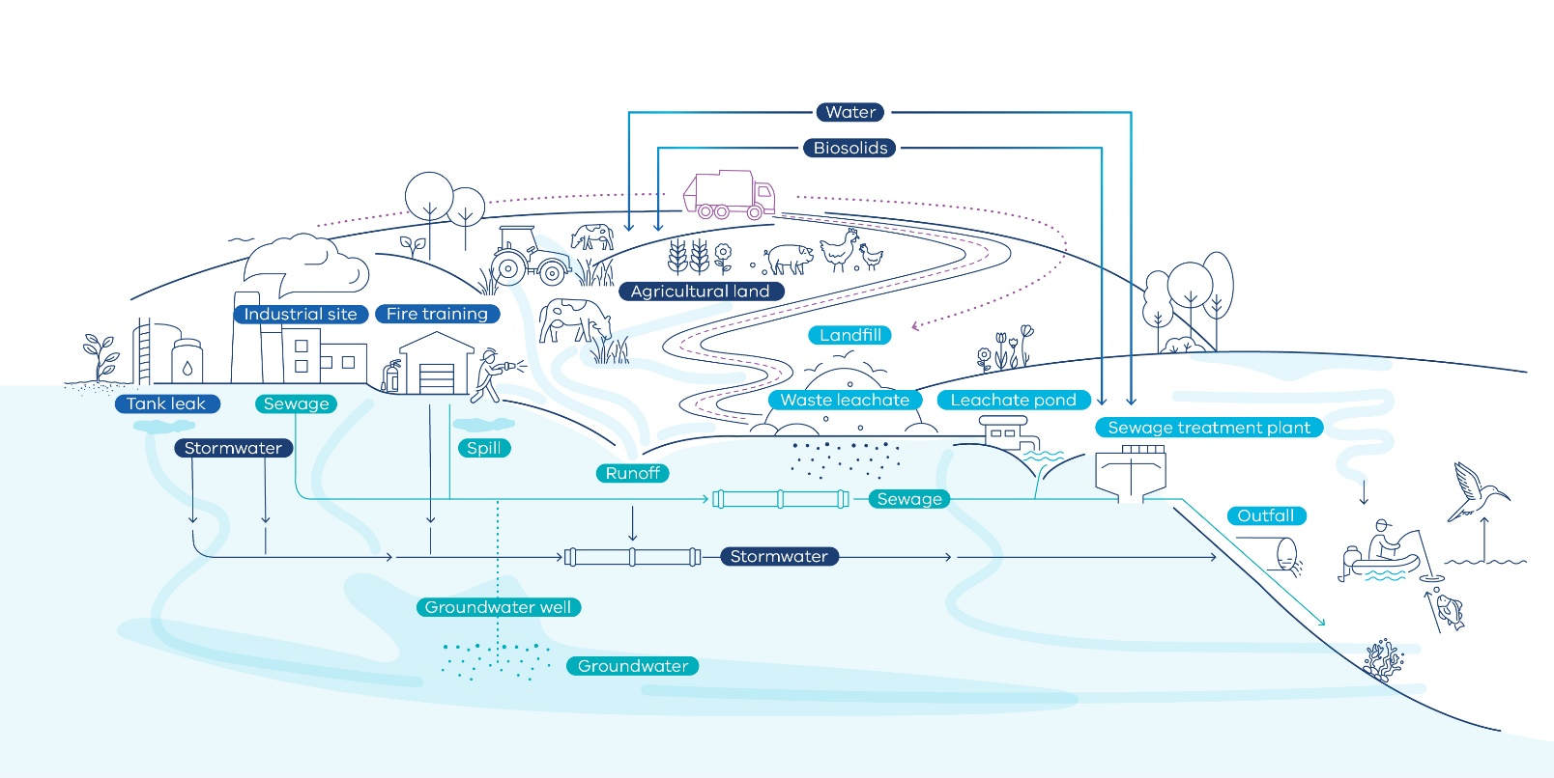
- . PFAS movement in the domestic environment and pathways for human and environmental
exposure in the domestic environment
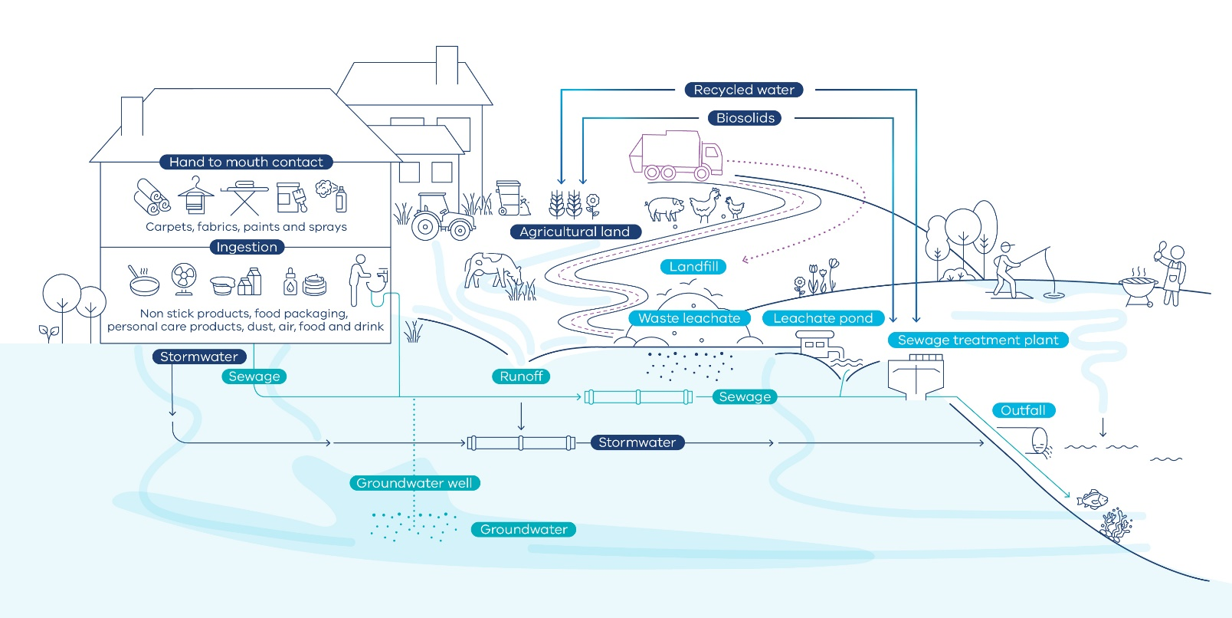
- PFAS impacts to the environment and human health
  - Health
We are all exposed to small amounts of PFAS in everyday life. This is through exposure to dust, indoor and outdoor air, food, water, and contact with consumer products that contain PFAS, such as outdoor gear (for example waterproof clothing), new carpets and cookware. This explains why there are ambient levels of these chemicals found in people who have no occupational exposure to PFAS.
EPA’s position on PFAS is reflects the findings of the 2018 Expert Health Panel for PFAS report and the 2019 Australian Government’s Environmental Health Standing Committee (enHealth) Guidance Statement. The current enHealth advice on the health effects of PFAS is:
“Although there is still uncertainty around the potential for PFAS exposure to cause significant adverse human health effects, we do know that some long chain PFAS, such as PFOS and PFOA, can persist for a long time both in the environment and in humans. Therefore, it is prudent to reduce exposure to PFAS as far as is practicable…”
In 2016, the Department of Health commissioned Food Standards Australia New Zealand (FSANZ) to develop health-based guidance values (HBGVs) for PFOS, PFOA and PFHxS. The HBGVs are set at a level where exposure over a lifetime will not result in significant health risk for humans. These HBGV have been used to develop environmental criteria protective of health as set out in the NEMP 2.0 and are used in risk assessments at contaminated sites.
Currently, investigations into PFAS exposure via dietary routes, e.g. via ingestion or intake by water, indicate no food safety concerns for Australian consumers (FSANZ, 2021). As previously mentioned, the 27th Australian Total Diet Study (ATDS) investigated a broad range of Australian foods for 30 different PFAS, including PFOS, PFHxS and PFOA. Concentrations were below the FSANZ HBGVs (FSANZ, 2021), as well as Australian drinking water guidelines (NHMRC, 2019). In addition, PFAS concentrations were consistently lower than levels found in Europe, the United States, the United Kingdom and China.
  - Ecological impacts of PFAS
Due to their structure and potential for bioaccumulation, PFAS can be harmful for organisms (Martin et al. 2003; Kelly et al. 2009). The accumulation of PFAS in biota depends on both abiotic (non-living, including sediment, water and soil) and biotic (living organisms, including plants, algae, invertebrates and fish) sources that are ingested. Fish represent one of the main exposure routes of PFAS to humans and wildlife (e.g. Suominen et al. 2011; Christensen et al. 2017).
Since PFAS can be transported over long distances in the atmosphere, they are also found in organisms from remote regions (e.g. high-altitude mountain lakes). PFAS have been detected in fish caught across the world including Australia. Recent studies have revealed that PFAS is present in both Australian native and introduced fish species (Taylor, 2018). There is evidence that concentrations of PFAS can biomagnify within increasing trophic levels in animals feeding on and exposed to PFAS contaminated foods (see Ghisi et al. 2019), waters and soils, such as waterfowl, fish-eating birds, aquatic mammals such as seals and polar bears, along with humans (Sharma et al. 2016; Su et al. 2017; Christensen et al. 2017; Boisvert et al. 2019)
The presence of PFAS in the environment is a growing concern as PFAS have been shown to have adverse impacts on fish and other organisms (Babut et al. 2017). Previous studies have shown that PFAS accumulate in the tissues of organisms, with laboratory studies indicating potential for negative effects on animal reproduction, immunity and development (e.g. Jantzen et al. 2016; Lee et al. 2017). Importantly, concentrations of PFAS increase significantly in the tissues of animals higher up in food chains making the long-lived animals the most vulnerable (e.g. Huber et al. 2015; Blévin et al. 2017).

- Ambient levels of PFAS in Victoria
  - Key concepts and definitions
For PFAS, there is no ‘natural’ concentration in the environment because they are manufactured industrial chemicals. PFAS present in water, sediment, soil, biota, air, dust and waste across Victoria arises from long-term use in products and industries and in waste materials.
Therefore, the following three concepts and definitions apply:
- Background sites - represent natural environments with no or minimal anthropogenic impact. Given PFAS is a synthetic substance there is no background level within the meaning of the Act, which is limited to the ‘naturally occurring concentration in the vicinity of the land’.
- Remote ambient sites – represent sites where the levels of PFAS present are very low (e.g. close to limit of reporting), such as national and state parks and where there is no known source.
- Agricultural ambient/urban ambient sites – represent sites, which are likely to include PFAS but without a known point source input.
  - Methodology: land-use classification
Since 2016, EPA has assessed ambient land-use based on environmental (soil, freshwater and freshwater sediment) and biota (fish, ducks and livestock) levels of PFAS in Victoria. Specifically, EPA has investigated the occurrence, concentration, and spatial distribution of PFAS across a gradient of land-use intensity. The scientific paper by Sardiña et al. (2019) presented the first results of these investigations, along with an ecological risk assessment for freshwater aquatic ecosystems. Since the publication, more sites have been sampled and studied, and the methodology for categorizing land-uses has been now refined. The new refined method is, as follows:
A sequential tiered approach was used to determine four land-use classes (remote-ambient, agricultural-ambient, urban-ambient and mixed-ambient). Firstly, the Victorian Land Use Information System (VLUIS) and Australia Land Use and Management (ALUM) Classification (version 8) were used to define seven Tier 1 land-use classes (Table 1). Secondly, the proportion of the Tier 1 land uses in the upstream sub-catchment for each studied site was analysed using multivariate statistical methods and four Tier 2 land-use classes were established (Table 2). All sites within 5 km (linear stretch) upstream or downstream of known point sources, as defined in Table 1, were excluded from this analysis.
- . VLUIS and ALUM primary land-uses used to define seven Tier 1 land-use classes in this document
VLUIS primary land-use categories | ALUM primary classes | Tier 1 land-use classes
1. Residential | 5. Intensive uses - secondary class 5.4.0 | Residential
2. Commercial | 5. Intensive uses - secondary class 5.5.0 | Commercial
3. Industrial | 5. Intensive uses - secondary class 5.3.0 | Industrial
4. Extractive industry | 5. Intensive uses - secondary class 5.8.0 | Industrial
5. Primary production | 2. Production from relatively natural environments  3. Production from dryland agriculture and plantations - secondary classes 3.1.0 and 3.2.0  4. Production from irrigated agriculture and plantations - secondary classes 4.1.0 and 4.2.0 | Low-intensity agriculture
 | 3. Production from dryland agriculture and plantations - secondary classes 3.3.0 and 3.4.0  4. Production from irrigated agriculture and plantations - secondary classes 4.3.0 and 4.4.0  5. Intensive uses - secondary classes 5.1.0 and 5.2.0 | High-intensity agriculture
6. Infrastructure and utilities | 5. Intensive uses - secondary class 5.6.0 | Industrial
7. Community services | 5. Intensive uses - secondary class 5.5.0 | Commercial
8. Sport, heritage and culture | 5. Intensive uses - secondary class 5.5.0 | Commercial
9. Conservation | 1. Conservation and Natural Environments | Remote
Various (examples of VLUIS secondary categories: defence services, naval base, service station, oil refinery, petrochemical manufacturing, wastewater, landfill, airport, fire station, speedways, recycling, toxic storage centre) | 5. Intensive uses - secondary classes 5.7.0 and 5.9.0 | Point-source
- . Tier 2 land-use classes defined by the upstream proportion of Tier 1 land uses
Land-use classes | Proportion of land-uses in the upstream catchment
Remote-ambient | > 85% remote and  <1% commercial and/or industrial and/or  <5% residential and/or  <2% high-intensity agriculture (for example, cropping, horticulture, feedlots) and/or  <10% low-intensity agriculture (for example, grazing)
Agricultural-ambient | >60% high- or low-intensity agriculture and  <10% commercial and industrial and/or  <25% residential
Urban-ambient | >50% commercial or/and industrial or/and residential
Mixed-ambient | Sites that do not fall within the remote, agriculture or urban land-use classes

- Current knowledge: ambient concentrations of PFAS in Victoria
EPA has conducted two ambient sampling campaigns to date (see further details in publications: Sardiָña et al. 2019; EPA publication 1879: Emerging contaminants assessment 2019–20: Summary of results). As a summary of our findings, here we present ambient concentrations and detection frequency for the three main PFAS compounds in riparian soil, freshwater and sediments in Victoria based on land-use class (Table 3).
- . Ambient concentrations and detection frequency for PFOS, PFHxS, and PFOA in riparian soil*, freshwaters and sediments in Victoria according to land-use classes
 |  | PFOS |  |  | PFHxS |  |  | PFOA
Matrix and Tier 2 land-use classes | n | Range |  | Detected (%) | Range |  | Detected (%) | Range |  | Detected (%)
RIPARIAN SOIL |  | mg/kg |  |  | mg/kg |  |  | mg/kg
Remote-ambient | 5 | <0.002 | <0.002 | 0 | <0.001 | <0.001 | 0 | <0.001 | <0.001 | 0
Agricultural-ambient | 16 | <0.002 | 0.003 | 12 | <0.001 | <0.001 | 0 | <0.001 | <0.001 | 0
Urban-ambient | 42 | <0.002 | 0.029 | 23 | <0.001 | 0.001 | 1 | <0.001 | <0.001 | 0
Mixed-ambient | 24 | <0.002 | 0.016 | 21 | <0.001 | <0.001 | 0 | <0.001 | <0.001 | 0
FRESHWATER |  | µg/L |  |  | µg/L |  |  | µg/L
Remote-ambient | 5 | <0.0002 | 0.0002 | 20 | <0.0002 | <0.0002 | 0 | <0.0005 | <0.0005 | 0
Agricultural-ambient | 16 | <0.0002 | 0.009 | 75 | <0.0002 | 0.004 | 69 | <0.0005 | 0.023 | 62
Urban-ambient | 42 | 0.0007 | 0.081 | 100 | 0.0005 | 0.044 | 100 | 0.0005 | 0.036 | 100
Mixed-ambient | 24 | <0.0002 | 0.048 | 87 | <0.0002 | 0.037 | 83 | <0.0005 | 0.006 | 71
SEDIMENT |  | mg/kg |  |  | mg/kg |  |  | mg/kg
Remote-ambient | 5 | <0.002 | <0.002 | 0 | <0.001 | <0.001 | 0 | <0.001 | <0.001 | 0
Agricultural-ambient | 16 | <0.002 | 0.005 | 19 | <0.001 | <0.001 | 0 | <0.001 | 0.001 | 6
Urban-ambient | 41 | <0.002 | 0.039 | 27 | <0.001 | 0.001 | 2 | <0.001 | <0.001 | 0
Mixed-ambient | 24 | <0.002 | 0.005 | 21 | <0.001 | 0.001 | 4 | <0.001 | <0.001 | 0
*Note: Soil samples were collected adjacent to freshwater sampling locations (Sardina et al 2019) and are therefore called 'riparian soils'. Riparian soil land-use was based on the land-use classification of the freshwater location.

- References
ANZG, 2018. Australian and New Zealand Guidelines for Fresh and Marine Water Quality. Australian and New Zealand Governments and Australian state and territory governments, Canberra ACT, Australia. Available at: www.waterquality.gov.au/anz-guidelines
Apelberg, B.J., Witter, F.R., Herbstman, J.B., Calafat, A.M., Halden, R.U., Needham, L.L., Goldman, L.R., 2007. Cord serum concentrations of perfluorooctane sulfonate (PFOS) and perfluorooctanoate (PFOA) in relation to weight and size at birth. Environmental Health Perspectives, 115, 1670–1676.
Babut, M., Labadie, P., Simonnet-Laprade, C., Munoz, G., Roger, M.C., et al. 2017. Per- and poly-fluoroalkyl compounds in freshwater fish from the Rhone River: Influence of fish size, diet, prey contamination and biotransformation. Science of the Total Environment, 605, 38 – 47.
Blévin, P., Angelier, F., Tartu, S., Bustamante, P., Herzke, D., Moe, B., Bech, C., Gabrielsen, G.W., Bustnes, J.O., Chastel, O., 2017. Perfluorinated substances and telomeres in an Arctic seabird: Cross-sectional and longitudinal approaches. Environmental Pollution, 230, 360-367.
Boisvert, G., Sonne, C., Riget, F.F., Dietz, R., Letcher, R.J., 2019. Bioaccumulation and biomagnification of perfluoroalkyl acids and precursors in East Greenland polar bears and their ringed seal prey. Environmental Pollution, 252, 1335 – 1343.
Christensen, K.Y., Raymond, M., Blackowicz, M., Liu, Y., Thompson, B.A., Anderson, H.A., Turyk, M., 2017. Perfluoroalkyl substances and fish consumption. Environmental Research, 154, 145-15.
Cousins, I.T., DeWitt, J.C.; Gluge, J., Goldenman, G., Herzke, D., Lohmann, R., Miller, M., Ng, C.A.., Scheringer, M., Vierke, L., Wang, Z., 2020. Strategies for grouping per- and polyfluoroalkyl substances (PFAS) to protect human and environmental health. Environmental Science: Processes & Impacts, 22, 7.
FSANZ, 2021. 27th Australian Total Diet Study, Per- and poly-fluoroalkyl substances. Food Standards Australia New Zealand (FSANZ).
Gaballah, S., Swank, A., Sobus, J.R., Howey, X.M., Schmid, J., Catron, T., McCord, J., Hines, E., Strynar, M., Tal, T, 2020. Evaluation of developmental toxicity, neurotoxicity and tissue dose in zebrafish exposed to GenX and other PFAS. Environmental Health Perspectives, 128, 4.
Ghisi, R., Vamerali, T., Manzetti, S., 2019. Accumulation of perfluorinated alkyl substances (PFAS) in agricultural plants: A review. Environmental Research, 169, 326 – 341.
Huber, S., Warner, N.A., Nygård, T., Remberger, M., Harju, M., Uggerud, H.T., Kaj, L., Hanssen, L., 2015. A broad cocktail of environmental pollutants found in eggs of three seabird species from remote colonies in Norway. Environmental Toxicology and Chemistry, 34, 1296-1308.
ITRC, 2022. PFAS Technical and Regulatory Guidance Document. Interstate Technology Regulatory Council (ITRC), Washington, DC. Available at: https://pfas-1.itrcweb.org/.
Kelly, B.C., Ikonomou, M.G., Blair, J.D., Surridge, B., Hoover, D., Grace, R., Gobas, F.A.P.C., 2009. Perfluoroalkyl Contaminants in an Arctic Marine Food Web: Trophic Magnification and Wildlife Exposure. Environmental Science & Technology, 43, 4037-4043.
Kudo, N., Bandai, N., Suzuki, E., Katakura, M., Kawashima, Y., 2000. Inducation by perfluorinated fatty acids with different carbon chain length peroxisomal beta-oxidation in the liver of rats. Chemicology - Biological Interaction, 124, 119-132.
Jantzen, C.E., Annunziato, K.M., Cooper, K.R., 2016. Behavioral, morphometric, and gene expression effects in adult zebrafish (Danio rerio) embryonically exposed to PFOA, PFOS, and PFNA. Aquatic Toxicology, 180, 123 – 130.
Lee, J.W., Lee, J.W., Shin, Y.J., Kim, J.E., Ryu, T.K., Ryu, J., et al. 2017. Multi-generational xenoestrogenic effects of Perfluoroalkyl acids (PFAAs) mixture on Oryzias latipes using a flow-through exposure system. Chemosphere, 169, 212 – 223.
Martin, J.W., Mabury, S.A., Solomon, K.R., Muir, D., 2003. Dietary accumulation of perfluorinated acids in juvenile rainbow trout (Oncorhynchus mykiss). Environmental Toxicology and Chemistry, 22, 189-95.
NHMRC, 2019. Australian drinking water guidelines. https://www.nhmrc.gov.au/about-us/publications/australian-drinking-water-guidelines
OECD, 2021. Reconciling Terminology of the Universe of Per- and Polyfluoroalkyl Substances: Recommendations and Practical Guidance, OECD Series on Risk Management, No. 61, OECD Publishing Paris.
PFAS National Environmental Management Plan Version 2.0., 2020. Department of Agriculture, Water and the Environment. https://www.awe.gov.au/sites/default/files/documents/pfas-nemp-2.pdf
Peterson, E.E., Sheldon, F., Darnell, R., Bunn, S.E. and Harch, B.D., 2011. A comparison of spatially explicit landscape representation methods and their relationship to stream condition. Freshwater Biology, 56, 590-610.
Peterson, E.E. and Pearse, A.R., 2017. IDW‐Plus: An Arc GIS Toolset for Calculating Spatially Explicit Watershed Attributes for Survey Sites. JAWRA Journal of the American Water Resources Association, 53, 1241-1249.
Pelletier, C., Ji, Z., Hagolle, O., Morse-McNabb, E., Sheffield, K., Webb, G.I. and Petitjean, F., 2019. Using Sentinel-2 Image Time Series to map the State of Victoria, Australia. In 2019 10th International Workshop on the Analysis of Multitemporal Remote Sensing Images (MultiTemp), pp. 1-4.
Sardiָña, P., Leahy, P., Metzeling, L., Stevenson, G., Hinwood, A., 2019. Emerging and legacy contaminants across land-use gradients and the risk to aquatic ecosystems. Science of the Total Environment, 695, 133842.
Sharma, B.M., Bharat, G.K., Tayal, S., Larssen, T., Becanova, J., Karaskova, P., et al. 2016. Perfluoroalkyl substances (PFAS) in river and ground/drinking water of the Ganges River basin: Emissions and implications for human exposure. Environmental Pollution, 208, 704 – 713.
Staponites, L.R., Barták, V., Bílý, M. and Simon, O.P., 2019. Performance of landscape composition metrics for predicting water quality in headwater catchments. Scientific reports, 9, 1-10.
Steenland, K., Fletcher, T., Savitz, D.A., 2010. Epidemiologic evidence on the health effects of perfluorooctanoic acid (PFOA). Environmental Health Perspectives, 118, 1100-1108.
Su, G., Letcher, R.J., Moore, J.N., Williams, L.L., Grasman, K.A., 2017. Contaminants of emerging concern in Caspian tern compared to herring gull eggs from Michigan colonies in the Great Lakes of North America. Environmental Pollution, 222, 154 – 164.
Suominen, K., Hallikainen, A., Ruokojärvi, P., Airaksinen, R., Koponen, J., Rannikko, R., Kiviranta, H., 2011. Occurrence of PCDD/F, PCB, PBDE, PFAS, and organotin compounds in fish meal, fish oil and fish feed. Chemosphere, 852011, 300-306.
Taylor, M.D., 2018. First reports of per- and poly-fluoroalkyl substances (PFASs) in Australian native and introduced freshwater fish and crustaceans. Marine and Freshwater Research, 69, 628-634.
US EPA, 2022. Technical Fact Sheet: Drinking water health advisories for four PFAS (PFOA, PFOS, GenX chemicals, and PFBS) (EPA 822-F-22-002). United State Environmental Protection Agency.
Wang, Z., DeWitt, J.C., Higgins, C.P., Cousins, I.T. 2017. A never-ending story of per- and polyfluoroalkyl substances (PFASs)? Environ. Sci. Technol, 51, 5, 2508 – 2518.

Accessibility
Contact us if you need this information in an accessible format such as large print or audio.
Please telephone 1300 372 842 or email contact@epa.vic.gov.au

Interpreter assistance
If you need interpreter assistance or want this document translated, please call 131 450 and advise your preferred language. If you are deaf, or have a hearing or speech impairment, contact us through the National Relay Service.
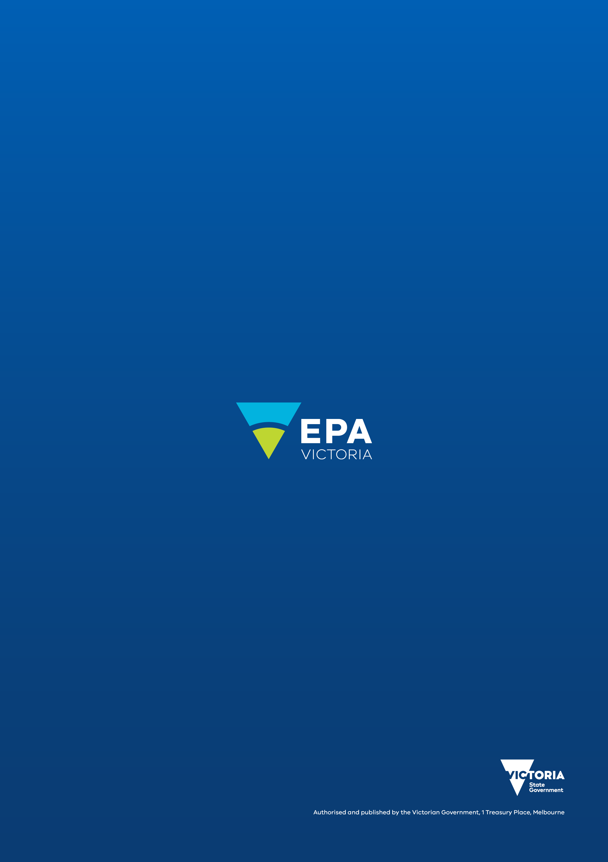
epa.vic.gov.au
Environment Protection Authority Victoria
GPO BOX 4395 Melbourne VIC 3001
1300 372 842

