Regulating onsite wastewater management systems

  - Local government toolkit

Publication 1974 | November 2022
Regulatory Enablement Branch

epa.vic.gov.au
Environment Protection Authority Victoria
GPO BOX 4395 Melbourne VIC 3001
1300 372 842

This publication is for general guidance only. You should obtain professional advice if you
have any specific concern. EPA Victoria has made every reasonable effort to ensure accuracy
at the time of publication.

Give feedback about this publication online: epa.vic.gov.au/publication-feedback

EPA acknowledges Aboriginal people as the first peoples and Traditional custodians of the land
and water on which we live, work and depend. We pay respect to Aboriginal Elders past and present
and recognise the continuing connection to, and aspirations for Country.

Contents
Disclaimer 5
About this toolkit 5
About the environment protection laws for OWMS 5
About the general environmental duty 6
Council investigation under different Acts 6
On-site wastewater management systems 6
Potential risks to human health and the environment 6
Priority waste 7
Part A: Permit for constructing, installing, or altering OWMS 7
What the law says 7
Transitional provisions for existing permits and new applications 7
Altering OWMS 7
Permit requirements 8
Enforcing permit law 9
Councils 9
Person appointed to take proceedings 9
Authorised officer 9
Administering permits 10
Permit applications 10
Permit fees 11
Permit expiry 11
Permit conditions 11
Approving OWMS for use 11
Inspecting a new or altered OWMS 12
Part B: Operation and maintenance of OWMS 13
What the law says 13
Enforcing the Regulations for operation and maintenance of OWMS 16
Regulatory approach to OWMS maintenance and operation 19
Risk of harm from the non-compliance 20
Attitude, behaviour, and actions of the person (or persons) in management or control of the OWMS 20
Other relevant factors 20
Investigating OWMS maintenance and operations issues 20
Process for investigating issues 21
Communicating with people who report an OWMS issue 22
Communicating with owners and land occupiers with OWMS issues 22
Contemporaneous notes 23
Inspecting OWMS to assess compliance 24
Part C: Regulating OWMS under the general environment duty 34
Delegation to councils and appointing authorised officers 34
How the general environmental duty applies to OWMS 35
Investigating OWMS issues under the general environmental duty 35
Assessing compliance under the general environmental duty 35
Enforcing the general environmental duty 36
Information and education 37
Notices under the Act 37
Enforcement of improvement and prohibition notices 38
Review of improvement notices and prohibition notices 38
Contact EPA 40
Appendix 1: OWMS permits 41
Appendix 2: Permit fees 47
Appendix 3: Investigation flowchart 48
Appendix 4: Notice ordering maintenance – regulation 163 49
Appendix 5: Infringement notices 51
Appendix 6: Prosecution 52
Appendix 7: Council authorised officer powers 54
Appendix 8: Improvement notice – section 271 58
Appendix 9: Prohibition notice - section 272 60
Accessibility 63
Interpreter assistance 63

Disclaimer
The information in this publication is for general guidance only. It does not constitute legal or other professional advice and should not be relied on as a statement of the law. Because it is intended only as a general guide, it may contain generalisations. You should obtain professional advice for your specific circumstances.
EPA has made every reasonable effort to provide current and accurate information, but it does not make any guarantees regarding the accuracy, currency or completeness of that information.

About this toolkit
Environment Protection Authority Victoria (EPA) has developed this toolkit to support local government (council) officers in Victoria to understand and enforce the laws under the Environment Protection Act 2017 (the Act) and Environment Protection Regulations 2021, in relation to on-site wastewater management systems with a design or actual flow rate of sewage not exceeding 5000 litres on any day (OWMS).
This toolkit also provides practical tips and advice on how to investigate complaints and issues relating to OWMS, using the Act’s risk-based compliance framework. The toolkit has three parts:
Part A - explains the permit for construction, installation or alteration of an OWMS and approval
of use.
Part B - explains the laws requiring proper operation and maintenance of OWMS, including the duties of owners and occupiers, and how council can enforce maintenance.
Part C - explains how councils can regulate OWMS under the Act’s general environmental duty (GED), through a delegation of powers from EPA.
Use this toolkit with:
- Environment Protection Act 2017
- Environment Protection Regulations 2021
- Code of practice – onsite wastewater management (EPA Publication 891.4)
(currently under review).
- Administering your powers under the Act: Guide for local government and litter authorities (EPA Publication 1993)

About the environment protection laws for OWMS
The Act and Regulations set out the laws that apply to owners and occupiers of land with OWMS.
Councils have an important and long-standing role in regulating OWMS. The Act and Regulations provide councils with a range of powers and tools to regulate OWMS.
The laws relating to OWMS that council can enforce include:
- the requirement for a permit from council to construct, install or alter an OWMS
- requirements for the operation and maintenance of OWMS for owners and occupiers
- general environmental duty (through functions and powers that EPA delegates to councils)

About the general environmental duty
The general environmental duty (GED) is central to the Act, and it applies to all Victorians. The GED requires any person engaging in an activity that may cause risk of harm to human health or the environment from pollution or waste to minimise these risks, so far as reasonably practicable (https://www.epa.vic.gov.au/about-epa/laws/new-laws/what-is-reasonably-practicable).
The GED applies to people who own or use an OWMS, including how the system is constructed, installed, altered, operated, and maintained. It also applies to how faults and system failures are dealt with and how waste is managed. This allows for a broad, prevention-based approach to the risks and impacts associated with OWMS.

Council investigation under different Acts
Council officers are often appointed under multiple Acts, so it is important to understand when you can investigate and enforce the Act and Regulations.
This toolkit sets out the powers of councils and council officers appointed under the Act to enforce the environment protection laws.

On-site wastewater management systems
OWMS, including septic tank systems, are used on residential, community and business premises. They treat and then recycle, or dispose of:
- greywater ─ from showers, baths, hand basins, washing machines, laundry troughs
and kitchens
- blackwater ─ toilet waste from water-flush, incineration or dry composting systems
- sewage ─ a combination of greywater and blackwater.
The Regulations includes the following definitions:
- on-site wastewater management system means an on-site wastewater treatment plant with a design or actual flow rate of sewage not exceeding 5000 litres on any day and includes all beds, sewers, drains, pipes, fittings, appliances and land used in connection with the treatment plant.
- on-site wastewater treatment plant means a treatment plant for the bacterial, biological, chemical or physical treatment of sewage generated on site. For example, a septic tank system, a wet or dry composting toilet, aerobic treatment, and sand filter.

Potential risks to human health and the environment
OWMS have the potential for major environmental and human health risks. Poorly installed or maintained systems, particularly old legacy systems, can create serious hazards. These might include polluted drinking water, contaminated land and water bodies, and offensive odours. Owners and occupiers have a responsibility to minimise these risks so far as reasonably practicable. Read more about OWMS and wastewater on the EPA website (https://www.epa.vic.gov.au/for-community/environmental-information/water/about-wastewater/onsite-wastewater-regulatory-framework).

Priority waste
Sewage from a septic tank system is considered a ‘priority waste’ under the Act and Regulations. This means it has the potential to pose a higher risk to the environment. If priority waste is disposed of illegally or improperly, such as releasing it into creeks or forests, there can be major environmental consequences.
Owners and occupiers have important obligations to make sure septic tank waste is appropriately managed and does not overflow. When septic tanks are pumped out, all reasonable steps must be taken to make sure whoever is transporting the waste takes it to an appropriate facility. Read more about reportable priority waste on the EPA website (https://www.epa.vic.gov.au/for-business/new-laws-and-your-business/manage-waste/reportable-priority-waste).

Part A: Permit for constructing, installing, or altering OWMS

What the law says
Under the Act, a permit from council is required to construct, install or alter an OWMS with a design or actual flow rate of sewage not exceeding 5000 L on any day.

Transitional provisions for existing permits and new applications
A permit to construct, install or alter a septic tank system, issued by a council under section 53M of the Environment Protection Act 1970 (the 1970 Act), is equivalent to a permit to construct, install or alter an OWMS under the Act (section 470) and the Regulations 219(2).
A permit application made under the 1970 Act, which was still in progress at the time the Act commenced (old application), is treated as a new application for the equivalent permit under section 474(1)-(3) of the Act and regulation 220(1).
The new application will be assessed under the Act. When assessing an application, council must give the applicant a reasonable opportunity to provide any further information which council may require to make an informed decision.

Altering OWMS
Altering an OWMS needs a permit from council. The Regulations define that to alter an OWMS means any change to:
- the design or construction of the system,
- the operation of the system, or
- the place or premises in or on which the system is located​, which may increase the hydraulic flow or organic load of the system.
An alteration does not include general maintenance of the system. Examples of maintenance activities are included in regulation 159(2) – see Table 2 in Part B of this toolkit.

Permit requirements
The laws relating to permits are set out in Parts 4.2 and 4.3 of the Act and Parts 3.1, 3.3 and Schedule 1 of the Regulations. These requirements are set out in Table 1 below. There are serious offences for constructing, installing or altering an OWMS:
- without a required permit or exemption
- in breach of a condition of a permit or exemption
- operating a new system without council approval.
Table 1: Requirements relating to OWMS permits
Act section  or  Regulation | Requirement* | Maximum court penalties in penalty units | Infringement penalties in penalty units | Infringement code
Section 46(1) | A person must not engage in a prescribed permit activity except as authorised by a permit in respect of the activity.  Note: Prescribed activities that require a permit are listed in Schedule 1 of the Regulations. This includes constructing, installing or altering an OWMS with a design or actual flow rate of sewage not exceeding 5000 L on any day. | 1000 (natural person) | N/A | N/A
 |  | 5000 (body corporate)
Section 63(2) | A person must not breach a condition of a permit issued to the person. | 1000 (natural person) | N/A | N/A
 |  | 5000 (body corporate)
Section 64 (a)-(c) | A person must not breach, in a permit issued or granted to the person, any condition prescribed in any of the circumstances listed in sections 64(a)-(c). | 120 (natural person) | 10 (natural person) | 0341
 |  | 600 (body corporate) | 50 (body corporate) | 0342
Regulation 33 | On completion of construction, installation or alteration of an OWMS in accordance with a permit, the council that issued the permit must inspect the system and must issue a certificate approving the use of the system if the Council is satisfied that the system complies with the permit.
Regulation 34(1) | The holder of a permit for a relevant activity related to an OWMS must ensure that the system specified in the permit is not used until council has approved it in accordance with Regulation 33. | 20 (natural person) | 6 (natural person) | 0245
 |  | 100 (body corporate) | 30 (body corporate) | 0246
Regulation 34(2) | Sub-regulation (1) does not apply to the holder of a permit that specifies the alteration of an OWMS.
*Read the Act and Regulations at legislation.vic.gov.au/

Enforcing permit law
The laws under the Act and Regulations relating to OWMS permits are administered and enforced by councils. Councils and persons appointed by council can take a range of enforcement actions.
The enforcement action taken must be proportionate to the nature of the offence – see Table 3: Compliance and enforcement tools for OWMS.

Councils
Councils can initiate court proceedings for permit related offences listed under regulation 171(2).
This power comes from section 347(3) of the Act. Councils will need to delegate this power to appropriate employees.

Person appointed to take proceedings
A person appointed by council to take proceedings can:
- initiate court proceedings for OWMS permit related offences listed under regulation 171(1). This power comes from section 347(3) of the Act.
- issue an infringement notice for a OWMS permit related infringement offence listed under regulation 171(1). This power comes from sections 307(4)(a) and 347(3) of the Act.

Authorised officer
An authorised officer (AO) appointed by council under section 242(2) or (2A) of the Act, via delegated powers from EPA, may issue an infringement notice for breach of a prescribed permit condition (section 64 of the Act). This power of AOs comes from section 307(4)(f) of the Act.
The role and powers of AOs of the councils are discussed further in Part B of this toolkit.

Administering permits
Regulation 25 sets out that constructing, installing or altering an OWMS is an activity that needs a permit administered by the local municipal district council.
OWMS permit applications must be sent to the relevant local council, not EPA.

Permit applications
The Regulations set out:
- the form and manner of a permit application
- the information that must be included in the application
- matters that council must consider when deciding whether to issue a permit
- the statutory timeframes that apply.
Additionally, the Act and the Regulations set out the circumstances where a permit must be refused.
Read more about permit applications in Appendix 1: OWMS Permits.
Figure 1 below shows the general process for administering permits.

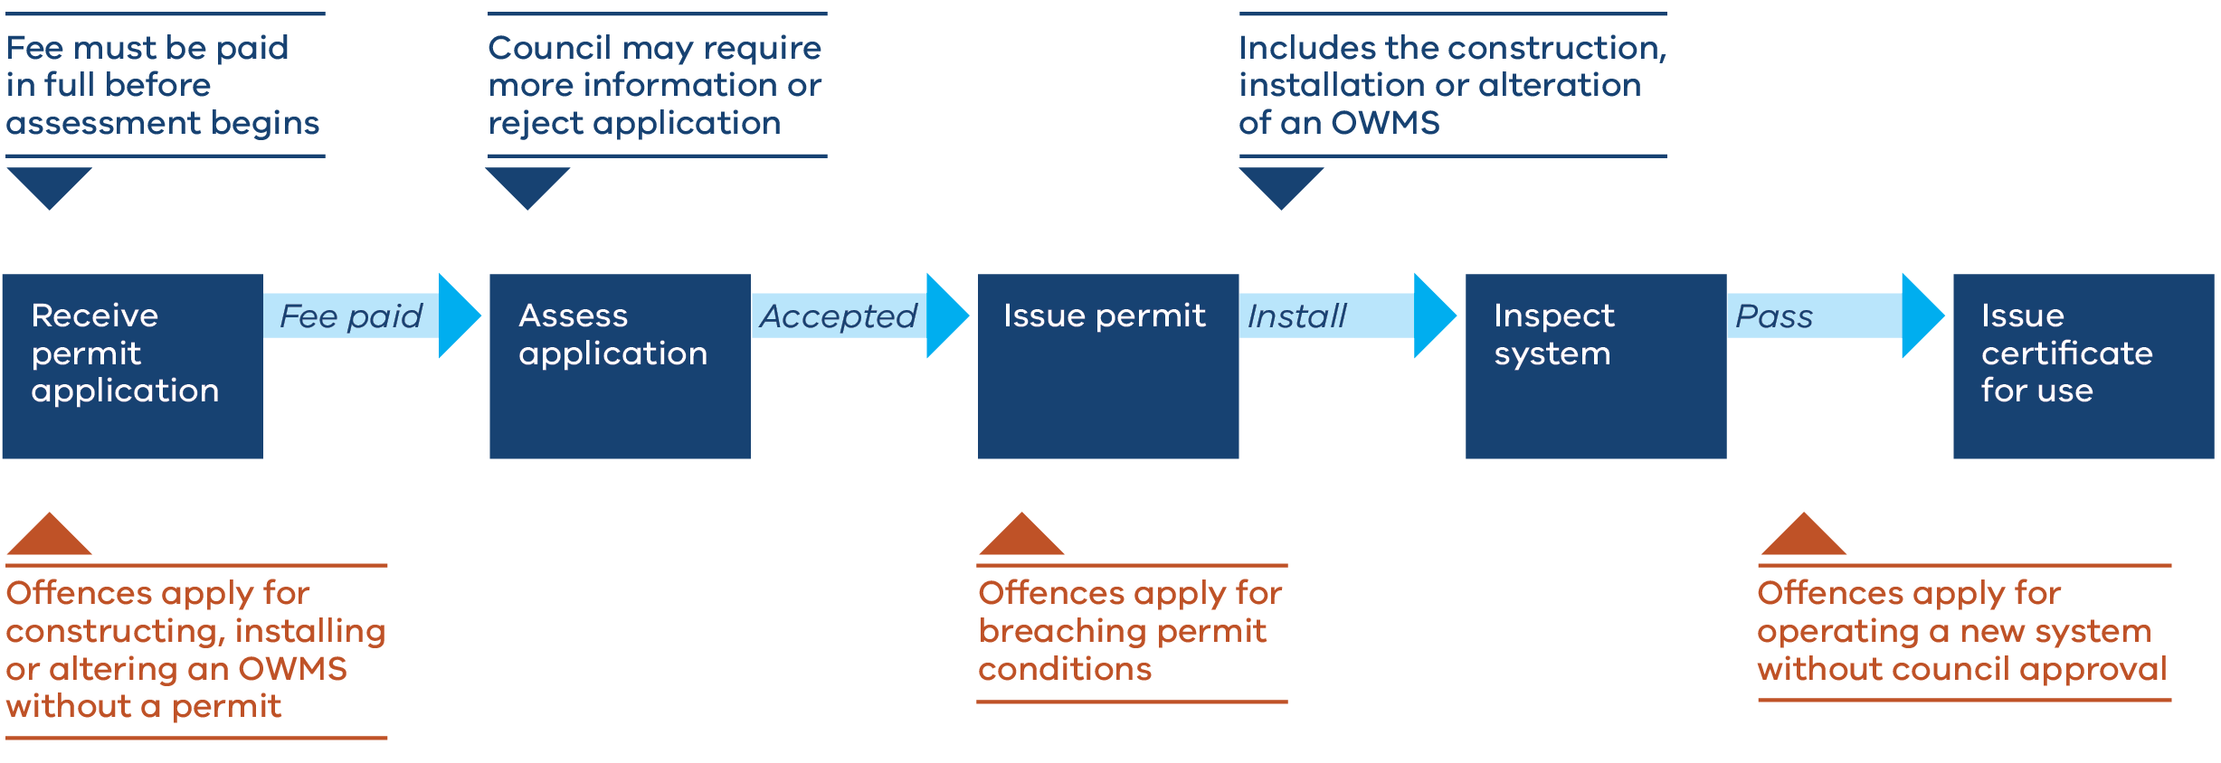
Figure 1: Permit process
Approving alteration of OWMS
Council must inspect OWMS that have been altered and confirm all permit conditions have been met before issuing a certificate for use of the altered system. However, unlike for construction or installation of new systems, it is not an offence to use an OWMS while it is undergoing alteration (see Table 1).

Permit fees
The fees that councils can charge relating to OWMS permit applications are prescribed in Part 8.4, Division 4 of the Regulations. Refer to Appendix 2: Prescribed fees for permits.
Councils may:
- retain fees paid under the Act ─ section 439(1) of the Act
- reduce, waive or refund fees if the council is satisfied it is reasonable to do so ─ regulation 215(2)
- suspend or revoke an OWMS permit, if the holder of the permit hasn’t paid any prescribed fee for the permit ─ section 60(1)(d) and 61(1)(d) of the Act. Other grounds for suspending or revoking permits are listed in Appendix 1: OWMS Permits.

Permit expiry
OWMS permits can be issued for a maximum of 5 years, with the option to renew before it expires.
Permits aren’t an ongoing compliance tool. A permit is only required until the OWMS work is done and council approves the system for use.

Permit conditions
Council can add any conditions to a permit that it considers appropriate. This is subject to the general principle that conditions must be consistent with the Act and Regulations.
It is an offence for a person who has been issued a permit by council to breach a permit condition.
Certain conditions are prescribed under the Regulations, and the Act includes a specific offence for breach of a prescribed permission condition.
Read more about permit conditions in Appendix 1: OWMS Permits.

Approving OWMS for use
Under regulation 33, once a system is fully constructed, installed or altered, the council who issued the permit must inspect the system. If council is satisfied the system complies with the permit, they must issue a certificate approving the use of the system.
For example, a council may be satisfied that the system complies with the permit if they can see that it adheres to the manufacturer's manual, supplied by the person managing or controlling the system.

Inspecting a new or altered OWMS
Inspection for the purpose of approving the system for use (regulation 33) can be undertaken by any council officer who has obtained the consent of the occupier to enter the premises. That person does not have to be an AO of the council. A council representative (contractor) may also seek and obtain consent to enter residential premises for the purposes of inspections under regulation 33.
Note: The role and powers of AOs appointed by council through the delegation from EPA is covered in Parts B and Part C of this toolkit.
Where a council officer (whether or not they happen to also be an AO) enters a premises with the consent of the occupier and inspects the OWMS for the purposes of assessing compliance with a permit and approving the system for use (regulation 33), a written report is not required.

Scenario: Poor installation
A landowner rang council to arrange final inspection of a newly installed/constructed OWMS under permit.
- Actions:
- Council officer arranged a time to inspect the system with the landowner who was the permit holder in this case. The plumber was also on site.
- During the inspection the council officer observed that certain conditions of the permit had not been complied with. This included the alarm not being installed at the pump well, Additionally the distribution pipes in the effluent disposal bed were not installed as per permit conditions. Poor installation would lead to effluent being distributed unevenly over the effluent disposal bed.
- Council officer provided education to the owner and plumber regarding their obligations to comply with the permit that has site specific conditions, as well as proper installation in compliance with Australian Standards.
- Outcomes:
The plumber completed the installation in accordance with the permit and a second inspection was conducted by council. Council then issued a certificate approving the of the system.
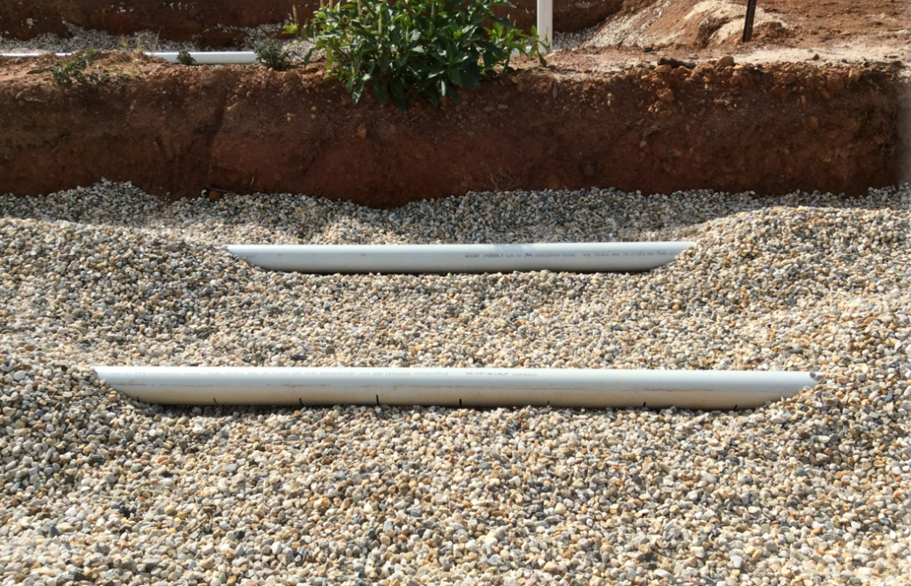

Part B: Operation and maintenance of OWMS

What the law says
Part 5.7 of the Regulations, ‘On-site wastewater management systems’, sets out the obligations on various people to minimise risks, including those in management and control of an OWMS. These obligations include:
- maintaining the system in good working order
- ensuring those operating the system have the information they need
- responding to any failures.
These obligations under the Regulations apply to all systems, including older systems that didn’t have a permit when they were installed. People may still operate old legacy systems, but they must take all reasonable steps to ensure the OWMS is maintained in good working order.
The Regulations aim to ensure OWMS are operated and maintained in a way that minimises risks to human health and the environment.
Some of these requirements under the Regulations apply to landowners and occupiers, including renters. Others do not apply to ‘renters’ within the meaning of the Residential Tenancies Act 1997, and some only apply to landowners.
Table 2 lists these requirements under the Regulations, the associated penalties for non-compliance, and action councils may take to order maintenance of OWMS.
As well as the Regulations for operation and maintenance of OWMS, councils can deal with OWMS issues through the Act’s general environmental duty (GED), through delegated powers from EPA. These delegated powers are explained in Part C.

Table 2: Requirements for operation and maintenance of OWMS
Regulation | Requirement* |  | Maximum court penalties in penalty units | Infringement penalties in penalty units | Infringement code
A person in management or control of land on which an OWMS is located (for example an owner or occupier) must:
159(1) | Take all reasonable steps to ensure the OWMS is operated so it does not to pose a risk to human health or environment.  For example, ensuring the OWMS is not overloaded to an extent that causes a blockage, runoff, spillage or leak. |  | 10 (natural person) | N/A | N/A
 |  |  | 50 (body corporate)
159(2) | Take all reasonable steps to ensure the OWMS is maintained in good working order.  Examples of maintenance activities include:  - regular desludging to remove the contents of the system  - ensuring the integrity of pipes, tanks and storage systems  - repairing and when required replacing components and fittings of the system, maintaining the biological and chemical processes integral to the proper functioning of the system  - maintaining the integrity of the land used in connection with the system to ensure access to the system is not impeded  - complying with the system manufacturer's specifications and recommendations (if provided)  - complying with any relevant council requirements; monitoring the system for signs of failure.  This requirement does not apply to a renter of a residence, (within the meaning of the Residential Tenancies Act 1997). |  | 10 (natural person) | N/A | N/A
 |  |  | 50 (body corporate)
159(3) | Ensure the contents of the septic tank system do not overflow. |  | 10 (natural person) | 2 (natural person) | 0331
 |  |  | 50 (body corporate) | 10 (body corporate) | 0332
161 (2) - (3)  161 (4) | Notify the council (in whose municipal district the system is located) as soon as practicable after the person becomes aware, or reasonably should have been aware, that the system poses a risk to human health or the environment, or is otherwise not in good working order.  The system poses a risk if any of the following apply (but is not limited to these circumstances):  - the absorption field of the system becomes sodden with wastewater pooling on the surface of the surrounding land  - there is wastewater runoff from the disposal area  - there is an odour of effluent emanating from or near the system  - the drain or toilet of the system is running slowly  - the grease trap of the system is full or blocked there are any other signs that indicate that the system poses a risk to human health or the environment or is otherwise not in good working order.  A notification under this regulation must include the steps the person has taken or proposes to take, to ensure the system no longer poses a risk to human health and the environment and is returned to good working order.  The person making the notification must include the steps they have taken, or propose to take, to address the issue. |  | 10 (natural person) | N/A | N/A
 |  |  | 50 (body corporate)
An owner of land on which an OWMS is located (landowner) must:
160 | Provide written information to a person in management or control of the OWMS (for example an occupier) regarding the correct operation and maintenance of the system.  For example, where the property is leased, landowners need to provide information to occupiers or renters on how to correctly operate the system. |  | 10 (natural person) | 2 (natural person) | 0333
 |  |  | 50 (body corporate) | 10 (body corporate) | 0334
162(1) | Keep and hold all records of maintenance activities carried out on the system, including any pump-out and service records, for five years after each activity. |  | 5 (natural person) | 1 (natural person) | 0335
 |  |  | 25 (body corporate) | 5 (body corporate) | 0336
162(2) | If the council requests it, make any records of maintenance activities kept under sub-regulation (1) available for inspection. |  | 5 (natural person) | 1 (natural person) | 0337
 |  |  | 25 (body corporate) | 5 (body corporate) | 0338
Council may order maintenance
163(1)-(3) | Where the council in whose municipal district the OWMS is located, or an AO of the council has either:  - received a notification under Regulation 161(2), or  - has a reasonable belief that an OWMS poses, or may pose, a risk to human health or the environment, or is not, or maybe not, in good working order;  - then, if a council AO has:  - entered and inspected the place or premises where the OWMS is located, exercising their powers under Part 9.3 of the Act, and  - formed the reasonable belief that the system poses a risk to human health or the environment or is not in good working order;  - the council AO may give written notice to the owner to undertake the maintenance activities specified in the notice.
The landowner must:
163(4) | Comply with council notice requiring maintenance. | 10 (natural person) |  | 2 (natural person) | 0339
 |  | 50 (body corporate) |  | 10 (body corporate) | 0340
*Read the proposed final Regulations at EPA website (https://www.epa.vic.gov.au/about-epa/laws/new-laws/subordinate-legislation).

Enforcing the Regulations for operation and maintenance of OWMS
The Regulations related to operation and maintenance of OWMS, listed in Table 2, are enforced by councils. Councils and persons appointed by council can take a range of enforcement actions.
Councils can:
- initiate court proceedings for offences listed under regulation 171(2). This power comes from section 347(5) of the Act.
- request that a person who owns land with an OWMS make their records of maintenance activities undertaken on the OWMS available for council to inspect. This comes from regulation 162(2).
Councils will need to delegate these powers to appropriate employees.
A person appointed by Council to take proceedings can:
- initiate court proceedings for offences listed under regulation 171(2). This power comes from section 347(5) of the Act.
- issue an infringement notice for infringement offences listed under regulation 171(2). This power comes from sections 307(4) and 347(5) of the Act.
Note on appointing persons to take proceedings
Councils can appoint a person to take proceedings for both OWMS permit and operation and maintenance offences. These powers come from sections 347(3) and 347(5) of the Act.
- s347(3) relates to OWMS permit offences
- s347(5) relates to operation and maintenance offences.
Council officers need to make sure they have the relevant appointment to take proceedings and issue infringement notices.

Authorised officers
Council can appoint a person or each member of a class of persons as an AO under section 242(2) or (2A) of the Act. This includes non-employees of the council, such as specialist contractors.
This is made possible by a delegation of functions and powers from EPA to councils. Councils can appoint AOs for certain purposes listed in the delegation, including regulating OMWS.
The powers of council AOs are limited by a direction issued by EPA with respect to the delegation.
An AO of the council can:
- exercise certain powers of entry and inspection under Part 9.3 of the Act
- issue a notice ordering maintenance of an OWMS under regulation 163
- issue improvement notices and prohibition notices under section 271 and 272 of the Act.
These powers and notices are explained in detail later in this toolkit.
Read more about appointing AOs and person to take proceedings in ‘Administering your powers under the Environment Protection Act 2017: Guide for local government and litter authorities’ (EPA publication 1993) https://www.epa.vic.gov.au/about-epa/publications/1993

Scenario: Failing system
Situation
A plumber contacts Council to report that an OWMS located at a residential property is failing.
The plumber has reported the issue to council because the system is a make that is no longer manufactured and it is difficult to get spare parts. As a result they can’t service the system effectively. The plumber tells the council officer that the landowner is upset because the tank was only installed 12 years ago and has had lots of issues resulting in expensive repairs.
After speaking to the plumber the council AO decides to inspect the system to assess the risks. The officer calls the landowner to organise an inspection.
Observations during inspection:
The council AO confirms the make and type of system and observes:
- effluent disposal is via spray emitters
- one of the membranes in MBR chamber was damaged.
The damaged membrane means that effluent will not be treated to 20/30 standard as per the Code of Practice. There is a high public health risk as the spray irrigation is close to house.
Action:
The AO issues a notice ordering maintenance under Regulation 163. The notice requires the tank to be replaced and subsurface irrigation to be installed.
Outcome:
The owner complies with the notice, undertaking the actions required to reduce the risk from the system.
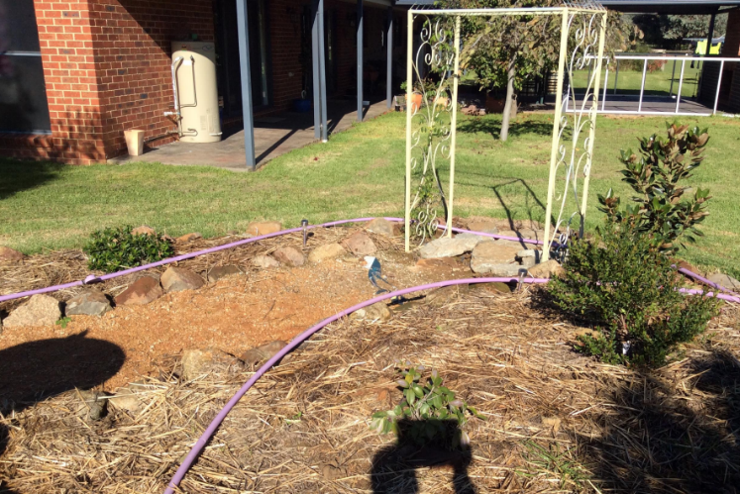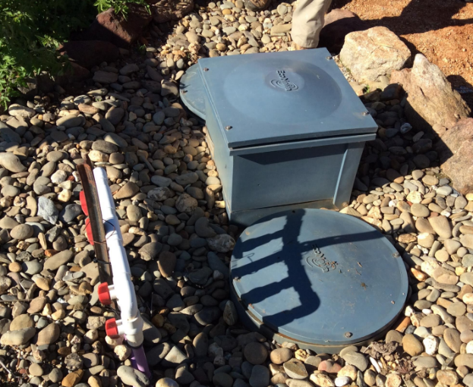

Scenario: System failure on public reserve
Situation
A local resident contacts council to report a persistent bad odour around the toilets at a recreation reserve.
Council is aware that the recreation reserve has a septic system that services a public toilet and a canteen.
The council AO organises an inspection with a local plumber after contacting the recreation reserve committee.
Observations during inspection
During the inspection the council officer observes multiple issues with the operation of the system, including overflow of the treatment tank. The plumber confirms the dripper lines are still operational.
Actions
Council contacts the recreation reserve committee and explains that the system poses a public health risk and requires maintenance.
The AO decides not to take enforcement action, such as issuing a notice, because the committee agree to fix the problem promptly and voluntarily.
Outcomes
Repairs were conducted (pump replaced). The recreation reserve committee plans to replace the system fully when funds are raised.

Regulatory approach to OWMS maintenance and operation
EPA recommends taking an escalating approach to compliance and enforcement action. This approach aims to:
- stop the unlawful activity and remedy any harm caused by the non-compliance
- raise awareness of the law and consequences of non-compliance
- punish offenders where appropriate.
Use the guidance in this section, along with Appendix 3: Investigation flowchart, and your council’s investigation procedures.
Nature and seriousness of the non-compliance
This includes:
- the extent to which controls are failing to meet the expected standard of management for a given risk
- the impact of either withholding or providing false information about environmental risk.

Risk of harm from the non-compliance
Consider the actual or potential impacts on human health (including psychological health) or the environment (including amenity).

Attitude, behaviour, and actions of the person (or persons) in management or control of
the OWMS
Consider, specifically, whether the person has:
- proactively identified risks and implemented controls to minimize those risks
- sought out and referred to industry, council and EPA guidance when they are unsure of how to manage risk
- notified council as soon as they are aware of an incident, as required by Regulation 161
- fully complied with any notices and promptly advised council of any issues that impeded compliance.

Other relevant factors
Consider other factors that may be relevant, for example:
- public interest
- the deterrent impact of enforcement ─ how much the use of enforcement action will
deter the specific offender from re-offending, as well as other people from committing similar offences
- council’s strategic priorities for compliance and enforcement action.

Investigating OWMS maintenance and operations issues
Councils may receive notifications, reports, or complaints about alleged OWMS operation or maintenance concerns in various ways. For example:
- a notification from a person in management or control of an OWMS, that the system is not in good working order, or poses a risk to human health or the environment. Examples under the Regulations of when the system poses a risk include (but are not limited to):
  - the absorption field of the system becomes sodden with wastewater pooling on the surface of the surrounding land
  - there is wastewater runoff from the disposal area
  - an odour of effluent emanating from or near the system
  - the grease trap of the system is full or blocked.
- reports from a person who has noticed an offensive odour or pooling of wastewater that they suspect is coming from their neighbour’s OWMS
- reports about wastewater run-off
- issues identified through a strategic campaign run by council to educate the community about their obligations to properly maintain and operate OWMS.

Process for investigating issues
When an alleged issue with the maintenance or operation of an OWMS comes to the attention of council, these stages should be followed:
- Stage 1: Initial investigation to understand all the relevant circumstances of the
alleged issue
- Stage 2: Site inspection to assess the environmental and human health impacts
- Stage 3: Use of compliance and enforcement tools in response to non-compliance.

Stage 1: Initial investigation
Perform an initial investigation to understand the problem.
Purpose | - understand the nature of the issue, such as its likely cause, impact, seriousness of risk to human health and the environment  - understand the people involved, such as the attitude, behaviour and actions of the relevant duty holder, any attempts to resolve the issue and the sensitivities of any people impacted  - consider the possible range of appropriate responses to start with, including providing information and guidance, direct compliance responses and speaking to affected people.
Approaches | - discuss the issue and share information about the operation and maintenance of OWMS, its impacts and the law, with the person in management or control of the system  - obtain information from the reporter if it’s applicable  - request that the landlord makes records of maintenance activities available for council to inspect - regulation 162  - respond within a reasonable time and move to action where possible  - show sensitivity to affected people and consider the impacts on their health  - acknowledge where a person in management or control of the OWMS has notified council of the issue, or where they were unaware of the problem  - explain the scope of the law and compliance pathways.
Questions to ask yourself | Review the notes you have about the incident:  - is there enough information about the issue?  - is there a known cause?  Notifications to council:  - has the person in management or control of the system reported issues with their OWMS to council before?  - will a site visit be required to assess the OWMS?  Reports/complaints:  - has the person affected reported OWMS issues to council before?  - will I need to meet the reporter on-site, for example, if their property is being affected, or at other land or water body?  - will I need to contact the person in management or control of the system suspected of causing the issue?  Council powers:  - do I have the power to take the enforcement action I am considering?  - does the issue also constitute a breach of the Public Health and Wellbeing Act 2008? Is the Environment Protection Act 2017 the best course of action?
Decision | Use your discretion to determine the appropriate response to take. For example, considering the range of educative, compliance and enforcement options.  You may have enough information at this point to provide advice to the person in management or control of the system, which may resolve the issue.  In some cases, you may consider the issue serious enough to investigate further, understanding the final decision may be issuing an official warning or infringement notice or a notice requiring action to be taken.  Follow your council’s investigation and interview procedures.  To support your approach, refer to the following information and considerations for communicating with people affected by OWMS and owners and occupiers.

Communicating with people who report an OWMS issue
Alleged non-compliance with the Act or Regulations may be discovered due to reports from the community to councils of offensive smells or wastewater being discharged from an OWMS, and the owner or occupier may not have
reported it.
How you communicate with the person affected by the OWMS issue can be as important as fixing the problem. Build trust with the person who’s reported the issue by acknowledging their frustration. They may have suffered from the issue for some time.
Be open in your communication. Explain the role of council in regulating OWMS and the outcomes they can expect.
Communicating with owners and land occupiers with OWMS issues
If you are investigating an issue that the owner or occupier has notified you about, as is their duty under Regulation 161, remember that they have done the right thing in bringing it to council’s attention. Work constructively with the person to identify the issue, and what they need to do to fix it.
Even if the issue has been reported by someone else, always be courteous. The person may not be aware of the alleged issue, and possible impact on their local community or environment. If the person doesn’t answer the door when you visit, leave a card for a call back.
In all situations start by identifying yourself and show your ID if asked. Explain the relevant obligations under the law to properly maintain and operate an OWMS. Also explain that overloading a system or discharging wastewater inappropriately may impact other people or the environment. Always maintain the standard of conduct expected of your professional role.
If a person is known to be aggressive, discuss the situation with your manager and consider requesting assistance from the police.
Be sure to act within the scope of your powers. If you do decide that further enforcement action is warranted, having taken into account the requirements in the Infringements Act 2006, explain what action you intend to take. If appropriate, educate and inform people in management or control of OWMS by providing guidance documents.

Contemporaneous notes
It’s crucial to take contemporaneous notes throughout your investigation. These notes detail your observations, including details of what you saw, heard and any conversations. Take notes as you observe actions occurring, or as soon as practicable after.
Always keep your original notes, which you may be required to produce for any related Court proceedings. These notes become both an official record and important evidence, to support any enforcement action.
Your notes may be needed to:
- complete a report, statement or affidavit, all of which can be used as evidence
- provide details that support enforcement action, such as issuing infringements and
other notices
- refresh your memory while giving oral evidence in relevant court proceedings (with the leave of the court) if you are unable to rely solely on your memory to answer questions.

Stage 2: Site assessment
The information you have gathered during your initial investigation forms part of the evidence available to council to assess the alleged OWMS operation or maintenance issue.
You may decide that a site assessment is then required to better understand the problem, especially if there’s an ongoing issue.
Purpose | - Investigate if there is an issue with the operation or maintenance of an OWMS  - Consider if there may have been an alleged breach of the Act or Regulations, for example by the person in management or control of the system, or landowner  - Resolve the issue by discussing with the person in management or control, or landowner  - If you can’t resolve through discussion, decide whether you consider that enforcement action under the Act or Regulations is appropriate, such as issuing an infringement notice or official warning, a notice to order maintenance or an improvement or prohibition notice – see Stage 3: Tools to address non-compliance.
Approaches | - Know your powers of entry under the Act:  - Only AOs of the council have powers to enter and inspect a place or premises to investigate OWMS issues under the Act or Regulations. These powers are explained in the next section and Appendix 7.  - There are limitations on entry into residential premises for AOs.  - AO powers of entry are required unless you have the consent of the occupier to enter and inspect  - Speak with the person in management or control of the system.  - Assess the system in person if possible.  - Plan your visit to maximise your chances of making a valid assessment and consider the timing, recurrence and nature of  the issue  - Follow your councils’ existing investigation and interview procedures  - Avoid lengthy investigations, use lower-level interventions where appropriate  - Consider the level of impact from the system to the environmental and human health  - Use approaches that reflect the attitude of the person who manages or controls the system and what its impact is on the environment or neighbours  - Where appropriate, enable people to resolve issues.
Questions to ask yourself | - Do I have power under the Act to enter the place or premises without the consent of the owner or occupier?  - Is there a time of day that’s best to do a site inspection, based on the use of the system?  - Is the system being maintained regularly? Do I need to request records of maintenance under Regulation 162(2)?  - Have I investigated and considered the attitude, behaviour and actions of the person in management or control of the system?  - Do I have sufficient evidence from my investigation to make a discretionary decision about what the appropriate action to take is (for example whether compliance or enforcement action is warranted)?  - Under the law, who is the relevant duty holder (for example would I be taking action against the landowner, person operating the system, such as a renter, or other)?  - Have I exercised a power of entry and inspection? If so, an entry report must be given to the occupier or apparent occupier under section 254 of the Act. See Council AO powers.
Decision | Use the following information, ‘Assessing the risks and impacts of OWMS’ and ‘Assessing against duties under the Regulations’ and in Part C ‘Assessing compliance with the GED’, to help you consider if an alleged offence may have occurred and whether an intervention, including enforcement action, may be warranted.

Inspecting OWMS to assess compliance
AOs of thew council may need to inspect an OWMS to assess compliance with the Act or Regulations, including for the purpose of:
- determining if a person has breached the requirements under the Act and Regulations relating to OWMS permits (see Part A)
- determining if a person has breached requirements relating to operation and maintenance of an OWMS
- ordering maintenance of an OWMS by notice
- determining compliance with the general environmental duty (see Part C)

AO powers of entry and inspection
AOs of the council appointed under s242(2) or(2A) of the Act, have powers of entry and inspection. These powers come from Part 9.3 of the Act.
An AO must only enter and inspect a premises for the purpose of performing a function or duty or exercising a power under the Act. This means that when inspecting OWMS, council AOs will need to be clear on the scope of their powers to enter and inspect premises, the purpose of the proposed entry/inspection and how that is linked to the functions and powers delegated to councils.
Importantly, AOs appointed under the Act have broad powers of entry to commercial premises, but more restricted entry powers to residential premises.
AOs may exercise entry and inspection powers in the circumstances below:
AO may enter and inspect any place or premises (sections 246-247 of the Act)
For the purpose of performing a function or duty, or exercising a power under the Act, an AO may enter and inspect a place or premises. Those purposes include the following:
- determining if a person has contravened the Act or Regulations
- monitoring compliance with the Act or Regulations
- determining if there is a risk of harm to human health or the environment from pollution, waste or contaminated land
- inspecting or testing equipment or a vehicle.
AOs may enter and inspect a place or premises at any reasonable time, including when open to the public. In circumstances where they reasonably believe there’s an immediate risk of material harm to human health or the environment, they may enter at any​ other time.
Residential premises (section 248 of the Act)
The Act establishes additional limitations/requirements in relation to entry and inspection of residential premises that effect an AO’s powers of entry and inspection under s.246.
Specifically, AOs must not enter and inspect premises that are used ​only for residential purposes ​except:
- with the consent of the occupier ​for the time being of the premises; or
- under the authority of a search warrant; or
- if the AO reasonably believe​s that a person has contravened, is contravening or is about to contravene, the Act or Regulations; or
- ​if the AO reasonably believe​s there’s an immediate risk of material harm to human health or the environment.
If an AO is entering and inspecting a residential premises on a reasonable belief as set out above, they can only enter ​and inspect a part of the premises that they believe is necessary for the purpose of determining if a person has contravened, is or is about to contravene, the Act or Regulations; or if there is an immediate risk of material harm to human health or the environment.
Entering residential premises with ‘reasonable belief’
As outlined in the boxes above, there are two circumstances of entry and inspection of a residential premises that rely on the AO forming a reasonable belief. These circumstances relate to contraventions of the Act or Regulations. For a belief to be reasonable, it must be based on facts that are sufficient to lead a reasonable person to hold that belief. It is not a concept which requires the AO to be absolutely certain of a risk or contravention, but it does require something more than a suspicion.

Evidence
Council AOs may rely on various sources of information and evidence to form a reasonable belief that a contravention has occurred, is occurring or is about to occur, or that there’s an immediate risk of material harm to human health or the environment in relation to an OWMS on residential premises.
For example, a complaint to the council from a reliable source, a notification under regulation 161 from the owner or occupier that their system is not working properly, or observations made by the AO such as odour near a property or leaking wastewater.
The evidence needs to indicate there is a problem or immediate risk with a particular OWMS. General information held by the council about a system, such as its age or design, may not be enough on its own for the AO to form a reasonable belief that the system is faulty. This kind of general information could be relied on in conjunction with other evidence such as complaints or odour, to form part of the circumstances giving rise to a reasonable belief.
Prior to exercising entry powers, the AO should make a note of the belief and the basis for that belief in case they need to make a statement and if enforcement action is required.

Actions on entry
Once the AO has formed a reasonable belief of a contravention or risk of material harm, they can enter and inspect an OWMS located on residential premises. Immediately upon entry, the AO needs to take all reasonable steps to notify the occupier of the place or premises (or the apparent occupier) of the entry and produce their identity card for inspection (section 249 of the Act).
This requirement to notify the occupier does not apply where the occupier has been notified in advance of the entry, or where announcing entry would unreasonably interfere with or delay the exercise of the inspection powers).
Remember that the power to enter and inspect a residential premises based on a reasonable belief of a contravention or an immediate risk of harm only extends to the part of the premises that its necessary to access – such as land where the OWMS is located in a back yard.

Entering residential premises with the occupier’s consent
An AO can request and obtain consent from the occupier of a residential premises to enter that premises.
A council inspector who is not an AO may also seek and obtain consent to enter residential premises, say, for the purposes of permit inspections under regulation 33.
Consent must be informed, genuine and should be provided in writing (such as by email) or verbally. If verbal consent is provided, it is recommended that the time, date, purpose and other relevant details of the consent is formally recorded, for example, in an inspection notebook.
Any entry to a residential premises that relies on the consent of the occupier must be limited to that part of the premises where the OWMS is located (and any other part of the premises enabling access to that system).
The inspector must act in accordance with the occupier’s instructions ─including leaving the premises if asked to do so. Council representatives (including AOs) must act consistently with a person’s right to privacy.
Councils who wish to undertake proactive inspections of OWMSs on residential premises, for example of older systems, will need to obtain the consent of the occupier to enter and inspect.

Entry reports
As soon as practicable after an AO exercises a power to enter and inspect a premises, they must provide a written report to the occupier. This requirement is under section 254 of the Act.
The entry report must include the following details:
- the time of entry and departure
- the purpose of entry and inspection
- what actions took place and what the officer observed, and
- how the occupier can contact council or the AO.

Assessing the risks and impacts of OWMS
Regulation 159 requires any person in management or control of land on which an OWMS is located (owners and occupiers), to take reasonable steps to ensure an OWMS is operated so it doesn’t pose risks to human health and the environment. You can check for signs of blockage, runoff, spillage or leak which may indicate that the system is being overloaded.
Owners and occupiers must also take reasonable steps to ensure that an OWMS is maintained in good working order. You can request maintenance records that can inform whether the system is being regularly desludged or pumped-out and what, if any, repairs have been undertaken, or components and fittings replaced. You can look for signs of system failure and the integrity of land used in connection with the system, and check compliance with any council requirements. Maintenance requirements do not apply to a renter of the residence (within the meaning of the Residential Tenancies Act 1997).
Regulation 159(3) is specific to septic tanks and requires that septic tank systems must not overflow.
The risks and impacts of OWMS may also be assessed under the general environmental duty (GED) – refer to Part C of this toolkit.

Assessing against the duties for operation and maintenance of OWMS
Landowners and occupiers have various duties under the Regulations in relation to OWMS on the property. When assessing if these duties have been complied with, consider the following:
Notify council of risks to human health or the environment -regulation 161 | Where you have identified an issue with the operation or maintenance of an OWMS (an alleged breach of regulation 159) and the owner or occupier did not notify council of the problem, they may be in breach of regulation 161. Assess whether it is reasonable to expect that the person would have been aware, or reasonably should have been aware, of the issue.  Also, assess whether there are obvious signs of system failure such as blockage, strong odour, runoff or pooling on the surface of surrounding land, or a lack of maintenance, where a system is not regularly desludged or pumped out.
Landowner must provide written information to person operating the system – regulation 160 | If there is a problem with an OWMS being operated by the occupier of a premises, rather than the landowner, you should find out whether the person was provided with information about the proper operation of the system.  If they weren’t, the landowner may have breached regulation 160, which requires the landowner to provide information to the occupier on the correct operation and maintenance of the system.
Keep and make available, records of maintenance – regulation 162 | If you request to see records of maintenance for the system, and the landowner either doesn’t have them or refuses to make them available to you for inspection, they may be in breach of regulation 162.  Records of maintenance are important evidence of whether the landowner has taken reasonable steps to keep the system in good working order, as required under regulation 159.

Stage 3: Compliance and enforcement tools
Once you have investigated the matter to a level that you sufficiently understand the unique facts and circumstances of the alleged issue, use your discretion to determine the appropriate and proportionate action to take. It’s crucial to understand the enforcement tools available to councils, so you can provide appropriate and proportionate responses to each OWMS issue.
Purpose | - Remedy the issue, to the greatest extent possible  - Enable relevant people in management or control to resolve issues  - Make a discretionary decision about whether enforcement action is warranted in the circumstances.
Compliance and enforcement tools | - Provide information and education, including explaining the possible enforcement outcomes for non-compliance  - Request that a landowner made records of maintenance activities available to inspect - regulation 162(2)  - Issue a notice ordering maintenance for a longer-term remedy of the problem - regulation 163  - Issue an improvement notice or prohibition notice under the Act if you reasonably believe there has been a relevant breach of the Act or Regulations (including alleged breach of the general environmental duty) – section 271 and 272 of the Act  - Issue an infringement notice for OWMS infringement offences:  - allowing a septic tank system to overflow (Regulation 159(3))  - failing to provide information to the occupier (Regulation 160),  - failing to keep maintenance records (Regulation 162(1))  - failing to make them available to council on request (Regulation 162(2)  - non-compliance with a notice ordering maintenance (Regulation 163(4))  - Prosecute through the Magistrates Court.  More information about compliance and enforcement tools for OWMS are included in the Appendix section of this toolkit.
Approaches | - Choose your approach based on the seriousness of the issue  - Be fair and consider the power imbalances between individuals  - Use approaches that have considered the attitude of the person in management or control of the system and the impacts on human health and the environment.
Questions to ask yourself | - Do I have the power to take the action I am considering?  e.g. appointment as an AO or person who may take proceedings for OWMS offences?  - Do I have sufficient evidence to support a compliance or enforcement response?  - What’s the most appropriate response, assessing all the unique facts and circumstances of the matter, including the attitude or behavior of the person in management or control?  - What tool or approach, or combination of approaches will provide an enduring remedy?
Decision | Make sure that you make a proportionate decision. Tools and approaches vary from advisory through to regulatory interventions.  Figure 2 demonstrates responsive regulation, helping officers to use an approach that considers the behaviour of those allegedly causing the non-compliance. Table 3 will help you to choose the appropriate intervention for the situation.

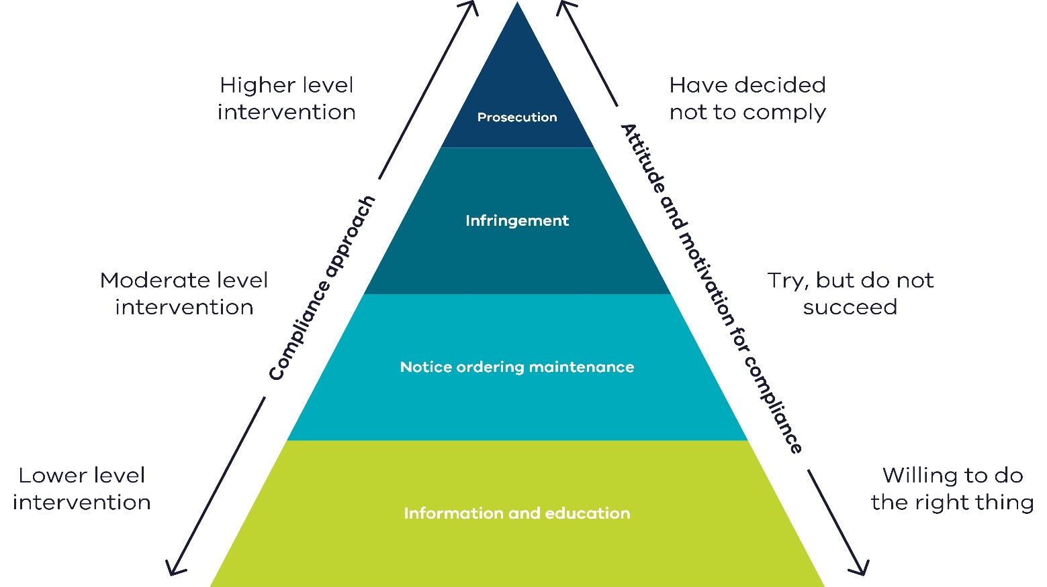
Figure 2: Compliance and enforcement approach for OWMS

Choosing a compliance and enforcement approach
When considering your OWMS compliance and enforcement options, you can refer to the following
Table 3 which sets out the compliance and enforcement tools and examples of when to use them.
Your approach to interventions should be dynamic, considering all the relevant facts and circumstances unique to the matter, including the behaviour of the person in management or control of the system, and the possible environmental and human health risks. For example, although you might routinely start with providing the person responsible with information and guidance, an enforcement response such as issuing an infringement notice or official warning may be a more appropriate response. This is where the person responsible is alleged to have an established pattern of deliberate breaches of the Act or Regulations.
Table 3 can help you to assess and determine the appropriate and proportionate compliance and enforcement tool(s) for the situation.

Table 3: Compliance and enforcement tools for OWMS
Level | Type of intervention | Suitable situations | Unsuitable situations | Other considerations
Lower level | Information and education | Where the relevant individual was unaware of overflowing wastewater from their OWMS and the impact on the health of people in the neighbourhood, and the local environment is low. | Repeat offenders and deliberate or known operation issues. | Level of harm to people in the area and the environment.
Moderate level | Request records of maintenance  ─ Regulation 162(2) | Where there are problems with the operation of the OWMS that need to be fixed. If the system hasn’t been maintained, then the problem may be more obvious. | Circumstances where there is evidence of ongoing or repeated non-compliance and records of maintenance have already been sought in the past. | Owners of land with OWMS must make records of maintenance available upon request by council.
 | Notice ordering maintenance  ─ Regulation 163 | Where there are problems with an OWMS that maintenance work is likely to fix. For example, replacing parts or pumping out the tank.  In this situation, the notice is an appropriate first step to bringing a person back into compliance. | Circumstances where there is evidence of ongoing or repeated non-compliance and the notice is unlikely to be effective.  Or where the OWMS is being maintained but the problems relate to the design of the system (particularly older or legacy systems). In this case council AOs can consider issuing an improvement or prohibition notice under the delegation from EPA. | A notice ordering maintenance may only be issued by a council AO appointed under section 242 of the Act.  A notice ordering maintenance may be issued alongside an infringement notice or official warning, if appropriate.
 | Infringement notices | - Where a person has allegedly breached a prescribed permit condition.  - Where a person has allegedly operated a newly constructed or installed OWMS without council approval of use.  - Where guidance or previous notices to order maintenance have been ignored, or where the impact of overflowing wastewater from the OWMS is high. | One-off, accidental or low impact. | This generally shouldn’t be the first enforcement tool, but it might be, depending on the level of harm or the attitude of the person towards their legal obligations to manage an OWMS.  Also consider issuing an official warning rather than an infringement notice. Under section 8 of the Infringements Act, any issuing officer may serve an official warning rather than an infringement notice, if they consider in all the facts and circumstances it is appropriate to do so.
Higher level | Prosecution (Magistrates Court proceedings) | - Alleged ongoing or repeat non-compliance with the Act or Regulations, where the impact is high and notices have not been complied with.  - Where an infringement notice has been ineffective in getting the person to fix the problem. | One-off, accidental or low impact.  Where a notice to order maintenance or infringement has worked to get the person to fix the problem. | Prosecution may be initiated alongside other interventions such as a notice to order maintenance.

Part C: Regulating OWMS under the general environment duty
In addition to the requirements for operation and maintenance of OWMS under the Regulations (explained in Part B), council can also regulate risks and impacts from OWMS under Victoria’s key preventative environmental law ─ the general environmental duty (GED). This is through a delegation of powers from EPA.
Regulating OWMS under the GED allows councils to focus their regulatory effort on preventing problems caused by poorly maintained or operated OWMS. Councils can then respond to community concerns about the impacts from OWMS, based on the risks posed and how effectively those risks are being managed.

Delegation to councils and appointing authorised officers
A delegation of enforcement powers from EPA enables councils regulate the risks and impacts from OWMS under the GED. As we learnt in Part B, this delegation allows councils to appoint a person or class of person as an AO under section 242(2) or (2A) of the Act.
AOs of the council have powers of entry and inspection, and powers to issue improvement and prohibition notices for breach of the GED.
Read more about:
- AO powers- Part B and Appendix 7
- Appointing AOs - ‘Administering your powers under the Environment Protection Act 2017: Guide for local government and litter authorities’ (EPA publication 1993) https://www.epa.vic.gov.au/about-epa/publications/1993

General environmental duty
The Act introduces a duty focused on prevention, called the general environmental duty (GED). This duty requires anyone conducting an activity that may pose risks of harm to human health or the environment from pollution and waste, to minimise those risks.
Guidance and good industry practices provide the expected performance standards for managing and minimising risks.
Section 25 General environmental duty
(1) A person who is engaged in an activity that may give rise to risk of harm to human health or the environment from pollution or waste must minimise those risks, so far as reasonably practicable.
Read section 25 of the Act in its entirety at legislation.vic.gov.au
Read more:
- General environmental duty on the EPA website
- Reasonably practicable (EPA publication 1856)

How the general environmental duty applies to OWMS
The GED broadly covers OWMS issues and so it can be used by councils alongside the Regulations. It applies to anyone who owns or uses an OWMS. It also applies to how someone constructs, installs, alters, operates, and maintains the system, deals with faults or system failures, and manages their waste.
The GED requires the person in management or control of an OWMS, including an older system, to take all reasonably practicable steps to make sure the system doesn’t pose a risk to human health or the environment.
A council AO can issue an improvement or prohibition notice if they reasonably believe the GED has been breached in relation to an OWMS. For example, if an older system discharges untreated wastewater off-site and into a stormwater drainage system, a council AO may decide to issue an improvement notice under section 271, using breach of the GED as the grounds for issuing the notice. Leaving the system operating as it is, may cause land and water contamination issues that can also impact human health and the environment. Refer to Compliance and enforcement tools for council AOs.

Investigating OWMS issues under the general environmental duty
When investigating an OWMS issue as an alleged breach of the GED, council AOs will follow the same general regulatory approach provided in Part B.
However, while the principles and general investigation steps will be the same, there are some key differences with how OWMS risks and impacts are assessed under the GED.

Assessing compliance under the general environmental duty
The GED duty may be breached whenever there is a risk of harm not being proportionally managed. It doesn’t matter whether there’s been an actual impact on people or the environment, or not.
Assess OWMS issues under the GED by determining how well an individual or business:
- understands how their OWMS activities may create risks of harm to people or the environment
- has put in place reasonably practicable adjustments to eliminate or reduce risks of harm from their OWMS.
Assess if the owner or occupier is using and maintaining:
- the OWMS in a way that minimises risks, for example, by installing and maintaining it to the manufacturer’s specifications
- processes for identifying, assessing and controlling risks
- adequate systems to make sure if harm eventuates the effects are minimised.
Have they provided information, instruction, supervision and training to people engaged in activities to make sure they comply with the above?
Use EPA guidance to help you decide if an owner or occupier is in breach of the GED, such as the Code of practice – On-site wastewater management (EPA publication 891.4) (currently undergoing review)

Summary of what to consider when assessing
In summary, look at whether good industry standards have been adopted, rather than just focusing on the level and impact of the harm from the OWMS.
Your assessment should consider the:
- Individual and/or business
  - how well do they understand how to operate the system, to minimise any risk it may pose so far as reasonably practicable (including maintaining the system in good working order)? How do you know?
  - what systems for identifying, assessing and controlling risks would you expect to be in place? How does that compare to other individuals or businesses undertaking similar OWMS activities?
- Risks and controls – what’s in place? How effective are those controls? How well are users of the system informed and competent in implementing these controls?
- Evidence – what kinds of evidence would you look for that could indicate how risks are being managed?
- Unmanaged risks – what additional reasonably practicable controls would you recommend?
- Communication – how do you work with the individual or business to understand their risks and controls?

Enforcing the general environmental duty
AOs of the council have compliance and enforcement tools to bring owners and occupiers of land with OWMS into compliance with the GED. This includes the power to issue improvement notices and prohibition notices under the Act.
EPA takes an escalating approach to compliance and enforcement. Figure 3 provides examples of how councils can apply this approach to OWMS.

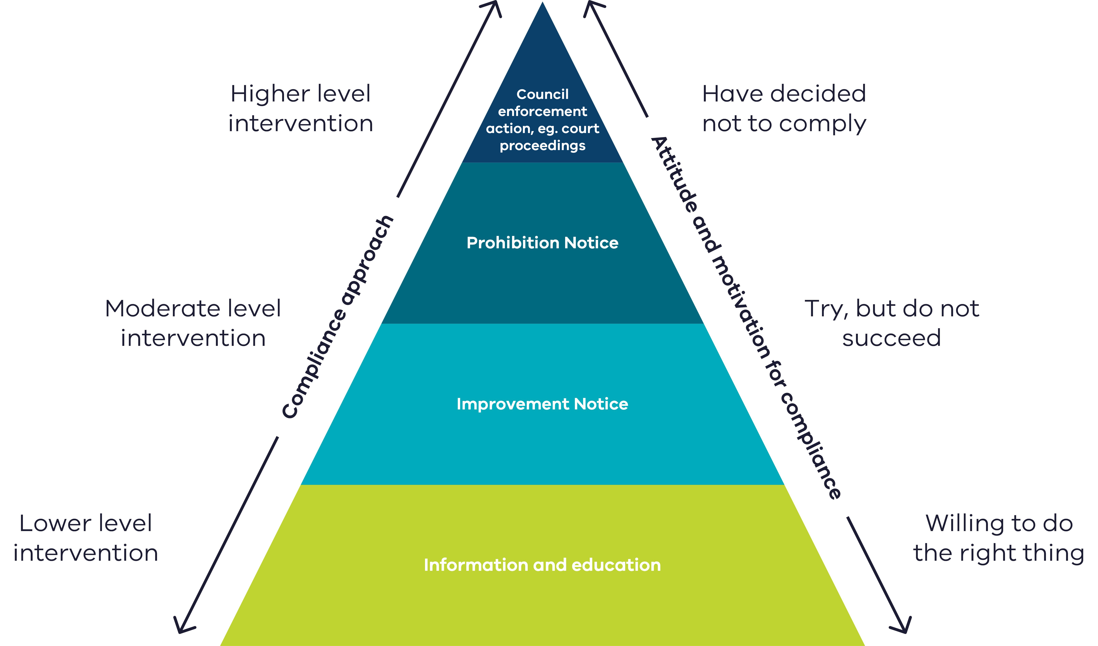
Figure 3: Compliance and enforcement approach to OWMS under GED

Information and education
Council AOs should provide EPA guidance to owners and occupiers so they can voluntarily comply with the GED when carrying out OWMS activities. When an owner or occupier is either unable or unwilling to voluntarily make changes to their activities, council AOs may issue an improvement notice or prohibition notice.

Notices under the Act
AOs of the Council may issue an improvement notice (section 271 of the Act) or prohibition notice (section 272 of the Act), if they have a reasonable belief that any of the grounds listed in those sections are satisfied. One ground for issuing these notices includes an alleged contravention of the Act or Regulations, including an alleged breach of the GED.
Notices are a tool intended to bring a person back into compliance with the law, by setting out the steps they must take to do so. A notice may compel the recipient to comply with the actions outlined by the council AO in the notice. Additionally, a notice ensures there’s a transparent formal record of the required action to remedy a risk or prevent harm. Notices will also include a timeframe(s) to comply.
Table 4 provides examples of situations where an AO of the council may consider issuing an improvement or prohibition notice.
Read more about these notices in Appendix 10 – Improvement notice & Appendix 11 – Prohibition notice.
Table 4: Improvement and prohibition notices
Intervention | Suitable situations | Unsuitable situations | Other considerations
Improvement notice – Section 171  Prohibition notice - Sections 172 | Where a notice ordering maintenance of OWMS (regulation 163) may not be appropriate. For example, where the OWMS is operating as it was designed to, and being adequately maintained, but that may nonetheless give rise to risks to human health and the environment and therefore, potentially breach the GED.  For example, the OWMS may have originally been designed to overflow, which may cause land and water contamination issues that can also impact human health. | - Where a notice ordering maintenance (regulation 163) can be issued to fix the problem. This should be your first go-to.  - Circumstances where there is evidence of sustained or repeated non-compliance and a notice is unlikely to be effective. | Improvement and prohibition notices can only be issued by a AO appointed by council under s242(2) or (2A) of the Act.

Enforcement of improvement and prohibition notices
Where an improvement or prohibition notice is not complied with, council can act. Action can be taken by an employee of the council that has been appointed under section 347(7) of the Act to take proceedings in relation to delegated functions and powers.
A council employee with this appointment can:
- take proceedings for an alleged offence of non-compliance with an improvement notice (section 286) or prohibition notice (section 287). This includes an alleged failure to report as required by such a notice (section 288). This power comes from section 347 of the Act.
- issue an infringement notice for non-compliance with a reporting requirement of a notice (section 288). This power comes from section 347 and 307 of the Act.
Note: Council cannot appoint a contractor or other non-employee to take proceedings. This limitation also extends to the power to issue an infringement notice for failure to comply with a reporting requirement in a notice. A council’s ability to engage the services of a legal practitioner to conduct proceedings on its behalf is not affected.
Read about appointing council employees to take proceedings in ‘Administering your powers under the Environment Protection Act 2017: Guide for local government and litter authorities’ (EPA publication 1993) https://www.epa.vic.gov.au/about-epa/publications/1993

Review of improvement notices and prohibition notices
A person who has received an improvement notice or prohibition notice has the right to apply to EPA for a review of the notice under section 429 of the Act.
Review of an improvement notice or prohibition notice issued by council can only be performed by EPA.
Notice recipients can apply to EPA for a review by calling 1300 372 842 (1300 EPA VIC).
If council receives review applications by mistake, email them to EPA immediately at internalreviews@epa.vic.gov.au.
Providing issued notices to EPA
EPA requires councils to provide copies of all improvement and prohibition notices issued by the council. This is so that EPA has a copy of the notice in the case of an internal review request. Send to issued notices to council_issued_notices@epa.vic.gov.au.

Contact EPA
epa.vic.gov.au
Ph 1300 372 842 (1300 EPA VIC)
EPA Council Support SharePoint site – council officers can email jointregulator@epa.vic.gov.au to become a member and access more resources.

Head office:  200 Victoria Street  Carlton 3053 | West Metro  Level 2, 12 Clarke Street  Sunshine 3020 | South West  West 1, 33 Mackey Street  North Geelong 3215
Southern Metro  Level 3, 14 Mason Street  Dandenong 3175 | North East  27–29 Faithfull Street  Wangaratta 3677 | Gippsland  8-12 Seymour St  Traralgon 3844
North Metro  Building One,  13a Albert Street  Preston 3072 | North West  Level 1, 47–51 Queen Street  Bendigo 3550

Appendix 1: OWMS permits
Council administers  OWMS permits | Under section 81- on receiving an application for a permit that complies with section 50, the council to which the application was made must:  - issue the permit subject to any conditions; or  - refuse to issue the permit.  Councils administer permits for constructing, installing or altering an OWMS located in their municipal district – regulation 25.
Information required in the application | Section 50 of the Act states that a permit application made to the council must:  - be made in the prescribed manner and form  - be accompanied by the prescribed fee  - specify that the application is for a permit  - specify the activity in relation to the permit application; and  - contain any prescribed information.  Council must not deal with the application if it does not comply with this section and must advise the applicant if this is the case.  Regulation 26(1) and (2) sets out the form and manner of a permit application and the information that must be included within it.  Form and manner - regulation 26(1)  - details of the applicant (name, address (postal and email if any), telephone number)  - address of the premises where the OWMS is/or planned to be located  - the owner of the relevant premises  - the name and contact details of the person undertaking any relevant plumbing works  - the name and contact details of any person undertaking construction, installation or alteration of the OWMS.  Prescribed information - regulation 26(2)  - detailed plans, specifications and particulars of the proposed construction, installation or alteration of the OWMS including a floor plan of the relevant premises  - details of the proposed use of the OWMS  - a copy of a certificate of conformity, issued by a body accredited under the Joint System of Australia and New Zealand (or any other accreditation body approved by the Authority) confirming that the proposed on-site wastewater treatment plant meets the appropriate standard – read more on the EPA website (https://www.epa.vic.gov.au/for-community/environmental-information/water/about-wastewater/onsite-wastewater-regulatory-framework); or a copy of an exemption granted by the Authority under section 459 of the Act (section 459 Exemption) stating that the applicant is exempted from the requirement to provide a certificate of conformity  - description of the proposed method of treatment and management of the effluent resulting from the OWMS, and evidence confirming the OWMS is appropriate for the proposed use  - land capability assessment (if required by council), prepared by a person council considers suitably qualified and to a standard acceptable to council.  Note: A section 459 Exemption may be granted to a permit applicant by EPA in highly exceptional circumstances that relate to innovative on-site wastewater treatment plants.  Transfer, amend or renew an OWMS permit  A permit may be transferred, amended or renewed (sections 56, 57 and 84 of the Act). For example, transfer may be necessary if a property associated with a permit is sold before the OWMS has been constructed, installed, or altered.  Regulation 26(3)-(6) sets out the form and manner and information required in an application to transfer, amend or renew an OWMS permit.  Additional information  The required information must have an acceptable level of detail provided by the applicant. If council considers additional information necessary, they may require the applicant to provide it under section 50(3) of the Act.
How long does council have to decide on the permit? | Council must decide on permit applications for OWMS within 42 business days after receiving the permit application – Regulation 27(2).  Statutory stop clock – if council has requested more information from the applicant, the Act allows the statutory clock to be stopped until the information is received (section 50(4)). This can also be through a joint agreement between the applicant and council.
What council must consider when deciding whether to issue the permit | Council must take the following matters into account when deciding whether to issue a permit – regulation 28(h):  - whether the site for the proposed construction, installation or alteration of the OWMS is environmentally sensitive or is otherwise unsuitable. Examples of environmentally sensitive sites may include freshwater lakes, sites in sandy areas with high water tables and sites in sensitive areas where the receiving waters may be at risk of algal blooms from high nutrient levels  - whether the proposed construction, installation or alteration of the OWMS is unsuitable for the site or proposed use  - whether the proposed use of the OWMS is inconsistent with the design specifications  - whether the area available for the treatment or disposal of the effluent resulting from the system is not suitable or sufficient  - the findings of any land capability assessment required under regulation 26(2)(e).
When council must refuse a permit | Under section 81(4)(c) of the Act, council must refuse to issue a permit if:  - council determines the permit applicant is not a fit and proper person to hold the permit; or  - council considers that the activity specified in the permit application poses an unacceptable risk of harm to human health or the environment; or  - any prescribed circumstances exist.  Regulation 29(4) prescribes that council must refuse a permit where the permit applicant has not provided the information required under Regulation 26(2)(c).  The prescribed information required under Regulation 26(2)(c) is:  - copy of the certificate of conformity confirming that the proposed on-site wastewater treatment plant meets the appropriate standard, or a copy of an exemption (from this requirement) granted to a permit applicant by EPA under section 459.  Under Regulation 29(5), this doesn’t apply to applications for alteration of an OWMS that was either:  - constructed or installed, or partially constructed or installed, before the Regulations commenced; or  - constructed or installed with a permit issued under the 1970 Act after the Regulations commenced.
Permit conditions | Section 81 says that council can issue a permit subject to any conditions it considers appropriate.  Section 64 makes it an offence to breach a prescribed permission condition.  These conditions are prescribed in the Regulations:  Regulation 18 Prescribed conditions under section 64 of the Act  (1) For the purposes of section 64(a) of the Act, a condition that is described in the permission as applying for the purposes of section 64 of the Act is prescribed.  (2) For the purposes of section 64(b) of the Act, the following classes of conditions are prescribed—  (a) conditions requiring the permission holder to provide data or to report on matters to the Authority, another agency or the public, including reporting on compliance with the permission or the conditions attaching to the permission;  (b) conditions requiring the permission holder to make and retain records for inspection.
How long is the permit in force? | Council may set a timeframe of between 2 and 5 years for which the permit will be in force. The timeframe must be included as a condition in the permit – Regulation 30(d).  If approval of use under Regulation 33 is granted before the timeframe set out in the permit conditions, the permit will cease on the date the approval of use is granted.
Permit exemptions | Section 83 of the Act allows a person to apply to council for an exemption from a permit.  An application for a permit exemption must:  - be made in the prescribed form and manner  - specify the activity involved  - be accompanied by the prescribed fee  - include any prescribed information.  On receiving an application that includes all the required information, council must decide on the exemption within 10 business days. When determining the exemption, a council must take into account any prescribed matter.  An exemption granted by council has no effect unless the applicable conditions are complied with.  Prescribed form and manner – Regulation 32(1)  - name, address (postal and email, if any) and telephone number of the applicant  - the address at which the activity specified in the application is to be engaged in if that address differs from the address required under paragraph (a)  - the name and contact details of the owner of the premises at which the activity specified in the application is occurring.  Prescribed information – Regulation 32(2)  - detailed plans, specifications and particulars of the proposed construction, installation or alteration of the OWMS including the floor plan of the premises at which the activity specified in the application is to be engaged in  - details of the proposed use of the OWMS  - in relation to the construction or installation of an OWMS, either a copy of a certificate of conformity, issued by a body accredited under the Joint Accreditation System of Australia and New Zealand (or any other accreditation body approved by the Authority), confirming that the proposed on-site wastewater treatment plant meets the appropriate standard; or a copy of an exemption granted by the Authority under section 459 of the Act, stating that the applicant is exempted from the requirement to provide a certificate of conformity  - a description of the proposed method of treatment and management of the effluent resulting from the OWMS and evidence confirming the system is appropriate for the proposed use  - if required by the council, a land capability assessment prepared by a suitably qualified person to a standard acceptable to the council.  Considerations for deciding a permit exemption  Regulation 32(3) lists the prescribed matters that council must consider when deciding whether to grant an exemption. These matters are:  - whether the activity specified in the application may pose a serious risk of harm to human health or the environment  - whether granting the exemption may adversely affect:  - the interests of any person other than the applicant; or  - any environmental values identified in any relevant environment reference standard.  Note: A section 459 Exemption may be granted to a permit applicant by the Authority in highly exceptional circumstances relating to innovative on-site wastewater treatment plants.
Council must approve the system for use | Under regulation 33, once the OWMS is constructed, installed or altered, council must inspect the system.  If council is satisfied the system complies with the permit, they must issue a certificate approving the use of the system.  For example, a council may be satisfied that the system complies with the permit if they see that the system complies with any manufacturer's manual supplied to them by the person in management or control of the system.  Regulation 34 prohibits the use of an OWMS following construction or installation, until council inspects and issues a certificate for use under Regulation 33.  This offence does not apply to the holder of a permit that specifies the alteration of an OWMS.
Consequences for not complying with OWMS permits | The Act sets out offences for not obtaining a permit and not complying with permit requirements.  Council or a person appointed by council to take proceedings can initiate court action or issue an infringement notice for certain offences.
Suspending and revoking a permit | Reasons for suspending or revoking a permit  The Act provides councils with the power to suspend or revoke a permit it has issued. This may temporarily or permanently remove the right of the permit holder to perform the associated activity.  A permit may be suspended under section 60 or revoked under section 61 of the Act, for any of the following reasons:  - the council believes on reasonable grounds that the holder of the permit has contravened the Act or Regulations  - the council does not consider the permit holder to be a fit or proper person to engage in the permit activities  - the council believes the permit holder has given to Council, or that the permit was obtained or renewed because of, materially incorrect or misleading information  - the permit holder has not paid any prescribed fee in relation to the permit  - the council is satisfied with any prescribed matter.  Additionally, council can revoke a permit if it is satisfied that the permit holder no longer engages in the permit activity. Or if it considers that the permit holder is no longer required to hold the permit.  Written notice of proposed suspension or revocation  Council must give the permit holder written notice stating:  - the activities in relation to which the council proposes to suspend the permit  - the reasons for the proposed suspension or revocation of a permit  - that the permit holder may, within 10 business days, make submissions to the council in relation to the proposed suspension or revocation.  Council must consider any submission before deciding whether or not to suspend or revoke a permit.  Decision to suspend or revoke a permit  As soon as practical after making a decision to suspend or revoke a permit, council must give the permit holder written notice stating:  - the decision and reasons for the decision  - the period of suspension, or the date the revocation takes effect  - that the permit holder may apply to VCAT for a review of the decision (except where the permit is no longer required).  Extension of suspension  Council can, by written notice, also extend the period of suspension, if on the date the suspension was to expire, council considers that the permit holder has not rectified any circumstances on which the council based its decision to suspend the permit. The permit holder can apply for a review of this decision by VCAT.

Appendix 2: Permit fees
Council can charge fees in relation to an application for a permit to construct, install or alter OWMS.
Application type | Fee design | Fee amount
Construct, install or alter OWMS ─ section 50(1)(b), regulation 196(1)(b),(2) | Variable application fee  A variable permit application fee has been prescribed to account for the differences in Councils’ cost base and the variety of systems for which a permit may be sought. | Minimum fee 48.88 fee units (for assessments not exceeding 8.2 hours) with an additional 6.12 fee units payable per hour of assessment (exceeding 8.2 hours) up to a maximum of 135.43 fee units.
Minor alteration to OWMS ─ section 50(1)(a), regulation 196(1)(a),(3)  (Minor alteration means an alteration that consists only of the installation, replacement or relocation of the internal plumbing, fixtures or fittings of an OWMS) | Flat application fee  A flat permit application fee has been prescribed for minor alterations to reflect that these applications are simpler, with lower variability in the amount of assessment time required. | 37.25 fee units
Transfer a permit ─ section 56(3)(b), regulation 197 | Flat application fee | 9.93 fee units
Amend a permit ─ section 57(3)(b),  regulation 198 | Flat application fee | 10.38 fee units
Renew a permit ─ section 84(3)(b),  regulation 200 | Flat application fee | 8.31 fee units
Exemption ─ section 83(2)(c),  regulation 199 | Variable application fee  A variable exemption application fee has been prescribed to account for the variability in the amount of assessment time required, as granting an exemption will turn on the specific circumstances relating to an application. | Minimum fee will be 14.67 fee units (for assessments not exceeding 2.6 hours) with an additional 5.94 fee units payable per hour (or part of an hour) of assessment (exceeding 2.6 hours) up to a maximum of 61.41 fee units.

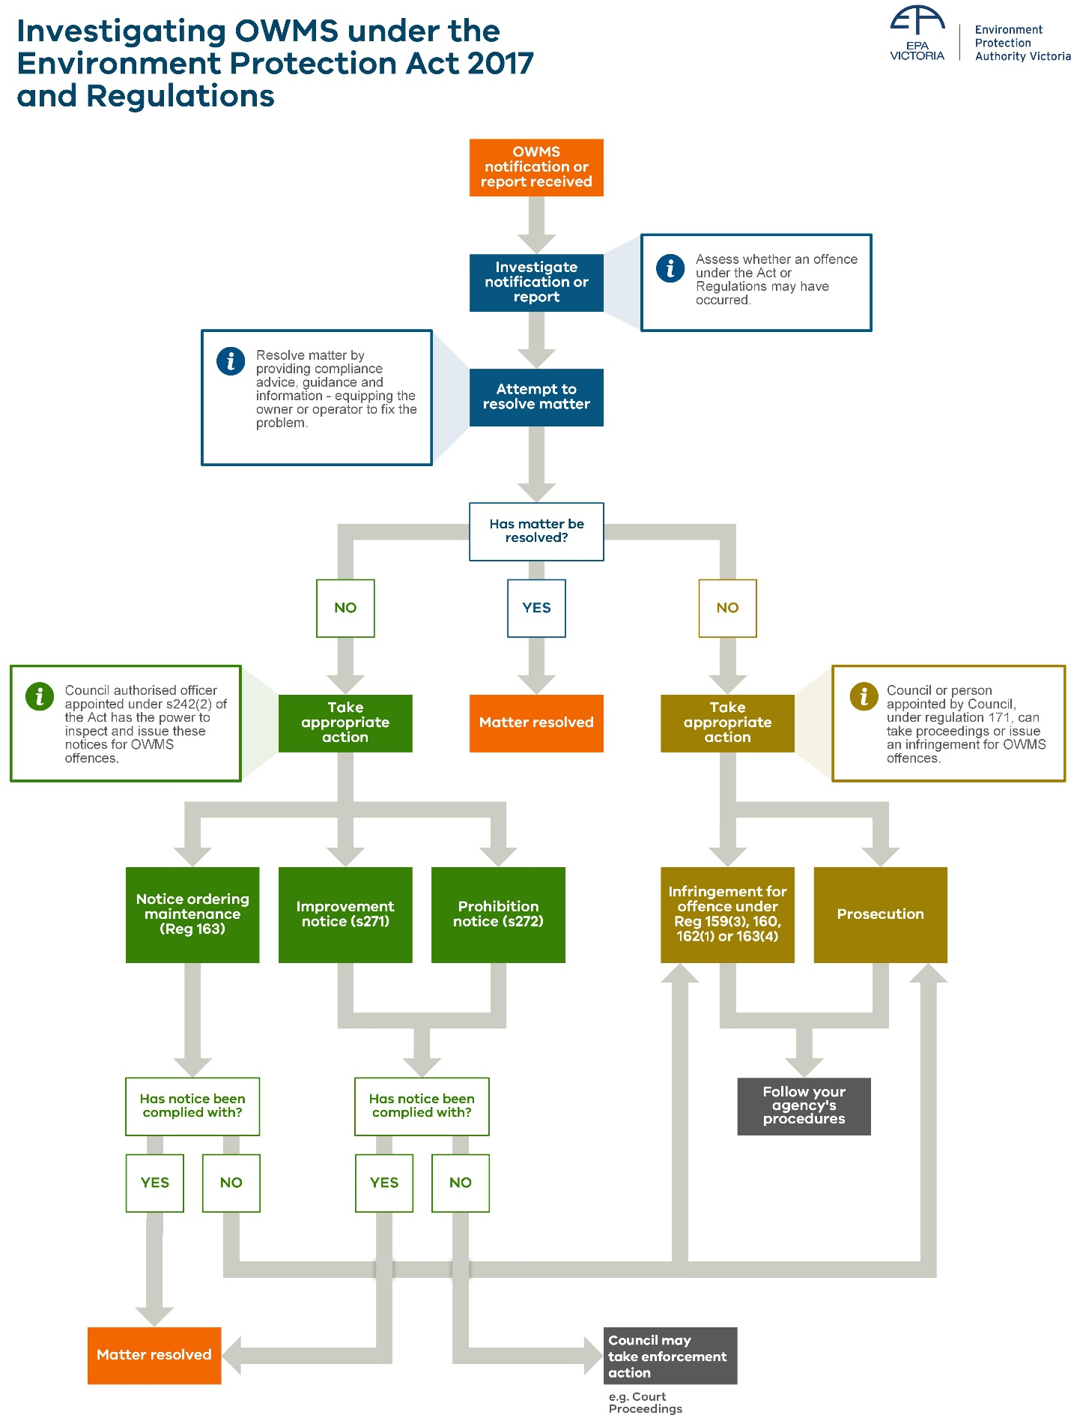
Appendix 3: Investigation flowchart

Appendix 4: Notice ordering maintenance – regulation 163
About this notice | Regulation 163 allows councils to require maintenance activities of an OWMS by issuing a written notice.
Grounds for issuing this notice | A notice ordering maintenance of an OWMS can be given to the landowner, where a council or council AO has either:  - received notification under Regulation 161(2); or  - has a reasonable belief that an OWMS located in their municipal district poses, or may pose, a risk to human health or the environment, or is not, or may not be, in good working order.  Also, a council AO has inspected the system and formed a reasonable belief of the above.
Power to issue this notice | This notice can only be issued by a AO of the council appointed under section 242 of the Act, who has inspected the system using their powers under Part 9.3 of the Act and formed a relevant reasonable belief about the issue.
Who can receive this notice | A notice ordering maintenance can be given to the landowner of the place or premises where the OWMS is located.
What the notice can require | The notice can require maintenance actions on the OWMS. For example, desludging or pumping out, if there is an overflow of the system, or to repair or replace components or fittings of a faulty system.  Under regulation 161(2), where a person in management or control of land on which an OWMS is located notifies the council of the problem, they are also required to notify steps taken or which they propose to take to fix the problem. These steps can also be included in the notice.  The grounds for the notice and required maintenance actions must be set out in the notice.
Information that must be included in the notice | Regulation 163(3) specifies that the notice must include:  - the name and address of the person to whom the notice is issued  - the location of the on-site wastewater management system  - the grounds on which the notice is issued  - maintenance actions that the person must take to comply with the notice  - the period within which the person must comply with the notice  - the penalty for failing to comply with the notice.  Use the notice template provided by EPA. Email jointregulator@epa.vic.gov.au for templates.
Setting timeframe to comply | The council AO will specify the timeframe for which the person must comply. This timeframe must be included in the notice.
Issuing the notice | Notices under the Act can be issued by:  - email  - in person  - postal mail  - by leaving it at the usual or last known residential address (with a person apparently at least 16 years old).  Refer to section 344 of the Act – Service of documents.
Consequences for not complying with the notice | It is an offence not to comply with a notice ordering maintenance– regulation 163(4).  Council or a person appointed by council to take proceedings can initiate court action or issue an infringement notice.

Appendix 5: Infringement notices
About infringement notices | An infringement notice is a notice served for an alleged offence against the law (an 'infringement offence’), in accordance with the requirements under the Infringements Act 2006. An infringement notice may impose a financial amount (the ‘infringement penalty’), the payment of which may otherwise expiate an alleged offence.  This allows certain offences (known as ‘infringement offences’) to be dealt with through payment of the infringement penalty, rather than through court proceedings (the recipient of an infringement notice however may elect to have the alleged offence referred to be heard and determined in Court). The value of the infringement penalty is expressed in ‘penalty units’.  Official warnings  Under section 8 of the Infringements Act, any issuing officer may serve an official warning rather than an infringement notice, if they consider in all the facts and circumstances it is appropriate to do so.
Infringement notices for OWMS related offences | The offences under the Act and Regulations that have an infringement penalty associated with them are listed in Schedule 10 to the Regulations.  Infringement offences related to OWMS permits  A person appointed by council to take proceedings may issue an infringement notice for OWMS related infringement offence listed in Regulation 171, including:  - section 64 - breach of a prescribed permit condition (see regulation 18)  - regulation 34(1) – OWMS not to be used until approved by council  This power comes from section 307(1) and (4), and section 347(3) of the Act.  An authorised officer of the council may also issue an infringement notice for an offence against section 64 of the Act.  This power comes from section 242(2)(2A), 307(1) and 307(4)(f).  Infringement offences related to operation & maintenance of OWMS  A person appointed by council to take proceedings may issue an infringement notice for OWMS related infringement offence listed in Regulation 171, including:  - regulation 159(3) – Ensure contents of septic tank system do not overflow  - regulation 160 – Provide written information to occupier  - regulation 162(1) – Keep records of maintenance for 5 years  - regulation 162(2) – Provide records of maintenance to council on request  - regulation 163(4)- Comply with a council notice issuing maintenance  This power comes from section 307(1) and (4), and section 347(5) of the Act.  Infringement offence related to improvement & prohibition notices  A council employee appointed under section 347(7) of the Act to take proceedings in relation to delegated functions and powers, may issue an infringement notice for an offence against section 288 of the Act– Failure to comply with a reporting requirement of an improvement or prohibition notice.  This power comes from sections 307(1) and (4) and 347(7) and of the Act.
Who can receive an infringement notice | - With regards to OWMS permits, infringement notices may be served on a permit holder for an alleged breach of  - A prescribed permit condition under section 64; or  - regulation 34.  - For offences related to operation and maintenance of an OWMS, infringement notices may be served on a person in management or control of the OWMS (the landowner or the occupier) for breach of regulation 159(3); or the landowner for breach of regulations 160, 161(1), 161(2) or 163(4).  - The recipient of an improvement or prohibition notice, may be issued an infringement notice for breach of section 288
Issuing infringement notices | Councils follow their own processes for serving infringement notices. EPA does not need to approve the infringement notice format used however it must comply with the requirements in the Infringements Act 2006 and associated Regulations. Notices under the Act may be served by email, postal mail, leaving it at the usual or last known address, or in person. Refer to section 344, ‘Service of documents’.
Disputing an infringement notice | Under the Infringements Act 2006, recipients of an infringement notice may apply to have their infringement reviewed by the enforcement agency that issued it. Applications for a review must be made within 14 days of the applicant becoming aware of the infringement notice (section 64(c) of the Infringements Act 2006).
What happens if the person doesn’t pay the infringement? | Councils have three options:  - Unpaid infringements may be referred to Fines Victoria who, for a fee, will pursue the recipient of the infringement to recoup the debt.  - The infringement may be withdrawn, with the offence then pursued through the Magistrates Court.
Penalty units | A penalty unit is a monetary amount that is fixed for a financial year by the Treasurer and adjusted annually in line with CPI - Department of Treasury and Finance website (https://www.dtf.vic.gov.au/home).  Offences under the Act and Regulations list the maximum number of penalty units that can be imposed by a court. The infringement offences listed in Schedule 10 of the Regulations, list the applicable penalty units for the infringement offence.  Penalty units for both natural persons and body corporates are listed. Penalty units for body corporates are five times higher.

Appendix 6: Prosecution
About prosecution | A ‘prosecution’ is a criminal proceeding initiated in a court of relevant jurisdiction, against a person alleged to have committed an offence against the law.  OWMS related offences under the Act and Regulations are generally summary offences, that have lower associated maximum penalties than indictable criminal offences. Summary offences are heard in a Magistrates’ Court.  Offences under the Act for the breach of the requirement to obtain a permit (section 46(1)), or breach of a permit condition (section 63(2)), and breach of an improvement or prohibition notice (sections 286 and 287) are Indictable offences. However, these offences may also be heard and determined summarily in a Magistrates’ Court (see section 28 of the Criminal Procedure Act 2009).
Taking proceedings for OMWS related offences | Council may initiate court proceedings for OWMS related offences.  Proceedings for OWMS permit & operation and maintenance offences  A person appointed by council to take proceedings may initiate court action for OWMS related offences listed under Regulation 171.  This power comes from section 347(3) and (5) of the Act.  Proceedings for offences relating to improvement and prohibition notices  A council employee appointed under section 347(7) of the Act to take proceedings in relation to delegated functions and powers, may initiate court proceedings for offences relating to improvement notices and prohibition notices.
Timeframe for court proceedings | Criminal proceedings for an alleged summary offence must be commenced (via filing and service of charges against the accused), within 12 months after the commission of the alleged offence. For further details see the Criminal Procedure Act 2009.

Appendix 7: Council authorised officer powers
Where EPA has delegated some of its functions and powers to council, the Act allows councils to appoint a person or class of person as an AO under section 242(2) and (2A) of the Act.
Council AOs have a limited set of AO powers that can be used to investigate OWMS issues.
Note: In this table ‘AO’ means a person appointed by a council as an AO under section 242(2) or (2A) of the Act.
Part 9.2 Appointment of AOs |  |  | Description
242(2) (2A) |  | Council may appoint a person as an AO | Where EPA has delegated powers or functions to council, council may appoint a specified person or class of specified person as an AO.  This appointment relates to the purpose of the functions or powers delegated to the council. This includes regulating onsite wastewater management systems.
243 |  | AO identity cards | Council must issue an identity card to each person it appoints as an AO.  AO must show their card when asked to do so when performing a function or exercising a power under the Act.
Part 9.3 Inspection and inquiry powers |  |  | Description
246  247 | AO may enter and inspect any place or premises  Entry and inspection of a place or premises when open to the public |  | When can an AO enter and inspect?  For the purpose of performing a function or duty, or exercising a power under the Act, an AO may enter and inspect a place or premises for the following purposes:  - determining if a person has contravened the Act or Regulations  - monitoring compliance with the Act or Regulations  - determining if there is a risk of harm to human health or the environment from pollution, waste or contaminated land  - inspecting or testing equipment or a vehicle.  AOs may enter and inspect a place or premises at any reasonable time, including when open to the public.  In circumstances where they believe there’s an immediate risk of material harm to human health or the environment, they may enter at any​ other time.  What is material harm?  Section 5 of the Act defines material harm​, in relation to human health or the environment, as harm ​that is caused by pollution or waste that:  - involves an actual adverse effect on human health or the environment that’s not negligible; or  - involves an actual adverse effect on an area of high conservation value or of special significance; or  - results in, or is likely to result in, costs in excess of $10,000​ (or a higher amount prescribed by the Regulations) being incurred in order to take appropriate action to prevent or minimise the harm or to rehabilitate or restore the environment to the state it was in before the harm.  Any one of the​ above ​may satisfy the definition of ‘material harm’.
248 | Residential premises |  | Restrictions on entry to residential premises  AOs must not enter and inspect premises that are used ​only for residential purposes ​except:  - with the consent of the occupier ​for the time being of the premises; or  - ​if the AO reasonably believe​s that a person has contravened, is contravening or is about to contravene, the Act or Regulations; or  - ​if the AO reasonably believe​s there’s an immediate risk of material harm to human health or the environment.  In the circumstances in the last two dot points above, an AO may only enter ​and inspect in a part of the premises that the council AO believes is necessary for the purposes of determining if:  - a person has contravened, is contravening or is about to contravene the Act or Regulations;  or  - ​if there is an immediate risk of material harm to human health or the environment.  Limitation on council AO powers (search warrant)  Council AOs are limited from applying for a search warrant from a magistrate (section 261 of the Act). This limitation means that section 248(1)(b) does not apply to council AOs. This limitation is set out in a direction in respect to the delegation to councils.
249 | Announcement on entry |  | Immediately on entering a place or premises, AOs must take all reasonable steps to notify the occupier or apparent occupier and show their identity card.  The AO is not required to do this if it would unreasonably interfere with performing a function or duty or exercising a power under the Act or cause unreasonable delay, or if the person has been notified in advance.
250 | Person(s) assisting AO |  | An AO may request the assistance of any person for the purpose of entry and inspection. For example, another council officer, police officer or interpreter.  The occupier of person in management or control must allow the person assisting the AO access.
251 except 251(2)(h) | Powers on entry |  | What can a council AO do during an inspection?  An AO may do anything they reasonably believe is necessary to perform a function or duty or exercise a power under the Act. This may include (but is not limited to):  - inspecting, examining and making enquiries  - take and remove samples of a substance or thing  - carrying out testing and examination  - taking photographic, audio, video or any other type of recording  - examine, copy or take extracts from a document  - inspect, examine or test any plant, equipment, vehicle or other thing  - bring equipment or materials to the place or premises  - request the assistance of any person at the place or premises  - take any other action.  An AO may carry out or cause to be carried out, any testing or examination or a thing, including testing of a thing that results in the destruction of that thing.  Council AOs must take all reasonable steps to minimise any disruption caused by their entry and not remain at the premises longer than reasonably necessary.  Limitation on council AO powers (seizure)  Council AOs are limited from using the power under section 251(2)(h) of the Act- that means they cannot seize and remove a thing connected with a suspected contravention. This limitation is set out in a direction in respect to the delegation to councils.
252 except s252(1)(c) | AO may require production of documents |  | During an inspection, a council AO may require documents necessary for the purpose of their investigation. They may also examine or make copies of documents.  Limitation on council AO powers (retaining documents)  Council AOs are limited from using the power under section 252(1)(c) of the Act- that means they cannot retain a document or part of a document. This limitation is set out in a direction in respect to the delegation to councils.
253 | AO may require information or answers |  | An AO who enters a place of premises may require information or answers from a person at the place or premises for the purpose of performing a function or duty or exercising a power under the Act.  An AO must only require information or answers if they reasonably believe that the person has knowledge of a matter or thing relevant to another person’s compliance with the Act or Regulations.  Note that section 268 of the Act provides protection against self-incrimination with regards to powers under Part 9.3. This means that if providing information would incriminate the person, they may have a reasonable excuse not to provide the information. This excuse doesn’t apply to producing documents and only applies to individuals, not companies.
254 | Report to be given about entry and inspection of place or premises |  | Entry report  If a council AO has used their powers of entry and inspection, they must give the occupier or apparent occupier a written report about the entry to the premises, when they leave the premises, or as soon as possible after the AO leaves the place or premises.  The report must be in writing and include:  - the time of the entry and departure  - the purpose of the entry and inspection  - a description of any actions taken at the place or premises  - a summary of any observations of the AO at the place or premises  - the procedure for contacting the AO for further details of the entry and inspection.  Note: the report may be emailed, given in person, mailed or left at the usual or last known residential address (with a person apparently at least 16 years old) - section 344 of the Act - Service of documents.
259 | AO may ask for a person’s name and address |  | An AO may ask a person to state their name and address if they reasonably believe the person has:  - committed, are committing or are about to commit an indictable offence against the Act; or  - they think the person can help them with their investigation of an indictable offence.  The AO must inform the person of their reasonable beliefs. If the person is suspected of committing an offence, the AO must give the person sufficient information to understand the nature of the offence.  For offences relating to OWMS, this power could only be used by council AOs investigating indictable offences including:  - failure to obtain a permit  - breach of a permit condition  - breach of the general environmental duty  - breach of compliance with an improvement or prohibition notice issued by the council AO.
Part 10.2 Improvement and prohibition notices |  |  | Description
271 | Improvement notice (issue) |  | An AO may issue an improvement notice.  Refer to Appendix 8.
272 | Prohibition notice (issue) |  | An AO may issue a prohibition notice.  Refer to Appendix 8.
279 | Amendment of notices |  | An AO may amend an improvement notice or prohibition notice. This includes extending the period which the person has to comply with the notice or revoking or amending any requirement in the notice.  Refer to Appendix 8.
Part 11.3 Infringement notices |  |  | Description
307 &  307(4)(f) | Serve an infringement notice for breach of a prescribed permission condition |  | An AO may serve an infringement notice on a person who they reasonably believe has committed an offence against section 64 of the Act (breach of a prescribed condition of an OWMS permit).

Appendix 8: Improvement notice – section 271
About this notice | An improvement notice (section 271 of the Act) can require a person to take action to remedy a non-compliance with the Act or Regulations.  This can include non-compliance with the GED, in relation to OWMS.
Grounds for issuing this notice | An AO of the council can issue an improvement notice if they have reasonable belief a person is:  - contravening the Act  - contravening the Regulations  - not complying with a permit to construct, install or alter an OWMS  - engaging in/proposing to engage in an activity that has caused or is likely to cause harm to human health or the environment from pollution or waste.  Improvement notices do not require harm to have occurred and can be issued during an inspection to address inadequately controlled risks observed onsite.
Power to issue this notice | This notice can be issued in relation to OWMS issues, by an AO of the council appointed under s242(2) or (2A) of the Act.
Who may receive this notice | Often improvement notices will be issued to the landowner of the land where the OWMS is located.
What this notice can require a person to do? | An improvement notice can require a person (meaning natural person, body corporate or company), to take any action that an AO reasonably considers necessary to remedy a non-compliance.  Alternatively, it can be used to require that the recipient remedy the activity that has caused or is likely to cause harm to human health or the environment from pollution or waste.
Information this notice must include | Section 271(4) requires that an improvement notice must:  - specify the name and address of the person to whom it is issued  - state the grounds on which the notice is issued  - specify the actions that the person must take to comply with the notice  - specify the period within which the person must comply with the notice  - set out the penalty for failing to comply with the notice, and  - specify how the person may seek review of the decision to issue the notice.  Use the template provided by EPA. Email jointregulator@epa.vic.gov.au for templates.
Serving the notice | Notices under the Act can be issued by email, in person, postal mail, or by leaving it at the usual or last known residential address (with a person apparently at least 16 years old).  For more information refer to section 344 of the Act - Service of documents.
Setting the timeframe to comply | The date by which the person must comply with the notice must be stated in the notice. The council AO preparing the notice will specify a reasonable length of time for which to comply. A notice recipient may seek review of, or amendment to the notice, including specified time frames, under the Act (see section 429 of the Act).
Revoked and amending this notice | By serving a written notice of amendment under section 279 of the Act, the council AO may:  - extend the period of time the person has to comply with the notice  - revoke or amend any requirements in the notice.
EPA review | A person who is issued an improvement notice from a council AO may apply to EPA to have the decision to issue the notice reviewed - Section 429 of the Act.  Applications to EPA must be made within 10 business days (after the day the notice is served).  Notice recipients can request a review by calling EPA on 1300 372 842 (1300 EPA VIC).  If council receives review applications by mistake, email them to EPA immediately at internalreviews@epa.vic.gov.au
VCAT review | If the review process by EPA is completed but the notice recipient still seeks further review, they may apply to the Victorian Civil and Administrative Tribunal (VCAT) for a review of the decision to issue the notice (section 430 and 431 of the Act).  Applications for VCAT review must be made by the notice recipient within 15 days of EPA making its review decision under section 429. An applicant must seek review by EPA under section 429 the Act before seeking VCAT review of the decision (see section 431(2) of the Act).
Consequences for not complying with this notice | Section 286 of the Act provides that a person to whom an improvement notice is issued must not, without reasonable excuse, fail to comply with that notice. Criminal or civil proceedings may be initiated for failure to comply with section 286.  Section 288 of the Act provides that a person must not fail to comply with a reporting requirement in an improvement notice.
Enforcing improvement notices | An employee of the council appointed under section 347(7) of the Act may:  - take proceedings for an offence against sections 286 or 288 of the Act  - issue an infringement notice for an offence against section 288 of the Act

Appendix 9: Prohibition notice - section 272
About this notice | A prohibition notice (section 272 of the Act) requires a person to stop an activity that involves an immediate risk of harm.  Prohibition notices may come into immediate effect and may be followed by an improvement notice to address ongoing OWMS issues.
Grounds for issuing this notice | An AO of the council may issue a person with a prohibition notice if the AO reasonably believes that the person:  - is contravening or has contravened the Act, Regulations or a subordinate instrument made under the Act; or  - is not complying or has not complied with a permission (for example OWMS permit) granted under the Act; or  - has engaged in or proposes to engage in an activity that has caused or is likely to cause harm to human health or the environment from pollution or waste.  AND  there is regard to the immediacy of risk and degree of harm that could occur, so that stopping an activity quickly is necessary.  The notice must state the grounds on which it is issued.
Power to issue this notice | A prohibition notice may be issued by an AO of the council appointed under section 242(2) or (2A) of the Act.
Who may receive this notice | A prohibition notice can be issued to the person (meaning natural person, body corporate or company) who the council AO believes has:  - contravened the Act or Regulations, or  - has not complied with a permit, or  - has caused harm to human health or the environment.  This could be the owner or occupier of the land with the OWMS. This depends on the activity that has caused the contravention or harm.
What this notice can require a person to do | The notice may prohibit the activity and may also require any other thing the AO reasonably considers necessary to prevent or minimise harm or risk of harm.
Information the notice must include | s272(3) requires that an improvement notice must:  - specify the name and address of the person to whom it is issued  - state the grounds on which the notice is issued  - specify the actions that the person must take to comply with the notice  - specify the date from which the prohibition takes effect and the period within which the person must do any other thing required by the notice  - set out the penalty for failing to comply with the notice, and  - specify how the person may seek review of the decision to issue the notice.  Use the template provided by EPA. Email jointregulator@epa.vic.gov.au for templates.
Issuing the notice | Notices under the Act can be issued by:  - email  - in person  - postal mail  - by leaving it at the usual or last known residential address (with a person apparently at least 16 years old).  For more information refer to Section 344 of the Act - Service of documents.
Setting the timeframe to comply | The notice must specify the date from which the prohibition takes effect and the time period for compliance with the notice. A notice recipient may seek review of, or amendment to the notice, including specified time frames, under the Act (see section 429 of the Act).
Revoked and amending this notice | By serving a written notice of amendment under section 279 of the Act, the AO can:  - extend the time period that the notice is in effect, or  - revoke or amend any requirements in the notice.
EPA review | A person who is issued a prohibition notice from an AO (including a council AO) may apply to EPA to have the decision to issue the notice reviewed (section 429 of the Act).  Applications to EPA must be made within 10 business days (after the day the notice is served).  A recipient is entitled to apply to the Authority for a stay of the decision to issue the notice, pending the outcome of any application for internal review under the Act (see section 429 of the Act).  Notice recipients can request a review by calling EPA on 1300 372 842 (1300 EPA VIC).  If council receives review applications by mistake, email them to EPA immediately at internalreviews@epa.vic.gov.au.
VCAT review | If the review process by EPA is completed but the notice recipient still seeks further review, they may apply to the Victorian Civil and Administrative Tribunal (VCAT) for a review of the decision to issue the notice (section 430 and 431 of the Act).  Applications for VCAT review must be made by the notice recipient within 15 days of EPA making its review decision under section 429. An applicant must seek review by EPA under section 429 the Act before seeking VCAT review of the decision (see section 431(2) of the Act).
Consequences for not complying with this notice | Section 287 of the Act provides that a person to whom an improvement notice is issued must not, without reasonable excuse, fail to comply with that notice Criminal or civil proceedings may be initiated for failure to comply.  Section 288 of the Act provides that a person must not fail to comply with a reporting requirement in prohibition notice.
Enforcing a prohibition notice | An employee of the council appointed under section 347(7) of the Act may:  - take proceedings for an offence against sections 287 or 288 of the Act  - issue an infringement notice for an offence against section 288 of the Act

Accessibility
Contact us if you need this information in an accessible format such as large print or audio.
Please telephone 1300 372 842 or email contact@epa.vic.gov.au

Interpreter assistance
If you need interpreter assistance or want this document translated, please call 131 450 and advise your preferred language. If you are deaf, or have a hearing or speech impairment, contact us through the National Relay Service.
epa.vic.gov.au
Environment Protection Authority Victoria
GPO BOX 4395 Melbourne VIC 3001
1300 372 842

Council AOs are restricted from applying for a search warrant. This limitation on Council AO powers under the Act is set out in the 'Direction in respect of functions delegated to councils by Delegation Reference 2021.Council.001’
Material harm in relation to human health and the environment is defined in section 5 of the Act.
Limitations of council AO powers are set out in the 'Direction in respect of functions delegated to councils by Delegation Reference 2021.Council.001’.

