
  - Science Report
July 2024
Science Division

Maribyrnong River: Assessment of risks associated with consumption of recreationally caught fish.


Authorised and published by the Victorian Government, 1 Treasury Place, Melbourne
epa.vic.gov.au
Environment Protection Authority Victoria
GPO BOX 4395 Melbourne VIC 3001
1300 372 84
This content is for general information only. Obtain professional advice if you have any specific concern. EPA Victoria has made reasonable effort to ensure accuracy at the time of publication. Except where noted at epa.vic.gov.au/copyright, all content in this work* is licensed under the Creative Commons Attribution 4.0 Licence. To view a copy of this licence, visit creativecommons.org. EPA acknowledges Victoria’s First Nations peoples as the Traditional Owners of the land and water on which we live and work. We pay our respect to their Elders past and present.


Contents
Introduction and overview 4
Background 4
Objectives 4
Sampling program 4
Reasoning for study 6
Assessment approach 7
Water quality 7
Fish 7
Results 8
Water and sediment 8
Fish 9
Conclusions and recommendations 12
References 13
Glossary terms 14
Appendix 1 15
Risk-based consumption limit table – PFOS (PFOS + PFHxS) 15

Introduction and overview
EPA provided consumption advice to recreational fishers in relation to fish caught from Arundel Creek, and from the Maribyrnong River upstream of Calder Freeway to Deep Creek at Bulla in 2019. This report presents the data on which the EPA advice was based.

Background
Per- and polyfluorinated alkyl substances (PFAS) are a large group of manufactured chemicals. They have been used for several decades in aqueous film-forming foams such as firefighting foams, and other industrial and consumer products like waterproof clothing, carpets and cookware.
The use of PFAS at Melbourne Airport over many years has impacted soil, groundwater and surface water, both on and off-site. In September 2018, airport management supplied EPA with surface water and groundwater data, which showed high levels of PFAS at some locations in waterways adjacent to the airport. Based on this data, EPA published precautionary advice recommending that people not eat fish caught from Arundel Creek, and from the Maribyrnong River upstream of Calder Freeway to Deep Creek at Bulla. EPA’s initial advice also recommended people and pets avoid contact with these waterways until further testing was completed.

Objectives
EPA collected additional water and fish samples from Deep Creek near Bulla to the Maribyrnong River near the Anglers Tavern, located on the corner of Anglers Way and Chifley Drive in Maribyrnong, to test for PFAS. The data from EPA’s sampling was used to assess risks to recreational water users, as well as recreational fishers eating fish caught from the area. This report presents the PFAS data collected by EPA, and how EPA used it to assess the potential risks from recreational contact and recreational fish consumption in these waterways.

Sampling program
Sampling aimed to identify the types and spatial extent of PFAS contamination in the Maribyrnong River and its tributaries. This data was then used to assess potential risks to human health. Sampling locations are shown in Figure 1.
EPA collected environmental samples of water, sediment and soil in September and December 2018. Water samples were collected from the water’s edge at a depth of 5–10 cm below the surface. Sediment samples were collected from the top 2 cm of sediment in shallow water. Sediment and water samples were then analysed by ALS Environmental laboratory.
Fish were collected on the same days as the environmental samples by the Arthur Rylah Institute, which is part of the Department of Environment, Land, Water and Planning (DELWP). Due to boat access constraints, fish sampling occurred at fewer sites than the environmental sampling. Whole fish were sent to the National Measurement Institute (NMI) where edible portions (axial muscle fillets, with skin removed) were sampled and analysed for PFAS. All samples were analysed using National Association of Testing Authorities Australia (NATA) accredited methods.
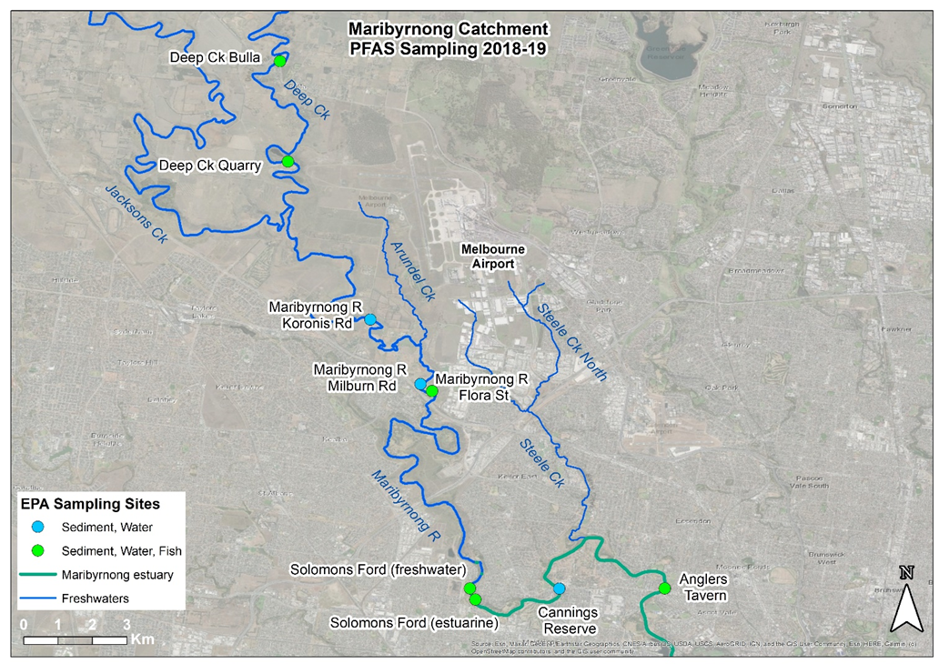
Figure 1– Location of sampling sites in Deep Creek and Maribyrnong River. Datum: GDA94
Sites where only water and sediment samples were collected were as follows:
• The Maribyrnong River at Koronis Road.
• The Maribyrnong River at Milburn Road.
• The Maribyrnong River at Canning Reserve.
Fish samples were collected at the following locations:
• Deep Creek at Bulla, upstream of the airport. This site was chosen to represent background conditions.
• Deep Creek, next to an unnamed water-filled former quarry located on Melbourne Airport land. This location was just downstream of a small tributary draining the western part of the airport. This location was identified by Melbourne Airport as having high concentrations of PFAS due to past fire-fighting training activities.
• The Maribyrnong River, at the end of Flora St, Keilor East, at the Caroline Chisholm Park. This location is also downstream of Arundel Creek — a creek which drains Melbourne Airport land — and is known to have high concentrations of PFAS in surface water.
• Maribyrnong River, upstream of Solomons Ford, representing the lowest freshwater portion of the river.
• Maribyrnong River, downstream of Solomons Ford (upstream of Cannings Reserve), representing the beginning of the estuarine portion of the river.
• Maribyrnong River, within the estuarine section, near the Anglers Tavern.

Reasoning for study
This study was performed to further assess analytical results obtained by Melbourne Airport regarding PFAS in waterways adjacent to the airport, and assess potential health risks to consumers of recreationally caught fish in those waterways.
This report details the data and analysis EPA used to assess potential health risks, which informed consumption advice to recreational fishers to limit consumption of fish caught from Maribyrnong River upstream of the Solomons Ford (freshwater site) in Avondale Heights, (including Deep Creek up to Bulla), to help them minimise their exposure to PFAS.

Assessment approach

Water quality
The Maribyrnong River is an important habitat for aquatic ecosystems, as well as a place for community recreation. This can include activities such as boating and fishing that may cause people to come into contact with the water. Water sampling results were assessed against the following water ecosystem criteria and recreational criteria:
- Ecological water quality guideline values - freshwater and interim marine (NEMP 2020).
- Guidance on Per and Polyfluoroalkyl substances in Recreational Water (NHMRC 2019)
Concentrations of perfluorooctane sulfonic acid (PFOS) and perfluorohexane sulfonic acid (PFHxS) were summed (PFOS+PFHxS) for the assessment of water and sediment samples against the NEPM 2020 and NHMRC 2019 criteria.

Fish
The species and number of fish collected varied, depending on the fish present at each site on the day of sampling. The collection target was 5 to 10 specimens per species, however this was not achieved for several species. A total of 110 fish consisting of 8 species were collected. Species found in abundance were redfin, carp and eel in the river’s freshwater reaches, and black bream and eel in the estuarine reach. Other species such as tench, bass and sea mullet were only found in small numbers but are included in the study for completeness.
Concentrations of PFOS + PFHxS in fish were summed to compare against Food Standards Australia New Zealand (FSANZ, 2017) proposed trigger points for investigation in finfish (0.0052 mg/kg).
A fish consumption risk assessment was performed using the methods described in Guidance for Assessing Chemical Contaminant Data for Use in Fish Advisories, Volume 2, Risk Assessment and Fish Consumption Limits (USEPA 2000). Risk-based consumption values for fish were calculated based on the FSANZ (2020) tolerable daily intake values. These values are presented in Appendix 1 along with the associated assumptions used, including the assumed meal size of 150 g for an adult and 75 g for a child. Edible fish flesh sample results (the sum of PFOS+PFHxS) were compared against these calculated risk-based consumption limits.

Results

Water and sediment
As shown in Table 1, all water samples from the Maribyrnong River catchment were above the draft guidelines for ecological health (>0.00023 µg/L) (NEMP 2020), and below the recreational water quality guideline (2.0 µg/L) (NHMRC, 2018). As a result of this assessment of PFAS concentrations in water, EPA lifted the advice to avoid contact with the waterways.
Table 1 – PFOS+PFHxS concentrations in water and sediment samples
Site | PFOS + PFHxS* in water (µg/L) | PFOS + PFHxS* in sediment (mg/kg) | Fish sampled
Recreational water guideline | 2.0 | -
Draft Australian and New Zealand Government Guidelines for ecosystem protection guidelines (PFOS)† | 0.00023† | -
Deep Creek (Bulla) [control site] | 0.008 | 0.0011 | Yes
Deep Creek (quarry) | 0.430 | 0.0030 | Yes
Maribyrnong River (Koronis Rd) | 0.183 | 0.0022 | No
Maribyrnong River (Flora St) | 0.129 | 0.0108 | Yes
Maribyrnong River (Milburn Rd) | 0.119 | 0.0022 | No
Maribyrnong River (upstream of Solomons Ford) | 0.236 | 0.0004 | Yes
Maribyrnong River (downstream Solomons Ford) | 0.240 | 0.0004 | Yes
Maribyrnong River (Canning Reserve) | 0.092 | 0.016 | No
Maribyrnong River (Anglers Tavern) | 0.066 | 0.0127 | Yes
*Samples where PFHxS was not detected are reported using half the value of the LOR.
†Guidelines apply only to PFOS.

Fish
Figure 2 shows the range of PFOS + PFHxS concentrations observed in the fish species collected from the 6 locations. They are shown as box and whisker plots overlayed with a dot plot to show the actual data points.
From this data, 3 results are notable:
- Across all species, the lowest concentration of PFOS + PFHxS in fish are from Deep Creek at Bulla, upstream of Melbourne Airport.
- The highest concentrations were detected in fish from Deep Creek next to the quarry, and adjacent to Melbourne Airport
- Low concentrations were detected in fish from sites within the estuarine reach of the Maribyrnong River, downstream of Solomons Ford and at Anglers Tavern.
The data shown in Figure 2 indicate that concentrations of PFOS + PFHxS in fish would result in an adult or child reaching their tolerable daily intake (TDI) for 1, 2, 3 or 4 serves per month. Refer to ‘Risk-based consumption limit table – PFOS (PFOS + PFHxS)’ in Appendix 1 for more information.
A)
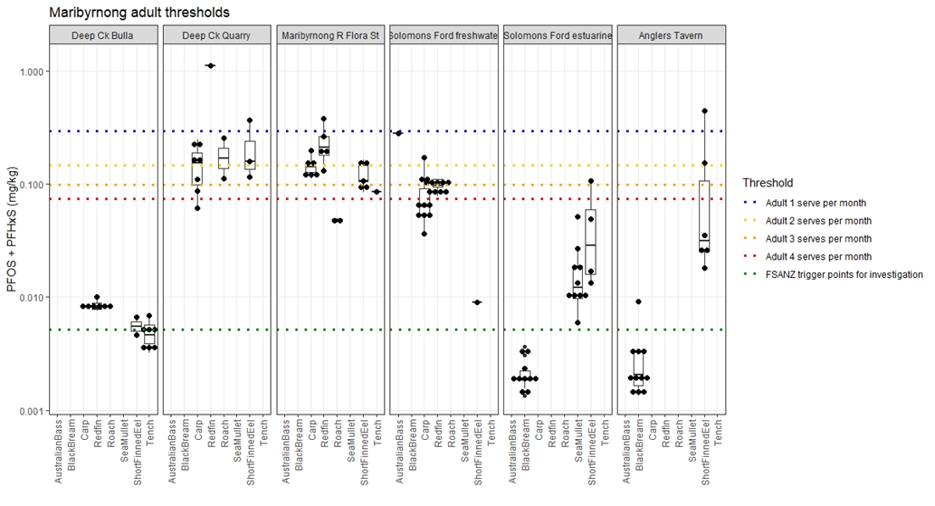

B)
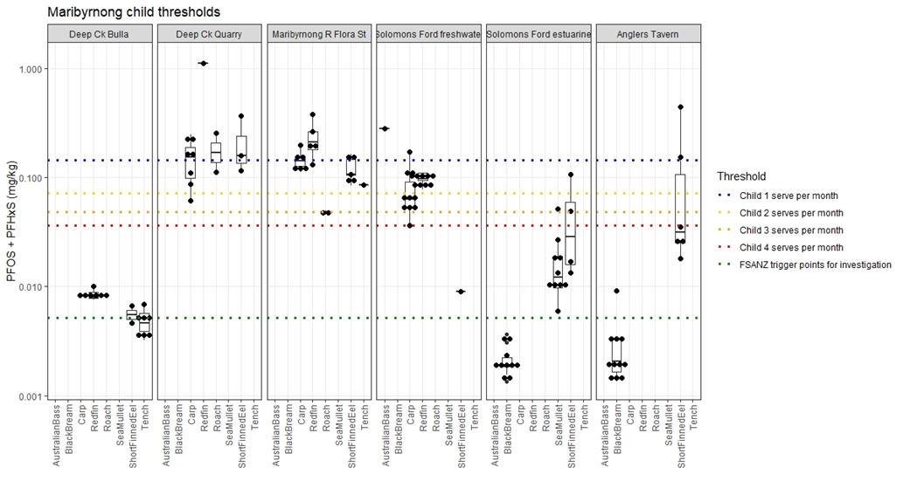
Figure 2 – Concentrations of PFOS + PFHxS (log scale axis) in fish species caught from sites in the Maribyrnong River catchment. Concentrations are plotted against A) adult and B) child thresholds for consumption. Where PFHxS was not detected, concentrations were summed using half the Limit of Reporting (LOR).
Compared to the upstream control site on Deep Creek, PFOS + PFHxS concentrations in fish collected from downstream sites were elevated.
Deep Creek (quarry) and Maribyrnong River (Flora St), which are immediately downstream of run-off from the airport (Figure 1), had the highest concentrations. Concentrations further downstream at the Solomons Ford freshwater site were slightly lower (Figure 2).
Concentrations in redfin, carp and short-finned eels at these sites exceeded trigger points for investigation, as well as adult and child consumption thresholds. EPA estimated that an adult or child consuming fish caught from these locations once a month will approach or reach the TDI for PFOS +PFHxS. All these sites were in the freshwater reach of the river.
Concentrations in fish were markedly lower in the estuarine section, although some individual short-finned eels had higher concentrations (Figure 2) This may be due to eels migrating from freshwater to marine waters for breeding, or because some of the eels were older and had accumulated more PFAS. However, because the age of the fish in the study was not assessed, this remains uncertain.

Results show clear trends for all species, with the lowest concentrations of PFOS + PFHxS in fish from Deep Creek at Bulla, upstream of the influence of impacts from the airport. Concentrations of PFOS + PFHxS at this location were slightly higher than the FSANZ trigger points for investigation in redfin, and generally lower than the trigger points in tench and eel. It should also be noted that PFHxS concentrations in all fish at this site were below the limit of reporting.
The highest concentrations detected were at Deep Creek at the quarry. These are approximately 2 orders of magnitude greater than at Deep Creek upstream of the quarry. Slightly lower concentrations were found in fish sampled at the Maribyrnong River at Flora St. This strongly indicates that surface water runoff from the airport is impacting the PFAS concentrations in the fish at Deep Creek next to the quarry, as well as the downstream freshwater reach. Runoff from the airport to Arundel Creek would be another source of PFAS entering the Maribyrnong River.

Conclusions and recommendations
EPA’s sampling of water and sediment showed that stream locations near drainage lines from Melbourne Airport – where firefighting training had occurred – had high concentrations of PFOS + PFHxS. These sites were Deep Creek near the quarry, and the Maribyrnong River downstream of its confluence with Arundel Creek. PFOS + PFHxS concentrations at other freshwater sites were still high, and well above the draft ecosystem protection guideline value for PFOS (ANZG 2018).
All PFAS concentrations in water samples were below the NHMRC (2019) guidance level for recreational water (2 µg/L). As a result of this assessment, EPA lifted the advice to avoid recreational contact with the Maribyrnong River in early 2019 (EPA 2019).
Due to low PFOS + PFHxS concentrations, no consumption recommendations are required for recreational fishers consuming fish caught in Deep Creek at Bulla. However, based on the analysis of 2018 and 2019 data, EPA (2019) advised recreational fishers as follows:
We have worked with Melbourne Water to test samples of water, sediment and fish from between Deep Creek in Bulla to the Anglers Tavern in Maribyrnong. Our advice for this part of the river is:
- do not eat fish caught in this part of the river
- there are no restrictions on using the river for irrigation and recreation, such as swimming and boating.
As of July 2024, this advice remains current on EPA’s website..
The consumption advice does not include the estuarine reach of the Maribyrnong River downstream of Solomons Ford, due to fish in the estuary having lower PFAS concentrations. However, consumption advice for the Lower Maribyrnong River (and the Lower Yarra) already exists based on polychlorinated biphenyls (PCBs) levels in fish. This advice states the following:
- Women of childbearing capacity and children aged less than 16 years should not eat caught eels. Everyone else should limit eating the eels they catch to one serve per month.
- Women of childbearing capacity and children aged less than 16 years should limit eating other caught fish to one serve per month.
- Everyone else should limit eating the fish they catch to 4 serves per month.
Further consumption advice to recreational fishers in the Lower Yarra and Maribyrnong is available at the Better Health Victoria website.

References
ANZG (2018) Australian and New Zealand Government Guidelines for fresh and marine waters. https://www.waterquality.gov.au/anz-guidelines
EPA (2019) Consumption advice for recreationally caught fish https://www.epa.vic.gov.au/about-epa/publications/1735
FSAZNZ (2017) Perfluorinated chemicals in food. https://www1.health.gov.au/internet/main/publishing.nsf/Content/2200FE086D480353CA2580C900817CDC/$File/consolidated-report-perfluorinated-chemicals-food.pdf
NEMP (2020) PFAS National Environmental Management Plan. Heads of EPAs (HEPA). https://www.epa.vic.gov.au/for-community/environmental-information/land-groundwater-pollution/pfas-national-environmental-management-plan
NHMRC (2019) Guidance on per and polyfluoroalkyl substances (PFAS) in recreational water. National Health and Medical Research Council.
FSAZNZ (2017) Perfluorinated chemicals in food. https://www1.health.gov.au/internet/main/publishing.nsf/Content/2200FE086D480353CA2580C900817CDC/$File/consolidated-report-perfluorinated-chemicals-food.pdf
NEMP (2020) PFAS National Environmental Management Plan. Heads of EPAs (HEPA). https://www.epa.vic.gov.au/for-community/environmental-information/land-groundwater-pollution/pfas-national-environmental-management-plan
NEPM (2013) National Environment Protection (Assessment of Site Contamination) Measure, 1999 (as amended 2013), Schedule B4. https://www.legislation.gov.au/Details/F2013C00288

EnHealth (2012) ‘Environmental Health Risk Assessment – Guidelines for assessing human health risks from environmental hazards’ available on the Department of Health website at: www.health.gov.au/internet/main/publishing.nsf/Content/health-pubhlth-publicat-environ.htm

Commonwealth Department of Health – Factsheet ‘Per and Poly fluoroalkyl substances – health effects and exposure pathways’ 2018: http://www.health.gov.au/internet/main/publishing.nsf/Content/ohp-pfas.htm#pfas

EPA Victoria, Interim Position Statement on PFAS, 2018 https://www.epa.vic.gov.au/our-work/publications/publication/2018/august/1669-2

Commonwealth Department of Health – Expert Panel for PFAS Report (2018) http://www.health.gov.au/internet/main/publishing.nsf/Content/ohp-pfas-expert-panel.htm

Glossary terms
PFOS | perfluorooctane sulfonic acid
PFHxS | perfluorohexane sulfonic acid

Appendix 1

Risk-based consumption limit table – PFOS (PFOS + PFHxS)
Monthly fish consumption limits for fish contaminated with PFOS.
Risk-based consumption limit | Adults | Children
Fish meals/month | Fish tissue concentration (mg/kg) | Fish tissue concentration (mg/kg)
None (<1) | >0.294 | >0.143
1 | >0.147-0.294 | >0.072-0.143
2 | >0.098-0.147 | >0.048-0.072
3 | >0.074-0.098 | >0.036-0.048
4 | >0.059-0.074 | >0.029-0.036
5 | >0.049-0.059 | >0.024-0.029
6 | >0.042-0.049 | >0.020-0.024
7 | >0.037-0.042 | >0.018-0.020
8 | >0.033-0.037 | >0.016-0.018
9 | >0.029-0.033 | >0.014-0.016
10 | >0.027-0.029 | >0.013-0.014
11 | >0.025-0.027 | >0.012-0.013
12 | 0-0.025 | 0-0.012
Notes
- The assumed meal size is 150 g for adults and 75 g for children.
- Exposure frequency = 365 days per year.
- Exposure duration = 70 years for adults, 5 years for children.
- Averaging time = 25550 days for adults, 1825 days for child 2-6 years.
- Body weight = 78 kg for adults, 19 kg for children
- Tolerable daily intake = 0.02 µg/kg bw/day (FSANZ 2016)
- Background intake* = 0.0014 µg/kg bw/day
- FSANZ recommends all persons limit the number of serves of fish to 2-3 serves per week (8-12 serves per week) based on mercury.
* Based on pooled serum PFOS measurements from Queensland in 2010/11, background PFOS intake has been estimated at 0.0024 µg/kg/day (Thompson et al 2010a⁴). This figure was later revised downward by a factor of 0.6 when a revised estimate of the apparent volume of distribution was applied to the serum concentrations (Thompson et al 2010b⁵) resulting in an estimate of 0.0014 µg/kg/day
FSANZ - Hazard Assessment Report — PFOS, PFOA and PFHxS. Food Safety Australia and New Zealand 2016.
Thompson J., Lorber M., Toms L-M.I., Kato K., Calafat A.M. and Mueller J.F. (2010a). Use of simple pharmacokinetic modelling to characterize exposure of Australians to perfluorooctanoic acid and perfluorooctane sulfonic acid. Environ. Internat. 36: 390-397.
Thompson J., Lorber M., Toms L-M.I., Kato K., Calafat A.M. and Mueller J.F.(2010b). Corrigendum to: Use of simple pharmacokinetic modelling to
characterize exposure of Australians to perfluorooctanoic acid and perfluorooctane sulfonic acid [Environmental International 36 (2010) 390-7].
Environ. Internat. 36: 647-648.
Accessibility
Contact us if you need this information in an accessible format such as large print or audio.
Please telephone 1300 372 842 or email contact@epa.vic.gov.au
Interpreter assistance

If you need interpreter assistance or want this document translated, please call 131 450 and advise your preferred language. If you are deaf, or have a hearing or speech impairment, contact us through the National Relay Service.



epa.vic.gov.au
Environment Protection Authority Victoria
GPO BOX 4395 Melbourne VIC 3001
1300 372 842



Authorised and published by the Victorian Government, 1 Treasury Place, Melbourne

