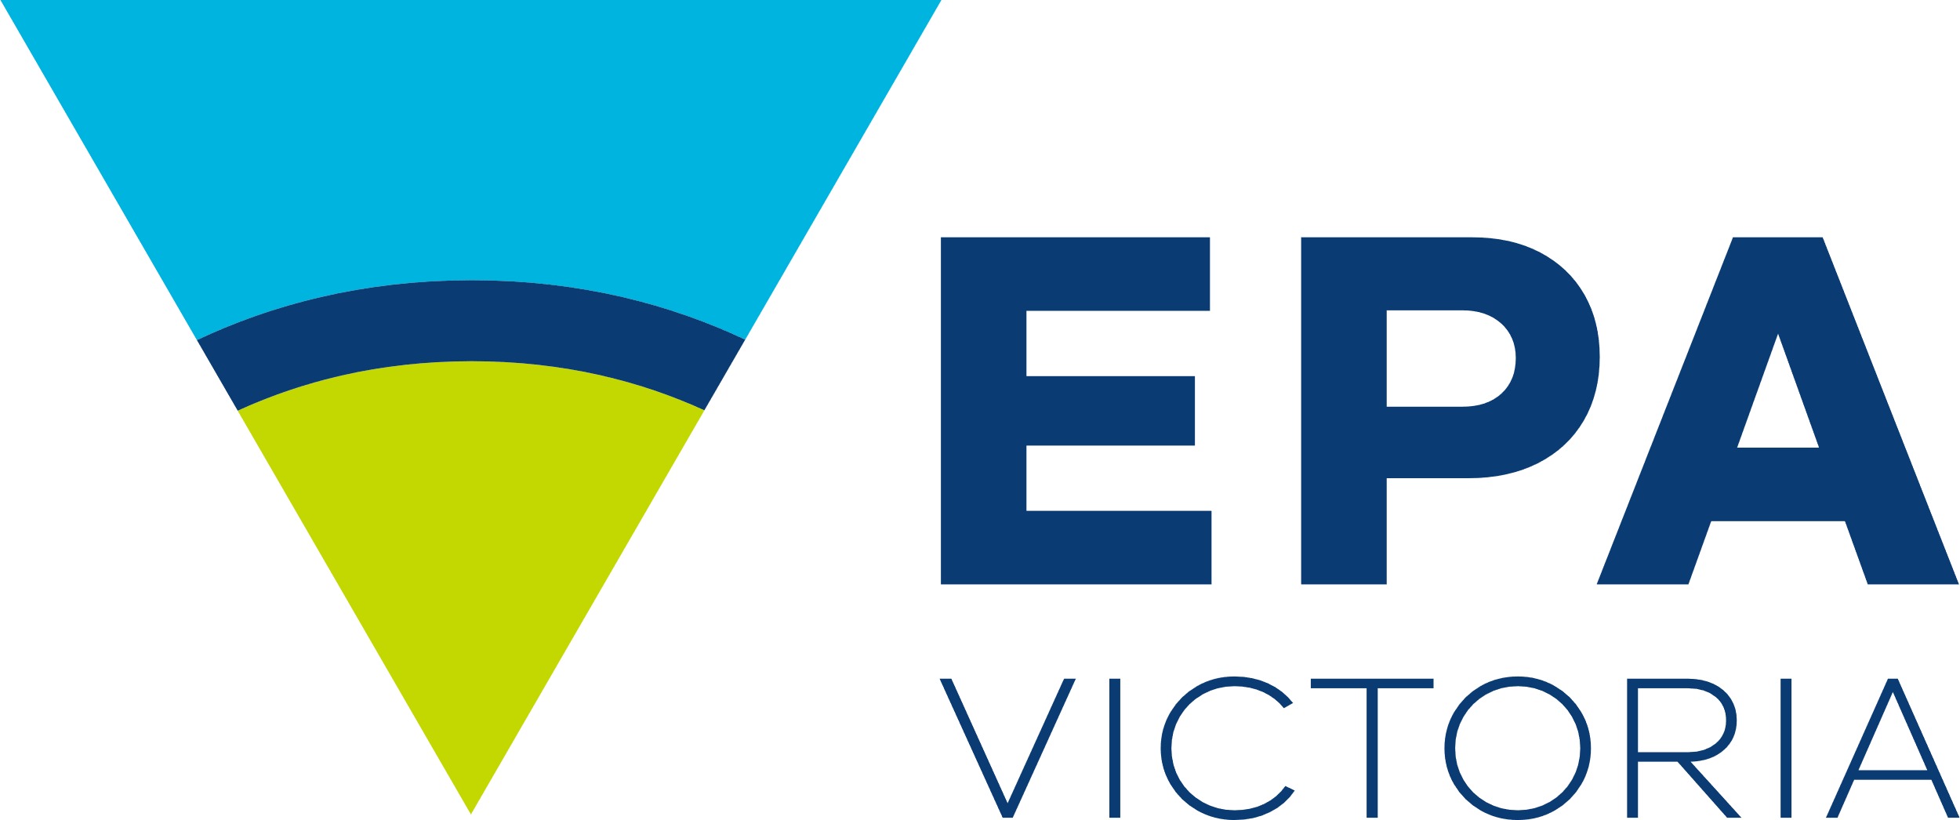

Report Card 2023-24

Port Phillip, Western Port and Gippsland Lakes

Publication 10001 | June 2025

Science Division



Authorised and published by the Victorian Government, 1 Treasury Place, Melbourne

# Summary

The annual Report Card shows the latest water quality in:

* Port Phillip Bay
* Western Port
* Gippsland Lakes.

Melbourne Water, Department of Energy, Environment, and Climate Action (DEECA) and EPA monitor these areas. The results are in this report.

Each year, the Report Card uses key indicators to provide an overall score. The score can be ‘Very Poor’, ‘Poor’, ‘Fair’, ‘Good’, or ‘Very Good’. This Report Card includes results from July 2023 to June 2024.

In 2023–24, water quality in Port Phillip Bay and some catchments improved compared to previous years. However, the conditions in the Gippsland Lakes and Western Port mostly stayed the same.

Water quality was often Very Good or Good in rivers at higher elevations. As the rivers flowed through rural, agricultural, and urban areas, quality generally dropped to Poor, or Very Poor. In the bays and lakes, water quality was mostly Very Good or Good in areas where it mixed with larger water volumes.

Data from the Bureau of Meteorology (BOM) shows rainfall in central Victoria was below average during this period. It was average in the Gippsland region. Drier weather likely:

* cut river flows
* decreased polluted runoff into waterways
* increased salinity
* led to more frequent or longer algal blooms.

The annual Report Card has been on the EPA’s website since 2019. Before that, results were available on the Yarra and Bay website.

Contents

Summary 2

What is the Report Card? 3

How are the scores calculated? 3

Climate in 2023–24 3

Port Phillip Bay and catchment 4

Western Port and catchment 7

Gippsland Lakes and catchment 10

Further information 12

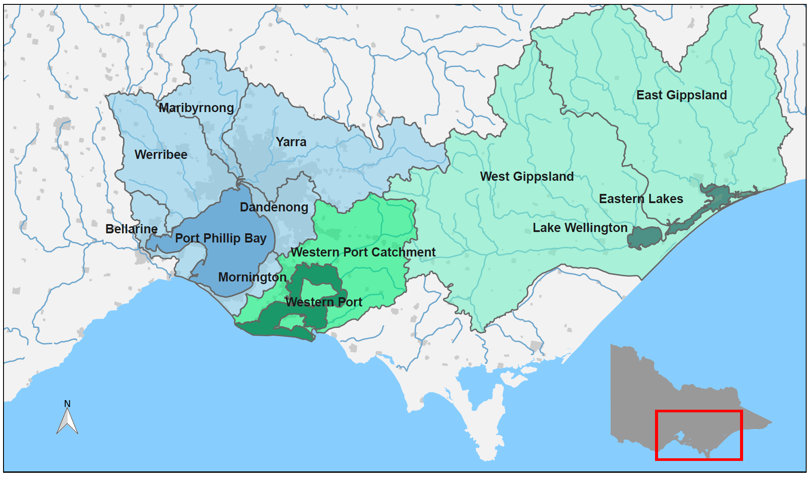

1. Location of Port Phillip Bay, Western Port, Gippsland Lakes (dark shading) and their catchments (light shading) within the state of Victoria.

# What is the Report Card?

This Report Card shows the water quality in Port Phillip Bay, Western Port, Gippsland Lakes, and their rivers and streams for 2023–24. These bays and lakes are the biggest coastal water areas in Victoria. The waterways include:

* rivers
* wetlands
* estuaries.

They are important for culture, the economy, and the environment.

In summer, the EPA predicts how safe the water is for swimming based on bacteria levels, but this information is not included here.

For more details, check the [Yarra Watch](https://www.epa.vic.gov.au/for-community/summer-water-quality/yarra-watch) and [Beach Report](https://www.epa.vic.gov.au/for-community/summer-water-quality/beach-report) programs.

# How are the scores calculated?

Key water quality indicators are checked against Victorian Environment Reference Standards (2021). These indicators are combined to calculate an overall water quality index score (WQI) out of 10, which gives a rating from Very Poor to Very Good (Table 1). For this Report Card, WQI scores cover the period from July 2023 to June 2024.

|  |  |  |
| --- | --- | --- |
| **Water quality index score** | **Rating** | **Description** |
| 8–10 | Very Good | High quality waterways generally not impacted by pollution |
| 6–8 | Good | Meets Victorian water quality objectives |
| 4–6 | Fair | Some evidence of stress |
| 2–4 | Poor | Under considerable stress |
| 0–2 | Very Poor | Under severe stress |

1. Water quality index (WQI) scoring categories for Report Card.

The water quality indicators used for catchment waterway sites are:

* dissolved oxygen
* metals
* nutrients (total nitrogen and total phosphorous)
* pH
* salinity (not at estuarine sites)
* water clarity.

The indicators used for bay and lake sites are:

* algae (chlorophyll-a)
* dissolved oxygen
* metals (where data is available)
* nutrients (total nitrogen – Port Phillip Bay and Western Port; total phosphorous – Gippsland Lakes)
* salinity (not at the estuarine Eastern Lakes)
* water clarity.

Key indicators measure risks to aquatic ecosystems. These include things like too many nutrients, more sediment, and algal blooms. The scores are summarized at both the catchment and bay levels. These scores are calculated by considering the area each site represents and finding the average. Only sites with at least six samples taken over the year are included. This ensures the Report Card accurately shows conditions throughout the year.

# Climate in 2023–24

In 2023–24, rainfall was below average in the Port Phillip and Western Port catchments. It was average in the Gippsland catchment compared to the long-term average (Figure 2). Mean air and sea temperatures rose by 0.5 to 1.0°C during this time.

Rainfall and air temperature changes affect water quality. Long dry spells can lower river flows, cut down on polluted runoff, raise salinity, and lead to more algal blooms. On the other hand, wet weather can increase pollutant transport. Nutrients and sediment travel through stormwater runoff into waterways and bays.

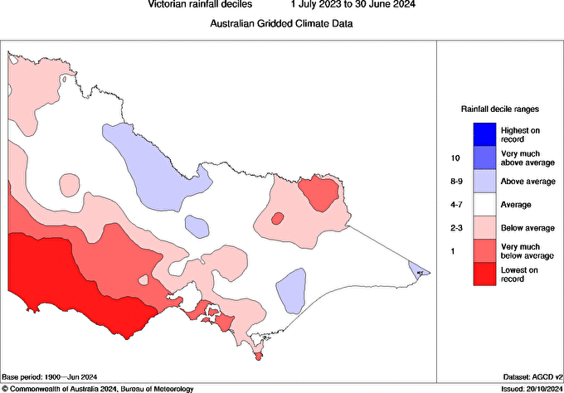

1. Victorian rainfall decile ranges from 1 July 2023 to 30 June 2024, shows below average conditions for Port Phillip and Western Port, and average conditions for Gippsland Lakes. (Source: © Commonwealth of Australia 2024, [Bureau of Meteorology](http://www.bom.gov.au/climate/maps).)

# Port Phillip Bay and catchment

Port Phillip Bay is a large, shallow bay. It is surrounded by mostly rural catchments, but has big urban areas along its shoreline, including Melbourne and Geelong. Major rivers like the Yarra, Maribyrnong, and Werribee flow from forested hills and mountains. They pass through rural properties and towns before reaching the bay. The bay connects to Bass Strait through a narrow entrance. In the south, bay waters mix well with ocean waters. In contrast, river inputs greatly affect the waters in the north and west. The bay is popular for boating, fishing, and swimming. It also hosts Victoria’s largest recreational fishery.

The Report Card for Port Phillip Bay and its catchment uses data from Melbourne Water and EPA. It includes data from 88 freshwater and 6 marine sites in the region to calculate WQI scores (Figure 3 and Figure 7). In 2023–24, water quality in Port Phillip Bay and its catchment ranged from very good to very poor. The southern bay and upper Yarra catchment were very good while urban waterways were very poor. This trend is similar to previous years (Figure 4 and Figure 6).

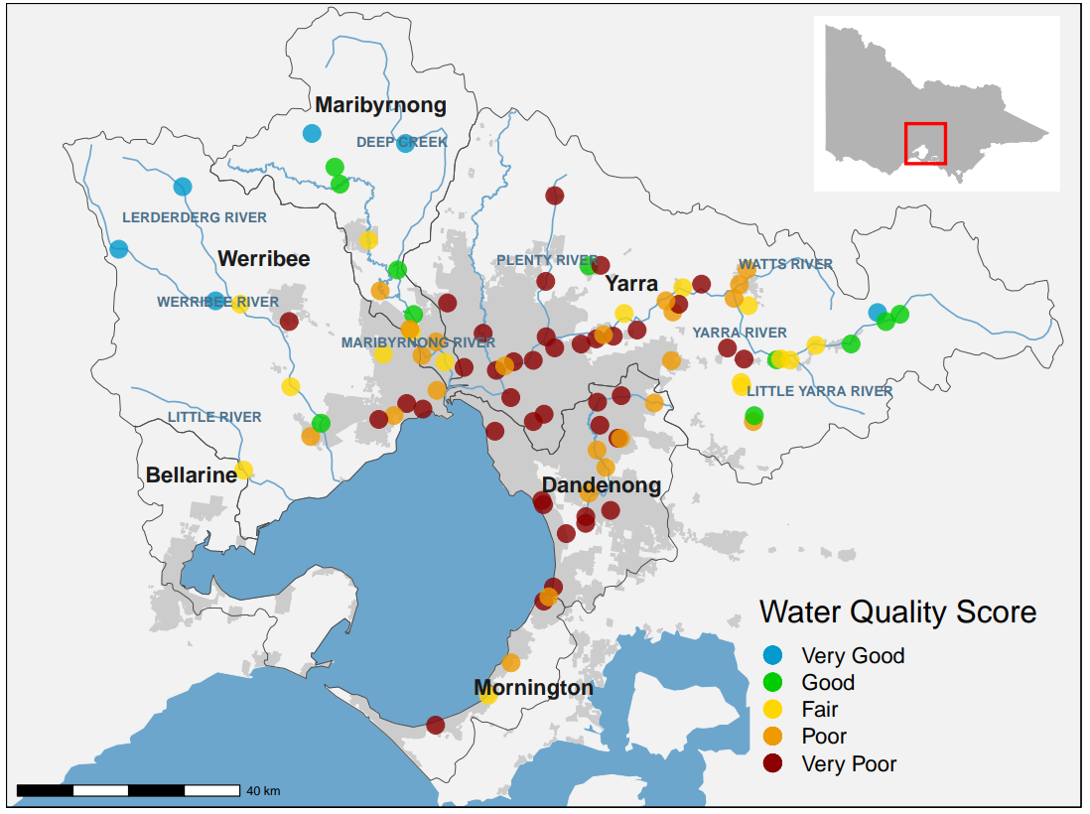

1. Location and WQI scores of Melbourne Water’s monitoring sites in the Port Phillip catchment. Colour indicates WQI score for each site in 2023–24.

## Port Phillip Catchment Report Card

Port Phillip Bay has six catchments (Figure 3):

* Yarra
* Werribee
* Maribyrnong
* Dandenong
* Mornington
* Bellarine.

For 2023-24, the western catchments (Werribee and Maribyrnong) improved from the 2022-23 floods. In contrast, the eastern Yarra catchment showed some minor reductions in water quality.

## Maribyrnong and Werribee catchments

### The Maribyrnong catchment includes rivers and creeks like Deep Creek and Jacksons Creek. These flow into the lower Yarra Estuary and then into Port Phillip Bay (Figure 3). In 2023-24, water quality in the Maribyrnong catchment was rated 'Good.' This is a big jump from ‘Poor’ in 2022-23 and ‘Fair’ in 2021-22. This shows recovery from the flooding impacts of 2022-23 (Figure 4). The Werribee catchment also improved, earning a rating of ‘Fair’ compared to last year’s 'Poor.'

## Yarra, Dandenong and Mornington catchments

### Water quality in the Yarra catchment stayed at ‘Poor’. There was a decline in the middle and upper Yarra sites compared to the last report. The urbanised areas of the small Dandenong and Mornington catchments had the lowest WQI scores in the Port Phillip region. They reported ‘Very Poor’ water quality (Figure 3). This trend matches previous years.

## Bellarine catchment

The Bellarine catchment is outside Melbourne Water’s service area. [Waterwatch](http://www.vic.waterwatch.org.au/) data is available for the Bellarine. However, it is collected in a different way therefore, a WQI score cannot be calculated for Bellarine catchment.

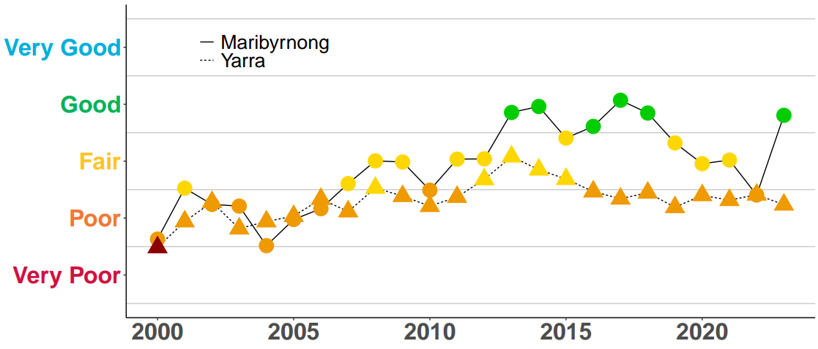

1. Historical WQI scores for the overall Maribyrnong and Yarra catchments. Colour indicates WQI score for each year. For 2023-24, there was a significant improvement in the Maribyrnong catchment from ‘Poor’ to ‘Good’, while the Yarra catchment maintained a ‘Poor’ rating for the last 8 years.

## Port Phillip Bay Report Card

Overall, water quality in Port Phillip Bay improved in 2023-24 compared to 2022-23. Three sites—Corio, Central, and Dromana—earned a ‘Very Good’ rating. This was due to better algae, nutrient, salinity, and water clarity indicators (Figure 5).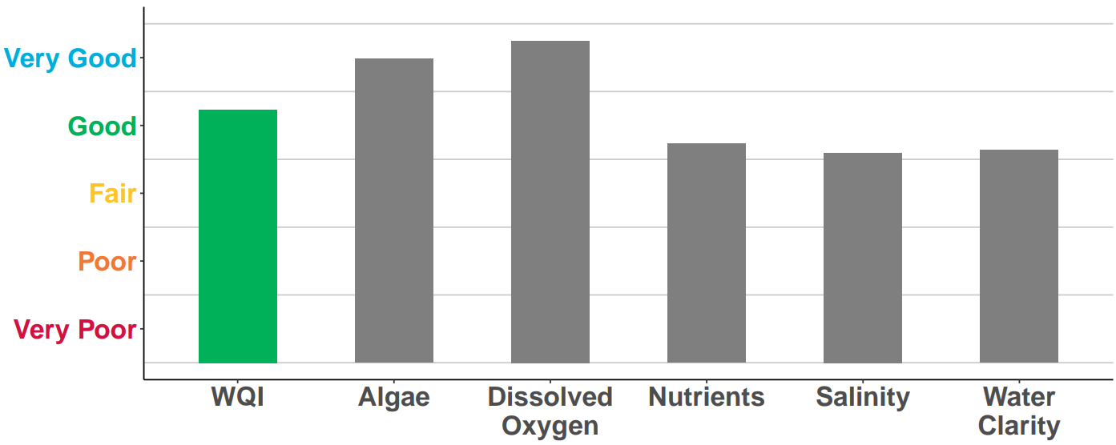

1. WQI scores for Port Phillip Bay in 2023–24. Coloured bar indicates the overall WQI score. Grey bars are the individual indicators used to calculate the overall WQI score.

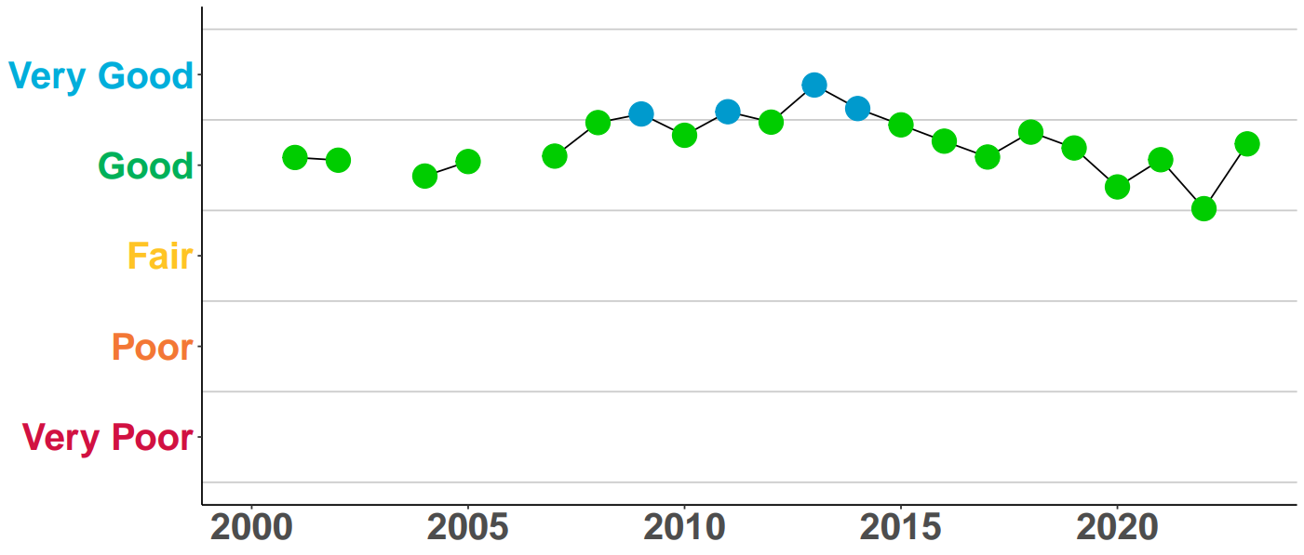

1. Historical WQI scores for Port Phillip Bay up to 2023-24.

The EPA monitors six locations in Port Phillip Bay (Figure 7). Since 2002, conditions have stayed fairly consistent. Overall water quality has ranged from ‘Good’ to ‘Very Good’ (Figure 6). For 2023-24, the Bay has a ‘Good’ WQI rating. This shows an improvement from past years, thanks to below-average rainfall during the period.

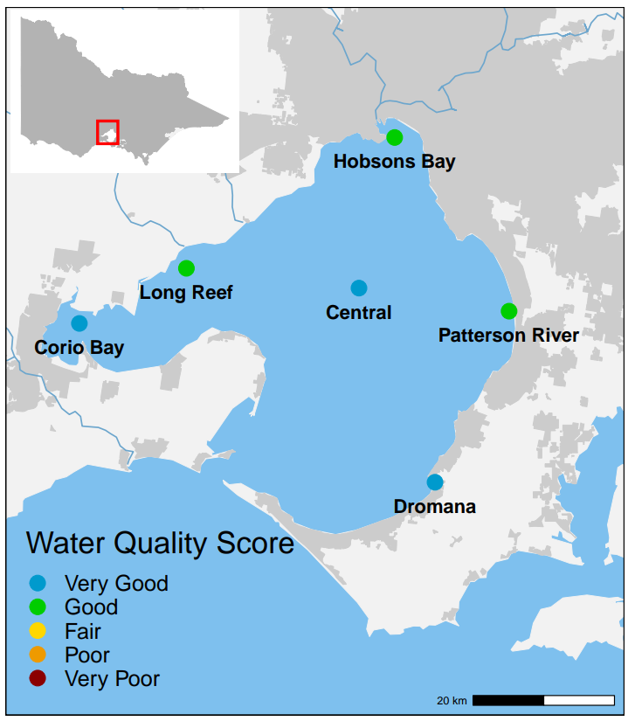

1. Locations and 2023-24 WQI scores of EPA long-term marine monitoring sites in Port Phillip Bay.

### Dromana, Corio and Central Bay

Dromana, Corio, and Central Bay all had ‘Very Good’ water quality. This is due to their distance from the major inflows in the bay's northern area.

### Patterson River, Long Reef and Hobsons Bay

Long Reef, Hobsons Bay, and Patterson River had ‘Good’ water quality. These sites are nearer to the higher river inflows, run-off, and stormwater that bring pollutants. This includes nutrients, sediments, and heavy metals.

# Western Port and catchment

Western Port is a semi-enclosed bay with two large islands, Phillip Island and French Island, that shape water flow. The catchment is mostly rural (70 per cent), includes state reserves (20 per cent) in the upper area, and features a rapidly growing urban corridor. Waterways in the catchment run through modified rural and urban lands. This area also includes Bunyip State Park and the Strzelecki Ranges. These regions have dense vegetation and support important environmental values. The bay's northern and eastern sections are mainly intertidal mudflats, fed by inflows from the Bunyip, Lang Lang, and Bass Rivers. Wind waves here can resuspend and move sediments. Tidal exchange with Bass Strait greatly affects the bay's western and southern parts.

The Report Card for Western Port and its catchment uses data from Melbourne Water and the EPA. In 2023–24, water quality varied across this region. ‘Good’ results were recorded in the upper catchment and some bay areas. ‘Very Poor’ results were recorded in highly urbanised or intensive agricultural zones.

## Western Port Catchment Report Card

Overall, the water quality in the Western Port catchment waterways was rated as ‘Poor’ for 2023-24. Four out of six water quality indicators showed ‘Poor’ or ‘Very Poor’ ratings (Figure 8). These scores have stayed mostly the same over time, with water quality often being ‘Poor’ (Figure 9).

Melbourne Water monitors how water quality changes. It checks water samples from different waterways in the Western Port catchment. For this Report Card, 23 sites in the Western Port catchment were used to calculate the WQI score (Figure 10).

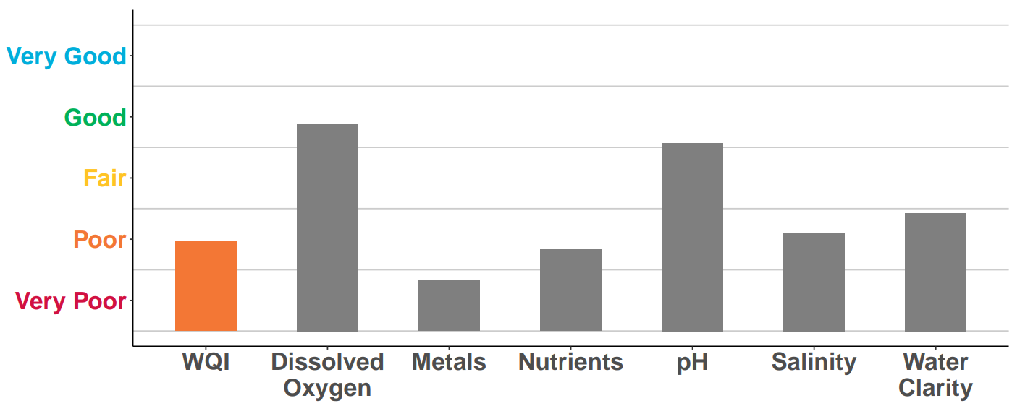

1. WQI scores for the overall Western Port catchment in 2023-24. Coloured bar indicates the overall WQI score. Grey bars are the individual indicators used to calculate the overall WQI score.

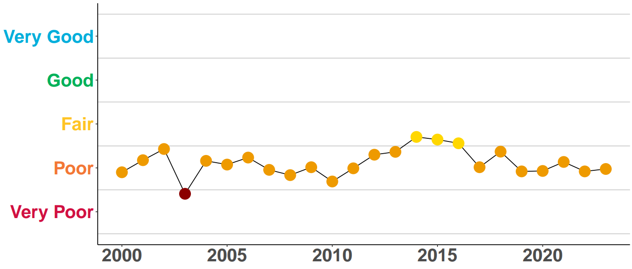

1. Historical WQI scores for the overall Western Port catchment up to 2023-24.

Water quality in the upper catchment of the Bunyip River was ‘Good’. In the upper catchment of Lang Lang, it was ‘Fair’. This shows improvement from the 2022-23 score. However, in the mid and lower catchment, water quality dropped to ‘Poor’ or ‘Very Poor’. This decline is due to land use changes to rural, agricultural, and urban areas.

Water quality in the Western Port catchment has changed significantly due to:

* vegetation clearing
* draining of the Koo Wee Rup swamp
* urban growth.

These changes in drainage and land use make it hard to maintain water quality in these rivers and streams.

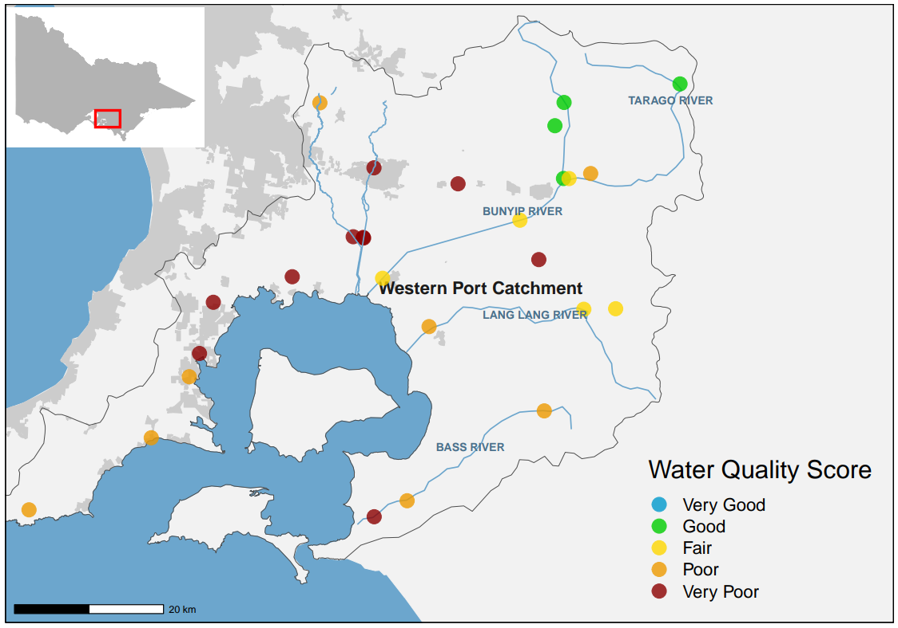

1. Location and 2023-24 WQI scores of Melbourne Water’s monitoring sites in the Western Port catchment.

## Western Port Bay Report Card

Overall, water quality in Western Port was rated as ‘Good’ for 2023–24. This is an improvement from past years, thanks to good ratings for nutrients and water clarity (Figure 11). Rainfall data from the Bureau of Meteorology showed below-average rainfall in the Western Port catchment in 2023–24 (Figure 2). Rainfall impacts the volume of surface and stormwater run-off. River inputs bring nutrients and sediment from the northern and eastern catchments.

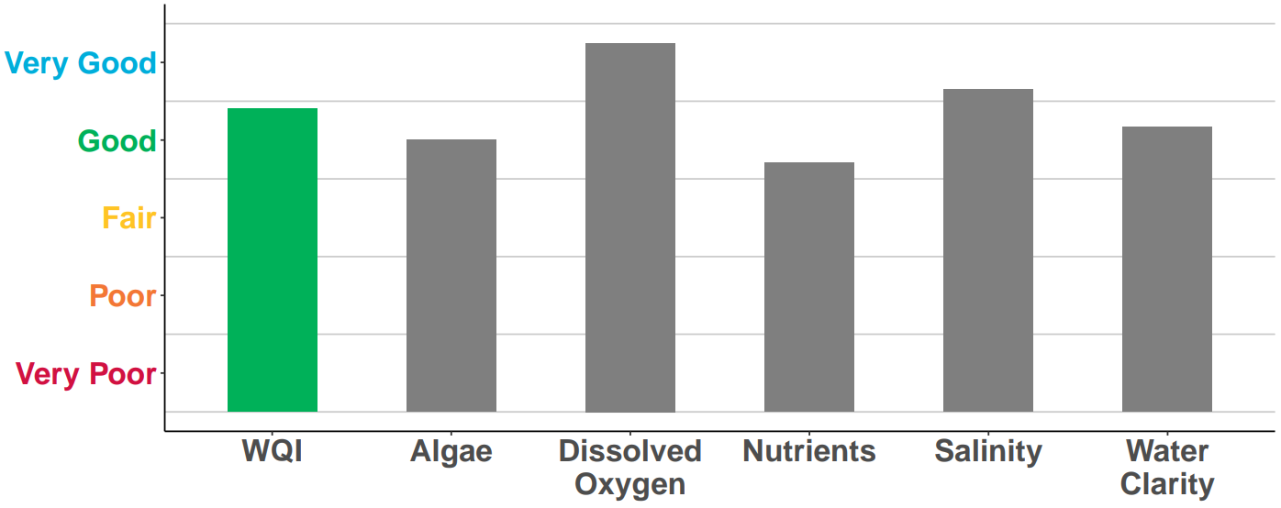

1. WQI scores for Western Port overall in 2023–24. Grey bars are the individual indicators used to calculate the overall WQI score.

Rainfall can temporarily change water quality. However, WQI scores in Western Port have stayed consistent since 2000 (Figure 12). Small catchment inflow volumes and mixing with Bass Strait help keep water quality good in Western Port. The EPA monitors two locations there (Figure 13).

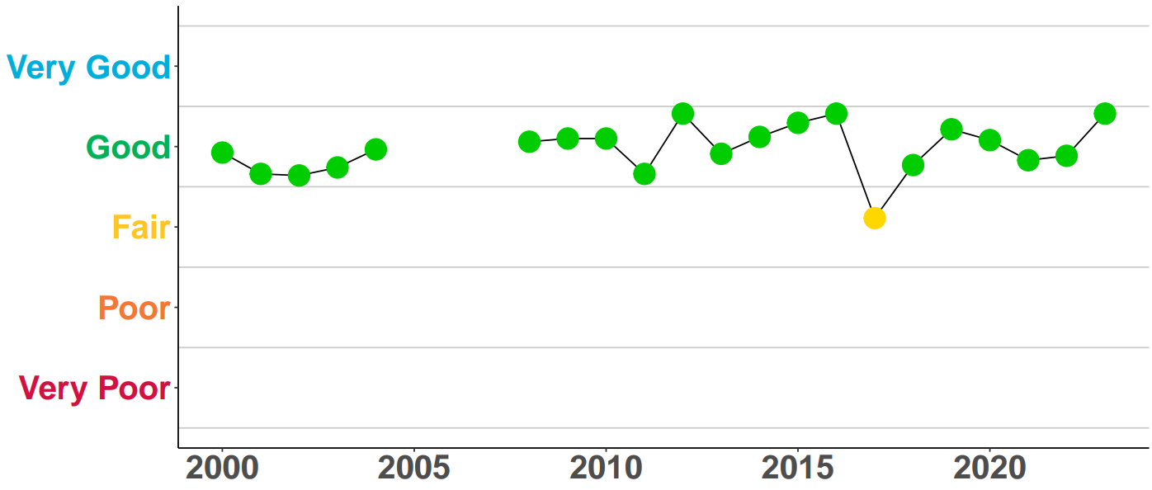

1. Historical WQI scores for Western Port up to 2023-24. Due to limited monitoring, no scores were calculated from 2005–08.

### Hastings

### The Hastings monitoring site showed ‘Very Good’ water quality. This is an improvement from the ‘Good’ rating last year. Regular flushing and mixing with ocean waters from Bass Strait help this area. Reduced easterly winds during 2023-24 likely lowered wind wave exposure. This also decreased sediment transport and resuspension. These factors contributed to the improvement at this western site.

### Corinella

The Corinella monitoring site had ‘Fair’ water quality. This is a change from the ‘Good’ rating last year. The shift to prevailing westerly winds in 2023-24 raised the risk of coastal erosion. Enhanced wind waves are likely reasons for the decline in water quality at this site. 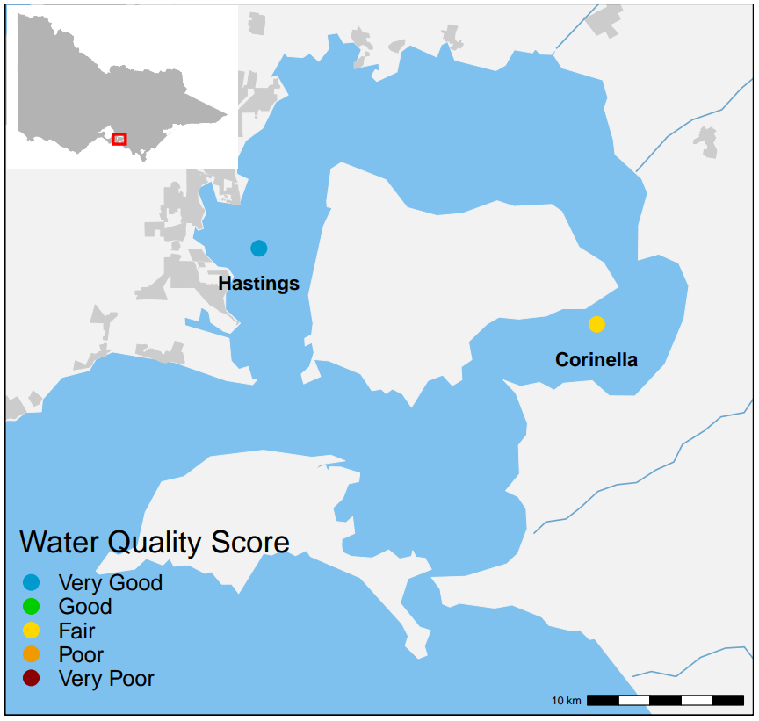

1. Locations and 2023-24 WQI scores of long-term EPA marine monitoring sites in Western Port.

# Gippsland Lakes and catchment

The Gippsland Lakes stretch for 70 km as a series of large, shallow coastal lagoons. A narrow channel at Lakes Entrance links the lakes to Bass Strait. The catchment area includes mostly state reserves, forests, and national parks (60 per cent) and rural land (39 per cent). Five major rivers feed directly into the lakes. The Mitchell, Nicholson, and Tambo Rivers flow into Lake King. The Latrobe and Avon Rivers flow into Lake Wellington.

The Report Card for Gippsland Lakes and its catchment uses monitoring data from DEECA (26 sites) and EPA (5 sites). Scores are calculated only for rivers and streams that drain into the Gippsland Lakes. In 2023–24, average rainfall (Figure 2) led to water quality ratings of ‘Very Good’ and ‘Good’ in most of the catchment’s waterways (Figure 14).

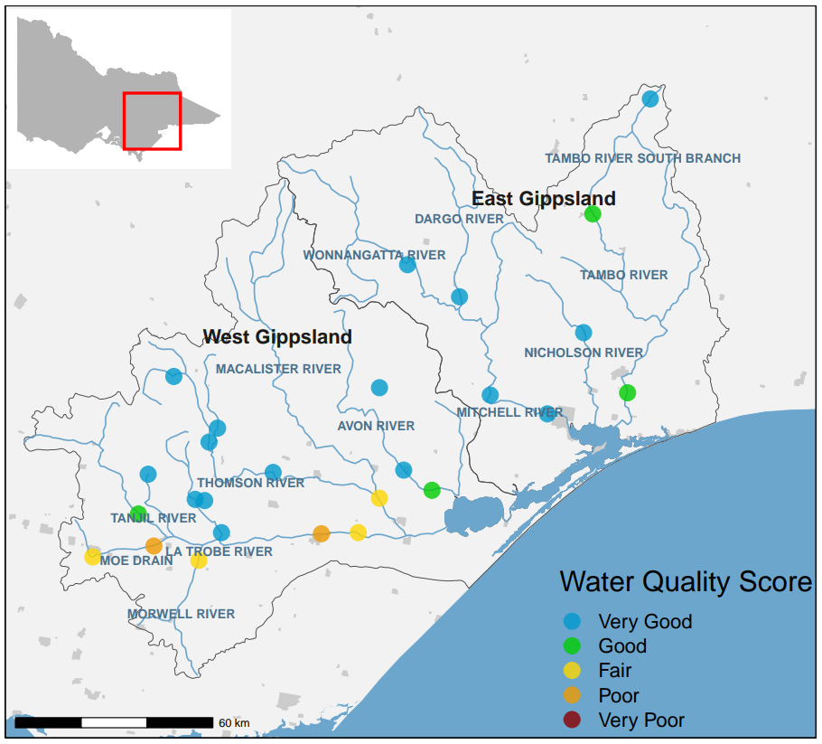

1. Location and 2023-24 WQI scores of DEECA’s monitoring sites in the Gippsland Lakes catchment.

## Gippsland Catchment Report Card

In West Gippsland, water quality was rated as ‘Good’, like in past years (Figure 16). The forested areas on the Great Dividing Range had ‘Very Good’ water quality. However, water quality dropped to ‘Fair’ or ‘Poor’ in the mid and lower Latrobe River. This decline was due to cleared land and urbanisation, that is reflected in lower ratings for nutrients and water clarity (Figure 16). In the East Gippsland catchment, water quality remained ‘Very Good’, consistent with previous years (Figure 15).

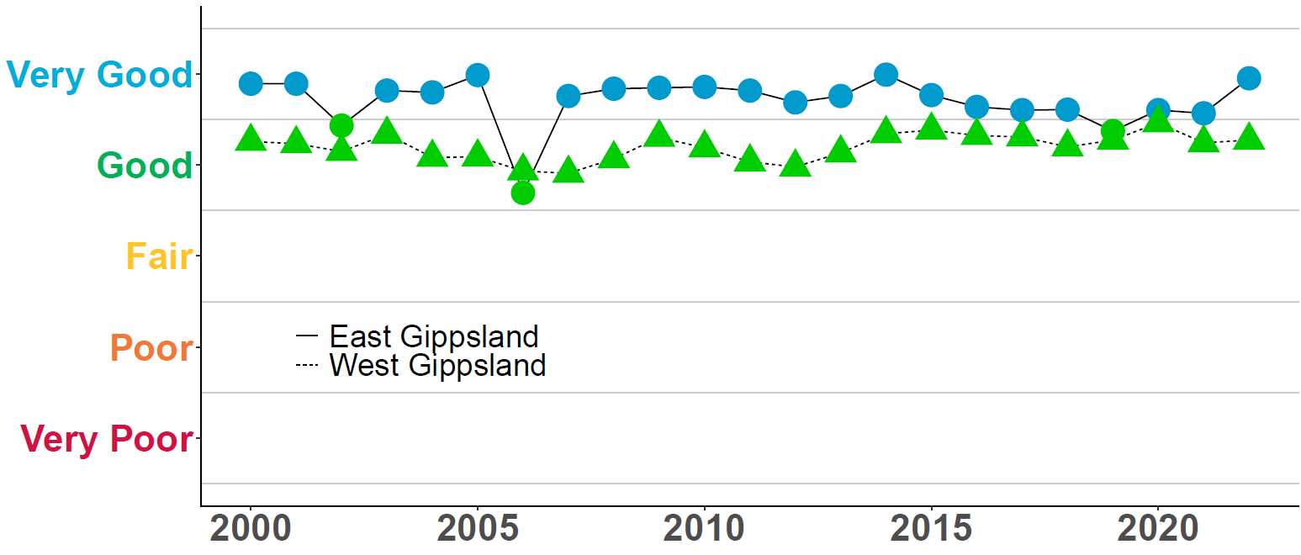

1. Historical WQI scores for the Gippsland catchments up to 2023-24.

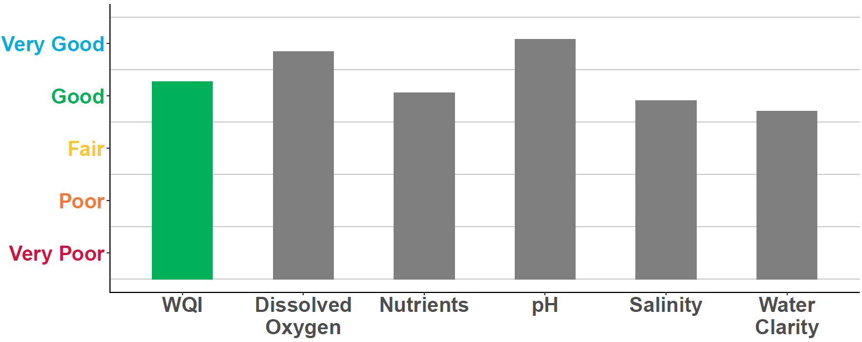

1. WQI scores for West Gippsland catchment in 2023–24. Grey bars are the individual indicators used to calculate the overall WQI score.

## Gippsland Lakes Report Card

EPA has five monitoring sites in the Gippsland Lakes (Figure 17). Sites closer to the Bass Strait entrance, like Shaving Point and Lake King, usually have better water quality. This is due to greater tidal exchange compared to sites further away, such as Lake Wellington and Lake Victoria.

### Lake Wellington

Lake Wellington collects sediments, nutrients, and contaminants. Wind and waves in the shallow waters can stir up these sediments and nutrients. This often leads to algal blooms due to the high nutrient levels. In drier times, with less river flow, the lake faces rising salinity from marine water and increased evaporation. Historically, Lake Wellington's water quality was rated ‘Poor’ or ‘Very Poor’ (Figure 18). Since 2020-21, good river flows have kept the rating at ‘Fair’ by lowering salinity.

### Eastern Lakes (Lakes King and Victoria)

Nutrient loads matched the average rainfall in 2023-24 for the Eastern Lakes. This resulted in a ‘Good’ rating, showing stable conditions like those of the past decade.

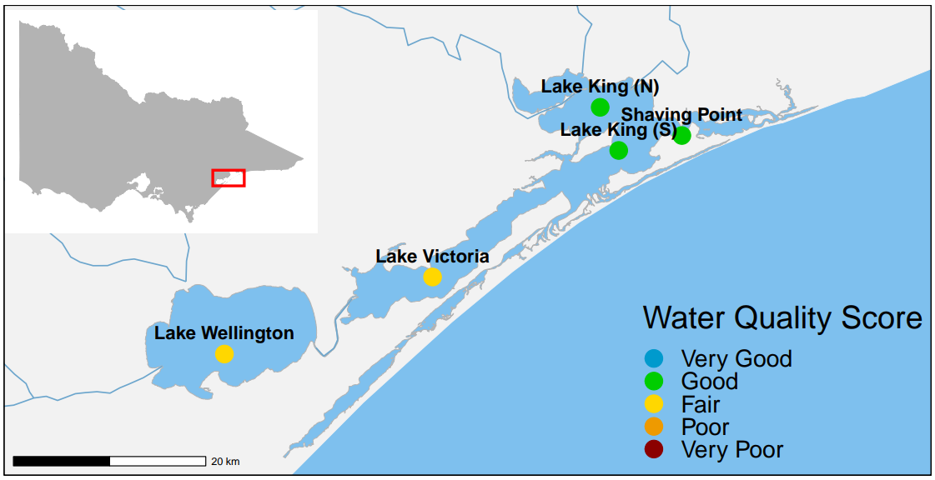

1. Locations and 2023-24 WQI scores of EPA’s long-term marine monitoring sites in Gippsland Lakes.

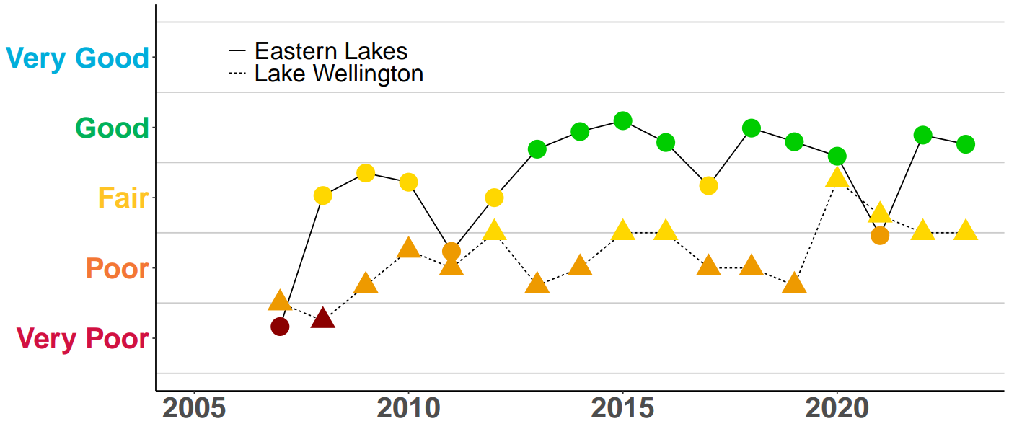

1. Historical WQI scores for Eastern lakes and Lake Wellington up to 2023-24. Due to limited monitoring, no scores were calculated for some years between 2001 and 2006.

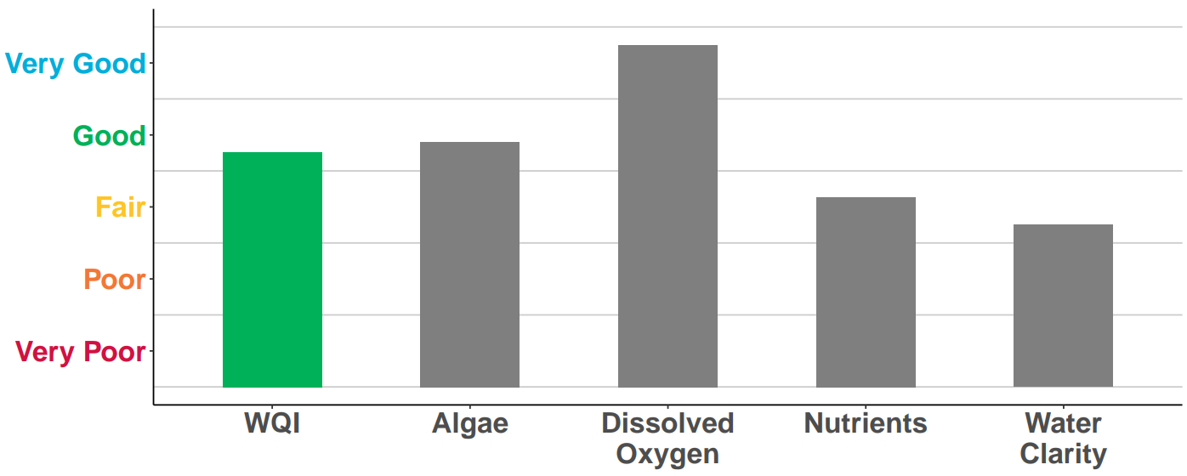

1. Overall WQI scores for the Eastern lakes (top) and Lake Wellington (bottom) in 2023–24. Grey bars are the individual indicators used to calculate the overall WQI score.

# Further information

## Water Quality Data

Find data from the catchments at the Victorian government’s Water Measurement Information System (<https://data.water.vic.gov.au/>).

Find data for the bays and lakes at the Victorian governments open data website Data Vic (<https://www.data.vic.gov.au/>)

Visit our website for more information on how EPA Victoria monitor and measure water quality ( <https://www.epa.vic.gov.au/how-we-monitor-water-quality>).

## Key References

Find out more about the Environment Reference Standard (2021) for Victoria at EPA’s website (<https://www.epa.vic.gov.au/environment-reference-standard>).

This includes developing and implementing monitoring procedures through your Risk Management and Monitoring Plan (RMMP).

This publication is for general guidance only. You should obtain professional advice if you have any specific concern. EPA Victoria has made every reasonable effort to ensure accuracy at the time of publication.

This work is licensed under a [Creative Commons Attribution 4.0 licence](https://www.epa.vic.gov.au/copyright).

EPA acknowledges Victoria’s First Nations peoples as the Traditional Owners of the land and water on which we live and work. We pay our respect to their Elders past and present.

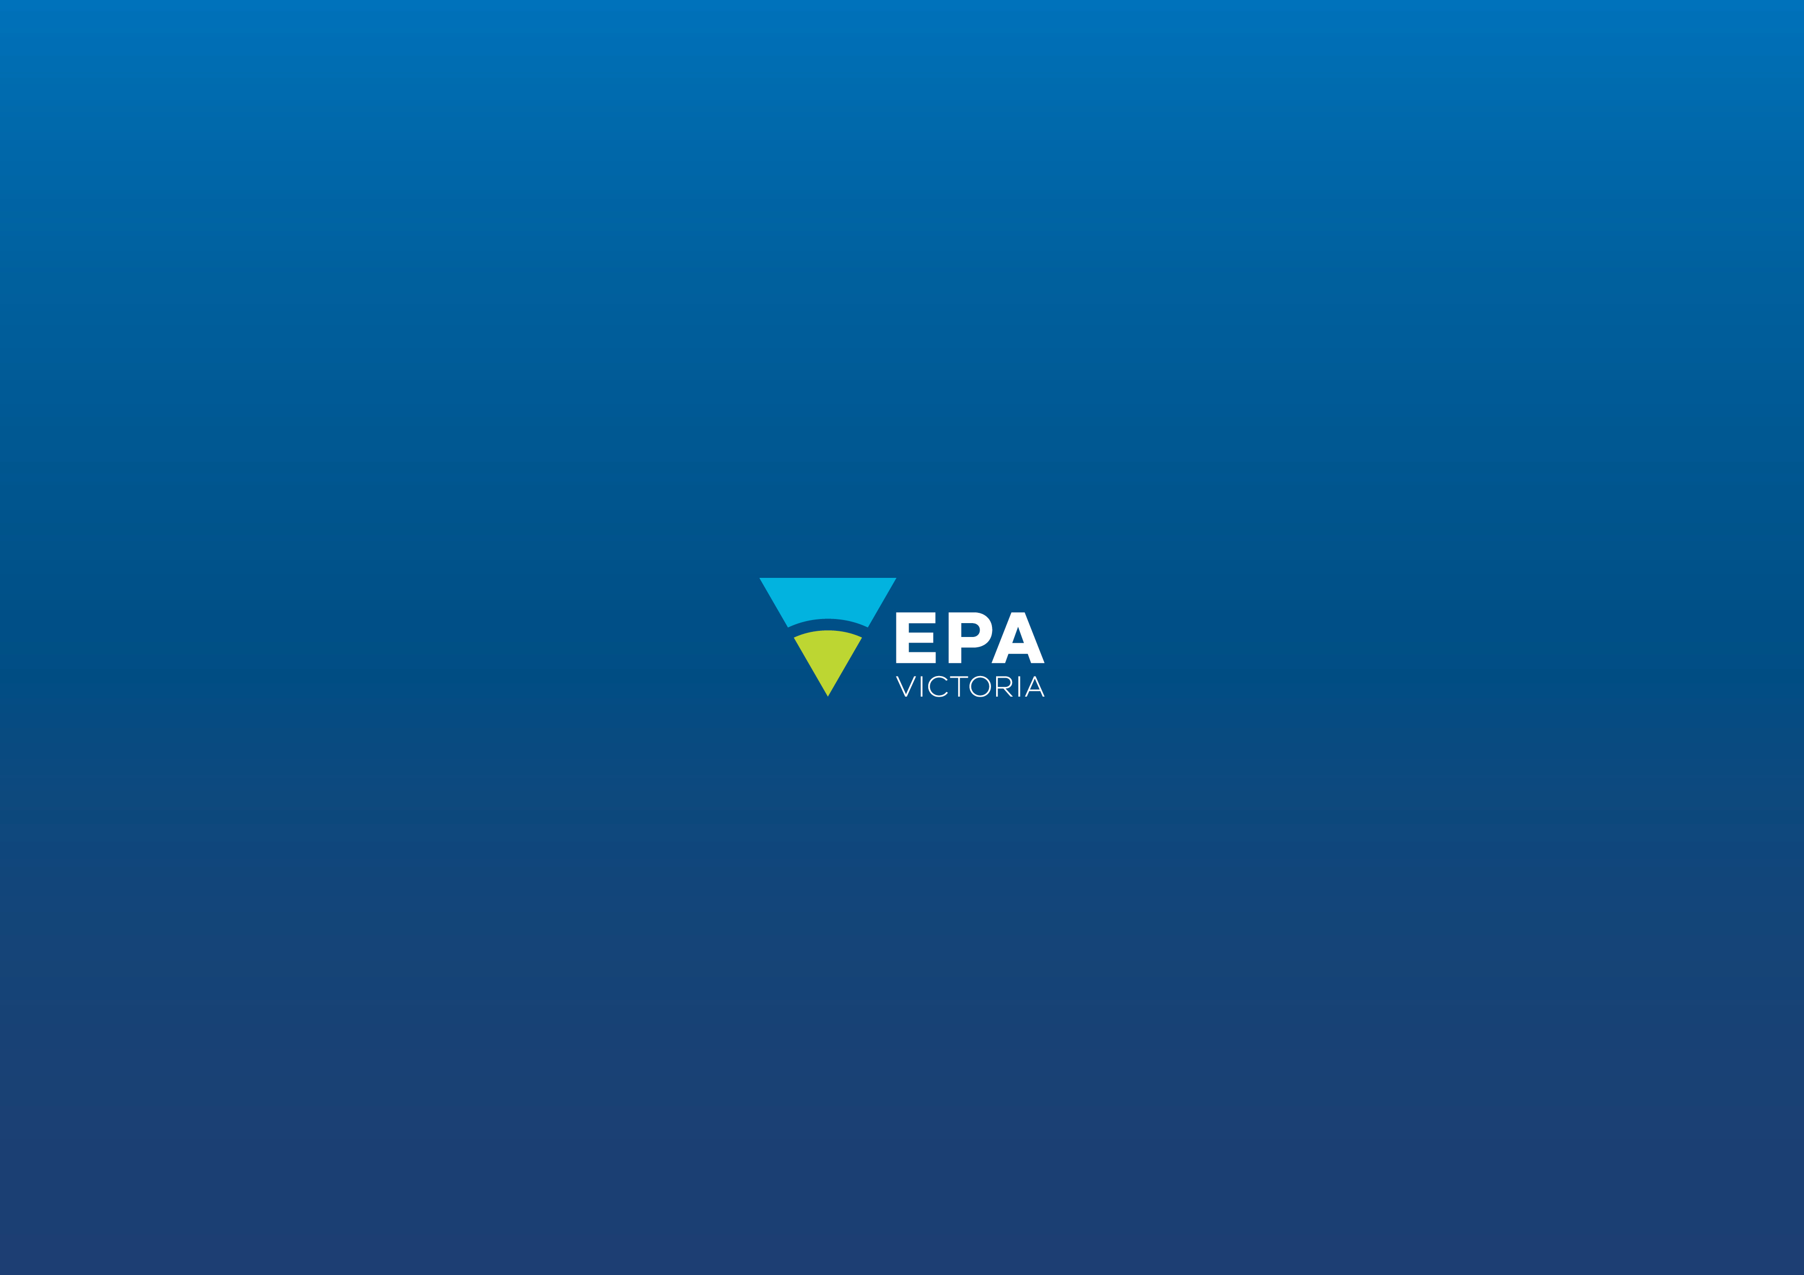



Authorised and published by the Victorian Government, 1 Treasury Place, Melbourne

](http://www.youtube.com/channel/UCTH9sYvphkFxGlAsIyTecJQ)

[epa.vic.gov.u](https://www.epa.vic.gov.au/)

Environment Protection Authority Victoria

GPO BOX 4395 Melbourne VIC 3001

1300 372 842