EPA West Gate Tunnel Project sensor air

monitoring
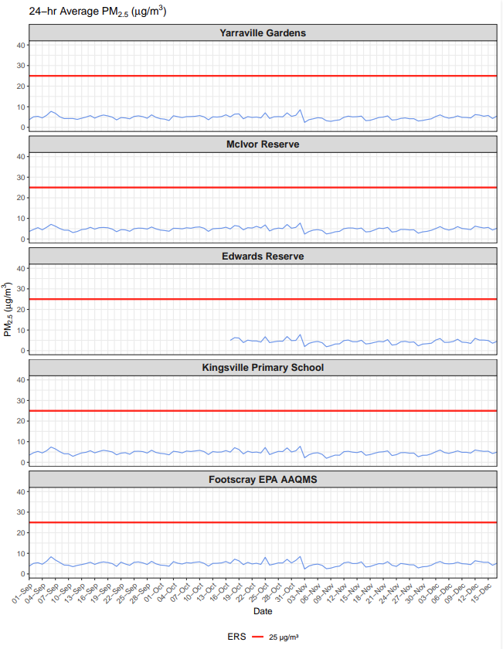
Figure 1: shows the Environmental Reference Standard (ERS) as 25 ug/m³. It also shows PM_{2.5} ug/m³ levels for each day from 1 September - 15 December 2025 from 5 EPA air sensor at Yarraville Gardens, McIvor Reserve, Edwards Reserve, Kingsville Primary School and Footscray. The PM_{2.5} results were well under the ERS.
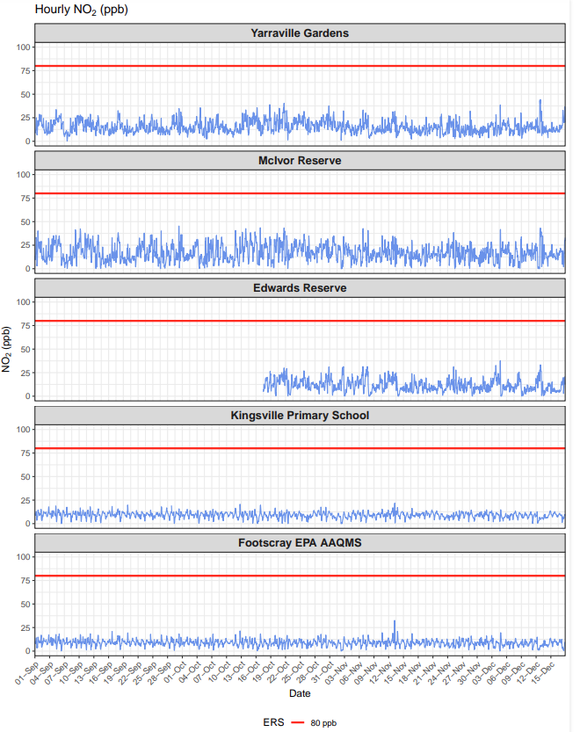

Figure 2: shows the Environmental Reference Standard (ERS) as 80 ppb. It also shows the hourly NO₂ ppb levels for each day from 1 September - 15 December 2025 from 5 EPA air sensor at Yarraville Gardens, McIvor Reserve, Edwards Reserve, Kingsville Primary School and Footscray. The NO₂ results were well under the ERS.

