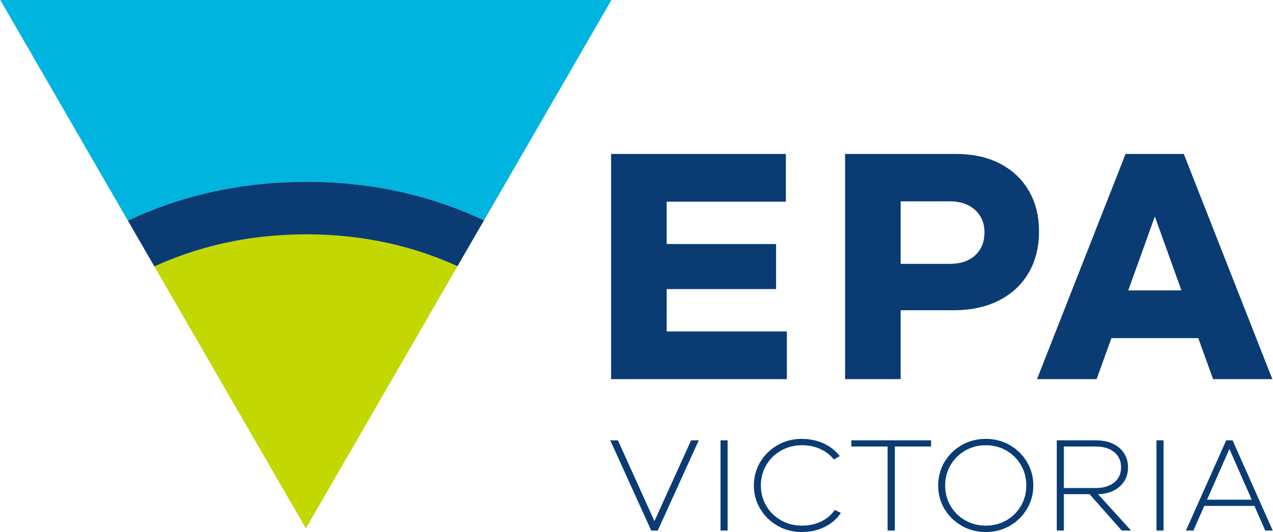


Authorised and published by the Victorian Government, 1 Treasury Place, Melbourne
Report Card 2024-25

Port Phillip, Western Port and Gippsland Lakes
  - April 2026
  - Science Division
Authorised and published by the Victorian Government, 1 Treasury Place, Melbourne

Summary

The annual Report Card shows the latest water quality in:

Port Phillip Bay

Western Port

Gippsland Lakes.

Along with Melbourne Water and the Department of Energy, Environment, and Climate Action (DEECA), we monitor these areas. You can find the results for July 2024 to June 2025 in this report.

.

In 2024–25, water quality in Port Phillip Bay and some catchments improved compared to previous years. However, the conditions in the Gippsland Lakes and Western Port mostly stayed the same.

Water quality was often Very Good or Good in rivers at higher elevations. As the rivers flowed through rural, agricultural, and urban areas, quality generally dropped to Poor or Very Poor. In the bays and lakes, water quality was mostly Very Good or Good in areas where it mixed with larger water volumes.

Data from the Bureau of Meteorology (BOM) shows that rainfall in central Victoria was below average during this period. It was average in the Gippsland region. Drier weather likely cut river flows, decreased polluted runoff into waterways, increased salinity, and led to more frequent or longer algal blooms.
In summer, we forecast how safe the water is for swimming based on bacteria levels. This information is not included in this report. Check the Yarra Watch and Beach Report programs for more information.

Contents
Summary 2
Contents 2
What area does the Report Card cover? 3
How are the scores calculated? 3
Climate in 2024–25 3
Port Phillip Bay and catchment 4
Western Port and catchment 5
Gippsland Lakes and catchment 9
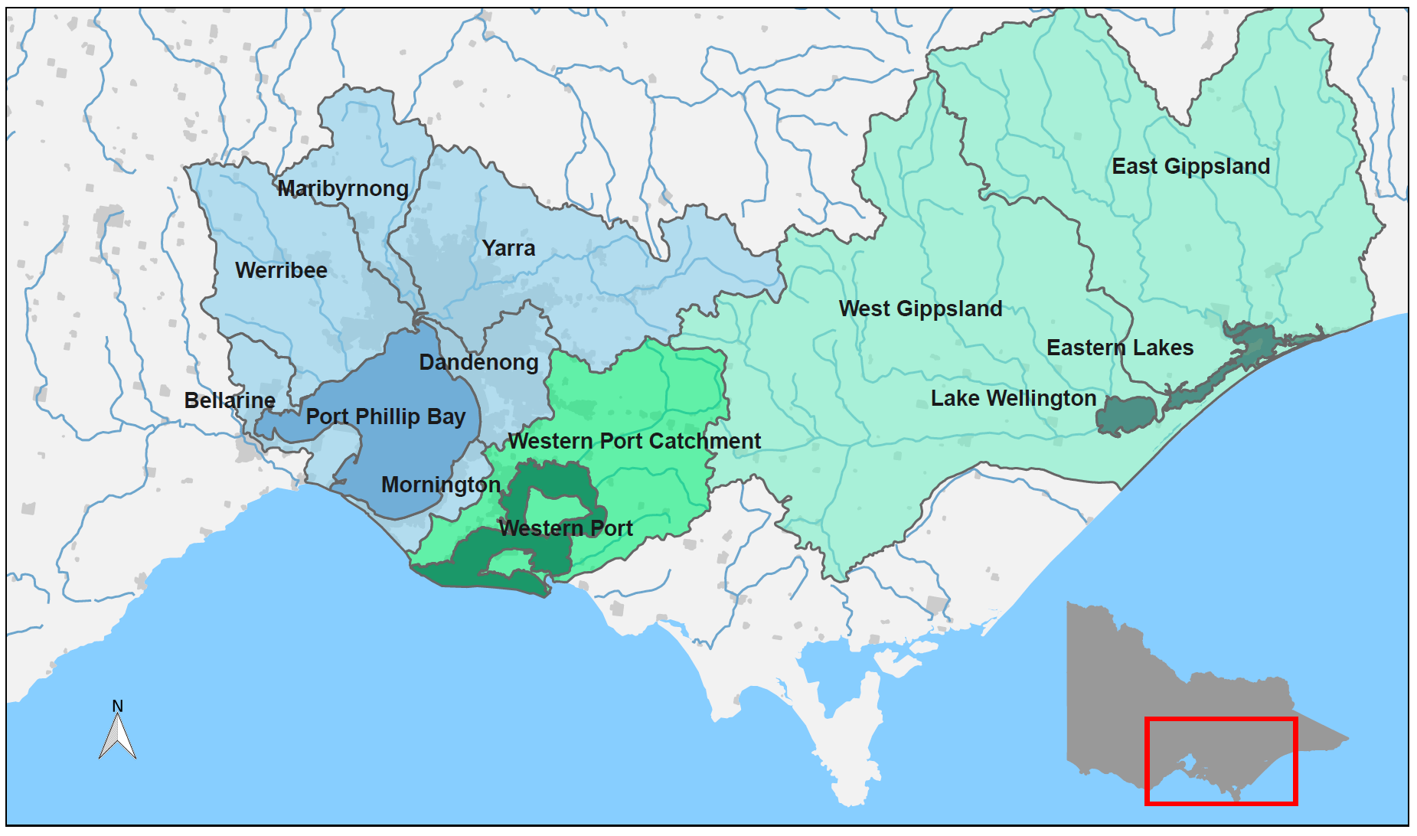
Further information 11

Figure 1: Location of Port Phillip Bay, Western Port, Gippsland Lakes (dark shading) and their catchments (light shading) within the state of Victoria.

What area does the Report Card cover?
Port Phillip Bay, Western Port, Gippsland Lakes, and their waterways for 2024–25 are the biggest coastal water areas in Victoria. The waterways include rivers, streams, wetlands, and estuaries, and they are important for culture, the economy, and the environment.

How are the scores calculated?
Key water quality indicators are checked against Victorian Environment Reference Standards (2021). These indicators are combined to calculate an overall water quality index score (WQI) out of 10, which gives a rating from Very Good to Very Poor (Table 1). For this Report Card, WQI scores cover the period from July 2024 to June 2025.
Table 1: Water quality index (WQI) scoring categories for Report Card.
Water quality index score | Rating | Description
8–10 | Very Good | High quality waterways generally not impacted by pollution
6–8 | Good | Meets Victorian water quality objectives
4–6 | Fair | Some evidence of stress
2–4 | Poor | Under considerable stress
0–2 | Very Poor | Under severe stress

The water quality indicators used for catchment waterway sites are:
- dissolved oxygen
- metals
- nutrients (total nitrogen and total phosphorous)
- pH
- salinity (not at estuarine sites)
- water clarity.
The indicators used for bay and lake sites are:
- algae (chlorophyll-a)
- dissolved oxygen
- metals (where data is available)
- nutrients (total nitrogen – Port Phillip Bay and Western Port; total phosphorous – Gippsland Lakes)
- salinity (not at the estuarine Eastern Lakes)
- water clarity.
These indicators measure risks to aquatic ecosystems from things like too many nutrients, more sediment, and algal blooms. The scores are summarised at both the catchment and bay levels. These scores are calculated by considering the area each site represents and finding the average. Only sites with at least 6 samples taken over the year are included. This is to make sure the Report Card accurately shows conditions throughout the year.

Climate in 2024–25

In 2024–25, rainfall was below average in the Port Phillip and Western Port catchments, and slightly drier than in 2023-24. Rainfall was average in the Gippsland catchment compared to the long-term average (Figure 2). Mean air and sea temperatures were above the long-term average by 0.5 to 1.0°C during this period.
Rainfall and air temperature changes affect water quality in inland, estuarine, and coastal waterways. Long dry spells can lower river flows, cut down on polluted runoff, raise salinity, and lead to more algal blooms. On the other hand, wet weather can increase pollutant transport, like nutrients and sediment, through stormwater runoff into waterways and bays.

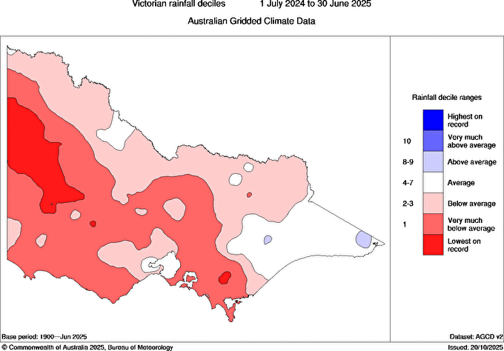
Figure 2: Victorian rainfall decile ranges from 1 July 2024 to 30 June 2025, shows below average conditions for Port Phillip and Western Port, and average conditions for Gippsland Lakes. (Source: © Commonwealth of Australia 2024, Bureau of Meteorology.)

Port Phillip Bay and catchment
Port Phillip Bay is a large, shallow bay. It is surrounded by mostly rural catchments, but has big urban areas along its shoreline. This includes Melbourne and Geelong. Major rivers like the Yarra, Maribyrnong, and Werribee flow from forested hills and mountains. They pass through rural properties and towns before reaching the bay. The bay connects to Bass Strait through a narrow entrance. In the south, bay waters mix well with ocean waters. In contrast, river input greatly affects the waters in the north and west. The bay is popular for boating, fishing, and swimming. It also hosts Victoria’s largest recreational fishery.

The Report Card for Port Phillip Bay and its catchment uses data fromMelbourne water and us . It includes data from 88 freshwater and 6 marine sites in the region to calculate WQI scores (Figures 3 and 7). In 2024–25, water quality in Port Phillip Bay and its catchment ranged from ‘Very Good’ in the southern bay and upper Yarra catchment to ‘Very Poor’ in urban waterways. This trend is similar to previous years (Figures 4 and 6).

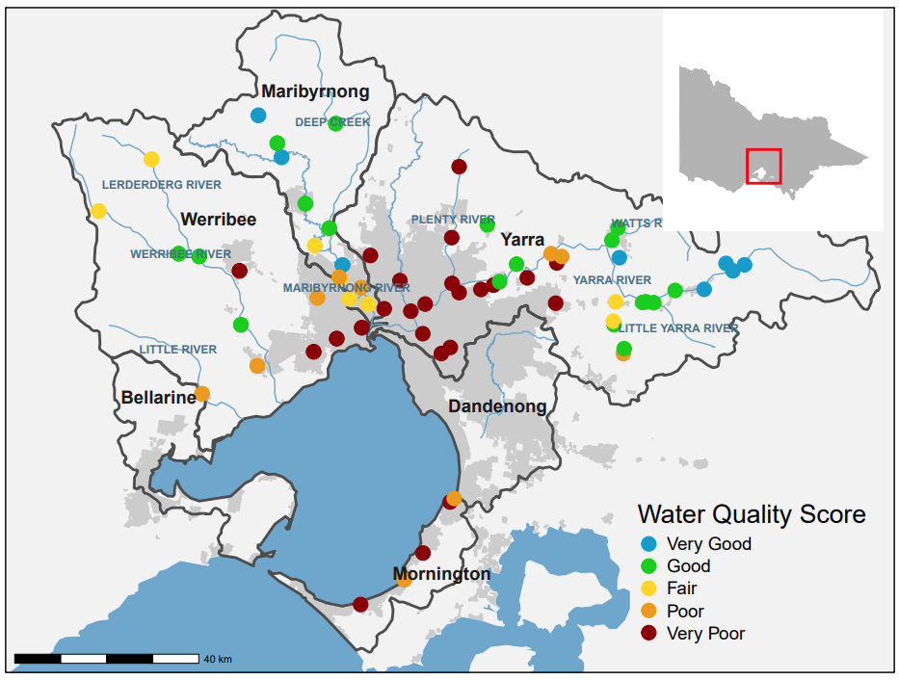
Catchment Report Card
Figure 3: Location and WQI scores of Melbourne Water’s monitoring sites in the Port Phillip catchment. Colour indicates WQI score for each site in 2024–25.
Port Phillip Bay has 6 catchments: Yarra, Werribee, Maribyrnong, Dandenong, Mornington, and Bellarine (Figure 3). For 2024-25, the western catchments (Werribee and Maribyrnong sustained their 2023-24 ratings. In contrast, the eastern Yarra catchment showed some minor improvements in water quality.

Maribyrnong and Werribee

The Maribyrnong catchment includes rivers and creeks like Deep Creek and Jacksons Creek. These flow into the lower Yarra Estuary and then into Port Phillip Bay (Figure 3). In 2024-25, water quality in the Maribyrnong catchment was rated 'Good.' This sustained the improved rating from 2023-24, which was a big jump from ‘Poor’ in 2022-23. This shows the recovery from the flooding impacts of 2022-23, was sustained in 2024-25 (Figure 4). The Werribee catchment also sustained a rating of ‘Fair’ compared to the 2022-23 'Poor' Rating.

Yarra, Dandenong and Mornington

Water quality in the Yarra catchment improved to Fair’, a first since 2015. There was an improvement in the middle and upper Yarra sites compared to the last report. The urbanised areas of the small Dandenong and Mornington catchments had the lowest WQI scores in the Port Phillip region, showing ‘Very Poor’ water quality (Figure 3). This trend matches previous years.

Bellarine
The Bellarine catchment is outside Melbourne Water’s service area. Waterwatch data is available for the Bellarine. However, it is collected in a different way therefore, a WQI score cannot be calculated for this catchment.
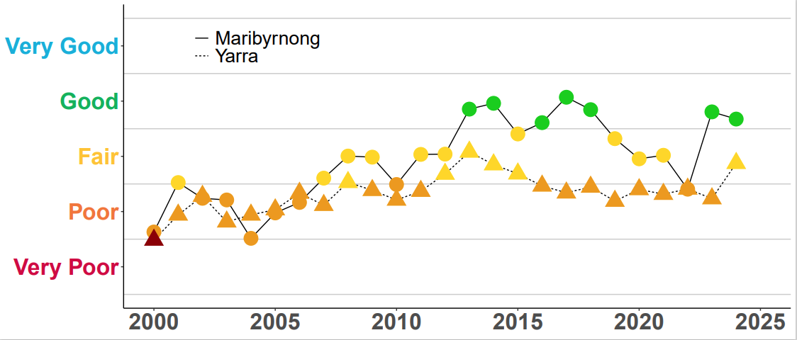

Figure 4: Historical WQI scores for the overall Maribyrnong and Yarra catchments. Colour indicates WQI score for each year. For 2024-25, there was a significant improvement in the Maribyrnong catchment from ‘Poor’ to ‘Good’, while the Yarra catchment maintained a ‘Poor’ rating for the last 8 years.

Bay Report Card
Overall, water quality in Port Phillip Bay continued improving in 2024-25 compared to 2022-23. Two sites—Central, and Dromana—sustained a ‘Very Good’ rating. This was due to better algae, nutrient, salinity, and water clarity indicators (Figure 5).

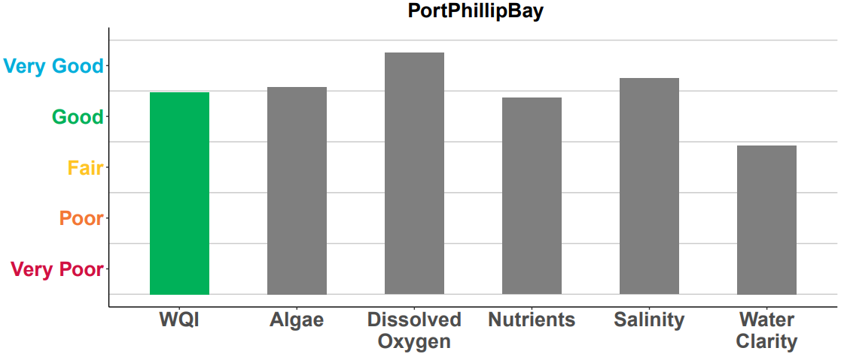
Figure 5: WQI scores for Port Phillip Bay in 2024-25. Coloured bar indicates the overall WQI score. Grey bars are the individual indicators used to calculate the overall WQI score.
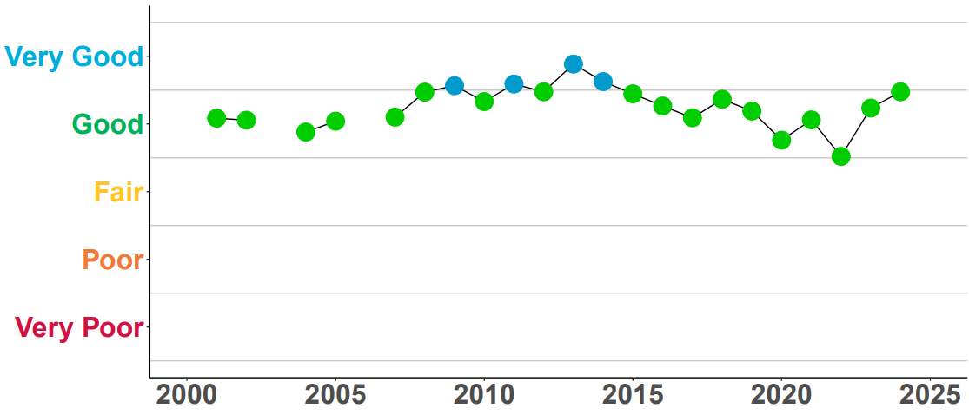
Figure 6: Historical WQI scores for Port Phillip Bay up to 2024-25.
e monitor 6 locations in Port Phillip Bay (Figure 7). Since 2002, conditions have stayed fairly consistent. Overall water quality has ranged from ‘Good’ to ‘Very Good’ (Figure 6). For 2024-25, the Bay has a ‘Good’ WQI rating. This shows an improvement from past years, thanks to below-average rainfall during the period.
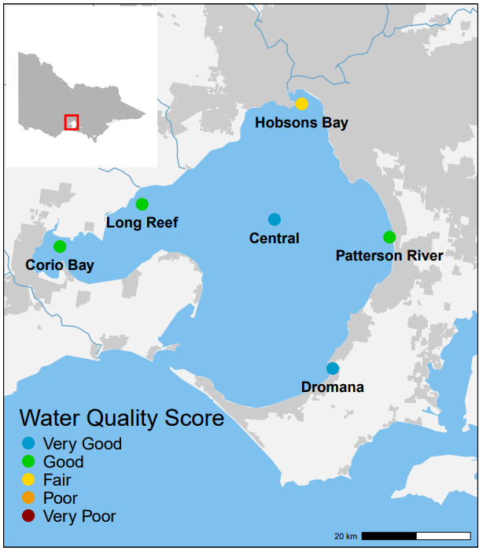
Figure 7: Locations and 2024-25 WQI scores of EPA long-term marine monitoring sites in Port Phillip Bay.

Dromana and Central Bay

Dromana and Central Bay both had ‘Very Good’ water quality. This is due to their distance from the major inflows in the bay's northern area.

Patterson River, Corio, Long Reef and Hobsons Bay

Long Reef, Corio, and Patterson River had ‘Good’ water quality while Hobsons Bay dropped to a ‘Fair’ rating. These sites are nearer to the higher river inflows, run-off, and stormwater that bring pollutants like nutrients, sediments, and heavy metals, with Hobsons Bay closest to the main catchment inflows from urban areas.

Western Port and catchment

Western Port is a semi-enclosed bay with 2 large islands, Phillip and French , that shape water flow. The catchment is mostly rural (70 per cent), includes state reserves (20 per cent) in the upper area and features a rapidly growing urban corridor. Waterways in the catchment run through modified rural and urban lands. This area also includes Bunyip State Park and the Strzelecki Ranges. These regions have dense vegetation and support important environmental values. The bay's northern and eastern sections are mainly intertidal mudflats, fed by inflows from the Bunyip, Lang Lang and Bass Rivers. Wind waves here can resuspend and move sediments. Tidal exchange with Bass Strait greatly affects the bay's western and southern parts.

The Report Card for Western Port and its catchment uses data from us and Melbourne Water. In 2024–25, water quality ranged from ‘Good’ in the upper catchment and some bay areas to ‘Very Poor’ in highly urbanised or intensive agricultural zones.

Catchment Report Card
Overall, the water quality in the Western Port catchment waterways was rated as ‘Poor’ for 2024-25. Four out of 6 water quality indicators showed ‘Poor’ or ‘Very Poor’ ratings (Figure 8). These scores have stayed mostly the same over time, with water quality often being ‘Poor’ (Figure 9).
Melbourne Water checks water samples from different waterways in the catchment to see how water quality is changing. For this Report Card, 22 sites in the Western Port catchment were used to calculate the WQI score (Figure 10).

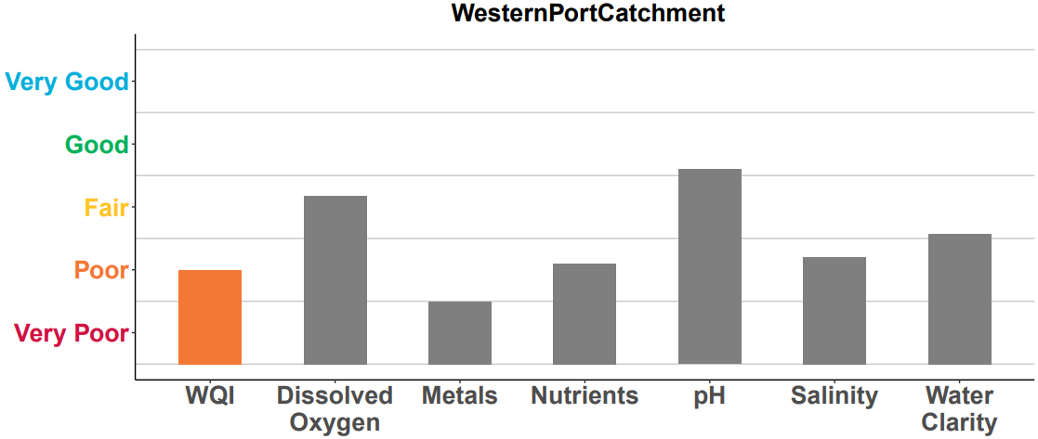
Figure 8: WQI scores for the overall Western Port catchment in 2024-25. Coloured bar indicates the overall WQI score. Grey bars are the individual indicators used to calculate the overall WQI score.

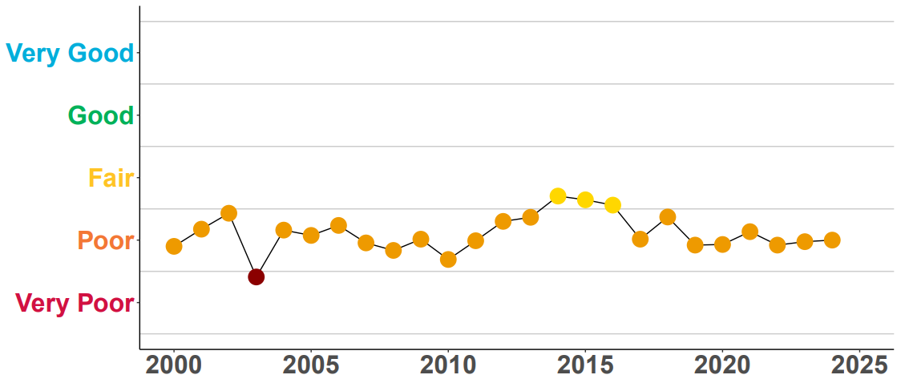
Figure 9: Historical WQI scores for the overall Western Port catchment up to 2024-25.
Water quality in the upper catchment of the Bunyip River was ‘Fair’ to ‘Good’. In the upper catchment of Lang Lang, it was ‘Poor’ to ‘Fair’. These conditions have stayed much the same as in previous yearsIn the mid and lower catchments, water quality dropped to ‘Poor’ or ‘Very Poor’. This decline is due to land use changesof rural, agricultural and urban areas.
Over time, vegetation clearing, draining of the Koo Wee Rup swamp and urban growth have significantly changed the Western Port catchment. These changes in drainage and land use make it hard to maintain water quality in these rivers and streams.
Five of the 6 Mornington catchment sites all rate as ‘Very Poor’ due to their small catchment size, more urbanised areas and intensive agriculture. While these sites generally rate as ‘Very Poor’ over time, the number of catchments receiving this rating has decreased since the previous year in half the sites.
.

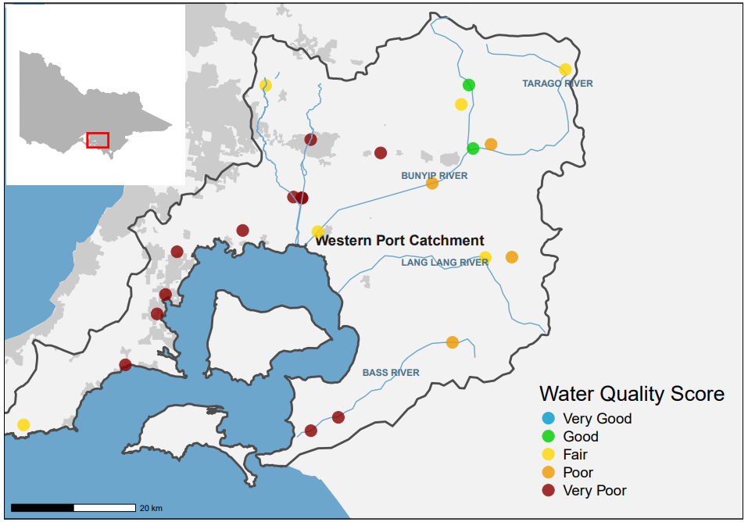
Figure 10: Location and 2024-25 WQI scores of Melbourne Water’s monitoring sites in the Western Port catchment.

Western Port Bay Report Card
Overall, water quality in Western Port was rated as ‘Good’ for 2024–25. This is an improvement from past years. This is thanks to an improved rating for algae that balanced out a reduced rating for Water Clarity. (Figure 11). Rainfall data from the BOM showed below-average rainfall in the Western Port catchment was sustained during 2024–25 (Figure 2). Rainfall impacts the volume of surface and stormwater run-off. River input bring nutrients and sediment from the northern and eastern catchments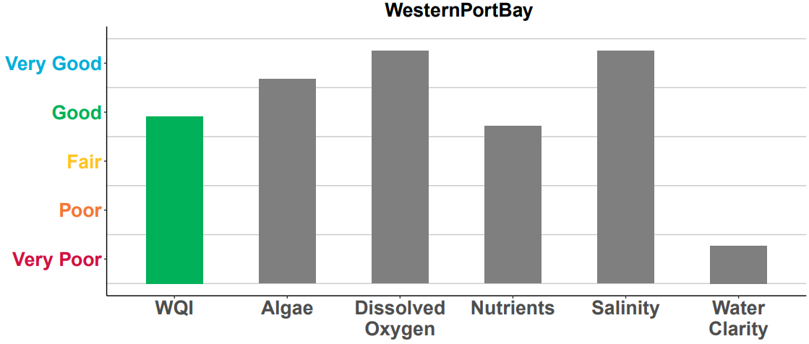
Figure 11: WQI scores for Western Port overall in 2024–25. Grey bars are the individual indicators used to calculate the overall WQI score.

Rainfall can temporarily change water quality. However, WQI scores in Western Port have stayed consistent since 2000 (Figure 12). Small catchment inflow volumes and mixing with Bass Strait help keep water quality good in Western Port. We monitors 2locations there (Figure 13).
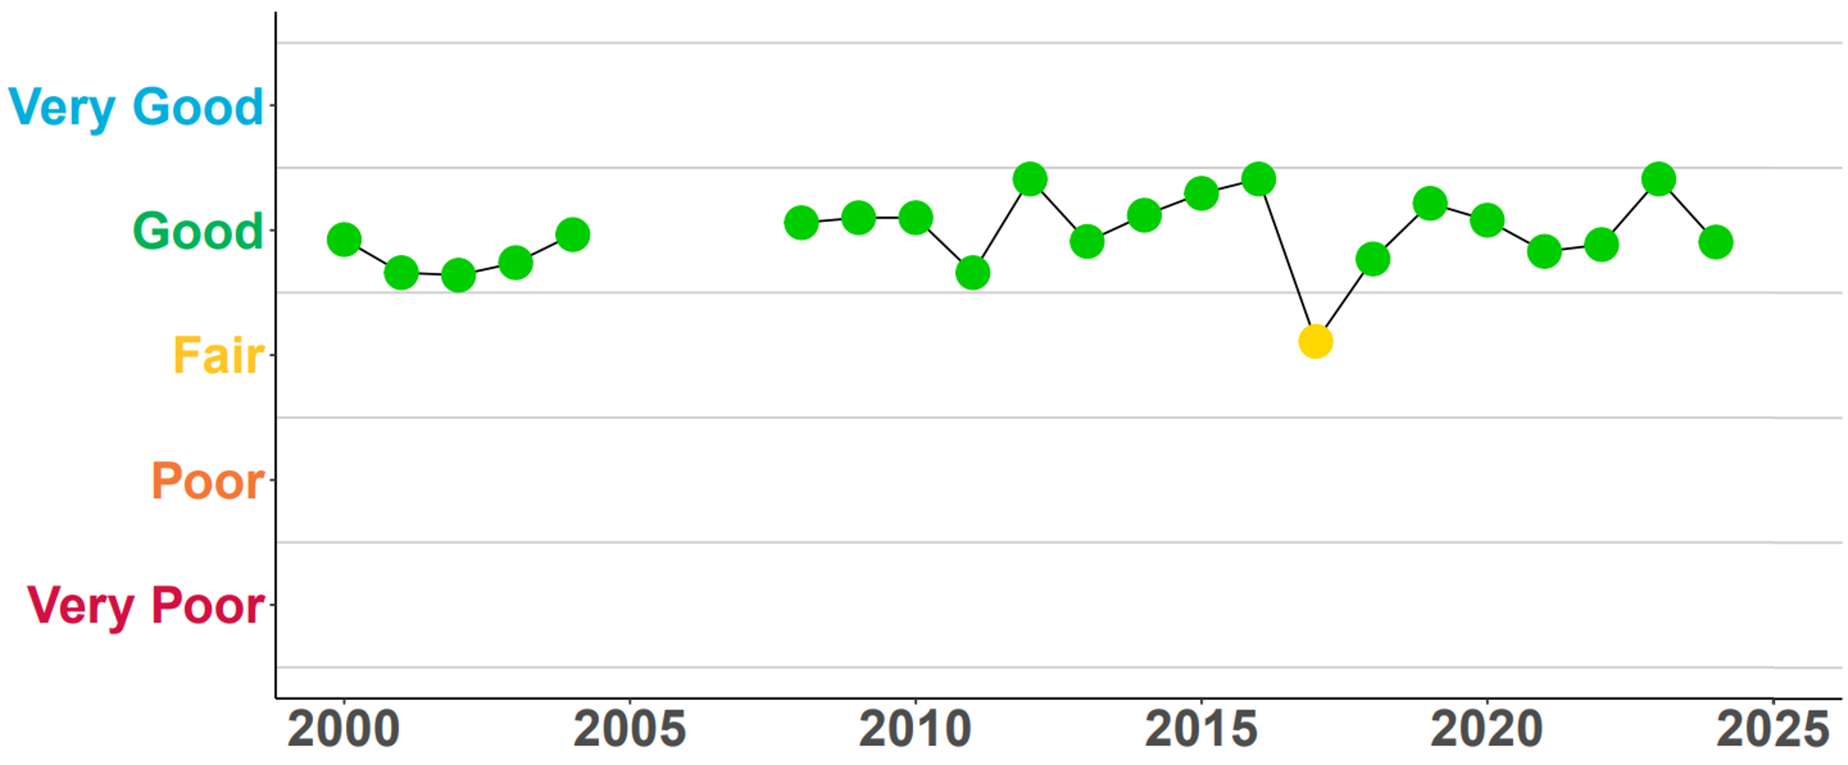

Figure 12: Historical WQI scores for Western Port up to 2024-25. Due to limited monitoring, no scores were calculated from 2005–08.

Hastings

The Hastings monitoring site showed ‘Good’ water quality. This is a decline from the ‘Very Good’ rating last year. Regular flushing and mixing with ocean waters from Bass Strait help this area. Increased south-westerly winds from 2024-25 likely increased wind wave exposure. This also increased sediment transport and resuspension, contributing to the decline at this western site.

Corinella
The Corinella monitoring site sustained a ‘Fair’ water quality, as in the previous year. The prevailing westerly winds in 2024-25 increased the risk of coastal erosion from enhanced wind waves at this site.
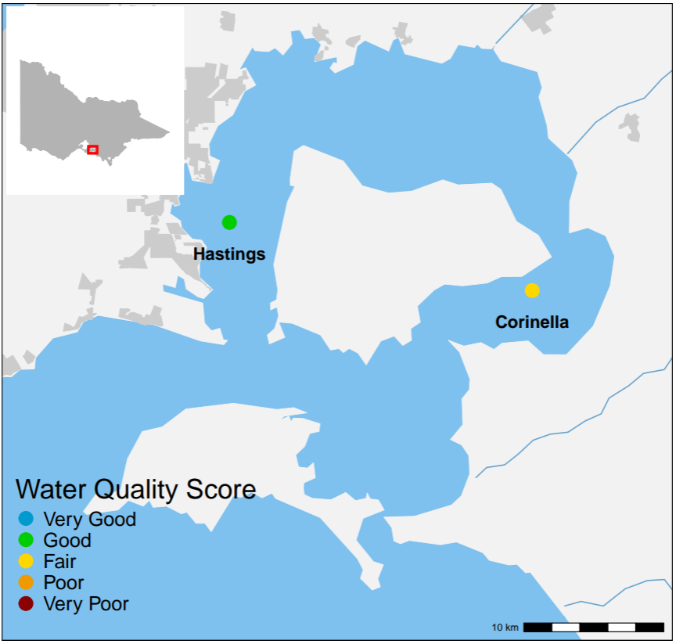
Figure 13: Locations and 2024-25 WQI scores of long-term EPA marine monitoring sites in Western Port.

Gippsland Lakes and catchment
The Gippsland Lakes stretch for 70 km as a series of large, shallow coastal lagoons. A narrow channel at Lakes Entrance links the lakes to Bass Strait. The catchment area includes mostly state reserves, forests, and national parks (60 per cent) and rural land (39 per cent). Five major rivers feed directly into the lakes: the Mitchell, Nicholson, and Tambo Rivers flow into Lake King, while the Latrobe and Avon Rivers flow into Lake Wellington.
The Report Card for Gippsland Lakes and its catchment uses monitoring data from DEECA (26 sites) and us(5 sites). Scores are calculated only for rivers and streams that drain into the Gippsland Lakes. In 2024–25, average rainfall (Figure 2) led to water quality ratings of ‘Very Good’ and ‘Good’ in most of the catchment’s waterways (Figure 14).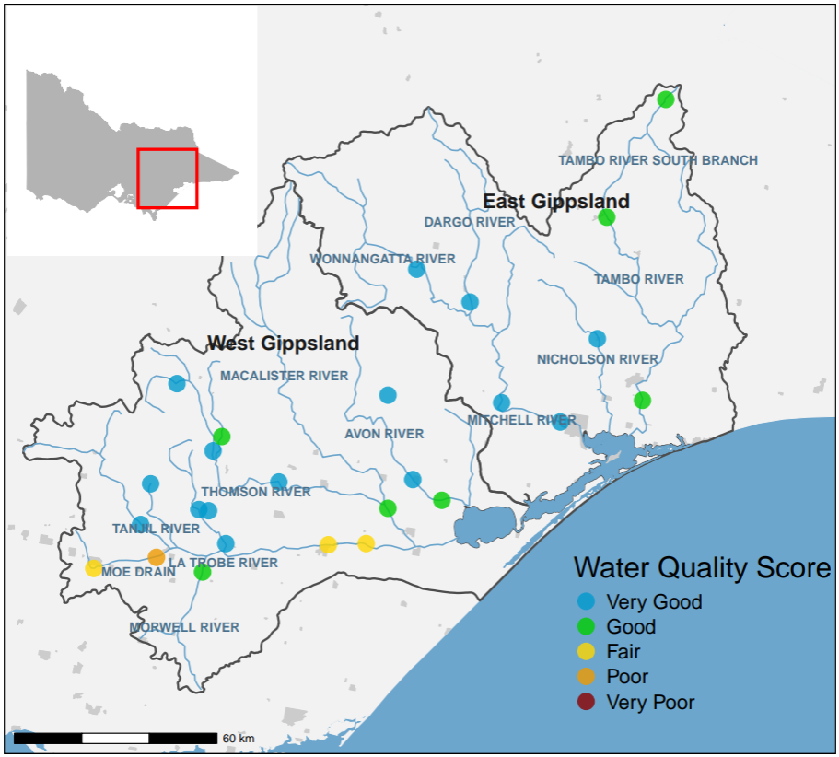
Figure 14: Location and 2024-25 WQI scores of DEECA’s monitoring sites in the Gippsland Lakes catchment.

Catchment Report Card
In West Gippsland, water quality was rated as ‘Good’, like in past years (Figure 16). The forested areas on the Great Dividing Range had ‘Very Good’ water quality. However, water quality remained ‘Fair’ or ‘Poor’ in the mid and lower Latrobe River. This lower rating was due to cleared land and urbanisation. In the East Gippsland catchment, water quality remained ‘Very Good’, consistent with previous years (Figure 15).
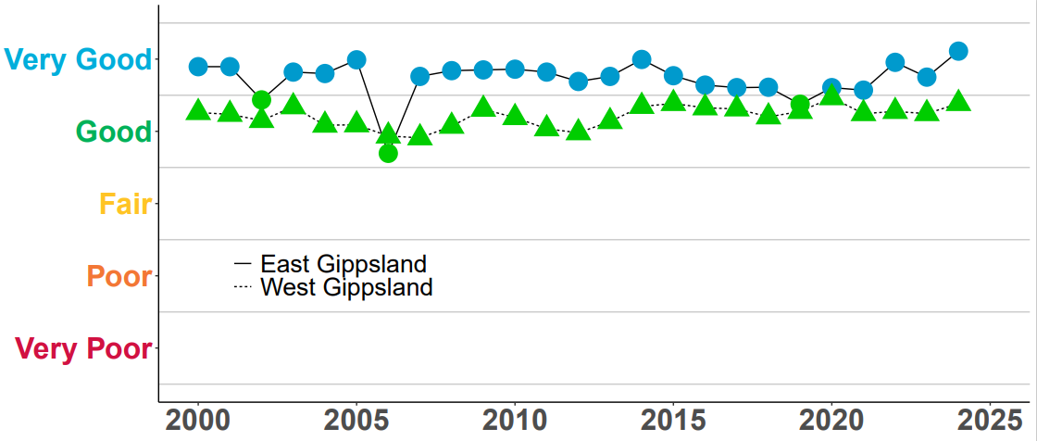
Figure 15: Historical WQI scores for the Gippsland catchments up to 2024-25.

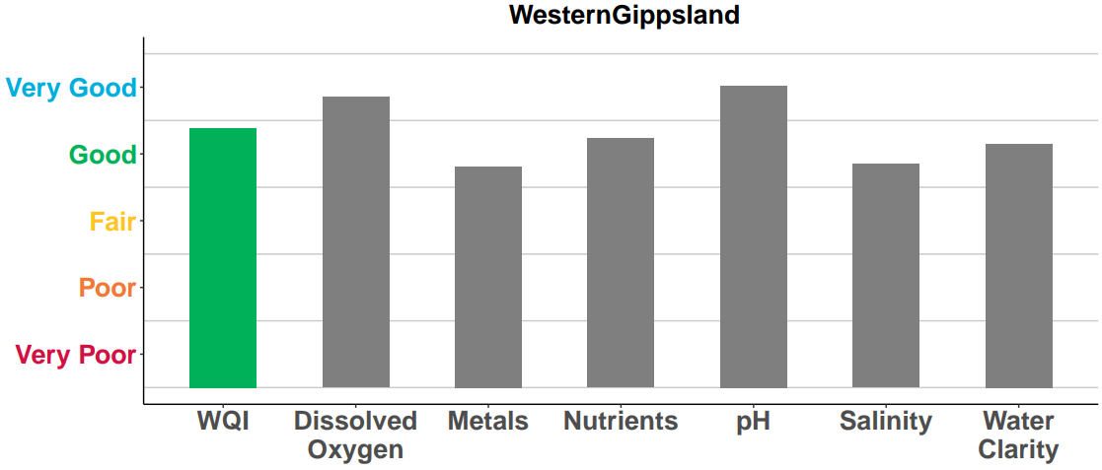
Figure 16: WQI scores for West Gippsland catchment in 2024–25. Grey bars are the individual indicators used to calculate the overall WQI score.

Gippsland Lakes Report Card

Sites closer to the Bass Strait entrance, like Shaving Point and Lake King, usually have better water quality. This is due to greater tidal exchange compared to sites further away, such as Lake Wellington and Lake Victoria.

Lake Wellington

Lake Wellington collects sediments, nutrients, and contaminants. Wind and waves in the shallow waters can stir up these sediments and nutrients. This often leads to algal blooms due to the high nutrient levels. In drier times, with less river flow, the lake faces rising salinity from marine water and increased evaporation. Historically, Lake Wellington's water quality was rated ‘Poor’ or ‘Very Poor’ (Figure 18). Since 2020-21, good river flows have kept the rating at ‘Fair’ by lowering salinity.

Eastern Lakes (King and Victoria)
Nutrient loads matched the average rainfall in 2024-25 for the Eastern Lakes. This resulted in a ‘Good’ rating, showing stable conditions like those of the past decade.

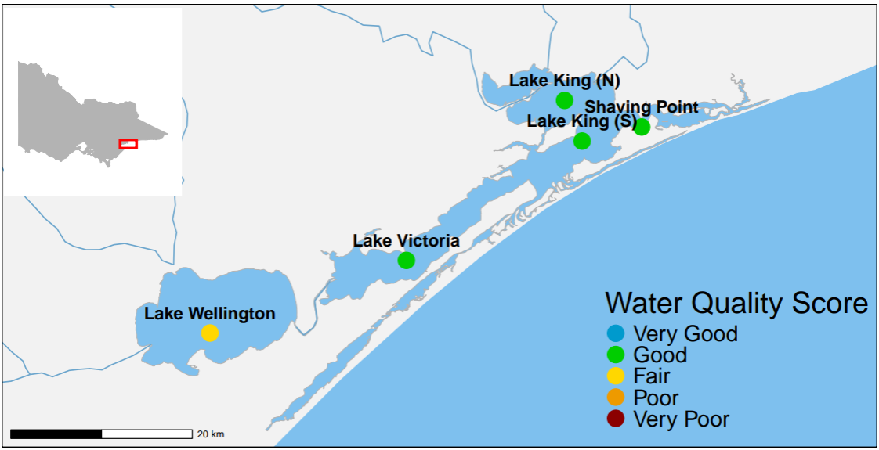

Figure 17: Locations and 2024-25 WQI scores of EPA’s long-term marine monitoring sites in
Gippsland Lakes.

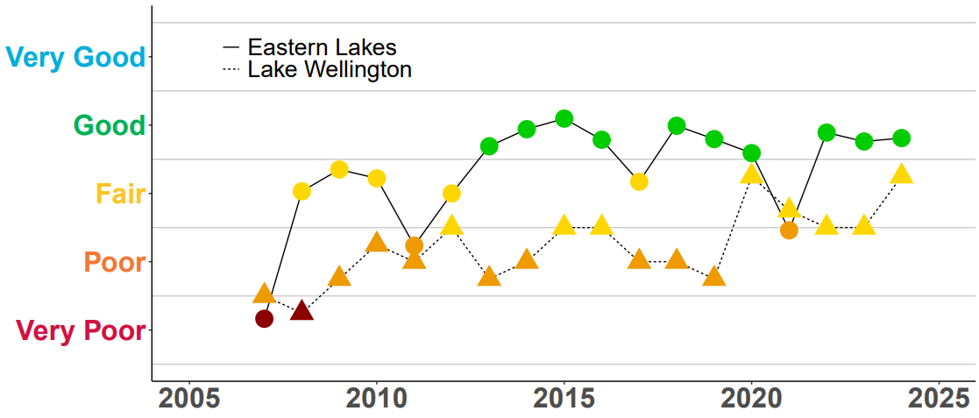
Figure 18: Historical WQI scores for Eastern lakes and Lake Wellington up to 2024-25. Due to limited monitoring, no scores were calculated for some years between 2001 and 2006.
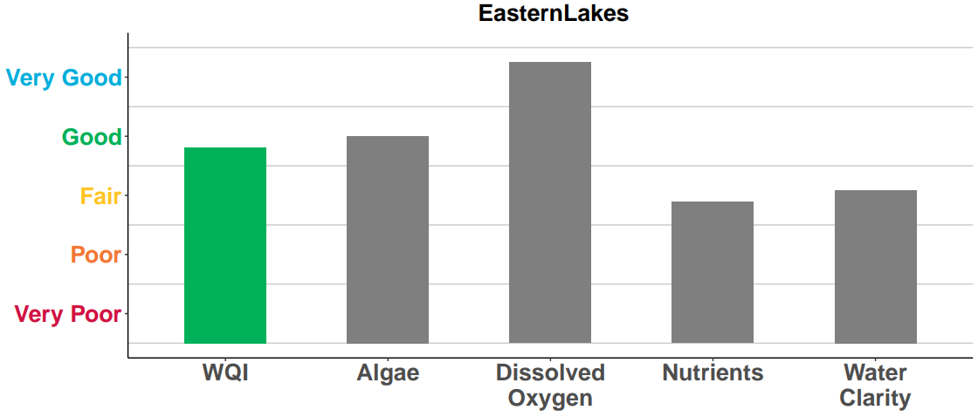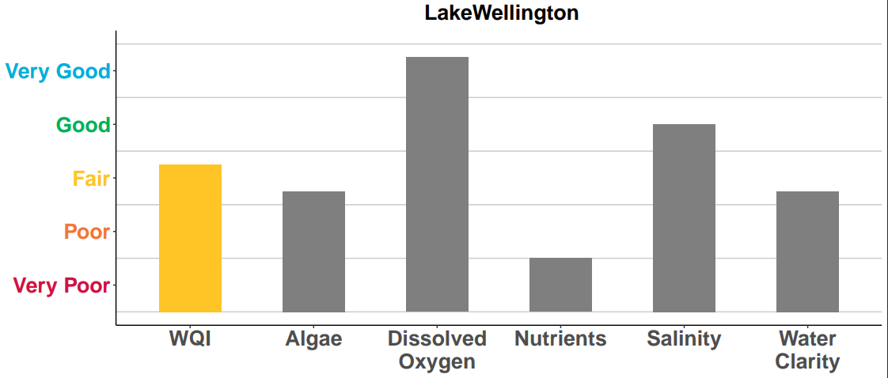
Figure 19: Overall WQI scores for the Eastern lakes (top) and Lake Wellington (bottom) in 2024–25. Grey bars are the individual indicators used to calculate the overall WQI score.

More information
- Victorian government’s Water Measurement Information System
- How water quality is monitored

This publication is for general guidance only. You should obtain professional advice if you have any specific concern. EPA Victoria has made every reasonable effort to ensure accuracy at the time of publication.

This work is licensed under a Creative Commons Attribution 4.0 licence.

EPA acknowledges Victoria’s First Nations peoples as the Traditional Owners of the land and water on which we live and work. We pay our respect to their Elders past and present.

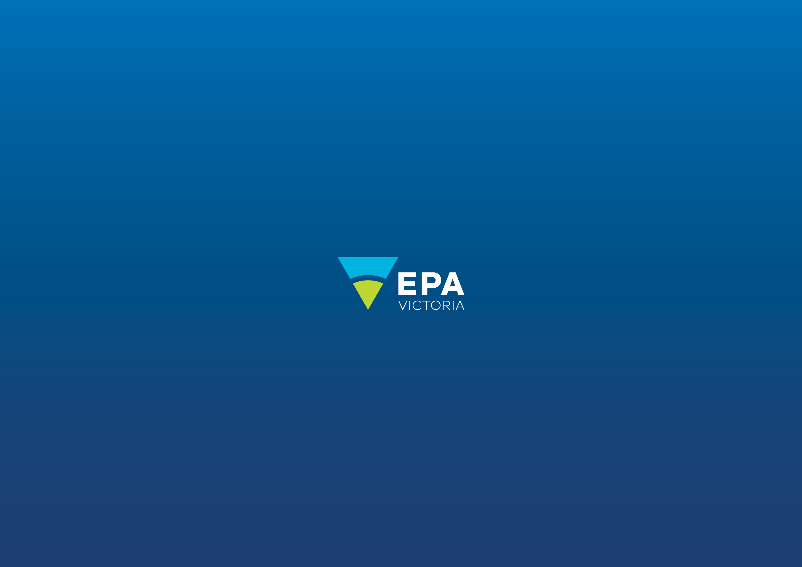
Authorised and published by the Victorian Government, 1 Treasury Place, Melbourne

epa.vic.gov.u
Environment Protection Authority Victoria
GPO BOX 4395 Melbourne VIC 3001
1300 372 842

