EPA West Gate Tunnel Project sensor air

monitoring
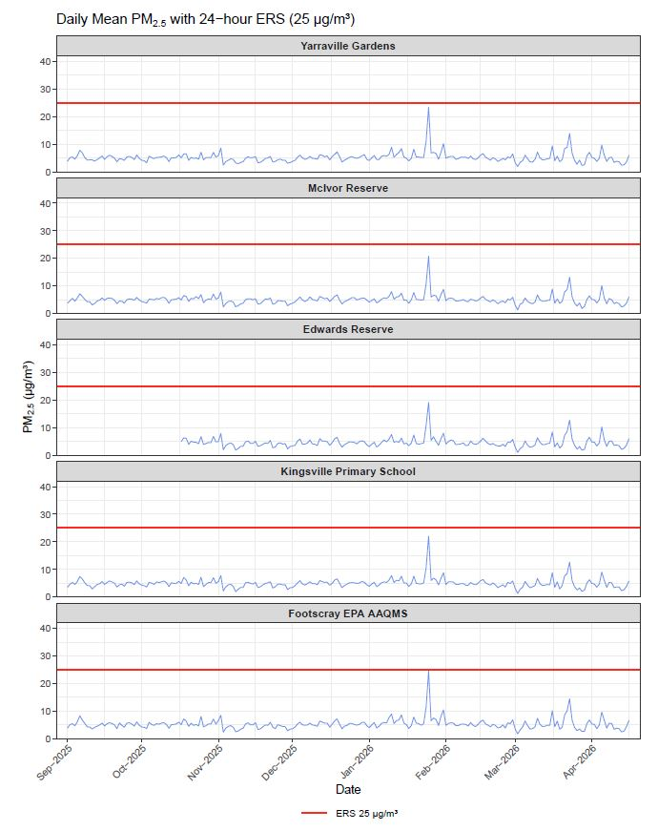
Figure 1: shows the Environmental Reference Standard (ERS) as 50 ug/m³. It also shows PM2.5 ug/m³ levels for each day from 1 September – 16 April 2026 from 6 EPA air sensor at Yarraville Gardens, McIvor Reserve, Edwards Reserve, Kingsville Primary School and Footscray. The PM2.5 results were well under the ERS.
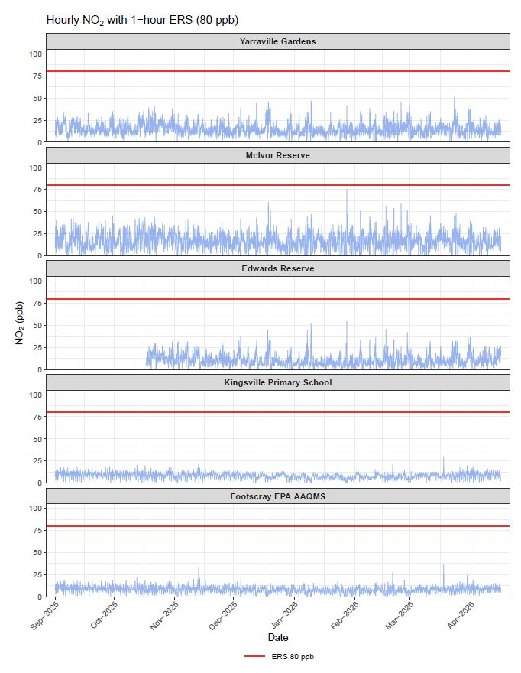
Figure 2: shows the Environmental Reference Standard (ERS) as 50 ug/m³. It also shows the hourly NO₂ ppb levels for each day from 1 September – 16 April 2026 from 6 EPA air sensor at Yarraville Gardens, McIvor Reserve, Edwards Reserve, Kingsville Primary School and Footscray. The PM2.5 results were well under the ERS.

