Hallam Road Landfill community forum
This event was held between 2pm and 5pm on Saturday 9 May 2026 at the Lynbrook Community Centre. It was held under section 236 of the Environment Protection Act 2017.
The purpose of the community forum was to support decisions that EPA needs to make about the allocation of $1,000,000 in the Restorative Project Account. The monies in the Account are a result of enforcement proceedings taken by EPA. It follows a long history of compliance issues regarding the operations of the Hallam Road Landfill.
The long-standing compliance history of the management of this landfill and the impacts for people residing near the landfill are available on the EPA website: https://www.epa.vic.gov.au/hallam-road-landfill.
This event summary outlines 8 project ideas raised and discussed by community members at the Hallam Road Landfill community forum.
The Hallam Road Landfill community forum was not a decision-making forum. The 8 project ideas in this document are at this stage ideas. They may be turned into formal submissions alongside other projects for consideration and decision by the EPA.
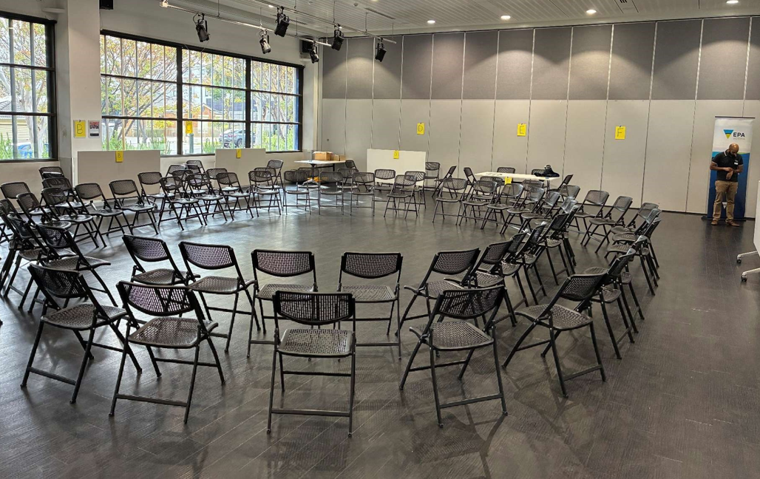

Community ideas
The following 8 ideas were raised by participants at the community forum:
- Community Garden
- All in one area or split (all the money to be spent in one area or the money shared around the site)
- Younger generation engagement
- Bam Bam Swamp Cranbourne Nature Conservation Reserve Restoration
- Parks and reserve updates and improvements
- Legacy micro grants setup for smaller projects over the next 5-7 years
- Community stage (permanent) at Banjo Paterson Park Lynbrook
- Hydrotherapy pool and mindfulness centre
The remainder of the document presents the notes captured at the community forum. They have been adapted from handwritten notes.
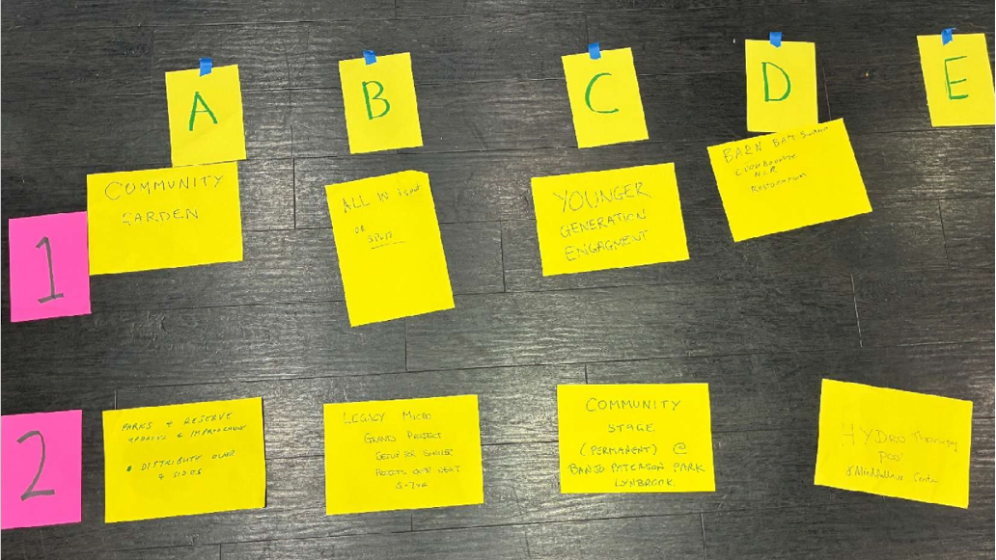

Idea 1: ‘The Garden’
Who put this idea forward? | Lynbrook Residents Association
Project name: | ‘The Garden’
The funding needs to be for Projects that restore or enhance the environment in a public space or for public benefit. Projects also need to benefit the community in the vicinity of the Hallam Rd Landfill.
Who else came?  Add names | Name/s redacted for privacy
What is this community project about?  (this is to help those who weren’t here understand) | Community Garden  Sustainable food growing  Environmental education  Social connection
Where will this happen?  Add a location/street name/ area | Lynbrook Primary School/ Ronans Retreat Lynbrook  Melbourne Water (in principle support) / Department of Education land
How will this benefit the environment and community? | Environment: increase local green space, encourage sustainable food production, composting organic waste, habitat corridor  Community: education, food security, inclusive/accessible community space, wellbeing, social connection, gathering space
Who (which organisation) could deliver this project?  If you do not know, leave blank | Lynbrook Residents Association with Lynbrook Primary School, Melbourne Water, Bunurong, Department of Education
Who in the community can help develop this idea after today?  Add names & contact details of people who might be able to help develop this idea. | Steering Committee will put together a plan.  Lynbrook Residents Association

Idea 2a: ‘Spend as a whole or split four ways’
Who put this idea forward? | Name/s redacted for privacy
Project name: | ‘Spend as a whole or split four ways’
The funding needs to be for Projects that restore or enhance the environment in a public space or for public benefit. Projects also need to benefit the community in the vicinity of the Hallam Rd Landfill.
Who else came?  Add names | Name/s redacted for privacy
What is this community project about?  (this is to help those who weren’t here understand) | Split the [$1 million] four ways distributed evenly to community projects on all four sides of the landfill.
Where will this happen?  Add a location/street name/ area | Split four ways on four sides, with specific projects yet to be proposed.
How will this benefit the environment and community? | Improve people’s lives
Who (which organisation) could deliver this project?  If you do not know, leave blank | Melbourne Water  Council (City of Casey)  LRA (Lynbrook Residents Association)
Who in the community can help develop this idea after today?
Add names & contact details of people who might be able to help develop this idea.

Idea 2b: ‘Spend as a whole or split’
Who put this idea forward? | Name/s redacted for privacy
Project name: | ‘Spend as a whole or split’
The funding needs to be for Projects that restore or enhance the environment in a public space or for public benefit. Projects also need to benefit the community in the vicinity of the Hallam Rd Landfill.
Who else came?  Add names | Name/s redacted for privacy
What is this community project about?
(this is to help those who weren’t here understand)
Where will this happen?  Add a location/street name/ area | I believe money should be spent as a whole in one area with South East Water, Council, Local contributions to turn $1 million into $3 million for a bigger project.
How will this benefit the environment and community?
Who (which organisation) could deliver this project?  If you do not know, leave blank | “Replas” is as company who makes recycled plastic park seats, and these could be put in various close parks including:  River Gum Creek Reserve
Who in the community can help develop this idea after today?  Add names & contact details of people who might be able to help develop this idea. | Council also  Melbourne Water may need to be involved for River Gum Creek Reserve.

Idea 3: ‘Engage Younger Generations’
Who put this idea forward? | Name/s redacted for privacy
Project name: | ‘Engage Younger Generations’
The funding needs to be for Projects that restore or enhance the environment in a public space or for public benefit. Projects also need to benefit the community in the vicinity of the Hallam Rd Landfill.
Who else came?  Add names | Name/s redacted for privacy
What is this community project about?  (this is to help those who weren’t here understand) | How to engage youth?  - Build an info station on current Veolia site that can be used to engage students  - Student advocacy programs – mindfulness activities
Where will this happen?  Add a location/street name/ area | Public schools and private  Veolia site for waste transfer station
How will this benefit the environment and community? | Focus the info station on environment and waste management  Increase awareness on:  - Being focused  - Mindful to take positive decisions
Who (which organisation) could deliver this project?  If you do not know, leave blank | Council managed
Who in the community can help develop this idea after today?
Add names & contact details of people who might be able to help develop this idea.

Idea 4: ‘Bam Bam Swamp - Cranbourne Nature Conservation Restoration’
Who put this idea forward? | Name/s redacted for privacy
Project name: | ‘Bam Bam Swamp - Cranbourne Nature Conservation Restoration’
The funding needs to be for Projects that restore or enhance the environment in a public space or for public benefit. Projects also need to benefit the community in the vicinity of the Hallam Rd Landfill.
Who else came?  Add names | Name/s redacted for privacy
What is this community project about?  (this is to help those who weren’t here understand) | Cultural vegetation surveys to see what is there of cultural significance.  Get rid of some of the weeds and feral animals and kick start to raise awareness.  Then try to start a ‘friends’ group’ from community
Where will this happen?  Add a location/street name/ area | Cranbourne Wetlands Nature Conservation Restoration’
How will this benefit the environment and community? | Having a nice environmentally sensitive area to enjoy.  Possible viewing platforms, seats etc.
Who (which organisation) could deliver this project?  If you do not know, leave blank | Melbourne Water  Bunurong Land Council Aboriginal Corporation – for surveys, rangers
Who in the community can help develop this idea after today?  Add names & contact details of people who might be able to help develop this idea. | Parks Victoria, Melbourne Water, Bunurong Land Council Aboriginal Corporation, City of Casey

Idea 5a: Parks and Reserves, upgrades and improvements
Who put this idea forward? | Name/s redacted for privacy
Project name: | Parks and Reserves, upgrades and improvements
The funding needs to be for Projects that restore or enhance the environment in a public space or for public benefit. Projects also need to benefit the community in the vicinity of the Hallam Rd Landfill.
Who else came?  Add names | Name/s redacted for privacy
What is this community project about?  (this is to help those who weren’t here understand) | Outdoors, parks and reserves to get trees done by volunteers and/or “replace” park benches in each area.
Where will this happen?  Add a location/street name/ area | Seats in River Gum Reserve near Ellendale Close, a play area is near too.  Family area at the Parkway.  Also, South Gippsland Hwy: Hallam Rd and Lynbrook Boulevard:
How will this benefit the environment and community? | + 2 more locations:  Maybe Lybrook’s stage or wetlands at Banjo Patterson Park: Clean up area.  Somewhere suitable for families’ mothers, babies, old people to sit down.  Stage to benefit community events at Lynbrook.  More vegetation.  Blackberry [removal) and clean up dead trees etc.
Who (which organisation) could deliver this project?  If you do not know, leave blank | Melbourne Water  Casey Council  Friends of River Gum Creek (Hampton Park Progress Association)
Who in the community can help develop this idea after today?
Add names & contact details of people who might be able to help develop this idea.

Idea 5b: ‘Parks and Reserves’
Who put this idea forward? | Name/s redacted for privacy
Project name: | ‘Parks and Reserves’
The funding needs to be for Projects that restore or enhance the environment in a public space or for public benefit. Projects also need to benefit the community in the vicinity of the Hallam Rd Landfill.
Who else came?
Add names
What is this community project about?  (this is to help those who weren’t here understand) | Equitable distribution of funds for work around the site.
Where will this happen?  Add a location/street name/ area | TBD
How will this benefit the environment and community? | It will make places that are great places to visit
Who (which organisation) could deliver this project?  If you do not know, leave blank | Melbourne Water and Casey Council
Who in the community can help develop this idea after today?
Add names & contact details of people who might be able to help develop this idea.

Idea 6: Legacy fund for micro grant projects over the next 5-7 years
Who put this idea forward? | Name/s redacted for privacy
Project name: | Legacy fund for micro grant projects over the next 5-7 years
The funding needs to be for Projects that restore or enhance the environment in a public space or for public benefit. Projects also need to benefit the community in the vicinity of the Hallam Rd Landfill.
Who else came?  Add names | Name/s redacted for privacy
What is this community project about?  (this is to help those who weren’t here understand) | A fund set up to administer smaller projects of $500-5000 per project.  ‘Spread the love”
Where will this happen?  Add a location/street name/ area | Set to a limited area surrounding the landfill site. Projects must be within this area.
How will this benefit the environment and community? | Could restore small but widespread patches of habitat  Increases natural biodiversity  Empowers schools, community groups, and residents to take environmental action.  Strengthens community connection.  Provides education opportunities.
Who (which organisation) could deliver this project?  If you do not know, leave blank | An impartial organisation set up specifically to hold funds and run grant rounds.  Google search: Australian Community Foundation.
Who in the community can help develop this idea after today?
Add names & contact details of people who might be able to help develop this idea.

Idea 7: Community Stage / Small sound shell / amphitheatre
Who put this idea forward? | Name/s redacted for privacy
Project name: | Community Stage / Small sound shell / amphitheatre
The funding needs to be for Projects that restore or enhance the environment in a public space or for public benefit. Projects also need to benefit the community in the vicinity of the Hallam Rd Landfill.
Who else came?  Add names | Name/s redacted for privacy
What is this community project about?  (this is to help those who weren’t here understand) | Community stage (permanent) at Banjo Paterson Park Lynbrook. Installing a permanent elevated stage that will enable more people to do new performances.  More events at Park due to existing stage.  Small sound
Where will this happen?  Add a location/street name/ area | Banjo Paterson Reserve Lynbrook (near Lake)
How will this benefit the environment and community? | More people able to see acts / entertainment at local community events. Assists volunteers by not having to install stage.  Low ongoing maintenance. Soil, concrete and power!
Who (which organisation) could deliver this project?  If you do not know, leave blank | Local community members and Lynbrook Residents Association
Who in the community can help develop this idea after today?  Add names & contact details of people who might be able to help develop this idea. | Community stage (permanent) at Banjo Patterson Park Lynbrook

Idea 8: Hydro therapy and relaxing space / mindfulness
Who put this idea forward? | Name/s redacted for privacy
Project name: | Hydro therapy and relaxing space / mindfulness
The funding needs to be for Projects that restore or enhance the environment in a public space or for public benefit. Projects also need to benefit the community in the vicinity of the Hallam Rd Landfill.
Who else came?
Add names
What is this community project about?  (this is to help those who weren’t here understand) | Space to reach out for all generations to be mindful, relax, soothe anxiety. Younger generation need a safe space, empowered to make choices. Kids are in bubbles, including new incoming golf links development with massive population boom.  *Conversation tilted toward reclaiming part of Veolia land for a youth-centred business or engagement district.  *Or short-term idea = youth space or youth engagement, especially around the new golf links development. Possibly use $$ for consulting kids to design a space / plan activity.
Where will this happen?  Add a location/street name/ area | Veolia should hand land back to Council – after acquisition, create mindfulness and youth space. (Most Melbourne Parks used to be landfills)  The area that can’t be used as Veolia wished – should not pay for this land.
How will this benefit the environment and community? | Not offered by schools as safe, empowering space – schools need focus, youth need a voice  Improve the health after years of breathing unsafe air  Empower kids, healthier, reduce crime
Who (which organisation) could deliver this project?  If you do not know, leave blank | Casey Leaders Program  Casey to community – get grants from Council for engagement projects and could collaborate on bringing young people or leading programs.
Who in the community can help develop this idea after today?  Add names & contact details of people who might be able to help develop this idea. | Kids/schools – empower youth to shape the space  Casey to community  City of Casey  Melbourne Water Owns adjacent land – collaboration or $$ match

