Circular Economy Risk,
Consequence and
Contingency Plan
  - 2024
We acknowledge and respect Victorian Traditional Owners as the original custodians of Victoria’s land and waters, their unique ability to care for Country and deep spiritual connection to it.
We honour Elders past and present whose knowledge and wisdom has ensured the continuation of culture and traditional practices.
DEECA is committed to genuinely partnering with Victorian Traditional Owners and Victoria’s Aboriginal community to progress their aspirations.
© The State of Victoria Department of Energy, Environment and Climate Action April 2024.
Creative Commons
This work is licensed under a Creative Commons Attribution 4.0 International licence, visit the Creative Commons website (http://creativecommons.org/licenses/by/4.0/).
You are free to re-use the work under that licence, on the condition that you credit the State of Victoria as author. The licence does not apply to any images, photographs or branding, including the Victorian Coat of Arms, and the Victorian Government and Department logos.
ISBN 978-1-76136-678-9 (pdf)
Disclaimer
This publication may be of assistance to you, but the State of Victoria and its employees do not guarantee that the publication is without flaw of any kind or is wholly appropriate for your particular purposes and therefore disclaims all liability for any error, loss or other consequence which may arise from you relying on any information in this publication.
Accessibility
To receive this document in an alternative format, phone the Customer Service Centre on 136 186, email customer.service@delwp.vic.gov.au, or contact National Relay Service (www.accesshub.gov.au/) on 133 677. Available at DEECA website (www.deeca.vic.gov.au).

Table of Contents
Executive summary 5
Acronyms 8
Introduction 10
What is system resilience in the waste, recycling, and
resource recovery sector? 10
What is a circular economy? 11
Legislative environment 13
Context 16
Purpose of this document 16
Scope 17
Recycling Victoria 18
Building greater resilience in Victoria’s waste recycling
and resource recovery sector 18
Alignment of the waste, recycling, and resource recovery
sector with Victoria’s Critical Infrastructure Resilience Arrangements 22
Global macro risks and trends affecting the sector 23
World Economic Forum Global Risk Report 2023 23
United Nations Sustainable Development Goals 25
Australian waste, recycling, and resource recovery industry overview 27
National trends and emerging issues in the circular economy 27
Risk management practices in the Victorian waste,
recycling and resource recovery sector 29
Victorian waste, recycling and resource recovery sector
risk assessment process 31
Risk management process 31
Risk assessment process 34
Risk treatment process 36
Victorian waste, recycling, and resource recovery sector risks 39
Risk treatments 56
Ongoing engagement and support 60
Appendices 62
Appendix 1 – Essential service providers for the Victorian waste, recycling and resource recovery sector 62
Appendix 2 – Definition of responsible entity 71
Appendix 3 – Market assessment / Market share detail 73
Appendix 4 – Risk assessment and rating references 80
Appendix 5 – Victorian waste, recycling, and resource recovery sector 94

Executive summary
This plan signals the implementation of a new framework for Victoria’s waste, recycling, and resource recovery sector to make the system more resilient and support Victoria’s transition to a sustainable and thriving circular economy.
The Circular Economy Risk, Consequence and Contingency (CERCC) Plan is part of an overarching Risk, Consequence and Contingency (RCC) planning framework that will enable Victoria to transition to a strong and resilient circular economy that can withstand shocks and stressors for the years ahead.
The inaugural CERCC Plan 2024 aligns to Recycling Victoria’s vision to develop ‘a world class circular economy system that helps build a sustainable future for all Victorians’ (DELWP (2020), Recycling Victoria: A new economy) and is delivered in accordance with the requirements to comply with section 74B of the Circular Economy (Waste Reduction and Recycling) Act 2021 (the CE Act) and the Circular Economy (Waste Reduction and Recycling) (Risk, Consequence and Contingency Plans and Other Matters) Regulations 2023 (the CE Regulations). The CERCC Plan 2024 comes in to force on May 9 2024, the date published on the Recycling Victoria website.
Publication of the CERCC Plan enables participants in the waste, recycling, and resource recovery sector to self-assess their level of market share, which is one factor relevant for determining their responsible entity status, and, if they are a responsible entity, to prepare their Responsible Entity Risk, Consequence and Contingency Plans (RERCC Plans). In accordance with the CE Act and the CE Regulations, within 60 days of the publication of the CERCC Plan, responsible entities must have assessed their responsible entity status and notified the Head, Recycling Victoria. Waste, recycling, and resource recovery entities that are not responsible entities have an enduring obligation to notify the Head, Recycling Victoria with 60 days of any change relating to the entity’s service provision that results in the entity becoming a responsible entity.
Responsible entities are required to prepare and submit their RERCC Plan to the Head, Recycling Victoria, on or before 30 September each year, in conjunction with a statement of assurance, with the first RERCC Plans due on 30 September 2024. The Head, Recycling Victoria will review RERCC Plans and will use this information in developing and consulting on a revised CERCC Plan for approval to the Minister by 31 December each year. The timeline for CERCC Plan and RERCC Plan development in 2023 and 2024 is included in Figure 1.
The CERCC Plan is a significant step towards increasing resilience in the waste, recycling and resource recovery sector and managing issues preventing the development of a stronger circular economy. It describes current global, national and Victorian sector trends impacting waste, recycling and resource recovery, impacts of recent incidents and emergencies on sector resilience, and identifies examples of resilience-building initiatives in aligned industries for strategic risk management.
Serious risks to widespread service continuity and progressing and developing a more circular economy are described to enable responsible entities to shape their risk management interventions:
- contamination – such as physical and chemical contamination of waste streams that compromise resource recovery outcomes and/or present serious risks to infrastructure or work health and safety
- external threats – such as a major emergency or security issue impacting a facility or entity
- planning – such as operational business planning and strategic land use planning pressures that may impact a facility or entity
- social acceptance – such as fostering trust in the waste, recycling, and resource recovery sector as part of a shared responsibility to delivering quality and better practice.
- internal threats – such as mishandling of hazardous materials, equipment failure, insufficient capability and capacity, or poor risk culture/control regimes
economic stressors – such as a loss of markets (loss of major supply contracts), or adjustments required to respond to increased regulation.
Through this inaugural CERRC Plan, Recycling Victoria will consider the existing controls responsible entities have in place, as provided through RERCC Plans, to determine control effectiveness and will develop and consult on any additional measures that may be required in subsequent CERCC Plan or RERCC Plans.
Figure 1: Timeline for CERCC Plan and RERCC Plan development in 2023 and 2024
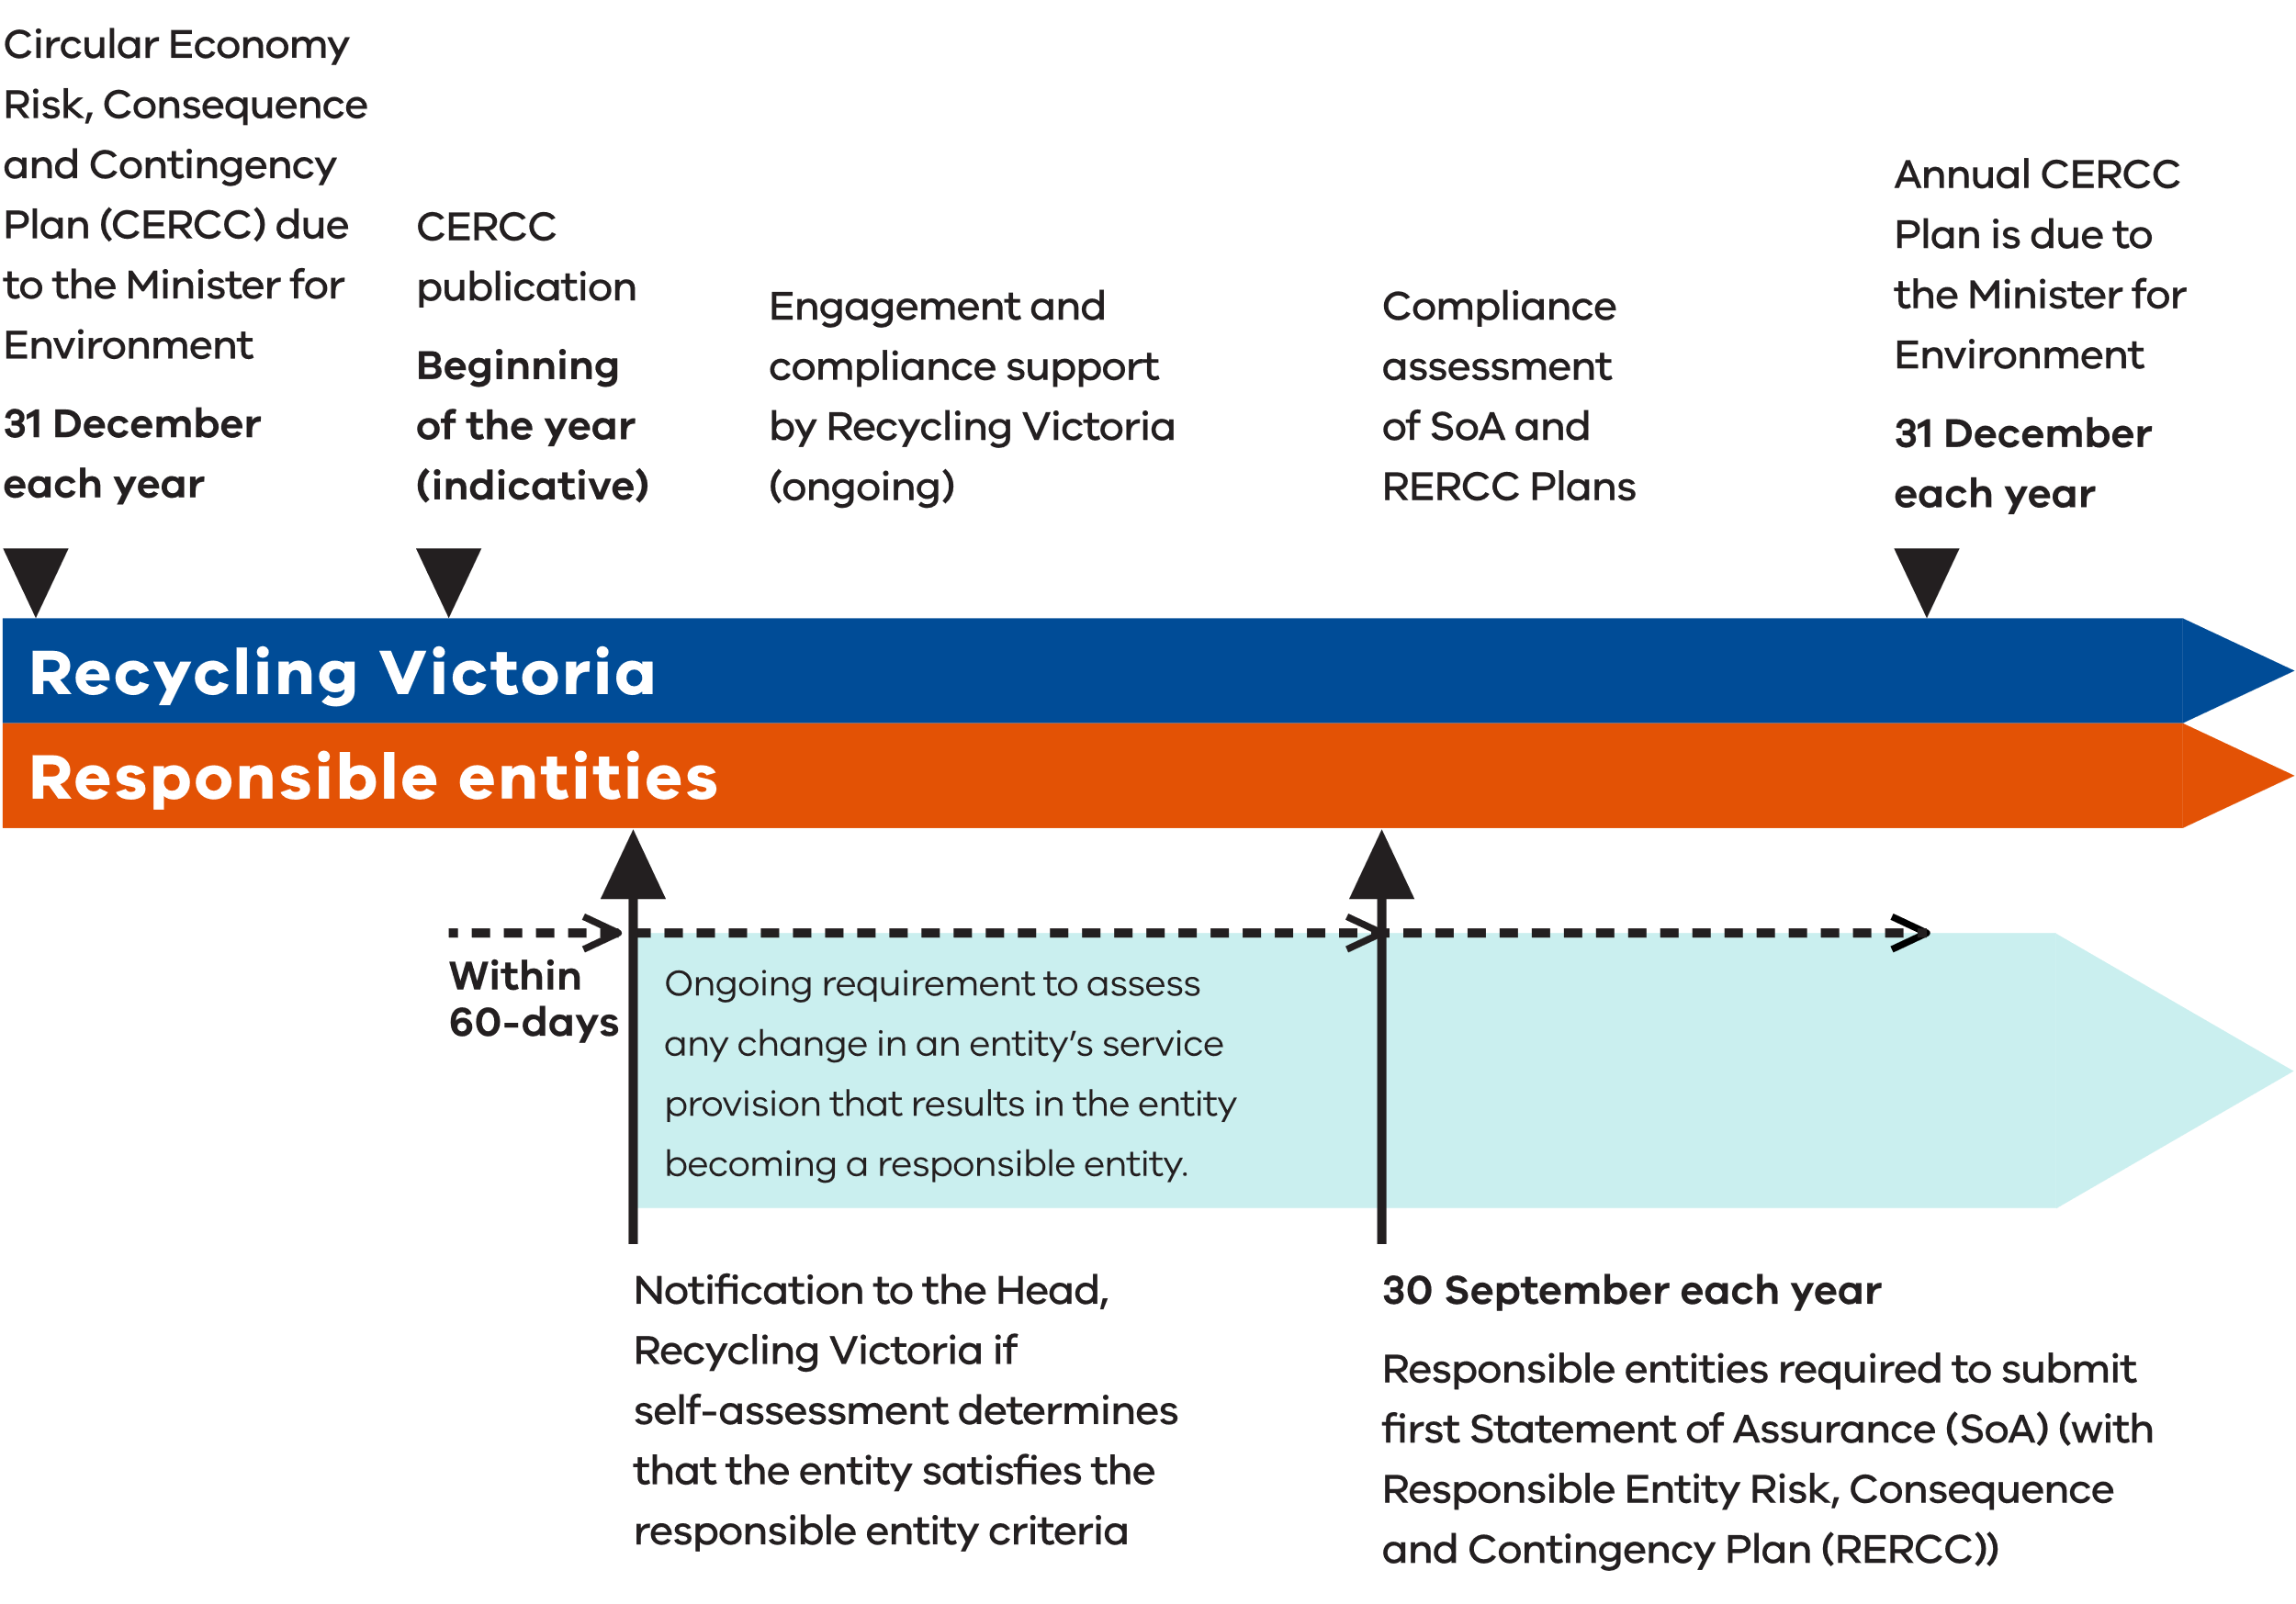

Acronyms
Table 1: List of Acronyms
Abbreviation | Full name
ABS | Australian Bureau of Statistics
ALARP | As low as reasonably practicable
AMIRA | Australian Metal Industries Research Association
APCO | Australian Packaging Covenant Organisation
ARV | Alpine Resorts Victoria
CDS | Container Deposit Scheme
CE Act | Circular Economy (Waste Reduction and Recycling) Act 2021
CE Regulations | Circular Economy (Waste Reduction and Recycling) (Risk, Consequence and Contingency Plans and Other Matters) Regulations 2023
CERCC | Circular Economy Risk, Consequence and Contingency
CIR | Critical Infrastructure Resilience
CO2-e | Carbon dioxide equivalent
COVID-19 | 2019 coronavirus
DCCEEW | (Australian) Department of Climate Change, Energy, the Environment and Water
DDP | Driver Delivery Program
DEECA | Department of Energy, Environment and Climate Action
DELWP | Department of Environment, Land, Water and Planning (the former)
DTP | Department of Transport and Planning
EM Act | Emergency Management Act 2013
EPA | Environment Protection Authority Victoria
FY | Financial year
HAZMAT | Hazardous materials
ISO | International Organization for Standardization
OECD | Organisation for Economic Co-operation and Development
PFAS | Per-and polyfluoroalkyl substances
RCC framework | Risk, Consequence and Contingency planning framework
RERCC | Responsible Entity Risk, Consequence and Contingency
SCADA | Supervisory control and data acquisition
WtE | Waste to energy

Introduction
In recent years, the Victorian waste, recycling, and resource recovery sector has undergone significant growth to meet demands posed by a growing population, at the same time as experiencing substantial volatility.
The Circular Economy Risk, Consequence and Contingency (CERCC) Plan aims to identify, describe and manage risks to service continuity and material circularity. The CERCC Plan must detail measures that responsible entities must address and include within their Responsible Entity Risk, Consequence and Contingency Plans (RERCC Plans). The CERCC Plan is an annual plan that the Head, Recycling Victoria must submit for approval to the Minister by 31 December each year. As this is the inaugural CERCC Plan, it does not set specific measures for responsible entities. This CERCC Plan focuses on identifying serious threats to service provision to provide responsible entities with an initial framework to assess their own preparedness and mitigation measures, either proposed or in place. There will be strong linkages between the CERCC Plan and RERCC Plans, with government and industry sharing responsibility and collaborating on the identification and minimisation of serious sector risks (refer Figure 3).

What is system resilience in the waste, recycling, and resource recovery sector?
System resilience in the waste, recycling, and resource recovery sector includes:
- a minimum level of industry strategic coordination
- sector-wide risk planning
- increased government visibility over sector-wide risks, operations, and data
improving sector-level risk, consequence, and contingency management practices by service providers.
The implementation of the Risk, Consequence and Contingency (RCC) planning framework aims to increase the base level of resilience that the sector demonstrates, which in turn, provides greater reliability and fewer significant disruptions to the provision of services.

What is a circular economy?
A circular economy aims to reduce the environmental impact of production and consumption while promoting economic growth through the efficient use of natural resources. It achieves this goal by designing products that eliminate waste and improve the recovery of materials that can be reused.
It encourages businesses to adopt more efficient models, such as product sharing and service-based models that include maintenance, repair, and disposal. By doing so, it increases the value people derive from the resources used to create goods and services. This approach replaces the traditional linear economy mindset of take, use, and throw away, with a more innovative and productive approach. It fosters creativity and productivity, invigorating existing businesses and creating new ones, which in turn creates more jobs and economic growth at the local, regional, state, national, and global levels (refer Figure 2).
Figure 2: Resource flows in a circular economy
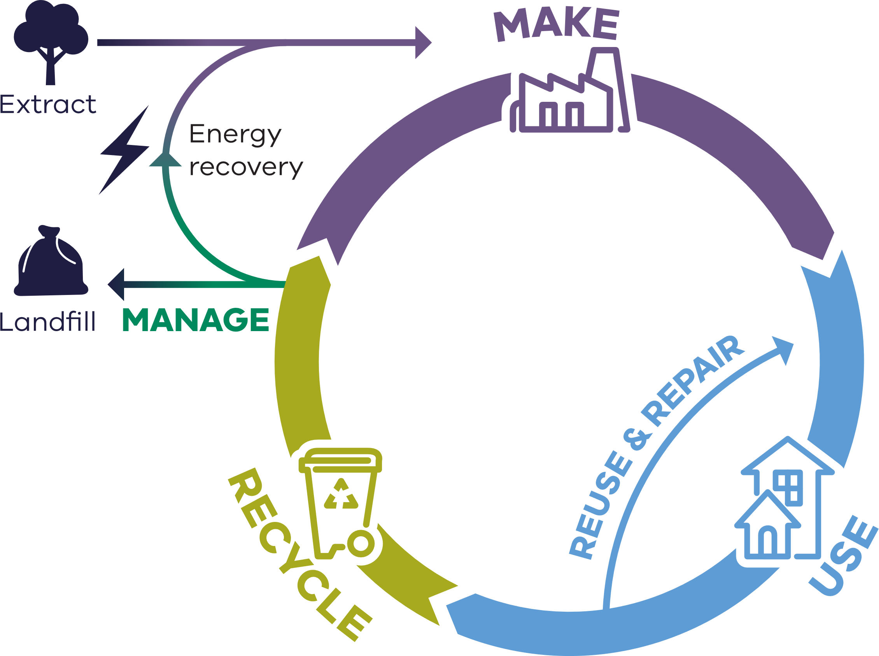
The Organisation for Economic Co-operation and Development (OECD) identified the main obstacles and barriers to transitioning to a circular economy in 2020 (OECD (2020), The Circular Economy in Cities and Regions.) (refer Figure 4). They provided guidance to governments, businesses and society on where risks may exist in successfully implementing circular economy elements. Although this data pertains to pre-pandemic challenges, it can be argued that these risks remain relevant, due to their alignment with a range of risks highlighted through industry engagement in the initial stages of the CERCC Plan’s development.
Victoria’s circular economy policy, Recycling Victoria: a new economy (DELWP (2020), Recycling Victoria: A new economy) outlines that it is the responsibility of all levels of government, along with industry, businesses, communities and individuals in Victoria to support the growth of a circular economy.
Figure 3: CERCC and RERCC annual development cycle
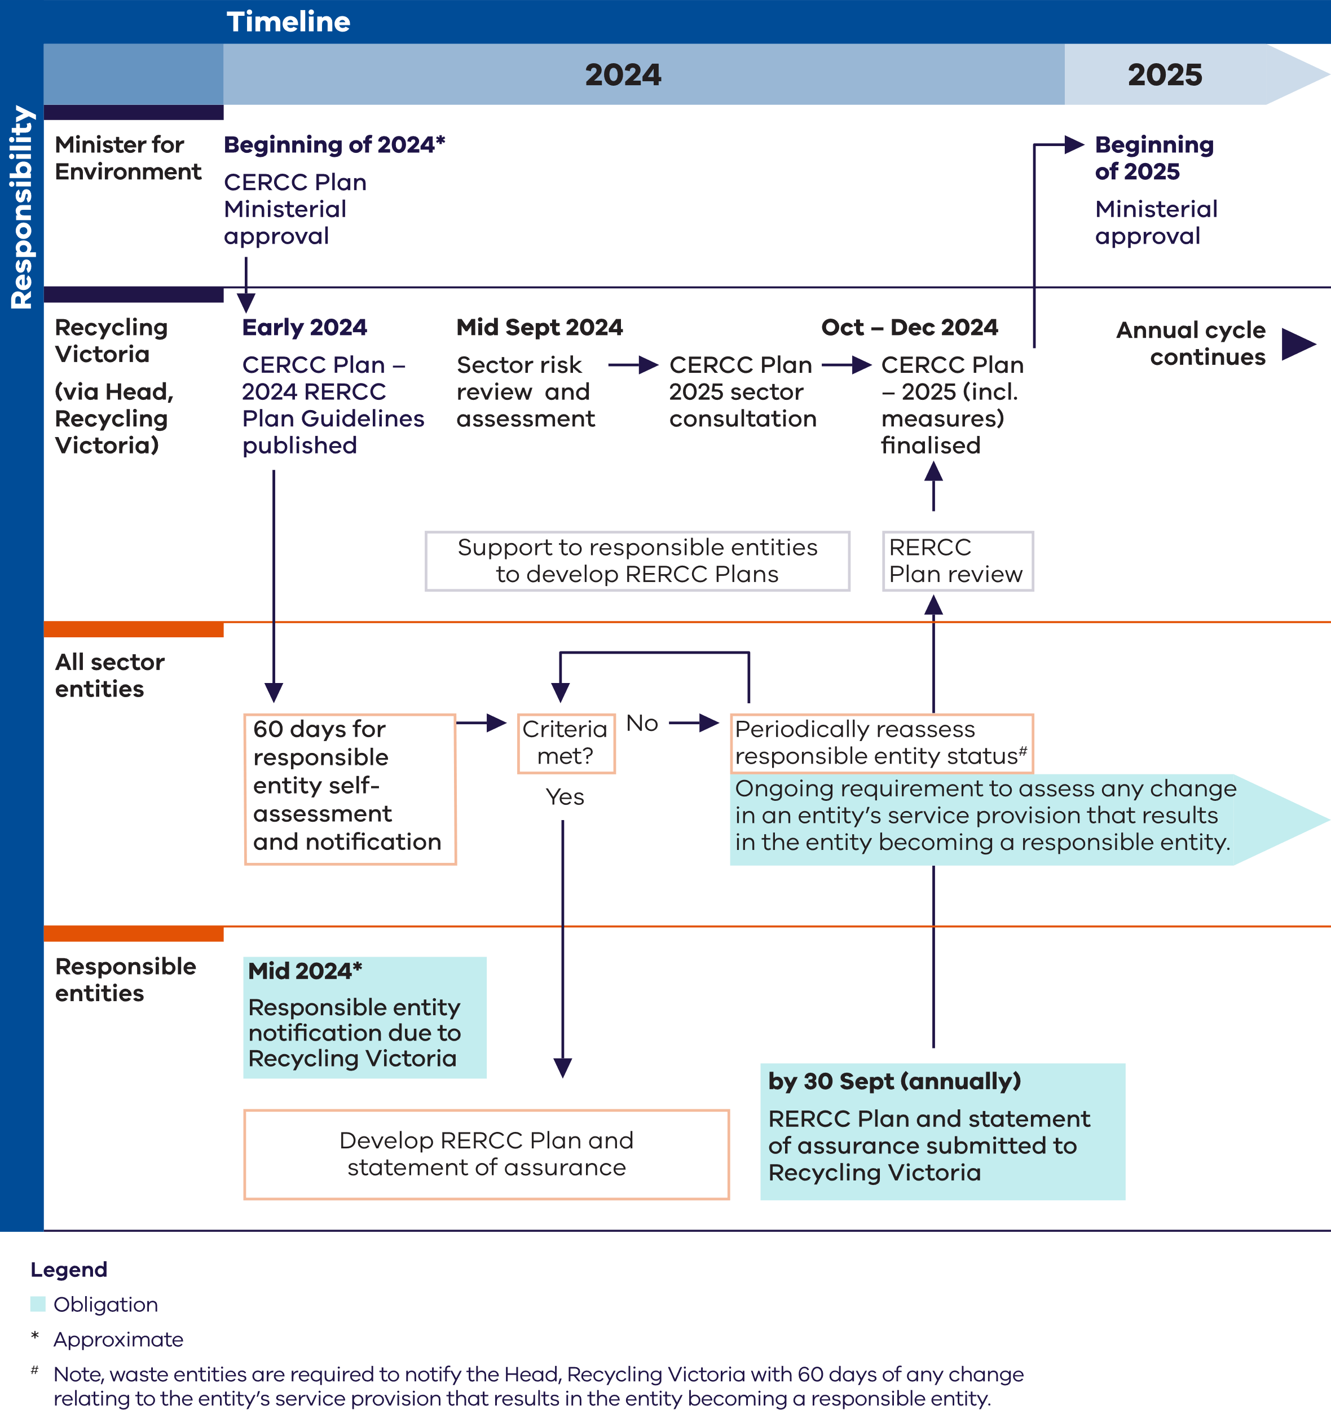

Figure 4: Obstacles to a circular economy transition
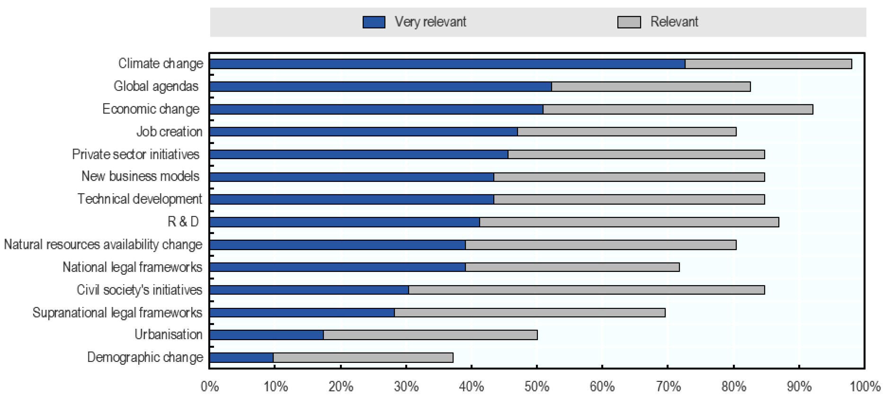
Source for data shown in Figure 4: OECD (2020), The Circular Economy in Cities and Regions: Synthesis Report, OECD Urban Studies, OECD Publishing, Paris, https://doi.org/10.1787/10ac6ae4-en.

Legislative environment
The Circular Economy (Waste Reduction and Recycling) Act 2021 (the CE Act) confers functions and powers on the Head, Recycling Victoria and places high-level obligations or requirements on various waste, recycling and resource recovery service providers and other entities to manage risks.
Section 74 of the CE Act, relating to service standards, imposes a duty on providers of essential waste, recycling, and resource recovery services to minimise risk of failure, disruption or hindrance of service.
Division 4 of Part 5 of the CE Act establishes a risk, consequence and contingency planning framework (RCC framework) to manage significant risks to the waste, recycling, and resource recovery sector. The RCC framework is designed to proportionately apply controls for providers of services in the waste, recycling or resource recovery that present the greatest risks if disrupted. For this reason, greater legislative obligations are placed on providers (referred to under the CE Act as responsible entities) of services that are identified as essential services and where the risks of impact of failures or disruptions to services are deemed high and unacceptably managed.
Key overarching elements of the RCC framework include:
- annual preparation of a CERCC Plan by the Head, Recycling Victoria, and a requirement that designated responsible entities must comply with this plan (section 74B)
- annual preparation of RERCC Plans by designated responsible entities, and a requirement that responsible entities must comply with their RERCC Plan (section 74F)
- statements of assurance by responsible entities that their plan has been prepared in accordance with the CE Act and CE Regulations and that it has regard to, and complies with, the CERCC Plan in force (section 74G)
- guidelines that the Head, Recycling Victoria may issue (under section 74K) with respect to risk, consequence and contingency planning established by responsible entities.
The CERCC Plan provisions in the CE Act have been modelled on the concept of Sector Resilience Plans as part of the Critical Infrastructure Resilience (CIR) model. The purpose of Sector Resilience Plans are to be a whole-of-sector, high-level risk management plan, focusing on key external threats, The content of the CERCC Plan is determined and prepared by the Head, Recycling Victoria and submitted to the responsible Minister for approval.
RERCC Plans are individual risk-management plans prepared by responsible entities. RERCC Plans comply with and have regard to the CERCC Plan and identify risks of serious failure, disruption or hindrance specific to the service provided by the entity, and mitigations to address these risks.
The RCC framework is designed to proportionately apply the regulatory burden in the parts of the waste, recycling, and resource recovery sector that present the greatest risks if disrupted. For this reason, the legislative obligations are placed on providers of essential services and self-identified responsible entities, rather than the sector as a whole.
Under section 183 of the CE Act, the CE Regulations have been made to further specify the details of the RCC framework.
The CE Regulations prescribe:
- certain services as ‘essential waste, recycling, or resource recovery services’ (see Appendix 1)
- certain entities as ‘responsible entities’, and their obligations with respect to the content of, and compliance with, the annual RERCC Plans (see Appendix 2 and 3 for responsible entity criteria)
- requirements relating to the preparation and content of the annual CERCC Plan
- offences relating to the obligations of responsible entities
- fees and other requirements relating to exemptions under Division 2 of Part 2 of the CE Act
the power of the Head, Recycling Victoria to waive fees.
The preparation of this plan acquits the legislative responsibilities under the CE Act to develop a CERCC Plan (section 74B)
It is important that all entities operating in the waste, recycling, and resource recovery sector are familiar with the requirements of the CE Act and CE Regulations. A copy of these can be found on the Victorian Legislation website at
www.legislation.vic.gov.au

Context

Purpose of this document
The purpose of the CERCC Plan is to comply, to the extent possible at this time, with the requirements of the CE Act and in so doing, mitigate harms associated with waste, recycling, and resource recovery sector risks, including those of a financial nature for government and to the sector.
Section 74B(2) of the CE Act outlines that the CERCC Plan must:
- identify risks of serious failure, disruption, or hindrance to the provision of waste, recycling, or resource recovery services; and
- identify risks of a financial nature to Victoria's transition to a circular economy and to responsible entities or any class of responsible entity; and
- outline the consequences of the risks identified under paragraphs (a) and (b), including the severity of the harm that may result; and
- specify any suitable measures that the responsible entity is required to take to prevent or minimise the risks identified under paragraphs (a) and (b), including, but not limited to measures specified in contingency plans prepared by the Head, Recycling Victoria for the whole of Victoria and in the market report submitted under section 32C; and
- specify any action that any responsible entity proposes to take to prevent or minimise a risk identified under paragraph (a) or (b); and
- identify issues relating to performance or supply (including issues relating to the generation, collection, sorting, reprocessing or re-manufacturing of waste) within the circular economy market or a part of the market; and
- outline any consultation that the Head, Recycling Victoria has carried out for the purposes of preparing the CERCC Plan; and
- specify measures required to address any issues identified during the consultation described in paragraph (g); and
- include any prescribed matter.

Scope
As the CERCC Plan captures risk across all services in the waste, recycling, and resource recovery sector and is a statewide report, it has relevance to everyone involved in the waste, recycling, and resource recovery sector, including consumers, producers, and state and local government.
The CERCC Plan provides information to providers of essential services related to assessing their responsible entity status based on market share and, if relevant, fulfilling their obligations with the relevant provisions of the CE Act and the CE Regulations. Information to make this assessment is included in Appendix 3.
This plan also guides responsible entities in developing their own resilience activities in the coming years. Further, the plan presents an opportunity to create a uniform and integrated approach to managing risks across the sector that can help maintain circularity and manage potential disruptions more efficiently.
The inaugural CERCC Plan focuses on identifying serious threats to service provision to provide responsible entities an initial framework to assess their own preparedness and mitigation measures either proposed or in place. Given this, measures that responsible entities must take (as per section 74B(2)(d)), have not been included as an additional requirement on responsible entities at this time. Future CERCC Plans are required to specify suitable measures for responsible entities to take to prevent or minimise risks. These will be based on Recycling Victoria’s assessment of sector preparedness and resilience following from issuing the inaugural Plan and the subsequent response from responsible entities.
This is the first plan of its kind and will remain in force until revoked or updated through publishing of a subsequent plan. Future CERCC Plans will adapt and progress risks, consequences, and contingencies as the circular economy continues to develop and continue to identify new risks and the level of information about industry as contingency planning for the sector grows.
Recycling Victoria acknowledges there are significant regulatory controls in place in Victoria to manage environmental risks associated with waste, recycling, and resource recovery. The CERCC Plan has been designed to not duplicate existing instruments but to complement them by providing an assessment of the risks of serious failure, disruption, or hindrance to the provision of waste, recycling and resource recovery services and risks of a financial nature to Victoria’s transition to a circular economy.
Recycling Victoria has worked in close collaboration with other regulators to prevent compliance duplication.

Recycling Victoria
Our vision is for a world-class circular economy system that helps build a more sustainable future for all Victorians.
Recycling Victoria was established in July 2022 to provide leadership, stewardship and oversight of waste, recycling and resource recovery services, and support the development of a circular economy. This includes providing regulatory oversight for the resilience in the provision of services in sector, as guided by Recycling Victoria’s inaugural Regulatory Strategy (Recycling Victoria (2023), Regulatory Strategy 2023 – 2026). Recycling Victoria’s strategic priorities for 2023 to 2026 (Recycling Victoria (2023), Strategic Plan 2023 – 2026) include identifying, monitoring, and mitigating serious system risks associated with waste, recycling, and resource recovery services.
Victoria is developing a waste and resource recovery system that minimises waste generation and maximises resource recovery.
Everyone has a part to play – collaboration between industry, community, and local, state and Australian governments is needed to help the sector respond to current and future challenges. Recycling Victoria will support the recycling sector to transition to a more resilient circular economy model, which delivers reliable waste, recycling and resource recovery services and the benefits that Victorians expect.

Building greater resilience in Victoria’s waste recycling and resource recovery sector
The waste, recycling, and resource recovery sector in Victoria has faced significant instability, service interruptions and incidents in the recent past, which has had a major impact on the environment, public health and society. These disruptions have also led to severe financial losses for the industry, requiring significant government intervention, with a high economic impact. Disruptions include China’s National Sword Policy in 2018, which disrupted international recyclable waste streams and highlighted Australia and Victoria’s vulnerabilities to external policy changes. The 2019 closure of SKM Recycling impacted 35 of the 79 Victorian councils, resulting in disrupted recycling services for 2 to 9 weeks.
Emergencies have also played a significant part in interrupting service continuity of the sector and creating significant sector demand, due to unheralded waste volumes. Emergencies in Victoria have caused major destruction to buildings, agriculture, and other infrastructure, resulting in direct impacts to the waste, recycling, and resource recovery sector. The sector relies heavily on critical dependencies that could be affected by future disasters. The sector is expected to face significant challenges with more frequent and severe emergencies driven by climate change and other causes.

A case for change: The Victorian Government response to the COVID-19 pandemic and consequences for the waste, recycling, and resource recovery sector
The Victorian Government’s response to the COVID-19 pandemic demonstrated vulnerabilities in the capability and capacity of the waste, recycling, and resource recovery sector to manage its requirements. Some of the key consequences of the pandemic on the waste, recycling, and resource recovery sector included:
- changes in the distribution of the population, including an expansion into regional Victoria and a stark reduction in Melbourne’s CBD population, impacting waste and recycling service distribution
- movement restrictions that limited waste mobility following declarations of a State of Emergency, with waste not classified as critical early in the pandemic response, which had significant implications for service delivery
- heightened sanitation requirements to limit virus spread causing a significant increase in the quantity of clinical waste to be managed
- labour disruptions experienced across all sectors leading to significant disruptions to service delivery continuity
- major logistical challenges associated with international freight disruptions leading to challenges accessing commodity markets and increased costs when freight was available
logistical challenges leading to service disruption and stockpiling in the waste, recycling and resource recovery supply chain, and significant delays in procuring new plant and equipment for waste infrastructure projects.
By partnering with sector operators, the Victorian Government facilitated solutions by:
- providing specific and tailored sector support and coordination throughout the pandemic
- providing coordination, support and engagement, which alleviated substantial pressure placed on Victorian clinical waste service providers and the wider health care system
- including waste collection, transport, treatment, disposal and transfer stations as an essential service, which ensured the sector could function during COVID-19 movement restrictions, and was prioritised for support where appropriate
- developing guidance on the management of COVID-19 waste to reduce demand on waste operators, while ensuring appropriate human health and environmental protections.
As the resilience of the waste, recycling and resource recovery sector grows, its capability and capacity to respond to shocks and stressors will improve. Key to this is improving the sector's understanding and management of inherent risks to service continuity and a circular economy.

A case for change: The Victorian Government response to the October 2022 floods and storms and consequences for the waste, recycling and resource recovery sector
Extensive flooding between October 2022 and February 2023, affecting 64 of 79 local government areas, produced unprecedented amounts of waste in Victoria. The demand for waste services in the aftermath of emergencies will continue to grow through climate change, as we face new, more frequent and severe emergencies. Not only did waste volumes increase, flooding directly and indirectly impacted sector capacity, particularly in regional Victoria.
In response, the Victorian Government implemented relief and recovery hardship assistance arrangements enabling Victorians from all flood-affected regions to access free waste disposal for flood waste, removing over 37,000 tonnes of material. This was achieved through a waiver of the waste levy and gate-fee rebate. The Victorian Government developed easy-to-access information in relation to the risks of flood waste material and supporting flood waste management, including tipping-fee waivers for flood material.
Through collaboration, Department of Energy, Environment and Climate Action (DEECA), Environment Protection Authority (EPA), Emergency Recovery Victoria, Agriculture Victoria, local councils and waste, recycling and resource recovery sector participants all supported their communities during this time of need. Increasingly, the sector will need to maximise opportunities for recycling and resource recovery during emergency events and limit landfill reliance.

Industry case study 1: Minimising skills shortage risks – industry partnering with government
The Victorian Transport Association’s (VTA) Driver Delivery Program (DDP) is a public / private partnership, funded by the Victorian Government’s Department of Transport and Planning (DTP) to deliver ‘Safer, smarter and more capable drivers through investing in heavy vehicle driver and safety training.’
The Victorian Government has provided funding support to deliver this heavy vehicle driver training program since its launch by the VTA in 2016. The DDP was established to address industry concerns about the shortage of safe and competent heavy vehicle drivers. The program is specifically targeted towards attracting and retaining younger employees in heavy vehicle driving in the transport and logistics sector.
The DDP is fully subsidised, allowing it to be offered at no cost to participants and employers. It operates as an 8-day program, providing individually tailored training, mentoring and behind-the-wheel driving experience to new drivers of heavy vehicles. On completion of the program, approved applicants obtain their Heavy Rigid or Heavy Combination licence after satisfying standard VicRoads licensing criteria.
The DDP included involvement of Victorian Waste Management Association members to represent the needs of the waste, recycling and resource recovery sector and provide necessary pathways to a career in waste transport.
Throughout 2022–23, the waste, recycling and resource recovery sector was impacted by driver shortages, requiring some collection companies to access drivers from interstate to maintain service delivery of kerbside collection services.
A total of 25 waste, recycling and resource recovery sector members have completed the DPP (out of a total of 180) and transitioned into roles in the industry. The success of the DPP as a partnership approach has seen continued funding by the Victoria Government until 2025.

Alignment of the waste, recycling, and resource recovery sector with Victoria’s Critical Infrastructure Resilience Arrangements
In Victoria, a Critical Infrastructure Resilience (CIR) model was introduced through legislation in 2015 to augment existing emergency risk management practices and strengthen the emergency resilience of critical infrastructure sectors. The CIR model is legislated in Victoria through the Emergency Management Act 2013 (the EM Act) and at the federal level, through the Security of Critical Infrastructure Act 2018 (Cth).
The CERCC Plan, as part of the RCC framework, has been modelled on Victoria’s Critical Infrastructure Resilience Arrangements described under Part 7A of the EM Act. There are some significant differences between the critical infrastructure sectors and the waste, recycling, and resource recovery sector, most notably that the waste, recycling, and resource recovery sector is not classified as essential under the EM Act. Further, the sector is multifaceted and subject to a range of volatilities and service disruptions. It therefore requires a tailored approach to identifying and managing risks.

Global macro risks and trends affecting the sector

World Economic Forum Global Risk Report 2023
The risks faced by the world today are more interdependent than ever before. Environmental and societal crises are being driven by underlying geopolitical and economic trends, which will continue to shape the next decade. Compounding shocks, interconnected risks and diminishing resilience are making society more susceptible to crises. The 2023 Global Risks Report (World Economic Forum (2023), The Global Risks Report 18th Edition Insight Report) serves as a call to action, urging us to prepare ourselves for the next crisis and work together to create a more stable and resilient world. The 2023 Global Risks Report ranks risks over the short and long term (refer Figure 5).
The current global rise in the cost of living, as shown in Figure 5, and the ongoing economic challenges faced by Australia, could impact Australia's progress towards circularity and service continuity. The recent fluctuations in interest rates in Australia have particularly impacted Victorian businesses, which may now struggle to secure the necessary funding to drive innovation or continue to operate.
The next decade will be characterised by environmental and societal crises, driven by underlying geopolitical and economic trends. ‘Cost-of-living crisis’ is ranked as the most severe global risk over the next two years, peaking in the short term. ‘Biodiversity loss and ecosystem collapse’ is viewed as one of the fastest-deteriorating global risks over the next decade, and all six environmental risks feature in the top 10 risks over the next 10 years. Nine risks are featured in the top 10 rankings over both the short and the long term, including ‘Geoeconomics confrontation’ and ‘Erosion of social cohesion and societal polarisation alongside two new entrants to the top rankings: ‘Widespread cybercrime and cyber insecurity’ and ‘Large-scale involuntary migration.’ (World Economic Forum (2023), The Global Risks Report 18th Edition Insight Report)
Figure 5: Global risks ranked by severity over the short and long term
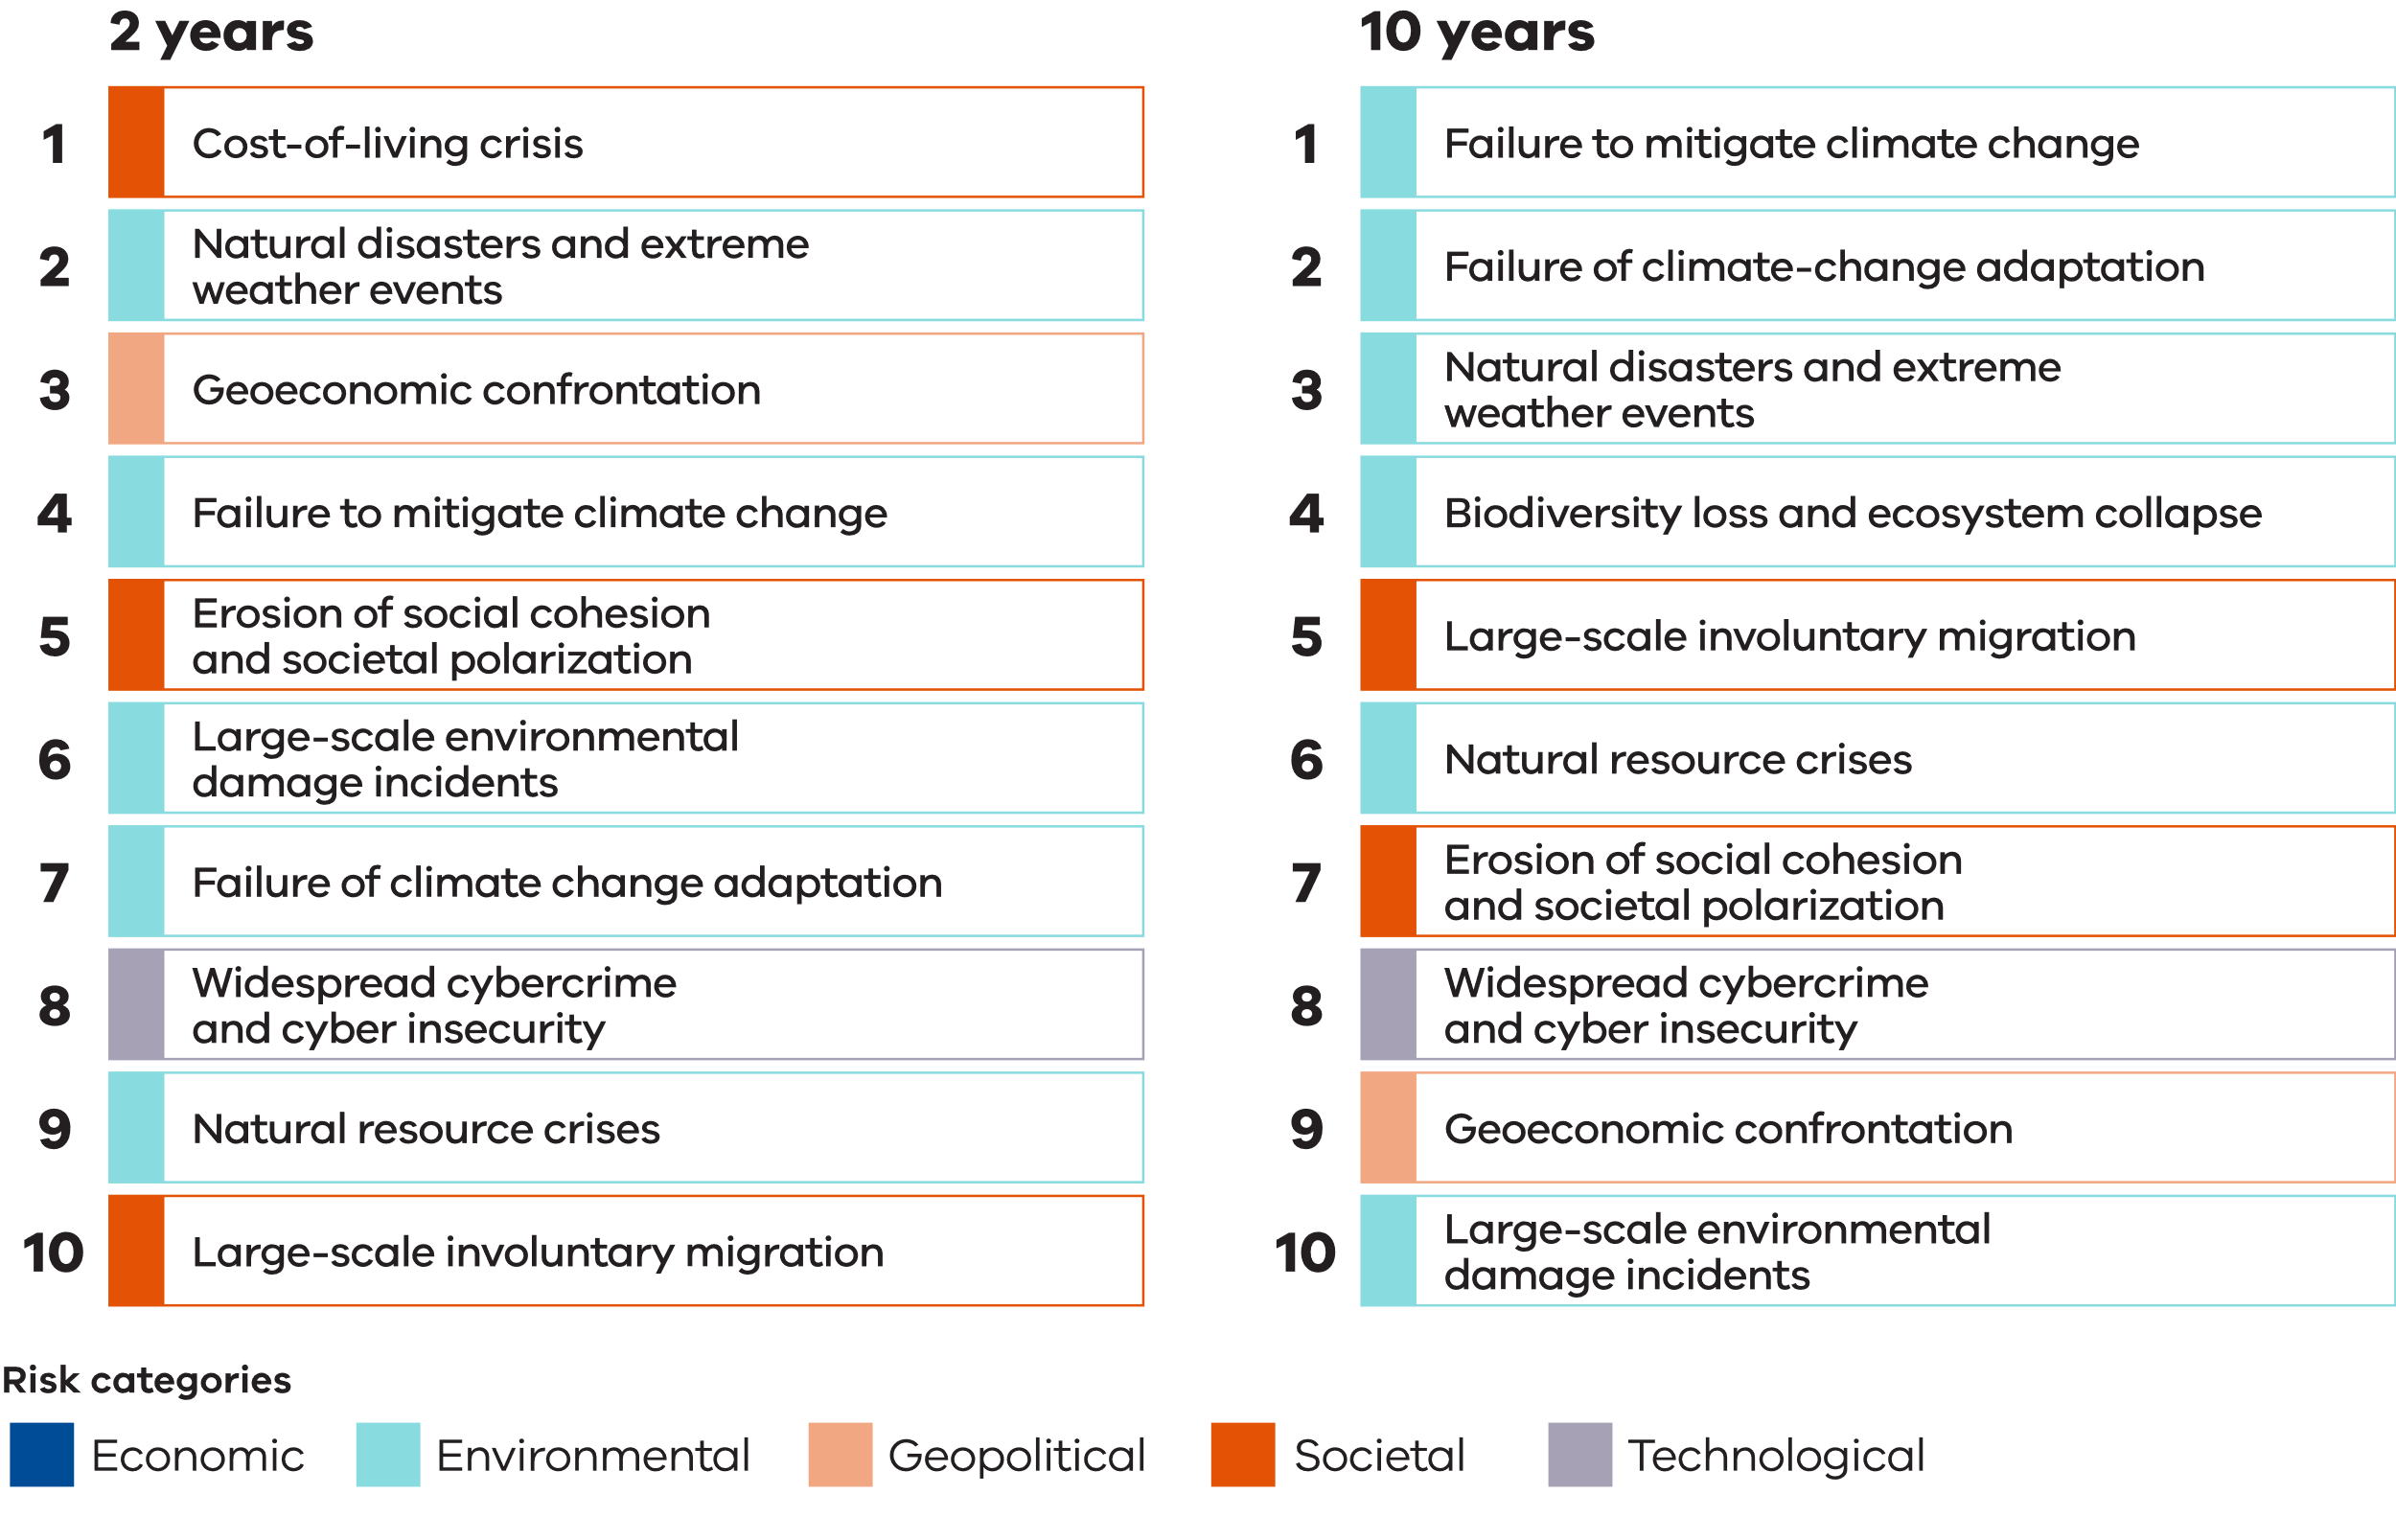

Industry case study 2: Mitigating service disruption through scheduled maintenance
The Australian Metal Recycling Industry Association (AMRIA) members implement staggered scheduled maintenance to maximise service continuity and foster sector resilience.
AMIRA members, who are competing metal reprocessing businesses, have entered into informal arrangements to schedule major infrastructure maintenance periods in a coordinated manner and provide mutual benefits to participating businesses. This facilitates metal recycling sector service continuity, while enabling periods of shutdown
for essential maintenance through a redistribution model aimed at maximising sector resilience.
These informal arrangements enable service continuity for the metal recycling sector through a coordinated demand / supply / redistribution model. Processing is then outsourced to operating plants and the material is redistributed accordingly. Through the partnership model, the arrangements are mutually beneficial, with reduction in processing during shutdown by a re-processor offset by increases in material supply while competitors undertake comparable maintenance.
This model helps manage the risk of bottlenecks in the metal processing chain that would otherwise result from periods of temporary shutdown. Bottlenecks can lead to stockpiling, which if not managed appropriately, can potentially cause harm to human health and the environment from fire. Metal and its by-products are classified as combustible recyclable and waste materials and subject to regulation, compliance and enforcement provisions.
Preventative and scheduled maintenance by AMIRA members aims to mitigate the potential of more serious shutdowns to their operations.

United Nations Sustainable Development Goals
Recycling Victoria is contributing to a global movement towards sustainable development based on the United Nations 17 Sustainable Development Goals and Targets (United Nations Department of Economic and Social Affairs (2015), Sustainable Development Goals and Targets – https://sdgs.un.org/goals). These targets aim to make cities and human settlements inclusive, safe, resilient and sustainable, ensure sustainable consumption and production patterns, and take urgent action to combat climate change and its impacts. Recycling Victoria’s Strategic Plan (2023-26) identifies contributions towards 12 of the 17 targets, as identified in Figure 6. (Recycling Victoria (2023), Strategic Plan 2023 – 2026).
The CERCC Plan specifically sets out to address 4 of the 17 goals:
- Goal 8: Decent work and economic growth.
- Goal 11: Sustainable cities and communities.
- Goal 12: Responsible consumption and production.
Goal 17: Partnerships for the goals.
Disruption to service continuity and material circularity will inhibit progress towards these goals, therefore the CERCC Plan will identify, analyse, evaluate, and treat risks to ensure Victorians can continue to contribute towards these targets.
Figure 6: United Nations Sustainable Development Goals
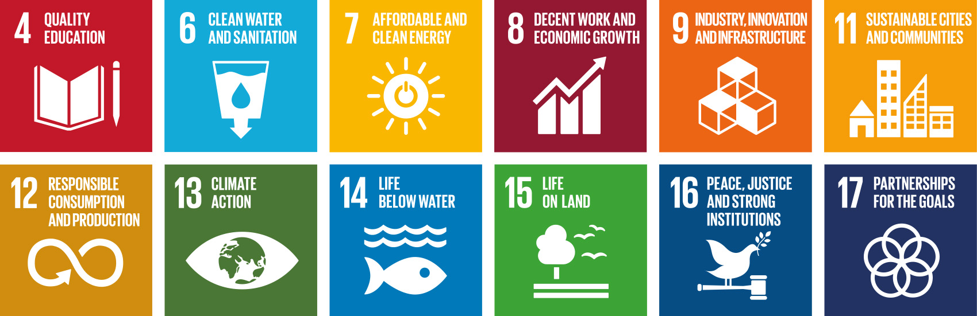

Australian waste, recycling, and resource recovery industry overview

National trends and emerging issues in the circular economy
In 2019, the Australian Bureau of Statistics (ABS) reported (Australian Bureau of Statistics (2020), Waste Account, Australia, Experimental Estimates – https://www.abs.gov.au/
statistics/environment/environmental-management/waste-account-australia-experimental-estimates/2018-19) approximately 27% of Australia’s waste goes to landfill. The ABS also indicated the amount of waste generated is 76 million tonnes, with around half of that, a figure of approximately 38.5 million tonnes being recycled. Only 16%of plastics are being recycled, despite more than half of packaging being found to be easily recyclable by the Australian Packaging Covenant Organisation (APCO).
The largest source of waste originates from the construction and demolition industry, spending $2 billion annually on waste services each year, representing a 35% growth since 2016–17. The construction sector alone generates 16.8% of annual total waste, making it the second largest waste producer behind manufacturing. Construction waste has increased by 22% since 2016–17.
The waste sector is also a contributor to carbon emissions. Australia’s Department of Climate Change, Energy, the Environment and Water detailed the following figures in its 2022 report (Department of Climate Change, Energy, the Environment and Water (2022), National Waste Report):
- 14 megatons of municipal solid waste from households and local government activities in 2020–21 (543 kg per capita and 18%of the total)
- 32.8 megatons from the commercial and industrial sector in 2020–21 (43% of the total)
- 29 megatons from the construction and demolition sector in 2020–21 (38% of the total)
- 9.8 megatons of carbon dioxide equivalent (CO₂-e) from solid waste management (landfill, biological treatment, and incineration) in 2019–20 (equivalent to 2.0% of Australia’s total).

In Victoria in 2021, the waste sector was responsible for 3.4% of Victoria’s total net greenhouse gas emissions – emissions from the sector in 2021 were 2.7 megatons of CO₂-e, significantly below the 6.4 megatons of CO₂-e emitted in 1990. (DEECA (2023), Victorian Greenhouse gas emissions – https://www.climatechange.vic.gov.au/victorias-greenhouse-gas-emissions-and-targets) The main source of waste sector emissions in 2021 was from the disposal of solid waste to landfill (65.8% of total waste sector emissions)
Australia's national, state and local governments have united to adopt an ambitious collaborative plan to enhance waste recovery and recycling rates. The National Waste Policy and Action Plan (2022) (Department of Climate Change, Energy, the Environment and Water (2019), National Waste Policy Action Plan) has been developed by Australia’s 3 levels of government. The plan aims to transition Australia's material use into a circular economy. There is now a national commitment to several goals, including gradually halting the export of critical waste streams such as plastic, paper, glass, and tyres by the end of 2024. This means that more of these categories of waste must now be processed domestically. Australia also aims to increase its resource recovery rate to 80% by 2030, reduce food waste sent to landfills by half by 2030 and set national packaging targets for the industry. These targets include:
- 100% of packaging should be reusable, recyclable or compostable by 2025
- 70% of plastic packaging should be recycled or composted by 2025
- 50% of packaging should be made up of recycled materials by 2025
- 100% of single-use plastic packaging should be phased out by 2025.
To fulfil these goals, Australia must increase its local processing and recycling capacity substantially, creating opportunities for investors. The Australian Government is also taking measures to increase its purchase of products with recycled content to generate demand for recycled materials, as outlined in the National Waste Policy Action Plan (2022).
In 2023, Australia’s environment ministers considered transition to a circular economy as part of a package of programs to develop a ‘Nature Positive Australia to leave our environment better off for our kids and grandkids.’ (Department of Climate Change, Energy, the Environment and Water (2023), Environment Ministers’ Meeting Agreed Communiqué 9 June 2023 –https://www.dcceew.gov.au/sites/default/
files/documents/emm-communique-09-june-2023.pdf) Ministers agreed to ‘Shift Australia toward a safer, circular economy by putting in place a new packaging regulatory scheme that will for the first time, develop mandatory packaging design obligations, so packaging is designed to minimise waste and be recovered, reused, recycled and reprocessed.’
Ministers also agreed to:
- the Australian Government leading development of a national framework to direct Australia’s transition to a circular economy
- Australia mandating obligations for packaging design as part of a new packaging regulatory scheme based on international best practice and make industry responsible for the packaging it places on the market
- develop a national roadmap for staged improvements to the harmonisation of kerbside collections, taking into account circumstances of metropolitan, regional and remote communities
- future consideration of a national framework for recycled content traceability that will provide manufacturers and other users with the confidence they need to use quality recycled materials, thereby supporting the transition to a circular economy
accelerating product stewardship efforts including developing a framework to guide inter-jurisdictional efforts and drive action on problematic products, such as packaging, solar panels, electrical equipment, tyres, and a product stewardship approach for solvents.
National progress towards a circular economy has informed development of this CERCC Plan and will continue to inform future risk, consequences and contingencies for the sector in Victoria through implementation of the CERCC Plan and RERCC Plans.

Risk management practices in the Victorian waste, recycling and resource recovery sector
Whilst various players in the industry will have well-developed risk cultures and processes in place, the capacity level is likely to vary significantly across the sector. Current risk management practices also emphasise individual service providers remaining viable. However, it is not enough to only minimise the harms of service disruptions as internally-oriented risk management, as this neglects broader sector impacts of service disruptions.
Evident through recent disruptions, the Victorian waste, recycling, and resource recovery sector has demonstrated its low capacity to manage sector-level risks, and this has resulted in significant harm being caused. The interconnected nature of the sector also means that disruptions to one business can have cascading effects on other businesses. This makes risk mitigation at an individual business level alone insufficient to deal with serious disruptions and failures in the sector and addressing the significant harms that can result.

Victorian waste, recycling and resource recovery sector risk assessment process

Risk management process
The CERCC Plan's risk assessment process is aligned with ISO 31000: 2018 – Risk Management Guidelines (International Standards Organisation (2018), ISO 31000:2018 Risk management Guidelines) (refer Figure 7) to maintain common language and a recognisable approach, while allowing the process to remain flexible and adaptable to the complexity of circular economy sector risks.
The International Organization for Standardization’s ISO 31000 – Risk Management Guidelines is a widely-accepted, generic workflow for risk assessment that has been largely included in a range of international, national, and state emergency risk guidelines, management plans and reports
Figure 7: Risk process as detailed in the ISO 31000 – Risk Management Guidelines
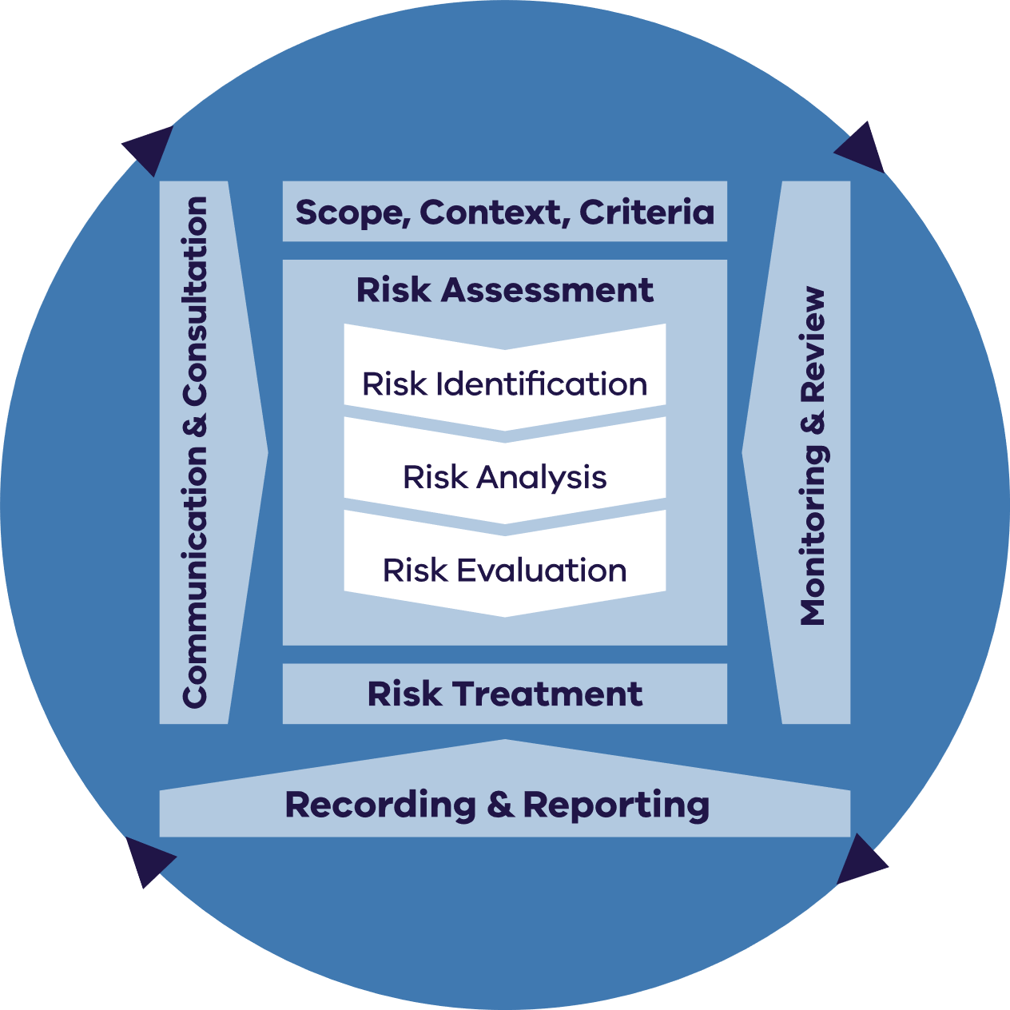
Figure 7 is Reproduced by Department of Energy, Environment and Climate Action (DEECA) in Victoria with the permission of Standards Australia Limited under licence CFL0424DEECAVIC.
Copyright in AS ISO 31000:2018 vests in Standards Australia and ISO. Users must not copy or reuse this work without the permission of Standards Australia or the copyright owner.

Scope, context, criteria
Defining the scope, context and risk criteria is a fundamental step in tailoring the risk assessment to meet the unique requirements of the sector. This involves gaining insight into internal and external factors and undertaking consultation with the sector.

Scope
The CERCC Plan encompasses significant market-level (macro) risks across all waste streams in the waste, recycling, and resource recovery sector. The sector comprises a mix of public and private industry participants outlined in Appendix 5.

Context
The circular economy has several objectives, however, achieving them poses multiple competing risk factors. These risk factors fall under various categories:
- Societal risks – natural or man-made hazards and the support of communities and individuals towards the objectives.
- Operational risks – technical and logistical challenges of implementing circular economy solutions, such as a lack of infrastructure, skills
and/or standards.
- Financial risks – costs and benefits of circular economy investments, such as return on investment, cash flow and/or market demand.
- Reputational risks – perception and expectations of stakeholders, such as customers, suppliers, investor and/or regulators.
Strategic risks – alignment and adaptation of business models and value propositions to the circular economy paradigm, such as innovation, differentiation and/or competitiveness.

Criteria
Recycling Victoria's Strategic Plan has set strategic objectives that emphasise the importance of transitioning Victoria to a circular economy and reforming our waste and resource recovery system over the next decade. The 4 strategic objectives focus on:
- opportunities to ensure a robust circular economy
- increasing the resilience of the waste and resource recovery system
- enabling sector investment and growth
- building system capacity and capability (Figure 8).
Identifying, analysing, and evaluating risks within the context of Recycling Victoria's strategic objectives will help frame the risks, considering the sector's current capabilities, capacity and opportunities for strengthening measures aligned with the transition to greater circularity. Considerations for these 4 strategic objectives were integral to the risk assessment process, as well as the development of risk treatments and measures.
The aim is to assess the risks to Victoria's circular economy stemming from various hazards and exposures. This includes identifying sector vulnerabilities and critical dependencies that can result in significant failures, hindrances or disruptions in waste, recycling or resource recovery services.
Figure 8: Recycling Victoria’s strategic objectives
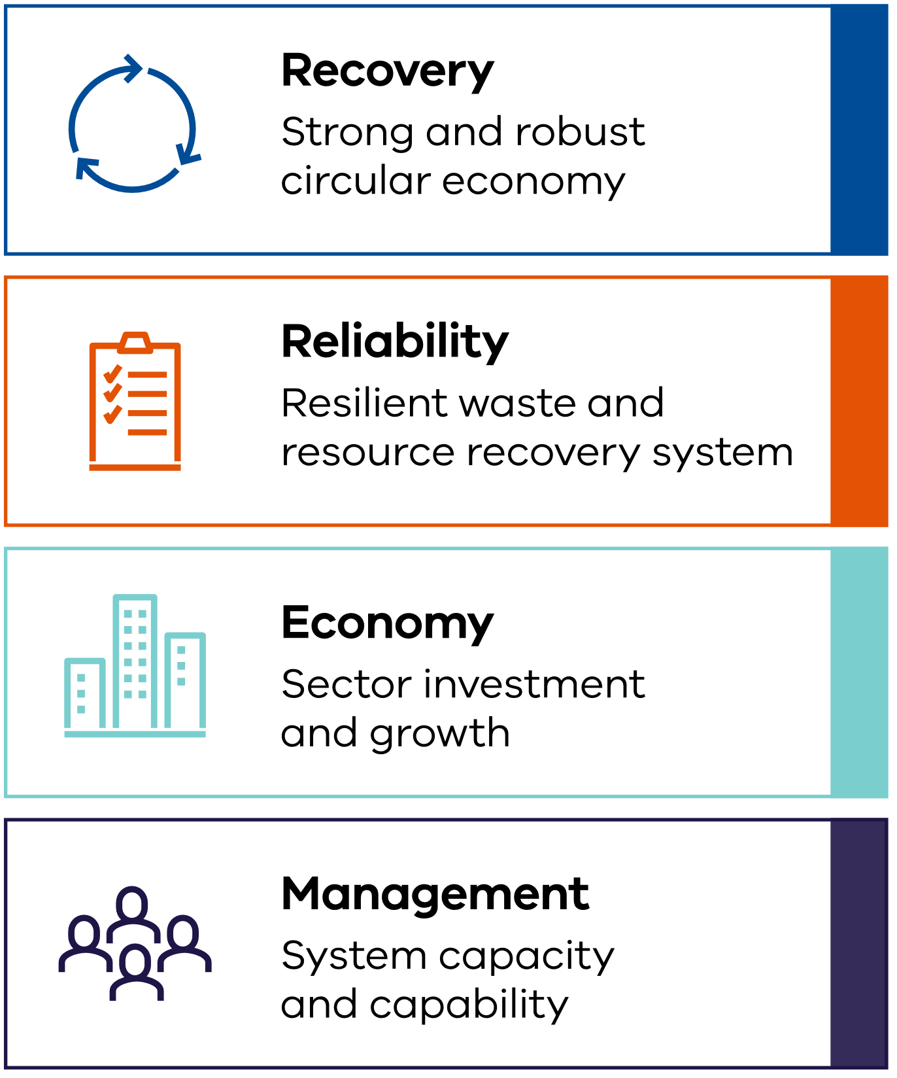

Risk assessment process

Risk identification
Through this plan, Recycling Victoria is required to identify risks of serious failure, disruption or hindrance to the provision of waste, recycling, and resource recovery services, and identify financial risks to Victoria's transition to a circular economy and to responsible entities.
Risk identification begins with an initial identification of relevant risks through industry consultation and existing knowledge, such as reports and past events. Building this knowledge base assists in selecting hazards, impacts and risks for consideration in the risk analysis phase.
Identifying the sector's risks requires consideration of natural and manmade hazards, direct and indirect exposures, sector vulnerabilities and system dependencies. Additionally, it involves understanding the sector's capacity to protect itself from significant disruptions in the provision of waste, recycling and resource recovery services and its long-term strategy to transition to a circular economy.
Risk identification was conducted through a series of workshops with industry and government entities to gather sector sentiments regarding hazards, exposures and vulnerabilities. An environmental scan of Victoria's risk environment was also performed.

Risk analysis
Through this plan, Recycling Victoria is required to outline the likelihood and consequence of each risk that has been identified including the severity of the harm that may result. Risk analysis is a critical step of the risk assessment process and helps develop an understanding of the identified risks. To analyse risk, an understanding of existing controls is necessary, as well as the risk criteria in which the risk will be analysed and evaluated including the likelihood of the risk occurring and the consequences of the risk to the sector.
Following the identification of sector hazards, exposures and vulnerabilities, Recycling Victoria developed 6 high-level risks, risk descriptions and consequence descriptions to reflect the threats that could disrupt, hinder or impact the provision of waste, recycling and resource recovery activities and impede Victoria's transition to a circular economy.
When analysing risk, it is important to consider the following:
- How likely is the event to occur?
What impact would it have on people, places and systems?
Likelihood refers to the probability of a risk occurring or the consequences of a risk resulting from an event. Consequence can be defined as the outcome of an event affecting objectives.
When determining the likelihood, a range of factors will need to be considered, including:
- timeframes
- causes which may lead to a risk materialising
- controls that are in place to reduce likelihood
the compounding and cascading events that might play out.
The sector risk assessment uses a likelihood rating and description to determine the probability of a risk, using Table 17 in Appendix 4 and consequence ratings (Table 18 – Table 25 in Appendix 4).

Risk evaluation
Once the likelihood and consequence ratings were determined for each risk, they were assessed using a qualitative risk matrix that combines the likelihood and consequence levels to determine the risk level, which ranges from low to high. The purpose of the risk evaluation process determines which risks need to be treated, as well as the priority for treatment based on the outcomes of the risk analysis performed. The risks were categorised as high, significant, medium or low, depending on the likelihood and consequence ratings.
Risks scored in accordance with a risk matrix (Figure 9 in Appendix 4) identified as having a significant or high rating were considered serious risks. These risks were tested through consultation to confirm the risks.

Risk treatment process
Risk treatments aim to determine and implement the most effective actions that will prevent or minimise risks.
Future CERCC Pans are likely to specify suitable measures for responsible entities to take to prevent or minimise risks. These will be based on Recycling Victoria’s assessment of sector preparedness and resilience following the issuing of the inaugural plan and the subsequent response from responsible entities.
Future measures will be developed in recognition of the causes and consequences within the control of the responsible entities and will form part of a consultation process. Responsible entities will be required to use these future measures as a guide to develop specific actions in their RERCC Plans.
Treatment takes into consideration the identified institutional and infrastructure risks. The risk treatments focus on bolstering the coping capacity of the Victorian Government and responsible entities to better manage hazards, exposures and vulnerabilities.
Risk treatment options aim to achieve one or more of the following:
- avoiding risk
- removing a risk source
- changing the likelihood of the source of risk or consequence occurring
- sharing the risk,
retaining the risk by informed decisions.

Recording and reporting
Recycling Victoria will record and report on the risks identified in the CERCC Plan, including their effectiveness at identifying serious risks to sector service continuity and material circularity.
The Minister can direct the Head, Recycling Victoria to prepare a written report on the CERCC Plan under section 74E of the CE Act. The report may include:
- the CERCC Plan’s ongoing suitability
- the effectiveness of measures to prevent or minimise any risks identified
- the compliance of a responsible entity or class of responsible entity with the CERCC Plan
- any actions the Head, Recycling Victoria has carried out or proposes to carry out in response to the report
recommendations that the Head, Recycling Victoria considers appropriate.

Monitoring and review
Recycling Victoria will monitor and annually review the CERCC Plan risks as part of risk recording and reporting processes.
The first RERCC Plans to be prepared by responsible entities are due to the Head, Recycling Victoria by 30 September 2024. Once RERCC Plans are submitted, Recycling Victoria will develop future CERCC Plans to specify any measures and/or actions that responsible entities will need to consider adopting to prevent or minimise risks. These measures and/or actions will involve assessing existing controls.

Communication and consultation
Recycling Victoria will continue to communicate and consult on risks identified in the CERCC Plan, through consideration of the inaugural RERCC Plans and their associated statements of assurance, and in review of any consultation outcomes of CERCC Plan 2025.

Victorian waste, recycling, and resource recovery sector risks
The Head, Recycling Victoria must outline any consultation that has been carried out for the purposes of preparing the CERCC Plan, in accordance with the CE Act section 74B(2)(g).
During August and September 2023, Recycling Victoria conducted more than 40 separate consultations with the waste recycling and resource recovery sector, including over 100 industry members and over 80 local government and Alpine Resort Victoria (ARV) entities. These consultations yielded valuable insights into the risks, concerns, opportunities, and challenges being faced and considered within the sector.
During this period, numerous representative bodies and other stakeholders requested follow up sessions with Recycling Victoria to involve additional executive leaders and expertise in their membership base. The participatory nature of the stakeholder response to this intensive engagement phase provided a comprehensive information base upon which to undertake further analysis.
Recycling Victoria also considered risks in aligned industries – those facing the critical infrastructure sector – which identified crucial dependencies affecting the waste, recycling, and resource recovery sector, such as access and availability of essential services, the impacts of more severe, more frequent, and compounding emergencies increasing waste volumes and the level of sector resilience.
The combination of hazards, exposures and sector vulnerabilities that generate risk is reduced or exacerbated by the sector’s ability to cope with the risk. In this context, the lack of coping capacity is determined by the institutional arrangements in place and the resilience of the sector’s infrastructure. Interactions and interconnections between hazards, exposures and vulnerabilities impact the circular economy and risk is determined by the sector’s institutional and infrastructure capacity to cope. Building an understanding of the sector’s capacity to cope will help determine the measures and actions needed to reduce the level of risk within the sector.

Recycling Victoria analysed and aggregated the risks, reviewing the common and disparate causes within and between risks. Consolidation of risks better reflected their interconnectedness and enabled more appropriate risk evaluation. In turn, this supported more effective identification of measures to mitigate or manage risks to limit the likelihood and consequence of risks eventuating.
As part of the final development of the CERCC Plan, Recycling Victoria provided industry stakeholders with an opportunity to test key sector risks and consequences that had been captured and confirmed that the assigned likelihood and consequence rating of each key sector risks was in line with their experience and expectation. This round of feedback was integrated into the final articulation of the sector risks and consequences to meet the requirements of sections 74B(2)(g) and (h) of the CE Act. In this inaugural CERCC Plan, no measures were required to address any issues identified during consultation carried out on the CERCC Plan, as required under section 74B(2)(h) of the CE Act.
Section 74B(2)(f) of the CE Act requires Recycling Victoria to identify issues relating to the performance or supply (including issues relating to the generation, collection, sorting, reprocessing, or re-manufacturing of waste) within the circular economy market or a part of the market of waste management services. Issues of performance and supply for the inaugural CERCC Plan have been included with the serious risks identified.
Examples of performance issues include:
- complex materials entering the market without infrastructure to collect, separate and recycle
- variable business planning standards within the waste, recycling, and resource recovery sector
- insufficient consideration of land use planning requirements
high profile service disruptions.
Examples of supply issues include:
- loss of major contracts
- overcoming workforce constraints, such as unavailability due to fatigue/illness, skills shortages, widespread industrial action, movement of workers or mass resignation/retirement
variability in material supply and demand forecasting.
The Head, Recycling Victoria, in accordance with section 74B(2) of the CE Act, is required to:
- identify risks of serious failure, disruption or hindrance to the provision of waste, recycling or resource recovery services; and
- identify risks of a financial nature to Victoria's transition to a circular economy and to responsible entities or any class of responsible entity;
- outline the consequences of the risks identified under paragraphs (a) and (b), including the severity of the harm that may result; and
- identify issues relating to performance or supply (including issues relating to the generation, collection, sorting, reprocessing or re-manufacturing of waste) within the circular economy market or a part of the market.
Recycling Victoria has addressed these requirements through the risks assessment by identifying 6 serious risks that may impact waste, recycling, and resource recovery service continuity, or limit the sector’s progress towards a circular economy.
These six risks are identified in Table 2 – Table 13.

Six serious risks that may impact waste, recycling and resource recovery service continuity or progress towards a circular economy.
Table 2: Risk 1 – Contamination
Risk description | Casual factors | Likelihood  rating | Consequence  rating | Evaluation
Physical and chemical contamination results in serious failure, disruption or hindrance to the provision of waste, recycling or resource recovery services and serious financial harm to Victoria's transition to a circular economy. | - Emerging contaminants, such as  Per-and polyfluoroalkyl substances (PFAS) with safe management  practices under developing  - Lack of accessible disposal options for certain products, such as batteries leading to contamination of other waste streams  - Materials entering the market that are complex to process, such as soft plastics  - Consumer behaviour, such as kerbside contamination  - Upstream factors, such as limitations in contract specifications or contract management | Almost  certain | Major  harm | High
Table 3: Consequences of Contamination
Consequences
Consequences that may arise from contamination may include:
- increase in fires at waste, recycling, or resource recovery facilities including significant fires resulting in protracted service disruptions
- an increase in costs - contaminated waste is challenging and costly to manage, requiring additional sorting, handling, and disposal efforts
- limited recycling potential - contaminated recyclables are often discarded and may need to be sent to landfill, undermining efforts to recover resources and achieve circular economy goals
- reduced resource recovery - contamination reduces quality of recycled material limiting market opportunities
- operational inefficiencies, lower system wide capacity
- equipment damage and increased maintenance needs
- significant environmental impact - improperly disposed batteries, chemicals or electronics can pose environmental or fire risks when they end up in landfill
- legal and regulatory requirements, including work, health and safety issues
- loss of consumer confidence
- oversupply or overproduction of unusable products, threatening that market’s ability to function.

Table 4: Risk 2 – External threats
Risk description | Casual factors | Likelihood  rating | Consequence  rating | Evaluation
External threats such as a major emergency or security issue impacting a facility or entity results in serious failure, disruption, or hindrance to the provision of waste, recycling or resource recovery services and serious financial harm to Victoria's transition to a circular economy. | - Biosecurity incursion  - Bushfire  - Cyber attack  - Earthquake  - Floods  - Pandemic  - Space weather  - Terrorism  - Tsunami  - Windstorm | Likely | Major harm | High

Table 5: Consequences of External Threats
Consequences
Consequences that may arise from external threats include:
- damage to assets, infrastructure and facilities, such as waste facilities or equipment
- disruption to the collection and transportation of material
- an increase of waste generation
- an inability to communicate, navigate effectively
- loss of process control, such as supervisory control and data acquisition (SCADA) systems
- loss of critical infrastructure, such as energy, water, and communications
- disruption to the supply chain of materials
- an increase of potentially recyclable materials entering landfill
- disruption to energy supply, reducing capacity to convert waste into energy and exacerbating landfill volumes
- an increase of contaminated material entering landfill
- an inability to maintain workforce or for existing staff to access the workplace
- loss of or delayed access via key transport routes that are critical to operations
- an increase in demands for waste, recycling, and resource recovery services.

Table 6: Risk 3 – Planning
Risk description | Casual factors | Likelihood rating | Consequence rating | Evaluation
Planning factors (both business and land use) impacting a facility or entity results in serious failure, disruption or hindrance to the provision of waste, recycling or resource recovery services and serious financial harm to Victoria’s transition to a circular economy. | - Variable business planning standards within the waste, recycling, and resource recovery sector  - Variability in material supply and demand forecasting  - Workforce constraints, such as unavailability due to fatigue/illness, skills shortages, widespread industrial action, movement of workers or mass resignation/retirement  - Insufficient consideration of land use planning and regulatory approval requirements  - Land use planning conflicts | Likely | Major harm | High
Table 7: Consequences of Planning
Consequences
Consequences that may arise from planning risks include:
- inability to expand and increase capacity of existing waste management facilities
- inability to operate in specific or preferred areas
- competition for available land, resulting in the prioritisation of other users over waste management, limiting growth
- increase in capital costs to acquire land suitable for functioning
- community opposition to facility location and expansion
- inability to perform functions and continue services
- human impact associated with overtime, such as fatigue, stress and illness
- loss of ability to operate and maintain critical infrastructure
- reduction in quality of process materials
- increased costs
- loss of investment in the innovation of more sustainable waste management technologies.

Table 8: Risk 4 – Social acceptance
Risk description | Casual factors | Likelihood rating | Consequence rating | Evaluation
Social acceptance impacting a facility or entity results in serious failure, disruption, or hindrance to the provision of waste, recycling or resource recovery services and serious financial harm to Victoria's transition to a circular economy. | - High profile service disruptions  - Lack of investment or participation in education and behaviour change campaigns  - Rapid changes to material streams and consumer goods  - Complex materials entering the market without infrastructure to collect, separate and recycle  - Increased expectations across the community and globally in response to climate action  - Possible misalignment of waste, recycling or resource recovery policy and regulation between local, state, national and international levels  - Inconsistency in service offering and costs across the state  - Variable access to certain services in regional and remote areas  - Socio-economic conditions | Likely | Major harm | High

Table 9: Consequences of Social acceptance
Consequences
Consequences that may arise from social acceptance, or a lack of include:
- inability of waste, recycling, and resource recovery facility proponents to gain or maintain a social licence to operate
- reputational damage to government and industry
- local community frustration and anger
- inability to recover true costs of service provision
- persistently higher contamination rates
- greater requirement for investment in decontamination processes and equipment
- loss of revenue due to inability to produce premium product grades
- slower processing impacts on system-wide capacity
- illegal dumping
- underutilisation of council services, such as resource recovery facilities
- greater prevalence of infiltration of the waste, recycling, and resource recovery sector by organised or opportunistic criminal operations
- loss of market/less demand for contaminated product
- inappropriate disposal of waste, recycling, and resource recovery material through charitable organisations.

Table 10: Risk 5 – Internal threats
Risk description | Casual factors | Likelihood rating | Consequence rating | Evaluation
Internal threats impacting a facility  or entity results in serious failure, disruption or hindrance to the provision of waste, recycling or resource recovery services and serious financial harm to Victoria's transition to a circular economy. | - Mishandling of hazardous material  - Industrial workplace accident  - HAZMAT incident such as a gas leak  - Critical equipment failure  - Vehicle accidents  - Poor site hygiene protocols  - Spontaneous combustion  - Environmental hazards emanating from a facility such as landfill gas  - Sabotage/disgruntled insiders  - Police operation  - Poor risk culture/control regime | Possible | Major harm | Significant

Table 11: Consequences of Internal threats
Consequences
Consequences that may arise from internal threats include:
- an increase in health and safety risks to employees and the community
- an increase in rates of environmental pollution
- higher Workcover premiums
- possible HAZMAT contamination of processed material, limiting market access or leading to breaches of standards
- significant disruption in the resource recovery process leading to impact of resource recovery and targets
- an increased prevalence of waste stockpiling
- enactment of contingency arrangements and plans - material diversion to alternative facilities
- a loss of workforce capability or capacity
- damage to infrastructure, assets, or storage due to hazards/fire
- a compromised operating environment due to the presence of a hazard
- shutdown, de-rating, replacement ,or retirement of hazard-affected assets and infrastructure, site remediation
- legal proceedings in relation to hazards and work health and safety issues
- reputational impacts and poor public perception of the industry
- impact on, or loss of, industry's social licence to operate
- increase of government regulations.

Table 12: Risk 6 – Economic stressors
Risk description | Casual factors | Likelihood rating | Consequence rating | Evaluation
Economic stressors impacting a facility or entity results in serious failure, disruption or hindrance to the provision of waste, recycling or resource recovery services and serious financial harm to Victoria's transition to a circular economy. | - Inflation impacts  - Increasing energy and labor costs  - Logistics cost increases, such as liquid fuel or shipping  - Rapid changes in commodity prices  - Loss of major contracts (supply)  - Loss of market, for instance as an adjustment to export bans  - Adjustment to increased regulation  - Escalation in insurance costs  - Inability to resume operations if non-insured/under-insured/self-insured  - Unintended negative consequences arising from policy decisions  - Information asymmetry, accessibility, and quality  - Scale of required investment to keep pace with a changing characterisation of material streams | Likely | Moderate harm | Significant

Table 13: Consequences of Economic stressors
Consequences
Consequences that may arise from economic stressors include:
- reduced investment in waste, recycling and resource recovery infrastructure, technologies, expansion, and diversification
- limited access to capital, which in turn will impact the expansion of recycling and resource recovery operations
- difficulties in predicting revenue and undertaking longer-term investment planning
- barriers to new market entrants
- market dominance - lack of healthy market tension through competition
- an increase in disruptions in the supply chain, impacting the availability of materials and machinery
- renegotiation/variations of waste management contracts
- loss of business revenue, including less maintenance and renewal
- less investment in workforce training and development
- potential for work health and safety standards deterioration
- increased rates of non-insurance and under-insurance
- voluntary and involuntary exit of market players.

Risk treatments
Recycling Victoria acknowledges a level of shared responsibility between industry and all tiers of government for the management of risks to waste, recycling and resource recovery services. In accordance with section 74F(2) of the CE Act, responsible entities must respond to the serious risks outlined in this document in the preparation of their RERCC Plan. The RERCC Plan must:
- identify risks of serious failure, disruption or hindrance to the provision of essential waste, recycling or resource recovery services by the responsible entity
- specify the actions and contingency measures that the responsible entity is taking, or proposes to take, to prevent or minimise the risks identified
- demonstrate that the RERCC Plan complies with, and is prepared having regard to, the CERCC Plan.
To assist responsible entities to complete their RERCC Plans and associated statements of assurance, Recycling Victoria will issue and maintain guidelines as provided for under section 74K of the CE Act. These will better enable entities to determine responsible entity status, and to navigate through the completion of their RERCC Plans and submission through to Recycling Victoria, by 30 September each year.
This being the inaugural CERCC Plan, measures that responsible entities are required to take (as per section 74B(2)(d)) of the CE Act), have not been included as an additional requirement on responsible entities. Responsible entities must assess their preparedness against the CERCC Plan to develop an annual RERCC Plan, which fulfills the requirements of the CE Act and the CE Regulations.
Recycling Victoria will utilise information provided within the inaugural RERCC Plans to inform measures and any possible actions to be undertaken by responsible entities under future CERCC Plans, in accordance with sections 74B(2)(d) and (e) of the CE Act. Recycling Victoria will also consult on the measures for responsible entities in accordance with 74B(2)(g) and (h) of the CE Act.

Victorian Government commitment
The Victorian Government is committed to building a thriving circular economy. It has invested $515 million to undertake reforms to establish a circular economy, including $380 million to lay the foundation for the state’s transition to a circular economy. This investment supports the creation of thousands of jobs, delivering on climate change targets and ensuring Victorian’s have a recycling system they can rely on.
Recycling Victoria will continue to collaborate with other Victorian agencies to reduce sector vulnerability to contaminated materials through existing initiatives such as the Fire Prevention Program, the Coordinated Prevention and Response Framework and other coordinated issues management working groups. The Victorian Government is investing $71.4 million to tackle waste crime and keep Victorians safe, with more resources to stop illegal dumping and stockpiling, and deal with high-risk sites and materials.
Recycling Victoria will continue to focus on infrastructure planning through the development of the Victorian Recycling Infrastructure Plan. This is a long-term plan based on infrastructure needs and projections to provide a more certain investment environment for sector resilience and growth. More than $100 million is being invested to improve recycling infrastructure in Victoria, to ensure that the ambitious targets in the Recycling Victoria: A new economy (DELWP (2020), Recycling Victoria: A new economy) policy can be met. This includes investing $34.9 million over 3 years to establish regional, small-material recovery facilities and optimise Victoria’s resource recovery and transfer station network, and $11.5 million through the hazardous waste infrastructure program.
Recycling Victoria will also support improved household recycling through development, implementation and monitoring compliance with service standards for household waste, recycling and resource recovery services. The Victorian Government is investing $129 million to support councils and communities to shift to a new recycling system, with a standardised household 4-stream waste and recycling service and our new container deposit scheme (CDS), supported by education and behaviour change programs.
Recycling Victoria will work to understand and respond to current and emerging issues through market intelligence and expand strategic market information for greater market transparency and confidence for future investment, with a view to enabling stronger circular economy opportunities and interventions. This will include improved sharing of information across government and industry regarding waste facility fire risks to facilitate appropriate mitigation responses.

Building a resilient sector

Examples of sector risk management approaches
The inaugural CERCC Plan focuses on identifying serious threats to service provision to provide responsible entities with an initial framework to assess their own preparedness and mitigation measures either proposed or in place. Future CERCC Plans are required to specify suitable measures for responsible entities to take to prevent or minimise risks. These will be based on Recycling Victoria’s assessment of sector preparedness and resilience following the issuing of the inaugural plan and subsequent response from responsible entities. Future measures are to be developed in recognition of the causes and consequences within the control of the responsible entities and will form part of the consultation process.
Throughout the development of the inaugural CERCC Plan, Recycling Victoria identified numerous examples of industry practice that make positive and deliberate contributions to service continuity or a circular economy refer to industry case studies 1, 2 and 3).

Industry case study 3: Mitigating risks of logistics and surge events – waste, recycling, and resource recovery services in an alpine environment
Alpine Resorts Victoria (ARV) provides sector-wide focus and strategic leadership to the management of Victoria’s 6 alpine resorts, including: Falls Creek, Lake Mountain, Mount Baw Baw, Mount Buller, Mount Hotham, and Mount Stirling. All resorts are located on Crown Land and provide essential services to support their local communities and snow tourism industries, including the management of waste and recycling, in unique and environmentally-sensitive locations. As land manager on behalf of the Victorian Government, ARV has the task of balancing accessibility and amenity with the need to protect these fragile areas and continually improve processes to ensure sustainability.
Together, the Victorian alpine resorts welcome over 1.5 million visitors annually (primarily from Victoria but also from interstate and overseas), contributing $1.5 billion to Gross State Product annually and supporting many regional areas, with demand growing as people seek to enjoy the specialised offering of these destinations. Most of these visitors attend the resorts in winter for about 3.5 months. The distinctive elements of this visitation in winter present a unique opportunity to influence waste, recycling and resource recovery service delivery:
- Extreme weather impacts operations and amenity for ARV operational staff and property owners as local roads are snow-covered and only accessible via over-snow vehicles or on foot.
- A spike in service demands each winter results in visitation numbers often 2 to 4 times higher than the locations’ summer visitation and brings a large seasonal operational staff group to the resort.
- Remote locations result in increased complexity in providing services and higher transportation costs. Extreme weather can also impact access to the resort, causing delays or closures to the access roads.
Resorts are located in environmentally-sensitive alpine environments.
In response, ARV, utilising its strong environmental sustainability focus and risk management culture, has developed innovative and flexible solutions in a variety of settings to manage risks associated with waste, recycling, and resource recovery service provision:
- Waste infrastructure design and location – residents and visitors place tied bags of waste and recycling in secure hutches and waste/recycling rooms associated with larger developments situated throughout the villages. Extended bin infrastructure across some ski areas enables collection of waste and recycling at the top and bottom of ski lifts, minimising waste/litter in this sensitive ecosystem
- Adoption of site-specific and modified waste collection vehicles – snowmobiles and 4WD trucks collect waste which is compacted and taken to landfill. Recycling is sorted and taken to nearby material recovery facilities and organic material is either processed on-site (Mount Buller, Mount Stirling and Mount Hotham) or taken to re-processors
- The Living Bin program – separating organic waste for recycling has been successfully implemented at the major alpine resorts since 2010, processing organic waste material at Falls Creek, Mount Buller, Mount Hotham and Mount Stirling in a closed loop food composting unit, eliminating the need for transport to a regional facility
- Glass collection and crushing – Mount Hotham reuses materials locally, for example, in roads and paths
- Education – effective and ongoing waste, recycling and resource recovery services education is implemented through delivery of communication campaigns and behaviour change programs
Resort emergency and risk management plans – waste, recycling and resource recovery service provisions have been incorporated, acknowledging the need to maintain services and anticipate possible disruptions. Resort environmental management plans include waste, recycling and resource recovery requirements to assist in reducing environmental impacts and identify management actions to mitigate threats to native flora and fauna.
ARV implements innovative solutions to complex waste, recycling and resource recovery service provisions, coordinating and implementing delivery of these services under a surge capacity model, to accommodate fluctuating seasonal service delivery.

Ongoing engagement and support

Engagement
Recycling Victoria will continue to work with partners, such as EPA and Sustainability Victoria, to inform and educate community and industry to promote awareness of the RCC framework, and the key risks and issues facing the waste, recycling and resource recovery sector including the actions they can take to contribute to a more circular economy.
Planning for the establishment of effective networking and engagement with the sector will focus on the principle of shared responsibility and cyclical rhythm of identifying entity level risks, and implementation of measures and actions identified in the CERCC Plan and RERCC Plans respectively. Hence, Recycling Victoria will continue to engage with local government and ARV, industry and place-based stakeholders, as well as using consultative statutory committees to advise the Minister and Head, Recycling Victoria of priorities and issues.
Preparation of future CERCC Plans will involve making a draft plan available for a consultation period of at least 14 calendar days to responsible entities and any public sector body that may be affected by the CERCC Plan, as per regulation 10(b) of the CE Regulations. Comments and submissions received during this consultation period will be considered in finalising the CERCC Plan as appropriate, as per regulation 10(c) of the CE Regulations.

Support
This CERCC Plan supports Recycling Victoria’s Regulatory Strategy by guiding service providers to understand and appropriately respond to the risk context in which they operate.
As described in its regulatory strategy, Recycling Victoria will draw upon a range of tools and methods to encourage and require compliance. Relevant to the early implementation of the RCC framework, Recycling Victoria will aim to build and seek compliance through a range of approaches, including supporting regulated entities to improve their understanding of the law, as well as their capabilities to address areas or risks of non-compliance.
To assist responsible entities to complete their RERCC Plans and associated statements of assurance, Recycling Victoria will issue and maintain guidelines. These will better enable entities to determine responsible entity status, to navigate the completion of their RERCC Plans and submit them to the Head, Recycling Victoria by 30 September each year.
Recycling Victoria will oversee measures and actions by responsible entities to ensure that risks are appropriately managed and continue to work across the Victorian Government to support industry and the community on responses to emergencies or major risks that cannot be fully mitigated.

Appendices

Appendix 1 – Essential service providers for the Victorian waste, recycling and resource recovery sector
Table 14: Essential service providers for the Victorian waste, recycling, and resource recovery sector.
Item | Essential waste, recycling, & resource recovery service | Description of the service | Exclusions
1 | Landfill services | Services relating to the operation of a landfill facility that receives, discharges or deposits solid waste to land, including waste containment and all associated services including but not limited to landfill gas management and leachate disposal. This includes landfill services related to the disposal of any of the following:  (a) hazardous waste  (b) putrescible waste  (c) solid inert waste. | Services relating to:  - the operation of a municipal landfill facility occupied by a council servicing fewer than 5000 people; or  - a landfill used only for the discharge or deposit of mining or extractive industry wastes in accordance with the Mineral Resources (Sustainable Development) Act (1990) that discharges or deposits waste solely to land; or  - the care and maintenance of a closed landfill facility.
2 | Hazardous waste services | Services relating to any of the following:  - the management of reportable priority waste  - the management of the disposal of radioactive materials  - services relating to the disposal of dangerous goods. | Services relating to the temporary storage of:  - 40 m³ or less of any biomedical waste not generated at the site by a council, a health service or an ambulance service; or  - less than 10 m³ of double wrapped, non-friable asbestos not generated at the site for a period of no more than 60 days on land:  - permitted under a planning scheme made under the Planning and Environment Act (1987) for use as a transfer station and which is allowed to accept asbestos; or  - used as a depot by a public utility or a contractor of the public utility that stores only asbestos generated by the public utility or a contractor of the public utility and that is 100 metres or more from sensitive land uses, including residential premises, health services, childcare centres and education centres; or  - 1000 litres or less of designated waste not generated at the site if the storage is for a period of no more than 60 days.
3 | Residual waste services | Services relating to residual waste arising from any of the following:  (a) municipal activities  (b) commercial activities  (c) industrial activities  (d) public waste services
4 | Thermal waste to  energy services | Services relating to the operation of a thermal waste to energy facility.
5 | E-waste services | Services relating to the management or disposal of e-waste.
6 | Long term waste containment  services | Services relating to the long-term  on-site retention of any waste type in a structure (other than a landfill) specifically designed to contain waste.
7 | Construction and demolition waste services | Services relating to wastes generated by construction and demolition activities. | Services related to skip bin services for private domestic construction and demolition works.
8 | Metal recycling services | Services related to waste metals.
9 | Municipal resource recovery centre and transfer station services | Services provided by or on behalf of a council or ARV relating to the operation of a:  (a) resource recovery centre or  (b) transfer station.
10 | Recycling services  (co-mingled) | Services relating to any of the following:  - recyclable materials  (commingled) collected from:  - municipal activities; or  - commercial activities; or  - industrial activities; or  - public waste services;  - recycling from waste arising from municipal, commercial or industrial activities.
11 | Organics services | Services related to organic wastes including any of the following:  - municipal food organics and garden organics services;  - commercial and industrial food organics and garden organics services;  - municipal green waste services;  - commercial and industrial green waste services;  - services processing organic waste by aerobic or anaerobic biological conversion;  - rendering, in which substances derived from animals are manufactured or extracted. | Services related to operations processing organic waste generated on-site where the processed organic waste is retained on-site.
12 | Public waste  services | Waste services provided by or on behalf of a government agency on public land including any of the following:  - waste services;  - litter services;  - waste-related maintenance of public assets including roadways (street sweeping and removal of roadkill);  - collection, transportation and disposal of illegally dumped waste.
13 | Secure waste destruction  services | Services providing secure destruction of waste including any of the following:  - documents;  - records;  - products;  - e-waste;  - hazardous waste;  - other waste of a secure or confidential nature.
14 | Recycling services (glass) | Services relating to:  - recyclable glass materials collected from any of the following:  (i) municipal activities;  (ii) commercial activities;  (iii) industrial activities;  (iv) public waste services;  (v) container deposit scheme.  - the recycling of glass arising from municipal, commercial or industrial activities.
15 | Container deposit scheme services | Services relating to the operation of the container deposit scheme.
(sourced from Table 1 in Schedule 1 to the Circular Economy (Waste Reduction and Recycling) (Risk, Consequence and Contingency Plans and Other Matters) Regulations 2023.

Appendix 2 – Definition of responsible entity
The following excerpt is from Regulation 6 of the CE Regulations (Circular Economy (Waste Reduction and Recycling) (Risk, Consequence and Contingency Plans and Other Matters) Regulations 2023) and defines a responsible entity, as well as their role in the CERCC Plan and RERCC Plans.
Regulation 6 - Responsible entity
- For the purposes of the definition of responsible entity in section 74A of the CE Act, an entity is prescribed as a responsible entity if:
- the entity provides an essential waste, recycling or resource recovery service that is not an essential service within the meaning of section 74C of the Emergency Management Act 2013; and
- the entity
- holds 20% or more of the Victorian market share for that service or that service for a type of waste; or
Example
Clinical waste is a type of waste dealt with by an essential waste, recycling or resource recovery service that provides hazardous waste services.
- holds one or more government contracts under which it delivers that service, with a total combined value of over $50 million over the life of the contracts; or
- provides services under ongoing arrangements or at regular intervals in 5 or more declared regions.
- A public sector body is not a responsible entity unless it provides an essential waste, recycling or resource recovery service as specified in sub-regulation (1):
- as one of its statutory functions; or
- for reward or profit.
- Sub-regulation (1)(b)(i) does not apply to a service if:
- a CERCC Plan is not in force; or
- the total annual amount of waste managed in Victoria by all providers of that service is not published in the CERCC Plan that is in force.
- Sub-regulation (1)(b)(i) does not apply to a service for a type of waste if:
- a CERCC Plan is not in force; or
- the total annual amount of waste of that type managed in Victoria by all providers of that service is not published in the CERCC Plan that is in force.
- For the purposes of sub-regulation (1)(b)(ii), the value of a contract does not include the value of any option to extend that contract.
- For the purposes of sub-regulation (1)(b)(iii), a person does not provide a service in a declared region solely by transporting waste and materials for resource recovery:
- through that region; or
- to that region for the purpose of being aggregated, stored, treated or disposed of at a facility operated by another party.

Appendix 3 – Market assessment / Market share detail
The following information satisfies the data provision requirements of the CERCC Plan as outlined in Regulation 11 of the CE Regulations (Table 15).
As per Regulation 7 of the CE Regulations:
The Victorian market share held by an entity providing an essential waste, resource recovery and recycling service during a specified period is the amount of waste managed in Victoria by the entity in that period:
- in the course of providing that service, expressed as a percentage of the total amount of waste managed in Victoria by all providers of the service in that period; or
- in the course of providing that service for a type of waste, expressed as a percentage of the total amount of waste managed in Victoria by all providers of that service for that type of waste in that period –as the case requires.
The amount of waste included in the relevant section of Table 15 applies for the purposes of determining an entity’s Victorian market share in the financial year commencing 1 July 2022 and ending on 30 June 2023.

Table 15: Total amount of waste managed in the Victorian market for essential waste, recycling or resource recovery services
Essential waste, recycling and resource recovery service | Type of waste | Tonnes per annum during specified period (2022–23 Financial Year (FY)) | Source
- Landfill Services | 1.1 Landfill Waste (Hazardous) | 872,100 | EPA Victoria
 | 1.2 Landfill Waste (Putrescible) | 3,861,500 | EPA Victoria
 | 1.3 Landfill Waste (Solid inert) | 706,200 | EPA Victoria
- Hazardous Waste Services | Hazardous Waste encompassing: | 2,343,500* | Recycling Victoria and EPA Victoria
 | 2.1 Hazardous Waste (Radioactive)
 | 2.2 Hazardous Waste (Tyres)
 | 2.3 Hazardous Waste (Household chemicals)
 | 2.4 Hazardous Waste (Quarantine and biosecurity)
 | 2.5 Hazardous Waste (Clinical and pharmaceutical)
 | 2.6 Hazardous Waste (Putrescible and organic)
 | 2.7 Hazardous Waste (Oils)
 | 2.8 Hazardous Waste (Paints, resins, inks and organic sludges)
 | 2.9 Hazardous Waste (Organics solvents)
 | 2.10 Hazardous Waste (Photographic chemicals and processing)
 | 2.11 Hazardous Waste (explosive nature)
 | 2.12 Hazardous Waste (Soil, sludges, slurries)
 | 2.13 Hazardous Waste (Organic, inorganic and reactive)
 | 2.14 Hazardous Waste (Cyanides, acids, alkalis)
 | 2.15 Hazardous Waste (Pesticides)
- Residual Waste Services | 3.1 Residual Waste (Municipal activities) | 1,568,600 | Recycling Victoria
- Thermal Waste to Energy Services | 4.1 WtE Permitted waste | – | N/A
- E-waste Services | 5.1 E-waste (General) | 168,400# | Recycling Victoria
 | 5.2 E-waste (Batteries) | 1,800# | Recycling Victoria
- Long term waste containment services | 6.1 Long term waste containment | – | N/A
- Construction and Demolition Waste Services | 7.1 Construction and Demolition activities | 5,602,700 | Recycling Victoria
- Metal Recycling Services | 8.1 Waste metals | 1,277,900 | Recycling Victoria
- Municipal Resource Recovery Centres and Transfer Station Services | 9.1 Municipal Resource Recovery Centre and Transfer Station | 405,500 | Recycling Victoria
- Recycling Services (Comingled) | 10.1 Comingled recycling (Municipal activities) | 536,200 | Recycling Victoria
- Organics Services | 11.1 Organics (Municipal food organics and garden organics services) and (green waste services) | 660,500 | Recycling Victoria
 | 11.2 Organics (Services processing organic waste by aerobic or anaerobic biological conversion) | 1,530,200 | Recycling Victoria
- Public Waste Services | 12.1 Public waste (Waste services, Litter services, Waste-related maintenance of public assets including roadways (street sweeping and removal of roadkill) and Collection, transportation and disposal of illegally dumped waste) | 165,000 | Recycling Victoria
- Secure Waste Destruction Services | 13.1 Secure Waste destruction services | – | N/A
- Glass Recycling Services | 14.1 Glass recycling (Municipal activities) | 12,600 | Recycling Victoria
 | 14.2 Glass recycling (Recycling of glass arising from municipal, commercial or industrial activities) | 233,800 | Recycling Victoria
- Container Deposit Scheme Services | 15.1 Container Deposit Scheme Services | – | N/A

Notes:
- Further information about data sets relating to Type of waste 7.1, 8.1, 10.1, 11.1, 11.2, 14.1 and 14.2 can be found here https://www.vic.gov.au/recycling-victoria-data-hub.
- N/A indicates that for some essential waste, recycling and resource recovery services, or types of waste/s, data is unavailable due to there being no data source or the service having not commenced at this time.
- # indicates the reported tonnes per annum are a proxy for the specified year, based on data from previous reporting periods, as data is not available for the specified period. These figures are to be relied upon for the market share assessment of the specified period.
- Type of waste 1.2 Landfill waste (Putrescible) includes tonnes of waste to landfills that can accept putrescible waste. Whether the waste entering each landfill is putrescible waste or solid inert waste cannot be differentiated. Total tonnes received are assumed to be putrescible waste.
- Type of waste 1.3 Landfill waste (Solid inert) includes tonnes of waste to landfills that can accept solid inert waste only. Total tonnes received are assumed to be solid inert waste.
- * indicates that only aggregated data is available for this service or Type of waste/s.

Appendix 4 – Risk assessment and rating references

Identifying and assessing existing controls
The sector risk assessment uses Table 16 to measure the effectiveness of existing controls.
Table 16: Control effectiveness
Control effectiveness rating | Description
(1) Good | - Controls are well designed, address the risk, and are effective and reliable at all times  - Require ongoing maintenance and monitoring  - There are multiple controls in place to reduce risk
(2) Satisfactory | - Most controls are designed correctly, and are in place and effective  - Controls address risk at least partially however may require further improvement  - Some work needs to be done to improve operating effectiveness or management has doubts about operational effectiveness and reliability of some controls  - Consideration should be given to implementing further controls for risks outside of appetite
(3) Poor | - There are controls, but they do not effectively address the risk or require significant improvement  - Most of the controls do not seem correctly designed and do not operate effectively  - Significant control gaps  - Additional controls must be developed for all risks outside of appetite
(4) Uncontrollable | - There are virtually no credible controls that exist to address the risk  - Management has no confidence that any degree of control is being achieved due to poor control design and/or very limited operational effectiveness  - Controls must be implemented to address risks outside of appetite

Assessing likelihood
The sector risk assessment uses Table 17 likelihood rating and description to determine the probability of a risk:
Table 17: Likelihood rating
Likelihood  rating | Description
- Rare | Conceivable but only under extreme circumstances / once in 100 years
- Unlikely | Hasn’t happened yet but could / once in every 10 years
- Possible | Could happen or known to happen / once a year
- Likely | Could easily happen / once a month
- Almost certain | Occurs often / once a week

Assessing consequences
The consequences tables (Table 18 to Table 25) provide detailed lists of potential consequences impacting Victoria’s transition to a circular economy. The highest potential impact from each table has been used when assessing the consequence rating. The rating is determined by judgement on the consequence and possible impact of the risk.

Consequences tables
Table 18: Financial consequences
Level of harm | Financial impact
(1) Negligible harm | Victorian Government: increased cost / loss up to $0.1M  Responsible entities: increased cost / loss <0.5% of operations
(2) Minor harm | Victorian Government: increased cost / loss $0.5M  Responsible entities: increased cost / loss 0.5 – 2 % of operations
(3) Moderate harm | Victorian Government: increased cost / loss $5M  Responsible entities: increased cost / loss 2-10% of operations
(4) Major harm | Victorian Government: increased cost / loss $10M  Responsible entities: increased cost / loss 10-20% of operations
(5) Extreme harm | Victorian Government: increased cost / loss $100M or greater  Responsible entities: increased cost / loss >20% of operations

Table 19: Environment consequences
Level of harm | Environment impact
(1) Negligible harm | - Negligible effect on the natural and/or built environment  - Environmental recovery is negligible and/or under 1 year  - Contained locally within a single site/area  - Negligible effect on the sector's capacity to process recyclable and non-recyclable materials
(2) Minor harm | - Limited effect on the natural and/or built environment and/or the environment suffers harm for 1–5 years  - Environmental recovery on minor scale up to 5 years  - Restricted to single township or locality  - Limited effect on the sector's capacity to process recyclable and non- recyclable materials
(3) Moderate harm | - Moderate effect on the natural and/or built environment and/or environment suffers harm for 5–10 years  - Environmental recovery on a small scale and/or over a period  5-10 years  - Impacts on a municipality or several responsible entities  - Moderate effect on the sector's capacity to process recyclable and non-recyclable materials
(4) Major harm | - Major effect on natural and/or built environment and/or environment suffers harm for 10–20 years  - Impacts on a region or multiple responsible entities  - Significant increase of recyclable and non-recyclable material in landfill causing major effect on sector capacity
(5) Extreme harm | - Very serious effect on natural and/or built environment and/or environment suffers long-term harm (20+ years)  - Environmental recovery on a very large scale and/or over 20+ years  - Impacts on multiple regions and responsible entities  - Very serious effect on the sector's capacity to process recyclable and non-recyclable materials
Table 20: Cultural heritage consequences
Level of harm | Cultural heritage impact
(1) Negligible harm | - Negligible effect on significant heritage or Aboriginal sites/artefacts  - Protection of cultural heritage is negligible and/or under 1 year  - Contained locally within a single site/area
(2) Minor harm | - Limited impact on significant heritage sites/artefacts  - Protection on a minor scale up to 5 years  - Restricted to single Traditional Owner or site
(3) Moderate harm | - Moderate impact on significant heritage or Aboriginal sites/artefacts/ sacred objects  - Aboriginal culture/site suffers harm for 5-10 years.  - Recovery on a small scale and/or over a period of 5-10 years  - Impacts on an Aboriginal group or multiple Aboriginal groups
(4) Major harm | - Major impact on significant Aboriginal heritage sites/artefacts  - Major impact on Aboriginal highly-sensitive cultural heritage such as sacred sites, environment and/or traditional food source.  - Major impact on Aboriginal spiritual, social and cultural connection and cultural values (tangible and/or intangible) with Country  - Recovery on a large scale and/or over 10-20 years.  - Impacts on a region or multiple areas under custodian of many Traditional Owners
(5) Extreme harm | - Very serious impact on significant Aboriginal heritage sites/ artefacts/environment, suffers long-term harm (20+ years)  - Impacts likely or almost certainly result in highly significant Aboriginal cultural values to be lost, degraded or damaged and notably altered, modified, obscured, or diminished  - Recovery on very large scale and /or over a long period (20+ years).  - Impacts on state or multiple Traditional Owners custodians of land and water
Table 21: Workforce consequences
Level of harm | Workforce impact
(1) Negligible harm | - On-site first aid treatment required by responsible entity staff, visitor, contractor or member of the public  - No staff downtime or turnover  - Staff disgruntlement  - Lack of consistency in some practices by staff across enterprise
(2) Minor harm | - Minor injuries or illness (physical/ mental) requiring medical attention by responsible entity staff, visitor, contractor or member of the public  - Responsible entity staff complaints, passively upset, uncooperative  - Industrial action that impacts the operations of a non-critical essential waste service  - Some responsible entity staff turnover with minor loss of skills, knowledge and expertise
(3) Moderate harm | - Significant injury or illness (physical/ mental) requiring in-patient hospitalisation of responsible entity staff, visitor, contractor or member of the public  - Low morale, disengagement, increased absenteeism and workplace conflict  - Industrial action that impacts the operations of a business unit or critical team  - Some responsible entity staff have limited understanding of circular economy  - Some turnover of key staff and loss of key skills, knowledge and expertise
(4) Major harm | - Significant injury or illness (physical/ mental) requiring in-patient hospitalisation of responsible entity staff, visitor, contractor or member of the public  - Low morale, disengagement, increased absenteeism and workplace conflict  - Industrial action that impacts the operations of an enterprise disrupting circularity  - Many responsible entity staff have limited understanding of circular economy  - Considerable turnover of key staff and loss of key skills, knowledge and expertise
(5) Extreme harm | - Single or multiple deaths or severe permanent disability or illness (physical/ mental) of staff, visitor, contractor or member of the public  - Enterprise-wide morale issues and mass absenteeism  - Widespread industrial action impacting responsible entity operations  - Most staff are not engaged or have limited understanding of circular economy  - Resignations of large numbers of key management staff with a significant loss of skills, knowledge and expertise  - Staff are not upskilled to meet responsible entity enterprise goals and targets
Table 22: Social license to operate consequences
Level of harm | Social license to operate impact
(1) Negligible harm | - Very limited public and political interest  - Minimal adverse local attention  - Complaint from one stakeholder regarding new facilities to support circularity
(2) Minor harm | - Adverse localised public and political interest regarding new facilities to support circularity or changes to waste, recycling or resource recovery practices  - Limited attention on a single issue in local media regarding circular economy or changes to waste, recycling, or resource recovery practices
(3) Moderate harm | - Adverse localised negative public and political attention regarding new facilities to support circularity or changes to waste, recycling or resource recovery practices  - Short-term negative local media attention regarding new facilities to support circularity or changes to waste, recycling or resource recovery practices  - Local community concern on a single issue over a sustained period regarding new facilities to support circularity or changes to waste, recycling or resource recovery practices
(4) Major harm | - Serious adverse public attention at state/national level  - Negative state/national media on one or more issues over a prolonged period  - Repeated displeasure by the Minister regarding public discourse on circular economy and waste, recycling, or resource recovery  - Medium-term negative public interest (correspondence and phone calls) and political interest (in parliament) regarding new facilities to support circularity or changes to waste, recycling or resource recovery practices
(5) Extreme harm | - Very serious public outcry at state/national level  - Negative state/national media over a prolonged period regarding Victoria's progress to a circular economy  - Breakdown of public confidence in the government/department/ Minister regarding Victoria's progress towards a circular economy  - Ongoing or prolonged negative public interest (correspondence and phone calls) and political interest (in parliament)
Table 23: Regulatory consequences
Level of harm | Regulatory impact
(1) Negligible harm | - Non-compliance with legislation identified, resulting in government acknowledgement and process review
(2) Minor harm | - Non-compliance with legislation or breach of duty and obligations as described in section 74 of the CE Act and either:  - resolved by departmental staff with no further escalation  - resulting in prosecution or civil action involving exposure to minor compensation and/or minor negative precedent
(3) Moderate harm | - Non-compliance with legislation or breach of duty and obligations as described in section 74 of the CE Act resulting in:  - investigation or report to responsible authority  - prosecution or civil action, with one of moderate level of compensation or moderate level of negative precedent
(4) Major harm | - Non-compliance with legislation or breach of duty and obligations as described in section 74 of the CE Act resulting in:  - investigation or report to responsible authority public inquiry, such as a royal commission or parliamentary committee  - prosecution or civil action with high level compensation and high-level negative precedent  - sanctions imposed by external regulator
(5) Extreme harm | - Non-compliance with legislation or breach of duty and obligations as described in section 74 of the CE Act resulting in:  - prosecution or civil action leading to imprisonment of an officer  - public inquiry such as a royal commission or parliamentary committee  - uninsured compensation payments  - negative precedent requiring very serious impact and major reform to the department  - severe sanctions imposed by external regulator
Table 24: Service delivery consequences
Level of harm | Service delivery impact
(1) Negligible harm | - Insignificant impact on the sector’s delivery of services/ function  - No inconvenience to customers/stakeholders/communities  - Negligible impact on the sector’s critical activities  - Insignificant impact (<5% delays) on transport and logistics
(2) Minor harm | - Minor, short-term impact on the sector’s delivery of services/functions  - Customers/stakeholders/communities slightly inconvenienced  - Less than 1 day’s impact on sector’s critical activities  - Minor impact (5-10% delay) on transport and logistics
(3) Moderate harm | - Moderate impact on the sector’s delivery of services/ functions  - Customers/stakeholders/ communities inconvenienced  - Up to 3 days’ impact on the sector’s critical activities  - Significant impact (10-20% delay) on transport and logistics
(4) Major harm | - Ongoing difficulties in delivering the sector’s services/functions  - May impact on multiple responsible entities and/or regions  - Major impact on customers/stakeholders/communities  - Up to 10 days’ impact on the sector’s critical activities  - Major impact (20-50% delay) on transport and logistics
(5) Extreme harm | - Long-term and severe impact on delivery of services/functions  - Impacts on multiple responsible entities and/or regions  - Severe impact on customers/stakeholders/communities  - More than 10 days’ impact on business unit’s critical activities  - Vital or very serious delays (>50% delay) to transport and logistics or operation’s objective is not met
Table 25: Consequences to Recycling Victoria’s strategic objectives
Level of harm | Recycling Victoria impact
(1) Negligible harm | - Delivery of core function is unaffected, or impacts are immaterial  - Insignificant impact on the sector's ability to grow and innovate
(2) Minor harm | - Limited reduction in delivery of core functions  - Limited impact on the sector's ability to grow and innovate
(3) Moderate harm | - Significant reduction in the delivery of core functions  - Divert some available Recycling Victoria’s resources to deliver core functions or seek external assistance to deliver some of its functions  - Moderate impact on the sector's ability to grow and innovate
(4) Major harm | - Severe reduction in the delivery of core functions  - Divert a significant amount of Recycling Victoria’s available resources to deliver core functions or seek external assistance to deliver the majority of its core functions  - Significant impact on the sector's ability to grow and innovate.  - Limited or inadequate redundancies in place to maintain circularity
(5) Extreme harm | - Unable to deliver core functions  - Severe impacts on the sector's ability to grow and innovate  - No redundancies in place to maintain circularity

Risk evaluation
Once the likelihood and consequence ratings are determined for each risk, the risk is given an overall rating using the following risk matrix (Figure 9). The qualitative risk matrix combines the likelihood and consequence levels to determine the risk level, which ranges from low to high.
Figure 9: Risk matrix table
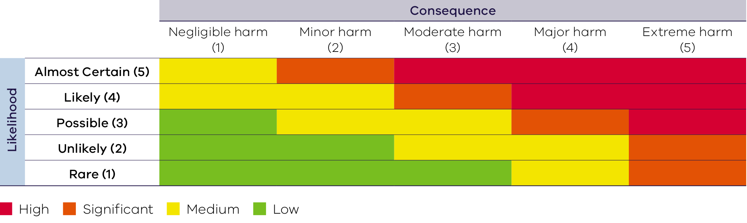

Risk treatment
Table 26 provides detail on the appropriate management response and activities for each level of risk.
Table 26: Risk treatments
Level of Risk | Treatment and level of reporting requirement
HIGH | - Falls outside risk appetite  - Accountability and responsibility to be managed by Recycling Victoria and/or the responsible entity  - A risk treatment plan must be established and implemented by Recycling Victoria and/or the responsible entity  - To be managed to a level that is as low as reasonably practicable (ALARP) based on resource, cost and practicality  - Active monitoring of risk and risk treatments  - Risk must be integrated with corporate and/or business planning  - Reporting must be provided from responsible entities to Recycling Victoria
SIGNIFICANT | - May fall outside risk appetite  - Accountability and responsibility to be managed by Recycling Victoria and/or the responsibly entity  - A risk treatment plan must be established and implemented  - Should be managed to a level that is ALARP based on resource, cost and practicality  - Regular monitoring of risk and risk treatments  - Risk must be integrated with corporate and/or business planning  - Responsible entities to report risks to Recycling Victoria at least quarterly
MEDIUM | - Falls within risk appetite  - Accountability and responsibility to be managed by Recycling Victoria and/or the responsible entity  - May be managed or accepted without further treatment, provided the risk is appropriately monitored at least every 6 months, with re-evaluation undertaken based on factors that may increase consequence or likelihood  - Risk should be integrated with corporate and/or business planning  - Risk owner to monitor the risk at least every 6 months
LOW | - Falls well within risk appetite  - Accountability to be managed by the appropriate risk owner  - May be reviewed to assess whether the risk is being over controlled, and whether some reduction in active controls may be considered  - Risk owner to monitor the risk at an appropriate frequency

Appendix 5 – Victorian waste, recycling, and resource recovery sector
The Victorian waste, recycling and resource recovery sector comprises a mix of public and private industry participants, including the following outlined in Table 27 (DEECA (2023), Circular Economy (Waste Reduction and Recycling) (Risk, Consequence and Contingency) Regulations 2023 Regulatory Impact Statement.)
Table 27: Participants in the Victorian waste, recycling and resource recovery sector
Organisation | Role/s
Australian Department of Climate Change, Energy, the Environment and Water (DCCEEW) | - Publishing the annual National Waste Database and action plans and reports
Victorian Department of Energy, Environment and Climate Action (DEECA) | - Policy, laws, and regulations  - Governance oversight and coordination of policy implementation
Recycling Victoria (commenced on 1 July 2022) | - Leadership, stewardship and oversight of waste, recycling, and resource recovery services and supports the development of a circular economy  - Oversight and regulation of the waste, recycling and resource recovery sector to improve its reliability and transparency  - Data collection, analysis and reporting  - Planning to manage risks of disruption of services
Sustainability Victoria | - Investment, research and innovation to scale up the circular economy transition  - Community education and behaviour change for waste and recycling
Environment Protection Authority Victoria | - Enforcing the general environmental duty and specific waste duties in the Environment Protection Act (2017)  - Environmental approvals, permissions and licences for waste and resource facilities and transport
Victorian local governments and Alpine Resorts Victoria | - Regulation and compliance  - Provision of waste and recycling services to their local communities  - Procurement of waste, recycling and resource recovery services to operators  - Direct and/or indirect operation of a range of waste, recycling, and resource recovery facilities including resource recovery centres, transfer stations and landfills
Private waste, recycling, or resource recovery operators | - Services for waste, recycling, and resource recovery including the:  - the collection, transport, storage, treatment, processing, sorting or recycling of waste, recycling and resource recovery materials  - disposal of waste

recycling.vic.gov.au

