Circular Economy Market Report 2026
Table of Contents
Executive summary 3
Purpose and scope 3
Economic and policy context 6
Commodity prices, market transparency and report scope 6
Outlook and next steps 8
Overview 10
Circular economy policy targets 11
Circular economy strategic priorities 12
Product stewardship 13
Market performance and opportunity 14
Advancing circular economy measurement 15
Circular economy metrics and market value 17
Circularity rate 17
Material footprint 17
Material productivity 18
Market overview and performance 2023– 24 20
Market overview – economic 20
Recovered material stream commodity price gap 24
Key market observations 33
Market overview – social 35
Market overview – environmental 42
Performance by activity 48
Performance by material 62
Aggregates, masonry and soil 62
Glass 70
Metals 78
Organics 88
Paper and cardboard 93
Plastics 100
Tyres 114
Textiles 124
Circular economy opportunities for Victoria’s renewable energy transition 131
Government policy and action 140
National action towards a circular economy 144
Victorian Government action towards a circular economy 145
Conclusion 153
Glossary 157
References 159
Appendix 1: Data method and quality 170
Appendix 2: The 10 R Circular Economy Framework 183
Publication information 189

Executive summary
Recycling Victoria’s vision is for a world-class circular economy system that supports economic growth, reduces waste and helps achieve Victoria’s long-term sustainability and climate objectives.
Recycling Victoria provides leadership, stewardship and oversight of the state’s waste and resource recovery system to enable a strong and resilient circular economy that attracts investment and supports market development.
The Circular Economy (Waste Reduction and Recycling) Act 2021 (CE Act) defines a circular economy market as “the market for waste, recycling or resource recovery services within the circular economy.”

Purpose and scope
The Circular Economy Market Report 2026 (CEMR 2026) delivers on Recycling Victoria’s Strategic Plan 2023–2026 by providing high-quality market data and insights. These insights inform policy, investment and regulatory decisions and support the achievement of Victoria’s circular economy and waste reduction targets.
The CEMR 2026 presents market performance data for the 2023–24 financial year across the 3 primary waste-generating sectors: construction and demolition (C&D); commercial and industrial (C&I); and municipal solid waste (MSW).
It draws on Victorian market sector data, supplemented by information reported through the Recycling Victoria Data Hub and incorporates updated analysis of commodity prices and market values for key material streams.
The 2026 edition continues to broaden the report’s scope to include emerging materials associated with renewable energy generation and storage systems - such as solar panels, wind turbines and batteries. This reflects the growing significance of end-of-life management for renewable infrastructure as Victoria transitions to a low-emissions energy system.
Key findings for 2023–24:
- Victoria generated 14.2 million tonnes of material (down 0.3 Mt tonnes from
2022–23)
- 9.9 million tonnes recovered for recycling, resulting in a statewide recovery rate of 70%
- per capita waste generation decreased to 2.1 tonnes per person (down from 2.2).
See Table 1 for a broader summary of the key data in this report.
Waste and resource recovery sectoral trends:
- MSW generation increased slightly, accompanied by higher recovery rates linked to the expansion of household recycling and organics services.
- C&D waste generation decreased by 0.5 million tonnes, continuing a downward trend driven by a reduction in the amount of demolition waste material managed in some big infrastructure projects moved closer to completion.
C&I waste generation remained stable for the third consecutive year, although sits below the national average for recovery.
Analysis of 8 years of Victorian waste and resource recovery data shows that overall performance remains strong. With approximately 15% population growth over this period, total waste generation has increased proportionally. Over the same timeframe, disposal to landfill has risen by less than 5% and since 2020–21, annual landfill volumes have decreased by approximately 7.5% (around 350,000 tonnes per year).
Despite strong population growth, Victoria reduced its waste sector emissions by 21% between 2005 and 2023. This emissions reduction was a result of improvements in Victoria’s waste management system including:
- higher diversion rates of organic waste from landfill
- improvements in landfill management practices
- increased capture of methane from both landfill and wastewater treatment
efficiencies in wastewater treatment processes.
Between 2016–24 Victoria achieved an increase of more than 20% in local material processing capacity, with an additional 1.7 million tonnes processed within the state.
During the same period, municipal solid waste (MSW) managed through kerbside systems has demonstrated notable improvement, including an 87% increase in material processed and a reduction of more than 50% in MSW disposal to landfill, contributing to a 21% increase in overall recovery rates. These outcomes reflect targeted policy and system reforms in the MSW stream.
Victoria recovered and circulated an estimated $3 billion worth of materials back into the economy in 2023–24, while materials with a potential value of $1.2 billion were lost to landfill. This highlights continued opportunities to strengthen end markets, improve processing capacity and support greater material circularity.

Economic and policy context
The Victorian Government’s 2024 Economic Growth Statement identifies the circular economy as one of 5 priority sectors for the state, highlighting its strategic importance for Victoria’s future development. This sector has a strategic role in supporting Victoria’s transition to net zero greenhouse gas emissions by 2045, while also driving emissions reduction, supply chain resilience and new economic opportunities.
By prioritising circular economy initiatives, Victoria aims to reduce waste, maximise the value of materials and create high-value employment opportunities, ensuring that environmental and economic objectives are pursued in parallel.

Commodity prices, market transparency and report scope
For the first time, the CEMR 2026 introduces a dedicated commodity price analysis. Indicative price ranges are presented for key virgin and recovered materials across major streams, providing greater visibility into Victorian market value trends.
The tracking of commodity prices for most materials in this report is challenging. The system for resource recovery has historically been about managing waste, which impacts perceptions of, for example, quality and contamination. The information included in this report provides a guide that helps to identify trends, rather than being a definitive source of pricing data.
Analysis of indicative price gaps between virgin and recovered materials illustrates the variation across Victorian markets. Three broad categories are evident:
- Established markets such as metals and construction aggregates, which benefit from mature processing systems and strong demand with relatively small price gaps.
- Developing markets including paper, glass, organics and rigid plastics, where prices remain more volatile due to quality variability and dependence on global commodity conditions.
Constrained markets such as soft plastics, textiles, tyres and e-waste, where limited domestic reprocessing capacity and weak secondary markets often require fee-based recovery.
Non-ferrous metals demonstrate the strongest commercial performance owing to high inherent value and established secondary markets, while textiles and mixed paper show the largest negative price differentials and limited market demand.
Aggregates and rigid plastics offer cost advantages over virgin materials, enabling substitution where quality requirements are met. Soft plastics remain the lowest value recovered stream.
These market signals reinforce the need for measures that build demand for recovered materials and improve product quality, including recycled content requirements, targeted infrastructure investment and procurement levers. Strengthening domestic reprocessing capability will be key to shifting constrained streams towards commercially viable circular markets.
Environment Ministers have agreed on the need for urgent reform to battery product stewardship to address rising fire risks and improve recovery of critical materials. Victoria, working closely with New South Wales (NSW), co-prepared a draft Regulatory Impact Statement that supports a regulatory approach to mandatory battery stewardship. Work has also commenced on a scheme for small batteries and products with embedded batteries to ensure safe collection, transport and recycling.
Victoria is also assessing the NSW legislative model to support alignment and minimise regulatory burden, while collaborating with other jurisdictions pursuing similar reforms. In parallel, Victoria is contributing to national work to establish a new stewardship scheme for solar photovoltaic systems to ensure consistent, safe and circular end-of-life management across Australia.

Outlook and next steps
The CEMR 2026 identifies ongoing opportunities to strengthen circular economy outcomes through:
- improved material recovery
- expanded reuse and repair networks
- investment in processing infrastructure.
- Areas identified for further focus include:
- advancing circularity opportunities across the C&I sector
- strengthening national alignment through data collaboration
- accelerating circular solutions for priority and complex material streams, such as progressing product stewardship for problematic batteries
continuing to foster strategic investment and partnerships in circular markets
The CEMR 2026 supports policy, planning and market decisions with a data-driven evidence base to help advance Victoria’s transition to a more resource-efficient, low-emissions economy.

From 1 July 2026, Recycling Victoria will transition into EPA Victoria, consolidating circular economy stewardship, regulatory oversight and market intelligence within a single entity. In line with the updated legislative framework, the Circular Economy Market Report will move to a biennial publication cycle, with future reports prepared and issued every two years commencing 31 December 2027, ensuring continued transparency, continuity of data and a robust evidence base to support policy, investment and system planning decisions.

Table 1: At a glance – Victoria’s circular economy market 2023–24
Indicator | 2023–24 Result | Change from 2022–23 | Notes
Total material generated | 14.2 million tonnes | Down 0.3 Mt | Waste generation has reduced by 10% since  2020–21 (post Covid)
Total material recovered | 9.9 million tonnes | – | Steady for third year
Recovery rate | 70% | Up 1% | Recovery rate has been 69-70% since 2017-18
Landfilled | 4.3 million tonnes | Down 10% | 3-year decline
Per capita generation | 2.1 t /person | Down 0.1 t /person | Continued reduction
Population | 6.9 million | Up 0.2 million | Steady growth in population
Estimated recovered market value | $3.0 billion | Up $1.2 billion vs  2022–23 | Predominantly metals
Estimated value lost to landfill | $1.2 billion | Down $0.1 billion | Ongoing opportunity

Overview
Recycling Victoria’s vision is for a world-class circular economy that supports a sustainable, efficient and resilient future for all Victorians.
Established in July 2022, Recycling Victoria provides leadership, stewardship and oversight of Victoria’s waste and resource recovery system. Its role is to support the development of a robust circular economy that encourages market transparency, investment and growth.
The circular economy is emerging as a key enabler of broader economic priorities, including:
- low-emissions manufacturing
- critical minerals recovery
renewable energy deployment and increases in productivity.
These sectors are increasingly interconnected, creating multiplier effects across regional and industrial economies. Circular systems improve supply chain resilience, reduce reliance on imported materials and support the transition towards high-value, low-waste industries.
In this context, Recycling Victoria plays an enabling role by aligning market development programs, investment incentives and regulatory frameworks to stimulate market demand for recovered materials and circular products.
Through coordinated actions, Victoria’s circular economy is positioned not only as an environmental reform agenda but also as a new economic paradigm – one that integrates material efficiency, innovation and industry growth to underpin long-term prosperity for all Victorians.
Between 2023 and 2024, a range of policy, market and global developments influenced Victoria’s circular economy transition. These changes are creating opportunities to reduce waste generation, increase material recovery and improve the management of resources across the economy.

Circular economy policy targets
The cornerstones of Victoria’s transition to a circular economy are the CE Act and Recycling Victoria – a new economy policy.
The CE Act and Recycling Victoria – a new economy policy provide the legislative and policy foundation for Victoria’s transition to a circular economy. The CE Act defines a circular economy market as “the market for waste, recycling or resource recovery services within the circular economy.”
The Recycling Victoria: a new economy policy establishes 4 headline targets:
- Divert 80% of waste from landfill by 2030, with an interim target of 72% by 2025.
- Reduce total waste generation by 15% per capita by 2030.
- Halve the volume of organic material sent to landfill between 2020–2030, with an interim reduction of 20% by 2025.
Ensure universal access to food and garden organics recycling or local composting by 2030.
These targets are guided by the 4 policy goals:
- design to last, repair and recycle
- use products to create more value
- recycle more resources
- reduce harm from waste and pollution.
The CEMR 2026 relates to these goals by:
- measuring material stream waste generated in Victoria
- identifying barriers and opportunities in each stream to achieve circularity
- identifying emerging new material streams entering the Victorian market.

Circular economy strategic priorities
Recycling Victoria’s strategic priorities for 2023–2026 include delivering reliable, timely and transparent market information to support business, investment and community decision making to expand and innovate in circular markets. This work is supported by key initiatives including the following:
- The statewide Container Deposit Scheme (CDS), improving material recovery rates, reducing litter and delivering cleaner recyclable material streams
- Standardised household waste and recycling services, progressing implementation of the state-wide four-stream system to reduce contamination and increase resource recovery
- The Victorian Waste to Energy (WtE) scheme, providing a framework to ensure thermal processing complements, rather than displaces higher-order circular economy activities
- This Circular Economy Market Report (CEMR): a legislated requirement under the CE Act, which monitors performance, trends and the economic contribution of Victoria’s waste, recycling and resource recovery markets
- The Victorian Recycling Infrastructure Plan (VRIP): outlines infrastructure needs and gaps, driving innovation and potential investment where it is needed most. The VRIP is accompanied by a prospectus that outlines investment opportunities in the waste, recycling and resource recovery sector and how Recycling Victoria can support investment (Recycling Victoria 2024d)
- The Circular Economy Risk, Consequence and Contingency Plan (CERCC): aims to identify, describe and manage risks to service continuity and the transition to a circular economy in Victoria’s waste recycling and resource recovery sector (Recycling Victoria 2024e).
Victoria’s approach also aligns with the United Nations Sustainable Development Goals (UN SDGs), particularly Goal 12: Responsible Consumption and Production, which focuses on sustainable resource management and waste reduction.

Product stewardship
Environment Ministers have recognised the need for urgent reform to battery product stewardship to address escalating fire risks and support a safer, more circular battery system. The December 2024 Environment Ministers’ Meeting considered a draft Regulatory Impact Statement (RIS) developed by Victoria and NSW, which assessed regulatory options for mandatory battery stewardship. The draft RIS identifies a regulatory approach as the most effective way to reduce fire risks, improve recovery of battery materials and support nationally aligned arrangements.
Victoria is strengthening its management of battery-related risks within its existing e-waste framework and has started work on a mandatory product stewardship scheme for small batteries and electrical products with embedded batteries. These products are a major source of fires in collection vehicles and waste and resource recovery facilities.
A mandatory scheme would require suppliers to take responsibility for end of life management, ensuring safe collection, transport and recycling while supporting recovery of critical materials.
Victoria continues to work closely with NSW, which is progressing a 2-stage reform pathway through its Product Lifecycle Responsibility Bill 2025 and subsequent regulations. Victoria will assess the suitability of the NSW approach for local application, with a shared commitment to harmonisation where appropriate and minimising regulatory burden for businesses. Other jurisdictions have also signalled interest in complementary reforms, providing an opportunity to build a nationally consistent stewardship framework.
Alongside battery reforms, Victoria is contributing to the development of a new national product stewardship scheme for solar photovoltaic systems. This work aims to establish consistent requirements across jurisdictions and ensure the safe and effective recovery, reuse and recycling of materials as solar systems reach end of life.

Market performance and opportunity
Victoria’s circular economy continues to evolve. Material recovery rates have remained steady at approximately 69–70% in recent years, with a policy target to divert 80% of non-hazardous waste from landfill by 2030. To maintain the recovery rate at the same level while undergoing growth in population requires growth in capacity for managing waste materials. Although the recovery rate has remained steady for several years, the amount recovered for processing has increased by more than 20% (or 1.7 million tonnes) since 2015–16.
In 2023–24, circular economy market activity recovered and circulated an estimated $3 billion within the Victorian economy, predominantly through metals recycling. Approximately $1.2 billion in materials were still disposed of to landfill, indicating scope for further recovery and value retention.
Beyond material recovery, circular economy activities also contribute to emissions reduction and more efficient use of natural resources. Reducing reliance on virgin materials lowers greenhouse gas emissions associated with extraction, processing and transport, while increasing the reuse and recycling of products supports resource efficiency.
Nationally, the circular economy is gaining momentum. The Department of Climate Change, Energy, the Environment and Water (DCCEEW 2024b), estimates that targeted circular economy initiatives in the built environment, transport, manufacturing and recycling sectors could create up to 150,000 ongoing jobs across Australia by 2025.
Internationally, analysis from the European Union indicates that each one percentage point gain in resource efficiency could generate 100,000–200,000 additional jobs, highlighting the potential scale of circular economic opportunity available to Victoria.

Advancing circular economy measurement
Since its first publication in 2024, the Circular Economy Market Report has supported the Victorian Government’s commitment to developing consistent and transparent metrics to measure circular economy performance.
The CEMR 2025 introduced baseline indicators that measure not only recovery rates but also material circularity, market value and sectoral contribution.
The CEMR 2026 shifts the focus of analysis to include:
- for the first time, a dedicated commodity price analysis. Indicative price ranges are presented for key virgin and recovered materials across major streams, providing greater visibility into market value trends.
- narrative on social and environmental outcomes from circular economic interventions
- cross-sector linkages between waste streams, remanufacturing potential and market demand
examples of opportunities in reuse, repair and remanufacturing that support waste reduction and create high-skill job growth.
Through this ongoing work, Recycling Victoria continues to strengthen the evidence base for policy, planning and investment in Victoria’s circular economy, demonstrating how the state can turn waste challenges into economic, social and environmental benefits at scale.

Circular economy metrics and market value
Victoria’s circular economy performance has historically been measured through material recovery rates, which indicate the volume of materials diverted from landfill but do not assess how efficiently materials are used or how value is retained across supply chains.
To provide a more comprehensive assessment, the CEMR 2025 introduced 3 additional state level indicators aligned with national guidance in The Circular Advantage and Australia’s Circular Economy Framework:
- circularity rate
- material footprint
- material productivity.
Below are the results published in the CEMR 2025. These remain the most current figures given calculations are conducted every 2 years.

Circularity rate
Measures the percentage of all consumed materials that are recycled, reflecting material reuse within the economy. Victoria’s circularity rate was measured as 7.5% – higher (better) than the national circularity rate (4.4%).

Material footprint
Quantifies demand for virgin materials per capita, indicating resource intensity. The material footprint for Victoria was measured as 28.1 tonnes per person – lower (better) than the national material footprint of 31.0 tonnes per person.

Material productivity
Measures the economic value generated per unit of materials consumed, reflecting resource efficiency. The material productivity for Victoria was measured as $3.49 per kilogram of materials consumed – higher (better) than the national material productivity figure of $2.04 per kilogram.
These indicators broaden the evidence base for policy and investment planning and will be updated and published in future reports.
Emerging research emphasises the importance of contextualising circularity metrics to national economic structures. A 2025 CSIRO analysis comparing Australia, Japan and the Netherlands found that circularity rate variations largely reflect each country’s position in global value chains and reliance on extractive industries (Miatto et al 2025)
Australia’s strong resource sector results in high primary material throughput and extractive waste that is currently challenging to recover, meaning its performance is broadly comparable with other advanced economies with similar industrial profiles.
As a result, circularity rate alone is not a definitive indicator of progress. Complementary measures, such as material footprint, waste generation, end of life recovery rates and stock and flow modelling, are needed to capture how long materials remain in use and when secondary resources become available.
International evidence suggests that developed economies may operate within a long-term circularity range of around 15–20%, supported by reduced reliance on virgin materials, enhanced secondary processing capability and stronger market demand for recovered materials.
These metrics collectively emphasise that a core principle of circularity is to keep products and materials circulating at their highest possible value for as long as possible.
The successful application of value retention strategies, often categorised using the 10R Circular Economy Framework (refuse, rethink, reduce, reuse, repair, refurbish, remanufacture, repurpose, recycle, recover) is fundamentally dependent on a commercially viable downstream market.
Each of these strategies contributes to the circular economy by extending the life of products, reducing the need for virgin materials and minimising waste. For example:
- refuse, rethink and reduce aim to prevent unnecessary consumption
- reuse, repair, refurbish and remanufacture keep products and components in use for longer
repurpose, recycle and recover extract remaining value from materials that can no longer serve their original purpose.
Together, these strategies help close material loops, reduce environmental impact and create economic opportunities within a sustainable, circular system. This retention of value, through practices such as extending product lifetimes and complex component refurbishment, is where the greatest economic and environmental gains of the circular model are realised.
Appendix 2 provides further details on the 10R Circular Economy Framework and illustrates Victorian examples of each application.

Market overview and performance 2023– 24

Market overview – economic
The transition to a circular economy is increasingly recognised as an economic imperative for Victoria and Australia. The Australian Government’s Circular Economy Framework (DCCEEW, 2024c) identifies the creation of active markets for circular goods and services as a foundational enabler of the national transition.
Policy certainty and regulatory signals including recovery targets, product stewardship and minimum standards further influence market behaviour by improving price signals and better reflecting environmental externalities. Government and corporate procurement continue to play a pivotal role in stimulating demand, particularly through large-scale purchasing decisions that favour recycled content and low-impact materials.
Digital marketplaces are also strengthening market transparency and competitiveness by improving the connection between secondary material suppliers and buyers, supporting the scale-up of commercial pathways for recycled and reused product end-markets (DCCEEW, 2024b).
Victoria’s circular economy sector was valued at more than $4 billion in 2023–24, demonstrating its role as a contributor to economic resilience, investment and local job creation. Approximately $3 billion in materials were recovered, reprocessed and recirculated into the Victorian economy during the year (Figure 1), underpinned by strong commodity prices for recovered metals and steady demand for construction and organics feedstocks. In contrast, an estimated $1.2 billion in materials disposed to landfill represents unrealised value and lost productivity.
Analysis of 8 years of Victorian waste and resource recovery data indicates that progress in system performance continues. With population growth of approximately 15% over the period, total waste generation has increased proportionally. Disposal to landfill has risen by less than 5% since 2015–16 and has decreased by approximately 7.5% (around 350,000 tonnes annually) since 2020–21.
Over the same period, Victoria has increased local processing capacity by more than 20%, supported by infrastructure investment and market reforms. This has enabled an additional 1.7 million tonnes of material to be processed within the state. The kerbside MSW system has delivered measurable improvements, including an 87% increase in processed material and a reduction of more than 50% in MSW disposal to landfill, contributing to a 21% rise in overall recovery rates.
These improvements reflect progressive rollout of the four-stream household waste service system, expanded organics recovery and broader policy focus on MSW system outcomes.
Collectively, these trends demonstrate that continued investment in circular economy infrastructure, market development and system reform is supporting improved environmental outcomes while delivering measurable economic value to Victoria.
Figure 1: Realised market value, potential market value and commodity value for 2023–24
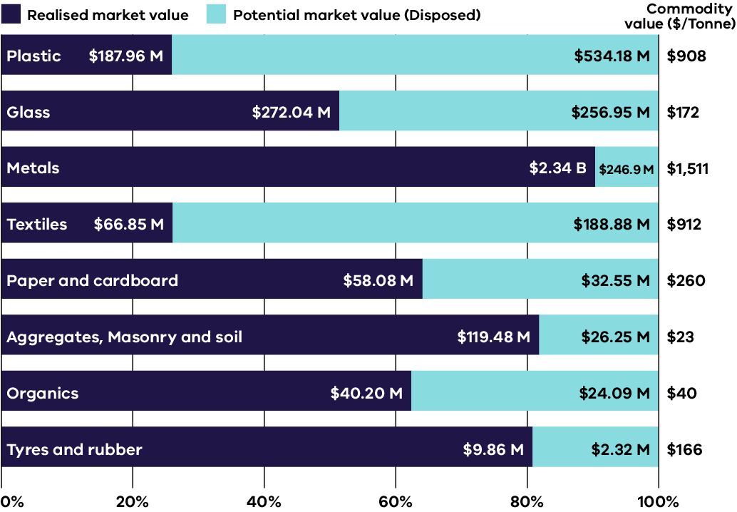
Note: Commodity value prices listed in the right-hand column are calculated from ABS data for exported and waste materials for streams other than aggregate, masonry and soils and organics. For these streams, market value was assessed based on previous years.
Data set 1: Realised market value, potential market value and commodity value for 2023–24
Material | Realised market  value | Potential market value (Disposed) | Commodity value  ($/Tonne)
Plastic | $187.96 M | $534.18 M | $908
Glass | $272.04 M | $256.95 M | $172
Metals | $2.34 B | $246.9 M | $1,511
Textiles | $66.85 M | $188.88 M | $912
Paper and cardboard | $58.08 M | $32.55 M | $260
Aggregates, Masonry and soil | $119.48 M | $26.25 M | $23
Organics | $40.20 M | $24.09 M | $40
Tyres and rubber | $9.86 M | $2.32 M | $166
The Victorian Government’s Economic Growth Statement (DTF, 2024) positions the circular economy as one of 5 strategic growth sectors for the state, highlighting its central role in achieving net zero emissions by 2045 while improving resource security and industrial competitiveness.
Building on this, the Victorian Industry Policy (DJSIR, 2025) nominates a clean and circular economy as a focus area for future growth. The policy identifies government working with industry to embrace circular production and reduce barriers to practices that improve resource efficiency, waste reduction and innovation, as a strategic opportunity to sustainable grow Victoria’s economy.
Economic modelling from Recycling Victoria: a new economy (DEECA, 2020) illustrates the scale of opportunity: a 5% improvement in economy-wide material efficiency could generate an estimated $6.4 billion uplift in Gross State Product (GSP) – equivalent to approximately 1.8% of Victoria’s total output (DCCEEW, 2017).
Realising the full potential of Victoria’s circular transition will require continued expansion of end markets, targeted infrastructure investment and strategic procurement reform to redirect material value back into the economy. Strengthening these market foundations will be critical to accelerating Victoria’s path towards a competitive, low-carbon and circular economy.

Recovered material stream commodity price gap
Victoria’s circular economy transition depends not only on how much material is recovered, but on how markets value those recovered materials relative to their virgin equivalents.
While price differential measures a numerical gap between virgin and recovered commodity prices, value reflects the broader set of benefits, environmental, social and strategic, that recovered materials contribute to Victoria’s economy. Understanding both is essential for assessing circular market maturity and investment readiness.
A price differential quantifies how much cheaper (or more expensive) a recovered material is compared to a virgin alternative. A wide negative differential indicates that recycled material is undervalued or burdened by quality and perception barriers. A narrowing or positive differential suggests improved competitiveness, efficiency and confidence in circular material supply chains.
By contrast, value extends beyond price; it captures avoided extraction impacts, emissions reductions, material security and local employment created through domestic reprocessing. As Victoria advances towards circularity, aligning price with true value will be a key marker of system maturity.

Why a narrower price gap matters
A narrowing price differential, or even a premium for high-quality recovered material, is a sign of a healthy and resilient circular market for 3 reasons:
- Reduced exposure to virgin commodity volatility
When recovered material prices more closely track virgin inputs, the market becomes less sensitive to global price shocks (such as oil price swings affecting polymer resin costs). Stable recovered material pricing encourages private investment in advanced sorting, beneficiation and reprocessing facilities
- Enhanced commercial viability
Competitive pricing improves the business case for manufacturers to incorporate recycled content without relying solely on regulation or subsidies. As recycled materials become cost-comparable to virgin inputs, market pull replaces policy push, stimulating innovation, procurement and reinvestment.
- Recognition of broader material value
Integrating environmental and social co-benefits into procurement and design decisions enhances the perceived value of recovered materials. This recognition helps shift market behaviour from ‘cheapest available input’ to ‘most sustainable and resilient input.’

Interpreting price data and market signals
Price monitoring across key Victorian material streams offers insight into market stability and the evolving perception of value. However, material pricing in the circular economy must be interpreted with care.
Historic pricing systems were designed for waste management, not for traded commodities. As a result, contamination, inconsistent grading and limited transparency often deflate prices for recovered products. For some streams, such as organics, tyres and e-waste, gate fees or processing credits replace conventional commodity pricing, reflecting the cost of achieving circular outcomes rather than direct market value. Therefore, the price differential is not an absolute indicator of success, but rather a proxy for how efficiently circular value is being recognised by the market.
The pricing information presented in this report is intended to indicate general market movements and comparative trends across material streams rather than provide definitive or exhaustive price data. Variations in contract arrangements, regional market conditions, product specifications and data availability mean that actual prices can differ significantly between operators and over time.
These figures should therefore be interpreted as indicative market signals to support policy and investment planning, rather than as precise benchmarks for commercial decision-making.
The indicative data presented in Table 2 illustrate the relative competitiveness of recovered materials in Victoria during 2023–24.
While absolute figures vary across regions, suppliers and grades, the trends show that most recovered materials remain priced below virgin equivalents, signalling both untapped value potential and investment opportunity.

Bridging the gap: from price to true value
Strengthening the market position of recovered materials requires deliberate efforts to close the gap between price and value.
Key enablers include:
- demand-side measures such as recycled content targets, performance-based procurement and design standards that reward circular inputs
- investment in quality and infrastructure, improving material consistency, certification and traceability – factors that increase confidence and justify price parity
market transparency through ongoing publication of circular economy price data, enabling buyers, reprocessors and policymakers to benchmark progress.
The analysis in Table 2 illustrates the relative cost competitiveness and price differentials across key material streams, underscoring the ongoing economic challenges and investment opportunities required to accelerate the Victorian market towards true circularity.
Data is presented as indicative price ranges (expressed in Australian dollars and averaged across Victoria and Australia) based on market activity and cross-referenced with government and industry reports.
Both the Virgin Equivalent Price and Recovered Material Price focus on the commodity value at the point of trade (ex-gate or Free on Board (FOB) for exports) and deliberately excluding midstream costs such as transport, storage, or final reprocessing.
Prices are highly subject to many factors including material grade, purity, contamination, domestic versus export market conditions and global commodity fluctuations.

Table 2: Indicative price information for virgin and recovered material in Victoria (2023–24)
Material  Stream | Virgin Equivalent Price  (AUD/t) | Recovered Material Price  (AUD/t) | Typical Price Differential –recovered vs virgin
Aggregates (crushed concrete, road base) | $60 – $120 (quarried road base / blue metal) | $10 – $70 (clean recycled crushed concrete / road base; small-order retail higher) | 12% – 83%
Masonry & soils (clean fill, screened topsoil/sand) | $40 – $110 (virgin sand / topsoil / engineered fill) | Gate fee (negative) to $60 (clean screened topsoil / premium screened loam >$60/t; can incur a gate fee) | -45% to negative (net cost).
Glass (beneficiated cullet) | $300 – $450 (virgin sand equivalent for glass production) | $120 – $300 (clear, furnace-ready cullet, mixed/lower grade is less) | -30% to -73%
Ferrous metals (steel scrap) | $900 – $1,200 (finished steel products, flat products) | $150 – $850 (varies significantly between light/contaminated to clean heavy/merchant scrap) | ~-11% to -87%
Non-ferrous Metals (copper, aluminium) | $10,000 – $13,000  (virgin copper cathode)  $3,000 – $4,500  (virgin aluminium ingot) | $7,500 – $12,000  (high grade copper scrap)  $1,800 – $3,500  (aluminium scrap, e.g. UBCs) | ~-5% to -25%  ~-20% to -60%.
Organics (composted product, soil conditioner) | n/a (No direct virgin equivalent, value tied to fertiliser/soil improvers) | $30 – $150 (bulk, standard compost/mulch, lowest for low-grade soil conditioner)  $150 – $450 (premium, certified organic/specialty) | n/a
Paper and cardboard (recovered fibre) | $600 – $900 (virgin pulp/linerboard) | $200 – $650 (Old Corrugated Cardboard – OCC, best value)  $0 – $150 (mixed paper/cardboard – MPC, lowest value) | -25% to -78% (grade dependent)
Plastics (PET, HDPE, mixed) | $1,500 – $2,500 (virgin polymer pellets – PE/PET/HDPE) | $400 – $1,000 (clear rPET flakes/pellets, natural rHDPE)  $50 – $300  (mixed/contaminated plastics) | ~-33% to -84%
Soft plastics  (film / PE/LDPE packaging) | $1,200 – $1,800  (virgin LDPE/LLDPE pellet comparator) | $0 – $150 (many soft-plastics streams low or near-zero value; some bale markets)  $50–$150/t (if clean & sorted) | ~-90% to -100%
Tyres (crumb, tyre derived fuel TDF) | n/a (manufactured product) | gate fee (-$50 to $150) (TDF/crumb, net value to reprocessor) | n/a
Textiles (post- consumer) | $2,500 – $4,000  (virgin cotton/synthetic fibre) | negative value (-$200 to -$50)  (gate fee due to low recovery rate, sorting cost)  $50 – $500 (high-quality rag/fibre for specific markets) | -80% or negative (gate fee)
E-waste (PCBs, black mass) | component-dependent  (e.g., virgin precious/critical metals) | $1,000 – $2,500  (high-grade PCBs, export)  negative value (mixed e-waste, processing gate fees) | n/a

Table 2 Methodology notes:
- Detailed data sourcing, calculation approach and quality considerations are outlined in Appendix 1: Data method and quality
- Price ranges are indicative averages for 2023–24, expressed in AUD per tonne and cover Victoria / Australia
- Commercial spot prices change and these figures represent indicative transactional bands for 2023–24.
- Ranges are provided to illustrate market competitiveness and price differentials between virgin and recycled materials. Actual prices may vary by region, supplier and material specification
- Differential calculation: percentage differential shown as (% cheaper) = (recovered price – virgin price) / virgin Price × 100; ranges reflect variability between lower- and upper-band values.
- Data combine government datasets (ABS 2024; DEECA 2024; DCCEEW 2024), industry surveys (TSA 2024; B-cycle 2024) and international benchmarks (LME 2024; ICIS 2024), with currency conversion using RBA 2023–24 exchange rates
- Virgin material prices reflect typical market rates at local mills, manufacturers or import cost benchmarks
- Recovered material prices reflect quality-weighted averages across grades and contamination levels, from mixed post-consumer streams to high-purity reprocessed materials
Figure 2 builds on the information presented in Table 2 and illustrates the average price differential between recovered and virgin materials in Victoria for 2023–24 (midpoint only).
The data highlights a consistent market signal: recovered materials are significantly cheaper than their virgin equivalents across most streams, supporting a strong economic case for using recycled content in these situations.
Figure 2: Average price differential: recovered vs. virgin (midpoint only) Victoria, 2023–24
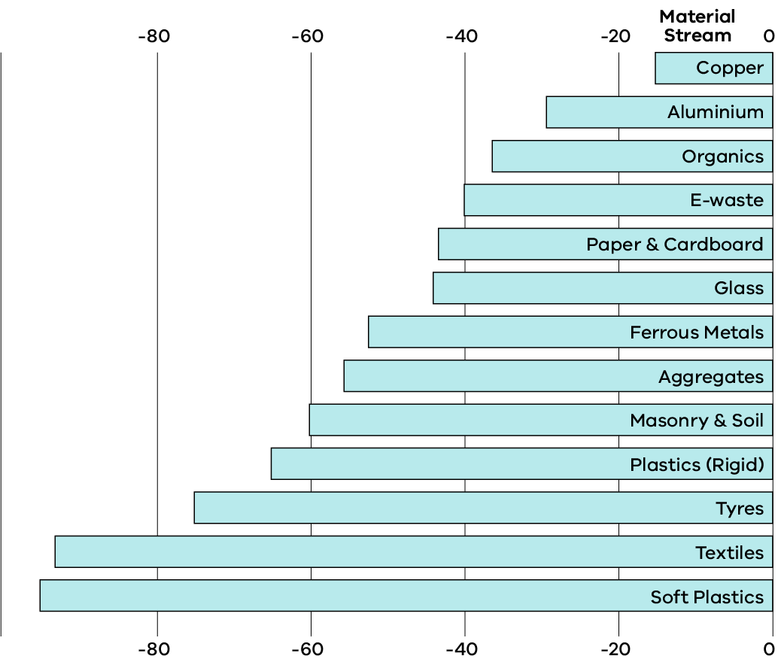
Note:
- The bar chart is sorted by the magnitude of the price difference, with the smallest differentials at the top.
- The percentages represent how much cheaper the recovered material is compared to its virgin counterpart.

Key market observations
Analysis of indicative price differences between virgin and recovered materials shows that market conditions vary widely between material types. In Victoria, material markets generally fall into 3 broad categories:

Established markets – metals and aggregates
Markets for materials such as ferrous and non-ferrous metals and C&D aggregates, are well developed. These materials have reliable end-markets and established processing systems. As a result, the price gap between recovered and virgin materials is relatively small. This reflects strong market confidence, consistent and high product quality and mature demand from the infrastructure and manufacturing sectors.

Developing markets – paper, glass, organics and rigid plastics
Recovered materials such as recycled (rigid) plastics (including rPET and rHDPE), recovered fibre, such as old corrugated cardboard (OCC) and organics remain more volatile in price and demand. These materials are often sold at significant discounts compared with virgin equivalents, due to variable quality, limited end markets and sensitivity to global commodity prices.

Constrained markets – soft plastics, textiles, tyres, e-waste
These streams exhibit the widest negative price differentials and, in many cases, require fee-based recovery and/or product stewardship. Limited domestic reprocessing, high sorting costs and weak secondary markets constrain commercial viability without targeted intervention.
This price weakness highlights the need for stronger demand-side measures, such as mandatory recycled content requirements, government procurement targets and greater investment in high-quality local reprocessing, to help close the ‘quality discount’ gap.
Non-ferrous metals such as copper and aluminium have the smallest price differentials (typically 5–25%), reflecting their high inherent value, efficient recovery systems and well-established global secondary metal markets.
Glass and ferrous metals show mid-range price differences of 30–80%, depending on contamination levels and product specifications. For example, clear furnace-ready glass cullet achieves higher value than mixed glass fines.
Aggregates and rigid plastics offer stronger price incentives for reuse, with recovered materials typically 40–85% cheaper than virgin equivalents. This supports uptake where quality and supply consistency can be maintained.
Textiles and mixed paper currently show the largest price gaps. In many cases, recovered materials have little or no market value and may attract a gate fee for acceptance. High sorting and processing costs, combined with limited domestic end-markets, make these materials commercially challenging without policy or procurement support.
Soft plastics continue to be the lowest-value recovered material stream in Victoria, with recycled feedstocks typically valued 90–100% below virgin polymer prices and often requiring gate fee support for processing. Ongoing market intervention, including product stewardship, advanced recycling investment, secure offtake agreements and strengthened procurement pull, will be critical to shift soft plastics from a cost burden to a functional circular material market.
For other streams such as organics, tyres and e-waste, direct price comparisons are not applicable. These operate through fee-based recovery systems, where the value is linked to processing outcomes such as compost, tyre-derived fuel or recovered components, rather than direct commodity prices.
Over time, as recovered materials are priced closer to their full environmental and economic value, Victoria’s circular economy is expected to evolve from a supply driven system (focused on managing waste) to a demand driven market—where recycled content becomes the preferred input due to its quality, reliability and recognised value.

Market overview – social
Victoria remains one of the fastest-growing states in Australia, with population growth continuing to place significant pressure on natural resources, waste management systems and the broader environment. As of 31 March 2024, the Australian Bureau of Statistics (ABS 2024) recorded Victoria’s population at 7 million, with projections indicating it will reach 10.3 million by 2051 (DTP 2023), an increase of nearly 50% in less than 3 decades.
This rapid growth, if unmanaged, is likely to drive higher material consumption, increased waste generation, greater demand for virgin resources and associated greenhouse gas emissions. The circular economy offers a pathway to mediate these pressures by promoting resource efficiency, extending product lifecycles and supporting the recovery and reuse of materials.
By embedding circular economy principles across industry, infrastructure and urban planning, Victoria can accommodate population growth while minimising environmental impacts, reducing pressure on landfill and resource extraction and simultaneously fostering innovation and economic opportunities (Infrastructure Victoria, 2024).
Victoria’s circular economy transition is designed to deliver measurable social outcomes. The sector contributes to employment, workforce capability, regional participation and alignment with the United Nations Sustainable Development Goals (UN SDGs), particularly SDG 12 – Responsible Consumption and Production.
Progress in 2023–24 reflects continued investment in workforce development, community participation and reuse initiatives that collectively advance Victoria’s transition towards sustainable production and consumption systems.

Employment and green skills

Sector employment
The circular economy is an emerging source of sustained employment in Victoria. In 2023–24, it is estimated that between 7,000 and 9,000 people were directly employed across waste collection, recycling, resource recovery and materials reprocessing activities (DCCEEW, 2023).
When including related activities such as repair, reuse, remanufacturing and materials innovation, the broader circular economy supports approximately 12,000 jobs, a figure projected to grow significantly by 2030 (DEECA).
Growth is being driven by both government and industry investment in recycling infrastructure, local reprocessing capacity and market development programs. Regional areas are key beneficiaries of this expansion, particularly in sectors such as organics processing, glass beneficiation and construction materials recovery.

Green skills development
Victoria’s Clean Economy Workforce Development Strategy 2023–2033 (DJSIR, 2023) identifies circular economy and resource recovery industries as priority growth areas. The strategy emphasises workforce transition and training to address skills shortages in:
- recycling and materials reprocessing operations (sorting, quality assurance, process management)
- product and materials innovation, including design for disassembly and recyclability
- repair and remanufacturing, particularly in electronics, machinery and textiles
- reverse logistics and materials tracking systems
- data and resource flow analytics, supporting improved decision-making and circular reporting
sustainable procurement and lifecycle assessment.
Complementary initiatives under the Victorian Skills Plan 2023–24 and State of the Victorian Labour Market 2024 note a growing demand for vocational and tertiary qualifications across engineering, environmental sciences, waste management and product design.
Job advertisement data indicates that clean economy skill clusters such as air quality and emissions, conservation, clean energy, water energy and climate change-related skills are among the fastest growing across Victoria. For example, demand for ‘air quality and emissions’ skills has increased by 387% from 2018 to 2023 (Victorian Skills Authority 2005).
These developments are expected to underpin the emerging green economy and strengthen Victoria’s progress towards its net zero emissions target by 2045.

Charitable reuse sectors
The charitable reuse sector continues to play a critical role in Victoria’s circular economy by extending product lifespans and reducing waste generation. The sector redistributes clothing, furniture, appliances and other household goods, enabling community access to affordable products while conserving materials and energy.
Across Australia, charitable reuse activities divert approximately 190,000 tonnes of materials from landfill annually, preventing an estimated 1.4 million tonnes of CO₂-equivalent. For textiles, extending the lifespan of a garment by just 9 months can reduce its carbon footprint by up to 20%. The reuse sector also conserves approximately 60,000 megalitres of water each year through avoided production (WRAP 2020).
Victoria hosts one of the most extensive reuse networks in the country, with around 650 charitable recycling and reuse stores operating statewide (MRA 2021). This network forms a key component of Victoria’s material circularity system and contributes to social inclusion and employment across metropolitan and regional communities.

Challenges
The sector faces several structural and operational challenges that limit scalability:
- Donation quality: An increasing volume of low-quality or non-reusable donations, linked to fast fashion and short product lifecycles, is driving up sorting and waste disposal costs.
- Illegal dumping: Continued dumping at collection points adds significant clean-up and compliance costs for operators.
- Rising operational costs: Increases in rent, transport and waste management costs limit reinvestment capacity.
Funding constraints: Limited access to capital investment restricts expansion of reuse facilities and digital tracking infrastructure.

Opportunities
- Improved impact measurement: Development of standardised frameworks to quantify environmental, social and economic benefits of reuse, similar to the NSW EPA’s Reuse Impact Study.
- Public education: Targeted campaigns to improve donation behaviours and understanding of reuse value.
Export quality assurance: Strengthening participation in the Clothing Reuse Export Accreditation Scheme to improve traceability and global compliance standards.
Figure 3: The 12 Sustainable Development Goals aligned with Recycling Victoria’s objectives and actions (United Nations n.d.)
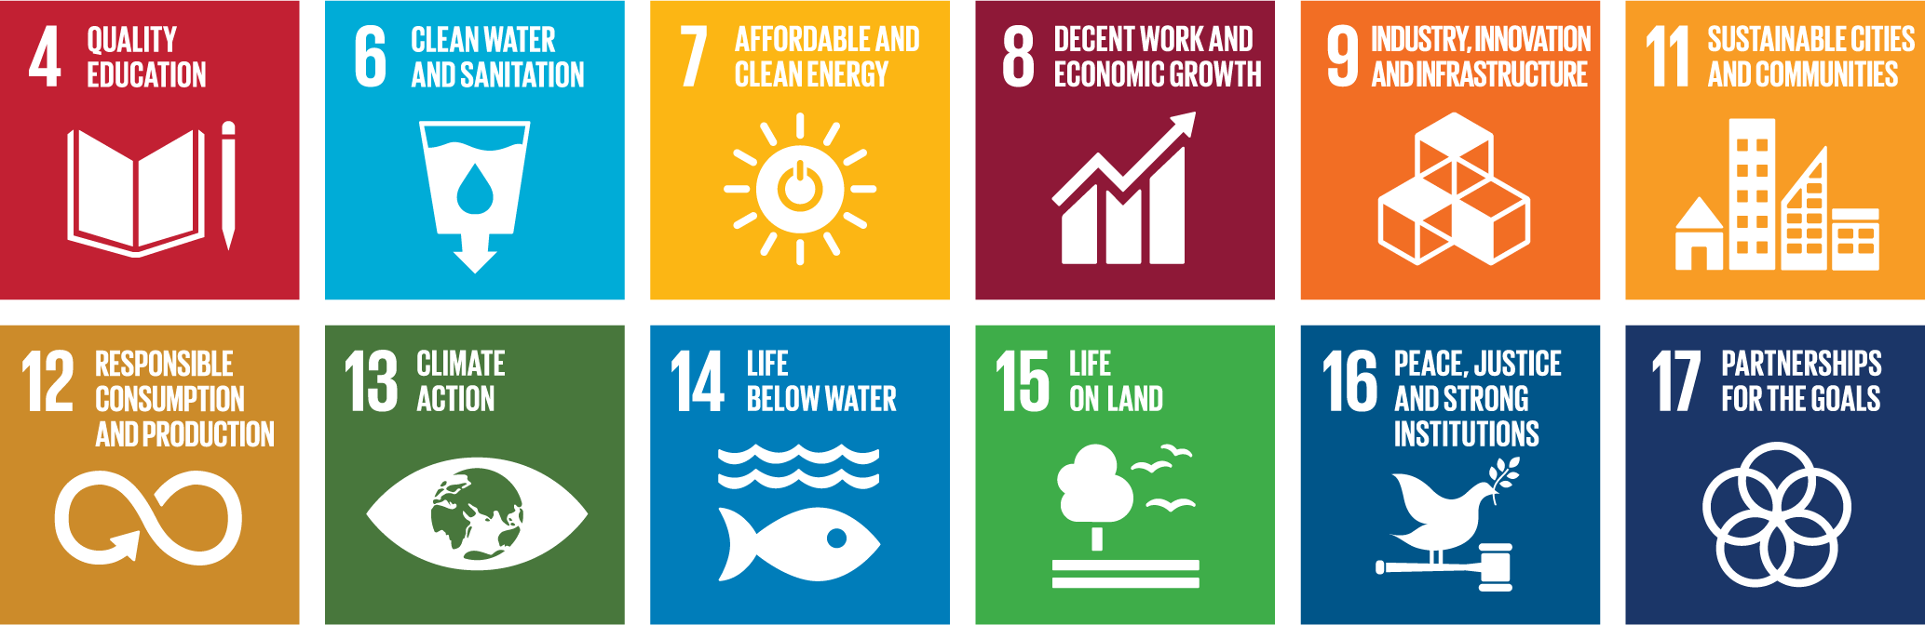
The 12 Sustainable Development Goals aligned with Recycling Victoria's objectives and actions (United Nations n.d.) are:
- SDG 4: Quality Education
- SDG 6: Clean Water and Sanitation
- SDG 7: Affordable and Clean Energy
- SDG 8: Decent Work and Economic Growth
- SDG 9: Industry, Innovation and Infrastructure
- SDG 11: Sustainable Cities and Communities
- SDG 12: Responsible Consumption and Production
- SDG 13: Climate Action
- SDG 14: Life Below Water
- SDG 15: Life on Land
- SDG 16: Peace, Justice and Strong Institutions
- SDG 17: Partnerships for the Goals

Alignment of Victoria’s circular economy with Sustainable Development Goals (UN SDGs)
Victoria’s circular economy initiatives demonstrate measurable alignment with key United Nations Sustainable Development Goals (UN SDGs), reflecting a comprehensive approach to economic and environmental policy.

UN SDG 12: Responsible Consumption and Production
Victoria’s circular economy activities directly address UN SDG 12 by focusing on decoupling economic growth from the consumption of finite resources and reducing waste generation.
Material recovery and diversion: In the 2023–24 financial year, Victorian households achieved an overall landfill diversion rate of 70% (Recycling Victoria 2024a). This performance indicates an effective shift from disposal to material circulation, directly supporting the UN SDG 12 target of substantially reducing waste generation through recycling and reuse.
Waste avoidance and reuse infrastructure: Initiatives focus on the higher order ‘R’ principles. For example, the state’s investment in resource recovery infrastructure and business support, such as the Circular Economy Business Innovation Centre (CEBIC), promotes product design for longevity and reuse, moving beyond end-of-pipe recycling to systemic waste avoidance. See Appendix 2 for further information.

UN SDG 8: Decent work and economic growth
The transition to a circular economy is a critical driver for new economic opportunities and workforce skills development, directly contributing to the targets of UN SDG 8.
Green job creation: Investment in new recycling and reprocessing infrastructure is essential for establishing local manufacturing capacity. In 2023–24, a direct investment of $9.5 million in recycling infrastructure leveraged $74.8 million in private and Australian Government capital (Sustainability Victoria 2024). This capital injection supports the establishment and scaling of facilities, leading to the creation of skilled ‘green jobs’ in areas such as material science, advanced manufacturing and resource management.
Workforce transition: The shift necessitates workforce reskilling and transition programs to ensure workers from traditional linear sectors can move into emerging circular roles, promoting sustained, inclusive and sustainable economic growth.

UN SDG 11: Sustainable cities and communities
By redesigning material flows and management systems, Victoria’s circular economy strategies improve the sustainability and liveability of urban and regional areas, a core objective of SDG 11
- Resource efficiency in the built environment: The increased use of recovered materials, such as recycled aggregates and plastics in public works, promotes resource-efficient infrastructure. In 2023–24, the use of recovered resources contributed to saving 395,988 tonnes of CO2​ equivalent emissions (Sustainability Victoria 2024), improving air quality and reducing the environmental footprint of construction activity in urban centres.
- Reduced landfill dependence: A high diversion rate of 70% for households significantly reduces reliance on landfill space, preserving land for alternative community use and mitigating environmental risks associated with waste disposal, such as methane emissions and groundwater contamination.
Access to affordable goods: Promoting repair, refurbishment and reuse models enhances community access to functional and affordable products, contributing to inclusive and sustainable urbanisation.
By embedding sustainability principles into production, consumption and material management systems, Victoria continues its trajectory towards a resilient, low-emissions circular economy that supports robust social, environmental and economic outcomes.

Market overview – environmental
Victoria’s circular economy continues to evolve as a core component of the state’s environmental performance framework, linking material efficiency with carbon mitigation, resource conservation and ecosystem resilience. The state’s environmental indicators show moderate progress towards waste diversion and emissions reduction targets, while emerging nature-based and natural capital approaches present new pathways for integrating environmental and economic outcomes.

Recovery performance and resource efficiency
In 2023–24, Victoria achieved an estimated 70% recovery rate for non-hazardous materials -consistent with recent years and reflecting a stable but plateauing trend in diversion performance. Approximately 14.2 million tonnes of materials were generated, with 9.7 million tonnes recovered through recycling, reprocessing and reuse activities and around 4.5 million tonnes disposed to landfill. This performance aligns with the interim trajectory towards the 80% recovery target by 2030 set under Recycling Victoria: A new economy policy (DEECA, 2020).
Stable recovery rates amid population and economic growth demonstrate system resilience but also highlight diminishing marginal gains from established collection and processing systems. Key streams sustaining recovery performance include metals, C&D materials, and paper and cardboard, while recovery rates for organics, plastics and emerging complex materials (such as textiles, composites, batteries) remain comparatively low.
The continued disposal of recoverable materials represents both a loss of embodied energy and economic value, estimated at $1.2 billion in unrealised resource value in 2023–24, and an environmental liability in the form of avoidable emissions, leachate generation and long-term land use pressure. Enhancing infrastructure capacity, improving separation efficiency and stimulating secondary material markets remain key to increasing resource circulation and mitigating these losses. Some of the materials recovered have no practical use besides energy production, but still have advantages over landfill, including recovery of energy, reduced emissions and not having ongoing land-based liabilities.

Carbon impacts and mitigation potential
The transition to a circular economy is a critical pillar in achieving Victoria’s ambitious climate targets, which include an interim reduction target of 75–80% by 2035 and net zero emissions by 2045. The circular economy framework is intrinsically linked to emissions reduction by mitigating direct emissions from waste and avoiding significant upstream emissions associated with material production.
The Victorian Waste Sector Emissions Reduction Pledge 2026–2030, released in 2025, establishes a coordinated commitment across government, industry and councils to accelerate emissions reduction within the sector and strengthen circular economy outcomes. The Pledge outlines shared actions to:
- reduce landfill methane
- increase recovery of organics
- expand markets for recycled materials
improve the carbon efficiency of waste and recycling infrastructure.
It also reinforces the central role of circular practices, such as product lifetime extension, high-value remanufacturing and material substitution, in reducing emissions beyond the waste sector, particularly in carbon-intensive manufacturing and construction supply chains.
Key targets within the Pledge directly complement the state’s climate objectives. These include accelerating the diversion of organics from landfill, improving capture and treatment of landfill gas and increasing the supply and use of recycled materials to displace emissions-intensive virgin production. By aligning circular economy actions with climate policy, the Pledge provides a clear framework for reducing both direct waste sector emissions and the substantial upstream emissions embodied in materials. This alignment underscores the strategic importance of circular economy interventions in delivering Victoria’s long-term net zero pathway.

The waste sector’s emissions profile
Overall, Victoria’s net GHG emissions were 84.2 Mt CO₂-e in 2023, marking a 31.4% reduction relative to 2005 levels, demonstrating progress consistent with the state’s legislated emission reduction trajectory.
The waste sector remains a material contributor to Victoria’s overall emissions.
In 2023, the waste sector accounted for approximately 3.3 Mt CO₂-e GHG emissions – equivalent to approximately 4% of Victoria’s total state GHG emissions.
The dominant source of these emissions (approximately 72%) is from solid waste disposal, primarily methane (CH₄) generated by the decomposition of putrescible organic materials in landfills (DEECA, 2023). Methane is a potent, short-lived climate pollutant, making organic waste diversion a high-priority climate action.
More than 12 million tonnes of carbon was embodied by materials going to landfill.
The remainder of the sector’s emissions (approximately 26%) originates from wastewater treatment and other sources.
Despite strong population growth, Victoria reduced its waste sector emissions by 21% between 2005 and 2023. This emissions reduction was a result of improvements in Victoria’s waste management system including higher diversion rates of organic waste from landfill, improvements in landfill management practices, increased capture of methane from both landfill and wastewater treatment and efficiencies in wastewater treatment processes.

Avoided emissions through resource recovery
The primary climate benefit of a circular economy is the avoided emissions achieved through the substitution of high-impact virgin materials with secondary (recycled) inputs. Resource recovery significantly displaces upstream emissions generated during resource extraction, energy-intensive primary processing and transport of raw materials. For example, recycling aluminium feedstock consumes up to 95% less energy than producing primary aluminium. Similar, albeit lower, savings are achieved across other material streams. In the 2023–24, the recycling of key commodities including metals, glass, paper and plastics is estimated to have collectively avoided 395,988 tonnes of CO2emissions (Sustainability Victoria, 2024).

Mitigating linear system pressures on natural capital
Linear material flows the ‘take, make, dispose’ model continue to impose measurable pressure on Victoria’s natural systems, primarily through resource extraction, habitat disturbance and environmental pollution. Globally, material extraction contributes to more than 90% of biodiversity loss and water stress (UN environment programme, 2019). In Victoria, impacts are linked to land clearing for raw material sourcing, quarrying, urban growth, agriculture and renewable energy projects and the potential for contaminant leaching from inadequately managed waste and stockpiles.
Circular economy interventions are essential to mitigate these pressures by prioritising resource retention, material substitution and supporting regenerative production systems. Key circular opportunities include the following:
- Organics recovery: Diverting food organics and garden organics (FOGO) from landfill and using it to create high-quality compost to enhance soil carbon, structure and water retention. This directly contributes to agricultural resilience and emissions reduction (a core focus of the Recycling Victoria: A New Economy policy).
- Recycled materials in construction: Utilisation of recycled aggregates, reclaimed timber and recovered glass fines reduces the demand for virgin extraction, thereby conserving biodiversity and native landscapes that would otherwise be subject to quarrying or land clearing.
- Advanced resource recovery: Sophisticated processing, such as advanced
e-waste recycling, prevents the release of hazardous substances (for instance lead and mercury) from entering the environment, protecting soils and waterways from contamination.
- These approaches deliver measurable environmental co-benefits and improve the state’s capacity to decouple material throughput from ecological impact.

Valuing nature and integrating environmental outcomes
Victoria is strengthening its capacity to integrate ecosystem value into economic and investment decisions, aligning circular economy practices with nature-positive outcomes.
- Natural Capital Accounting (NCA): The Victorian Government, through DEECA, uses the System of Environmental-Economic Accounting (SEEA) framework to develop integrated information on the state’s environmental assets (such as forests and coasts) and the services they provide. While full-scale NCA for all industrial and regional planning remains resource-intensive, DEECA continues to apply the SEEA framework to inform key government policy and investment decisions. This work provides a foundation for quantifying ecosystem services (such as soil health, water retention) and for integrating these metrics into future resource management and circular economy programs.
Biodiverse carbon programs, such as the Victorian Government’s BushBank program (a grant program that contributes funds for biodiverse plantings that increase carbon sequestration and create habitat for biodiversity) provide financial incentives for landholders to restore habitat and sequester carbon. These projects can participate in carbon credit and nature repair schemes to deliver verified outcomes.
Embedding natural capital and biodiversity metrics into circular economy programs provides a mechanism to reward industry for nature-positive outcomes, strengthening links between waste reduction, emissions abatement and ecosystem regeneration.

Integrating carbon and nature into circular strategy
Victoria’s circular economy framework serves as a cross-cutting mechanism that integrates waste, carbon and nature objectives within a single market transition pathway. This holistic approach ensures policy and market interventions deliver compounding benefits across all 3 spheres. Priority actions for industry include:
- Low-carbon and nature-positive procurement: Adopting policies that favour reused or recycled materials with verified low-embodied carbon and minimal virgin resource impact.
- Nature-positive design standards: Implementing product and infrastructure standards that actively minimise habitat loss and resource depletion across the full lifecycle.
- Decentralised organics processing infrastructure: Investing in decentralised processing to reduce transport emissions while simultaneously producing high-quality soil amendments that improve soil carbon retention and agricultural productivity.
Advanced circular infrastructure investment: Prioritising investment in new infrastructure capable of generating co-benefits in emissions reduction, verifiable biodiversity gain and regional economic development.

Performance by activity

Material generation
In 2023–24 Victoria’s generation of waste materials totalled 14.2 million tonnes.
The C&I sector represents the second largest contributor, accounting for just under one third of total material generation by weight. The largest material stream contributors to this are:
- aggregates, masonry and soils
- organics
- paper and cardboard
- metals
Figure 3 presents a Sankey diagram illustrating the flow of materials through the Victorian economy. The width of each stream is proportional to the quantity of material it represents, providing a visual summary of how resources move from generation to their eventual destination.
The diagram distinguishes materials that are disposed to landfill, exported (both interstate and international) and those that are recovered and processed in Victoria, highlighting the balance between domestic processing and outbound material flows.
Further details about the data used in this report are in Appendix 1.
Figure 4: Materials generated, recovered for processing and disposed of in 2023–24 (tonnes)
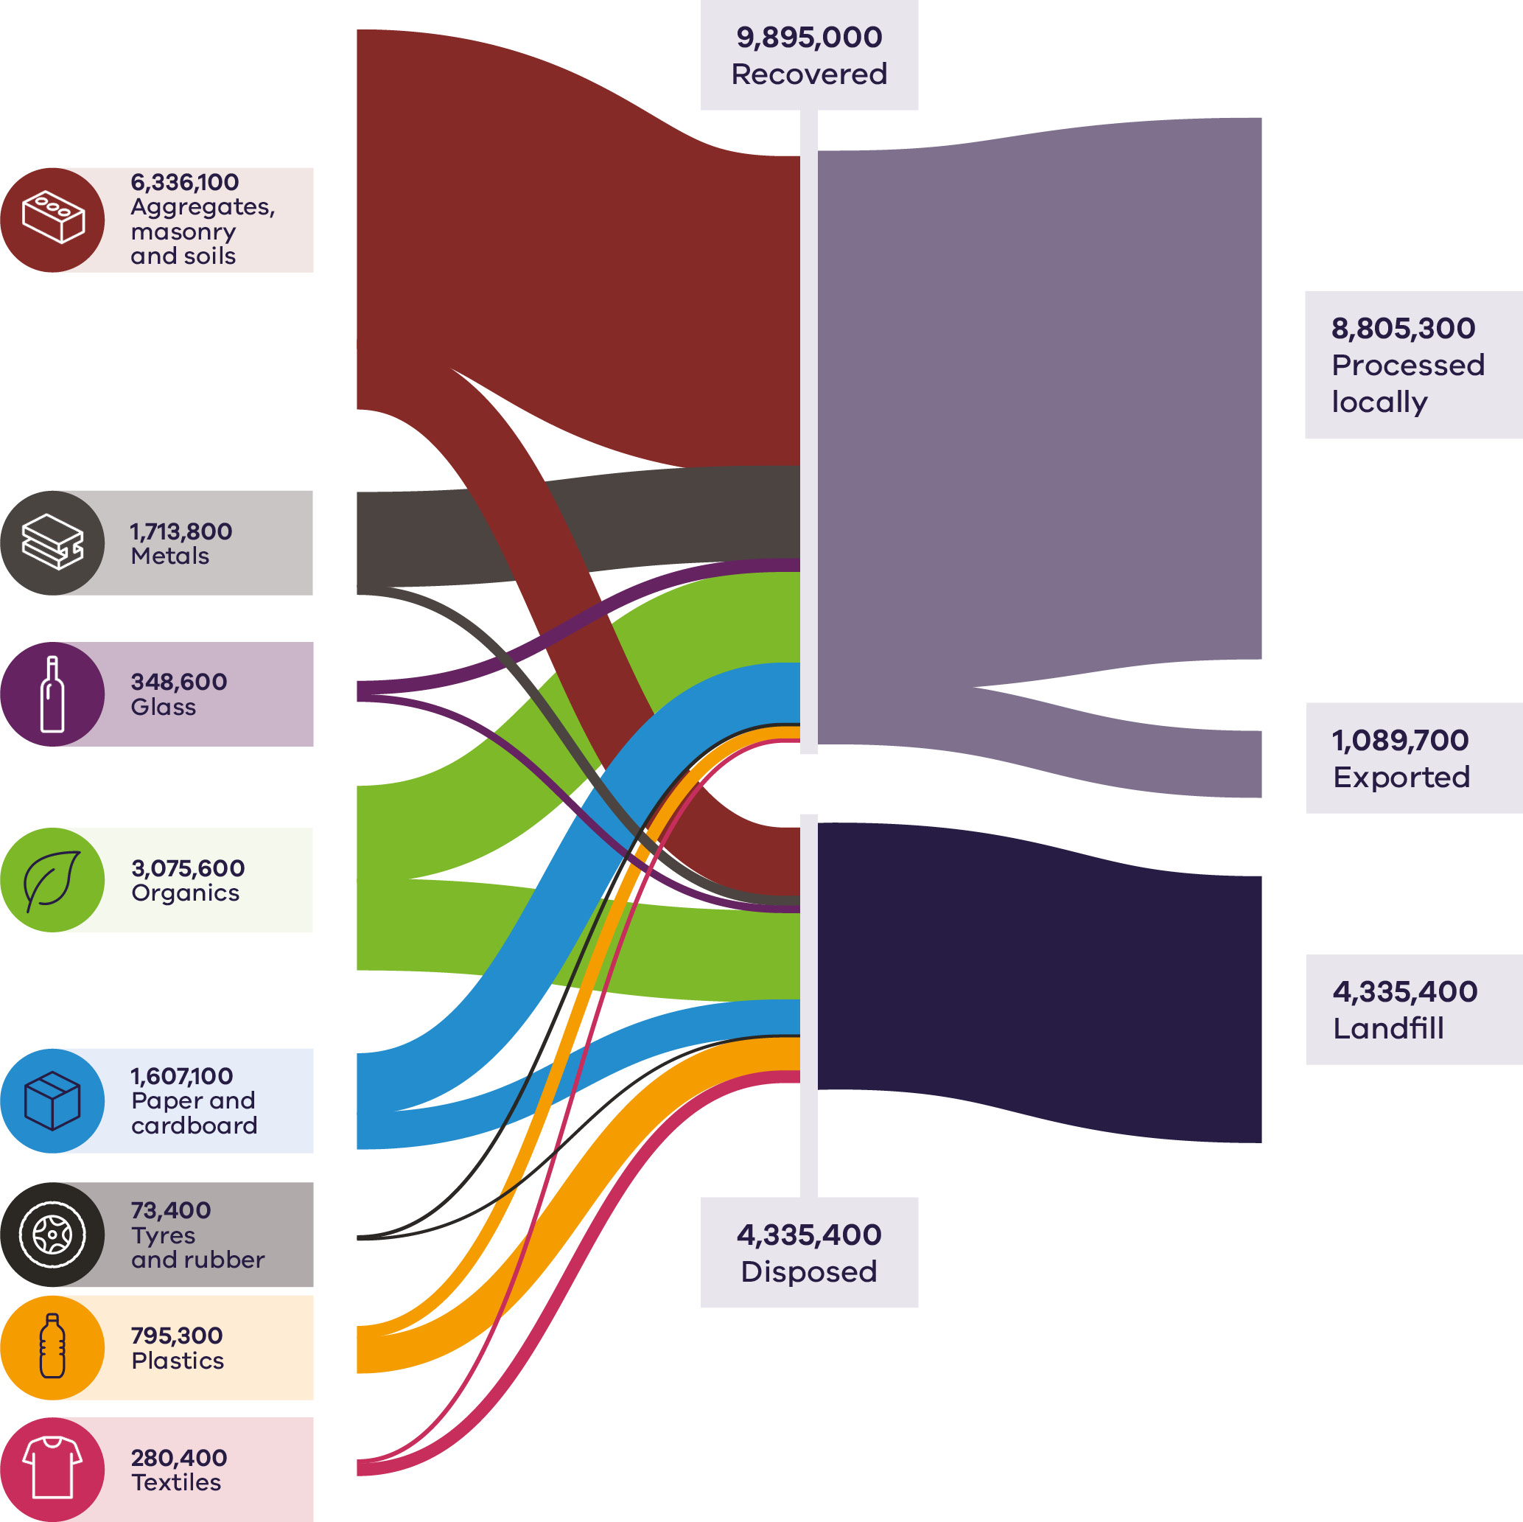

Resource recovery trends
Table 3: Comparison of material generation, recovery and disposal between financial years (Recycling Victoria 2024a) presents trends in resource recovery across Victoria between 2020–21 and 2023–24. Arrows indicate whether each parameter has increased or decreased compared with the previous year, while colour shading represents the overall direction of change across the period, green for favourable trends, orange for negative trends and yellow for stable performance.
Over this timeframe, C&D waste generation has continued to decrease, although disposal volumes have remained largely unchanged, resulting in a slight decrease in the overall recovery rate. In contrast, MSW generation has risen in line with population growth, but recovery performance in this sector has also improved, reflecting stronger household recycling and diversion initiatives. The C&I stream has shown relatively stable waste generation and recovery levels, indicating a steady but mature recovery performance across the sector.
Table 3: Comparison of material generation, recovery and disposal between financial years (Recycling Victoria 2024a)
Source sector | Total generation (million tonnes) |  |  |  |  | Recovered (million tonnes)
 | 20–21 | 21–22 | 22–23 | 23–24 | 4 year trend | 20–21 | 21–22 | 22–23 | 23–24 | 4 year trend
MSW | 3.3 | 3.5 | 3.6 | 3.7 | ↑ increase | 1.6 | 2.0 | 2.0 | 2.3 | ↑ increase
C&I | 4.9 | 4.3 | 4.2 | 4.3 | ↑ increase | 2.9 | 2.3 | 2.3 | 2.4 | ↑ increase
C&D | 7.7 | 6.6 | 6.7 | 6.2 | ↓ decrease | 6.6 | 5.6 | 5.6 | 5.1 | ↓ decrease
Total | 15.8 | 14.4 | 14.5 | 14.2 | ↓ decrease | 11.1 | 9.9 | 9.9 | 9.9 | « stable

Source sector | Disposed (million tonnes) |  |  |  |  | Recovery rate (%)
 | 20–21 | 21–22 | 22–23 | 23–24 | 4 year trend | 20–21 | 21–22 | 22–23 | 23–24 | 4 year trend
MSW | 1.7 | 1.5 | 1.6 | 1.4 | ↓ decrease | 49% | 57% | 56% | 62% | ↑ increase
C&I | 2.0 | 2.0 | 1.9 | 1.9 | « stable | 60% | 54% | 54% | 56% | ↑ increase
C&D | 1.1 | 1.1 | 1.0 | 1.0 | « stable | 86% | 84% | 84% | 83% | ↓ decrease
Total | 4.7 | 4.5 | 4.5 | 4.3 | ↓ decrease | 70% | 69% | 69% | 70% | ↑ increase

In 2023–24, total material generation in Victoria was 14.2 million tonnes, representing the lowest level recorded in recent years and continuing a general downward trend observed since 2020–21. The reduction is primarily associated with lower material generation in the C&D sector, potentially linked to increased on-site material re-use prior to classification as waste.
The C&D sector remains the largest contributor to total material generation by weight, accounting for 44% of all waste materials generated in 2023–24. This reflects the higher mass of materials typically produced in the sector, such as aggregates, masonry and soils. The MSW stream accounted for 26% of total material generation, with the remainder attributed to the C&I sector.
Material generation trends in the C&D sector since 2020–21 include:
- a 1 million tonne decrease in material generation from 2020–21 to 2021–22, likely caused by efficiencies in material use, as well as reduced sector activity
- a subsequent increase of approximately 100,000 tonnes from 2021–22 to 2022–23, likely reflecting a return to sector activity, particularly linked to transport infrastructure projects a significant decrease of approximately 500,000 tonnes from 2022–23 to 2023–24, possibly reflecting improvements for in-situ material recovery.

Material generation trends observed in the C&I sector since 2020–21 include:
- a 600,000 tonne decrease from 2020–21 to 2021–22, possibly influenced by COVID-19 which disrupted typical waste generation patterns as workplaces shifted to home-based activity
- a smaller subsequent drop of 100,000 tonnes from 2021–22 to 2022–23 return to 2021–22 levels in 2023–24.
Material generation trends observed in the MSW sector since 2020–21 include:
- a gradual increase in waste generation since 2020–21, possibly attributed to post COVID-19 population growth and the shift towards remote working.
Over the next 30 years total material generation is projected to increase by about 93%, increasing the state-wide generation to an estimated 27 million tonnes by 2053 (Recycling Victoria 2024a). C&D is the largest contributor to material generation and is projected to grow and contribute 53% of the total material generation in 2053. The C&I and MSW sectors are expected to decrease contribution to 25% and 22% respectively (Recycling Victoria 2024a).

Material generation per capita and Gross State Product
Gross State Product (GSP) measures the total economic output of Victoria and serves as the state-level equivalent of Gross Domestic Product (GDP), reflecting the value of goods and services produced across all sectors. Linking GSP to the circular economy enables assessment of not just economic growth, but also its efficiency and sustainability. Victoria’s Gross State Product is currently $606.1billion
By embedding circular principles such as resource recovery, product life extension and waste reduction into industry and infrastructure, Victoria can drive economic expansion while reducing reliance on virgin resources, minimising environmental impacts and supporting high-value job creation—achieving growth that is both productive and environmentally responsible.
The amount of waste material generated in Victoria by the 3 source sectors is shown compared with population across the last 5 monitoring years (Figure 5). The flattening of population growth in 2020–21 and 2021–22 corresponds to COVID-19 impacts. C&D waste generation has fallen by about 1.5 million tonnes since June 2021, while C&I generation peaked at just under 5 million tonnes in June 2021 before falling to 4.2-4.3 million tonnes in successive years. Waste generation in the MSW sector varied between 3.3 and 3.7 million tonnes across the past 5 years peaking in 2023–24 while the population approached 7 million (Figure 5).
Figure 5: Material waste generation by source compared with Victorian population
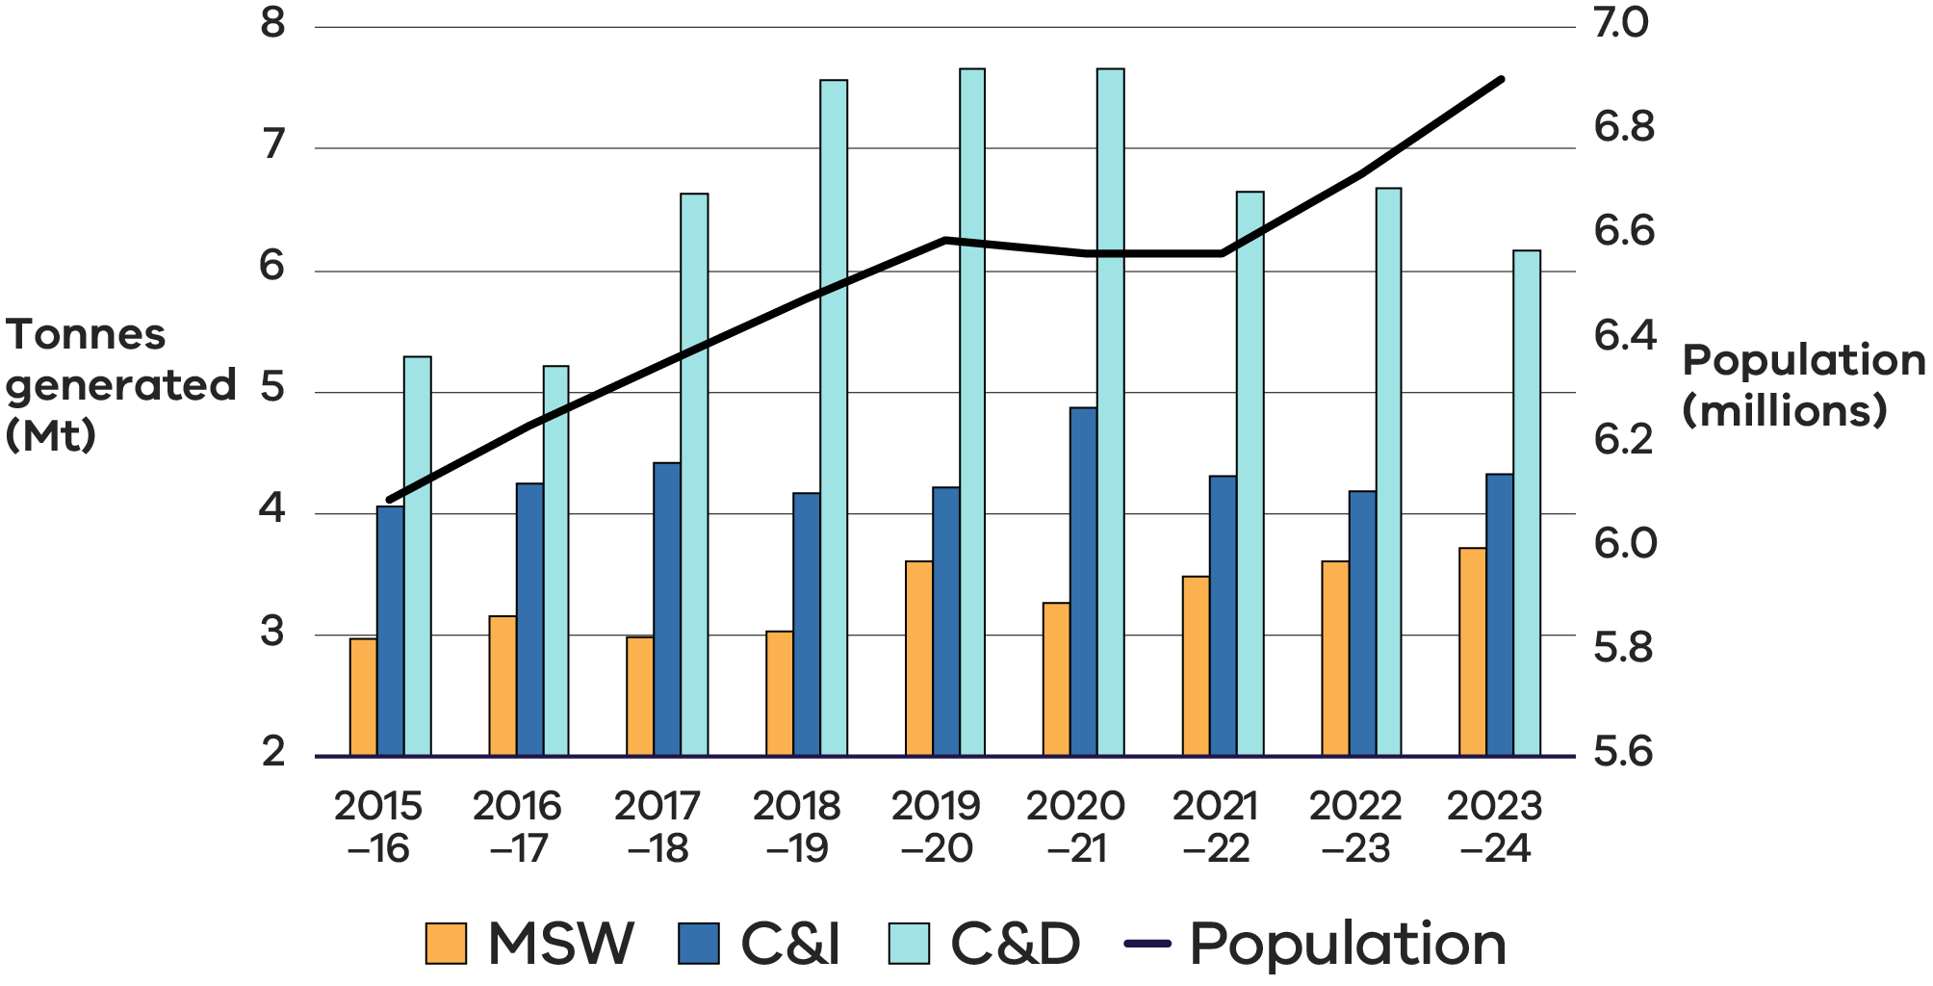
Figure 6 shows the MSW generated since 2015–16 compared with the population of Victoria in the same timeframe, highlighting the relationship between the population and amount of MSW generated
Figure 6: Annual MSW generation by source compared with Victorian population
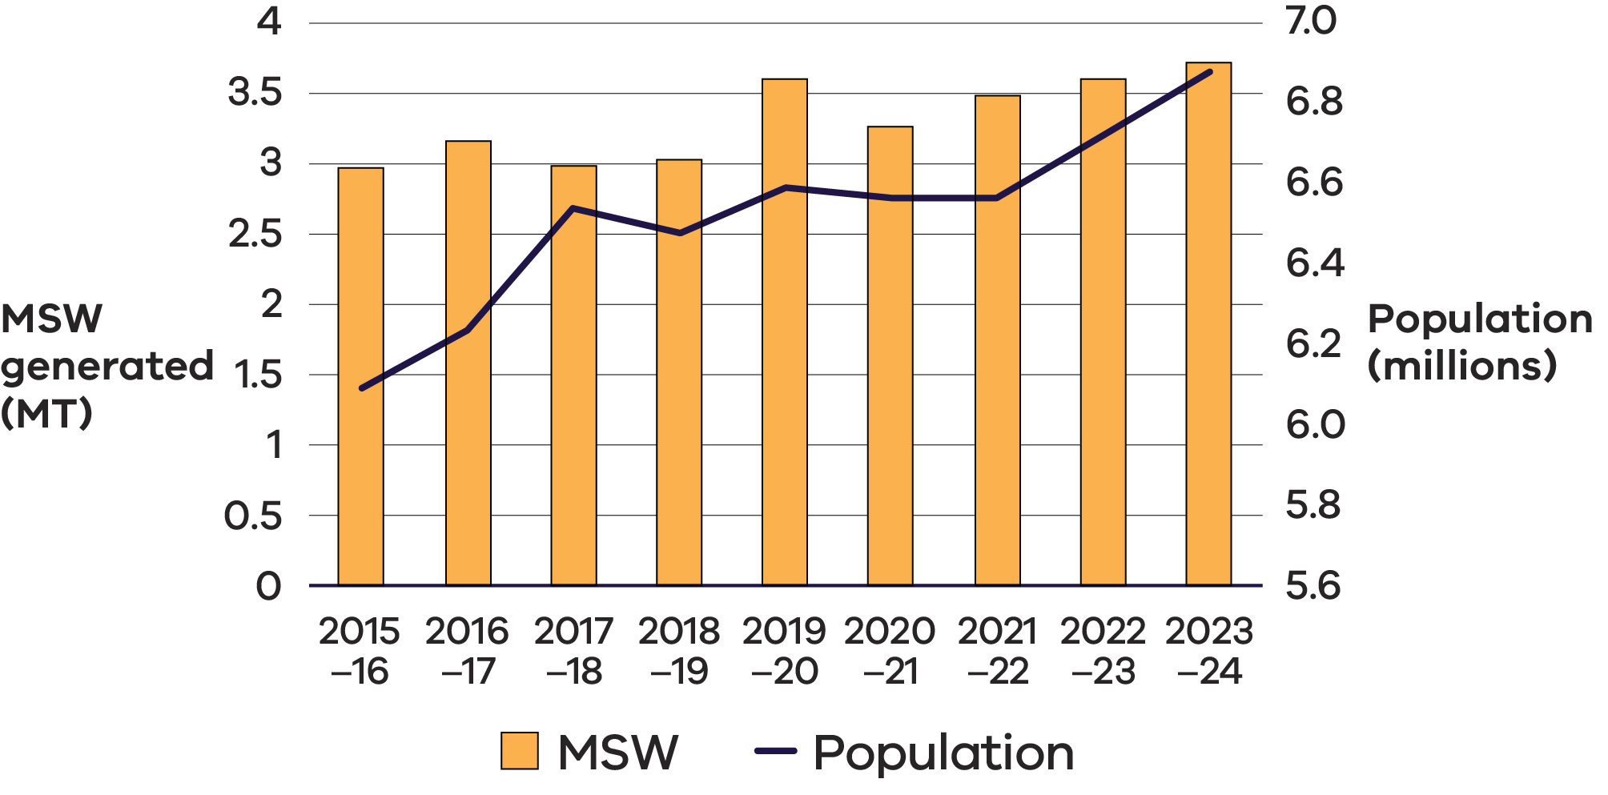
By contrast, the relationship between C&I waste generation and GSP (Figure 7) shows no correlation between them.
This suggests that in Victoria, waste generation does not mirror GSP growth. The C&I waste generation has remained consistent over the time frame in Figure 7, with 2020–21, the first full year of COVID-19, standing out as a partial outlier.
Figure 7: Waste generation by C&I compared with Victorian GSP
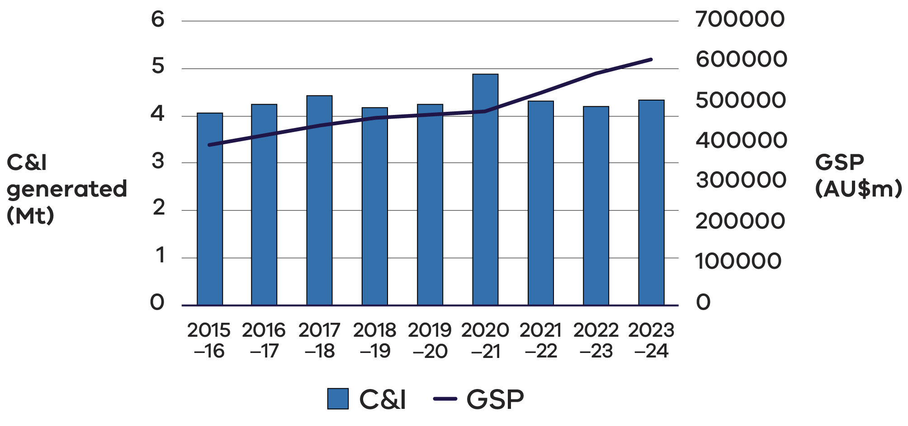

Material recovery
Figure 8 presents resource recovery rates by material type in Victoria for 2023–24. While recovery rates provide only a partial indication of circularity, they offer a useful comparative measure of performance across material streams. These rates help identify materials achieving higher levels of recovery in the Victorian market and where further improvement opportunities may exist.
Figure 8: Resource recovery rates for key materials in Victoria 2023–24
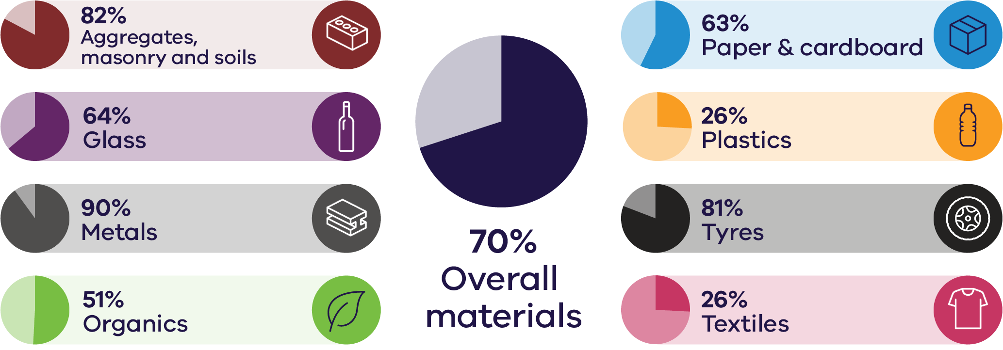
Across recent years, metals, tyres and aggregates, soils and masonry have had the highest recovery rates within Victoria, with textiles, plastics and organics having the lowest recovery rates (Table 4). Plastics have the most improved recovery rate among all key materials since 2020–21, though rates are very low relative to other waste streams.
Table 4: Comparison of recovery rates for 8 key material streams 2020–21 to 2023–24
Material | 2020–21 | 2021–22 | 2022–23 | 2023–24
Aggregate, masonry and soils | 85% | 83% | 83% | 82%
Glass | 71% | 63% | 64% | 64%
Metals | 89% | 89% | 88% | 90%
Organics | 50% | 47% | 48% | 51%
Paper and cardboard | 57% | 60% | 59% | 63%
Plastic | 18% | 23% | 23% | 26%
Tyres and rubber | 86% | 76% | 74% | 81%
Textiles | 23% | 21% | 24% | 26%
The recovery rate data across source sectors (Table 5) indicates steady performance among the key materials most relevant to the C&D sector, a positive trend in MSW recovery for all key materials (other than glass) and challenges in maintaining or improving recovery in the C&I sector and for specific material streams. Increased focus on improving waste management strategies for materials like plastics, textiles and organics could further improve recovery rates across all sectors.
The C&D sector continues to report the highest recovery rate among the 3 sectors, however, overall recovery rate in 2023–24 is marginally lower than observed in the 3 previous years. The strong performance in this sector is primarily driven by effective recovery in metals, glass and aggregates, masonry and soils since 2020–21, noting that glass recovery in 2023–24 is down on the recovery rates observed in the previous 2 years for this sector (Table 5).
The MSW sector has an overall recovery rate of 62% in 2023–24, representing a significant increase in recovery year on year since 2020–21. This improvement is likely a result of the continuing rollout of additional kerbside collection services, specifically FOGO. The changes are also linked to post COVID-19 behavioural shifts, with more people working from home, leading to increased waste being captured by household collection services.
The C&I sector has an overall recovery rate of 56% in 2023–24, which is an improvement on recovery in the previous 2 years, but down on the peak recovery observed in 2020–21 (Table 5).
Table 5: Recovery rate for key material streams across source sectors (2020–21 – 2023–24)
Material | MSW |  |  |  | C&I |  |  |  | C&D
 | 2020–21 | 2021–22 | 2022–23 | 2023–24 | 2020–21 | 2021–22 | 2022–23 | 2023–24 | 2020–21 | 2021–22 | 2022–23 | 2023–24
Aggregate, masonry and soils | 13% | 38% | 21% | 65% | 11% | 36% | 41% | 39% | 89% | 87% | 87% | 86%
Glass | 69% | 66% | 66% | 59% | 75% | 58% | 59% | 70% | – | 67% | 67% | 45%
Metals | 79% | 87% | 85% | 89% | 92% | 91% | 91% | 92% | 72% | 77% | 76% | 86%
Organics | 52% | 60% | 60% | 61% | 53% | 35% | 36% | 41% | – | 12% | 12% | 40%
Paper and cardboard | 45% | 53% | 52% | 68% | 63% | 64% | 64% | 58% | 56% | – | – | 1%
Plastic | 21% | 24% | 31% | 33% | 15% | 23% | 12% | 19% | 14% | 13% | 16% | 15%
Tyres and rubber | 57% | 61% | 53% | 78% | 88% | 79% | 77% | 82% | – | – | – | 0%
Textiles | 37% | 42% | 44% | 49% | 11% | – | 1% | 1% | – | – | – | 0%
Total | 49% | 57% | 56% | 62% | 60% | 54% | 54% | 56% | 86% | 84% | 84% | 83%
Note: Missing values indicate that no material was reported as recovered for that material in that year. This is likely due to variations in reporting or the material not being present in those recovery streams for the source sector.

Residual management
In 2023–24, just over 44% of Victoria’s disposed waste came from the C&I sector, making it the largest contributor. MSW accounted for just over 33% of total disposal, while the C&D sector contributed the remaining 23%.
The Victorian waste levy has increased steadily over time, rising from around $2 per tonne in 1992 to $63.28 per tonne in 2017–18 and reaching $129.27 per tonne in 2023–24. On 1 July 2025, the levy was further increased to $169.79 per tonne, aligning Victoria more closely with neighbouring jurisdictions (EPA 2025). These increases the cost of landfill disposal, to create stronger economic incentives for businesses and households to reduce waste, increase recycling and pursue recovery options.
By influencing disposal behaviour and encouraging material circularity, the waste levy directly supports Victoria’s circular economy objectives. Higher levy rates drive investment in reuse, recycling and recovery infrastructure, promote innovation in waste management practices and help divert materials from landfill, ultimately contributing to resource efficiency, emissions reduction and the sustainable growth of Victoria’s economy.

Performance by material

Aggregates, masonry and soil
Aggregate is a granular material used in construction. The most common natural aggregates include sand, gravel and crushed rock. Aggregates are used in a wide variety of applications including the construction of roads, pavements, building foundations and other parts of the built environment.
Demand for aggregate materials remains steady as an increasing population requires more materials for the construction of essential infrastructure including such as residential premises, roads, bridges, schools and hospitals – all important features in livability across Victoria. Recycled concrete aggregate is highly effective for use in road bases and hardstand areas due to its compaction properties, which result in stronger and more durable surfaces compared to virgin aggregate.
Masonry materials include heavy materials such as concrete, bricks and asphalt and are primarily generated by the construction industry. Masonry materials are the highest contributors to Australia’s total waste generation.
The soil referred to in this material stream is exclusively non-contaminated soil. Soil with contaminants above specified thresholds or containing asbestos is classified as contaminated soil and is a reportable priority waste. Material with extremely low contamination levels is commonly reused as fill material and utilised for levelling land or filling pits (EPA 2024). It is noted that most fill material does not enter the formal waste management system as it is reused onsite or transported directly to fill sites. When development projects generate contaminated soils, they are dealt with under ‘Hazardous wastes’ in the national waste database (DCCEEW 2025a) and not accounted for in the Victorian waste and recycling sector data.
Building and demolition wastes are recovered from most large development projects but less so from smaller projects including residential development, from which mixed material loads may be sent directly to landfill (DCCEEW 2025a).
Asphalt, bricks and concrete have a very high recovery rate reflective of the valuable application in the built environment. The recovery and reuse of materials like aggregates in the construction sector have become well-established practices. The processing of these materials locally has proven to be highly efficient, with substantial potential for regional investment. Due to the high transport costs associated with moving heavy materials over long distances and the relatively low technological requirements for reprocessing, local reprocessing capacity is well-positioned to meet growing demand across the state (Recycling Victoria 2024b).

Market performance
The most dominant material types by weight in this waste stream in 2023–24 were concrete, soils and bricks (Figure 9).
The overall recovery rate for aggregates, masonry and soil in Victoria in 2023–24 was 82%, consistent with recovery rates observed in the previous 3 years which ranged from 83-85%.
Figure 9: Aggregates, masonry and soil generated, recovered for processing and disposed of in Victoria in 2023–24 (tonnes)
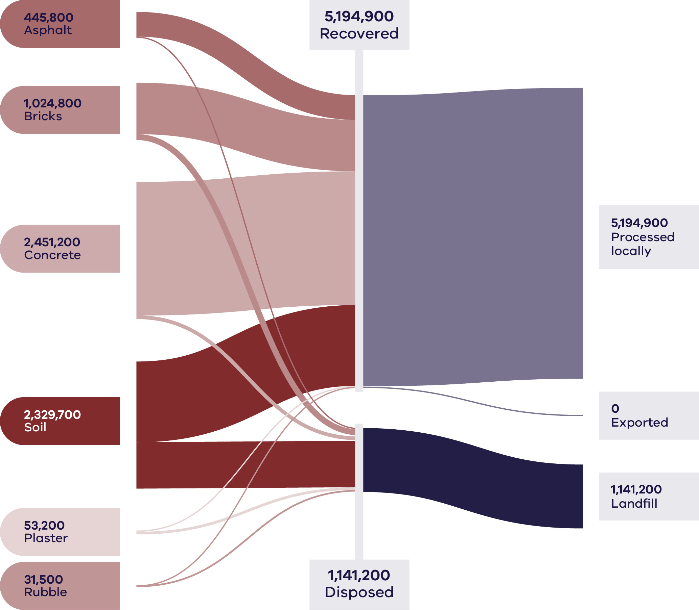
Resource recovery was largely driven by the C&D sector, with the MSW and C&I sectors generating a relatively low volume of material and lower recovery rates (65% and 39% respectively). There was a significant improvement in the MSW recovery rate from 21% in 2022–23 to 65% in the current period. Recovery rates for C&I and C&D were consistent between the 2 years.
As in previous years, there was no export of aggregates, masonry and soil from Victoria in 2023–24. All processing is carried out in Victoria, ensuring that the investment and full value of resource recovery activity is captured locally. Aggregates, masonry and soil combined, are Victoria’s largest waste stream by mass (6.3M tonnes in 2023–24), representing 45% of all state-wide waste generation. Most (90%) of this material was generated and managed by the C&D sector (Table 6).

Table 6: Source streams and recovery rates for aggregates, masonry and soils in Victoria in 2023–24
Stream | Generated |  | Recovered for reprocessing |  |  | Disposed | Recovery rate
 |  |  | Processed locally | Exported | Total
 | Tonnes | Proportion | Tonnes | Tonnes | Tonnes | Tonnes | %
MSW | 183,300 | 3% | 118,500 | 0 | 118,500 | 64,800 | 65%
C&I | 423,000 | 7% | 167,000 | 0 | 167,000 | 256,000 | 39%
C&D | 5,729,800 | 90% | 4,909,400 | 0 | 4,909,400 | 820,400 | 86%
Total | 6,336,100 |  | 5,194,900 | 0 | 5,194,900 | 1,141,200 | 82%

Material | Generated |  | Recovered for reprocessing |  |  | Disposed | Recovery rate
 |  |  | Processed locally | Exported | Total
 | Tonnes | Proportion | Tonnes | Tonnes | Tonnes | Tonnes | %
Asphalt | 445,800 | 7% | 440,200 | 0 | 440,200 | 5,600 | 99%
Bricks | 1,024,800 | 16% | 919,000 | 0 | 919,000 | 105,900 | 90%
Concrete | 2,451,100 | 38% | 2,384,800 | 0 | 2,384,800 | 66,300 | 97%
Plaster | 53,200 | 1% | 6,000 | 0 | 6,000 | 47,200 | 11%
Rubble | 31,500 | 1% | 1,400 | 0 | 1,400 | 30,100 | 4%
Soil | 2,329,700 | 37% | 1,443,600 | 0 | 1,443,600 | 886,100 | 62%
Total | 6,336,100 |  | 5,194,900 | 0 | 5,194,900 | 1,141,200 | 82%

Increased rates of waste generation for this material stream are highly correlated with high rates of urban development (DCCEEW 2025a). Nationally, building and demolition waste generation grew by 33% from 2016–17 to 2022–23, whilst the recovery rate increased from 76% to 84% in the same period (DCCEEW 2025a).
With the construction industry being the fourth largest employer in Victoria (Victorian Government n.d.), there are strong and viable local end markets for recycled materials across the state. Because of factors such as transport costs and carbon emissions, the uptake of recycled or reused materials in these projects is higher in metropolitan Melbourne than in regional areas.
Nationally, there are good markets for recycled concrete aggregates for use as road base, aggregates and hardstand areas. This is due to the ability to consolidate well and form a harder and more stable hardstand than pure virgin aggregate. There are also good options for recycling bricks and asphalt.
Recovered aggregates and masonry materials remained cost-competitive compared with virgin quarry materials during 2023–24.
Prices for clean crushed concrete and recycled road base ranged from $10 to $60 per tonne, depending on grade and distance to site. The Victorian landfill levy increase and local government procurement specifications (such as VicRoads Class 2 recycled crushed concrete) supported stable demand.
Clean fill and screened soil traded between $15 and $60 per tonne, reflecting strong uptake in construction and landscaping sectors. Market competitiveness is primarily influenced by transport cost and the availability of local quarries.

Developments and changes
Victoria’s rapid growth and investment in major infrastructure projects continue to increase demand for quarry products such as soil, sand and rock. This is consistent with projections of demand doubling between 2015 and 2050 (Resources Victoria 2023).
The Victorian Government’s ecologiQ initiative, supported by the Recycled First policy, has continued to provide end market pull-through of aggregates and masonry into large government infrastructure projects (ecologiQ 2024). In its Economic Growth Statement (DTF 2024), the Victorian Government has committed to expand the Recycled First policy to major government projects in non-transport sectors.
Commissioning of a new $15 million asphalt plant in Warrnambool’s industrial estate began in early 2025. The Fulton Hogan plant in the Horne Road industrial estate replaces the local 30-year-old facility and has greater capacity to process recycled product, including recycled glass and asphalt. Raw materials such as dust, crushed glass, rock and sand are combined with bitumen and fed into a drum which heats it to 170 degrees and the processed material is laid on roads (Lovell 2025).

Market issues and challenges
The amount of aggregate, masonry and soil waste generated is projected to grow to nearly 15 million tonnes annually over the next 30 years, from the current level of 6.3 million tonnes per annum (Recycling Victoria 2024a).
In smaller construction projects, mixed material loads are frequently sent directly to landfill, perpetuating reliance on virgin materials. Approximately 17 cubic metres of waste is generated in the construction of a house and costs the buyer about AU$10,000 to send to landfill (DCCEEW 2024b). Compared to large-scale projects, smaller projects are more likely to have barriers towards circularity such as a comparative lower purchase power to leverage.
The generation of spoils of all types (the supply) and the need for spoils offsite (the demand) are difficult to coordinate and timing may not align. Spoils vary and quick removal from the generating site is often needed. The lack of approved local sites for the offsite use of spoils increases transport distances and cost significantly and constrains an otherwise major spoils market.
The reuse of materials, particularly soil, can sometimes be hindered by lack of space to sort and temporarily store material.
Focus areas for greater circularity – aggregates, masonry and soils
Opportunities to make this material stream more circular include:
- reuse of existing assets (for example, renovating buildings rather than demolishing them)
- project design choices that embed circularity (such as using prefabricated or modular layouts)
- increased use of circular materials
- exploring the potential of additional spoil infrastructure, including physical soil banking and virtual soil banking to enhance reuse of waste.

Glass
Glass is a key material used in a wide range of applications including windows, food and beverage packaging, solar panels, electronics (such as device screens), medical technologies and fibre optic cables. One of the unique qualities of glass is its ability to be endlessly recycled – melted down and reshaped without losing its structural integrity (Sustainability Victoria 2025b). Australia’s major glass manufacturers Visy and Orora are both working to increase the recycled content of their product (DCCEEW 2025a) both in Victoria (Visy) and South Australia (Orora).
The market demand for glass-based construction materials remains high. The glass recovery sector is serviced by glass beneficiation plants, glass crushing processors and a packaging manufacturing plant.
Recovered glass packaging markets in Victoria are stable and improving but the volume of glass suitable for recycling can be improved. A large proportion of glass recovered in Victoria is still sourced from the mixed recycling stream. This reduces the amount of cullet (>3mm) that can be recovered for recycling, compared to glass sourced through the container deposit scheme and separate glass collection services.
Glass fines, the remnants of glass containers less than 3mm and unable to be sorted by colour, are generally crushed into glass sand and incorporated into construction materials such as road base. The use of glass sand in construction in Victoria is supported by changes to construction specifications that support an increase in the volume of glass sand that can be used in rail and road construction.

Market performance
The overall recovery rate for glass in Victoria in 2023–24 was 64%, as was the case in 2022–23. This is consistent with the recovery rate of 63% observed in 2021–22, but less than the recovery rate of 71% observed in 2020–21.
Glass continues to have a high circularity opportunity, with the ability to remanufacture glass packaging into new glass packaging. Producing new glass material from cullet uses around 20–30% less energy compared to glass from virgin silica sand (Recycling Victoria 2025).
Figure 10: Glass generated, recovered for processing and disposed of in 2023–24 (tonnes)
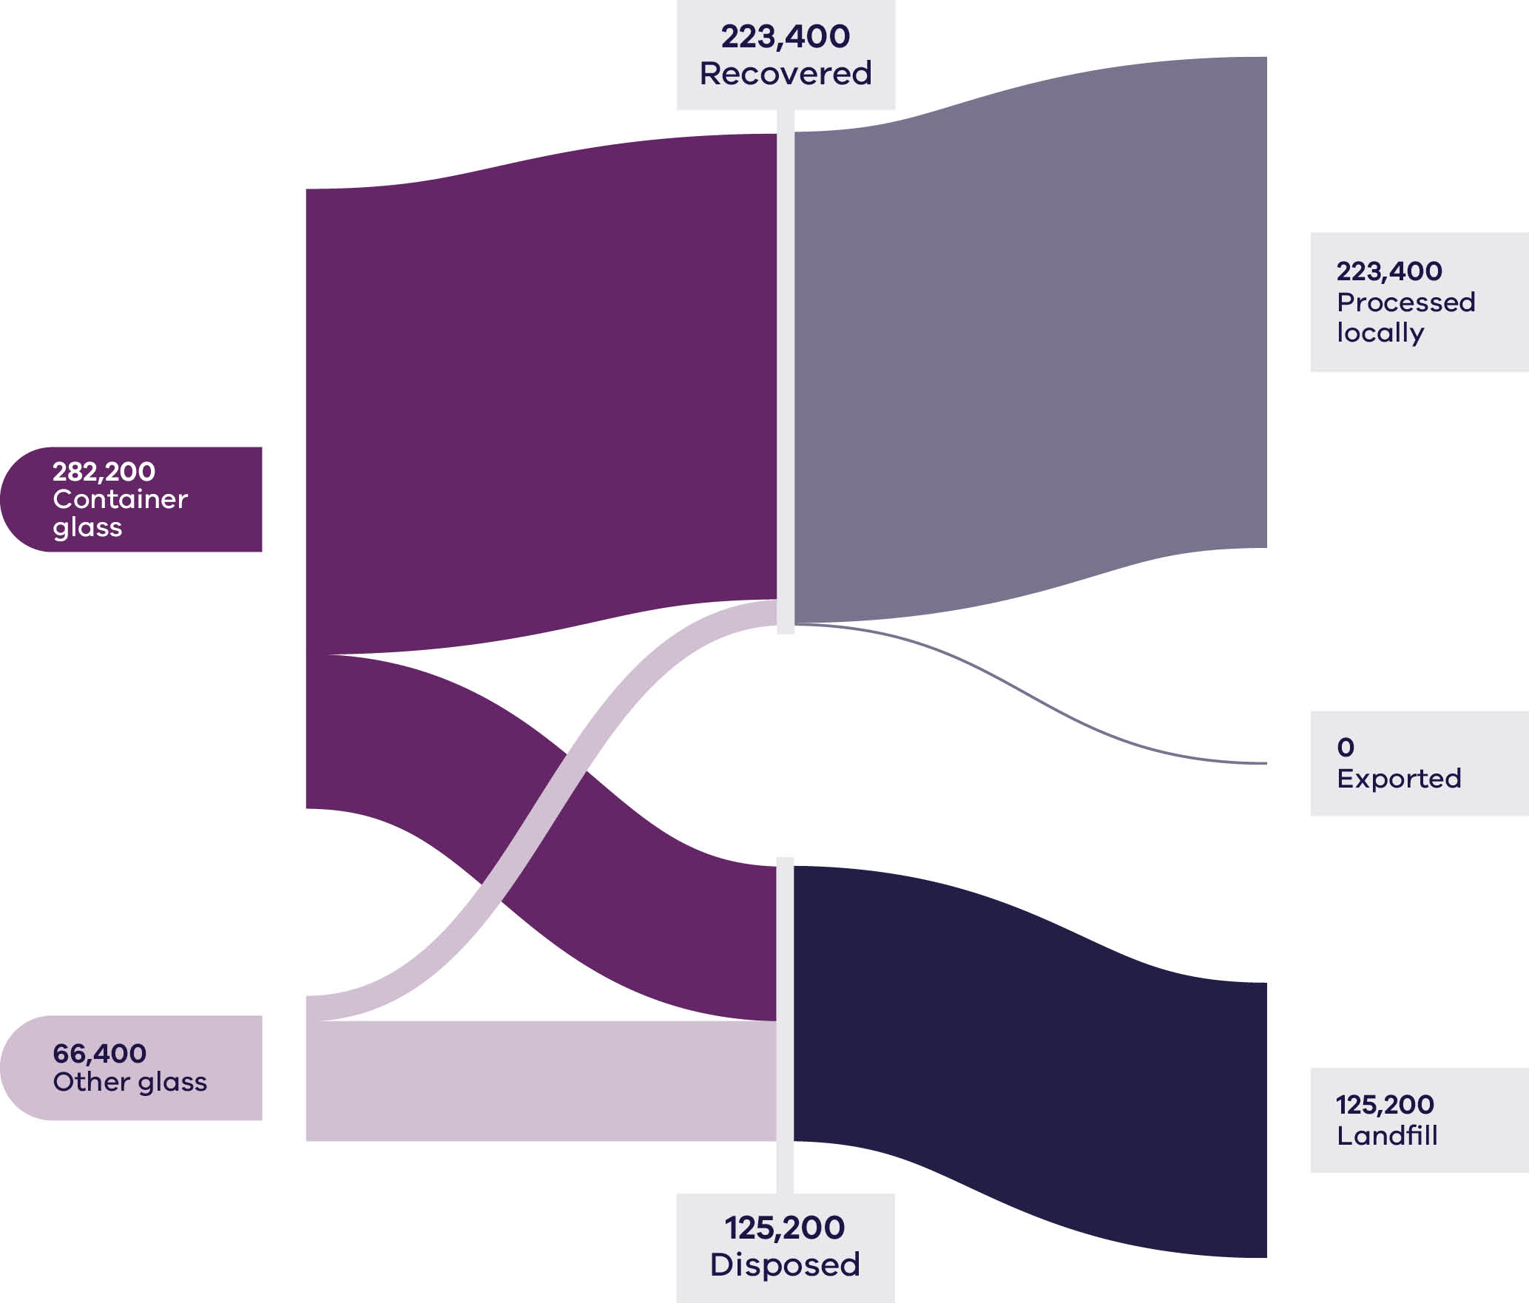
Households (MSW) and C&I each contributed 49% to the generation of glass waste (Figure 10) in 2023–24. The recovery rate for ‘container glass’ (75%) is significantly higher than that observed for ‘other glass’ (17%) in 2023–24. The same recovery rates were noted in 2022–23 for these material types.
Based on 2022–23 commodity values, it is estimated that almost $22 million from the glass sector was lost in landfill in 2023–24, compared to approximately $39 million of recovered material.
There was no export of glass materials out of Victoria in 2023–24 (Table 7). Export tonnages have been a very minor component (<0.1%) of all recovered glass in previous monitoring years, with almost all material reprocessed locally.
Beneficiated container glass maintained moderate values, with cullet prices averaging $120–$250 per tonne. Exported cullet achieved around $130–$160 per tonne early in 2023–24. Price growth is expected as domestic beneficiation capacity scales up.
The introduction of Victoria’s Container Deposit Scheme (CDS Vic) in late 2023 significantly increased feedstock supply and improved colour sorting. Domestic glass beneficiation capacity expanded, improving quality and consistency.
Export of mixed glass under the Recycling and Waste Reduction (Export-Waste Glass) Rules 2020 has been regulated nationally since January 2021. The regulations require additional processing and licencing prior to export. National exports subsequently fell from 3% of recovered glass to 0.1% (DCCEEW 2025a), consistent with Victorian trends.

Table 7: Source streams and recovery rates for glass in Victoria in 2023–24
Stream | Generated |  | Recovered for reprocessing |  |  | Disposed | Recovery rate
 |  |  | Processed locally | Exported | Total
 | Tonnes | Proportion | Tonnes | Tonnes | Tonnes | Tonnes | %
MSW | 169,600 | 49% | 100,700 | – | 100,700 | 69,000 | 59%
C&I | 171,700 | 49% | 119,500 | – | 119,500 | 52,200 | 70%
C&D | 7,300 | 2% | 3,200 | – | 3,200 | 4,000 | 45%
Total | 348,600 |  | 223,400 | – | 223,400 | 125,200 | 64%

Stream | Generated |  | Recovered for reprocessing |  |  | Disposed | Recovery rate
 |  |  | Processed locally | Exported | Total
 | Tonnes | Proportion | Tonnes | Tonnes | Tonnes | Tonnes | %
Container glass | 282,200 | 81% | 211,800 | – | 211,800 | 70,400 | 75%
Other glass | 66,400 | 19% | 11,600 | – | 11,600 | 54,800 | 17%
Total | 348,600 |  | 223,400 | – | 223,400 | 125,200 | 64%

Developments and changes
Improvement in the circularity of glass has long been a target in the glass packaging market. Glass containers are approximately 40% lighter than they were 30 years ago (Glass Packaging Institute n.d.)
The recycled glass content has grown from about 30-35% in 2020 to a target range of 60-70%. In April 2025 Visy announced it had achieved an average of 70% recycled glass content in its locally made bottles and jars in New Zealand (Visy 2025).
CDS Vic has collected more than 2 billion eligible containers in less than 2 years at over 600 refund points across the state. Over 60,000 tonnes of CDS collected material was sold to recycling companies in 2024–25, with an overall CDS return rate of 62% as of 30 June 2025.
As at September 2025, 42 of the 79 Victorian councils have introduced access to separate glass collection, including 26 with a separate kerbside glass service.
In February 2025, Oceania Glass announced the closure of Australia’s only architectural glass manufacturer (Lucadou-Wells and Li 2025).

Market issues and challenges
The glass recycling stream is expected to grow by more than 50% over the next 30 years, with Victoria projected to generate over 500,000 tonnes by 2053.
Glass recycling facilities in Victoria (also referred to as glass beneficiation plants) sort and clean the mixed glass product, which helps increase the percentage of recycled content in glass packaging. Glass collected in the mixed recycling stream is often broken into finer shards and contaminated with other materials like plastics and debris, which makes it difficult to separate and recycle glass effectively. Broken glass can also contaminate other material streams such as paper and cardboard, hindering their recovery. The Laverton Glass Beneficiation Plant, which opened in 2024, is a state-of-the-art facility that processes up to 200,000 tonnes of glass, sorting it by size and color for remanufacturing into new bottles and jars.
Although recovery of small shards or heavily damaged glass may be suitable for construction and infrastructure applications (such as in road base), it is important that the principles of the waste hierarchy are observed. Glass from beverage containers that is recycled into new containers has a higher circularity impact than glass in lower grade construction material and asphalt.
Victoria is addressing the issue through the introduction of a standardised household recycling system with a separate glass stream and the establishment of CDS Vic. The establishment of a container deposit scheme without a separate glass household stream may partially improve the quality of glass and other mixed recyclables, by leading to further separation. However, a container deposit scheme alone is unable to remove all glass from mixed recycling because some people are unable or unwilling to utilise it. Maximising glass separation from mixed recycling through a separate glass stream can realise the greatest recovery benefits.

Focus areas for greater circularity – glass
Opportunities to make the glass stream more circular include:
- recovery of separated glass from C&I
- transitioning to a standardised household recycling system
- understanding and addressing barriers to transporting separated glass to beneficiation, including from regional areas.

Case Study: Remanufacturing glass – Victoria’s circular container solution
Visy’s investment in glass beneficiation and remanufacturing infrastructure in Victoria demonstrates the practical application of circular economy principles, particularly recover, remanufacture, reuse and reintegrate.
The company committed $50 million to upgrade its Laverton glass beneficiation facility, first announced in 2021 and officially opened in February 2024, doubling Victoria’s glass recycling capacity. The Laverton plant now processes up to 200,000 tonnes of glass cullet annually, equivalent to approximately 150 recycled bottles and jars per Victorian per year, ensuring the state’s entire recyclable glass stream can be recovered and reintegrated into new products.
The new facility addresses a key technical limitation in traditional glass recycling. The older plants could only separate glass down to 10 mm, leaving smaller glass fragments (less than 10 mm) along with any reject ‘glass-like material’ such as ceramics and Pyrex for use in low-value applications such as road base. The new Laverton facility employs 21 state-of-the-art optical sorters capable of separating glass down to cullet to 3 mm in size and into 3 colours – flint, amber and green.
This advancement improves recycling efficiency, increases the volume of material recovered for higher-value applications and enables the plant to process glass fragments that previously couldn’t be recovered for bottle to bottle remanufacture. The new facility doubles its throughput while contributing to multiple circular economy objectives including diverting waste from landfill, reducing resource extraction and enabling local remanufacturing.
Recovered glass from Laverton is transported approximately 15 minutes away to Visy’s Spotswood glass furnace, the only facility of its type in Victoria. Here it is remanufactured into new glass jars and bottles. The Spotswood plant produces around 3 million glass containers every day.
The operation supported 92 jobs during construction and supports 6 ongoing operational positions, highlighting the socio-economic benefits of industrial circularity. The remanufacturing process integrates recycled content into new containers, with a target of 70% recycled glass in locally made bottles and jars. This demonstrates the full material loop from collection, beneficiation and remanufacture to finished product.
The Visy project exemplifies the 10R framework in action. Recover and recycle are demonstrated through high-efficiency cullet sorting, while remanufacture and reintegrate are realised through the production of new glass containers using recovered material. The project also contributes to reduce by substituting virgin raw materials and rethink by designing plant processes that maximise material recovery and product quality.
Mark de Wit, CEO of Visy said ‘This marks a major milestone for both Victoria and Visy. We’re now able to recycle 100% of Victoria’s glass bottles and jars right here in the state. It will also help us achieve our goal of an average 70% recycled content in our locally made glass bottles and jars. It’s a powerful demonstration of the circular economy in action’.
By enabling all of Victoria’s recyclable glass to be processed locally, Visy’s Laverton and Spotswood facilities illustrate a scalable and technically sophisticated model of circular economy practice in the glass sector. The integration of advanced sorting, local remanufacturing and high recycled content in new products positions Victoria as a leader in sustainable packaging and resource efficiency. This provides a replicable example of how industrial infrastructure can operationalise circular economy principles at scale.

Metals
Sources of waste metals in Victoria include:
- packaging from households
- commercial businesses and the hospitality industry
- components from discarded furniture, household appliances and e-waste
- scrap generated by industrial manufacturing processes
- materials from end-of-life vehicles
beverage containers.
The greatest proportion of recovered metals in Victoria is structural steel and aluminium (Recycling Victoria 2024a). Packaging metals, particularly those from food and beverage containers, make up a small portion of the total recovery, typically 3–4% of household recycling bin contents.
In Australia, more than 90% of steel is recycled at the end of life. Recycled steel is less resource-intensive than primary steel, eliminating the need for over 1400 kg of iron ore, 740 kg of coal and 120 kg of limestone for every 1000 kg of steel scrap recycled into new steel (Circular Australia and Arup 2024).
The waste metals recovery and reprocessing system is well established and the industry is mature. There is strong dependence on exporting processed metals.
The domestic metal recycling market is based on many small scrap metal collectors who collect material so that it can be aggregated into sufficient volumes to be managed. Waste generation and management levels have been relatively stable for several years. Generally, steel and aluminium packaging is recycled back into post-consumer metal pools to manufacture durable applications such as vehicles, building materials and many other products.
Exported steel and aluminium packaging are sold into large markets. The material flows from all countries are destined for wherever the demand is present for metal for production. Demand and pricing can fluctuate based on worldwide conditions.
E-waste has been banned from landfill in Victoria since 2019 and is considered a ‘priority waste’ under the Environment Protection Act 2017. This prevents some toxic metals (including cadmium and cobalt) and precious metals (such as gold and palladium) from landfill.

Market performance
The overall recovery rate for metals in Victoria in 2023–24 was 90% which is consistent with the previous 3 years where metals recovery ranged between 88-89%.
Approximately 37% of all scrap metal generated was exported in 2023–24, making it the biggest export component of recyclable materials, as was the case in 2022–23. Over 60% of all recovered aluminium was exported for processing in 2023–24, compared to 70% total aluminium recovery in 2022–23 (Figure 11). Victoria does not have local aluminium reprocessing capacity, so relies on the export market for managing this material stream. A total of 634,700 tonnes of metals were exported internationally in 2023–24, compared to 606,800 tonnes in 2021–22 and 512,200 tonnes in 2022–23.
Figure 11: Metals generated, recovered for processing and disposed of in 2023–24 (tonnes)
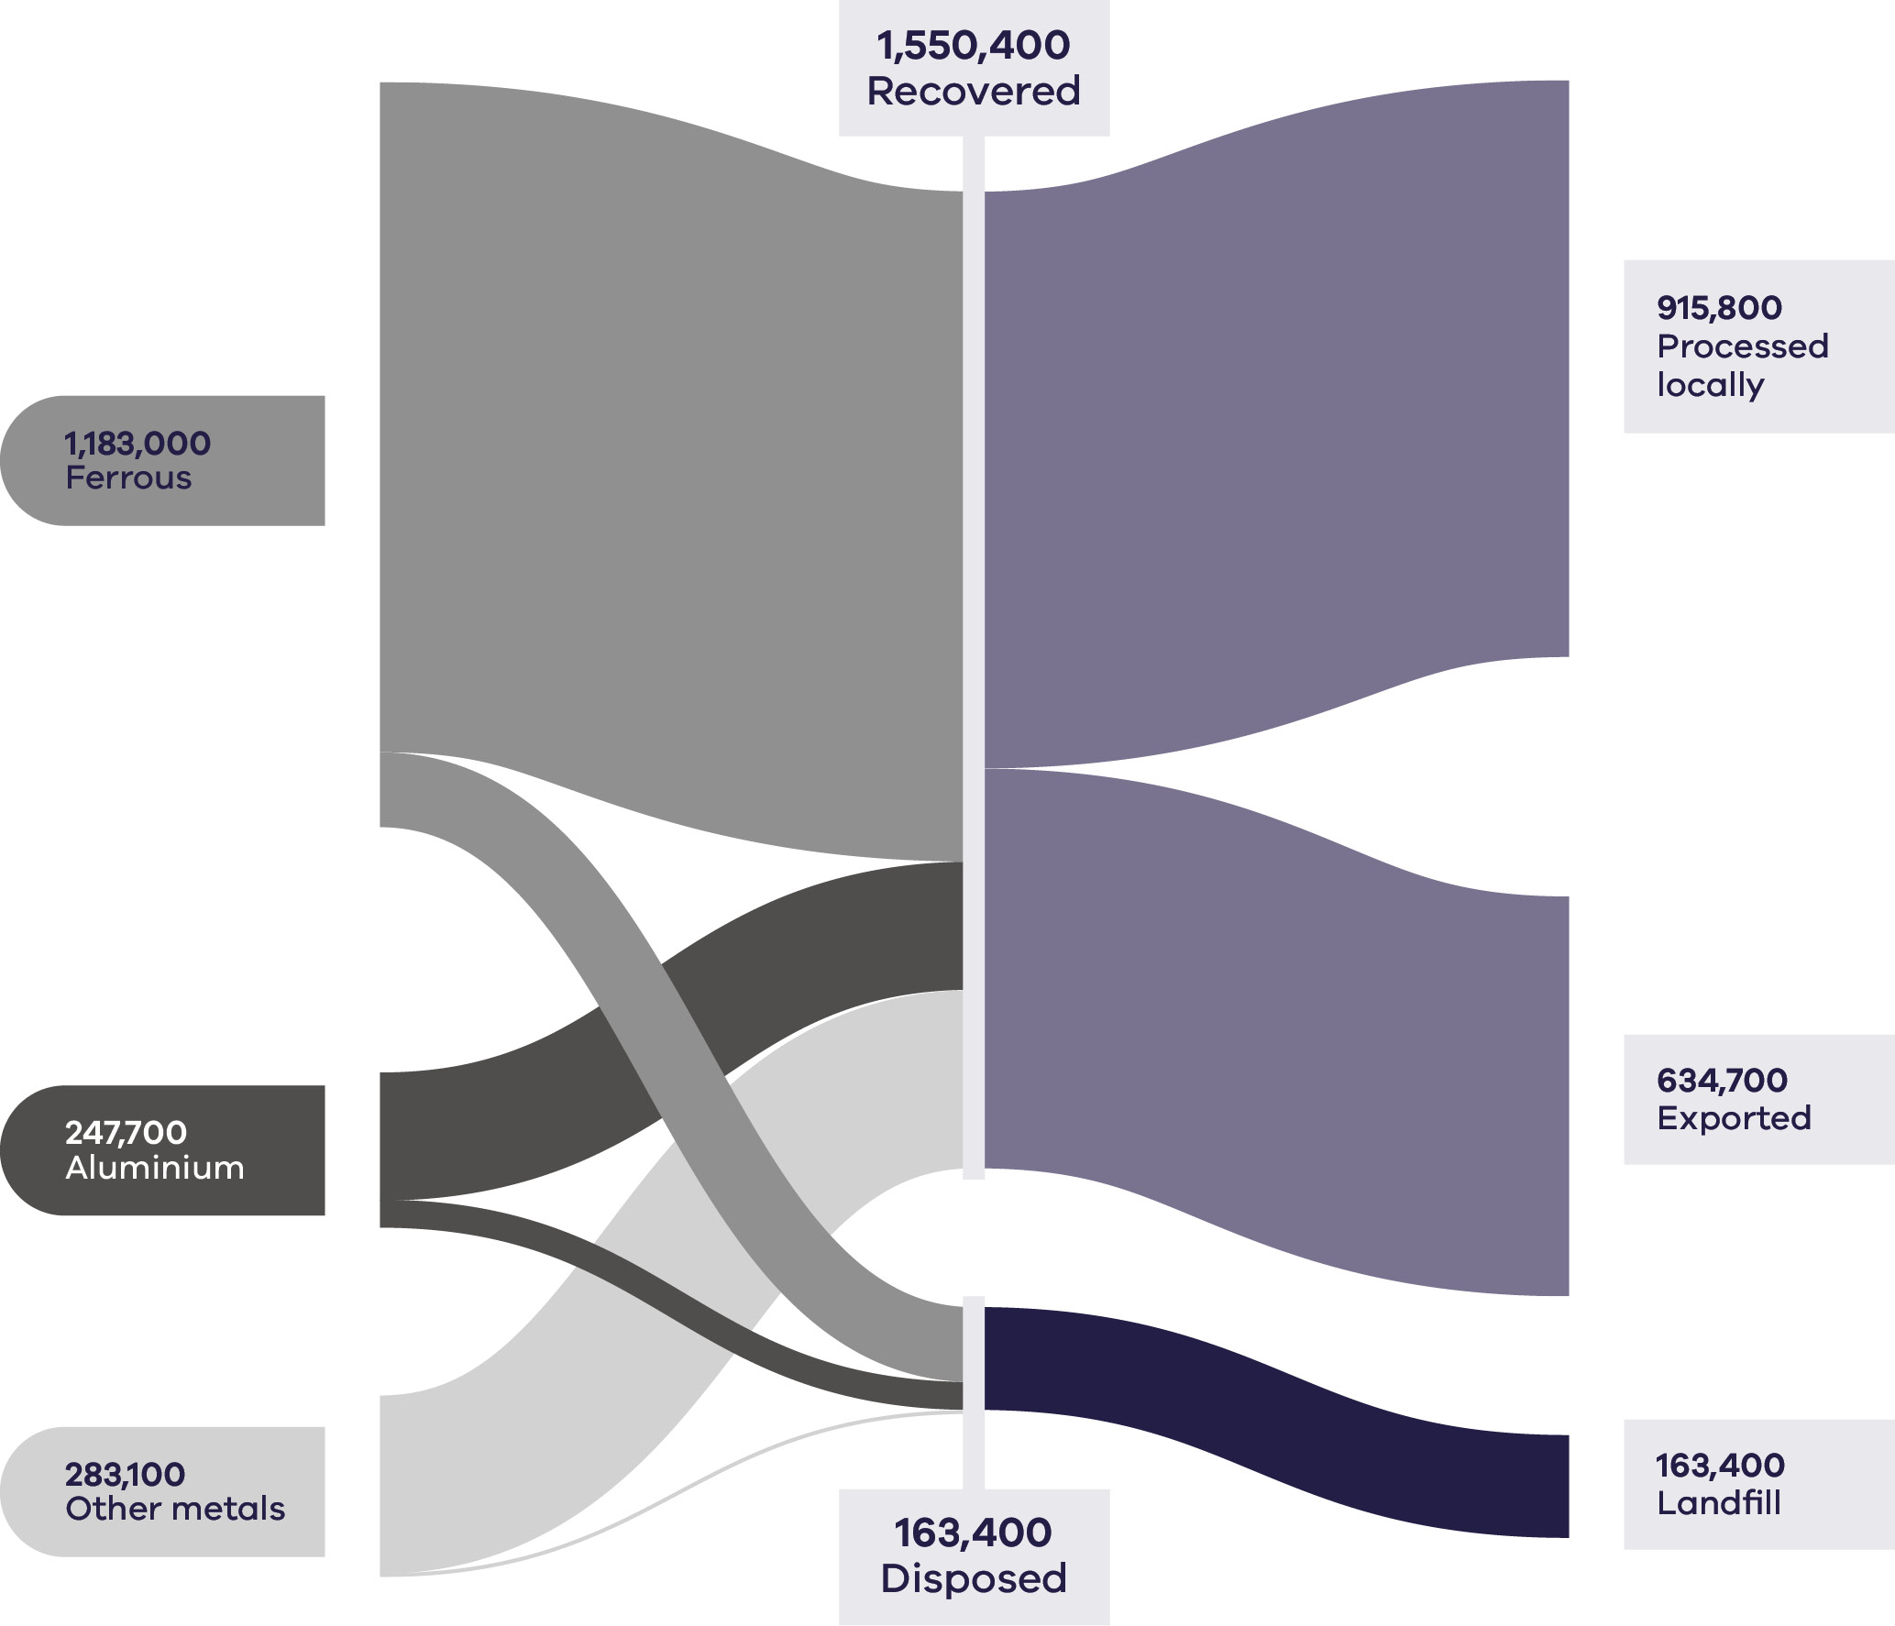
C&I was the largest contributor to the generation of metal (66%) and maintained a similar recovery rate (92%) to the previous 3 years. A key driver of the high recovery rate for metal waste is the high commodity prices that can be achieved (Recycling Victoria 2024b). The rate of recovery exceeded 80% across all sectors in 2023–24. Similarly high recovery rates were observed in recent monitoring years.
Approximately 53% of recovered metal waste was processed locally in 2023–24 (Table 8).
All ‘other metals’ were processed locally or exported internationally in 2023–24, with similarly high processing rates reported in previous years and no disposal of this material type to landfill.

Table 8: Metal flows by stream and material sub-groups for 2023–24
Stream | Generated |  | Recovered for reprocessing |  |  | Disposed | Recovery rate
 |  |  | Processed locally | Exported | Total
 | Tonnes | Proportion | Tonnes | Tonnes | Tonnes | Tonnes | %
MSW | 444,200 | 26% | 220,800 | 173,300 | 394,100 | 50,100 | 89%
C&I | 1,123,500 | 66% | 612,100 | 419,000 | 1,031,100 | 92,400 | 92%
C&D | 146,000 | 9% | 82,800 | 42,300 | 125,200 | 20,900 | 86%
Total | 1,713,800 |  | 915,800 | 634,700 | 1,550,400 | 163,400 | 90%

Stream | Generated |  | Recovered for reprocessing |  |  | Disposed | Recovery rate
 |  |  | Processed locally | Exported | Total
 | Tonnes | Proportion | Tonnes | Tonnes | Tonnes | Tonnes | %
Aluminium | 247,700 | 14% | 55,600 | 147,800 | 203,400 | 44,400 | 82%
Ferrous | 1,183,000 | 69% | 600,400 | 463,600 | 1,064,000 | 119,000 | 90%
Other metals | 283,100 | 17% | 259,800 | 23,300 | 283,100 | 0 | 100%
Total | 1,713,800 |  | 915,800 | 634,700 | 1,550,400 | 163,400 | 90%

It is estimated that while the recovered material had a potential value of $2.34 billion, material with a value of $247 million was lost to landfill in Victoria in 2023–24, indicating an opportunity for improved recovery.
The pricing for recycled steel and aluminium reflect that these feedstocks are highly integrated into global markets for virgin commodities. Therefore, these prices tend to reflect global influences on demand and supply, including perceptions of future global growth. Aluminium cans had a scrap price of about $2,000–$4,000 per tonne in the 2023–2024 timeframe, while copper scrap prices averaged $9,000–12,000 per tonne. Scrap steel traded between $100 and $800 per tonne, driven by global steel demand and local construction activity. Export markets remained stable.

Developments and changes
The metal waste stream is projected to grow by around 50% in the next 30 years, generating around 2.5 million tonnes of waste annually in 2053. Metal markets are well established with high value materials.
Shredder floc and e-waste bring challenges in management. Both groups of materials are composed of several materials which are not always easy to separate. Floc consists of glass, rubber, plastics, fibres, dirt and fines that remain after ferrous and nonferrous metals have been removed and is a growing challenge for metal recyclers as the cost for disposal continues to rise. E-waste includes a wide range of items from computers and mobile phones to televisions and appliances.
Operating for almost 2 years now, CDS Vic has created a new collection pathway for metal beverage containers, presenting opportunities for reprocessing to capitalise on this new high value material stream.

Market issues and challenges
There is the possibility to take action to replace exports with local reprocessing if conditions are economically viable. Management of separating the metal stream of shredder floc and e-waste for recovery is also necessary.
Steel is a highly tradable good and the local steel industry faces competition from international producers, including many with lower production costs and environmental standards. To remain competitive, the local industry needs ongoing investment in new technology. This is challenging given the capital costs of new equipment and the need for significant facility and energy infrastructure upgrades (Circular Australia and Arup 2024).
Major sources of lost value in the Australia steel value chain include:
- up to 500,000 tonnes of steel that is lost to landfill nationally each year
- more than a third of all unprocessed scrap metal is exported annually, which could be processed locally to add value to the national economy
- quality degradation of recycled steel due to contaminants (for example, copper)
- The impact of greenhouse emissions
- The energy intensity of recycling
environmental impacts of iron ore extraction (Circular Australia and Arup 2024).
Traditionally Australia’s scrap industry has been able to meet the steel industry’s growing demand for ferrous scrap. Due to the recent and significant increase in the export of unprocessed metal, the steel manufacturing industry has had to supplement its supply with imported scrap to satisfy existing and additional markets and to decarbonise manufacturing processes (National Waste and Recycling Industry Council 2025).
For many materials, recycling can be energy and carbon intensive, which can reduce the benefit of recycling. But for metals, production impacts from virgin resources are high, so that recycling has clear carbon mitigation benefits.
E-waste recycling is a growing issue as technology accelerates with Victoria generating 170,000 tonnes of e-waste in 2021 (Sustainability Victoria, 2023b).

Key focus areas for greater circularity – metals
- Opportunities to make the metals stream more circular include:
- increasing local reprocessing capacity and local end markets where economically viable
- replacing exports with local reprocessing and increasing domestic supply
- improving methods for managing and processing e-waste and shredder floc
- recovery of precious and rare earth metals in e-waste.

Case Study: Giving unwanted paint a new life
The management of unwanted paint and associated packaging presents a significant challenge within Australia’s waste system. Paint is among the most common hazardous wastes found in households and construction sites. Historically, much of it has been disposed of in landfill or through inappropriate channels such as drains, leading to potential contamination of soil and waterways.
In response, Paintback, a national not-for-profit stewardship organisation, was established in 2016 to create a structured, industry-led mechanism for paint recovery and recycling. Paintback is funded by a 15-cent per litre levy on eligible architectural and decorative paints sold in containers from one to 20 litres. The scheme was founded by major Australian manufacturers including Dulux, Haymes, PPG, Resene and Hempel, who collectively represent around 90% of the national architectural and decorative paint market.
Its purpose is to provide a safe and consistent disposal pathway for leftover paint and packaging, aligning with circular economy principles such as reduce, recover, recycle and reintegrate.
Paintback currently operates more than 165 permanent collection sites across Australia, including 40 in Victoria, located primarily at local government depots. Households and trade painters can drop off up to 100 litres per visit in containers up to 20 litres, covering both water-based and solvent-based paints.
Once collected, the material is transported to licensed processing facilities. Solvent-based paints are repurposed for energy recovery in cement kilns, while water-based paints are processed to recover water and reusable materials for industrial applications. Metal and plastic packaging is separated and recycled, closing multiple material loops.
In May 2025, Paintback expanded its operational capacity through the opening of the Paint Circular Economy Headquarters (PaCE HQ) in Braeside, Victoria. The multi-million dollar facility represents a significant step in transitioning from waste management to a circular resource recovery model for paint and packaging. PaCE HQ has a daily processing capacity of approximately 19,000 kilograms of paint, 3,000 kilograms of plastic and 5,000 kilograms of metal packaging. The site employs 30 staff, including 17 new full-time positions and integrates sorting, cleaning and materials separation within a single operation to improve efficiency and reduce transport related emissions.
The facility also incorporates a research and innovation hub focused on identifying new end uses for paint and recovered materials. This positions Paintback to focus on the development of recycled paint blends and utilising paint derived by-products across construction infrastructure, industrial feedstocks and as sustainable replacements for virgin adhesive materials. This aligns with the rethink, redesign and repurpose elements of the 10R framework, demonstrating how waste materials can be reintroduced as valuable resources that meet requirements under Victoria’s Recycled First Policy.
Since 2016, Paintback has collected and processed over 65 million kilograms of paint and containers, reducing landfill disposal and improving material recovery across Australia. By embedding circular economy principles into an established product stewardship model, Paintback demonstrates how industry-led systems can reduce environmental risks, recover and generate new value and create new pathways for secondary materials.
The development of PaCE HQ strengthens Victoria’s circular economy infrastructure by providing onshore processing capacity and a platform for future collaboration with manufacturers, councils and research institutions. Together, these initiatives contribute to keeping materials in circulation for longer, improving resource efficiency and reducing the environmental footprint of the paint sector.

Organics
Organic waste includes biodegradable material such as:
- food scraps
- garden waste and other plant-based materials
- biodegradable packaging materials
- by-products from food processing and manufacturing
- biosolids from water treatment processes.
These materials can be recovered, composted or used for bioenergy production to reduce disposal to landfill.
Organics are the most potent source of greenhouse gas emissions in landfill (DCCEEW 2024c). Recovering organics into compost and fertiliser products reduces greenhouse gas emissions, regenerates landscapes and builds healthier soils.

Market performance
Victoria recovered just over half (51%) of all organic material generated in 2023–24, compared to 48% organics recovery in 2022–23. Of the 3 contributing sectors, households (MSW) contributed the most to the total tonnes generated (52%) and had the highest recovery rate (61%) among sectors.
There has been ongoing improvement in the household organics recovery rates since 2020–21 (52%), reflecting the benefits of the ongoing rollout of FOGO collection services across the state. Recovery rates of 41% and 40% were noted for the C&I and C&D sectors respectively in 2023–24, with a marked improvement in organics recovery in the C&D sector compared to last year (20%) (Table 9).
Food organics and garden organics each contribute approximately a third of the total material generation by weight (Figure 12). The recovery rate is markedly better for garden organics (82%) than for food organics (21%).
Figure 12: Organics generated, recovered for processing and disposed of in 2023–24 (tonnes)
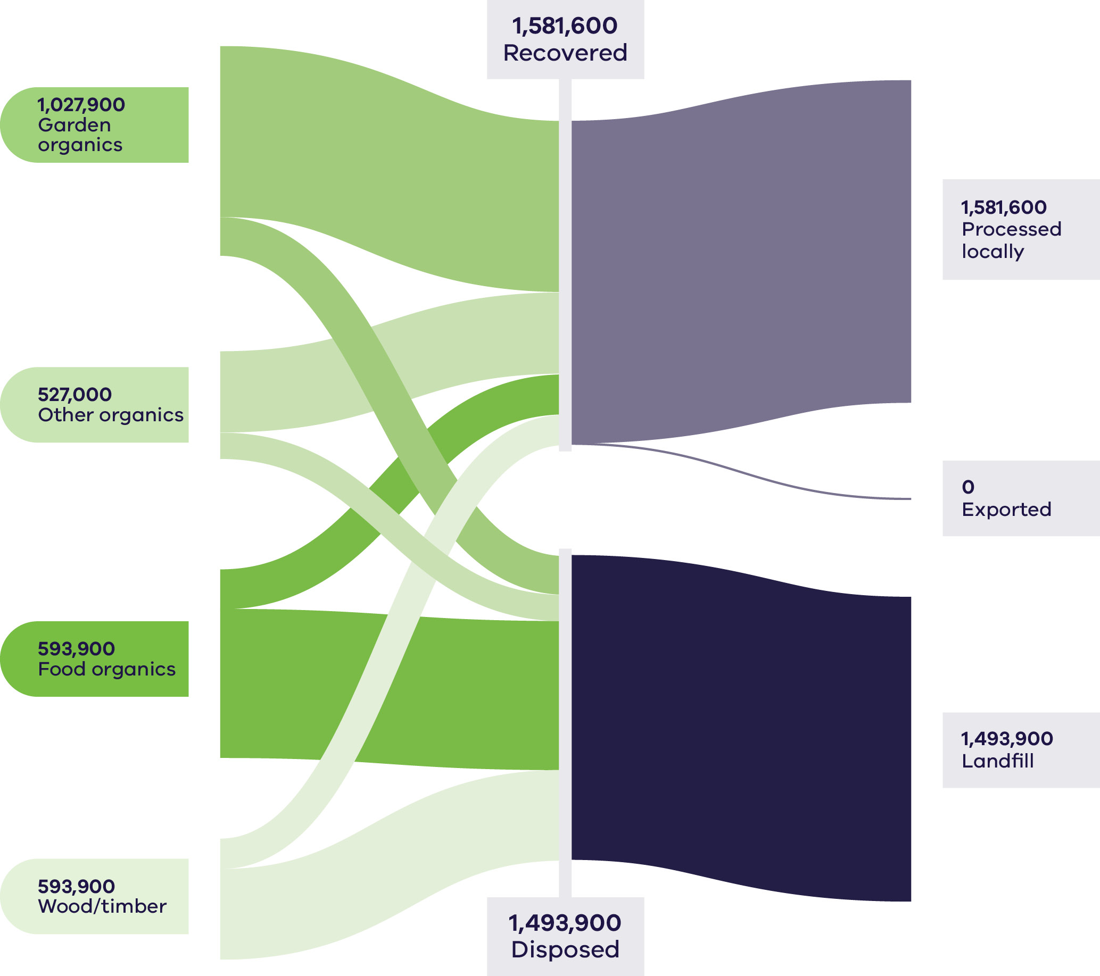

Table 9: Organics flows by stream and material sub-groups for 2023–24
Stream | Generated |  | Recovered for reprocessing |  |  | Disposed | Recovery rate
 |  |  | Processed locally | Exported | Total
 | Tonnes | Proportion | Tonnes | Tonnes | Tonnes | Tonnes | %
MSW | 1,585,200 | 52% | 961,300 | 0 | 961,300 | 623,900 | 61%
C&I | 1,246,500 | 41% | 522,000 | 0 | 522,000 | 724,500 | 42%
C&D | 243,800 | 8% | 98,300 | 0 | 98,300 | 145,500 | 40%
Total | 3,075,600 |  | 1,581,600 | 0 | 1,581,600 | 1,493,900 | 51%

Stream | Generated |  | Recovered for reprocessing |  |  | Disposed | Recovery rate
 |  |  | Processed locally | Exported | Total
 | Tonnes | Proportion | Tonnes | Tonnes | Tonnes | Tonnes | %
Food Organics | 926,700 | 30% | 196,300 | 0 | 196,300 | 730,400 | 21%
Garden Organics | 1,027,900 | 33% | 838,000 | 0 | 838,000 | 189,800 | 82%
Other Organics | 527,000 | 17% | 398,300 | 0 | 398,200 | 128,800 | 76%
Wood/Timber | 594,000 | 19% | 149,000 | 0 | 149,100 | 444,900 | 25%
Total | 3,075,600 |  | 1,581,600 | 0 | 1,581,600 | 1,493,900 | 51%

Table 9 shows the amount of food and garden organics generated by and recovered from households (MSW). The amount of MSW garden organics collected increased by approximately 80% from 2018–19 to 2022–23 but decreased to below 2021–22 levels in 2023–24. The garden organics recovery rate in the MSW sector has steadily improved in recent years to a peak recovery rate of 89% in 2022–23 and 2023–24. The volume of food organics collected via the MSW sector is expected to steadily increase as councils across the state expand green bin services to include food organics, although generation of food organic waste was steady between 2018–19 and 2022–23. Food organics waste generation in the MSW sector dipped in 2023–24 to the lowest levels observed in recent years. The food organics recovery rate in the MSW sector has steadily improved from about 14% recovery in 2022–23 to 23–24% in the last 2 years.
Composted material values varied widely across Victoria, with low-grade compost (bulk landscaping) selling for approximately $30–$100 per tonne, while premium horticultural blends are up to $320 per tonne. Processing capacity constraints and contamination (especially plastics) limited premium output volumes.

Development and changes
Household recovery of FOGO continues to develop with the introduction of kerbside FOGO services across 59 local government areas as of September 2025. This is in line with the Victorian Government target to ensure households have access to FOGO recycling services by 2030 (consistent with the Recycling Victoria – a new economy policy).
The development of small-scale composting infrastructure for regional councils is a recent advancement. In December 2024, the City of Greater Bendigo approved a planning permit for Western Composting Technology to develop an organics facility to process up to 30,000 tonnes of organic waste per annum, primarily from domestic and commercial food and garden waste (Pittorino 2024a). Gippsland Regional Organics facility has also been upgraded in 2024–25 to increase capacity from 70,000 tonnes to 250,000 tonnes per year (Gippsland Water n.d.). Bio Gro, based in Newbridge, have recently expanded their principal composting and manufacturing facility in Victoria to a capacity of 50,000 tonnes per year.

Market issues and challenges
Approximately 7.6 million tonnes of food is wasted annually in Australia. It is estimated that food waste costs the economy an estimated $36.6 billion annually, with the average Australian household losing $3,800 every year (Foodbank n.d).
There are opportunities to reduce food waste generation across the entire value chain, from cultivation and harvesting, processing and manufacturing, transport and distribution to retail, households and the hospitality sector.
The organics market operates locally, with materials recovered, processed and sold largely within Victoria. Market value for some compost and fertiliser products is not high. These factors, along with transport costs and the perishable nature of organics, result in geographical limitations on supply chains and market reach.
There are issues of plastic contamination getting into the FOGO recycling stream, including materials marketed as ‘compostable’ or ‘biodegradable’. Research by Veolia in early 2025 found that 72% of those surveyed thought compostable single-use coffee cups could be recycled in the mixed recycling stream and 58% thought biodegradable plastic bags could be recycled. Veolia advises that both items would be managed appropriately by placing them in red bins for disposal into landfill. (Lyons, 2024)
Work is ongoing between industry and regulators to establish clear, balanced and enforceable standards for compostable and biodegradable products. Until these are finalised and widely adopted, uncertainty will continue to undermine market confidence, contribute to contamination and create mixed messaging for consumers and businesses.

Key focus areas for greater circularity – organics
Opportunities to make the organics stream more circular include:
- reduction in contamination across all organic material types, including by ongoing education and awareness
- investment and reduction in barriers to food waste collection in the C&I sector
- setting and implementing appropriate product and processing standards
overcoming practical and financial barriers that contribute to the wastage of food, particularly nutritious food, that could otherwise be consumed.

Paper and cardboard
Paper and cardboard waste includes:
- cardboard
- liquid paperboard
- newsprint and magazines
- printing and writing paper
other mixed paper materials.
Paper and cardboard can be recycled into:
- newsprint
- printing and communication products
- tissue products
- packaging and industrial products
- other products like kitty litter, compost insulation, egg cartons and building products.
Recycling paper and cardboard is especially important from an environmental perspective. When paper is disposed of in landfill rather than recycled, it produces methane as it breaks down.

Market performance
The overall recovery rate for paper and cardboard in Victoria in 2023–24 was 63% (Table 10). This is consistent with the recovery rate of 57% observed in 2020–21, 60% observed in 2021–22 and 59% observed in 2022–23. Nationally, the estimated resource recovery rate was 56% in 2022–23, down from 68% in 2016–17 (DCCEEW 2025a). This work linked this decline in national recovery to reduced consumption of newsprint and magazines and printing and writing papers – grades with traditionally high recycling rates.
C&I was the largest contributor to the generation of paper and cardboard (51%), closely followed by MSW (48%) in 2023–24. Recovery rates for MSW and C&I respectively were 68% and 58% in 2023–24, with marked improvement in paper and cardboard recovery in the MSW sector since 2020–21.
At a national level, the decline in paper and cardboard waste generation from 2016–17 to 2022–23 is linked to the digitisation of information. Nationally, annual consumption of newsprint and magazine material has fallen over the last decade by 400,000 to 500,000 tonnes per year and printing and writing papers by another 300,000 to 400,000 tonnes per year. Packaging papers, including cardboard, have grown strongly but not enough to offset these major declines (DCCEEW 2025a).
Almost 700,000 tonnes of paper and cardboard was processed locally in 2023–24.
Cardboard and other paper (mixed) had the highest rates of export and recovery among all paper and cardboard material types in 2023–24, except for newspapers and magazines, where recovery was 100% but with very little waste generated relative to other types (Figure 13).
The packaging (typically corrugated boxes) used to transport imported goods is not accounted for as part of the packaging material imports data. This means that the Australia-wide volume of paper and paperboard available for recovery may be significantly greater than total consumption.
It is estimated that over $157 million was lost in landfill in 2023–23, compared to $261 million in value of material recovery from the sector in Victoria.
Approximately 30% of all paper and cardboard recovered in 2023–24 was exported out of Victoria (306,200 tonnes), consistent with the previous year’s data. More material was exported from the C&I sector than the MSW sector in 2023–24 (Table 10). Similar tonnages were exported to international markets in 2021–22 (Recycling Victoria 2025a).
At a national level, exports of scrap paper and cardboard have fallen by more than a third from their peak in 2012-13. From July 2024, Australia began regulating paper and cardboard exports through the implementation of a licensing and declaration scheme, with licensing mandatory from 1 October 2024. This is to ensure exported materials are of a quality suited to direct recycling without removal of contamination overseas (DCCEEW 2025a).
Figure 13: Paper and cardboard generated, recovered for processing and disposed of in 2023–24 (tonnes)
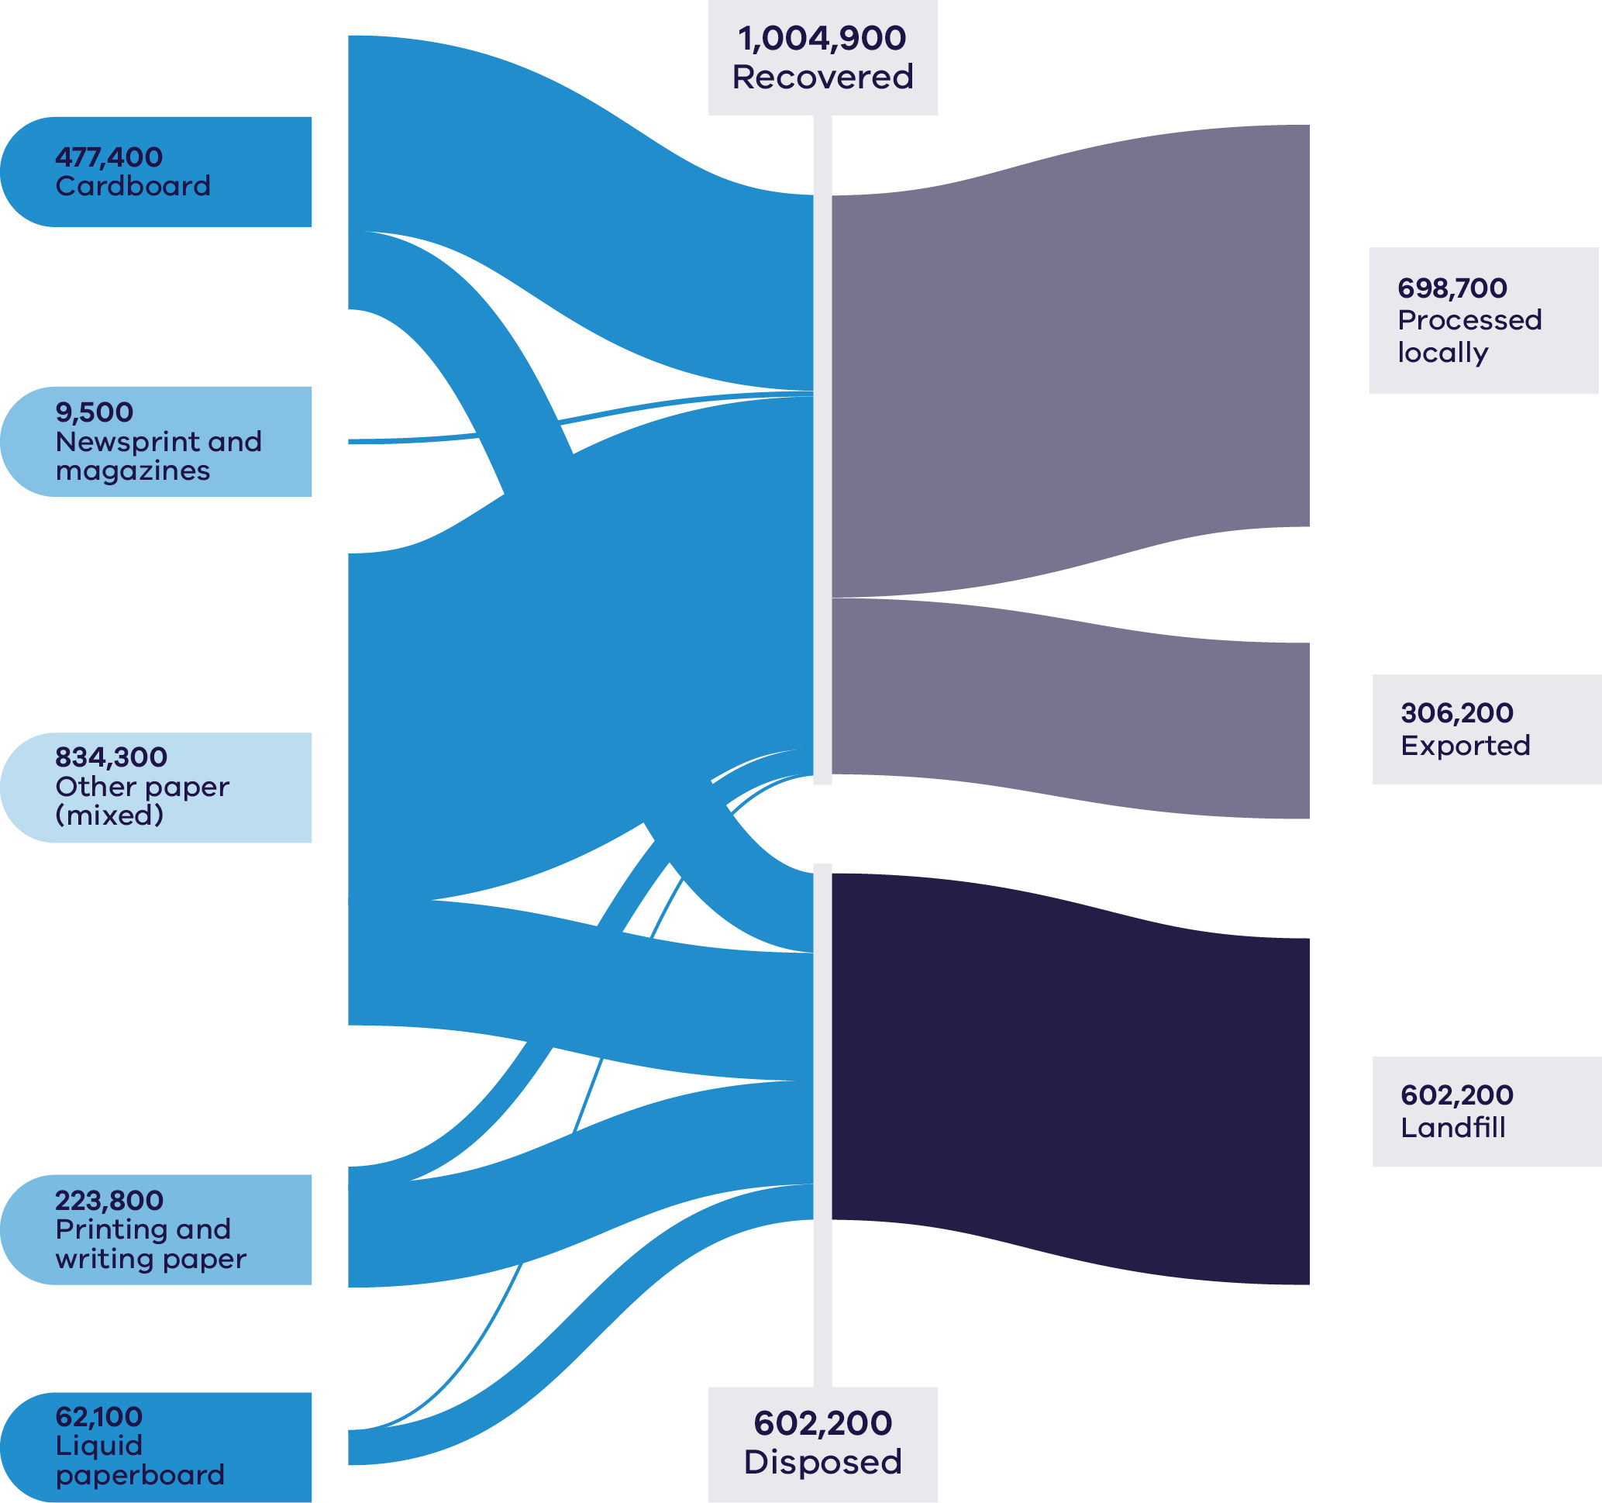

Table 10: Paper and cardboard flows by stream and material sub-groups for 2023–24
Stream | Generated |  | Recovered for reprocessing |  |  | Disposed | Recovery rate
 |  |  | Processed locally | Exported | Total
 | Tonnes | Proportion | Tonnes | Tonnes | Tonnes | Tonnes | %
MSW | 777,800 | 48% | 419,200 | 112,300 | 531,600 | 246,300 | 68%
C&I | 820,900 | 51% | 279,400 | 193,800 | 473,200 | 347,700 | 58%
C&D | 8,400 | 1% | 100 | 0 | 100 | 8,300 | 1%
Total | 1,607,100 |  | 698,700 | 306,200 | 1,004,900 | 602,200 | 63%

Stream | Generated |  | Recovered for reprocessing |  |  | Disposed | Recovery rate
 |  |  | Processed locally | Exported | Total
 | Tonnes | Proportion | Tonnes | Tonnes | Tonnes | Tonnes | %
Cardboard | 477,400 | 30% | 166,100 | 173,900 | 340,000 | 137,400 | 71%
Liquid paperboard | 62,100 | 4% | 300 | 0 | 300 | 61,700 | 1%
Newsprint & magazines | 9,500 | 1% | 6,800 | 2,800 | 9,500 | 0 | 100%
Other paper (mixed) | 834,300 | 52% | 485,800 | 126,100 | 611,900 | 222,300 | 73%
Printing/writing paper | 223,800 | 14% | 39,800 | 3,400 | 43,100 | 180,700 | 19%
Total | 1,607,100 |  | 698,700 | 306,200 | 1,004,900 | 602,200 | 63%

Developments and changes
The introduction of separate glass recycling and CDS Vic have diverted glass and beverage packaging from the mixed recycling kerbside stream, leaving less contaminated and cleaner material. The recovery rate for paper and cardboard went from 52% to 68% in 2023–24 for the MSW sector. Recovered fibre markets stabilised following volatility in the 2021–22 financial year. Prices for mixed paper ranged from $200 to $350 per tonne, while sorted office and cardboard grades achieved between $400 and $600 per tonne.
Strong packaging demand, coupled with domestic capacity expansion and e-commerce growth supported the current pricing. Energy and logistics costs influence virgin pulp prices.

Market issues and challenges
Over the next 30 years, the paper and cardboard waste stream is projected to grow by 47%, with Victorians expected to generate over 2.4 million tonnes by 2053. Cardboard and other paper make up 81% of the waste stream and this is projected to increase to approximately 92% in 2053.

Focus areas for greater circularity – paper and cardboard
Opportunities to make the paper and cardboard material stream more circular include:
- improved sorting to reduce contamination and allow different material grades to be collected and recycled to maximise higher order end markets and meet export regulations
- collection and recovery of high value cardboard streams from the C&I sector
- development of new products using materials with a lower recovery rate.

Plastics
Plastics are used to make many modern products including:
- packaging
- household goods
- synthetic textiles
- furniture
- pipes, hoses and cabling
plastic film.
Existing end markets for plastics include:
- the built environment
- electrical and electronic applications
- industrial applications
- transport and logistics
- packaging
energy recovery.
Plastic is ubiquitous in Australia, especially across the food and beverages sector (Circular Australia and Arup 2024). The most recent Clean Up Australia Litter Report identified plastics as the biggest contributor to litter in our environment, dominating all other materials and representing 80.7% of all counted litter in 2023–24 (Clean Up Australia 2024). In 2020–21, Australia produced 6.74 million tonnes of packaging – 44% of which was disposed of in landfills (DCCEEW 2024c).
Asia became the dominant market for plastic scrap in the 21st century. Much of this material was in poorly sorted bales that were sorted and processed at lower cost, resulting in poor environmental outcomes such as use as fuel or unmanaged release into the environment. China imposed import restrictions in 2018. Exports are now reduced and are increasingly comprised of sorted and processed product requiring no further preparation (DCCEEW 2025a).

Market performance
The overall recovery rate for plastics in Victoria in 2023–24 was 26% (Table 11). This was the lowest performing recovery rate across the key material streams but was a small improvement on recovery rates in 2021–22 and 2022–23 (23%) and 2020–21 (18%).
In 2023–24, plastics accounted for over 5% of all waste generated by weight in Victoria. The unrealised market value of plastics lost to landfill was approximately $534 million based on 2022–23 commodity values. This was the highest value lost to landfill out of all material types.
Market prices for recycled plastic were above long-term historical averages throughout 2023–24. Recycled polyethylene terephthalate plastic (rPET) prices began 2023–24 as low as $200–$250 per tonne before increasing to $500–$800 per tonne by year-end, reflecting improved demand and reduced virgin resin oversupply. Recycled high density polyethylenes (HDPE) traded within a similar range, while mixed plastics often had negative or negligible value. Prices for recovered HDPE followed a similar pattern, averaging AUD$900 – $1,100 for the financial year.
While Victoria does export plastics for reprocessing, export bans and licensing requirements currently limit international end market opportunities for processors, in favour of local solutions. Approximately 22% of all recovered plastics (44,800 tonnes) was exported interstate or internationally for processing in 2023–24 (Figure 14).
Figure 14: Plastic generated, recovered for processing and disposed of in 2023–24 (tonnes)
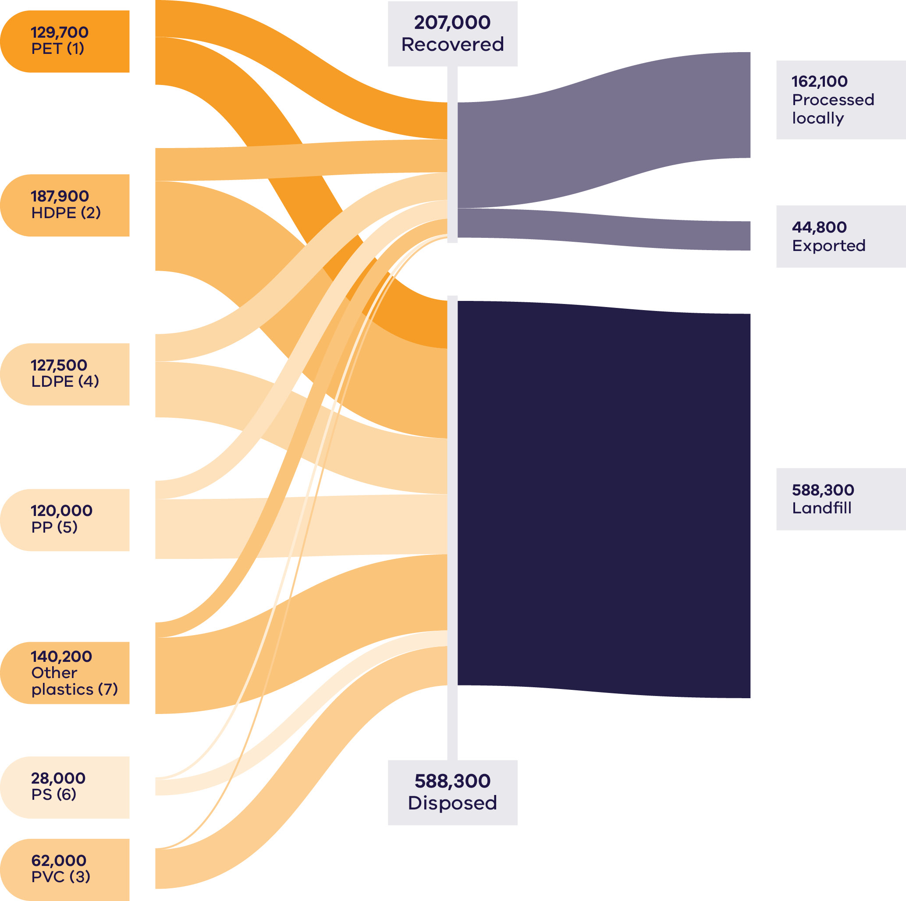

Table 11: Plastic flows by stream and material sub-groups for 2023–24
Stream | Generated |  | Recovered for reprocessing |  |  | Disposed | Recovery rate
 |  |  | Processed locally | Exported | Total
 | Tonnes | Proportion | Tonnes | Tonnes | Tonnes | Tonnes | %
MSW | 411,000 | 52% | 108,700 | 26,000 | 134,800 | 276,300 | 33%
C&I | 362,100 | 46% | 50,500 | 18,400 | 68,900 | 293,200 | 19%
C&D | 22,200 | 3% | 2,900 | 400 | 3,300 | 18,800 | 15%
Total | 795,300 |  | 162,100 | 44,800 | 207,000 | 588,300 | 26%

Stream | Generated |  | Recovered for reprocessing |  |  | Disposed | Recovery rate
 |  |  | Processed locally | Exported | Total
 | Tonnes | Proportion | Tonnes | Tonnes | Tonnes | Tonnes | %
PET (1) | 129,700 | 16% | 45,300 | 11,200 | 56,500 | 73,200 | 44%
HDPE (2) | 187,900 | 24% | 38,700 | 11,800 | 50,500 | 137,400 | 27%
PVC (3) | 62,000 | 8% | 1,800 | 0 | 1,800 | 60,100 | 3%
LDPE (4) | 127,500 | 16% | 25,600 | 16,500 | 42,100 | 85,400 | 33%
PP (5) | 120,000 | 15% | 25,000 | 3,400 | 28,400 | 91,600 | 24%
PS (6) | 28,000 | 4% | 3,700 | 400 | 4,100 | 23,900 | 15%
Other plastics (7) | 140,200 | 18% | 21,900 | 1,500 | 23,500 | 116,700 | 17%
Total | 795,300 |  | 162,100 | 44,800 | 207,000 | 588,300 | 26%

While low, Victoria’s recovery rates are higher than all jurisdictions other than South Australia (DCCEEW 2025a). The overall recovery rate obscures the fact that some plastics, such as PET and HDPE are more easily recycled and have higher recovery rates than other types. The national recovery rate for plastics in 2022–23 was 12.5% (DCCEEW 2025a), although a direct comparison to Victorian results is not possible given the differing waste data sets (see Table 19).

Developments and changes
There is growing focus on improving plastic recovery due to increased environmental awareness, stricter regulations and consumer preference for sustainable products. Governments are enforcing policies to reduce plastic waste, while companies and consumers are shifting towards recycled materials for environmental benefits. Economic incentives also make recycled plastics an attractive alternative, contributing to a robust and expanding future market for recycled plastics.
Major advances are being made through a focus on innovation and significant investments in research and development, process technology and environmental protection. These advances span the use of sustainable bio-based and plastics waste feedstocks for polymer production, innovative materials and designing for recyclability to significant progress in cutting-edge chemical recycling technologies.
The collapse of REDcycle left a void in the soft plastics collection and processing sector. The creation of Soft Packaging Stewardship Australia (including ACCC approval) will, amongst other things, take over supermarket collections from the Soft Packaging Taskforce (ACCC 2025). As at August 2025, pilot collections were underway in over 500 selected stores in Melbourne, Brisbane, Sydney and Newcastle.
The NSW Government announced further action to reduce plastic waste, announcing the next phase of single-use and problematic plastic phase-outs in November 2025. Amongst the new actions, takeaway food service businesses will be required to accept reusable cups by 2028 and large food service businesses must provide reusable cup options by 2030.
Samsara Eco is addressing the growing plastic problem with its environmentally friendly enzymatic recycling technology transforming end-of-life plastics and textiles back into their original building blocks to be used in remanufacturing (DCCEEW 2024c). This will create 50 local jobs and support the infinite recycling of 20,000 tonnes of plastic a year from 2024 (Breakthrough Victoria 2022). They recently partnered with lululemon to release the world’s first enzymatically recycled nylon 6,6 garment, as well as an enzymatically recycled polyester jacket, which sold out. The apparel was made from post-consumer and post-industrial waste, highlighting the feasibility and potential for large-scale implementation of the technology (DCCEEW 2024c).
Victoria is working together with other states, territories and the Australian Government to align action on problematic and unnecessary plastics across Australia.

Market issues and challenges
Plastic waste in Victoria is projected to grow by around 50% over the next 30 years, generating over 1.2 million tonnes by 2053 (Recycling Victoria 2024b).
Multiple factors limit the recovery of plastics. Feed streams are often a heterogenous mixture of different polymers and in many cases this causes issues in sorting blended feed streams to get a uniform input. Virgin plastics feedstocks remain comparatively inexpensive, reducing the incentive of product manufacturers to use recycled materials.
Circular Australia and Arup (2024) identified the following major sources of lost value in the Australian PET value chain:
- Leakage of plastic waste to landfill or the environment.
Insufficient source-separation of bottles. Bottles collected through CDS collection points are often higher-quality and less contaminated than through MRFs.
Exported PET – current recycling practices reduce the opportunity for the local bottle manufacturing industry to incorporate this feedstock into its manufacturing processes and subsequently requires the import of additional virgin PET.
Plastic packaging is an important component of the MSW and C&I source streams nationally and a longstanding focus of public policy and community concern due to inconsistent products not being designed for circularity. The Australian Government is reforming Australia’s national packaging regulation to improve environmental outcomes for packaging, minimise waste and drive investment in better packaging design and recovery systems.
Soft plastic recyclers across Australia have identified key challenges in convincing brand owners to adopt Australian-sourced recycled content, with many packaging products imported but the waste burden falling on local systems. Some recyclers are reported to be operating below their production capacity, citing high labour, energy and transport costs, in addition to limited retailer support (Hughson 2024).
Bioplastics have emerged as a potential pathway to more sustainable plastic. However, the production, use and disposal of bioplastics creates new challenges with potential implications for circularity, carbon mitigation and biodiversity (Circular Australia 2025).

Focus areas for greater circularity – plastics
Opportunities to make the plastics material stream more circular include:
- designing for better recycling and reuse outcomes, including difficult to recycle plastics
- aiming for the highest order beneficial recycling outcomes
supporting the continued deployment of mechanical reprocessing, chemical processing proven at scale and emerging technologies to provide increased capability for challenging plastic types and increased system capability to support kerbside collection of soft plastics
driving national product stewardship to ensure greater accountability for recovery and processing of packaging introduced to the marketplace.

Case Study: Industrial remanufacturing of
post-consumer plastics
Circular Plastics Australia (CPA) represents a large-scale, collaborative approach to advancing circular economy outcomes for post-consumer plastics. Established as a joint venture between Cleanaway, Asahi Beverages, Pact Group and Coca-Cola Europacific Partners, CPA was formed to build and operate end-to-end PET recycling infrastructure in Australia.
PET is a high-value, recyclable polymer widely used in beverage bottles and food packaging and CPA’s operations demonstrate the practical application of circular principles such as recover, recycle, remanufacture and reintegrate within an industrial context.
CPA has constructed 2 major PET recycling facilities to expand Australia’s domestic reprocessing capacity. The first facility is located in Albury NSW and commenced operations in March 2022, servicing customers across the eastern states. A second facility in Altona North in Victoria, began operations in December 2023.
Together, the 2 facilities represent an investment of approximately $100 million, creating more than 225 construction-phase jobs and around 40 ongoing operational roles at each facility. The Altona North plant is the largest of its kind in Victoria and is designed to process approximately 2.5 tonnes of PET per hour, equivalent to 20,000 tonnes of recycled PET resin per year—the same as recycling up to 1 billion 600mL PET beverage bottles annually.
The facilities apply a multi-stage recovery process designed to meet international standards for recycled food-grade resin. Incoming PET bottles are first processed through infrared and optical sorting systems to separate contaminants such as labels, caps and metals. The sorted PET is then shredded, washed and ground into flakes, followed by 2-stage heating and drying to remove moisture and impurities. The final extrusion and purification steps produce recycled PET (rPET) resin compliant with US Food and Drug Administration (FDA) food-grade standards, enabling it to be reintroduced into the manufacture of new beverage bottles and packaging.
CPA’s operations support domestic material circularity by substituting imported recycled plastics and reducing reliance on virgin polymer. In 2024, the Altona North facility processed approximately 65% of PET bottles collected through CDS Vic, while combined, the Albury and Altona North plants recycled an estimated 77% of PET bottles returned through container deposit schemes nationwide. This represents a significant contribution to achieving national packaging recovery targets and demonstrates the scalability of closed-loop recycling systems.
From a sustainability perspective, both CPA facilities incorporate energy-efficient and low-impact design features. The Altona North facility is built to achieve a 5 Star Green Star Rating and includes solar power generation, onsite water treatment and rainwater harvesting systems to reduce energy and water consumption.
These design features align with rethink and reduce principles of the 10R framework, complementing the recycling operations by addressing upstream environmental impacts.
By remanufacturing discarded PET bottles into high-quality rPET resin, CPA creates a circular value chain that supports brand owners and producers in meeting National Packaging Targets and proposed mandatory recycled content requirements. The initiative demonstrates how industry collaboration and capital investment can accelerate the transition towards a domestic circular plastics economy.
CPA’s integrated PET recycling network reduces landfill disposal, offsets virgin resin production and contributes to lowering Australia’s carbon emissions, while establishing the operational and market foundation for future circular economy growth in the plastics sector.

Case Study: Advancing circularity in Australia’s plastic pipe industry
The circular economy for plastic pipes is based on a whole-of-lifecycle approach, incorporating circular actions across design, production, use and end-of-life recovery. Unlike single-use plastics, plastic pipes are engineered for long service life, typically exceeding 100 years and are designed for reuse, repair and recycling. Most pipe systems are composed of single thermoplastics, such as polyethylene (PE) and polyvinyl chloride (PVC), which simplifies sorting and recycling processes.
Plastic pipes deliver essential public services including water supply, wastewater management, energy distribution and agricultural irrigation. Recycled polymers are already used in a range of non-pressure applications such as electrical conduit, sewer and stormwater pipes. However, the availability of recycled feedstock remains limited because few pipes have yet reached end of life due to their long operational lifespan.
Despite the low availability, industry is proactive in collecting available post-consumer and post-industrial material and processing it to meet strict guidelines and standards. The Plastics Industry Pipe Association (PIPA) POP208 Guidelines provide best-practice frameworks for the safe and effective use of recycled plastics in pipe systems, supporting quality assurance and material traceability.
Two examples from Victoria demonstrate the application of circular economy principles and the 10R framework within the plastic pipes manufacturing sector.
Vinidex’s StormFLO® system, manufactured locally since 2021, is a lightweight polyethylene (PE) pipe used in stormwater drainage applications. Each pipe incorporates a minimum of 30% and up to 65% recycled content sourced from post-consumer and post-industrial plastics, much of it supplied by Victorian recyclers.
Designed for a 100 year service life and full recyclability at end of life, StormFLO® supports a closed-loop system that reduces reliance on virgin materials. Manufactured in compliance with AS/NZS 5065, StormFLO® provides high hydraulic efficiency, abrasion resistance and long-term durability.
The product has gained approval for use in Victorian road and rail infrastructure and contributes to reduce, recover and reintegrate principles by lowering material inputs, reusing recovered polymers and reinserting recycled content into new infrastructure. Development was internally funded with Vinidex investing in research, testing and quality assurance to demonstrate performance equivalence with conventional materials. Market adoption required engagement with authorities and contractors to confirm compliance and reliability, alongside efforts to establish consistent local supply chains for recycled feedstock.
A second example is Pipemakers Australia’s Drain Flex Pro, a next-generation subsoil drainage pipe introduced in Victoria in 2023. Manufactured in compliance with AS/NZS 2439 this product features a twin-wall coextruded design that provides greater structural strength and flow performance compared with traditional single-wall alternatives. Drain Flex Pro incorporates post-consumer recycled polyethylene as a core material input, supporting Recycle, Rethink and Renew principles through its design and sourcing strategy.
The development was fully financed through internal resources rather than external funding or regulatory mandates, reflecting a market-driven approach to innovation. Pipemakers currently sources qualified recyclate from South Australia and is progressing the qualification of Victorian suppliers to strengthen local circular supply chains.
Key challenges included ensuring consistent quality and availability of recycled polymers, differentiating the product in a competitive market and meeting required technical standards for road, rail and agricultural applications.
Both Vinidex and Pipemakers demonstrate how Victorian manufacturers are operationalising circular economy frameworks by integrating recycled content, maintaining product performance and building the foundations for a closed-loop plastics sector.
The Victorian plastic pipes industry demonstrates practical integration of circular economy principles through local manufacturing, recycled content use and product design for recyclability. Both case studies show that circular design and end-of-life recovery can be incorporated into technically demanding infrastructure applications without compromising quality or safety.
These developments strengthen local supply chains, support material recovery markets and contribute to the progressive decoupling of infrastructure growth from virgin material consumption.

Tyres
Tyres are a composite product made from natural and synthetic rubber, steel wire, textile fibres, carbon black and other additives. At end-of-life, tyres are generally managed in one of 2 ways. One stream involving mechanical size reduction, granulating and crumbing for local manufacturing to dimensions below 5mm (but typically less than 1 mm) and shredding for export as tyre derived fuel, producing pieces between 40 mm and 80 mm.
Whole baled tyres have been banned from landfill in Victoria since 1 July 1993. Export of all whole tyres, including baled tyres was banned from 1 December 2021 under the Council of Australian Government national waste export regulations. Exports have since been limited to shredded tyre-derived fuels that meet a specification, whole tyres for reuse, large tyres for retreading or processed tyre material for recycling (DCCEEW 2025a).
Onshore processing of tyres is mostly for recycling. Markets include road construction additives, playground flooring, sports surfaces and retaining walls (DCCEEW 2025a).
Victoria plays a leading role in Australia’s tyre recycling and resource recovery network. According to the Australian Tyre Recovery Association (ATRA, 2024) and data from the National Waste Report 2024 Victoria is the largest producer of tyre-derived granules and crumb rubber in the country, processing end-of-life tyres from both within the state and neighbouring jurisdictions to meet strong domestic demand for these materials.
Victoria’s advanced processing capacity and established manufacturing markets for rubber-modified products—such as road surfacing, playgrounds and sporting surfaces—have positioned the state as a national hub for high-value material recovery. To sustain throughput and efficiency, Victorian recyclers routinely import end-of-life tyres from NSW, South Australia and Tasmania, enabling continuous operation of granulation and crumbing facilities.
In addition to its leadership in fine rubber processing, Victoria ranks as the third largest producer of tyre shred nationally (ATRA, 2024). Tyre shred is primarily used in civil engineering, construction and alternative fuel applications. The combination of strong local demand for granulate and crumb and a growing export and interjurisdictional trade in tyre shred, demonstrates Victoria’s strategic importance in supporting Australia’s circular economy for end-of-life tyres.
A voluntary national product stewardship scheme for end-of-life tyres operates under Tyre Stewardship Australia (TSA), which is accredited by the Australian Government. The scheme aims to improve the sustainable management of tyres throughout their lifecycle—encouraging collection, recycling and responsible reuse, while reducing illegal stockpiling and landfill disposal.
As of 2025, approximately 57% of tyre importers by market share are participants in the scheme (Productivity Commission, 2025). This level of participation represents a substantial proportion of the domestic tyre market but also highlights opportunities to expand coverage, particularly among non-participant importers and smaller distributors.
Tyres entering the Australian market fall into several key categories (Table 12), each with distinct end-of-life recovery and recycling considerations.

Table 12: Summary of tyre types and circular economy considerations
Tyre category | Typical applications | Share of  market / volume | Primary recovery pathways | Circular economy considerations
Passenger & Light Commercial (PLT) | Passenger cars, SUVs, light vans and utes | Highest by number of units | Shredding, granulation, crumbing | Readily recyclable due to uniform size and composition; major source of crumb rubber for road surfacing, playgrounds and moulded products.
Truck & Bus (T&B) | Heavy transport, freight and public transport vehicles | Moderate volume, high tonnage | Retreading, shredding, energy recovery | Retreading significantly extends service life; post-use tyres support civil engineering and energy recovery applications.
Off-the-Road (OTR) | Mining, construction, agriculture and earthmoving machinery | Lower by units, very high tonnage | Mechanical shredding, cut-and-fill reuse, limited recycling | Difficult to transport and process due to size and steel reinforcement; growing potential for on-site recovery and reuse in civil applications.
Motorcycle & Specialty Tyres | Motorcycles, aircraft, industrial and specialty vehicles | Small market share | Shredding, energy recovery | Low recovery volumes; typically  co-processed with passenger tyres for material or energy recovery.
Source: Productivity Commission (2025); Tyre Stewardship Australia (2024); ATRA (2024).
The circularity potential for each tyre category varies according to product design, market size and end-use infrastructure. Passenger and truck tyres currently dominate national recycling and reprocessing markets, while off-the-road tyres remain a key focus for future collection and processing innovation under the Tyre Stewardship Australia scheme.

Market performance
The overall recovery rate for tyres in Victoria in 2023–24 was 81% which represents the best tyre recovery rates since 2020–21 (86%) and a significant improvement on recovery rates last year (74%). Almost 60,000 tonnes of tyres were recovered in Victoria in 2023–24, representing a 41% increase in recovery tonnages since the previous year (Figure 15).
C&I was the largest contributor to the waste generation of tyres (86%) in 2023–24, with the highest recovery rate (82%) observed since 2020–21 (88%) in this source sector.
Some truck and bus tyres are sent for retreading, although the local retreading industry has declined over the past couple of decades with the introduction of cheaper truck and bus tyres entering Australia. Retreading a tyre produces 74% less emissions and uses 54% less materials (by weight) compared to manufacturing a new tyre (Productivity Commission 2025).
It is estimated that $23 million of value was lost to landfill for this material in Victoria in 2023–24.
Approximately 55% (32,900 tonnes) of all recovered tyres were exported from Victoria in 2023–24 (Table 13). A similar tonnage (32,900 tonnes) was exported internationally in 2021–22, although international exports were down in 2022–23 (18,200 tonnes). Victoria continues to be reliant on overseas markets, with tyre derived fuels as the primary export market. Most of this is sent to Asia to be used as a coal replacement in high heat applications such as in cement kilns.
‘Other rubber’ accounted for 62% of tyre waste generation in 2023–24, followed by truck tyres (30%), with smaller volumes generated from passenger and offroad tyres (Table 13). Recovery rates for all material types exceeded 70%, with 100% recovery of truck and offroad tyres in 2023–24.
Figure 15: Tyres generated, recovered for processing and disposed of in 2023–24 (tonnes)
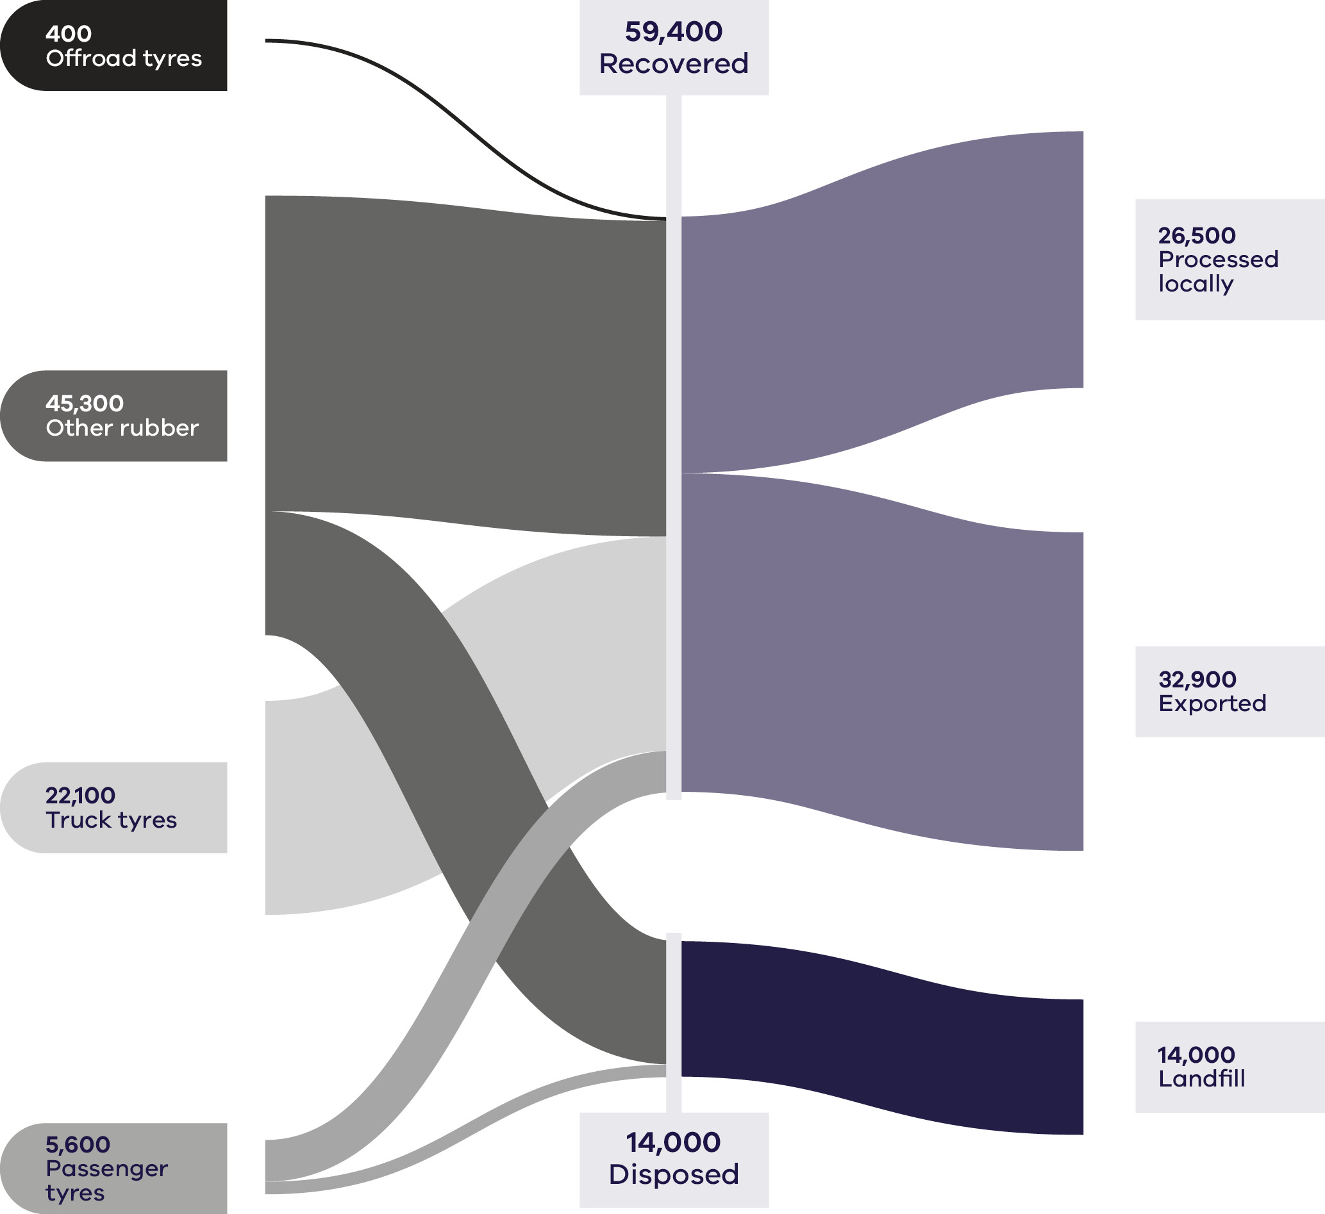

Table 13: Tyre flows by stream and material sub-groups for 2023–24
Stream | Generated |  | Recovered for reprocessing |  |  | Disposed | Recovery rate
 |  |  | Processed locally | Exported | Total
 | Tonnes | Proportion | Tonnes | Tonnes | Tonnes | Tonnes | %
MSW | 9,800 | 13% | 4,300 | 3,300 | 7,600 | 2,200 | 78%
C&I | 63,300 | 86% | 22,200 | 29,700 | 51,800 | 11,500 | 82%
C&D | 300 | 0% | 0 | 0 | 0 | 300 | 0%
Total | 73,400 |  | 26,500 | 32,900 | 59,400 | 14,000 | 81%

Stream | Generated |  | Recovered for reprocessing |  |  | Disposed | Recovery rate
 |  |  | Processed locally | Exported | Total
 | Tonnes | Proportion | Tonnes | Tonnes | Tonnes | Tonnes | %
Offroad tyres | 400 | 1% | 300 | 100 | 400 | 0 | 100%
Other rubber | 45,300 | 62% | 0 | 32,600 | 32,600 | 12,800 | 72%
Passenger tyres | 5,600 | 8% | 4,300 | 0 | 4,300 | 1,300 | 78%
Truck tyres | 22,100 | 30% | 21,900 | 200 | 22,100 | 0 | 100%
Total | 73,400 |  | 26,500 | 32,900 | 59,400 | 14,000 | 81%

Developments and changes
There is a tension between the need to keep or improve sustainability properties of tyres with the need to ensure that performance standards are met. In designing tyres with low abrasion rates, compositional changes that may help the lifespan of the tyres regarding abrasion may negatively affect separability of the tyre at the end of life (Navarro et al 2024).
Electric and hybrid cars use tyres that are different from the conventional tyres fitted to combustion engine automobiles. This is because the tyres of electric and hybrid cars must bear more weight, apply a higher torque to the road surface, have low rolling noise and have low rolling resistance (Continental, 2024).
The increasing market penetration of electric vehicles for passenger transport will lead to a greater proportion of end-of-life tyres in the material stream and design features such as noise reduction foams may be challenging in reprocessing (Tyre Stewardship Australia 2024).

Market issues and challenges
Tyres and rubber waste in Victoria is projected to grow to 100,000 tonnes by 2053, representing a 44% increase on 2023 tonnages. Tyre recycling activity remained steady, supported by Tyre Stewardship Australia (TSA) and national export restrictions on whole tyres.
Some illegal export of whole tyres persists and prosecutions have occurred (DCCEEW 2025a).
Barriers exist that limit recovery of offroad tyres including high collection costs due to distance, variability in offroad tyre sizes, feedstock quality and the legality of tyre burial in mine sites. The main barrier is the higher cost of collecting and transporting tyres from regional and remote areas. As a result, tyre stockpiling and illegal dumping are more pronounced in regional and remote areas (Productivity Commission 2025).
Economic returns are variable: some processors charge gate fees, while others achieve modest positive value for TDF or crumb depending on logistics and energy markets.
Material end-uses included tyre-derived fuel (TDF), crumb rubber for roads and mats and emerging pyrolysis applications.

Focus areas for greater circularity – tyres
An opportunity to make the tyre material stream more circular is to, in line with the Recycled First policy program, further explore the use of government procurement to support increased uptake of tyre-derived products.

Case Study: Transforming end-of-life tyres into sustainable infrastructure
Australia relies entirely on imported tyres with over 100 million in use at any time. This leads to the generation of significant volumes of used tyres and the need to find beneficial applications for the recycled ‘tyre derived material’ (TDM) resource.
In 2023–24 Victoria imported 143,000 tonnes of new tyres and generated 100,000 tonnes of used tyres. Of the 100,000 tonnes of used tyres generated, 86% were recovered for a beneficial use.
However, the majority of this is destined for export to be burnt as fuel in high heat industrial applications in Asia, such as cement production, which is not a circular outcome. With unrecovered tyres continuing to be sent to landfill, dumped illegally and stockpiled, this means only 34% of used tyres are recycled or reused contributing to material circularity.
Amid this problem, Victoria, the pioneer of using TDM in roads in Australia, is seeking to remain the national leader by increasing the use of TDM crumb rubber in bitumen for road construction. The two main applications of crumb rubber modified bituminous binders in road surfacing and pavement construction are, sprayed sealing and asphalt.
This application has huge potential. Crumb rubber upgrades the performance of bitumen binders, exemplifying the practical application of circular economy principles and the 10R framework in action.
Through collaboration between Recycling Victoria, the Department of Transport and Planning, Sustainability Victoria, Tyre Stewardship Australia and road manufacturers and contractors, the use of TDM crumb rubber bitumen has expanded from rural roads to major urban freeways.
Major projects on the Monash and M80 Freeways and East Boundary Road in Bentleigh East showcase Victoria’s Recycled First policy, which mandates recycled content in public infrastructure. These projects contain 66 tonnes of crumb rubber (approximately 9,900 tyres), demonstrating the recover, recycle and repurpose stages of circularity.
Crumb rubber asphalt roads deliver enhanced durability and flexibility, reduced cracking, lower noise and up to 12% lower carbon emissions. Future reductions of up to 40% are expected as binder technologies evolve.
The success of these trials has shaped statewide standards, allowing councils and contractors to adopt recycled crumb rubber more broadly. This supports the refuse and reduce principles by replacing virgin materials and enables reuse and remanufacture through continual revalorisation of TDM inputs.
A growing domestic market is also strengthening local tyre recyclers, asphalt producers and logistics providers – boosting regional employment and joining the dots between resource recovery, resilient infrastructure and the push to net zero emissions.
With 24.4% of bitumen in Victorian roads now containing crumb rubber – the highest in mainland Australia - Victoria is leading the road towards a circular economy. And this may be just the beginning. Tyre Stewardship Australia encourage decision makers to ensure that all roads use 15% or more crumb rubber – which would consume tens of thousands of tonnes of the TDM resource available.

Textiles
Textiles and clothing businesses make a variety of products with a range of industrial and household applications. Industrial applications include tents, life vests, ropes, packaging and seats and upholstery in automotive vehicles. Household applications include clothing apparel, blankets, carpets, mattresses and curtains (Productivity Commission 2025).
Textile waste is primarily composed of discarded:
- clothing
- sheets
- curtains
- carpets
- bedding
other items made from natural or artificial fibres.
Clothing makes up the largest component of the waste stream. The clothing and textiles industry contributed $27.2 billion to Australia’s economy and 489,000 jobs in 2021, with the largest share of jobs from the retail sector. Australia, whilst a major producer of wool, merino wool and cotton, has limited textile manufacturing capacity (Circular Australia and Arup 2024).
Australia consumes more textiles products than it makes. Australian households and organisations consume an average of 39kg of textiles and clothing per person each year (ACTA 2021), well above the global average of 15.5kg per person (Textile Exchange 2024). The Australia Institute reports that Australia is the biggest per-capita consumer of clothing in the world, with the average Australian purchasing 56 items of new clothing annually (Productivity Commission 2025).
About 70% of generated textile waste is from the C&I source stream and most of the rest from MSW. The recycling rate for products in this category is estimated at only 5%, most of which is carpet recycling (DCCEEW 2025a).
In addition to taking up space in landfills, the replacement of new for old textiles to replace those discarded consumes 98 million tonnes of non-renewable resources such as oil, fertilisers, dyes and other materials (Sustainability Victoria 2023).
Textile waste can be repurposed through various end markets to support sustainability and reduce landfill impact. Key markets for textile waste include remanufacture of textiles or fibres, upcycling into accessories or home décor and using waste as insulation, building materials, or stuffing for products. Composting and energy recovery through waste to energy plants, are additional options.
A strong international export market exist for second-hand clothing.

Market performance
Victoria recovered just over a quarter (26%) of all textile material generated in 2023–24 (Table 14). The recovery rate is almost wholly dependent on exports. Of the 3 contributing sectors, households (MSW) contribute the most to the total tonnes generated (52%) and have the highest recovery rate (49%). C&I is the next largest contributor to total tonnes generated (44%) and has a less optimal recovery rate than that for households (1%). Very similar generation and recovery of textiles was observed last year. The amount of textiles that are collected from charitable recyclers for re-use are not directly measured in Victoria, although NSW, South Australia and Tasmania have all reported measurement of this stream.
It is estimated that almost $190 million value was lost to landfill through disposal in 2023–24.
Of the 73,300 tonnes of textiles recovered in 2023–24, approximately 97% was exported (Figure 16). Almost all recovered clothing (99%) is exported for reprocessing as this waste material is relatively lightweight and has relatively low transport costs (Recycling Victoria 2024b).
Figure 16: Textiles generated, recovered for processing and disposed of in 2023–24 (tonnes)
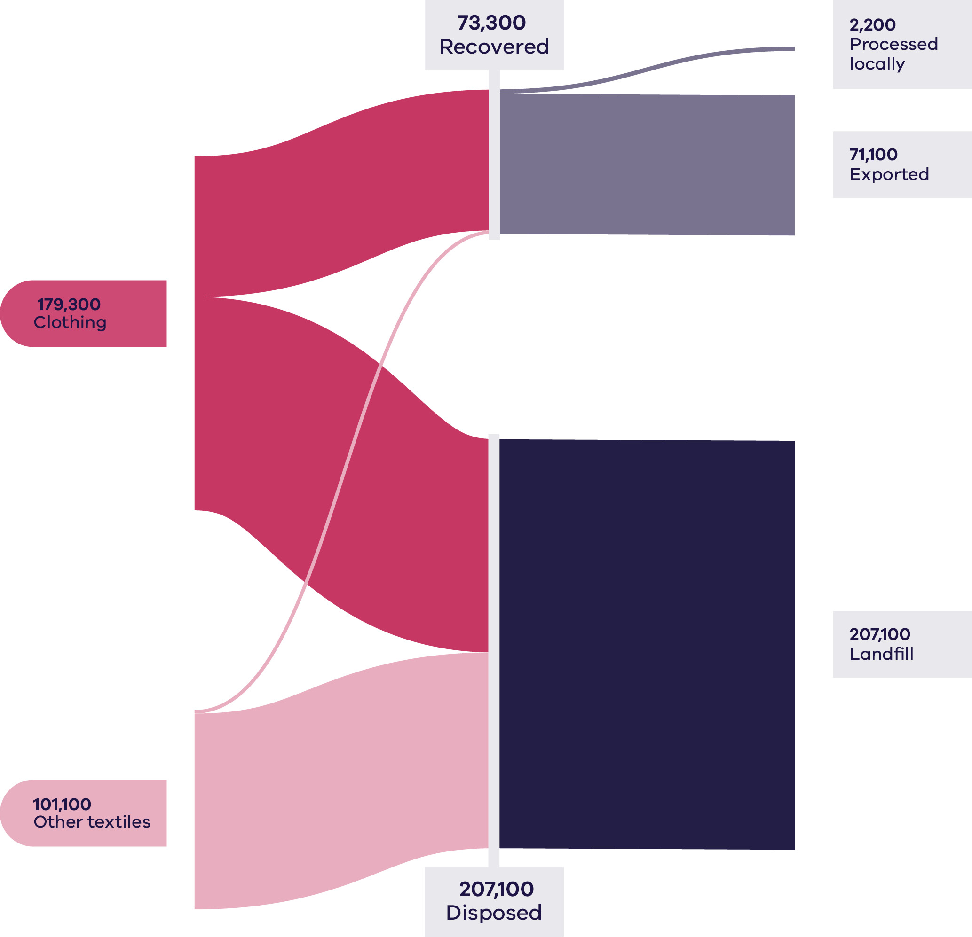
Table 14: Textile flows by stream and material sub-groups for 2023–24
Stream | Generated |  | Recovered for reprocessing |  |  | Disposed | Recovery rate
 |  |  | Processed locally | Exported | Total
 | Tonnes | Proportion | Tonnes | Tonnes | Tonnes | Tonnes | %
MSW | 146,600 | 52% | 1,500 | 70,800 | 72,300 | 74,200 | 49%
C&I | 123,400 | 44% | 600 | 300 | 1000 | 122,400 | 1%
C&D | 10,500 | 4% | 0 | 0 | 0 | 10,500 | 0%
Total | 280,400 |  | 2,200 | 71,100 | 73,300 | 207,100 | 26%

Stream | Generated |  | Recovered for reprocessing |  |  | Disposed | Recovery rate
 |  |  | Processed locally | Exported | Total
 | Tonnes | Proportion | Tonnes | Tonnes | Tonnes | Tonnes | %
Clothing | 179,300 | 64% | 600 | 70,800 | 71,300 | 108,000 | 40%
Other textiles | 101,100 | 36% | 1,900 | 300 | 1,900 | 99,200 | 2%
Total | 280,400 |  | 2,200 | 71,000 | 73,200 | 207,100 | 26%

Developments and changes
The Australian Government is supporting the transition to a circular textiles sector through targeted product stewardship reforms and the Environmentally Sustainable Procurement Policy, which encourages the incorporation of recycled and sustainably sourced textiles in government procurement. Product stewardship is increasingly recognised as a critical mechanism to internalise environmental costs, stimulate market demand for circular business models and enable effective reuse and recycling of textile materials.
A key development in 2023–24 was the operational commencement of Seamless, Australia’s industry-led clothing product stewardship scheme, on 1 July 2024. Seamless aims to make Australian clothing circular by 2030 and represents one of the world’s leading textile stewardship programs, aligning industry incentives with circular economy outcomes. Member organisations contribute 4 cents per new clothing item placed on the market, funding 4 priority areas:
- Incentivising businesses to design more durable, repairable, sustainable and recyclable clothes.
- Growing the market for new business models based on repair, reuse, remanufacturing and rental.
- Establishing collection and sorting systems to enable reuse of wearable items and recycling of non-wearables.
- Educating and empowering consumers to make informed decisions in acquiring, reusing, caring and disposal of clothes.
In addition, Seamless has commenced circular design training for members, embedding consideration of material selection, durability and end-of-life management early in the design process. These initiatives are providing a framework for industry to adopt more sustainable practices while simultaneously creating economic opportunities in textile reuse, recycling and remanufacturing.
The 2023–24 period has seen a shift from voluntary engagement towards structured, incentive-based participation. The federal Minister for the Environment has signalled that if voluntary adoption of Seamless is insufficient, formal regulation of the textile sector may be introduced (Productivity Commission 2025). This highlights the increasing regulatory expectation for Australian textile producers and importers to participate in stewardship initiatives.
Seamless has demonstrated early impact in guiding industry towards circular practices, supporting capacity building across design, collection and recycling infrastructure. The scheme represents a significant policy shift in aligning industry responsibility, consumer behaviour and government oversight to reduce textile waste, increase resource recovery and strengthen domestic circular markets. Its implementation is also expected to stimulate innovation and investment in textile recycling technologies and new circular business models, positioning Australia as a global leader in circular textiles.

Market issues and challenges
The Victorian textile waste stream is projected to grow by over 53% to more than 400,000 tonnes annually by 2053 (Recycling Victoria 2024b). It is estimated that over 200,000 tonnes of textiles are sent to landfill each year in Australia (Stock 2024a).
According to a RMIT-led survey of 3,080 Australians, most Australians are confused about what to do with their unwanted clothes, leading about a third to throw them in the rubbish (Payne, 2024). The survey found 84% of people owned garments they hadn’t worn in the past year, including a third who hadn’t touched more than half of their wardrobe. The results revealed consumers were confused about how to responsibly discard clothing (Stock 2024a).
Circular Australia and Arup (2024) identified the following factors leading to lost value in the textiles value chain nationally:
- High turnover of low-quality garments – the fast fashion industry often produces inexpensive, non-durable clothing to meet consumer demand, with short turnarounds for new styles and trends.
- Microplastics – it is estimated that 35% of microplastics released to oceans globally originate from washing synthetic textiles.
Complexity of textiles and limited traceability.
The Productivity Commission (2025) identified further potential areas for action including:
- improving information availability on circular textiles and clothing products
- measures to mitigate the risk of greenwashing for textiles and clothing products
- product labelling to help consumers select circular textiles and clothing products
- product labelling to help textiles businesses adopt circular opportunities
enhancing effectiveness of product stewardship schemes.

Focus areas for greater circularity – textiles
Opportunities to make the textile material stream more circular include:
- designing textiles for longer life, reuse and repair
- reducing consumption of high turnover materials
- finding further opportunities to support the charitable reuse market.

Circular economy opportunities for Victoria’s renewable energy transition
The Victorian Government has committed to achieving net zero by 2045. Victoria’s renewable energy targets are 65% by 2030 and 95% by 2035 and the government is legislating energy storage targets of at least 2.6 GW by 2030 and 6.3 GW by 2035.
As highlighted in previous editions of the CEMR, this leads to a range of ‘emerging’ materials and products that will require careful end-of-life management in Victoria over the coming decades. Key examples include photovoltaics (solar panels), batteries and wind turbines, which are contributing to a growing volume of e-waste.
E-waste encompasses any electrical or electronic equipment, device or machine powered by an electric current or electromagnetic field (Solar Victoria 2024). Understanding and managing these materials is critical to ensuring that Victoria’s circular economy can accommodate technological growth while minimising environmental impacts and recovering valuable resources.

Photovoltaic systems
Solar photovoltaics (solar panels) are deployed in large scale commercial utility scale facilities as well as in domestic rooftop arrays. The most referenced lifespan is the industry standard of 25 years, which is based only on performance warranties with limited practical module performance and decommission statistics. The performance guarantees equate to 80% power output after 25 years of operation.
Currently, there is no publicly available data in Australia or globally concerning the age of photovoltaic (PV) modules when decommissioned and the actual operating lifetimes of modules are unknown. Predictions of PV waste are likely underestimated, meaning the amount of PV waste will increase at a faster rate than expected (Tan et al, 2022).
This means that as the oldest solar panels in Victoria are starting to reach end-of-life, the need to find material reprocessing options is increasing. Global e-waste volumes are projected to increase by more than 30% from 2022 to 2030, with solar PV system waste expected to quadruple during this period (UNITAR 2024). To meet legislated renewable generation targets, approximately 25GW of additional large and small-scale generation capacity will be needed from 2024 to 2035, requiring installation of an additional 27 million new solar panels and 900 new wind turbines (Monaghan 2024).
The University of NSW partnered with the Australian Centre for Advanced Photovoltaics to undertake a scoping study on the end-of-life management of Australian solar panels and published their research last year. The report indicates that solar panel waste from small-scale and large-scale projects in Australia is projected to reach 685,000 tonnes by 2030 and 1.157 million tonnes by 2035.
The early growth of the country’s residential solar market will see most of the waste comes from residential solar panels. By 2035 however the proportion of waste from large-scale solar projects will increase, accounting for 22.9%of the total waste, up from 9.8%in 2023, as panels from solar farms reach the end of their lifespan (Australian Energy Council, 2024).
The early decommissioning of still well-functioning solar panels is accelerating this waste. Contributing factors include rebate incentives, preferences for newer models and renovations that require solar panel removal (Productivity Commission 2025). From 1 April 2025, all new solar installations must use modules that meet 2021 standards (IEC 61215:2021) to be eligible for small-scale technology certificates. This reduces the ability to develop reuse strategies for older panels (Clean Energy Council n.d.).
Recycling the eventual waste streams from these energy sources will require significant infrastructure capacity and capability advancement. The ecological and climate benefits of using recycled materials are not yet fully accounted for in the costs of the materials used in renewable energy. This means suitable secondary materials regularly compete on price with primary materials that are often cheaper (European Environment Agency 2021). In addition, the technical processes to recycle much of this waste is currently still evolving.
The Australian Government has announced its intention to develop a mandatory product stewardship scheme for solar PV systems to address many of these barriers. In the communique following the meeting of the Energy and Climate Change Ministerial Council, the Ministers agreed that NSW will work with other states to develop a regulatory impact statement while the Commonwealth will work with states to proof a national product stewardship scheme. All parties agreed to report back on progress in early 2026.
Solar panels inevitably reach the end of their service life. While they are typically designed to last 25–30 years, actual lifespans can be shorter due to factors such as weather damage, installation errors, manufacturing defects, or cell-specific issues—including degradation of the anti-reflective coating and discoloration or delamination of the cells. In some cases, panels are removed before reaching the end of their intended life; for example, when an inverter fails or a new battery is installed, households or solar farms may replace the entire system with new panels (Stock, 2024b). Additionally, falling costs of PV systems may encourage early upgrades, even for fully functional panels, contributing to increased waste generation.
Victoria’s solar panel recycling businesses are developing capacity to process PV panels beyond basic processing of recyclable components, such as removing aluminium frames from the panels. In Victoria, Elecsome has recently entered the market as the first Australian solar panel recycling plant that operates by transforming end-of-life solar panels into higher value products. Elecsome have created a product called Solarcrete, claiming it as the world’s first nano-engineered blend containing solar panel glass fines replacing a portion of aggregates.

Wind turbines
Wind power accounted for 21 per cent of Victoria’s renewable power generation in 2023 (DTP 2025)
A wind farm typically has a nominal design life of 20 to 30 years. However, site conditions being less severe than the design conditions and enhancements in technology and maintenance practices mean that many turbines can exceed this design life. Some wind farms are now designed for an operating life of a minimum of 30 years. The prospect of decommissioning wind farms has become even closer than before, as Pacific Blue engages with the local community to discuss rehabilitating their Codrington windfarm site in the state’s southwest when it reaches the anticipated end of its service life in the coming years (Pacific Blue n.d.).
The Australian Energy Council reports that currently Victoria has 39 operating windfarms with more than 1500 turbines across the state. Additionally, more than 200 offshore wind turbines will need to be developed and in operation by 2035 for the government’s stated renewable energy target (DTP 2025).
There are currently 31 Australian wind farms that are more than 15 years old, equating to a total of 599 wind turbines approaching the end of their design life. Eight of these windfarms are in Victoria (Clean Energy Council 2023).
Fibre-reinforced composites, which make up approximately 6% of a wind turbine by mass, represent the largest fraction of material that is not readily recyclable (Cooperman, Eberle and Lantz 2021). Nearly all utility-scale wind turbine blades are currently manufactured using epoxy resin, a hardening material that binds glass or carbon fibre to create a strong, lightweight and durable composite product—which makes recycling difficult and not always economical. Mechanical, thermal and chemical recycling processes for recycling composite wind turbine blades have been demonstrated in laboratories and are at various stages of scaling up to commercial implementation. Some researchers are looking at replacement feed materials, for instance thermoplastic resins, to 3D printing to optimise the structural design of the blades (US Department of Energy 2022). There is no clear pathway for end-of-life wind turbine blades at this time.

Batteries
Batteries are used in consumer products from mobile devices to laptop computers and in toys, appliances and tools. The electrification of the transport sector continues to grow the market for electric vehicles (EVs), e-bikes and scooters.
The global battery market consists of primary batteries (which are non-rechargeable) and secondary batteries (which are rechargeable). Just under 75% of batteries in the global market are secondary batteries, typically Lead Acid Batteries (LABs) and Lithium-Ion (Li-ion) batteries. The market direction is strongly moving to Li-ion becoming the most common battery type. Compared to LABs, Li-ion are lighter, less bulky, have longer cycle lives and have lower self-discharge rates.
Battery lifespans depend on a number of factors, such as their chemical composition and physical construction, their quality and their end use. Different forms of storage will need to be used depending on the situation, with the “depth” of the system (the length of time that electricity can be dispatched at maximum output before the stored energy is exhausted) being an important variable. Energy storage batteries tend to be used more intensively (deep cycling) and therefore often degrade more quickly.
In 2021, Australia recycled 99% of lead acid batteries, compared to just 10% of Li-ion batteries (CSIRO 2022). The active components found in Li-ion (graphite, cobalt, nickel and lithium) are used to produce a ‘mixed metal dust’. This product goes into manufacturing cathode materials for new Li-ion outside Australia.
Like solar panels, the operational lifespan of batteries is relatively short, with a need to be replaced around every 20 years. Batteries that will have been installed through the 2020s are likely to be replaced in the 2040s – when the transition to net zero by 2050 will be at full steam.
Li-ion batteries can be highly flammable. The insurance industry is seeking regulations to govern the sale and safety of these batteries. To reduce the risk of battery-related fires in the waste and recycling section, Victoria has started work on a mandatory product stewardship scheme for small batteries and electrical products with embedded batteries. This will result in more community battery collection points, increased flow of batteries to recycling and recovery of more critical minerals.

Waste to Energy (WtE)
Victoria’s WtE Scheme is a key initiative designed to enable the state’s transition to a circular economy. Established under the Circular Economy (Waste Reduction and Recycling) Act 2021 and the Circular Economy (Waste Reduction and Recycling) (Waste to Energy Scheme) Regulations 2023, the framework requires all thermal WtE facilities that process permitted waste to be licensed. Licences provide permission to use a specified amount of permitted waste within an overall ‘cap limit’ for Victoria.
The Scheme places an annual cap of 2.5 million tonnes on the amount of permitted waste that can be thermally processed for energy recovery across Victoria. This cap is designed to maintain strong alignment with the waste hierarchy – prioritising avoidance, reuse and recycling before energy recovery.
A cap licence is one of several regulatory approvals that must be held before a thermal WtE facility can be developed. Anyone who wants to develop and operate a thermal WtE facility in Victoria must obtain all required regulatory approvals before they can commence construction and operation.
In 2025, Recycling Victoria concluded the application process for thermal waste to energy cap licences and issued 7 licences totalling 2,350,000 tonnes per annum.
Many of the projects that have received a cap licence are at a feasibility stage. The issuing of cap licences to these projects will enable them to move through to the next phase of development, including applying for other required regulatory approvals.
EPA Victoria, Recycling Victoria and planning authorities each have a role to ensure that thermal WtE facilities meet the short and long-term needs of the Victorian community. Independent assessment processes by these agencies ensure a range of different criteria are considered. This includes ensuring best practice environment protection and human health outcomes and land use planning are appropriately addressed and that the facilities will work well with local communities in which they operate.
Importantly, the Scheme has been designed to also support emerging non-thermal technologies such as anaerobic digestion which are not required to hold a cap licence, broadening opportunities for innovation in waste to energy.

Case study: Closing the loop on embedded battery waste
Opened in September 2025 by the Victorian Minister for Environment, the EcoBatt Battery-in-Devices Shredding (BIDS) facility in Campbellfield represents a significant development and a national first in Australia’s capability to manage emerging hazardous waste streams within a circular economy framework.
Developed by EcoBatt, a subsidiary of EcoCycle Group, the facility demonstrates the practical application of circular economy principles and the 10R framework—from refuse and reduce through to recover and recycle—in addressing the challenges associated with products containing embedded or built-in batteries.
Since the 2019 Victorian landfill ban on e-waste and batteries, managing devices such as vapes, electric toothbrushes, power tools, laptops and mobile phones has been increasingly complex. These products typically contain sealed or inaccessible batteries that pose safety, environmental and logistical risks throughout collection and recycling.
Existing recycling infrastructure was largely designed for loose batteries, creating a gap in safe, scalable recovery pathways for battery-in-device products. The BIDS facility directly addresses this gap by introducing the world’s first water-based BIDS shredding technology, designed to safely dismantle and separate materials without the fire and explosion risks associated with conventional mechanical shredding.
The BIDS process integrates automated shredding, underwater handling and advanced separation technologies capable of recovering up to 95% of materials from mixed BIDS waste streams. This includes recovery of metals, plastics and critical minerals such as lithium, cobalt, nickel and copper.
Operating at a throughput of up to one tonne per hour, the system exemplifies recover and recycle principles by reclaiming valuable resources for reuse in new batteries, electronics and manufacturing applications. The water-based process also represents rethink and redesign principles – embedding safety, environmental control and efficiency into the recovery process itself by eliminating airborne contamination and thermal hazards.
In addition to its technological innovation, the facility strengthens domestic recycling capacity and supports reconnect and repurpose principles through integration with EcoBatt’s established national collection network of more than 7,500 drop-off points across major retail and supermarket chains. This network ensures a continuous feedstock supply for processing and facilitates a closed-loop recovery pathway from consumer drop-off to material reintroduction into the manufacturing supply chain.
The Campbellfield facility was supported by a $2 million investment from the Victorian Government’s Circular Economy Infrastructure Fund (Hazardous Waste – Round 3). This partnership illustrates the role of targeted public co-investment in enabling the development of advanced recycling infrastructure for complex and hazardous waste streams.
The project aligns with Victoria’s Circular Economy Policy – Recycling Victoria: A New Economy, which prioritises innovation and local processing capacity to reduce reliance on overseas recycling markets.
By combining safety-focused process design, high material recovery efficiency and integration with national collection systems, the BIDS facility provides a scalable model for managing embedded battery waste. It contributes to reducing hazardous landfill disposal, mitigating fire risks in waste management facilities and capturing finite critical materials for future battery production.
The project demonstrates how industrial design, material innovation and policy support can align, to operationalise circular economy principles—advancing recover, reuse and reintegrate outcomes while supporting Victoria’s transition to a resilient, resource-efficient economy.

Government policy and action
Summary of Australia’s multi-level circular economy policy transition
The transition to a circular economy is actively being driven by all levels of government in Australia—national, state and local. This coordinated effort involves embedding CE principles into new and existing policy, strategy and regulation across the nation. This whole-of-government approach is supported by both financial and non-financial levers designed to stimulate progress and investment in circular practices.
Table 15 summarises the key national and jurisdictional circular economy and waste management strategies currently guiding Australia’s transition. It highlights the core policy focus areas and measurable objectives being pursued across all states and territories to advance circularity, resource efficiency and sustainable materials management.

Table 15: National and other State Government’s circular economy policy frameworks (2024 Update)
Jurisdiction/Level | Policy/Strategy name | Publication/  Status | Key circular economy focus/objective | Key target/action
Australian Government | Australia’s Circular Economy Framework (DCCEEW 2024) | Released late 2024 | Provides the national blueprint to guide Australia’s transition to a circular economy, focusing on systemic change and material flow. Identifies four key sectors: Industry (Manufacturing), Built Environment, Agriculture & Food and Resources (Mining). | Double Australia’s circularity by 2035.
National | National Waste Policy Action Plan 2024 | Agreed December 2024 | Supports the Circular Economy Framework by setting out actions to achieve the National Waste Policy targets, focusing on waste reduction and resource recovery. | 80% average resource recovery rate from all waste streams by 2030. 10% reduction in total waste generated per person by 2030. Halve the amount of organic waste to landfill by 2030.

State/Territory CE-Related Initiatives (examples)
Jurisdiction/Level | Policy/Strategy name | Publication/  Status | Key circular economy focus/objective | Key target/action
South Australia | Accelerating SA’s transition to a circular economy: South Australia’s waste strategy 2025–2030 | Draft (Consultation Concluded) | Sets a framework of objectives and priority actions to accelerate SA’s transition, reduce reliance on virgin resources and eliminate waste and pollution. | 10% reduction in material footprint by 2035. 30% increase in material productivity. 10% reduction in total waste generated per person by 2030. 50% reduction in organics to landfill.
Queensland | Queensland Waste Strategy 2025–2030 – Less Landfill, More Recycling | Draft (Consultation Concluded) | Sets the strategic framework to reduce waste to landfill, boost recycling and stimulate economic growth through a transition to a more circular system. | Establishment of a $130 million Resource Recovery Boost fund to support councils and critical waste infrastructure investment. Focus on diverting more landfill material into recycling.
New South Wales | NSW Waste and Sustainable Materials Strategy 2024 | Current Strategy | Focuses on reducing waste, increasing recycling and transitioning to a circular economy with a strong emphasis on addressing problematic wastes (for instance plastics, textiles). | Deliver programs to increase resource recovery to 80% across all waste streams by 2030. Halve the volume of food waste sent to landfill by 2030.
Western Australia | Waste Avoidance and Resource Recovery Strategy 2030 | Current Strategy | Outlines a vision for WA to become a low-waste, circular economy. It follows the waste hierarchy and supports market development for recovered materials. | 75% material recovery rate (2030 target, up from 62% in 2018-19). 20% reduction in per capita waste generation by 2030.

National action towards a circular economy

National policy drivers and Victorian market implications
Australia’s transition towards its goal of doubling circularity by 2035 is being structurally supported by key national policy and economic documents that provide clear market signals.
The foundational ten-year roadmap is the National Circular Economy Framework (NCEF). Its national targets—a 10% reduction in per capita material footprint, a 30% increase in material productivity and 80% resource recovery—signal the primary direction for future regulatory development and investment, specifically impacting the manufacturing and built environment sectors. These targets also provide market stimulation for circular services, including those in Victoria.
Complementing this, the Productivity Commission’s final report, Opportunities in the circular economy (released post-August 2025), delivers the economic analysis anticipated to inform and guide both national and state investment strategies.
Further clarity for the manufacturing sector is provided by the conclusion of consultation for the Design for Kerbside Recyclability Grading Framework. Although a non-harmonised standard, this framework offers manufacturers greater definition regarding material design requirements. The National Waste Policy Action Plan 2024 continues to maintain 7 existing targets, providing the measurable operational milestones necessary for ongoing infrastructure funding allocation.

Victorian Government action towards a circular economy
Victoria’s transition to a circular economy accelerated since 2020, with sustained government investment, industry partnerships and reforms driving systemic change. These actions occurred against a backdrop of a recovering construction sector, ongoing cost-of-living pressures and heightened global focus on supply chain resilience and resource efficiency.
Table 16 highlights key state-level policy, programs, reforms and market interventions completed or undertaken since CEMR 2025.

Table 16: Victorian Government action towards a circular economy (2020–2026)
Program / Policy | Purpose / Description | Key Outcomes (as at 2025–26)
Recycling Victoria – a new economy | Provides policy and direction for transformation to a circularity economy in Victoria | Targets (by 2030):  - Divert 80% of waste from landfill, with an interim target of 72% by 2025.  - Reduce total waste generation by 15% per capita.  - Halve the volume of organic material sent to landfill (baseline 2020), with a 20% reduction by 2025.  - Food and garden organics recycling or local composting for all Victorian households.
Victoria’s Economic Growth Statement | Designates the circular economy as one of the state’s priority sectors for economic growth, aiming to stimulate investment and job creation | - Make: Design products to last, be repaired and be recycled.  - Maximise value from products during their use phase.  - Recover more resources through improved recycling systems.  - Manage: Minimise harm from waste and pollution.
Victorian Industry Policy | The Victorian Industry Policy is the state’s new framework to drive industry competitiveness, productivity and economic resilience. | - The Victorian Industry Policy sets a clear direction that backs business to invest with confidence, grow sustainably and create secure, high-value jobs.  - Building on the priority sectors outlined in the Economic Growth Statement, the industry policy provides a framework and necessary layer of depth and guidance for industry to embrace focus for impact areas such as circular production.  - The policy represents a commitment and mandate for sustainable industry development, which will influence government’s decision making across key areas and investments.
Victorian Investment Fund (VIF) | A $150 million consolidated investment fund, including a dedicated regional stream. | - The Victorian Investment Fund was announced as part of 2025–26 Victorian State Budget and shaped by the priority areas nominated in the Economic Growth Statement and Victorian Industry Policy.  - The fund will provide support to secure business investment that creates jobs, supports innovation and underpins Victoria’s long term economic growth in priority sectors, including circular economy.  - Tailored support is offered through the Victorian Government’s Investment Front Door (https://www.invest.vic.gov.au/get-tailored-support/investment-front-door).
Circular Economy Business Innovation Centre  (CEBIC) | Supports Victorian businesses to innovate, collaborate and implement circular business models through capability-building and targeted funding. | - 50+ activities delivered to 8,000+ professionals; 95% increased capability.  - 51 projects funded leveraging $17.2M private investment.  - 340 partnerships formed; 226 new circular jobs created.  - 55,800 tpa new circular capacity; 107,800 tonnes waste avoided.  - 170,000 tonnes diverted from landfill; 262,000 t CO2-e avoided.  - 140+ new circular products/services launched.
Industry Support and Market Development Funds | Stimulate recycling infrastructure, processing capacity and market demand for recovered materials. | - Circular Economy Infrastructure Fund – Materials: 8 projects increasing glass and organics processing by 337,000 tpa.  - Markets Fund: 31 innovation projects in organics and materials recovery.  - Organics Sector Transition Fund: new regional hub in Swan Hill.  - Waste Levy Relief for Charitable Recycling: ongoing social enterprise support.
Container Deposit Scheme (CDS Vic) | Launched Nov 2023 to reduce litter and increase recycling of beverage containers. | - >2 billion containers returned via 600+ refund points (62% return rate by June 2025).  - 71% reduction in CDS-eligible litter in metro/coastal areas.  - 1,282.5 million containers (63,198 t) sold to recyclers in FY2025.
Four-stream waste and recycling reform | Standardises household waste and recycling systems across Victoria (FOGO, glass, commingled, residual). | - 60 of 79 councils offer FOGO (59 kerbside).  - 42 councils offer separate glass collection (26 kerbside).  - Improved recovery quality, especially for glass, paper and cardboard.
Victorian Waste Sector Emissions Pledge  2026–30 | Sets a coordinated sector-wide commitment to reduce waste-related greenhouse gas emissions and accelerate circular economy outcomes, supporting Victoria’s legislated emissions reduction targets and the pathway to net zero by 2045. | - Establishes shared actions for government, industry and councils to reduce landfill methane, increase diversion of organics and improve landfill gas capture and treatment.  - Strengthens commitments to expand recycled material markets and reduce embodied emissions through circular design, reuse, repair and high-value material recovery.  - Provides clear emissions-reduction expectations for the waste and resource recovery sector for 2026–30, aligning circular economy action with climate mitigation priorities.  - Supports delivery of Victoria’s 75–80% emissions reduction target by 2035 and net zero by 2045 through targeted interventions across waste, material flows and infrastructure systems.
Waste to Energy  Scheme | Supports thermal processing of residual  waste to recover energy; capped at 2.5 million tpa. | - 7 cap licences issued totalling 2.35 million tpa capacity  - 4 ‘existing operator’ licences issued totalling 1.14. million tpa capacity  - Encourages diversion from landfill and scaled to complement recycling investment.  - Provides reliable alternative energy source for industry and grid.
Recycled First policy | Embeds use of recycled materials in government infrastructure procurement. | - Expanded use of crushed concrete, recycled fill, plastics, rubber and organics in road and rail projects.  - Recycled First facilitated the use of over 4.4 million tonnes of recycled and reused materials across projects statewide  - Stimulated secondary markets and local reprocessing capacity
Circular Procurement – Buy Circular | Embeds circular principles in government procurement and purchasing. | - Draft Buy Circular Guidelines released 2024.  - Pilot projects trialled recycled construction materials, remanufactured office furniture and IT reuse.  - Policy reform to increase long-term demand for circular products.
Behaviour change initiatives | Builds community participation in recycling reforms through education and engagement. | - Small Acts, Big Impact campaign increased FOGO tonnages, reduced contamination and improved material separation and return rates.

Sources: Sustainability Victoria (2025); Recycling Victoria (2025); Department of Energy, Environment and Climate Action (DEECA, 2025).
This combined program of reform, infrastructure investment, behavioural change and market development places Victoria on track to meet the targets set in Recycling Victoria: a new economy, while unlocking new economic, environmental and social benefits.

Government action driving circular growth: Recycled First and ecologiQ
The Victorian Government is implementing measures to advance a circular economy through infrastructure procurement. The Recycled First policy requires consideration of recycled and reused materials in government-led transport projects, providing a consistent demand signal for industry and supporting the development of local material recovery sectors.
In 2023–24, ecologiQ supported projects across the Victorian Infrastructure Delivery Authority’s (VIDA) program to apply the Recycled First policy resulting in the use of over 4.4 million tonnes of recycled and reused materials across transport projects statewide, including crushed concrete, reclaimed asphalt pavement (RAP), crumb rubber and recycled glass sand.
Since 2020, Recycled First has contributed to diverting more than 8.6 million tonnes from landfill and reducing associated emissions.
Key outcomes in 2023–24 include:
- Deployment of recycled materials in pavement and road base, with average RAP content exceeding 25% on major freeway upgrades.
- Establishment of advanced reprocessing capacity for glass, rubber, and plastics to meet technical specifications.
Publication of updated technical standards and specifications, facilitating broader adoption of recycled content.
Shifting materials from landfill to recycling contributes to economic outcomes. Analysis indicates that every 10,000 tonnes of material diverted from landfill supports approximately 9 jobs, compared with 3 jobs in landfill operations (PwC 2023).
With Victoria’s transport infrastructure pipeline exceeding $100 billion, continued application of Recycled First is expected to support regional industry capacity and material supply resilience.
The 2024 Economic Growth Statement noted that the Recycled First Policy will be expanded to additional government projects in non-transport sectors. The Victorian Government will implement these requirements, extending recycled content obligations across state procurement and increasing certainty for suppliers, while supporting ongoing growth in local material recovery and manufacturing sectors.

Conclusion
The Circular Economy Market Report 2026 provides an updated evidence base on the circularity of key material streams in Victoria, drawing on the latest 2023–24 market data and broader sector intelligence. The report delivers insights to government, industry and the community to support informed decision-making, investment and progress towards a resource-efficient Victorian economy.
Analysis of recent trends indicates that C&D recovery continues to perform strongly, underpinned by mature recycling markets and infrastructure investment. MSW recovery also shows steady improvement, supported by enhanced collection systems and community engagement. However, contamination in the organics stream, including plastics marketed as compostable or biodegradable, remains a persistent challenge for MSW recovery, undermining material quality and highlighting the need for ongoing education, clearer standards and improved processing systems. The C&I sector continues to face challenges in improving recovery rates for specific materials, underscoring the need for stronger market signals, better data and targeted policy support.
In the financial year 2023–24, approximately $3 billion in materials were recovered, reprocessed and recirculated into Victoria’s economy (Figure 2), led by the high market value of recovered metals. However, an estimated $1.2 billion in materials disposed to landfill represents a significant unrealised economic opportunity, as well as lost environmental and energy value.
The adoption of national circular economy metrics—developed in collaboration with the Australian Government—has enhanced Victoria’s ability to benchmark, track and compare performance across jurisdictions. These metrics are now supporting more consistent national reporting and helping guide strategic policy and investment decisions.
The release of The Circular Advantage (Circular Economy Ministerial Advisory Group, 2025) and Australia’s Circular Economy Framework has further strengthened the policy environment, enabling greater collaboration across governments, industries and communities. Together, these initiatives provide a unified platform to scale circular solutions, leverage private and public investment and align Victoria’s progress with national and global circular economy goals.
Growing safety risks and the strategic value of critical materials are driving rapid national action on battery product stewardship, with environment ministers signalling strong support for urgent regulatory reform. Victoria, working closely with NSW, is helping shape a mandatory national approach while progressing a stewardship scheme for small and embedded batteries to ensure safer collection, transport and recycling.
Alignment with the NSW legislative model is being explored to reduce regulatory burden and support interoperability across jurisdictions. At the same time, Victoria is contributing to national efforts to establish a stewardship scheme for solar PV systems, positioning Australia for more consistent, safe and circular end-of-life management. Together, these reforms signal a maturing circular economy framework that will strengthen material recovery and market confidence in the years ahead.
Victoria continues to offer strong conditions for circular economy growth—supported by clear government policy direction, robust domestic demand and a dynamic innovation and research ecosystem. Continued collaboration across sectors will be critical to advancing investment in infrastructure, expanding markets for secondary materials and embedding circular principles in design and production systems.
To accelerate the transition towards a modern, resource-efficient and competitive circular economy, this report identifies priority areas for strengthening circularity within each material stream. These insights provide a roadmap for collective action—helping ensure that Victoria remains a national leader in the transition to a sustainable, circular future.
Recycling Victoria has outlined the following priorities for the market for the next year as follows:
Table 17: Priorities for financial year 2025–26
Priority | Action
Advance circularity opportunities across the commercial and industrial sector | - Continue to identify and assess opportunities to improve material efficiency, resource recovery and circular business models, including within Victoria’s C&I sector.  - This includes supporting innovation in product design, reuse and remanufacturing to reduce waste generation and strengthen circular value chains.
Strengthen national alignment through data collaboration | - Actively contribute to the implementation of Australia’s Circular Economy Framework by enhancing data sharing, interoperability and collaboration with other jurisdictions.  - Improved national consistency in circular economy metrics will support evidence-based decision-making and facilitate market development across state boundaries.
Accelerate circular solutions for priority and complex material streams, such as progressing product stewardship for problematic batteries | - Maintain and expand efforts to improve circular outcomes for materials with low recovery rates or complex end-of-life pathways - particularly solar panels, organics, plastics and textiles.  - This includes working with industry to develop collection systems, recycling technologies and end-market applications that enable higher-value resource recovery.  - Continue to focus on priority emerging material streams, including product stewardship of problematic materials such as batteries and packaging  - Continue to advocate for stronger, more effective product stewardship.
Continuing to foster strategic investment and partnerships in circular markets | - Build and strengthen partnerships with investors, industry leaders and research organisations to scale circular infrastructure and innovation.  - Focus investment attraction on high-impact market opportunities that deliver measurable economic, social and environmental benefits for Victoria’s circular economy.

Glossary
Glossary of acronyms used in this document and their full meanings
Acronym | In full
ABS | Australian Bureau of Statistics
ACCC | ACCC Australian Competition & Consumer Commission
AEMO | Australian Energy Market Operator
ARENA | Australian Renewable Energy Agency
ARV | Alpine Resorts Victoria
CDS | Container Deposit Scheme
CDS Vic | Container Deposit Scheme Victoria
CE | Circular Economy
CE Act | Circular Economy (Waste Reduction and Recycling) Act 2021
CEMR | Circular Economy Market Report
C&D | Construction & Demolition
C&I | Commercial and Industrial
CPA | Circular Plastics Australia
CRA | Crumb Rubber Asphalt
CSIRO | Commonwealth Scientific and Industrial Research Organisation
EOL | End of Life
EOLT | End of Life Tyres
EPA | Environment Protection Authority
EPS | Expanded Polystyrene
EU | European Union
EV | Electric Vehicles
FOGO | Food Organics and Garden Organics
GDP | Gross Domestic Product
GSP | Gross State Product
GW | Gigawatts
HDPE | High Density Polyethylene
MRF | Materials Recovery Facility
MSW | Municipal Solid Waste
PaCE HQ | Paint Circular Economy Headquarters
(r)PET | (recycled) Polyethylene Terephthalate
PFAS | Perfluoroalkyl and Polyfluoroalkyl Substances
PV | Photovoltaic
R&D | Research and Development
SDG | Sustainable Development Goals
UN | United Nations
US FDA | United States Food and Drug Administration

References

References for Table 1: Indicative Price Ranges for Virgin and Recovered Materials 2023–24
DCCEEW (Department of Climate Change, Energy, the Environment and Water) (2024a). Australian Plastics Flows and Fates Study – National Report 2021–22. DCCEEW website, accessed 27 October 2025
Australian Government Department of Climate Change, Energy, the Environment and Water (DCCEEW). (2024). APFF Method Report 2023–24. DCCEEW website, accessed 27 October 2025
IndexMundi. (2024). Copper commodity price series (AUD per tonne). IndexMundi website, accessed 27 October 2015
London Metal Exchange (LME) (2024). LME Copper – Historical Prices and Monthly Averages. LME website accessed 27 October 2015
Recycling Victoria (2024b) Victorian Recycling Infrastructure Plan | vic.gov.au, Victorian Government website, accessed 27 October July 2025.
Recycling Victoria. (2023) Recycling Victoria Data Hub – Transfer station and gate fee dataset. Melbourne: Victorian Government. https://www.vic.gov.au/recycling-victoria-data-hub
Sustainability Victoria. (2022). Recycled Products in Pavement Construction – Technical Report. Sustainability Victoria website, accessed 27 October 2025
Sustainability Victoria. (2025). Invest in Victoria’s circular economy Sustainability Victoria website, accessed 27 October 2025
Tyre Stewardship Australia (TSA). (2025). Annual Report 2024–25. Tyre Stewardship Australia. website, accessed 27 October 2025
Australian Tyre Recyclers Association (ATRA). (2024) Industry Update – Australia’s Used Tyre Recycling Market ATRA website, accessed 27 October 2025
The Australia Institute. (2024). Textiles Waste in Australia. The Australia Institute website , accessed 27 October 2025
Vic Star Metals (2025). Scrap metal prices Melbourne Vic Star Metals website, accessed 27 October 25 2025

General References
ABS (2020) Waste Account, Australia, Experimental Estimates, 2018–19 financial year | Australian Bureau of Statistics, ABS website, accessed 30 July 2025
ABS (2024) Australia’s population officially passes 27 million ABS website, accessed 30 July 2025
ACCC (Australian Competition & Consumer Commission) (2025) ACCC proposes to authorise new scheme for soft plastics recycling, accessed 12 August 2025
ACTA (Australasian Circular Textiles Association) (2021) Thread Count NSW Textile Data Report, NSW EPA website, accessed 31 July 2025.
Australian Government (2023) Measuring What Matters Statement | Treasury.gov.au, Australian Government website, accessed 31 July 2025
Australian Government (2025) Industry Profile Victoria. Australian Government website, accessed 1 September 2025.
Australian Energy Council (2025) Solar Report Year of 2024, Energy Council website, accessed 30 July 2025
ATRA (Australian Tyre Recyclers Association) (2024) Industry Update – Australia’s Used Tyre Recycling Market ATRA website, accessed 27 October 2025
B-cycle (2023) B-cycle-Positive-Charge-Report-20231207.pdf, B-cycle website, accessed 31 July 2025.
Breakthrough Victoria (2022) Breakthrough technology to Close the Loop on Plastic Recycling. Breakthrough Victoria website, accessed 30 July 2025
Circular Australia and Arup (2024) Unlocking Circular Markets in Australia, November 2024, Arup website, accessed 31 July 2025.
Circular Australia (2025) Research Appendix Integrating circular economy, climate & biodiversity March 2025, Circular Australia website, accessed 31 July 2025.
City of Melbourne (n.d.) Food organics high-rise pilot City of Melbourne website, accessed 30 July 2025.
Clean Energy Council (2023) Winding Up Decommissioning, Recycling and Resource Recovery of Australian Wind Turbines, Clean Energy Council website, accessed 30 July 2025.
Clean Energy Council (n.d.) PV modules standards change Clean Energy Council website, accessed 30 July 2025.
Clean Energy Regulator (2025) Small-scale installation postcode data | Clean Energy Regulator, CER website, accessed 31 July 2025.
Clean Up Australia (2024) Litter Report FY24, Clean Up Australia website, accessed 30 July 2025.
Continental (2024) Four reasons why electric cars need special tires Continental website, accessed 30 July 2025
Cooperman A, Eberle A and Lantz E (2021) Wind Turbine Blade Material in the United States: Quantities, Costs and End-of-Life Options National Renewable Energy Laboratory Research Hub, accessed 31 July 2025
CropLife (2025) Australia’s first industry-led collection and recycling program bag MUSTER®, starts rounding up agriculture’s soft plastic bags, CropLIfe website, accessed 31 July 2025.
CSIRO (2022) Lithium-ion battery recycling CSIRO website, accessed 17 October 2025
DCCEEW (Department of Climate Change, Energy, the Environment and Water) (2017) Headline economic value for waste and materials efficiency in Australia. DCCEEW website, accessed 22 October 2025
DCCEEW (Department of Climate Change, Energy, the Environment and Water) (2021) Hazardous Waste in Australia 2021. DCCEEW website, accessed 30 July 2025
DCCEEW (Department of Climate Change, Energy, the Environment and Water) (2023) Wired for change: Regulation for small electrical products and solar photovoltaic systems – DCCEEW, DCCEEW website, accessed 31 July 2025.
DCCEEW (Department of Climate Change, Energy, the Environment and Water) (2024a) Circular Economy Ministerial Advisory Group: Interim Report, DCCEEW website, accessed 31 July 2025
DCCEEW (Department of Climate Change, Energy, the Environment and Water) (2024b) Circular Economy Ministerial Advisory Group: Final Report. DCCEEW website, accessed 31 July 2025
DCCEEW (Department of Climate Change, Energy, the Environment and Water) (2024c) Australia’s Circular Economy Framework – DCCEEW, DCCEEW website, accessed 31 July 2025
DCCEEW (Department of Climate Change, Energy, the Environment and Water) (2024c) Energy recovery, DCCEEW website, accessed 31 July 2025.
DCCEEW (Department of Climate Change, Energy, the Environment and Water) (2024d) National waste and resource recovery reporting – DCCEEW, DCCEEW website, accessed 31 July 2025
DCCEEW (Department of Climate Change, Energy, the Environment and Water) (2024e) Reforming packaging regulation – DCCEEW, DCCEEW website, accessed 31 July 2025
DCCEEW (Department of Climate Change, Energy, the Environment and Water) (2024f) Australian Standard for Waste and Resource Recovery Data and Reporting – second edition, DCCEEW website, accessed 31 July 2025.
DCCEEW (Department of Climate Change, Energy, the Environment and Water) (2025a) National waste and resource recovery report 2024 – Final, DCCEEW website, accessed 31 July 2025
DEECA (Department of Energy, Environment and Climate Action) (2025). Victorian Waste Pledge 2026–2030 Circular Economy Market Report. State Government of Victoria. https://www.vic.gov.au/circular-economy-market-report DEECA website accessed 21 November 2025
DJSIR (Department of Jobs, Skills, Industry and Regions) (2023) Clean Economy Workforce Development Strategy 2023 to 2033 DJSIR website, accessed 27 October 2025.
DJSIR (Department of Jobs, Skills, Industry and Regions) (2024a) Medical remanufacturing facility boosting Victoria’s circular economy DJSIR website, accessed 30 July 2025.
DJSIR (Department of Jobs, Skills, Industry and Regions) (2024b) Victorian Industry Policy DJSIR website, accessed 5 Sept 2025.
DTF (Department of Treasury and Finance) (2024) Economic Growth Statement Victoria: Open for Business DTF website, accessed 30 July 2025
DTP (Department of Transport and Planning) (2023) Victoria in Future 2023 Population and Household Projections to 2051 November 2023, DTP website, accessed 31 July 2025.
DTP (Department of Transport and Planning) (2025) Renewable Energy Projects Victoria, DTP website, accessed 14 October 2025.
ecologIQ (2024) Recycled-First-Summary-Report.pdf, ecologIQ website, accessed 31 July 2025
EPA (Environment Protection Authority Victoria) (2024) Managing waste soil | Environment Protection Authority Victoria, EPA website, accessed 30 July 2025.
EPA (Environment Protection Authority Victoria) (2025). Waste levy | Environment Protection Authority Victoria, EPA website, accessed 30 July 2025.
European Environment Agency (2021) Emerging waste streams – Challenges and opportunities, European Environment Agency website, accessed 30 July 2025.
Foodbank (n.d.) Food waste in Australia Foodbank website, accessed 30 July 2025
Gippsland Water (n.d) Gippsland Regional Organics expansion Gippsland Water website, accessed 30 July 2025
Glass Packaging Institute (n.d.) Facts About Glass Recycling Glass Packaging Institute website, accessed 30 July 2025
Hughson (2024) Coming full circle: Recyclers speak out, Packaging News website, accessed 30 July 2025
Infrastructure Victoria (2024) A National Urban Policy for Victoria Infrastructure Victoria website, accessed 23 October 2025
Lovell (2025) Future sealed, iSentia website, accessed 30 July 2025.
Lucadou-Wells and Li (2025) Oceania Glass Factory to close, 150-plus jobs potentially lost. Dandenong Star Journal, accessed 30 July 2025.
Lyons (2024) Poor labelling allows ‘massive amounts’ of plastic into Australia’s garden waste, companies warn The Guardian website, accessed 30 July 2025
Malooly and Daphne (2023) R-Strategies for a Circular Economy Circularise website, accessed 30 July 2025
Medsalv (2025) Medsalv – changing health care for good. Medsalv website, accessed 30 July 2025
Miatto A, Schandl H, Yamashita N and Fishman T (2025) Detailed waste flows and circularity rates reveal the limits of the circularity gap concept Resources, Conservation & Recycling 219 (2025) 108319.
Monaghan (2024) A tale of two approaches: How does Victoria’s energy plan differ from the 2024 ISP?, Australian Energy Council website, accessed 31 July 2025.
Morseletto (2020) Targets for a Circular Economy Resources, Conservation & Recycling 153 (2025) 104553.
MRA (2021) Measuring the Impact of the Charitable Reuse and Recycling Sector MRA Consulting Group, accessed 17 October 2025
Navarro D, Samaraweera D, Srivastava P and Kirby J (2024) Exploring global influences on the tyre industry: Chemicals of concern, microplastics and design LITERATURE REVIEW, Tyre Stewardship Australia website, accessed 30 July 2025
NWRIC (2025) Economic and Environment Benefits from an Australian unprocessed ferrous scrap metal export ban Submission to Productivity Commission, accessed 28 October 2025
OECD (2024), Monitoring progress towards a resource-efficient and Circular Economy. OECD Publishing, Paris accessed 25 August 2024
Pacific Blue (n.d.) Discussions underway on the responsible decommissioning of Codrington Wind Farm Pacific Blue Wind Farm website accessed 30 July 2025
Payne, A (2024) Keeping Clothes Out of Landfill: A landscape survey of Australian consumer practices’. RMIT University, accessed 17 October 2025
Pittorino (2024) Bendigo Council approves planning permit for organics processing facility.Waste Management Review website, accessed 30 July 2025
Productivity Commission (2025) Australia’s circular economy: Unlocking the opportunities. Interim Report March 2025, Productivity Commission website, accessed 30 July 2025.
Recycling Victoria (2023) RV_Strategic-Plan_2023-26_Final.pdf, Victorian Government website, accessed 30 July 2025.
Recycling Victoria (2024a) Victoria’s waste projection model dashboard | vic.gov.au, Victorian Government website, accessed 30 July 2025.
Recycling Victoria (2024b) Victorian Recycling Infrastructure Plan | vic.gov.au, Victorian Government website, accessed 30 July 2025.
Recycling Victoria (2024c) Waste to Energy Scheme | vic.gov.au, Victorian Government website, accessed 31 July 2025.
Recycling Victoria (2024d) RV Waste, Recycling and Resource Recovery Investment Prospectus, Victorian Government website, accessed 31 July 2025
Recycling Victoria (2024e) Circular Economy Risk, Consequence and Contingency Plan | vic.gov.au, Victorian Government website, accessed 31 July 2025.
Recycling Victoria (2025) Circular Economy Market Report 2025, Victorian Government website, accessed 30 July 2025
Resources Victoria (2023) Quarry materials – Resources Victoria, Victorian Government website, accessed 31 July 2025.
Solar Victoria (2024) How to manage end-of-life solar PV | solar.vic.gov.au, Victorian Government website, accessed 31 July 2025.
Stock (2024a) One in three Australians throwing unwanted clothes in rubbish, survey finds, The Guardian website, accessed 31 July 2025.
Stock (2024b) Through the roof: how a Brisbane shed is turning old solar panels into silver and copper | Solar power | The Guardian, The Guardian website, accessed 31 July 2025.
Sustainability Victoria (2023) Our war on textile waste | Sustainability Victoria, Sustainability Victoria website, accessed 31 July 2025.
Sustainability Victoria (2023b) Victorian e-waste material flow analysis, Sustainability Victoria website, accessed 1 October 2025
Sustainability Victoria (2024) Annual Report, Sustainability Victoria website, accessed 1 October 2025
Sustainability Victoria (2025a) Textiles circular economy opportunities, Sustainability Victoria website, accessed 31 July 2025.
Sustainability Victoria (2025b) Glass circular economy opportunities, Sustainability Victoria website, accessed 1 September 2025.
Tan V, Dias P, Chan N and Deng R (2022) Estimating_the_Lifetime_of_Solar_Photovoltaic_Modules_in_Australia, Sustainability 14(9):5336
Textile Exchange (2024) Textile Exchange Materials Market Report September 2024. Textile Exchange website, accessed 30 July 2025.
The State of Victoria (2021) Circular Economy (Waste Reduction and Recycling) Act 2021 | legislation.vic.gov.au, Victorian Legislation website, accessed 30 July 2025.
Tyre Stewardship Australia (2024) Implications of the Transition to EVs for End-of-Life Tyre Recovery. Tyre Stewardship Australia website, accessed 30 July 2025.
UNITAR (United Nations Institute for Training and Research) (2024), The Global E-Waste Monitor 2024 UNITAR website, accessed 30 July 2025
US Department of Energy (2022) Wind Energy Supply Chain Deep Dive Assessment US Department of Energy website, accessed 31 July 2025
Vanguard (2025) Sustainability in the hospital – An investment in the future Vanguard website, accessed 30 July 2025
Victorian Government (n.d.) Construction Victorian Government website, accessed 19 August 2025
Victorian Skills Authority (2025) State of the Victorian Labour Market Report 2024 VSA website, accessed 27 October 2025
Visy (2025) Industry-leading 70% recycled glass target smashed by manufacturer Visy, in New Zealand first. Visy website, accessed 4 September 2025
Wynne (2025) Insurance industry seeks regulation to curb lithium-ion battery fires. ABC website, accessed 30 July 2025

Appendix 1: Data method and quality

1.1 Data rounding
Figures in the CEMR 2026 have been rounded and as a result individual values may not add up to totals in a table or other tables and figures across the report. Additionally, calculated percentage figures are based on the unrounded data and may be different to those calculated using the rounded figures in the report.

1.2 Data sources
The waste and resource recovery dataset presented in this report is compiled from a range of internal Recycling Victoria and external datasets. The external datasets are sourced by Recycling Victoria and standardised by material and source sector to produce a comprehensive dataset on resource recovery and disposal in Victoria by financial year. The datasets, collection mechanisms and the data provider are summarised below.
Table 18: Dataset collection provenance
Dataset | Data collection mechanism | Data publisher
Local material recovery (excluding plastics and tyres) | Victorian Recycling industry annual survey | Recycling Victoria
Local material recovery  (plastics) | Australian Plastics Fates and Flows survey | Blue Environment
Local material recovery  (tyres) | Australian Tyre Consumption and Recovery | Tyre Stewardship Australia
Exports of material  for recovery | Australian Border Force Export Declaration | Australian Bureau of Statistics
Landfill disposal | Waste Levy Statement returns | Environment Protection Authority Victoria
Landfill composition | Landfill composition audit | Sustainability Victoria
Population | Victoria in Future | Department of Transport and Planning, Victoria

1.3 Data quality and updates
Significant effort is made by Recycling Victoria to ensure that all data presented in the CEMR 2026 is reliable and accurate. All data collected and collated by Recycling Victoria undergoes a rigorous data quality assurance and quality check process prior to publication.
Data that is reported directly to Recycling Victoria via the voluntary industry annual survey is self-reported by facilities before being validated by Recycling Victoria. Validation is done by:
- comparing individual responses to the previous years data.
- examining trends in aggregated data and identifying underlying drivers
- consulting with individual facilities and organisations on recycling activities and trends within material speciality
- adjusting figures for double counts, which are captured in the survey as part reported transfer of materials between Victorian reprocessors facilities.
Given the voluntary and consultative nature of the survey data collected, it is not surprising that the data may be liable to variability from year to year or errors. As such, Recycling Victoria may update historic data based on the latest available knowledge. This means that historical figures presented in this report may differ from those presented in the Circular Economy Market Report 2024 or 2025.
The best efforts have been made by respondents and Recycling Victoria to mitigate any changes and to report representative trends and insights. As such, Recycling Victoria is confident that the findings of this report are representative of the waste management, resource recovery and circular economy trends in Victoria at the time of writing.
For the latest updates to the historic published dataset, please visit the Recycling Victoria Data Hub at Victoria’s waste projection model dashboard | vic.gov.au
The CEMR 2026 provides data and discusses changes in generation and circularity for material streams which have occurred since the Circular Economy Market Report 2025.
This report uses 2023–24 data, which is the most current data available at time of writing. The inaugural report used 2020–21 data.
Throughout this report, hazardous and ash waste materials are excluded, for tracking of waste generation, recovery, disposal and recovery rates in Victoria.

1.4 Data harmonisation
Materials data presented in this report in the form of Sankey diagrams, data tables and graphs has been sourced from the Recycling Victoria data hub (Recycling Victoria Data Hub | vic.gov.au). This centralised data and market intelligence hub has been developed to inform industry, government and the community about waste and resource recovery in Victoria. Data in this report covers the Financial Year 1 July 2023 – 30 June 2024 unless stated otherwise. Insights drawn from the data were determined over the time frame 1 July 2024 – 30 June 2025.
The National waste and resource recovery report 2024 (DCCEEW 2024) was released in December 2024. The National report covers all waste generated in Australia and is guided by the Australian Standard for Waste and Resource Recovery Data and Reporting – second edition (DCCEEW 2024f). The Standard was developed in coordination with state and territory authorities to harmonise waste management data nationally. The methods used by the Australian Government for categorising and analysing waste data are not always the same as those used by individual states and territories. Consequently, data presented as part of the Victorian Circular Economy Market Report 2025 may differ from corresponding data presented in the national report.

Table 19: Comparison of waste categories and material types between the Recycling Victoria Data Hub and the National Waste and Resource Recovery Report 2024 (DCCEEW 2025a)
Recycling Victoria Data Hub | National Waste and Resource Recovery Report 2024 (DCCEEW 2025)
Aggregate, masonry and soils | Asphalt; bricks; concrete; plaster; rubble; soil. | Building and demolition materials | Asphalt; bricks, concrete and pavers; ceramics, tiles and pottery; plasterboard and cement sheeting; uncontaminated soil, sand and rock; rubble.
Glass | Container glass; other glass. | Glass | Glass from food and beverage containers; other glass.
Metals | Ferrous; aluminium; other metals. | Metals | Ferrous; stainless steel; aluminium; other non-ferrous metals.
Organics | Food organics; garden organics; other organics; wood/timber. | Organics | Food organics; vegetation; timber; sawdust; biosolids (non-contaminated); and other organics. Excludes paper, cardboard, textiles, leather, rubber and hazardous organic wastes, which are included in separate categories.
Paper and cardboard | Cardboard; liquid paperboard; newsprint & magazines; other paper (mixed); printing/writing paper. | Paper and cardboard | Cardboard; polymer-coated paperboard; newsprint and magazines; office paper; other paper.
Plastic | PET (1); HDPE (2); PVC (3); LDPE (4); PP (5); PS (6); other plastics (7). | Plastic | PET (1); HDPE (2); PVC (3); LDPE (4); PP (5); PS (6); certified compostable plastics; other plastics (7).
Tyres and rubber | Offroad tyres; other rubber; passenger tyres; truck tyres.
Textiles | Clothing; other textiles. | Textiles, leather and rubber (excl. tyres) | Textiles; leather and rubber (excluding tyres).
 |  | Other materials | Hygiene and sanitary products; unclassified materials.
 |  | Hazardous | Acids; alkalis; inorganic chemicals; reactive chemicals; paints, resins, inks and organic sludges; organic solvents; pesticides; oils; food-derived organic wastes (K100, K110 and K200); other putrescible or organic waste (K140 and K190); organic chemicals; contaminated soils; asbestos contaminated materials; other soil/sludges; clinical and pharmaceutical; tyres3; other miscellaneous; unclassified hazardous wastes.
 |  | Ash | Ash from coal-fired power stations; bottom ash from thermal waste processing; other bottom ash.

1.6 Data Methodology and Quality for Table 2: Indicative Price Ranges for Virgin and Recovered Materials — 2023–24
The following Data Methodology and Quality section is tailored for Table 2: Indicative Price Ranges for Virgin and Recovered Materials — 2023–24 and includes detailed sourcing, calculation approach and quality considerations.
Table 2 presents indicative market price ranges (AUD per tonne) for selected virgin and recovered material streams in Victoria and Australia during 2023–24. The table includes metals, plastics, paper and cardboard, glass, aggregates, organics, tyres, textiles and e-waste. The price ranges presented in Table 2 were derived from a combination of verified national datasets, state-level monitoring reports, industry surveys and international commodity indices, as outlined below:

Australian Government Sources:
- ABS (2024), Waste Account, Australia, 2023–24 (Cat. No. 4602.0.55.006) – provides recovered material volumes and indicative market values.
- ABS (2024), Producer Price Indexes, Australia, March Quarter 2024 (Cat. No. 6427.0) – used for virgin material price baselines.
- DEECA (2024), Recycling Victoria Data Releases: 2023–24 Summary – state-level recycled material pricing, volumes and processing data.
- DCCEEW (2024), National Waste Report 2024 – national market context and price benchmarking for recovered paper, plastics, metals and glass.

Industry and Market Sources:
- Sustainability Victoria (2024), Recycling Markets in Victoria – Annual Data Release 2024 – operational MRF and reprocessor gate pricing.
- Tyre Stewardship Australia (2024), Market Development and Investment Report 2023–24 – recovered tyre crumb and granulate pricing.
- Battery Stewardship Council B-cycle (2024), Annual Impact Report 2023–24 – lithium-ion and lead-acid battery collection and material value.

International Comparative Sources:
- London Metal Exchange (LME, 2024) – baseline pricing for virgin metals (copper, aluminium, steel scrap) converted to AUD.
- Plastics Recyclers Europe / ICIS (2024) – recycled polymer pricing for PE, PP and PET, Asia–Pacific region.

Additional references:
- Infrastructure Victoria (2023), The Role of Recycled Materials in Victorian Infrastructure – aggregates and masonry price benchmarks.
- Reserve Bank of Australia (2024), Statistical Tables: Exchange Rates – AUD/USD annual average for currency conversion of international data.

Price Aggregation and Conversion
- Price ranges for virgin and recycled materials were collated from multiple sources to reflect typical market conditions across Victoria and Australia.
- For internationally-traded commodities (e.g., copper, aluminium, plastics), prices were converted to AUD using 2023–24 average exchange rates from the RBA.
- Recovered material prices were weighted averages, accounting for typical quality, purity and contamination levels as reported by MRFs and reprocessors.

Material Classification
Materials were classified according to primary commodity streams, aligning with DEECA and DCCEEW frameworks:
- Metals: copper, aluminium, steel.
- Plastics: PE, PP, PET.
- Paper and cardboard: mixed recovered paper, high-grade fibre.
- Glass: container glass, mixed cullet.
- Aggregates and masonry: recovered concrete, brick, asphalt.
- Organics: FOGO, compost feedstock.
- Tyres: crumb and granulate.
- Textiles: mixed post-consumer textiles.
E-waste: printed circuit boards, metals, batteries.

Calculation of Price Ranges
- Lower bound: reflects average recycled material price at lower quality or higher contamination, typical of mixed post-consumer streams.
- Upper bound: reflects high-quality, sorted or processed recycled material suitable for reprocessing or direct industrial use.
- Virgin material prices: represent market rates at local mills, manufacturers, or national import cost benchmarks.

Timeframe and Currency
- All prices correspond to 2023–24 (1 July 2023 – 30 June 2024).
- Prices are expressed in AUD per tonne, unless otherwise noted. International prices were converted at the average 2023–24 AUD/USD exchange rate (RBA 2024).

Data Quality and Limitations
- Prices are indicative averages; actual market prices may vary by location, material quality and contract terms.
- Recovered material prices can fluctuate due to contamination levels, seasonal collection variability and market demand shifts.
- For some emerging streams (e.g., textiles, e-waste), data coverage is limited, resulting in broader ranges and higher uncertainty.
- The methodology aligns with DEECA Reporting Standards, combining government data, verified industry sources and international benchmarks to produce a robust, defensible dataset for policy and market analysis.

Appendix 2: The 10 R Circular Economy Framework
Table 20 below presents Victorian case study examples aligned with the 10R Circular Economy Framework, a tiered approach to guide the transition from a linear (‘take-make-dispose’) to a circular economic model. The 10R framework is a crucial tool because it systematically ranks circular strategies from most to least circular, compelling businesses to prioritise actions that retain the highest value in products and materials for the longest time. The strategies link to specific stages of a product’s lifecycle:
Design Stage (R0-R2): Focuses on upstream actions—refusing non-circular products, rethinking business models (e.g., sharing) and reducing material use.
Consumption Phase (R3-R7): Centres on extending product lifespan through mid-stream activities like reuse, repair, refurbish, remanufacture and repurpose.
End-of-Life Management (R8-R9): Involves downstream processes like recycling and energy recovery to ensure materials are fed back into the economy and minimise environmental impact.
By providing clarity and consistency, this framework supports effective decision-making, guides policy and investment and enables measurable progress towards a truly circular economy. Table A2 outlines the 10 R-strategies along with a brief description and a relevant Victorian case study for each.

Table 20: 10 “R Strategies” with most beneficial interventions at the top (OECD 2024, Based on Malooly and Daphne (2023), Morseletto (2020)
 |  | Strategy | Description | Generic Example | Victorian Case Study
Design  Stage | R0 | Refuse | Not using products/materials that are non-circular; avoiding single-use items. | Opting to turn down a plastic bag at a shop | Local councils and event venues in Victoria implementing programs to refuse single-use plastics and replace them with reusable systems for cups and containers. Bass Coast Shire Council and other councils are focusing on this via their CE Frameworks.
 | R1 | Rethink | Making products or services more intensive (e.g., sharing) or substituting non-renewable for renewable resources. | Borrowing a tool from a neighbour | Car sharing platforms operating in Melbourne and other Victorian cities, which rethink car ownership by promoting collaborative consumption and increasing the utility of vehicles.
 | R2 | Reduce | Reducing material or energy consumption in production and use. | Buying from a bulk bin produce retailer | Businesses participating in Sustainability Victoria’s Circular Economy Business Innovation Centre (CEBIC) programs to achieve material efficiency and reduce waste at the source.
Consumption Phase | R3 | Reuse | Using a product or component more than once for the same purpose. | Using a re-fillable drink bottle | Reuse pilot projects funded by Sustainability Victoria in the hospitality sector, demonstrating models like reusable cup/container library systems (e.g., Cercle Melbourne, The Cube Wodonga) to reuse items repeatedly.
 | R4 | Repair | Fixing a defective product or component to prolong its functional life. | Patching a hole in a pair of jeans | Community initiatives such as Repair Cafés and new business models focused on product maintenance and repair services across Victoria, supported by local government and community groups.
 | R5 | Refurbish | Restoring an old product to a new or updated condition. | Refurbish a coffee table by sandling back the surface and repainting | Companies in the office furniture sector in Victoria offering services to refurbish and restore used office furniture to give it a second or third life, instead of sending it to landfill (e.g., Deartree).
 | R6 | Remanufacture | Rebuilding a product using a combination of reused, repaired and new components, maintaining its function. | Salvaging car parts to repair a different vehicle | Examples are less common than other Rs, but some Victorian businesses are exploring remanufacturing high-value equipment or components, particularly in the manufacturing and technology sectors, often with CEBIC support.
 | R7 | Repurpose | Using a discarded product or component in a different application. | Use of t-shirts as rags for cleaning purposes | Social enterprises in Victoria focused on collecting and repurposing reclaimed goods and materials for new uses, such as using corporate textile waste for new products.
End-of-Life Management | R8 | Recycle | Processing used materials to create new raw materials for new products. | Recycling paper | Victorian councils and the State Government promoting the use of recycled materials in infrastructure, such as using recycled glass and waste rubber tyres in road resurfacing programs (e.g., Latrobe City Council, Yarra City Council).
 | R9 | Recover | Recovering materials or energy from waste that can’t be recycled. | Incineration to generate energy | Victorian government focus on waste-to-energy (WtE) and other advanced resource recovery technologies to recover energy from residual waste, as part of the broader Recycling Victoria policy.

The following deep-dive example demonstrates how R-strategies are being applied across Victoria to understand circularity outcomes across various material types, highlighting opportunities for improvement and greater resource efficiency:

Remanufacture | Single-Use Medical Devices – Medsalv, Victoria
Remanufacturing is an industrial process where used products are disassembled, inspected, repaired and rebuilt to meet or exceed their original specifications. This often involves replacing worn or obsolete components, integrating upgraded technologies and restoring full operational performance.
The process supports circular economy principles, particularly Recover, Remanufacture, Reuse and Reintegrate, by extending product life, reducing resource consumption and diverting waste from landfill. Remanufacturing is widely applied in sectors such as automotive, aerospace, heavy machinery, electronics and medical devices (Vanguard 2025).
Victoria is emerging as a leader in medical device remanufacturing, with Medsalv operating from a (DJSIR 2024a). Medsalv collects single-use medical devices from hospitals across Australia and remanufactures them to meet stringent performance and safety standards. The process reduces single-use device waste in the healthcare system by approximately 93% (Medsalv 2025), demonstrating the environmental and operational benefits of remanufacturing.
Devices that do not pass inspection are responsibly disassembled, with components separated for recycling, ensuring that even non-reusable parts contribute to resource recovery. The facility combines quality assurance, safety compliance and process efficiency to deliver products that are functionally equivalent to new devices. Medsalv is also investing in research and development to expand its remanufacturing capabilities to additional categories of single-use medical devices (DJSIR 2024a), further embedding circularity within the healthcare sector.
Through this model, Medsalv exemplifies how remanufacturing operationalises circular economy principles, creating local employment, reducing hazardous medical waste and reintroducing high-value components into the supply chain. It highlights the potential for remanufacturing to scale across other industrial sectors where extending product life and recovering critical materials can reduce environmental impact while maintaining performance standards.

Publication information

Acknowledgement of Victorian Traditional Owners
We acknowledge and respect Victorian Traditional Owners as the original custodians of Victoria’s land and waters, their unique ability to care for Country and deep spiritual connection to it.
We honour Elders past and present whose knowledge and wisdom has ensured the continuation of culture and traditional practices.
DEECA is committed to genuinely partnering with Victorian Traditional Owners and Victoria’s Aboriginal community to progress their aspirations.

Copyright
© The State of Victoria Department of Energy, Environment and Climate Action, April 2026.

Creative Commons
This work is licensed under a Creative Commons Attribution 4.0 International licence, visit the Creative Commons website (http://creativecommons.org/licenses/by/4.0/).
You are free to re-use the work under that licence, on the condition that you credit the State of Victoria as author. The licence does not apply to any images, photographs or branding, including the Victorian Coat of Arms, and the Victorian Government and Department logos.
ISBN 978-1-76176-785-2 (pdf/online/MS word)
ISBN 978-1-76176-784-5 (Print)

Disclaimer
This publication may be of assistance to you but the State of Victoria and its employees do not guarantee that the publication is without flaw of any kind or is wholly appropriate for your particular purposes and therefore disclaims all liability for any error, loss or other consequence which may arise from you relying on any information in this publication.

Accessibility
To receive this document in an alternative format, phone the Customer Service Centre on 136 186, email customer.service@delwp.vic.gov.au, or contact National Relay Service on 133 677 or visit http://www.accesshub.gov.au/. Available at DEECA website (www.deeca.vic.gov.au).
End of document.

Note that hazardous wastes are not included in this report
The full chemical names of these types of plastic are provided in Glossar
Tyres are hazardous due to fire risks. In some parts of the report, tyres are addressed separately from hazardous wastes because they are a major waste material and are subject to specific export regulations (DCCEEW 2025).
Fly ash from sources other than coal-fired power stations is classified in the ‘hazardous’ category (DCCEEW 2025).

