EPA West Gate Tunnel Project sensor air

monitoring
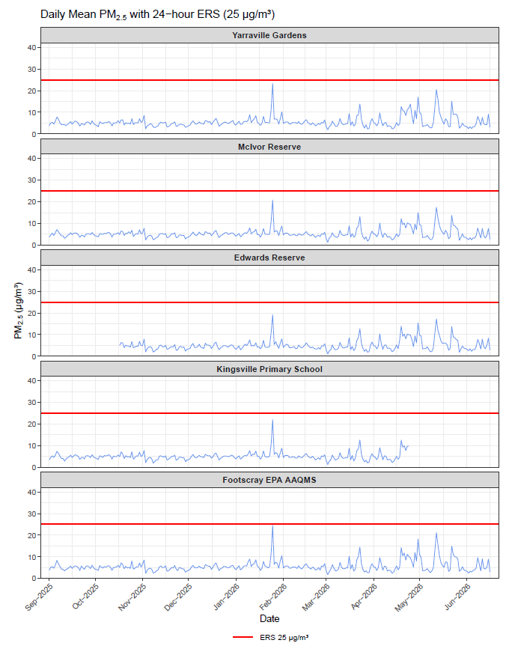
Figure 1: shows the Environmental Reference Standard (ERS) as 50 ug/m³. It also shows PM2.5 ug/m³ levels for each day from 1 September – 16 June 2026 from 6 EPA air sensor at Yarraville Gardens, McIvor Reserve, Edwards Reserve, Kingsville Primary School and Footscray. The PM2.5 results were well under the ERS.
Note: The Kingsville air monitoring site has been temporarily decommissioned. EPA officers are working on finding a new location in the area to resume monitoring.
Yarraville Gardens was relocated on 24 April 2026 from the eastern area to the northwest area of the Yarraville Gardens.

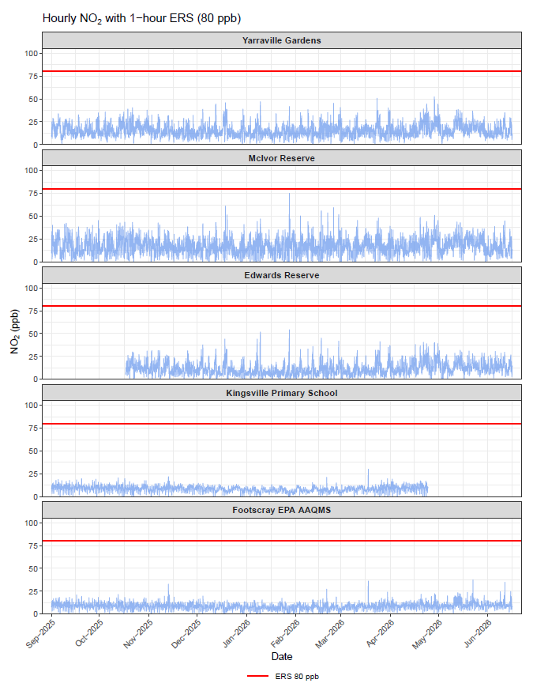
Figure 2: shows the Environmental Reference Standard (ERS) as 50 ug/m³. It also shows the hourly NO₂ ppb levels for each day from 1 September – 16 June 2026 from 6 EPA air sensor at Yarraville Gardens, McIvor Reserve, Edwards Reserve, Kingsville Primary School and Footscray. The PM2.5 results were well under the ERS.
Note: The Kingsville air monitoring site has been temporarily decommissioned. EPA officers are working on finding a new location in the area to resume monitoring.
Yarraville Gardens was relocated on 24 April 2026 from the eastern area to the northwest area of the Yarraville Gardens.

