
  - Publication 2011.1
July 2026
Permissioning Licensing Unit

Guide to development licences


Authorised and published by the Victorian Government, 1 Treasury Place, Melbourne

epa.vic.gov.au
Environment Protection Authority Victoria
GPO BOX 4395 Melbourne VIC 3001
1300 372 842
This content is for general information only. Obtain professional advice if you have any specific concern. EPA Victoria has made reasonable effort to ensure accuracy at the time of publication. Except where noted at epa.vic.gov.au/copyright, all content in this work* is licensed under the Creative Commons Attribution 4.0 Licence. To view a copy of this licence, visit creativecommons.org. EPA acknowledges Victoria’s First Nations peoples as the Traditional Owners of the land and water on which we live and work. We pay our respect to their Elders past and present.


Contents
Introduction 4
What is a development licence? 4
Roles and responsibilities 5
Public participation 8
Joint processes 9
Our approach to proportionate assessment 10
Assessment criteria 12
How to prepare an application 13
How to submit an application 16
How we assess your application 19
How we decide your application 25
How to amend your licence 26
How to transfer your licence 28
Conducting your development activity 29
Operating your activity 32

Introduction

Purpose
This guide explains how to apply for and manage a development licence.
It outlines EPA’s processes, expectations, and decision-making frameworks, including our risk-based approach to proportionate assessments for development licence applications.
Developed alongside our governance policies and Charter of Consultation, this guide promotes transparency and accountability of our development licence application and assessment processes by making them clear and accessible for all Victorians.

Scope
This guide covers the full life cycle of a development licence. Information is presented in a step-by-step sequence, beginning with preparing an application. It helps explain the statutory processes and requirements of applying for and managing a development licence under the Environment Protection Act 2017 (the Act) and Environment Protection Regulations 2021 (the Regulations).
It is primarily intended for development licence applicants or holders. To make the contents easier to understand, ‘you’ is used throughout this guide to refer to applicants and licence holders. The guide also includes useful information on our processes for community, co-regulators, and other interested stakeholders.
For the approved application form and supporting content guide, refer to our Development licence application form and content guide.

What is a development licence?
In Victoria, you need permission under the Environment Protection Act 2017 to conduct certain activities that could harm human health or the environment from pollution and waste. These activities are listed in Schedule 1 of the Environment Protection Regulations 2021 and are called prescribed activities.
Permissions include licences, permits, and registrations. You can learn more about permissions on our website. A development licence is one type of permission. Its purpose is to prevent and minimise the risk of harm before an activity starts.

When you need a development licence
Under section 44 of the Act, you must hold a development licence for prescribed development activities if you plan to:
- construct or install plant or equipment
- develop processes or systems
- modify plant or equipment (except for general maintenance), processes or systems that create a risk of material harm to human health or the environment.
If you require a development licence, you may apply for an exemption from a development licence under section 80 of the Act. You can learn more about exemptions on our website.

Why development licences matter
A development licence is a preventative tool. It gives us oversight of your proposal before any part of the activity begins. The application assessment process checks that you:
- understand the risks of harm that your activity poses, or may pose, to human health and the environment
- have measures in place to eliminate or minimise those risks.
A development licence does not allow you to operate an activity. In most cases, you’ll need an operating licence after a development licence. Some activities may only require a permit or no permission at all. You can find which permission you need on our website but we always recommend you get advice before applying.

Get advice before applying
Preparing a quality application takes time and money. If you are unsure of the type of permission you need, use our free permission pathway process before you start your application.
Development licence application requirements are complex and depend on the activity. Our pathway advice can help you understand:
- whether you need a permission
- what information you will need to provide in an application

How long it takes
We have a statutory assessment timeframe of 4 months to assess development licence applications. It can take longer if we need to request additional information to make a decision.
If we issue a development licence, it will be valid for a specified period that must cover all key development phases, including detailed design, construction, and commissioning.
Development licences are an important project milestone. It can take several years for a proposal to progress from concept to full operation. Understanding the process can help you avoid unnecessary costs and delays.
Submit your application well before your planned start date.

Roles and responsibilities

EPA Victoria
Environment Protection Authority Victoria (EPA) is Victoria’s independent, science-based environmental regulator. We protect human health and the environment from the impacts of pollution and waste. You can learn more about us and how we regulate on our website.
Our role includes managing the development licence application process. We assess applications against the statutory requirements of the Act and Regulations to determine compliance with the assessment criteria.
As part of this process, we are responsible for:
- notifying the community when we receive an application
- considering community submissions and feedback
- engaging with referral agencies
- assessing the potential risks of harm to human health and the environment
- documenting our decision-making in an assessment report
- notifying the applicant, community, and other stakeholders of our final decision.
Our Charter of Consultation explains our commitment to transparency and accountability. We aim to keep everyone with an interest in a development licence application informed about the progress of our assessment and decision-making. We mainly do this through Engage Victoria, the state government’s engagement platform.
Both applicants and affected third parties have legal rights to appeal the lawfulness or merits of our decisions.
If we issue a development licence, it will include conditions that must be met. We’ll monitor and enforce compliance with these conditions.

Applicants and licence holders
Applicants are responsible for:
- designing their proposal
- engaging community and stakeholders
- preparing and submitting application documents
- paying the application fee
- working cooperatively with us and stakeholders during our assessment process.
If a development licence is issued, the licence holder must comply with all conditions within the development licence.
To meet these responsibilities, applicants must:
- understand the process for applying and holding a development licence, and their legal obligations under the Act including all relevant duties
- demonstrate and document awareness of potential risks and the controls available to eliminate, and if that isn’t reasonably practicable, minimise them so far as reasonably practicable
- implement good design, considering best available techniques or technologies, including site selection, process design, control measures, and potential impacts
- engage early with community and stakeholders before applying, gather meaningful feedback and explain how the feedback received influenced the final proposal
- conduct robust assessments of the proposal and its potential impacts using accepted methodologies and standards
- submit complete, accurate, and high-quality documents
- participate constructively in the development licence application process, including in any EPA-led engagement
- respond promptly and fully to our requests for information and keep us informed of expected response times or delays
- maintain open communication with community and stakeholders throughout the application and development licence process.

EPA Portal and permission administrators
Our portal (https://portal365.epa.vic.gov.au/) is used for:
- submitting requests, including permission pathways advice and pre-application meetings
- submitting and managing applications
- managing permissions, including amending, transferring, or surrendering your development licence.
You can find help on how to use the portal on our website.
Permission administrators are portal users with access to advanced features. They manage requests, applications, permissions, and account details on behalf of their business.

Referral agencies
We work with other government agencies during our assessments. These agencies provide technical or regulatory expertise. Some referrals are mandatory, others are discretionary. If we receive comments from a referral agency, we must consider them in our decision-making.
If a referral agency raises concerns or needs more information, we may issue a request for information. Applicants should include referral agencies in their stakeholder analysis and engage with them early to avoid delays.
Below are our most common referral agencies and why we seek their advice.

Planning responsible authorities
Responsible authorities consider and determine planning permit applications under the Planning and Environment Act 1987 (PE Act). They are usually municipal councils or the Minister for Planning. They are prescribed referral agencies for all development licence applications under regulation 22(1) of the Regulations.
They have 15 business days to advise whether:
- the activity is allowed or prohibited by the planning scheme
- a permit under the PE Act is required, has been issued or is being considered.
They also have 32 business days to advise whether they:
- support, do not object to, or object to the application
- recommend conditions if we issue a development licence.
If a planning permit is also required, consider requesting joint advertisement of notices with your development licence application.

Department of Health
The Department of Health (DoH) is a prescribed agency for significant development licence applications. These are applications reasonably likely to have significant implications for public health and that meet specific criteria.
We refer these applications to the Secretary to the DoH for their advice on:
- radiation (both hospital/medical, and industrial radiation)
- drinking water
- food-for-sale
The Secretary to the DoH has 15 business days to provide comments, which may include objections or recommendations. The DoH may object to the application if public health is likely to be endangered. In these cases, we must refuse the application under s 69(4)(c) of the Act.
Table 1 Common referral agencies
Authority | Responsibilities | Referral expertise | Referral time | Types of applications referred
Fire Rescue Victoria (FRV) | Fire and rescue services | Emergency response planning and fire protection systems for dangerous goods and combustible materials | 15 business days | Storage or management of combustible materials and dangerous goods
WorkSafe Victoria | Workplace health and safety regulation | Major hazard facilities, handling and storage of dangerous goods, fire safety controls | 15 business days | Major hazard facilities, handling and storage of dangerous goods
Water corporations | Water, sewage, trade waste services | High-volume water supply, trade waste agreement | 15 business days | High-volume water supply, trade waste agreement
Water catchment management authorities | Integrated catchment management | Reuse or application of waste to land, discharge to a waterway | 15 business days | Reuse or application of waste to land, discharge to a waterway
Earth Resources Regulator | Earth resource exploration, mining and quarrying activities | Activities under the Mineral Resources (Sustainable Development) Act 1999 (MR(SD) Act) | 15 business days | Extractive industries and mining
Agriculture Victoria | Public health risks from animal industries | Public health risks from zoonotic disease, biosecurity risks transmission (e.g., Q-Fever), or biosecurity risks | 15 business days | Animal industries such as piggeries or goat farms

Public participation
Our purpose is to protect the human health and the environment from pollution and waste. There are 10 principles of environment protection set out in sections 13-23 of the Act, and they include the following principles which are relevant to public participation in the development licence process:
- shared responsibility means everyone—government, industry, communities, and individuals— has a responsibility for protecting human health and the environment
- accountability ensures people:
  - have access to reliable and relevant information
  - are engaged and are given opportunities to participate in decisions
  - have their interests considered
- equity recognises that everyone is entitled to a safe and healthy environment, regardless of who they are or where they live – and that people should not be disproportionately affected by harm or risks of harm to human health and the environment. This includes ensuring that the state of the environment is maintained for the benefit of future generations.

Traditional Owners
Traditional Owners are the traditional custodians of Country. They have rights and interests across their Country. The Aboriginal Heritage Act 2006 protects Aboriginal cultural heritage and establishes Registered Aboriginal Parties, who speak for Country on cultural heritage matters.

How we engage with the public
Our Charter of Consultation explains how we consult and engage. We apply the principles of environment protection and tailor our engagement to the level of risk and complexity associated with each application.
Our engagement begins when we receive an application. Pre-application engagement is the applicant’s responsibility.

How we expect you to engage with the public
We expect you to undertake public engagement as part of the process of developing your application. This means identifying and engaging with the community and other stakeholders who have an interest in or are potentially impacted by your proposed activity. This should be done before submitting a development licence application.
Early and ongoing engagement helps to:
- make the community and stakeholders aware of your proposal
- identify, address, and resolve any issues with your project design
- reduce the number or complexity of matters we must assess
- support community and stakeholders to make informed submissions or comments during our statutory assessment period
- build trust and provide social licence for you to conduct your activity
Your engagement should reflect the principles of shared responsibility, accountability, and equity.
Learn more about how to conduct pre-application engagement on our website. This includes an explanation of the steps for notifying and engaging with local communities, examples of engagement methods (benefits and limits), advice on engaging with culturally and linguistically diverse (CALD) communities, and templates for engagement plans and pre-application register.

Joint processes

Environment effects statements
An environment effects statement (EES) is a type of development assessment required under the Environment Effects Act 1978 (EE Act). The Minister for Planning decides whether an EES is needed following a referral.
If an EES is required, we cannot make a decision on a development licence application until the Minister has completed their assessment. We must then consider the Minister's assessment when deciding on the application.
Learn more about EES requirements in the Ministerial guidelines for assessment of environment effects on the Department of Transport and Planning (DTP) website.

Joint notifications and exhibition
The EES process includes a public review and exhibition period. You may request that this process is combined with the notice and submission period for your development licence application.

Changes to review rights
You and third parties may not apply to VCAT to review our decision to issue a development licence if:
- the advertising and notification were combined and
- the development licence we have issued is substantially in accordance with the assessment of the Minister for Planning

Planning permit or scheme amendment applications
Planning permits are a type of statutory approval for the use or development of land. Responsible authorities consider and determine planning permit and scheme amendment applications under the PE Act.

Joint notifications
Planning permit and scheme amendment applications may require a public comment and submission period. You may request that this is combined with the notice and submission period for your development licence application.

Changes to review rights
You and third parties may not apply to VCAT to review our decision to issue a development licence if:
- the advertising and notification were combined and
- a planning panel has been appointed and
- the development licence we have issued is substantially in accordance with application or amendment as heard by the panel

Our approach to proportionate assessment
All development licence applications go through a comprehensive assessment. However, not all applications pose the same level of risk or complexity.
We use a risk-based approach informed by science, intelligence, and evidence. This helps us focus our efforts where they will have the greatest impact.
We are committed to making decisions that are transparent and accountable. To do this, we use the permission application profile assessment (Figure 1) as a framework for managing applications in a consistent and proportionate way.
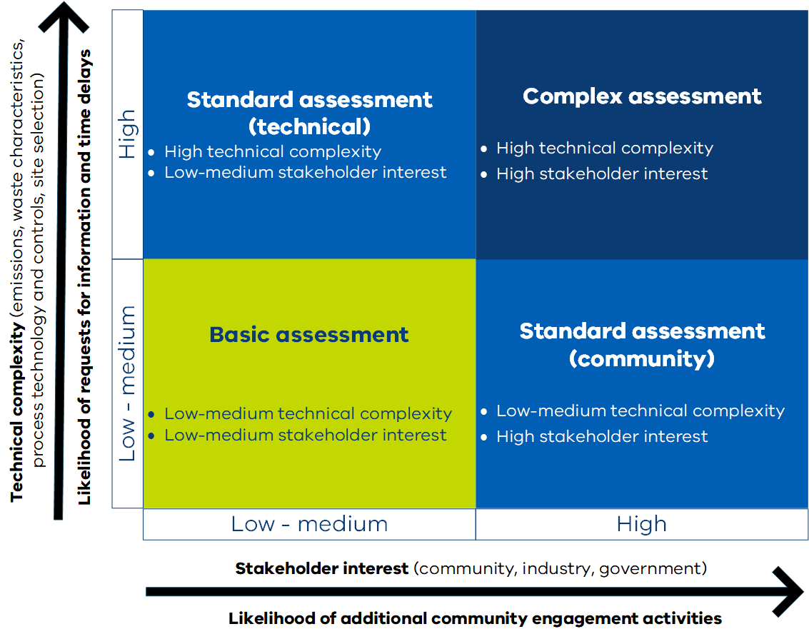
Figure 1 Our permission application profile assessment

Factors that influence an application profile rating
Two main factors influence an application’s profile rating: technical complexity and stakeholder interest.

Technical complexity factors include:
- site location and proximity to sensitive environments or public health concerns
- existing levels of background or cumulative pollution
- novelty of process or environmental control
- volume and characteristics of emissions or discharges
- volume and characteristics of waste managed or generated
- reuse of waste

Stakeholder interest factors include:
- site location and proximity to sensitive environments or public health concerns
- the applicant’s or industry’s compliance track record or record of complaints
- level of community interest and pre-application engagement
- other regulatory approvals required, such as environmental effect statements, planning scheme amendments, or waste to energy cap licences

Profile rating and assessment timeframes
An application with a higher profile rating is more likely to involve:
- more community engagement activities
- more submissions or referral agency comments
- extra requests for information.
These factors can affect the timeliness of our decision. Higher-profile applications should expect that we will need the full 4-month statutory assessment period. This does not include the time you need to respond to any requests for information.
In some circumstances, we may request additional time to complete our assessment.

How you can support timely decisions
You can help us make faster, more robust decisions by:
- seeking our pathways advice before you start preparing your application
- conducting thorough community and stakeholder engagement before applying
- addressing community concerns by showing how feedback influenced your proposal design
- managing technical complexity by engaging qualified professionals and subject matter experts
- submitting high-quality documents that are clear, concise, well-organised, and supported by strong evidence
- describing your process in detail and providing schematics that identify hazards and critical control points
- clearly explaining your risk assessment, including hazard identification, risk evaluation, control measures, and monitoring
- considering and assessing risks of cumulative impacts from your existing and proposed activities, as well as from surrounding and neighbouring activities, and clearly demonstrating how these risks will be managed
- proposing best available techniques or technologies or clearly justifying why they are not feasible
- meeting recommended separation distances as set out in our Separation distance guideline and Landfill buffer guideline.

Assessment criteria
We assess development licence applications against the criteria in section 69(3) and (4) of the Act. Additional statutory or risk-based considerations may apply depending on your proposal.
Refer to our Development licence application form and content guide to identify all relevant application requirements.

What your application must demonstrate
Your application must enable us to assess:
- how you will comply with the general environmental duty
- the impact of the activity on human health and the environment, including any environmental values in the Environment Reference Standards
- how you apply the principles of environment protection
- the use of best available techniques or technologies in the process design and controls
- whether the activity is consistent with the Act and the Regulations
- any other prescribed matter.
During the assessment, we may also request additional information to address:
- comments from referral agencies
- submissions received through our community engagement process.

Other statutory considerations
Our assessment may also include decision-making responsibilities under other legislation, such as:
- Climate Action Act 2017
- Fauna and Flora Guarantee Act 1988
- Charter of Human Rights and Responsibilities Act 2006.
These Acts create additional obligations we must consider when making certain decisions, such as deciding on a development licence application. You can learn more about the information we need to complete these assessments, and other frameworks to consider, in the Development licence application form and content guide.

Grounds for refusal
Under the Act and Regulations, we must refuse your application if:
- you are not a fit and proper person to hold a development licence
- the proposed activity poses an unacceptable risk of harm to human health or the environment
- the application is for a new landfill that is not listed in the Victorian Recycling Infrastructure Plan (VRIP).
We must also refuse your application if the Act or Regulations prohibit the proposal. For example:
- Regulation 19 prohibits us from issuing a permission for an activity that results in a wastewater discharge or deposit to surface waters in a special water supply catchment area
We may also refuse your application if:
- referral agencies object to the proposal
- the proposal is inconsistent with the Victorian Recycling Infrastructure Plan (VRIP)
- the proposal seeks to extend an existing landfill that is not consistent with the VRIP.

How to prepare an application
You must prepare your own application documents or engage a qualified professional to do so on your behalf. Your application must use the Development licence application form and content guide.
Use the form and guide to:
- understand what information is required
- ensure you submit a complete and compliant application
- avoid unnecessary delays and costs

Key steps in preparing an application
Preparing a development licence application can be complex. Complete the following steps to meet all requirements:
- Get pathways advice
- Get professional help
- Understand your regulatory requirements
- Assess technical feasibility and regulatory alignment
- Understand the state of knowledge for your activity
- Manage risk
- Show acceptable risk of harm
- Engage stakeholders
- Engage community
- Use the application form
- Avoid common mistakes

Get pathways advice
Request pathway advice through our permission pathway process before you prepare an application. It is free and highly recommended.
We may also offer additional pre-application support, including:
- support from an assessing officer to advise you on application requirements
- meeting with our technical experts to advise you on key matters to address in your application
We only offer this additional support if you seek pathway advice through our portal. The Permissions proposal pathway guideline has more information on preparing your pathway request.

Get professional help
Your application is a legal document once it has been submitted. Make sure it meets professional standards. This will help you avoid legal risks or complications during our assessment.
We recommend you engage:
- a suitably qualified professional to prepare your application, such as an environmental consultant
- suitably qualified subject matter experts for any detailed technical studies and reports
If your application is low quality, we may not be able to make an evidence-based decision. In these cases, we will refuse your application.

Understand your regulatory requirements
Your application will need to show how your proposal complies with our assessment criteria. To do this you need to understand your obligations and duties under the Act.
Identify and document all relevant regulatory standards you will need to address in your application, such as:
- the Act
  - your duties
- the Regulations
- legislative tools and instruments
  - the Environment Reference Standards
  - Noise Protocol
  - waste classification assessment protocol
- compliance codes or codes of practice
- policies and guidelines
Learn more about these and related requirements on our website.

Assess technical feasibility and regulatory alignment
Your application must show that you understand your activity, the risks it may create, and the controls needed to eliminate or minimise those risks so far as reasonably practicable. It must also be technically viable and able to meet all relevant regulatory requirements.
This may involve balancing business objectives with social, economic, and environmental requirements. For example, improving one aspect of a proposal may increase public health or environmental impacts in another. Your application should identify these trade-offs and explain how the proposal achieves the best overall public health or environmental outcome.

Understand the state of knowledge for your activity
Your proposal should reflect current information and industry knowledge about the activity, its risks, and available controls. Use relevant sources of information to prepare your application, including EPA publications, industry guidance, manufacturer information, research, and comparable development licence applications published on Engage Victoria.

Manage risk
Understanding and managing risk is central to a development licence application and your obligations under the general environmental duty. Use a risk management process to identify hazards and assess the risks of your proposal, including risks of cumulative impacts on the local environment.
This includes identifying:
- the likely or potential risks of harm to human health or the environment
- the likelihood of those risks eventuating
- the degree of harm that would result if those risks eventuated
- the availability of controls for eliminating or reducing those risks, including best available techniques or technologies
- the costs of eliminating or reducing those risks
A documented risk management process is required as part of your development licence application and must demonstrate how risks, including cumulative risks, will be effectively mitigated or managed.
Detailed risk assessments may be required depending on the nature, scale, complexity, and risk of your activity. They are usually needed where your risk assessment identifies medium-to-high risks, cumulative impacts, sensitive receiving environments, significant uncertainty, or controls that require detailed design or precise operation.
The Development licence application form and content guide includes more information on when detailed risk assessments may be needed and the methods you should use.

Show acceptable risk of harm
We must refuse an application if it poses an unacceptable risk of harm to human health or the environment. Your application must demonstrate that any residual risk of harm associated with the proposed activity:
- has been minimised so far as reasonably practicable
- does not pose an unacceptable risk of harm, including to any values of the Environment Reference Standards
- will not emit unreasonable noise
Use EPA publications and accepted assessment methods to assess potential risks of harm to human health and the environment.

Engage stakeholders
Before submitting your application, you should identify and engage with a range of stakeholders. Early and ongoing engagement with these stakeholders will help you avoid delays during assessment.
This includes:
- other government agencies that may advise you on separate statutory approvals
- any relevant referral agency listed in Table 1 Common referral agencies

Engage community
Communities have a right to know about activities that may pose a risk of harm to their health and environment. We expect you to engage with the community early in your proposal and before submitting your application.

Use the approved application form
You must use the Development licence application form and content guide. If you do not use the approved application form, your application will be noncompliant. By law, we cannot assess noncompliant applications.

Avoid common mistakes
Common mistakes lead to delays and refusals. Avoid these common mistakes:
- ignoring our advice or not seeking pathway advice
- not using the Development licence application form and content guide
- engaging unqualified or inexperienced consultants
- not engaging technical experts or failing to verify their qualifications or their experience with similar applications
- insufficient detail on the proposal, risk assessment, or proposed controls
- a lack of supporting technical evidence
- not engaging with stakeholders and community

How to submit an application
Once you have prepared your application, you must submit it through our online portal.
We will only process properly submitted applications. This means you must:
- answer all the questions in the form
- attach your application documents
- agree to all declarations and submit the form
- pay the application fee
We must reject your application if any of these steps are incomplete.
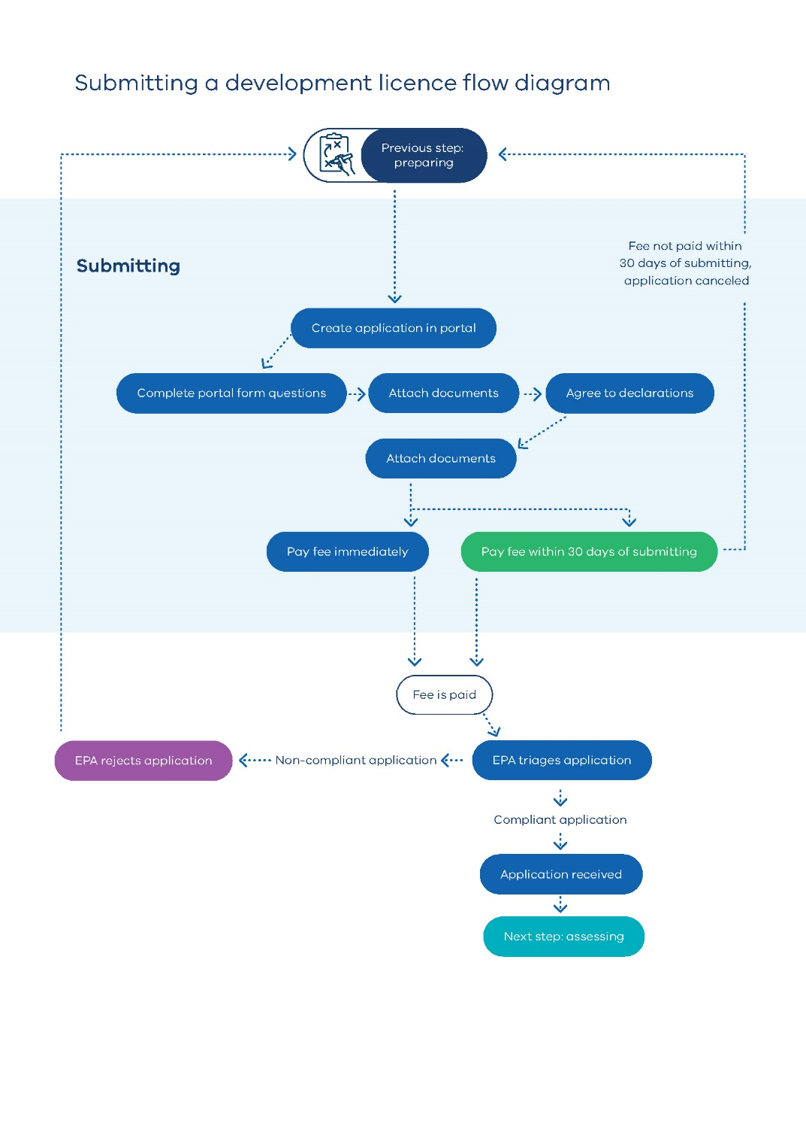
Figure 2 Submitting a development licence application flow diagram

Create an application in our online portal
All applications must be submitted via the EPA portal. To create an application:
- sign up to the EPA portal and log in
- select Apply for permission and click Start an application from your dashboard
- choose new in the Application type dropdown
- select development licence from the Permission type dropdown
You can save your application and return to it later. It will remain in the draft status until it is submitted.

Answer all questions
The portal form includes mandatory and optional questions. You do not need to repeat information already included in your application documents. Instead, reference relevant sections to help us complete our compliance check.

Attach your application documents
You must attach your application and appendices, prepared in accordance with our Development licence application form and content guide.
This is one of the final steps before submission. Make sure your files meet the required format, size, naming conventions, and other specifications.
Appendix A of the guide includes a checklist to help you complete this step.

Agree to all declarations and submit
Before submitting, you must agree to a series of declarations. Once you agree to the declarations, click Submit. Your application status will change from Draft to Submitted.

Pay the application fee
All applicants must pay the prescribed development licence fees.
You can pay the fee immediately by credit card when you submit your application. If you choose not to pay straight away, you will receive a tax invoice with payment instructions, the fee amount, and due date.
We do not consider your application received until the fee is paid. If you miss the due date, your application will be cancelled, and you will need to start a new one.
Fees are set under regulations 172 to 174 in Part 8.1 of the Regulations. Additional fees may apply if we need more time than allowed under the Regulations to assess your application.
For more information, see Fees.

Application compliance check
Once you submit your application and pay the fee, we will review your application to check if it meets the requirements of section 50(1) of the Act.
By law, we cannot assess noncompliant applications. If your application is noncompliant, we will notify you in writing, usually within 2 business days. You will need to submit a new application and may need to pay a new fee.

We reject noncompliant applications
We cannot accept your application if:
- you have not prepared your application documents using the Development licence application form and content guide
- it is not submitted via the correct form in our online portal
- your application or required documents are missing or are not in the correct format
- the application fee is not paid by the due date

How we assess your application
All development licence applications undergo a comprehensive assessment. At the end of this process, we make a decision based on an application’s merit. Our assessment considers multiple inputs and involves a range of stakeholders.
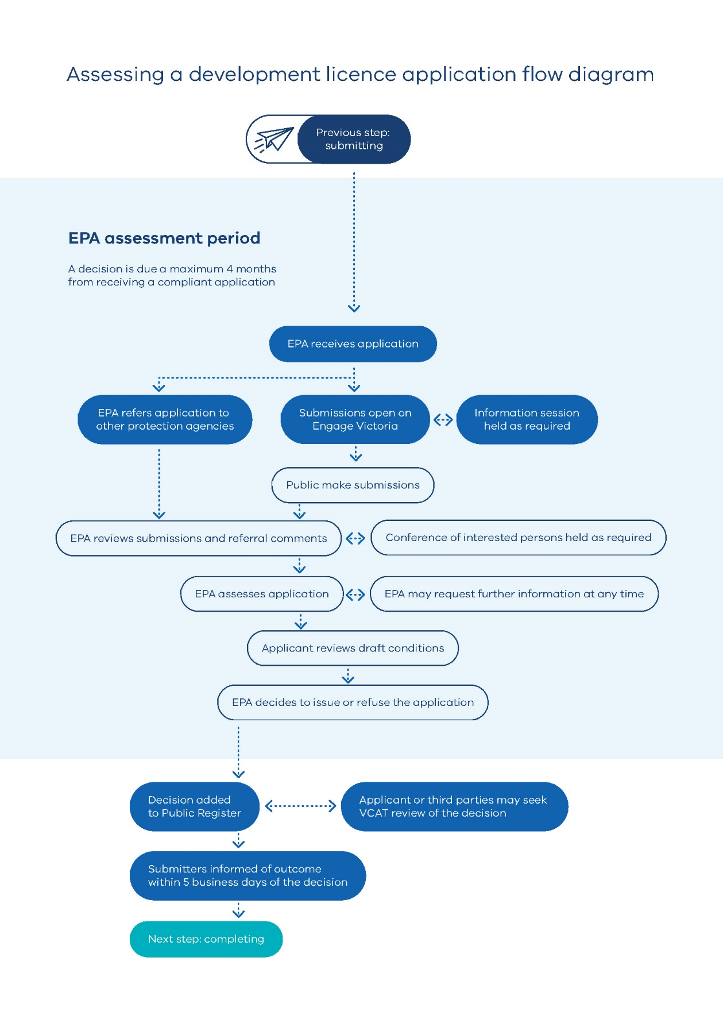
Figure 3 Assessing a development licence application process flow diagram

When assessment starts
The statutory assessment period (or statutory clock) starts when we receive a compliant application. From this date, we have 4 months to complete our assessment. We may make a decision earlier, or in some cases, after the statutory due date.
The statutory timeframe excludes:
- any time you take to respond to a request for information
- any additional time agreed to between you and us.

Community and public engagement
Ensuring that the process for all development licence applications is consistent with the environment protection principles requires public engagement. Public engagement requires consideration of all those who are likely to be impacted or have an interest in the application. This includes community and other stakeholders.
Community engagement is an important part of our process. Our Charter of Consultation sets out our commitment to consult Victorians. Engagement ensures the community is aware of an application and has a meaningful opportunity to provide input. This contributes to robust decisions.

Publishing a notice of your application
We must publish a notice for every application. We do this on:
- Engage Victoria (the whole-of-Victorian government engagement platform)
- on our website
- a local newspaper (if available)
- other channels as we consider appropriate
The notice explains:
- who is applying
- the activity
- how to access the application
- how to make a submission
We publish the notice as soon as possible after receiving your application.

Joint advertising with other processes
Some development licence applications are advertised together with other statutory processes. For example, if your application also requires:
- a planning permit or planning scheme amendment under the Planning and Environment Act 1987
- an environment effects statement under the Environment Effects Act 1978
Joint advertising helps align decision-making processes and timelines. If this applies to your application, contact your EPA Permissioning Officer to determine if this is possible in your situation.

Engage Victoria
Engage Victoria is our primary platform for community engagement on development licence applications. For each application we create a dedicated project page where we publish:
- the application
- updates on the status of our assessment
- submissions and referral agency comments
- requests for information
- applicant responses to submissions and requests
- our decision
- updates on any legal challenges and outcomes.
Information remains on the project page indefinitely. This ensures transparency and allows stakeholders to review applications and our decision-making process.

Submission period
We invite public submissions on all applications. The law requires a minimum submission period of 15 business days (excluding the day the notice was published). There is no maximum period in the Act. However, we limit submission periods to 25 business days to meet statutory deadlines.
Anyone can make a submission during this period. All submissions must:
- be lodged by the specified closing date
- be submitted via Engage Victoria (unless we advise otherwise)
- use our standard online form.
Submitters can attach files, such as detailed written submissions.

Information sessions and other activities
In some cases, we may run additional engagement activities, such as information sessions. This helps the community understand a proposal, the assessment process, and how to make a submission. We decide this on a case-by-case basis, guided by our approach to proportionate assessment.
For more detail, see our pre-application engagement guidance and Charter of Consultation.

Responding to community submissions
All submissions will be published on Engage Victoria. These are de-identified before publishing to protect the privacy and security of submitters.
We may require you to provide a response to any submissions we receive. We will do this via request for information. Requests for information pause the statutory clock, and it will remain paused until we receive a satisfactory response.
Responding to submissions is an opportunity to:
- address community and stakeholder concerns
- clarify or provide additional information
- build trust and develop your social licence to operate.
Make sure the tone of your response is easy to understand, constructive, and respectful.
Once we receive a satisfactory response we will publish it on Engage Victoria for submitters to view. You can find examples of how previous applicants have responded to submissions on Engage Victoria.
We will finalise our technical assessment and make a decision on your application if we do not receive any submissions.

Responding to referral agency responses
All referral agency responses will be published on Engage Victoria, unless requested otherwise by the referral agency or due to commercial-in-confidence considerations.
We may require you to provide a response to any referral agency responses we receive. We will do this via request for information. Requests for information pause the statutory clock, and it will remain paused until we receive a satisfactory response. You can find examples of how previous applicants have responded to referral agency responses on Engage Victoria.

Conferences of interested persons
We may establish a conference of interested persons relating to a development licence application decision to:
- assist in a just resolution of a matter affecting our decision, and
- provide an informal way for us to consider an issue or matter relating to our decision.
We make the decision to have a conference as soon as practicable after receiving submissions and referral agency responses. They are for issue resolution and are not community engagement events. We will only hold a conference for a development licence application if we believe it will assist in a just resolution of an issue relating to our decision.
If a conference is held, we will appoint a chair to convene it and make recommendations for our assessment. The outcomes of a conference will assist our decision-making, but any recommendations are not binding on us.
We are committed to making it as easy as possible for interested persons to participate in any conference. We will always aim to:
- use convenors who are skilled in facilitating diverse groups and finding ways for everyone to have their say
- hold the conference online or in a local venue that is convenient and accessible for participants
- choose a time and day that suits as many interested persons as possible
- find other ways for the interested persons to participate if the conference format is not suitable.
The convenor will then prepare a report summarising the findings of the conference. We will publish any report or recommendations made by the conference chair on Engage Victoria.

Technical assessment
Once we have completed our community engagement and referral processes, we will be able to complete our technical assessment. We use subject matter expertise across EPA to assess the merits of your application. We may engage independent external technical expertise if it will assist us in our decision-making.
Our assessment is guided by the environment protection framework as shown in Figure 4. This framework establishes a hierarchy of procedural, statutory, and discretionary merit-based requirements. The Act is our primary legislation. It establishes the legal framework of environment protection obligations and duties. It is supported by regulations and legislative instruments that also set out legal requirements. Publications, such as guidelines, support our decision-making but are not legally binding.
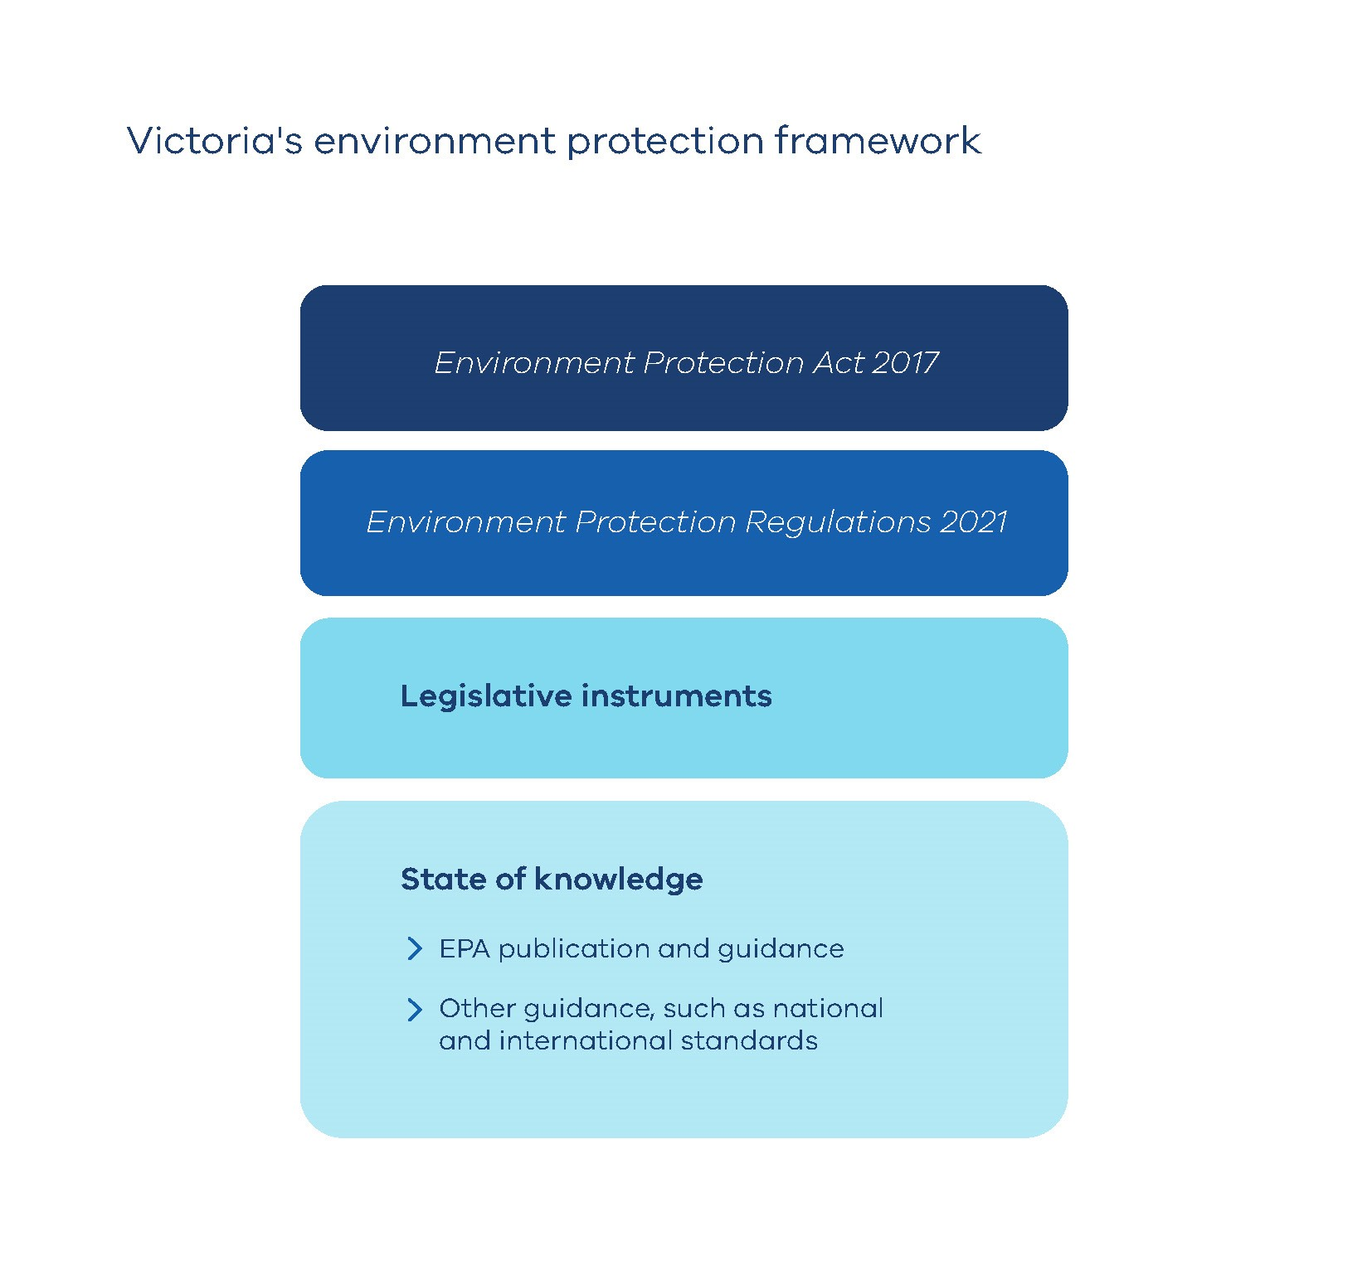
Figure 4 The environment protection framework

Request for information
We may need to request more information from you during our assessment. The statutory clock pauses once we make a request, and it does not resume until we receive a response.
We only make a request for information if it is relevant to our decision. We will work with you to clarify or expand on what is needed in a timely manner. To respond to our request, you must update your application document or provide the information as an appropriately identified addendum. All changes must be tracked in your application document using version control. See our Development licence application form and content guide for more instructions on proper documentation.
Failure to provide a complete or timely response may result in additional requests or the refusal of your application.

Request for additional time
Under section 51B(b) of the Act, EPA and an applicant may agree to extend the timeframe by which we must decide your application.
Some examples of when we may request additional time to assess your application include:
- there are complex technical matters that are taking longer than usual to assess
- we believe a conference of interested parties may be beneficial to the outcome of our decision
- we need external subject matter expertise to complete our assessment.
By agreeing to an extension of the statutory clock you limit your right to seek a decision for our failure to make a decision within the statutory timeframe from the Victorian Civil and Administrative Tribunal (VCAT).

Review of draft conditions
Prior to deciding your application, we may request that you review a draft development licence. This may confirm administrative details or seek your comment on any non-standard conditions. This is usually a standard administrative step. We will specify a reasonable timeframe for you to respond to this request. If you need additional time you will need to agree to a request for additional time.

How we decide your application
After we assess your application, we will decide whether to issue a development licence.

Type of conditions
If we issue a development licence, it will contain conditions. All conditions are mandatory. There are 3 types:
- General conditions that apply to all development licences.
- Standard conditions that apply to each industry or prescribed permission activity, such as A01 (Reportable priority waste management).
- Specific conditions that are tailored to the development activity. We impose these conditions when environmental or human health risks are considered high. They are prescriptive and require further actions that are managed under our oversight.
If you propose a staged development, our conditions will match the complexity of each stage. They will be used to verify that each stage aligns with your approved application. We may also require further EPA approval or oversight by an EPA-appointed auditor.
The conditions we impose are guided by our approach to proportionate assessment and the quality of the application.

Commissioning under conditions of a development licence
Development licences often include conditions for commissioning. Commissioning proves the performance of the plant, equipment, system, or processes in your application.
Commissioning is usually required for activities involving:
- waste and wastewater management
- emissions, discharges, or deposits into the environment
Our commissioning conditions cover planning, implementation, monitoring, proof of performance, and reporting. See our Development licence application form and content guide for more information about what to include in your application regarding commissioning.

Duration of a development licence
All development licences include a condition stating when they expire. You must meet all conditions and complete the approved development activity within this period including detailed design, construction, and commissioning. The duration is application-specific but will usually range from 2 to 5 years. Your application must outline a reasonable timeframe for you to complete your development activity.

Publishing our decision and notifying submitters
We publish our decisions on:
- the Permissioning Decision Register
- an application’s dedicated Engage Victoria webpage.
We also email submitters directly. We aim to notify submitters within 5 business days of our decision and inform them of their appeal rights.

Victorian Civil and Administrative Tribunal (VCAT) and judicial appeals
You or a third party can seek a review by VCAT within 15 business days (after the day of our decision) if you object to:
- our decision to issue a development licence
- the conditions of the development licence
- our decision to refuse a development licence
For details, see the Appeal our decision page.

How to amend your licence
You may need to amend your development licence from time to time, for example to:
- update administrative details
- make minor changes to the activity’s configuration or staging
If your amendment changes the risk profile of your activity, you may need to apply for a new development licence. The application only needs to cover the change or variation to your activity.
Before preparing an amendment application, request pathway advice through our permission pathway process.
Submit your application through our portal. Our webpage on how to Amend a licence, permit, or registration has details, including what to include in your application.
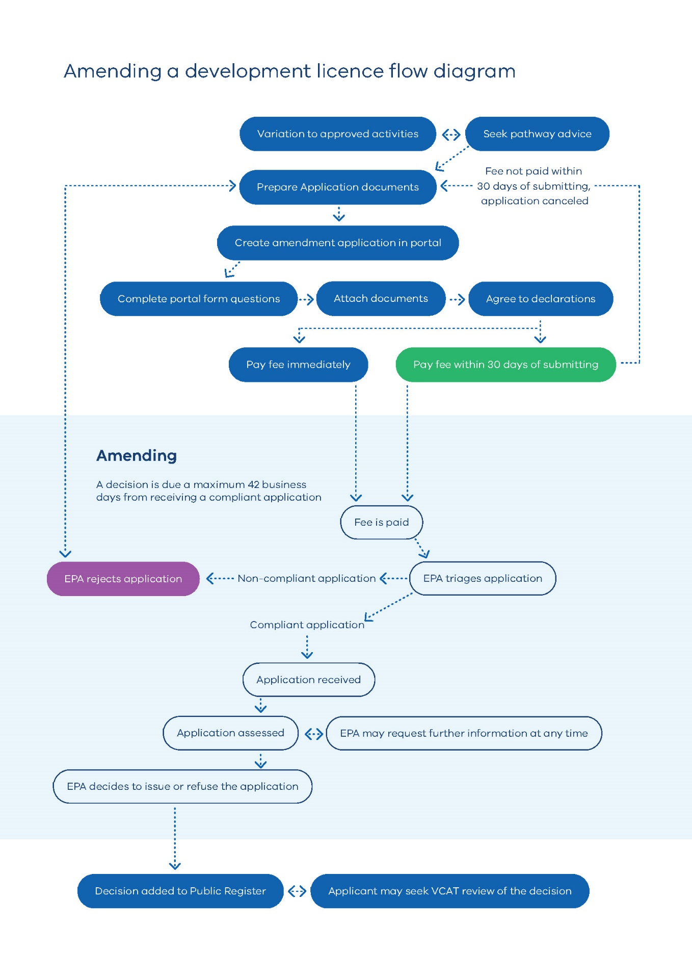
Figure 5 Amending a development licence flow diagram

How to transfer your licence
You may apply to transfer a development licence from the current holder to another person or organisation. You must have a written agreement to transfer the licence. The new licence holder must submit the application, not the current licence holder.
Submit your application through our portal. Transfer a licence or permit has details, including what to include in your application.
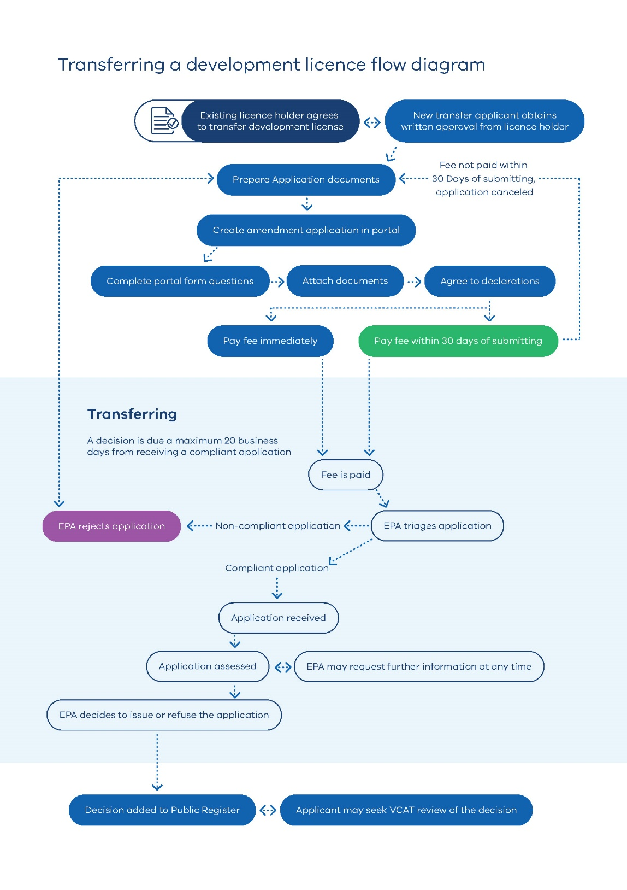
Figure 6 Transferring a development licence flow diagram

Conducting your development activity
If we issue a development licence, it will have an expiry date. You must complete your development activity by this date, including meeting all conditions of the development licence. If your activities are staged, you must complete them in the approved sequence.
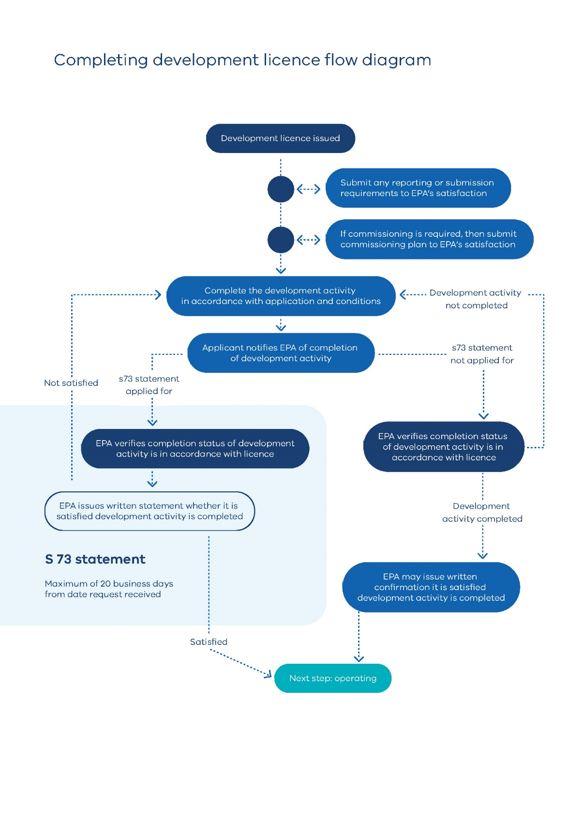
Figure 7 Development licence completion flow diagram

Commencing development activity
You must notify us when you start development activities.
Email Permissions@epa.vic.gov.au and include your development licence number and the relevant condition code.

Reporting or submission requirements
Development licences may include conditions that require you to submit reports or documents with additional technical details, plans, or designs for approval. These conditions usually require implementation or monitoring plans, such as a construction and environment management plan, or the final detailed designs of an environmental control.
We use these conditions when these details are not technically or financially feasible to provide at the application stage. These conditions verify that your activity, or part of it, matches your development licence application and meets all requirements.
These conditions usually limit your ability to commence your development activity, or the relevant component of the activity, until we are satisfied that the required reports or documents are acceptable. These conditions may also contain additional requirements, such as requiring reports, plans, or designs to be prepared or endorsed by a suitably qualified professional.
Submit these reports by emailing Permissions@epa.vic.gov.au and include your development licence number and the relevant condition code.

Commissioning
Some development licences require commissioning. This verifies that your activity meets the standards detailed in your application. Our commissioning conditions cover planning, implementation, monitoring, and reporting.
The sequence for commissioning is:
- submit a commissioning plan for our approval before you start commissioning
- submit a monitoring report at the end of the commissioning period. The report must show the results of your proof of performance testing
- complete commissioning by the end of the validity period.
You cannot operate your activity until your commissioning results show compliance with the information that you provided in your development licence application.

Risk management and monitoring program
Development licences may include a condition requiring you to prepare a risk management and monitoring program (RMMP). The RMMP should be developed for your operating phase only. We may request part or all of your RMMP when you apply for an operating licence.
Preparing a risk management and monitoring program has more information.

Financial assurance
EPA may require a financial assurance as a condition of a development licence. This applies to certain prescribed activities as listed in Regulation 167 of the Regulations. They are:
- A01 (Reportable priority waste management)
- A05a (Landfills (excluding municipal landfills servicing fewer than 5,000 people))
- A13a (Large-scale waste and resource recovery)
- A13b (Medium-scale waste and resource recovery)
- G04 (Bulk storage)
- L02 (Onsite soil containment for contaminated sites)
EPA decides whether financial assurance is needed by applying the risk assessment criteria outlined in Regulation 168 of the Regulations. The risk assessment criteria cover:
- the risk of harm to human health and the environment
- your history of compliance
- if you are a prohibited person
- your financial capacity
- the risk of abandonment
- how much clean-up might cost
Each case is assessed individually. Financial assurance may be required to cover the potential costs of clean-up or remediation related to the activity.
Generally, financial assurance is more likely to be required if the site will:
- accept or store priority and/or reportable priority waste
- construct a landfill cell under the development licence.

Evidence of completion of development activities
You must not operate the activity until you have completed the development activities and received written confirmation from us. There are two options for obtaining this confirmation. We may conduct an inspection of the activity as part of either of the verification processes.

Requesting written evidence
Request this confirmation by emailing Permissions@epa.vic.gov.au and include your development licence number. Include a summary of how you have satisfied each condition of your development licence.

Applying for a section 73 statement
You may also apply for a statement from us confirming whether we are satisfied that you have completed your development activity. This is referred to as a section 73 statement. It is not mandatory to apply for a statement, but it is highly recommended
We must provide a statement within 20 business days after receiving an application. There is currently no application fee when applying for a section 73 statement.
Apply by emailing Permissions@epa.vic.gov.au and include your development licence number. Include a summary of how you have satisfied each condition of your development licence.
We may conduct an inspection of the activity as part of the verification process.

Requesting an extension of time
You may request an extension of time if you are unable to complete your development activities by the end of your licence validity period.
Email Permissions@epa.vic.gov.au and include your development licence number. We will only consider requests that include:
- clear mitigating reasons why an extension of time is required
- a revised completion timeline.
We cannot consider requests after the validity period has expired.

Compliance checks
We may inspect your activity during the validity period of your development licence. These inspections verify whether the processes or plants are being implemented or constructed to the approved specifications.
We may initiate compliance and enforcement activities if we detect any non-compliance with the requirements of the development licence.

Operating your activity

Permission requirements
In most cases, an operating licence is required after a development licence. However, some activities only require a permit or may not require a permission to operate.
Apply for an operating licence or permit through our portal. If your development licence modifies an existing permissioned activity, apply to amend your current permit or operating licence.
More information on permits or operating licences is available on our website.
If you do not need a permission to operate, you must still meet all your duties under the Act. We may inspect your activities to check compliance.

Operating licence applications and section 73 statements
If you are applying for a new operating licence and you hold a development licence and a section 73 statement confirming you have completed your development activity, you will:
- receive a decision within 15 business days
- not have to pay an application fee
If you have not obtained a section 73 statement, you will:
- receive a decision within 42 business days
- pay an application fee

Accessibility
Contact us if you need this information in an accessible format such as large print or audio.
Please telephone 1300 372 842 or email contact@epa.vic.gov.au
Interpreter assistance

If you need interpreter assistance or want this document translated, please call 131 450 and advise your preferred language. If you are deaf, or have a hearing or speech impairment, contact us through the National Relay Service.



epa.vic.gov.au
Environment Protection Authority Victoria
GPO BOX 4395 Melbourne VIC 3001
1300 372 842



Authorised and published by the Victorian Government, 1 Treasury Place, Melbourne

