EPA West Gate Tunnel Project sensor air

monitoring
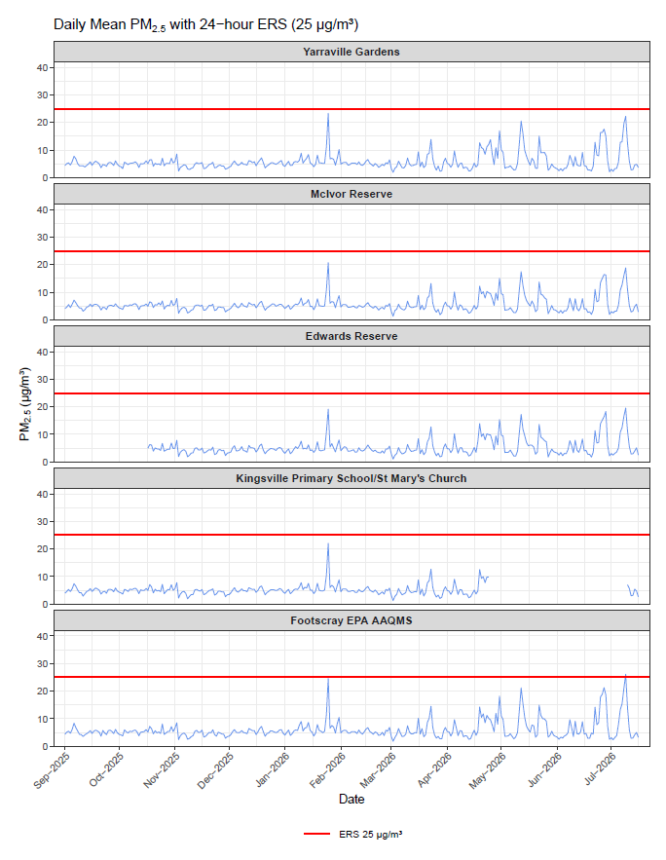
Figure 1: shows the Environmental Reference Standard (ERS) as 50 ug/m³. It also shows PM2.5 ug/m³ levels for each day from 1 September – 16 July 2026 from 6 EPA air sensor at Yarraville Gardens, McIvor Reserve, Edwards Reserve, Kingsville Primary School/St Mary’s Church and Footscray. The PM2.5 results were well under the ERS.
Note: The Kingsville air monitoring site was offline from 24 April 2026-9 July 2026 and was moved to its new location at St Mary’s church, 2 blocks away. On 10 July 2026 air monitoring resumed at St Mary’s.

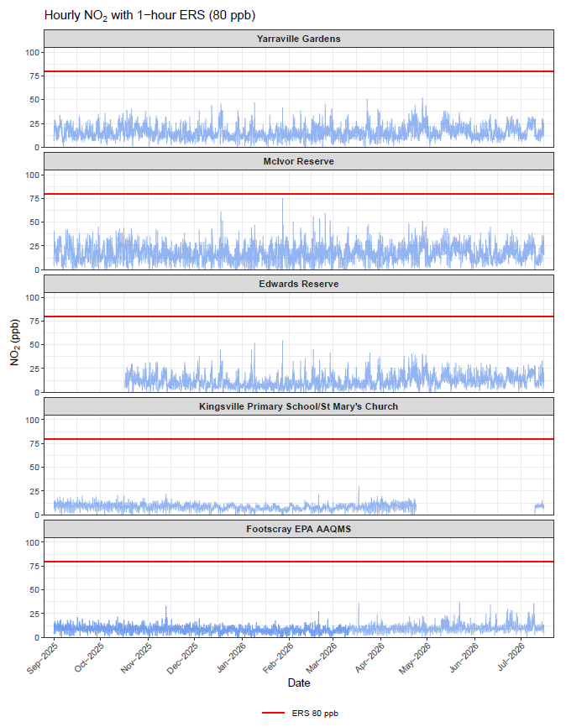
Figure 2: shows the Environmental Reference Standard (ERS) as 50 ug/m³. It also shows the hourly NO₂ ppb levels for each day from 1 September – 16 July 2026 from 6 EPA air sensor at Yarraville Gardens, McIvor Reserve, Edwards Reserve, Kingsville Primary School/St Mary’s Church and Footscray. The PM2.5 results were well under the ERS.
Note: The Kingsville air monitoring site was offline from 24 April 2026-9 July 2026 and was moved to its new location at St Mary’s church, 2 blocks away. On 10 July 2026 air monitoring resumed at St Mary’s.

